Some Great Bank
UI Spec
DRAFT
Version 0.01
Publish date
December 1, 2005
Submitted by
<<author>>
IBM Global Services
<Application Name> Release <number>

Table of Changes

Revision Number | Date of Change | Section(s) Affected | Brief Description of Change | Change Made By | Organization
0.01 | 04/05/04 | ALL | Document created | <<Author >> | IBM

Table of Contents
1. Introduction 1
2. Image Tab <<screen inventory name>> (UI-IM022<<screen inventory number>>) 2
2.1 Control Specification 2
2.2 System Event Handling 4
3. Industry, Inquiry Reason and Informationals (UI-CS002) 5
3.1 Control Specification 6
3.2 System Event Handling 9
Appendix A. 10
A.1 10
Appendix B. 1
B.1 1
B.1.1 1

Table of Figures
Figure 2-1 <<screen inventory #>> UI-IM022 Images Tab<<screen inventory name>> 2
Figure 3-1 UI-CS002 Select informational 6

List of Tables
Table 1 Portal Framework Components and Initial Sizes 11
Table 1. IM022 Control Specification 15
Table 2. CA01 System Event Handling 18

Document Details

Document Scope
The purpose of the User Interface Design Specification (UI Spec) is to provide detailed guidance to the developers and testers concerning how to program and test the user interface. The UI Spec describes a set of screens (such as the window, dialog boxes, and prompts) the user expects to see and interact with on the screen. It also includes detailed screen design, objects, widgets, options, menus, buttons, visuals, dialog boxes, button states, screen behaviors, user exception handling, and error messages.

Document Contacts

Information
The following people may be contacted for information about this document.
Name | Title | Email | Phone
Jane Doe | UI Lead | jdoe@company.com | 305-555-1212
Jack Martin | Project Manager | jmartin@company.com | 305-555-1215

Reviewers
The following people are responsible for reviewing this document.
Name | Title | Email | Phone
Mary Mendez | Business Analyst | mary@companyx.com | 305-555-1216
Pedro Butler | Business Analyst | pbutler@companyx.com | 305-553-2121

Approvers
The following people are authorized to approve this document.
Name | Title | Email | Phone
Ed Quo | Lead Business Analyst | edquo@companyx.com | 305-555-1214
John Madera | Operations Mgr | jmadera@companyx.com | 305-555-1213

Reference Documents
The documents listed below will be useful in helping the reader understand the requirement. Documents that support this document (e.g., downstream documents) are not listed.
Title | Version | Filename | Section | Page Number(s)
Use Cases | 1 | H:/usecases/case.doc | All | All
K245 | 1.1 | H:/requirements/req1_1.doc | 3.2, 3.3 | 24-35

Design Overview

Background
The purpose of Release 1 is to provide an IBM solution to create and maintain single bonds, loans, cmo deals, and run reports.
The SOW (Schedule H) indicates that the following functionality will be delivered:
- Agency and Non-Agency CMO’s
- Non-Agency Securitized Deals,
- Commercial Whole Loans
- Residential Whole Loans
- Secondary Issues/Single Bonds
- CMBS
- FHA Project Loans

Prototype
Screen renderings depicting the user interface appear in this specification. The most current version of the prototype is available http://122.22.1.1/ui/prototype/Launcher.html or by request from Annie Martin, am@us.ibm.com.
Internet Explorer 6.0 is required to run the prototype.

UI Guidelines
These screens follow the UI Guidelines that can be found on H:/ui/guidelines/uiguidelinesv1.doc. Mortgage Products Front End will follow the coding standards as listed by Sun Microsystems at http://java.sun.com/docs/codeconv/

Accessibility Considerations
Section 508 guidelines should be adhered during development. For more information go to: http://www.section508.gov.

Site Map
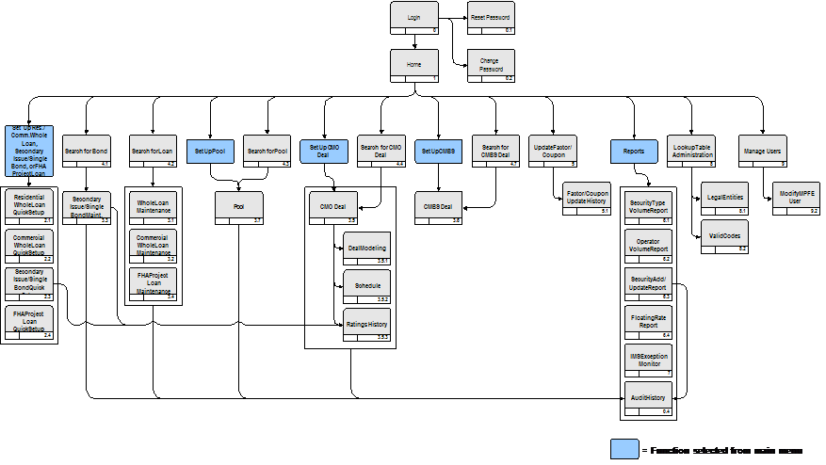

Usage
- MPFE will be the point of origination for mortgage security set up
- The security will be immediately available for trading after a successful set up
- Business units will be able to set up securities via MPFE screens eliminating the need for e-mail requests to Security Coding
- Only Security Coding will be able to change data once a security has been set up
- MORT_PROD will automatically update IMS

Entitlements
MPFE will develop its own database tables and security packages to enforce entitlements within application. The core security model is based on java.security.acl package
# | Screen Name | Screen Number | Description | View/Access | Set Up/Create | Update
1 | Login | 0 | Allows the User to enter an authorized User ID and password to access the MPFE application | All
2 | Reset Password | 0.1 | Allows the User to reset the password associated with User ID | All
3 | Change Password | 0.2 | Allows the User to change the password associated with User ID | All
4 | Audit History | 0.4 | Provides a detailed history of the changes (fields and data), timestamps, and users who effected the changes for a selected bond or deal | All
5 | Home | 1 | Provides a landing point after User has logged on to MPFE; provides navigation to the primary functions of MPFE and shortcuts to more frequently-used functionality, such as search interfaces for bonds, loans, or deals, links to updating factors and coupons, or links to reports | All
6 | Residential Whole Loan Quick Setup | 2.1 | Allows the User to quickly set up a new Residential Whole Loan by entering only the minimum required fields needed to set up the product |  | SO. SC
7 | Commercial Whole Loan Quick Setup | 2.2 | Allows the User to quickly set up a new Commercial Whole Loan by entering only the minimum required fields needed to set up the product |  | SO, SC
8 | Secondary Issue/Single Bond Quick Setup | 2.3 | Allows the User to quickly set up a new Secondary Issue/Single Bond by entering only the minimum required fields needed to set up the product |  | TS, PB, FD, CDO, RD, SC
9 | FHA Project Loan Quick Setup | 2.4 | Allows the User to quickly set up a new FHA Project Loan by entering only the minimum required fields needed to set up the product |  | SO, SC
10 | Residential Whole Loan Maintenance Screen | 3.1 | Allows the User to view, set up, or maintain a Residential Whole Loan by viewing, entering, or modifying the superset of data fields associated with the respective product | All |  | SO, SC
11 | Commercial Whole Loan Maintenance Screen | 3.2 | Allows the User to view or maintain a Commercial Whole Loan by viewing, entering, or modifying the entire set of data fields associated with the product | All |  | SO, SC
12 | Secondary Issue Maintenance Screen | 3.3 | Allows the User to view or maintain a Secondary Issue/Single Bond by viewing, entering, or modifying the entire set of data fields associated with the product | All |  | SC (excluding security records owned by MA)
13 | FHA Project Loan Maintenance Screen | 3.4 | Allows the User to view or maintain an FHA Project Loan by viewing, entering, or modifying the entire set of data fields associated with the product | All |  | SO, SC
14 | CMO Deal | 3.5 | Allows the User to view or maintain a CMO Deal by viewing, entering, or modifying the entire set of data fields associated with the product | MA, SO, SC, RMPA, TS | MA | MA
15 | Collateral | 3.5.1 | Allows the User to view, set up, or maintain collateral information for a CMO Deal by viewing, entering, or modifying the superset of data fields associated with the CMO collateral | MA, SO, SC, RMPA, TS | MA | MA
16 | Schedule | 3.5.2 | Allows the User to view, set up, or maintain payment schedule information for a CMO Deal | MA, SO, SC, RMPA, TS | MA | MA
17 | Ratings History | 3.5.3 | Allows the User to view, add, or update ratings history information for a single bond | All | MA, SO, SC | MA, SO, SC
18 | CMBS Deal | 3.6 | Allows the User to view, set up, or maintain a CMBS Deal by viewing, entering, or modifying the superset of data fields associated with the respective product | All | SO, SC | SO, SC
19 | Pool | 3.7 | Allows the User to view, set up, or maintain a Pool by viewing, entering, or modifying the superset of data fields associated with the respective product | SO, SC | SC | SC
20 | Search for Bond | 4.1 | Allows the User to search for a bond by entering search criteria | All
21 | Search for Loan | 4.2 | Allows the User to search for a loan by entering search criteria | All
22 | Search for Pool | 4.3 | Allows the User to search for a pool by entering search criteria | All
23 | Search for CMO Deal | 4.4 | Allows the User to search for a deal by entering search criteria | MA, SC, SO, RMPA, TS
24 | Search for CMBS Deal | 4.7 | Allows the User to search for a CMBS deal by entering search criteria | SC, SO, RMPA, TS
25 | Update Factor/Coupon | 5 | Allows the User to view, enter, or update recent factor data (for securities that pay down) or recent coupon data (for adjustable rate securities) | All | MA (for records owned by MA); SO/SC (for records owned by MA, can only make updates pertaining to current month; for all other records owned by others, have full update capability) | MA (for records owned by MA); SO/SC (for records owned by MA, can only make updates pertaining to current month; for all other records owned by others, have full update capability)
26 | Factor/Coupon Update History | 5.1 | Allows the User to view, enter, or update all historical factor data (for securities that pay down) or all historical coupon data (for adjustable rate securities) for a selected class or CUSIP | All | MA (for records owned by MA); SO/SC (for records owned by MA, can only make updates pertaining to current month; for all other records owned by others, have full update capability) | MA (for records owned by MA); SO/SC (for records owned by MA, can only make updates pertaining to current month; for all other records owned by others, have full update capability)
27 | Security Type Volume Report | 6.1 | Provides a user interface for setting parameters and running the Security Type Volume Report (see 5.2.6 Productivity/Volume Reporting) | SO, SC
28 | Operator Volume Report | 6.2 | Provides a user interface for setting parameters and running the Operator Volume Report (see 5.2.6 Productivity/Volume Reporting) | SO, SC
29 | Security Add/Update Report | 6.3 | Provides a user interface for setting parameters and running the Security Add/Update Report between a starting and ending date entered by the User; each CUSIP links to its respective Audit History screen | SO, SC, MA
30 | Floating Rate Report | 6.4 | Provides a list of securities with coupon rate schedule for upcoming week. | SC
31 | IMS Exception Monitor | 7 | Provides a queue of instances of unsuccessful data bridgeback from Mort_Prod to IMS for Securities Coding | SC
32 | Lookup Table Administration | 8 | Allows the User to select Lookup Tables relevant to MPFE for viewing and maintenance of values (e.g. Legal Entities) | All
33 | Legal Entities Lookup Table Detail | 8.1 | Provides a view of the values of the Legal Entities Lookup Table and allows the User the ability to modify those values, including selection of types of legal entities (e.g. Underwriter, Servicer, Trustee) | All | SC, SO, MA | SC, SO, MA
34 | Valid Codes | 8.2 | Provides a view of the coded data fields that can be modified and allows the User the ability to add to or modify those values. | All | SC, SO, MA | SC, SO, MA
35 | Manage Users | 9 | Provides a list of MPFE users for viewing and maintenance of their individualized access rights | SA
36 | Modify MPFE User | 9.2 | Provides a view of the access rights of a selected MPFE User and Allows the User ability to modify those access rights | SA |  | SA

Common/Reusable Elements

Menu Bar Specification
Subset of whole menu for sample purposes only.
Menu Hierarchy | Description | Display Logic | Event Handling
Home | Home Menu. | - Always visible.  - Always enabled. | - n/a
Home | Menu item that takes user back to the home page which gives him/her capability to search or initiate another bond | - Always enabled. | - Take the user to the home page for his or her default role/organization combination  - If page load is not successful, display the generic message page with the user message E001 – Try again.
Logout | Menu item that allows user to logout of the server. | - Only visible when the user is logged into the server.  - Always enabled.  - Tooltip: “Logout of MPFE” | - Log the user out of the server.  - Set the Title Bar text to display the following: “MPFE”.  - Take user to login page
Setup/Maintain/View | Menu that allows user setup,view or maintain of different mortgage products. | - Only visible when the user is logged into the server and the user has permission to create mortgage products (based on current role)..  - Always enabled  - Tooltip: “Setup page” | - Set content frame to specified type
CMBS | If off setup menu: Opens blank version of CMBS Deal Setup  If off maintain menu: Opens blank version and allows for search.  If off view menu: Opens blank version and allows for search. | - Only visible when the user is logged into the server and the user has permission to view mortgage products (based on current role)..  - Always enabled if visible | - Set content frame to specified type
CMO | Opens blank version of CMO Deal Setup | - Only visible when the user is logged into the server and the user has permission to create mortgage products (based on current role)..  - Always enabled if visible | - Set content frame to specified setup type

Framework Specification
Struts/Tiles Framework (View)
The Tiles framework allows building pages by assembling reusable Tiles. As an example, the page in the next figure can be build by assembling a header, footer, a menu and a body.

Header
Menu
Body/SESSION frame
Footer frame
The following table gives a high level view of the contents of the various components of the framework.
Table 1 Portal Framework Components and Initial Sizes
Component | Sub-components | Size (WxH) | Description
Header |  | 1014 x180 | Contains a logo, menu and quick search appropriate for the logged in user and their current state in the application
SESSION frame | Dynamic <iframe> | 1014x 538 | Displays application pages to the user
Footer |  | 1024x50 | Displays the required footer including terms, conditions and small print

The components shown to the user, and their contents, at any particular time depend on several factors:
- User’s Operator Class
- User’s current state in the application

View Detailed Design: Search Bonds Screen ID - 4.1

Overview:
<Insert brief description of UI interaction>

Traceability:
Related use cases: Search Mortgage Products
Reference documents: Setup Process Flows ( H:/processflows/setupflows.doc)
Additional related business requirements: None

Visual Design:

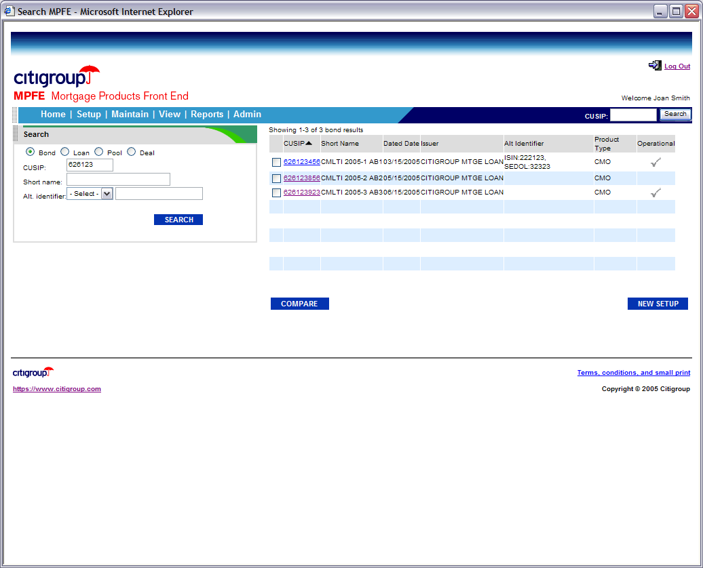

Figure 2-1 <<screen inventory #>> UI-IM022 Images Tab<<screen inventory name>>

Tabbing order
Tab order | Element/Control
1 | Bond Radio Button
2 | Loan Radio Button
3 | Pool Radio Button
4 | Deal Radio Button
5 | CUSIP Text Field
6 | Short Name Text Field
7 | Alternate Identifier Type DDLB
8 | Alternate Identifier Value Text Field
9 | Checkboxes
10 | Compare Button
11 | New Setup Button
12 | CUSIP Quick Search Text Field
13 | CUSIP Quick Search Button

Control Specification
Table 2. IM022 Control Specification
Control Name | Description | Display Logic | Event Handling
Search Type  Radio Button | - Identifies the types of searches available based on user’s role.  - The radio button options are:  - Bond  - Loan  - Pool  - Deal | - Initial state: Bond Selected  - Visibility: Always visible  - Enabling: Always enabled  - Data source: search.searchTypes | - Click: Shows fields needed to conduct search  - Validation (Client): isRequired
Short name  Text Entry | - Allows user to enter the short name of the bond such as FNMA03.53 | - Keying limit: 9  - Visual size: Actual size+1  - Format: None  - Visibility: Visible if Bond is Selected  - Enabling: Always enabled if visible  - Data source: search.ShortName | - Key Typed:  - Validation (Client):  - isFormat: FNMA or GNMA + 2 digit year + ‘.”+’2 digit number’  - isRequired
Alternate Identifier Type  Drop-down List Box | - Allows user.  - The list also includes: - Select – | - Visual size: Actual size  - Visibility: Visible if Bond is selected  - Default value: All, - Select a XXX -, specific value  - Enabling: Always enabled if visible, Always enabled  - Data source: search.altIdentiferType | - Validation (Client): None
Search Button  Button | - Submits the filter criteria to backend, which returns the results matching the filter criteria. | - Icon: none – use style- “blueButton”  - Format: None  - Visibility: Always visible  - Enabling: Always enabled | - Click: Upon Validation (Client), Shows results on same screen.  - Error Handling (Server): Leave user on same page, show error in error div.  - Validation (Client): Display an error message if at least no value has been entered into any of the filter controls
Table Counter  Label | - Displays the number of xx results returned. | - Visibility: Always visible  - Format: ‘Showing’ + <space> + <begNum> +<space> + ‘-‘ + <space> + <endNum> + <space> + ‘of’ + <space> + <totalNumberXX> + ‘xx” | None
Bond Results  Table | - Displays a list of bonds that meets the filter criteria.  - Checkboxes in first column are used to select results for comparison. There is no heading for the checkbox column.  - The headings are:  - <checkbox>  - Short Name  - Dated Date  - Issuer  - Alt Identifier  - Product Type  - Operational  - The columns that can be sorted are:  - CUSIP  - Dated Date  - Issuer  - Product Type  - Operational | - Visibility: Visible after search has been conducted  - Format:  - CUSIP: #########.  - Dated Date: mm/dd/yyyy  - Alternate identifier: commas separated.  - Minimum width: Optimize all available real estate  - Scrollbar policy: Vertical Scrollbar as needed, Horizontal scrollbar as needed  - Row selection policy: multiple selection for compare; single selection via link on CUSIP column.  - Word wrap: True  - Default sort order: CUSIP  - Default filter: None  - Data source: bond.cusip, bond.shortName, bond.DatedDate, bond.Issuer, bond.AltId, bond.productType, bond.operationalFlag | - <Item> Selection:  - If the user checks the checkbox, highlight row and open new window based on number of selections after user clicks Compare button.  - If the user selects a CUSIP link, go to Maintenance view for cusip based on user role’s permissions.  - Column Header Click: Sort Ascending then Descending
Compare Button  Button | - Opens 2 new instances of the browser window tiled with the details of the selected bond. | - Icon: none –  - Format: None  - Visibility: Always visible  - Enabling: Enabled when there are results in the table | - Click: Open 2 new browser windows tiled  - Error Handling (Server): Open error on specific page
New Setup  Button | - Replaces session frame with setup bond screen | - Icon: none –  - Format: None  - Visibility: Visible if user has right to create new bonds  - Enabling: Always Enabled if visible

System Event Handling
Table 3. CA01 System Event Handling
System Event | Description | Event Handling
Initialization | Displays Search Portlet  Search Results table is shown empty  Compare button is disabled  New Setup button is enabled | Set Search type to bond  Set focus to CUSIP field.

Help Information
Attributes
Comments
File name: | FPATH.HLP
Topic Panel ID | 1020
Keys Panel ID | 1021
Title Text | Search Bonds Help

Open and Closed Design Issues

Issue | Resolution | Resolved by on date
If we cannot determine user-specific details will we be able to show Bonds only to users belonging to organizations that created the Bonds? | Technology agreed to give users read-only access for those who do not belong to the organization that created the bond. | John Doe 12/01/05

