Client Name
<<Workstream Name>> UI Spec
DRAFT
Version 0.01
Publish date
December 1, 2005
Submitted by
<<author>>
IBM Global Services
<Application Name> Release <number>

Table of Changes

Revision Number | Date of Change | Section(s) Affected | Brief Description of Change | Change Made By | Organization
0.01 | 04/05/04 | ALL | Document created | <<Author >> | IBM

Table of Contents
1. Introduction 1
2. Image Tab <<screen inventory name>> (UI-IM022<<screen inventory number>>) 2
2.1 Control Specification 2
2.2 System Event Handling 4
3. Industry, Inquiry Reason and Informationals (UI-CS002) 5
3.1 Control Specification 6
3.2 System Event Handling 9
Appendix A. 10
A.1 10
Appendix B. 1
B.1 1
B.1.1 1

Table of Figures
Figure 2-1 <<screen inventory #>> UI-IM022 Images Tab<<screen inventory name>> 2
Figure 3-1 UI-CS002 Select informational 6

List of Tables
Table 1. IM022 Control Specification 2
Table 2. IM022 System Event Handling 4
Table 3. UI-CS002 Select Informational Control Specification 6
Table 4. UI-CS002 Select Informational System Event Handling 9

Document Details

Document Scope
The purpose of the User Interface Design Specification (UI Spec) is to provide detailed guidance to the developers and testers concerning how to program and test the user interface. The UI Spec describes a set of screens (such as the window, dialog boxes, and prompts) the user expects to see and interact with on the screen. It also includes detailed screen design, objects, widgets, options, menus, buttons, visuals, dialog boxes, button states, screen behaviors, user exception handling, and error messages.

<<Brief Description about the functionality contained within this spec.>>

Document Contacts

Information
The following people may be contacted for information about this document.
Name | Title | Email | Phone | Tie Line

Reviewers
The following people are responsible for reviewing this document.
Name | Title | Email | Phone | Tie Line

Approvers
The following people are authorized to approve this document.
Name | Title | Email | Phone | Tie Line

Reference Documents
The documents listed below will be useful in helping the reader understand the requirement. Documents that support this document (e.g., downstream documents) are not listed.
Title | Version | Filename | Section | Page Number(s)

Design Overview

Background
The purpose of Release 2 is to provide an IBM solution to create and maintain cases.
The SOW (Schedule H) indicates that the following functionality will be delivered:
- End user Case setup
- End user Case maintenance

Prototype
Screen renderings depicting the user interface appear in this specification. The most current version of the prototype is available [indicate the location where this document can be found; URL, Notes database, etc.] or by request from [provide a contact person’s name and contact information, such an e-mail address].
Internet Explorer 6.0 is required to run the prototype.

UI Guidelines
These screens follow the UI Guidelines that can be found [indicate the location where this document can be found; URL, Notes database, etc.].

Accessibility Considerations
Section 508 guidelines should be adhered during development. For more information go to : http://www.section508.gov.

Screen Transition Diagram/Site Map
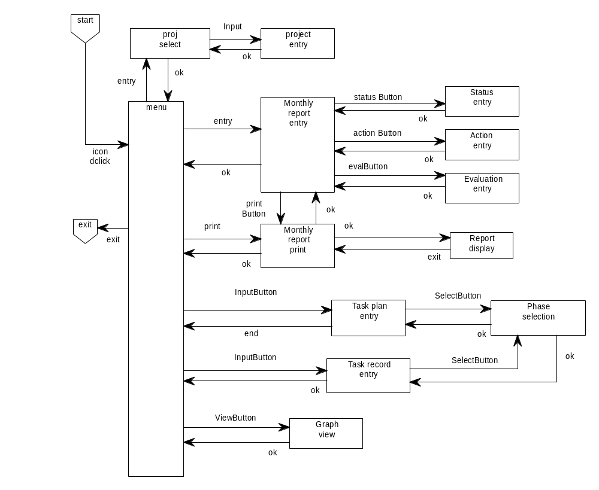
: a window state (such as menu, dialogue box, and view)
: an event
: start/exit of application

Usage
Describes the overall usage of the user interface. This description should be a summary and will correspond closely to the flow of events communicated in its accompanying use cases. If process flows are available then this section should also link users to these documents or describe where to find the documents.

Entitlements
Screen ID | Screen Name | Customer Service Representative | Team Lead | Systems Administrator
CA01 | Case Setup | RW | RW | R
CA02 | Create Override | RW | R | R
CA03 | Approve Override |  | RW | R

Common/Reusable Elements

Menu Bar Specification
Menu Hierarchy | Description | Display Logic | Event Handling
File | File Menu. | - Always visible.  - Always enabled. | - n/a
Login | Button that allows user to login into the server. | - Only visible when the user is not logged into the server.  - Always enabled.  - Tooltip: “Login to ACMS server” | - Log the user into the server using his or her default role/organization combination.  - If login is successful, do the following:  - Set the Title Bar text to display the following: “ACMS – “ + <firstName> + <space> + <middleInitial> + “. “ + <lastName> + “ (“ + <role> + “ – “ + <orgID> + <space> + <orgName> + “)”  Example: “ACMS – Thomas E. Rose (Manager – CAD Chicago District Office)”  NOTE: Don’t display the period if the middle name is null. (Example: “ACMS – Thomas Rose (Manager – CAD Chicago District Office)”.  - Set the Last Synchronize Label to the date and time the user last synchronized.  - Update the text on the Synchronize Status Button to reflect the number of errors and number of submitted cases.  - If any of the following conditions are true, launch the Acknowledge Dialog (DLG_Acknowledge):  - New cases have been assigned to the user.  - Cases have been reassigned or unassigned from the user.  - One or more of the user’s cases have been reviewed. (Close Case Functionality)  - Select the Local Database Radio Button.  - If the user is logged in as the role of manager, do the following:  - Load the manager version of the Assigned Cases Tab Panel (TAB_ManagerAssignedCases) onto the Assigned Cases Tab.  - Load the manager version of the Unassigned Cases Tab Panel (TAB_ManagerUnassignedCases) onto the Unassigned Cases Tab.  - If the user is logged in as the role of staff, do the following:  - Load the staff version of the Unassigned Cases Tab Panel (TAB_StaffUnassignedCases) onto the Unassigned Cases Tab.  - Add all of the user’s role/organization combinations as menu items in the Role menu.  - Update the Login Status Panel to indicate the user is logged in.  - If login is not successful, display user message E001 – Login Not Successful.  - If login is successful, display logic is affected for the following:  - File → Logout and File → Login menu buttons.  - File → Search for Cases menu button  - File → Create Case menu button  - File → Create Reports menu button  - Server Database Radio Button  - Synchronize Button  - Last Synchronize Label  - Synchronize Status Button  - Role menu.  - Assigned Cases Tab  - Unassigned Cases Tab
Logout | Button that allows user to logout of the server. | - Only visible when the user is logged into the server.  - Always enabled.  - Tooltip: “Logout of ACMS server” | - Log the user out of the server.  - Set the Title Bar text to display the following: “ACMS”.  - Update the Login Status Panel to indicate the user is logged out.  - Select the Local Database Radio Button.  - Update the Action Menu.  - Update the Role Menu.  - Affects the display logic of the following:  - File → Logout and File → Login menu buttons.  - File → Search for Cases menu button  - File → Create Case menu button  - File → Create Reports menu button  - Role menu.  - Server Database Radio Button  - Synchronize Button  - Last Synchronize Label  - Synchronize Status Button  - Assigned Cases Tab  - Unassigned Cases Tab
Synchronize | Button that cauess the local database, AFE, and the server database to be synchronized with each other. | (see Synchronize Button below) | (see Synchronize Button below)
_____________ | Separator. | - Always visible. | - n/a
Search for Cases… | Button that launches a dialog that allows the user to search for specific cases. | - Only visible when the user is logged in.  - Only enabled when the Server Database Radio Button is selected.  - Tooltip: “Search for cases” | - Launch the case search dialog (DLG_SearchCases).
Create Case… | Button that launches a dialog allowing an authorized user to create one or more new cases. | - Only visible when the user is logged into the server and the user has permission to create cases (based on current role).  - Only enabled when the Server Database Radio Button is selected.  - Tooltip: “Create a new case” | - Launch DLG_CreateCase.
Print Cases… | Button that launches the print dialog that provides basic printing capability. | - Always visible.  - Only enabled when the current view is printable.  - Tooltip: “Print cases” | - Launch the standard print dialog, passing in a reference to the active, printable window.
Reports … | Button that launches a dialog allowing an authorized user to create and print reports. | - Only visible when the user is logged into the server and the user has permission to create reports (based on current role).  - Only enabled when the Server Database Radio Button is selected.  - Tooltip: “Launch reports page” | - Launch dialog allowing user to create reports.
_____________ | Separator. | - Always visible. | - n/a
Exit | Button that exits the ACMS application. | - Always visible.  - Always enabled.  - Tooltip: “Exit ACMS” | - Display user message Q001 – Exit Confirmation.  - If the user clicks the Yes button on the dialog, log out of the server (if applicable) and close the ACMS application.
View | View Menu. | - Always visible.  - Always enabled. | - n/a
Show Tooltips | Checkbox indicating if the user wants tooltips to be displayed. | - Always visible.  - Always enabled.  - Default is on.  - Tooltip: “Turns tooltips on or off” | - If the checkbox is checked, turn tooltips on.  - If the checkbox is unchecked, turn tooltips off.
_____________ | Separator. | - Always visible. | - n/a
Local Database | Indicates that the user will be viewing data from the local database. | (see Local Database Radio Button below) | (see Local Database Radio Button below)
Server Database | Indicates that the user will be viewing data from the server database. | (see Server Database Radio Button below) | (see Server Database Radio Button below)
Action | Action Menu. The menu buttons on this menu are built dynamically based on the current tab. | - Always visible.  - Only enabled when there are actions within the Action menu.. | - n/a
Role | Role Menu. | - Only visible when the user is logged in and ANY of the following are true:  - User has > 1 role.  - User can be an authorizer.  - Always enabled. | - n/a
(Role List) | Dynamically configured, numbered list of Radio Buttons representing role/organization combinations for the current user. This list is configured when the user logs into the server. | - Always visible.  - Always enabled. | - If the user selects the same role/organization, do nothing.  - Load the appropriate versions of the Assigned Cases Tab and Unassigned Cases Tab based on what the user is allowed to view.  - If a new role is selected, Update the Title Bar text based on the new role/organization combination.
_____________ | Separator. | - Only visible if the user can be an authorizer. | - n/a
Authorizer… | Radio button that launches the dialog allowing a user to log in as an authorizer. This option is considered to be another role. | - Only visible if the user can be an authorizer. | - Launch the Authorizer Dialog (DLG_Authorizer).  - If the user successfully enters an Authorizer ID, do the following:  - Load the appropriate versions of the Assigned Cases Tab and Unassigned Cases Tab based on what the user is allowed to view.  - Set the Title Bar text to display the following: “ACMS – “ + <firstName> + <space> + <middleInitial> + “. “ + <lastName> + “ (Clerk for “ + <authFirstName> + <space> + <authMiddleInitial> + “. “ + <authLastName> + “, “ + <authRole> + “ – “ + <authOrgID> + <space> + <authOrgName> + “)”  Example: “ACMS – Thomas E. Rose, III (Clerk for James S. Williams, Manager – CAD Chicago District Office)”  NOTE: Don’t display the period if the middle name is null. (Example: “ACMS – Thomas Rose (Clerk for James S. Williams, Manager – CAD Chicago District Office)”.  - Affects the display logic of the following:  - File → Create Case  - File → Reports  - If the user does not successfully enter a valid Authorizer (i.e., clicks the Cancel Button on the dialog), simply re-check the previously checked role without performing any actions.
Help | Help Menu. | - Always visible.  - Always enabled. | - n/a
ACMS Help… | Launches the help system. | - Always visible.  - Always enabled.  - Tooltip: “Launch the help system” | - Launch the Help Dialog (DLG_Help).
About ACMS… | Displays the current software level of ACMS. | - Always visible.  - Always enabled.  - Tooltip: “Display current software level of ACMS” | - Display an information dialog that shows the current software level of ACMS.

Framework Specification

Menu
LEFT frame | SESSION frame
LEFT frame | ACTIONS frame
The following table gives a high level view of the contents of the various components of the framework. More detailed information is provided later in this document for the Menu, LEFT frame, Tab Bars, and ACTIONS bar components. The other UI Spec documents describe more fully how they use the SESSION frame and ACTIONS frame components.
Table 1 Portal Framework Components and Initial Sizes
Component | Sub-components | Size (WxH) | Description
Menu |  | 1014 x 21 | Contains a menu appropriate for the logged in user and their current state in the application (see Error: Reference source not found, Error: Reference source not found, Error: Reference source not found, and Error: Reference source not found for the contents of this area by operator class)
LEFT frame | Account | 219 x 46 | Displays the account number currently being worked. Optionally, an input field and “Go” button that can be used to search for a specific account number.
LEFT frame | Cardmember | 219 x 148 | Displays information about the Cardmember that owns the account
LEFT frame | Case | 219 x 46 | Displays the case number currently being worked. Optionally, an input field and “Go” button that can be used to search for a specific case number.
LEFT frame | Toolkit | 219 x 386  (H=435 if Case not shown) | Links to other applications (see Error: Reference source not found or Error: Reference source not found)
LEFT frame | Error | 215 x 70 | Used to display error messages that occur when validating inputs in either the Account of Case sub-component.
LEFT frame | Button | 219 x 30 | Contains buttons pertinent to setting up a case (either from a work queue or the image queue).
SESSION frame |  | 795 x 658 | Displays application pages to the user. Except when working with an Action in the ACTIONS frame, this frame uses most of the display area to the right of the LEFT frame.
SESSION frame | DYNAMIC <iframe> | Page dependent | Some application pages displayed in the SESSION frame may need to display supplemental pages to the user. Those pages are displayed in an <iframe>.
SESSION frame | Account Level Case Search Tab Bar | 795 x 29 | A set of tabs displayed at the top of the SESSION frame. It gets its name from the contents of the first tab – the Account Level Case Search/Summary page. Selecting a tab displays the appropriate page in the DYNAMIC <iframe>.
SESSION frame | Case Summary Tab Bar | 795 x 29 | A set of tabs displayed in conjunction with the Case Summary displayed about midway down the SESSION frame. Selecting a tab displays the appropriate page in the DYNAMIC <iframe>.
ACTIONS frame |  | 795 x 40 | Displays application Actions (e.g., Close Case) to the user. When working on an Action, this frame expands in height to use most of the display area to the right of the LEFT frame (with a corresponding shrinkage in the height of the SESSION frame).
ACTIONS frame | ACTIONS bar | 780 x 32 | Displayed at the top of the ACTIONS frame. The ACTIONS bar can have various short-cut buttons on it that causes the application page for a particular Action to be loaded into the ACTIONS frame.
ACTIONS frame | <iframe> | Page dependent | Displays the actual application page for an action.

The components shown to the user, and their contents, at any particular time depend on several factors:
- User’s Operator Class
- Mode in which the user logged in (“Get Next” or “Search/Update”)
- User’s current state in the application

View Detailed Design: <<screen inventory name>> <<screen inventory number>>

Overview:
<Insert brief description of UI interaction>

Traceability:
Related use cases: Create Case
Reference documents: Case Process Flows ( H:/abc/caseprocessflows.doc)
Additional related business requirements: None

Visual Design:
<insert screen capture>
Figure 2-1 <<screen inventory #>> UI-IM022 Images Tab<<screen inventory name>>

Tabbing order
Tab order | Element/Control
1 | Navigation trail
2 | Subtitle
3 | Link
4 | Image
5 | Control (e.g., drop down, etc.)
6 | Button
7 | Icon

Control Specification
Table 2. IM022 Control Specification
Control Name | Description | Display Logic | Event Handling
Drop-down list name  Drop-down List Box | - yada, yada description.  - The list also includes: - Select role – | - Visual size: Actual size, specify a specific width.  - Visibility: Always visible, Visible for ZZZ role, Visible if RRR checkbox is checked, etc.,  - Default value: All, - Select a XXX -, specific value  - Enabling: Always enabled if visible, Always enabled  - Data source: abc | - Item Selection:  - Validation (Client): isRequired, Must select value other than “- Select a XXX –“
Button name  Button | - Submits the filter criteria to backend, which returns the results matching the filter criteria.  - Cancel: Discards all data entered. | - Icon: filename of icon (remove if needed)  - Format: small button, (regular size button = none)  - Visibility: Always visible, Visible for ZZZ role, Visible if RRR checkbox is checked, etc.,  - Enabling: Always enabled if visible, Always enabled, Enabled if YYY checkbox is checked, etc. | - Click: Upon Validation (Client) Goes to UI-IV002. Prompt users to save without changes.  - Error Handling (Server): Leave user on same page, show error in error div.  - Validation (Client): Display an error message if at least two XXX are not checked.
Radio button group name  Radio Button | - yada, yada description.  - The radio button options are:  - Radio button 1 label  - Radio button 2 label | - Initial state: <<indicates default selection/deselection>>  - Visibility: Always visible, Visible for ZZZ role, Visible if RRR checkbox is checked, etc.,  - Enabling: Always enabled if visible, Always enabled, Enabled if YYY checkbox is checked, etc.  - Data source: abc.def | - Click: Shows YYY checkboxes, Shows RRR fields  - Validation (Client): isRequired
Checkbox group or name  Checkboxes | - yada, yada description.  - The checkboxes options are:  - All  - checkbox 2 label | - Initial state: <<indicates default selection/deselection>>  - Layout: specifies layout if dynamically being built. (i.e. 3 columns, n rows)  - Visibility: Always visible, Visible for ZZZ role, Visible if YYY radio button is selected, etc.,  - Enabling: Always enabled if visible, Always enabled, Enabled if YYY radio button is selected, etc.  - Data source: aaa.bbb | - Click: Show/Hide  - Validation (Client): isRequired
Text Entry Name  Text Entry | - Yada, yada description. | - Keying limit: 18  - Visual size: Actual size+1, specified size  - Format:  - Floating Commas (e.g. 999,999.99), no dollar sign, commas and decimal point optional.  - XXX@XXXX.XXX  - Visibility: Always visible, Visible for ZZZ role, Visible if YYY radio button is selected, etc.,  - Enabling: Always enabled if visible, Always enabled, Enabled if YYY radio button is selected, etc.  - Data source: bbb.ccc | - Key Typed: Does calculation and enables other field  - Validation (Client):  - IsCurrency  - IsEmail  - isFormat:<regExp>  - isFormatCI:<regExp>  - isInList:<list>  - isInListCI:<list>  - isInRange:<range>  - isInt  - isMaxLength:<length>  - isMinLength:<length>  - isMinPlusInc:<min>,<inc>  - isNegCurrency  - isNegCurrency0  - isNegInt  - isNegInt0  - isNegReal  - isNegReal0  - isPosCurrency  - isPosCurrency0  - isPosInt  - isPosReal  - isPosReal0  - isReal  - isRequired
Text Area Name  Text Area | - Yada, yada description. | - Keying limit: 255  - Visual size: width by rows….  - Minimum height: 3 rows  - Visibility: Always visible, Visible for ZZZ role, Visible if YYY radio button is selected, etc.,  - Enabling: Always enabled if visible, Always enabled, Enabled if YYY radio button is selected, etc.  - Editable: Editable  - Scrollbar policy: Vertical scrollbars always, horizontal scrollbars never.  - Word wrap: True  - Data source: abc.def | - Key Typed: Enabling of another field  - Validation (Client): isRequired,
Link name  Link | - yada, yada description. | - Icon:  - Format: <industryName> + <space> + <industryCode>  - Visibility: Always visible, Visible for ZZZ role, Visible if YYY radio button is selected, etc.,  - Enabling: Always enabled if visible, Always enabled, Enabled if YYY radio button is selected, etc. | - Click: Navigates to UI-XX999, Show/Hides <div>
Read-only field name  Label | - Yada, yada description. | - Format:  - Currency (e.g. $ 999,999.99)  - XXX@XXXX.XXX  - mm/dd/YYYY  - 999-99-9999  - Visibility: Always visible, Visible for ZZZ role, Visible if YYY radio button is selected, etc.,  - Enabling: Always enabled if visible, Always enabled, Enabled if YYY radio button is selected, etc.  - Data source: aaa.bef | None
Table Counter  Label | - Displays the number of xx results returned. | - Visibility: Always visible  - Format: ‘Showing’ + <space> + <begNum> +<space> + ‘-‘ + <space> + <endNum> + <space> + ‘of’ + <space> + <totalNumberXX> + ‘xx” | None
Table Description  Table | - Displays a list of xx that meets the filter criteria.  - Checkboxes in first column are used to select images to yada, yada. There is no heading for the checkbox column.  - The headings are:  - <checkbox>  - Column 2 title  - Column 3 title  - Column 4 title  - The columns that can be sorted are:  - Column 1  - Column 2 | - Visibility: Always visible, Visible for ZZZ role, Visible if YYY radio button is selected, etc.,  - Format: All Headings, spell out when special format, otherwise leave blank as shown below)  - Description: First 40 characters of description or case note.  - <<correspondence link>>:  - Prompt Date: mm/dd/yyyy  - Originator:  - Amount ($): If the amount is a credit, it will show as a negative and should be displayed as follows: ‘-‘ + <space> + <amount>.  - Lift Date: mm/dd/yyyy  - Status:Description: First 40 characters of description or case note.  - <<correspondence link>>:  - Prompt Date: mm/dd/yyyy  - Originator:  - Amount ($): If the amount is a credit, it will show as a negative and should be displayed as follows: ‘-‘ + <space> + <amount>.  - Lift Date: mm/dd/yyyy  - Status:  - Minimum width: Optimize all available real estate  - Scrollbar policy: Vertical Scrollbar as needed, Horizontal scrollbar as needed  - Row selection policy: No selection, single selection, etc.  - Word wrap: True  - Default sort order: YYY column ascending  - Default filter: Filter by YYY  - Data source: table.abc | - <Item> Selection:  - If the user selects a row, show Case Summary.  - If the user selects a row, the details for the row open below the Case History table.  - Column Header Click: See Appendix A. Checkbox selects/clears all on page.

System Event Handling
Table 3. CA01 System Event Handling
System Event | Description | Event Handling
Initialization | Displays YYY | If form elements are hidden, blah blah blah.
Refresh | Data coming back from popup | Redisplays with the appropriate values from popup.

Help Information
Attributes
Comments
File name: | FPATH.HLP
Topic Panel ID | 1020
Keys Panel ID | 1021
Title Text | Account Transaction History Help

Open and Closed Design Issues

Issue | Resolution | Resolved by on date
If we cannot determine user-specific details (i.e., provide user specific “Credit to SAP Customer #” choices), will we be able to show Cases only to users belonging to organizations that created the Cases? | Business agreed to only show Cases to organizations that created them only. | John Doe 12/01/05
Reason codes should be narrowed down to reasons that fit the situation instead of providing all possible reason codes (66 or so) in the drop-down. | Open

