

IBM Global Services

Benchmarking

Technique Paper (TP)

© Copyright International Business Machines Corporation 2001, 2002
All Rights Reserved
Version 2.0, May 2002
- Description
This technique paper is intended to describe the basics of benchmarking. Since, IBM’s core business is IT related; benchmark engagement experiences have mostly been made with IT benchmarks. Therefore the described examples are mainly IT related. Nevertheless this technique paper gives general guideline on how to conduct benchmarking engagements.
Benchmarking compares a company’s status quo to the average, and / or best practices, and / or some specific peers.
Benchmarks are best if they can be achieved within the same industry. However, they can be highly dynamic and are constantly being improved or changed.
The objectives and uses of benchmarking are diverse:
- Benchmarking may be a vehicle to analyze the operation of an enterprise.
The enterprise wants to assess its strength and weaknesses by analyzing its current work processes, critical cost components, end user satisfaction, and areas for improvement by comparing its performance to others.
- Benchmarking can be used to get new ideas and approaches from the outside, including best practices.
New and best practices can be incorporated to optimize the company's IT and / or business. This is achieved by learning from leading enterprises that have been benchmarked, uncovering where they are and where they are going. In effect learning the leader’s superior practices and why they work.
- Enterprises may want to check the competitiveness of their IT organizations and operations in the marketplace.
An enterprise wants to know the competition and industry leaders in order to determine how they compare to the best of the best. Benchmarking can determine the relative position of the enterprise’s IT operation and related business areas within their industry and the marketplace. Especially if not only costs and value, but also the associated services, their delivery and quality are included.
- Enterprises want to become a new benchmark within their industry.
An enterprise can only become better than the competition if it knows how good the competitors are. Through benchmarking a company can find out its relative position and gain an understanding about the current benchmark in the industry. With this information it may improve its own operations in order to become the new benchmark. In this context, the benchmark objective is a combination of the three previous objectives.
- One example where several of these objectives may apply is in a merger and acquisition situation. Here we have a number of potential approaches. As well as using external comparative data we can try to select appropriate best practices within the merged companies. From this we can also establish a baseline from which improvements (including reducing the costs and increasing the value) can be measured.
Two basic questions need to be answered when initiating a benchmark:
- What will be benchmarked, i.e. what information is to be obtained in the end?
- For example, a cost benchmark will focus on finding ways to optimize costs. In this respect the chosen benchmarks don’t just incoproate costs; but also related services, their quality, the IT environment, the business requirements, etc., because all these have an influence on the costs.
- A process or service benchmark has to consider the required outputs and their quality as well as end user satisfaction in order to produce significant and meanginful results.
- The overall issue for all benchmarks is to identify and take into account those factors that influence the information gathered and the desired results .
- Who or what will the benchmark data source be?
- Often the first and easiest choice for a benchmark data source is identifying an internal source, e.g. a peer department or business area. These may have implemented best practices that can be transferred to the department or area initiating the benchmark.
- An alternative is looking at best practices from external sources, e.g. research institutes benchmark databases.
- Peer to peer benchmarking with external peers, e.g. companies from the same industry, is the most difficult, as confidentiality and competitive issues may prevent sharing and publication of relevant data and therefore convincing and engaging benchmark partners may become difficult.
- The possibility that the enterprise initiating the benchmark may be a “loser” of the overall benchmarking exercise, i.e. poorer performer than the external source benchmark or than internal / external peer benchmarks, is an overall issue when selecting the benchmark data source. This should be taken into account and communicated to all clients involved in the benchmark exercise in order to prepare them for possible “bad” results.
The two questions – “what” and “who” - are dependent on each other, i.e. the benchmark topic will influence the selection of benchmark data sources and vice versa. This is indeed an iterative process, as the first answer to the "what" question followed by the "who" question may lead back to updating the benchmark topics.

As an example, Figure 1 illustrates many of the aspects of benchmarking.
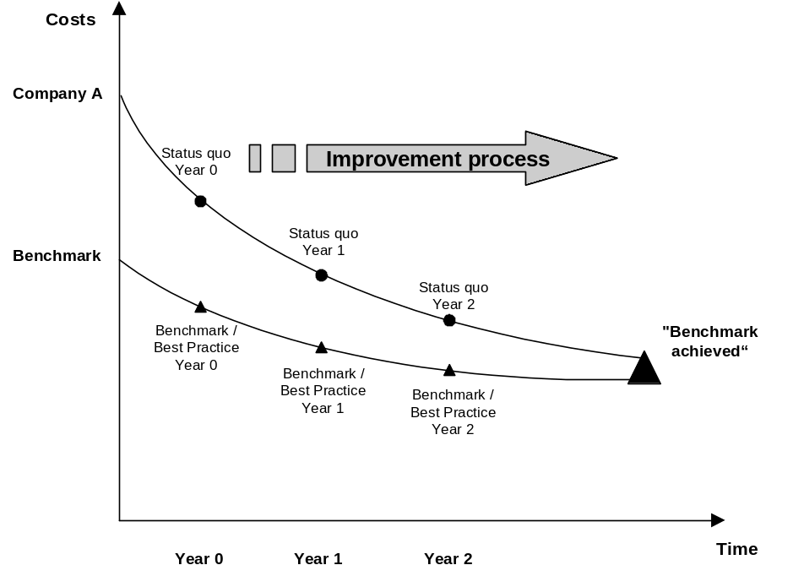
Figure 1: Achieving Benchmarks
This is a benchmark on the topic of costs. It illustrates that Company A is benchmarking against best practices for the available cost benchmark which combines delivered services and their quality. (It is very important that other relevant factors are incorporated in the comparison as well as costs and that they are related to the delivered service quality and performance.). The picture shows that in year 0 there is a big difference between Company A’s costs and the benchmark costs. By realizing certain actions and improvement initiatives (e.g. reducing complexity of system architecture, or improving service efficiency) Company A’s costs come closer to the benchmark costs from year to year. Finally Company A’s costs equal the benchmark costs, i.e. Company A then becomes the benchmark and source for best practices itself.
- Context
Benchmarking is a consulting engagement that is often relevant when companies face challenges and want to see how peer companies have coped with such situations or what best practices are available to overcome these challenges.
Benchmarking requires certain data to be available – e.g. if a cost and value benchmark should be performed, cost and value baseline data has to be available before benchmarking can be initiated, availability of relevant comparative data is key to benchmark initiation.
This is particularly true if a client / company is being pressured to or has provided transparency of its IT costs and / or the value to its business clients, i.e. In conducting a cost or value baseline, clients clearly want to move quickly into optimization but at the same time they generally want appreciation of their market and competitive position relative to cost and value. It is situations such as these that provide the trigger for a benchmarking engagement.
It is appropriate to repeat that just comparing the costs and value does not help the client – the factors that influence the costs and the value have to be considered, too. Since it is these that you attempt to directly impact in order to deliver greater value and / or reduce overall costs. Only analyzing and understanding the relationship between costs and value and cost reduction and value generation enablers can lead to meaningful conclusions.
The most appropriate approach should be determined based on individual client situations. The 2 basic approaches are:
- Looking at best practices from internal or external sources
(i.e. benchmark the client’s baseline data to internal peer or external source data)
- Peer to peer
(i.e. benchmark the “original” client’s baseline data to the baseline data of other external peer clients who are willing to participate in the benchmark)
Depending on the objectives and depth of the benchmark study, a benchmark can be done as part of a bigger engagement or as a self-contained engagement.
- Steps
Performing a benchmark is divided into several steps or phases. These steps or phases are illustrated in Figure 2 and described in the following sections.
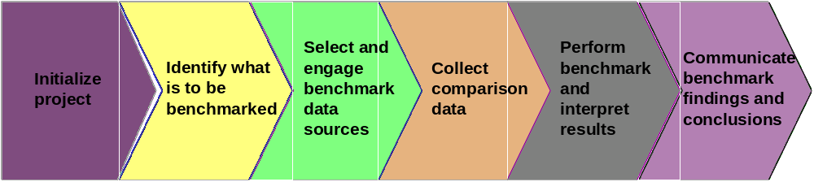
Figure 2: Benchmarking steps
Step 1: Initialize project
At the beginning of the engagement it is critical to define and document the benchmark requirements together with the client.
Two questions should be answered:
- Why should a benchmark be performed?
- Why does the client want IBM to perform the benchmark?
The second question is equally as important as the first one because the client has to realize up front that any result of the benchmark may be subject to criticism that it was not objective and biased. IBM’s position and interest within the client and scope of the benchmark has to be made very clear upfront in order to avoid credibility issues and internal “battles” within the client.
The consulting work that IBM has to do for the client also incorporates advising the client on remedial action that will satisfy the objectives of a benchmark report – Although IBM may perform an objective benchmark, at some point decisions tend to made concerning the provision of further IBM services and products. As such a benchmark performed by IBM can often be deemed within the client as self-satisfying and not objective. This whole issue needs to be dealt with sensitively and openly when embarking on a benchmarking engagement.
In response to the two questions posed above, project initialization should include definition and agreement on the following items:
- Desired output, i.e. scope, of the benchmark
- Client expectations
- Requirements
- Approach used
- Key milestones
- Reporting structure
- Communication and documentation of this understanding
Additionally the client should be prepared for the results of the benchmark, as they may not be favorable to the client. Communicate that even if the benchmark shows that the relative position of the client is not quite optimal the benchmark is an opportunity to learn from others, improve and get closer to the optimal state. This will help ensure that everyone is in agreement on what the output of the benchmark will be and how it will be achieved. Thus room for interpretation on the project and its results by the client will be minimized.
Step 2: Identify what is to be benchmarked
Next determine the topic and subject areas for the benchmark and what information should be benchmarked / compared. Primary benchmark data topics are usually:
- Costs (what costs?)
- Value (what value?)
- Performance (which measures?)
- Other (e.g. processes, services)
In addition to the primary benchmark data, identify influencing / enabling factors to take into consideration for comparison of the primary data in order to achieve significant findings and subsequent recommendations. For example comparing costs may well include incorporation of the underlying IT environment, delivered services and their quality and end user requirements within the scope of the overall benchmark. It is critical to interrelate benchmark results to enable subsequent remedial action that can impact costs. So for instance:
- Cost considerations as they relate to IT environment / process maturity
- Cost considerations as they relate to the organization
- Cost considerations as they relate to service quality / customer satisfaction
- Value considerations as they relate to delivered service quality
- Etc.
All elements contribute to the cost and value models that are the basis for the cost and value baseline (which is completed before the benchmark is conducted) and the benchmark itself.
Remark:
It is important that the same cost and value baseline structure is used for all enterprises that participate in the benchmark. Unless the underlying cost and value models comprise the same cost blocks and value elements for all enterprises, the benchmark results will not be very meaningful and significant. (See the section about Normalization in Step 5: Perform benchmark and interpret results.)
This is especially important to bear in mind if the benchmark is conducted against best practices from research institutes. Sometimes it is very difficult – or even impossible – to find out the underlying baseline cost and value models used for the research results. Nevertheless they may add very useful information to the benchmark as they provide an invaluable view from the outside.
Even if the benchmarking focus is on the costs or on the value that is provided do not neglect the importance of also looking at and understanding the practices that contribute to outstanding operational performance and benchmark them, also. Thus include at least the following aspects in the benchmarking engagement:
- Services and products
- Business and IT processes
- Organization
- Performance measures

The following table shows sample IT benchmark topics (not necessarily complete or all inclusive, more topics can be found in the attachment “IT Comparison Output.prz”). This maps benchmark topics with some related benchmark metrics.Benchmark Topics | Benchmark Metrics
IT cost relative to IT and business parameters | - IT cost relative to revenue (in $ etc.) / revenue per employee (in $ etc.)  - IT costs per cost block / split of cost blocks relative to total IT costs  - IT cost per IT user (TCO per end user) (in $ etc.)  - IT cost per end device (PC) (in $ etc.)  - IT cost per employee (may be different, e.g. in manufacturing) (in $ etc.)  - Number of end devices (PCs) per IT user (total number)  - Project costs for similar project types (e.g. SAP deployment, Win 2000 migration) while taking into account scope of project (in $ etc.)  - IT costs compared to service level agreements / service delivery (qualitative benchmark)
Analysis of IT employee metrics | - Number of IT employees relative to total number of employees (percentage)  - Number of IT employees for systems operation and administration relative to total number of IT employees (percentage)  - Number of IT employees for help desk / problem management relative to total number of IT employees (percentage)  - Number of IT employees for application development relative to total number of IT employees (percentage)  - Number of education days per IT employee per year (total number)  - IT employee turnover (percentage)  - Number of IT employees relative to process maturity (qualitative benchmark)
Investment cycles | - Average age of end devices (total number)
IT Performance metrics | - Recovery time for business-critical systems (in minutes)  - CPU / enterprise server load at peak times (percentage)  - Time when network is over-loaded relative to total time (percentage)  - Downtimes of business-critical systems (planned and unplanned) per year (total number and in minutes / hours)  - Process maturity (according to ITPM or other process model maturity assessments)  - Service level agreements (qualitative benchmark)
Step 3: Select and engage benchmark data sources
Once the benchmark framework has been established, select the benchmark data sources. Find data sources that will provide comparable results for the client, so that the benchmark is meaningful and significant, providing sufficient valuable information to the client.
Possible data sources are:
- Research institutes such as Gartner Group or META Group, which publish industry benchmarks and best practices and explicit data from anonymous peer companies through their benchmark databases.
- Real benchmark partners, i.e. real companies which are peers to the client and are willing to participate in a benchmark or even other departments within the clients own enterprise.
- IBM's Intellectual Capital system, consisting of best practices from many different areas.
The benchmark data sources identified should have characteristics and similarities sufficiently close to the client to yield meaningful and valuable benchmark results and findings, i.e. compare "apples to apples”.
In most cases, the benchmark data sources will not match the client 100%. Take care that at least the most important criteria are similar, because otherwise it will be difficult to explicitly explain possible differences in the benchmark results. Specific industry comparisons should relate very closely to the client environment, as should business processes and application environment. When considering more general IT aspects the overall infrastructure architecture and underlying organizational model need to be of a similar style.
In selecting benchmark partners consider any geographic regional differences that need to be take into account and whether or not they have the granularity of regional comparison data available. I.e. price level, currency exchange rates, salary level, skill differences, working hours and other national particularities. If not specifically available then these variables have to be adjusted by using certain assumptions or conversion factors to ensure the comparability of the benchmark partners. (See the section about Normalization in Step 5: Perform benchmark and interpret results).
Also, if the size of the benchmark partners is too different, size effects will cause most of the variation in benchmark results. This does not lead to any significant conclusions and does not help to identify optimization options. However, sometimes it may be useful to look at best practices or comparisons from completely different environments in order to be able to adopt the most useful and innovative ideas. The following criteria are relevant when selecting the benchmark data source, especially when looking for real benchmark partners or explicit data from anonymous peers:
Benchmark Partner Selection Criteria | Examples for Relevant Metrics
Industry | Remark: In most case it is preferred to look for a benchmark partner within the same industry. It may be useful to look at best practices from other industries and adopt them for this business or industry.
Size | - Revenue per year  - Number of end users  - Number of services computers / number of systems (mainframes, servers, etc.)  - Market share (regional, national, international)
Structure | - Structure of locations (centralized / decentralized)  - Technological, application and process environment
Services | - Services in scope / out of scope
Geographic region
Customer profile | - Customer groups in scope / out of scope
National / international business
Etc.

An important and related task to the selection of benchmark data sources - especially where real benchmark partners are involved - is engaging the benchmark partners. In this case it will be necessary to get written agreement from all benchmark partners on exchanging data in order to be able to conduct the benchmark. This is a sensitive issue, as the benchmark partners often have to exchange confidential data. Don’t underestimate the time that it takes to find and engage real and appropriate benchmark partners. It may be a cumbersome process to convince peer companies of the benefits they achieve from benchmarking and to set up an agreement document between the benchmark partners about exchanging data. It is very important to show the value of benchmarking to the benchmarking partners (e.g. identifying best practices, areas for optimization).
When engaging data sources such as Gartner Group or META Group, be particularly careful and sensitive about the results, because in most cases it is not known which companies (with which specifics) are the source of the retrieved data and how the data has been assessed. Sometimes only average data values are available.
Step 4: Collect comparison data
Once the benchmark partners are identified and engaged it is critical to collect and aggregate the relevant data in the same way for all benchmark partners. This means that with the comparison data collection it is necessary to look for cost and / or value baselining data (according to the agreed benchmark framework, i.e. cost and value models) and gain an understanding of the benchmark partner’s environment.
For details about this step please also refer to the technique paper about TCO (Total Cost of Ownership) analysis.
Step 5: Perform benchmark and interpret results (Compare Baseline to Target State)
When all relevant data has been collected, compare the data of all benchmark partners and interpret the results, e.g. do a ranking of all peers. The benchmark topics and criteria define what to compare (i.e. the cost and value models).
Figure 3 shows the steps of collecting and aggregating all of the relevant data as well as the benchmarking itself – where cost and value influencing / enabling factors such as services delivered by the benchmark partners, their internal processes, etc. are included. It also shows a very important intermediate step between data collection and actual benchmarking: the normalization of the data in order to make it really comparable. As this is a very important task, a separate sub-section will explain the issue of normalization.
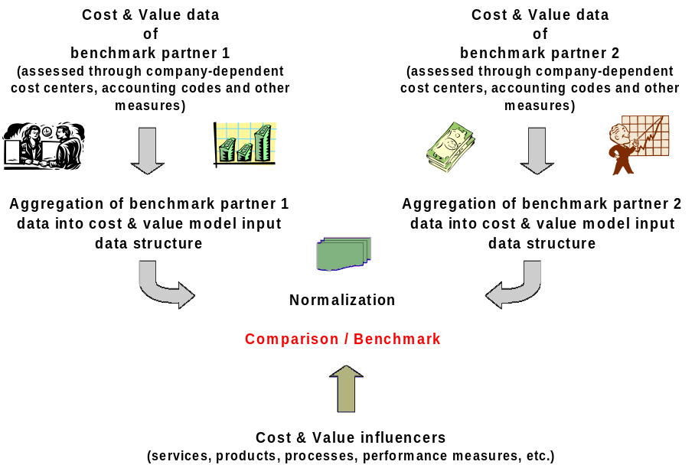
Figure 3: From data collection to benchmarking
Data Normalization
Data normalization means standardizing all data in order to place it on the same level. This is necessary to allow a valid comparison between all benchmark partners. A very simple example is not comparing costs in different currencies. But there are many more aspects that need to be taken into consideration:
- Cost and value models:
Starting with the cost and value models that form the benchmark framework, ensure that the same costs and the same value measures are collected and compared. For example, for personnel costs that are included, ensure that either burdened or unburdened costs are used for all benchmark partners. Another example is hardware costs; they should either comprise all platforms from mainframe to clients or only client costs. Determine if application development costs are included or not? And there are many more considerations.
- Cost and value influencing / enabling factors:
- If cost and value influencing / enabling factors such as services, processes etc. are included, make sure that the same definitions for services and processes are used at each benchmark partner.
- Service levels sometimes also need adaptation as they may mean different things to each benchmark partner even if they use the same words. Clearly define terms such as “server downtime” or “response time”.
- If research institutes have been chosen as benchmark data sources, determine if these institutes use data normalization or not, as this has a significant influence on the validity of the benchmark results. For example GartnerGroup does not have service definitions tied to costs, thus as a result their comparison in the distributed and server space are not valid. On the contrary, META Group has a normalization methodology for cost benchmarking.
- Cost and value data:
- The cost and value data itself may need normalization or scaling, especially if the collected data is from different geographical regions. For example currency exchange rates, tax rates, salary levels, working hours or depreciation periods and models have to be taken into account. Special costs that only appear once or only at one benchmark partner (e.g. costs for a specific project) have to be omitted.
- Some data just can’t be normalized, such as service times, complexity or skill differences in different countries. Nevertheless take them into account when interpreting the benchmark results. They may be the cause for some significant cost and value differences.
Once all normalization efforts are concluded, the actual benchmarking and interpretation of the results can take place. In addition to the normalization several things are important:
- Specific costs and benefits may only be compared, if they result from the same analysis model, i.e. do not compare the overall TCO per client of benchmark partner A to the TCO per sales force of benchmark partner B, because these are two different measurements.
- The IT and end user environment, the delivered services (and their quality) of all enterprises that participate in the benchmark must be taken into consideration thoroughly. Without that it will be difficult to explain and analyze differences between the different enterprises costs and value. Besides taking into account the IT environment for cost interpretation, it may also be one of the objectives of the benchmark to explicitly compare the IT environments or to look at IT management best practices.
If anything appears noticeably different, look for reasons and interpret these results. Generally, reasons for cost differences in the assessment of the IT environment and the delivered services are due to reasons such as size of the enterprise, number of terminals / PCs, location structure, skill levels of personnel, etc. In most cases circumstances that are specific to the various benchmark partners have to be taken into account as the benchmark results are interpreted.
Begin communicating the results of the benchmark to the client as soon as possible, even if they are still at an intermediate stage – focus on preparing the client for the final results, one thing we want to avoid is giving clients unexpected ‘shocks’ during a final presentation. Continual communication is therefore very important because the results may not be favorable for the client, they may even be surprising if the client’s self-perception is much higher than reality shows. It is possible that you may be the bearer of bad news and thus exposed to the client’s disappointment and maybe even anger.
In addition to the basic benchmarking results, also identify:
- Best practices and / or
- Innovative approaches and /or
- Practical and effective / efficient approaches
This is especially useful for those partners participating in the benchmark whose results are not optimal, e.g. where room for improvement has been identified. The best practices and innovative approaches may be a starting point for recommending and implementing cost and value optimization initiatives. This may result in determining performance gaps from the various metrics and /or projecting future performance levels that may be applicable to the benchmark partners in order to optimize their cost or overall IT performance situation.
Step 6: Communicate benchmark findings and conclusions
Finally the findings and the conclusions from the benchmark results and their interpretation as well as the recommendations have to be communicated to all benchmark partners. Before you present the final report discuss its contents with the client to avoid surprises. Any critical findings should be carefully reviewed with and explained to the client. Always show ways to resolve a disadvantageous and unfavorable result from the benchmark by giving recommendations for improvement.
In this context you may come up with establishing functional goals for those benchmark partners who have optimization needs and some high level action plans in order to implement optimization initiatives. From an IBM perspective we should use this as an opportunity to create some follow on business by helping the client realize the optimization improvements, monitoring the progress and repeating benchmarking studies on a periodic basis. After realization of optimization initiatives, improvement can be demonstrated; the most innovative best practices can then be assessed again, to stay current with industry advances and standards.
On the other hand be aware that some benchmarking results may imply disadvantages for IBM, e.g. if the way the client is doing business with IBM is identified as a less than optimal method for this client’s business.
- Tools
Tools that help you perform a benchmarking engagement are IBM’s Intellectual Capital Management System, which contain questionnaires for gathering costs and the IT environment information (e.g. in the IT Cost & Value Mgmt and the Enterprise Systems Management ICM databases).
If using META Group benchmark data, please refer to the IT Optimization ICM database, category “700 Benchmarks” for data and the conditions of using them.
- Literature, Examples
For additional information about benchmarking also see:
- Robert C. Camp, “Business Process Benchmarking finding and implementing best practices”, ASQ Quality Press, 1995
Also see the work product BUS 303 Financial Benchmarks and the presentations attached to the task “Compare client to peers” in the IT Management Strategy & Assessment engagement model. Note:
- Revision History
Revision Number | Revision Date | Summary of Changes | Changes Marked?
2.0 | May 2002 | Updated style, spelling and grammar.
1.0 | August 2001 | Base Version

