

IBM Global Services

Creating a Network Conceptual Design

Technique Paper (TP)

© Copyright International Business Machines Corporation 2002
All Rights Reserved
Version 1.0 September 2002
- Description
This technique paper focuses on how to develop a Network Conceptual Design work product instance. A Network Conceptual Design is the first step in crafting a network solution to support business requirements. It establishes a common understanding between the stakeholders and the people architecting and designing the network by describing the network in a way that indicates its support of client business requirements. It is the first design presented to a client and is intended to provide an executive level understanding of how the network design addresses stated business goals and objectives.
The Network Conceptual Design describes the relationship between the building blocks or functions (i.e., connections for point of sale terminals) that comprise the network and services required to meet business needs. At this level, technology is not specified but support of the business purpose is shown. Business requirements are mapped to the network through guiding principles, conceptual network design diagrams and profiles. The Network Conceptual Design uses material from the two activities in the Client Environment phase, Understanding the Business Environment and Objectives, and Understanding the Current IT Environment and Plans. Its development is the foundation for starting the Network Specified Design.
There are two rules of thumb to address to determine if the Network Conceptual Design is at the appropriate level:
- If a non-network professional or an executive cannot understand the presentation materials the diagrams are probably too detailed.
- If the typical network specialist finds little value in the diagrams they are probably about right. If the specialist finds a lot of value they are probably too detailed.
- Context/Purpose
Network Conceptual Design is created in the activity Develop Conceptual Network Design and consists of four tasks used to create two work products.
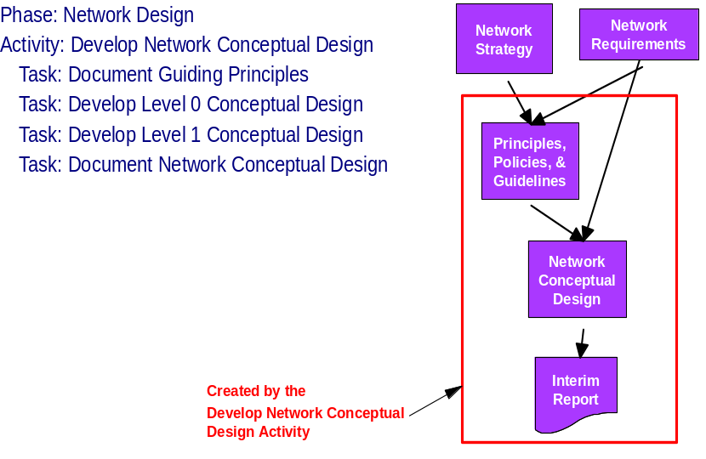
This technique paper is specifically associated with the Network Conceptual Design work product as it is developed through the last three tasks above.
- Steps
The development of a Network Conceptual Design involves three primary tasks: Document Guiding Principles, Develop Level 0 Conceptual Design, and Develop Level 1 Conceptual Design.
Document Guiding Principles
Guiding Principles are a key input in developing a Network Conceptual Design. The development of the Network Conceptual Design will be incomplete without the Guiding Principles and key Network Requirements.
- Principles, Policies and Guidelines are the first product created in the activity of developing a Network Conceptual Design.
- Key requirements and business drivers are used as input to build the design principles
- The principles/business requirements statements set the stage for developing the architecture. Guiding principles state high-level business needs the network architecture must satisfy in a clear and unambiguous way. Business requirements provide a source for profiles including user, site, application and security.
- Guiding Principles are described in the technique paper,”Developing Guiding Principles for a Network Design”
Develop Level 0 Conceptual Design
Development of the Level 0 Conceptual Design is done by mapping Guiding Principles to business requirements for network services. It is essential to understand which building blocks are required. Each Level 0 Conceptual design is unique based upon guiding principles, network requirements and circumstances specific to the client’s business situation. This is the crossroad where technology direction begins to take shape and network attributes are applied to the business case. This is also an area where use cases can offer value in the description of how the conceptual design supports the required applications and user groups.
Level 0 chart types
Barometric, egg shaped, and block charts are commonly used to show the design building blocks, the inter-relationship of the building blocks, and an understanding of what the network must support at a level that is understandable to executive management. The charts illustrate what functionality the network must supply to fulfill business requirements. These visual aids provide an overview of how the network is segmented and the relationship of various user groups to data and application services they are accessing.
- Common categories in the Level 0 design using the barometric chart are:
- Network Connectivity including access and transport
- Internet Access
- Internal and External Security
- Internet Activity Tracking and Reporting
- Internal Corporate Service Access
- Shared Services including major applications
- Requirements by Communities of Interest (Management Level of Responsibility)
- User communities
- Common categories in Level 0 design using the egg shaped chart are the network layers beginning with Enterprise Services, moving out to the end user access layer
- Core network
- Routing layer
- Switched Service Access
- Shared Access or Switched End User Access
The type of chart selected depends on two main factors. First, what resonates with the client? Early interactions with the client will provide clues on the types of messages that work. Second, what are you, the developer, comfortable presenting and advocating? If you are uncomfortable with the form of the recommended conceptual design it will be difficult to obtain the critical early buy-in.
Creating a Level 0 Design
- Level 0 designs are created from profile building blocks that are based on information gathered and validated from workshops, interviews and research about the client’s business (annual report, 10 K, news articles, industry trends).
- Before creating the conceptual design, it is key to understand which architectural building blocks are required. The building blocks are found in profiles (user groups, sites, applications, security, etc.), network requirements, design principles and key business requirements. These profiles are created during data collection and analysis activities in a design engagement.
- It is important to remember that these are high level diagrams and should be simple to understand. Trying to put all of the required details in one diagram will make the diagram overly complex and lose the audience. Typically there are several layers to consider for every design and it is recommended that you create a separate diagram for each layer. This will make it possible to keep each diagram as simple as possible while documenting all of the required network layers.
- There are several ways to look at creating profiles to represent users, sites and applications that can be used as the foundation of your network conceptual design at Level 0. While not the focus of this paper, two examples of profiles are included.
- In the first example, user groups were organized by job type and further classified by the three key applications identified during the design process. User group location and retail store size was also considered. This information was used to develop the retail Level 0 Conceptual Design.

 | Email | SAP | POS | Small | Medium | Large | Corp | Whs
Store Sales |  |  | Y | Y | Y | Y
Buyer |  | Y | Y |  |  |  | Y
Office Staff |  | Y | Y |  | Y | Y | Y | Y
Warehouse |  | Y | Y |  |  |  |  | Y
Customer Service |  | Y | Y | Y |  |  | Y
IT |  | Y | Y | Y |  |  | Y
Web |  | Y |  |  |  |  | Y
Exec | Y |  |  |  |  |  | Y
Mgmt | Y | Y | Y | Y | Y | Y | Y | Y
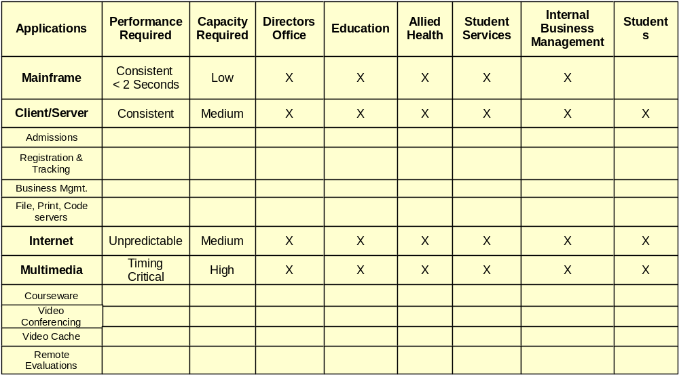
- In the second example profile, user groups were organized by category, performance requirements and network capacity required. This table represents another way to see profiles connecting to architectural requirements. Each column in this profile that represents a user group and each row that represents an application is used in a later example to create a design building block.

Level 0 Conceptual Chart
With the information gathered and validated for a client custom profile, you are ready to construct a Level 0 chart to present to management. It must be simple and clearly illustrate all user groups and major applications supported. The user and application building blocks are combined with network specific building blocks like backbone services and security to form the conceptual design.
The first step is to create the design building blocks required to construct the Level 0 diagram. In the example below these building blocks are derived from an application/user group profile.
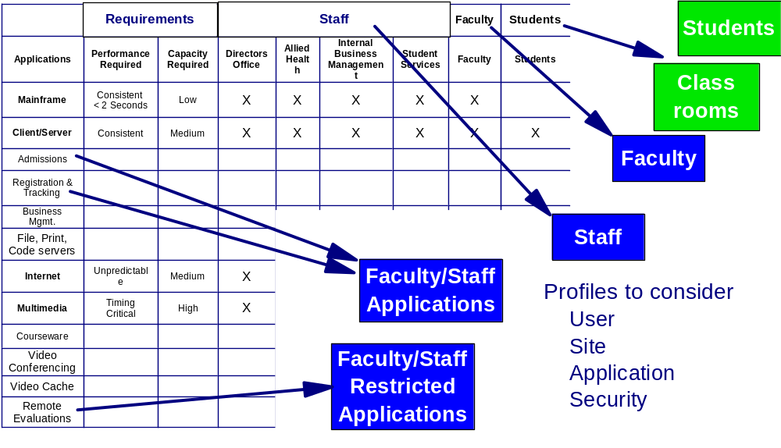
In the second step the building blocks are placed on the Level 0 diagram.
The example that follows is a conceptual Level 0 design in a barometric chart for an academic institution. This example provides an overview of how the network is segmented and the relationships of the various groups of users to the data and application services they are accessing. This chart is useful as an illustration to executive management of what the network must support for the business.

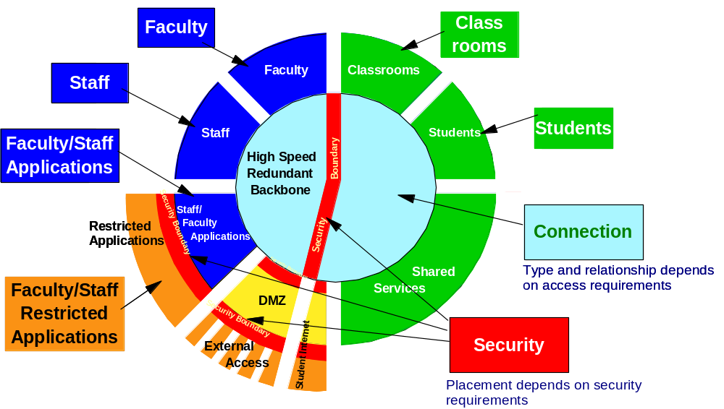
The next diagram illustrates how each of the building blocks is documented. The summary information shown in the diagram should be supplemented with more detailed information for each block.
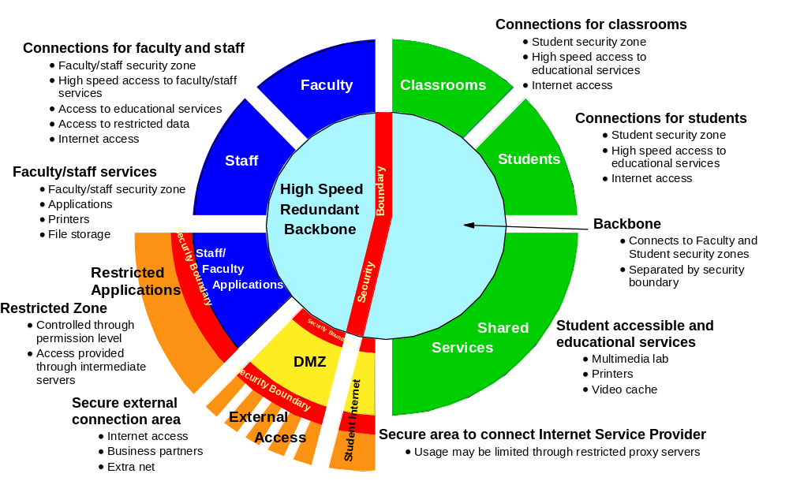
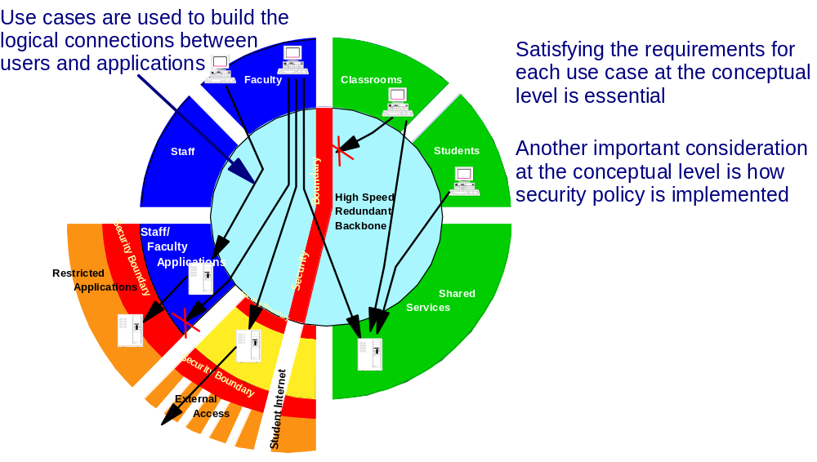
The next diagram links access to user groups. You can see how the executive is taken from the overall concept to the access required to for each user group performing work to support the business. This link can be added using the use case information that is typically produced for application expectations, such as performance, connectivity, availability, scalability and recoverability. These use case requirements carry through from conceptual design to the most detailed design and can be used to validate design decisions.

Develop Level 1 Conceptual Design
The next major step is to develop the Level 1 conceptual design, which is derived from the Guiding Principles, the building blocks in the Level 0 design and the next level of detail from the Network Requirements work product. This design is intended to be a bridge between conceptual design and specified design. This diagram provides a basic schematic diagram of the different functions.
To create a Level 1 design, the architect will relate the Level 0 design components to a schematic diagram. Additional details will be filled in from the profile information gathered during the Level 0 work effort. The Level 1 design is the next step that identifies functional design for the conceptual design and links technical function to business requirements for the first time. This design is for more technically aware management. It is a basis for later detailed design.
Two typical examples from academic institutions are shown. Note how the different user profile requirements are represented in the first diagram, showing access for each group and general application function. The first diagram clearly defines access to and security control of information.
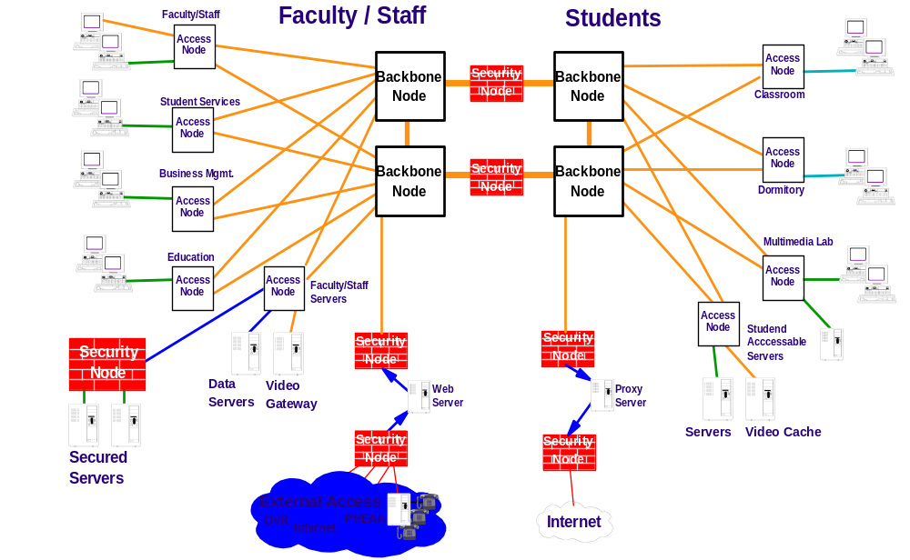
The second diagram shows actual links from the barometric chart to the Level 1 node design. The links between Level 0 and Level 1 are essential to illustrate the links between concept and specific design results. The links between Level 0 and Level 1 clearly indicate each user group and the network nodes that meet that group’s communications and application access requirements.
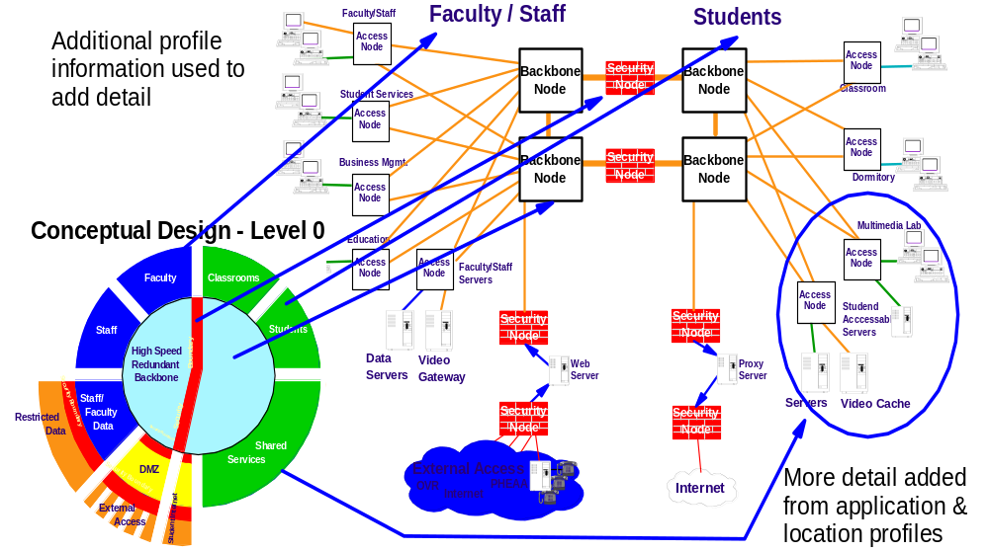
Each unique node type that appears in the Level 1 diagram is described by a design profile. Creating a short summary of each profile, customized to the client, and relating these to the diagram is an effective means of communicating the design and functionality of each node. In this example there are three node profiles in the illustration above. These three nodes fall into three general classifications of nodes, which are defined here:
- Access Nodes: provide connections to access to all resources available through switched network connections.
- Backbone Nodes: provide necessary capacity to enable all known applications that exist or are planned. Access nodes are typically connected to backbone nodes by high speed redundant links. Network speed and redundancy enhances availability and performance characteristics.
- Security Nodes: placed at all entry points into the network preventing any outside intrusion in the centers’ facilities. Added firewalls are used to ensure that sensitive data is only available to those with the need to know. Security nodes (firewalls) configured to prevent unauthorized use of information provide control of access to all resources (or certain designated resources). In this example, students will be prevented from accessing any resources on the Faculty/Staff network.
In some cases it may be helpful to first determine which general classifications of nodes are required before developing profiles for each unique instance of a node. The above lists three potential nodes types.
- Additional Examples
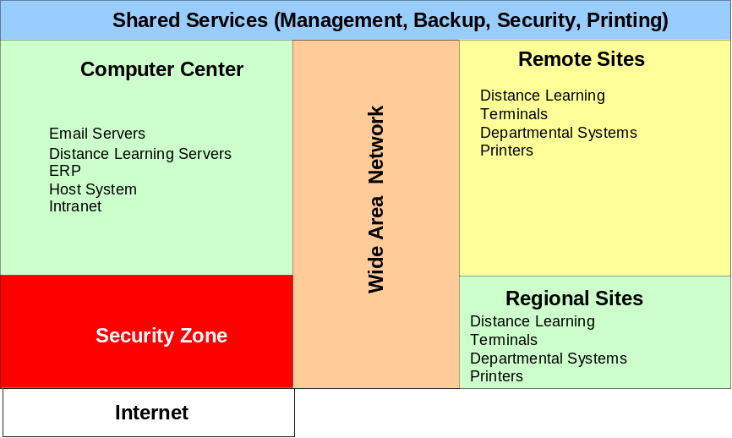
Level 0 Block Diagram example:
Retail Level 0 example:
The example conceptual architecture for a retail client provides secure access to applications for each user profile group.
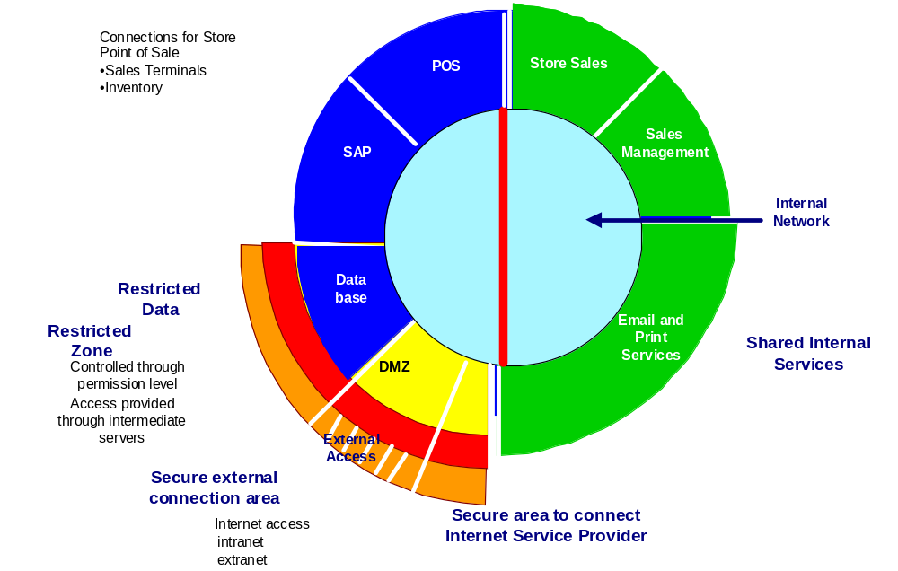
This chart provides an overview of how the network is segmented and the relationship of the various user groups to data and application services required to support the business. It is a valuable illustration of what the network must support to executive management. The architectural building blocks are derived from guiding principles and user profiles. These, along with other information are used to create the Level 0 diagram.
An additional retail Level 0 example (stadium seating chart) from the Rapid Infrastructure Design (RID) reference design:
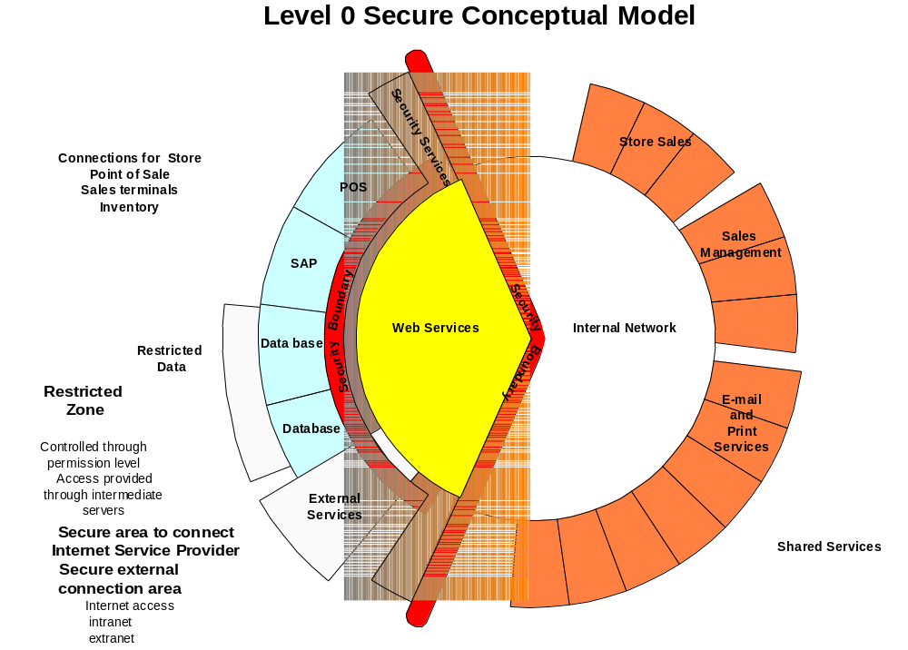
Network Services concentric circle (fried egg shaped) design:
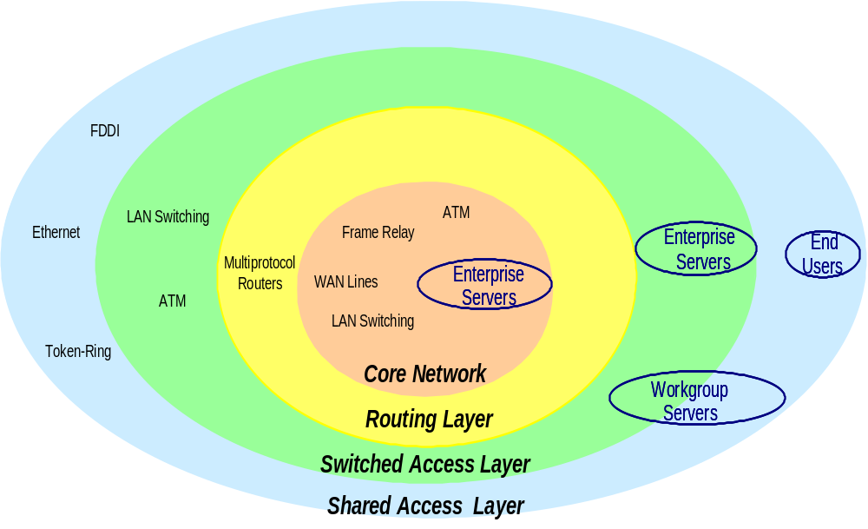
This type of diagram is useful for illustrating multiple network layers such as core network, routing, switching, and shared access.
The conceptual design at Level 1 provides insight into the logical flow of the newly designed network. Access to applications for the user groups is shown in this retail Level 1 design example.
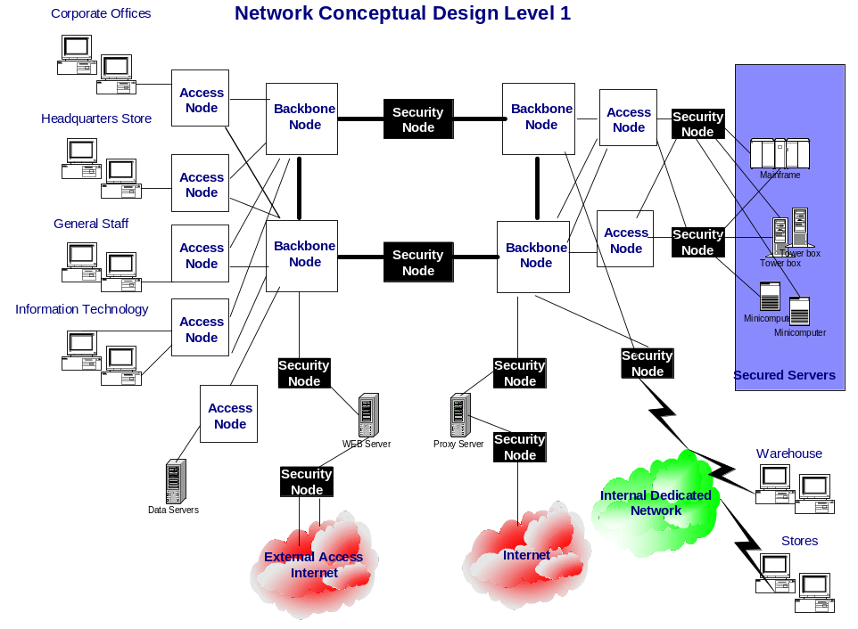
The next diagram shows links between the Level 0 conceptual design and the Level 1 design. User groups and important requirements such as security are directly linked.
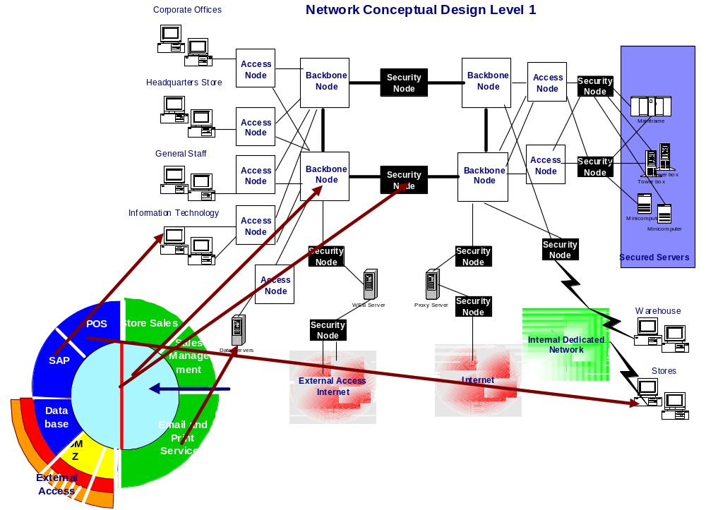
- References
You can find additional examples and reference instances of ARC 322 Network Conceptual Design and ARC 309 Principles, Policies, and Guidelines in the Network and Connectivity AssetWeb database using one of the following URLs:
North America, Latin America, and Asia-Pacific: http://w3-3.ibm.com/services/icm-assetweb/network.nsf
Europe - Middle East - Asia: http://w3-5.ibm.com/services/icm-assetweb/network.nsf
Within AssetWeb, perform keyword searches using different combinations of the work product name you are looking for. Examples:
- ARC 322 Network Conceptual Design
- ARC 322
- Conceptual
- Tools
Presentation software such as Lotus Freelance or Microsoft Power Point is used to create presentation materials. Some graphs and visuals require Microsoft Visio or another precision drawing package with reusable templates. When inserting these into presentations it is worthwhile to past each graphic as a picture (within Microsoft products) or as a jpeg/gif object to save space and allow the audience access to only the information intended for them.
- Revision History
Revision Number | Revision Date | Summary of Changes | Changes Marked?
Version 1.0 | September 2002 | Base version – Diane Cone

