

IBM Global Services

TCO Analysis

Technique Paper (TP)

© Copyright International Business Machines Corporation 2001, 2002 All Rights Reserved
Version 2.0 May 2002
- Description
One option to perform an engagement that includes cost baselining is using the TCO approach.
Objective of a TCO - Total Cost of Ownership - engagement is to analyze all IT costs and to identify areas for optimization.
Definition of TCO
TCO for IT components is defined by the
- Lifetime costs of an IT component including the initial hardware and software purchase price, as well as installation, management, service, support, administration, upgrades, training, downtime and disposal costs, i.e. all costs related to the owning, management and support and usage of an IT component.
(Intel, 1998)
In this way the TCO is driven by processes, people and technology / tools and comprises all costs in the lifecycle of an IT component (see picture).

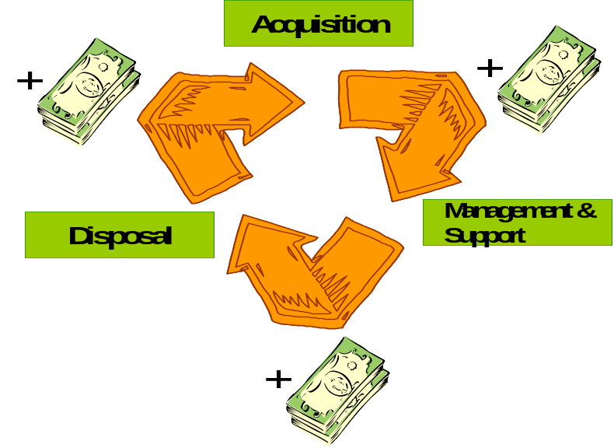
Be aware that the lifetime of an IT component, i.e. the period while the IT component is really used, may be shorter than the depreciation time of its purchase costs. For a TCO analysis it is important that the full purchase costs, i.e. all depreciation costs until the IT component is fully depreciated, are included – no matter if the IT component is no longer used at this point in time. Similar considerations are valid, if the IT component is leased. However, the management and support costs associated with the usage of IT component are only included as long as the IT component is really used.
Typically, the TCO is calculated as costs per IT component / computer per year. Alternatively you can calculate the TCO as costs per end user per year.
Apart from the cost analysis that is done in a TCO study, assessing the IT environment is an important part of a TCO study as well. You need a certain degree of understanding and assessment of the client's IT environment in order to explain the costs that you discover, i.e. why they are high or low in certain areas, and to identify areas for cost optimization.
You should especially look at the following areas:
- System architecture
- Application architecture
- IT and systems management (processes, services, tools)
- IT organiszation
- End user requirements
- Delivered services including service quality
The degree of the IT assessment is determined
- by the project scope,
- by the costs that you discover, i.e. if you discover high costs in a certain area you may want to concentrate the IT assessment on this area.
Value of a TCO Anaylsis
TCO studies show clients the cost structure in their IT environment, make IT costs transparent, establish the basis for pricing and accounting and show areas for optimization and cost savings.
This is done by:
- Defining the objectives of the TCO analysis together with the client (i.e. the target components),
- Defining the cost elements relevant for the analysis,
- Baselining the costs in scope, i.e. determining the actual TCO,
- Benchmarking this TCO with best practices or other companies,
- Uncovering gaps between the client’s TCO and the benchmarks,
- Assessing the reasons for these gaps,
- Identifying recommendations to overcome these gaps and optimize the costs.
Evaluating the influence of the implementation of these recommendations leads to the target TCO.
In this way TCO studies enable clients to make significant cost-saving business decisions, and facilitate an effective and efficient management of the IT infrastructure.
Specifically, TCO studies may support optimization in the following areas:
- Technology
Through a TCO analysis you may discover areas for reducing the complexity of the IT and application environment or areas where scalability of the environment may lead to cost-savings.
Also, you may find ways to increase the availability of IT components which leads e.g. to less productivity losses for the end users.
A TCO study can also uncover the inefficient usage of assets.
- Processes
A TCO Study may support the development of effective processes with reduced administrative costs, improved end user productivity and increased customer satisfaction (e.g. asset management process, but also desktop management process, systems management and support processes, other IT processes, e.g. alignment between business and IT).
Apart from being more effective the processes can become more efficient by using state-of-the-art automation techniques, standardization and optimization of their interfaces.
- People / Organization
The assessment in the TCO study may show that there are skill gaps in the organization (both IT and end user organization) which can be overcome by introducing an innovative skill development program.
Apart from that staff motivation is a factor that highly influences people efficiency and that may be uncovered by a TCO study and the respective assessments.
Additionally, the structure of the IT organization and their stability both influence the TCO and may be areas for improvement.
Cost Structures in a TCO Analysis
The TCO can be divided into direct and indirect costs.
- Direct costs are those costs that can be directly associated to the owning and management of the IT component, i.e. hardware and software costs, network and communication costs, IT personnel costs. In most cases, you'll find the direct costs included in the IT budget of a company. Sometimes - especially when a company has an independent IT shop as a subsidiary - the business departments host some IT personnel for local support as well. These costs have to be collated to the direct costs, too.
- Indirect costs are costs or productivity losses that result from the usage of IT and reflect the influence of IT on the end user. I.e. indirect costs include productivity losses through downtimes of the IT equipment, through reduced productivity due to problems with the IT equipment, through necessary end user IT training etc. These costs are typically not budgeted.
In order to further differentiate the direct and indirect costs they are divided up into several cost blocks, which are further divided into cost elements themselves. The detailed assessment of these cost blocks and cost elements support the exact analysis of the IT cost structure. This is the basis to give valuable advice to our clients with regard to cost-saving actions.
You can break down the costs to even more detailed cost points if necessary (e.g. break down the host hardware cost element in the hardware / software cost block into processor depreciation, processor leasing, hard disk depreciation, hard disk leasing, costs for connectivity hardware, etc.).
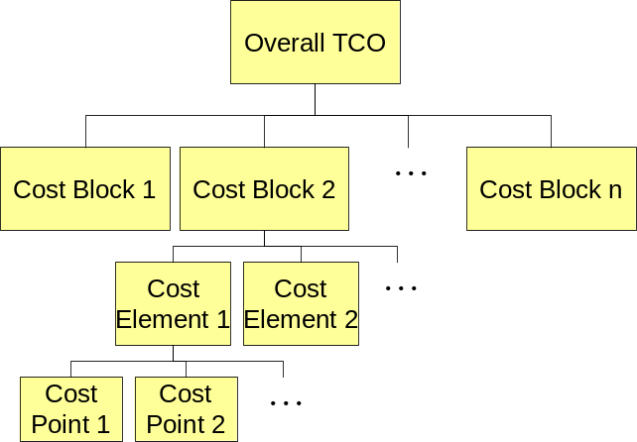
The level of detail for the cost blocks, elements and points is determined by the scope of the TCO analysis.
The sum of all of the above costs for one year results in the overall TCO of the enterprise in that particular year. If this sum is divided by the number of computers in the enterprise you get the TCO per computer per year for the enterprise.
The following picture gives an overview of possible cost blocks and cost elements:
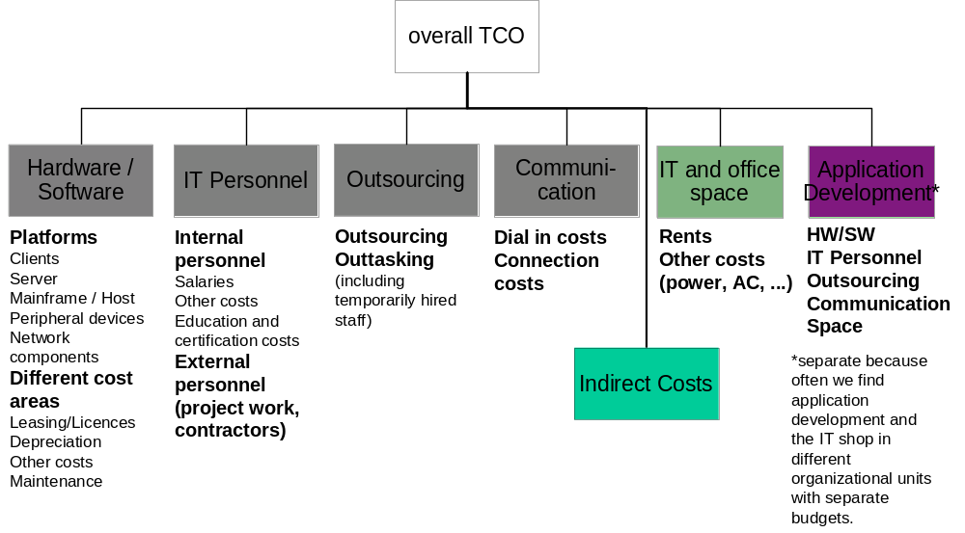
Additionally, the attachment "tco costs.xls" gives further detail how cost blocks, cost elements and cost points may be defined.
Apart from breaking down the costs into blocks, element and points it may be necessary to assess the costs separately for different organizational units, e.g. sales force vs. internal staff.
Research Institutes and TCO
There are a lot of research institutes such as GartnerGroup, Forrester or Metagroup that publish TCO studies and white papers.
Be aware that the published TCO values may differ significantly as the different researchers use different TCO models as a base for their studies, i.e. the type of costs that are included or excluded in the studies may not be the same for all researchers (especially on the indirect cost side).
However, all researchers agree on the fact that the administration / operations costs for IT components comprise the largest part when looking at the direct costs.
For example GartnerGroup publishes TCO cost blocks and respective cost splits as shown in the following picture:
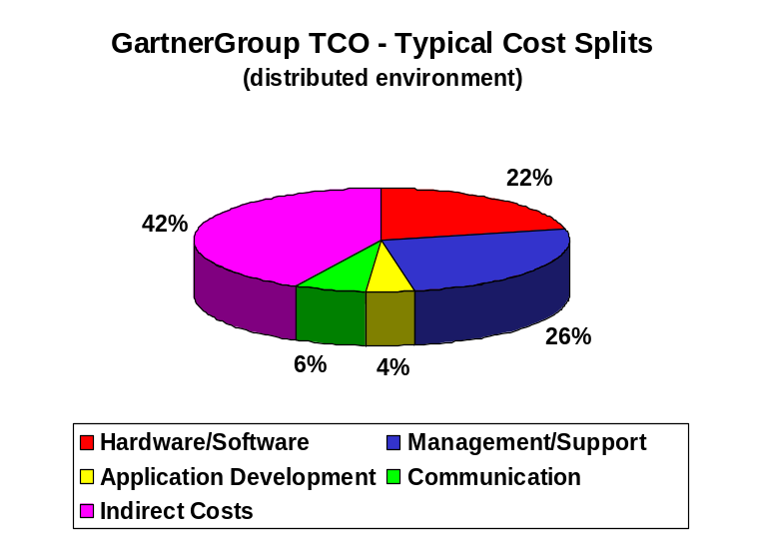
- Context
The applicability of a TCO analysis is diverse.
Basically, a TCO analysis can be carried out whenever the client wants to:
- See the structure of his IT costs and the actual or future total IT costs that are incurred by his IT department:
- What are the costs and what are the cost splits? How much does a computer cost?
A TCO analysis considers all IT related costs and calculates what portion of the costs are relevant for one computer.
- End users ask, why the IT department charges high costs for the usage of a PC.
A TCO analysis shows which costs have to be taken into account when calculating the charge for a PC: acquisition, management and support as well as disposal costs.
- Which influences does a system architecture change have on the IT costs?
Once the current TCO in the different cost blocks is assessed, you can forecast the costs that apply when you change certain environment specifics, e.g. the server platform, by exchanging the current server costs (HW, SW, personnel) with the new forecasted server costs.
- What can you save by consolidating your data centers?
Similarly to the change in system architecture, you can forecast the TCO for consolidated data centers when you base your forecasting on the current TCO.
- Compare to benchmarks:
- How does the IT department compare with other IT service providers?
In order to answer this question it is not sufficient to do a TCO analysis. But you need the current costs as a basis for benchmarking and comparing the IT department with other IT service providers.
- Identify areas for optimization:
- How can my IT become more efficient and effective?
A TCO analysis provided recommendations about how to improve the cost situation in IT and the efficiency and effectiveness of processes, services, people and technology.
Thus, there are many situations where a cost baseline is needed and where you can apply the TCO methodology or a slightly modified approach. This means that the TCO methodology is generally flexible enough to be applied in various situations. However, you should take care when to use the term TCO and when to use “cost baselining” or “cost assessment” instead as the term TCO as Total Cost of Ownership is predefined by research institutes such as Gartner Group.
- Steps
In this chapter the basic steps of a TCO analysis are covered. However, as many of the steps are carried out according to the phases, activities and tasks described in the IT Cost & Value engagement model, the emphasis lies on the most important aspects and on differences to the engagement model: A TCO analysis in one special path through the engagement model.
A TCO analysis is a consulting engagement that is divided into several steps. The steps or phases of a TCO analysis are illustrated in the following picture:
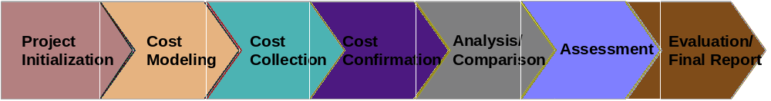
Step 1: Project Initialization
The project initialization is a very important phase in the project because in this phase the scope of the project, the client expectations as well as some basic facts about the client environment are determined and documented.
The main activities are:
- Define project objective
In order to ascertain which of the client's objectives have to be taken into consideration in the TCO analysis and what results the client expects from the TCO analysis you have to agree on and document the project objectives. Sample project objectives might be:
- Establish clarity about the IT cost structures and the actual TCO
- Assess areas for cost optimization
- Benchmark the client’s TCO
- Establish a basis for evaluating future scenarios
- Select project team (client and IBM)
The client should provide a sponsor and a project leader for the TCO analysis. The client project team should consist of at least one contact person for cost issues (e.g. an IT controlling person), for the number of IT components and for the IT environment respectively. However, it may happen that you need the involvement of more client staff for assessment workshops etc.
The IBM project team consists of a project leader plus financial and IT consultants. The number of people you need in the project team depends on the size and the scope of the project.
The relevant contact persons and project team members should be documented, e.g. as a communications matrix.
- Define range of assessed costs
The objective of this activity are to define which costs should be considered in the TCO analysis, e.g. will direct and indirect costs be included, which direct costs will be included, how much detail do you need, etc. This is done together with the client and should be documented for later reference in the project scope.
- Select analysis models
Together with the client you have to define in which way you will analyze the costs once they are collected, e.g. will you calculate the TCO per client, the TCO per client in sales force, the TCO per terminal.
As this activity contributes to the project scope, the analysis models should be documented.
- Agree on project plan
Once you have put the project scope together you have to agree on a timeline, the project plan, with the client. This is an important task as you document the client’s involvement in the project in the project plan.
- Determine client environment
In order to determine the client environment please look at the respective phase in the engagement model.
Outputs of this phase:
- Project Scope
- Communication Matrix
- Project Plan
- Description of Client Environment
Step 2: Cost Modeling
The second major step in a TCO analysis is the creation of a cost model that will be used throughout the TCO study.
The major activities are:
- Identify cost blocks, elements and points
The cost model is based on the costs in scope that you have agreed upon in the project initialization step. These costs have to be developed into cost blocks, cost elements and even cost points that have to be analyzed.
- Map cost blocks, elements and points to client specific accounting structure
Once you have composed the relevant cost blocks, elements and points, the more difficult task is to map these to the accounting structure and systems of the client in order to identify where you have to look for which costs in the cost collection step. This means that you have to identify which accounting codes in which cost centers can be mapped to which cost points, elements and blocks.
The following picture shows the relation between cost centers and finally cost blocks. It reads like this:
“The accounting code AC1 in the cost center 101 contributes to the cost point depreciation for NT client hardware, which belongs to the cost element client hardware in the hardware / software cost block.”
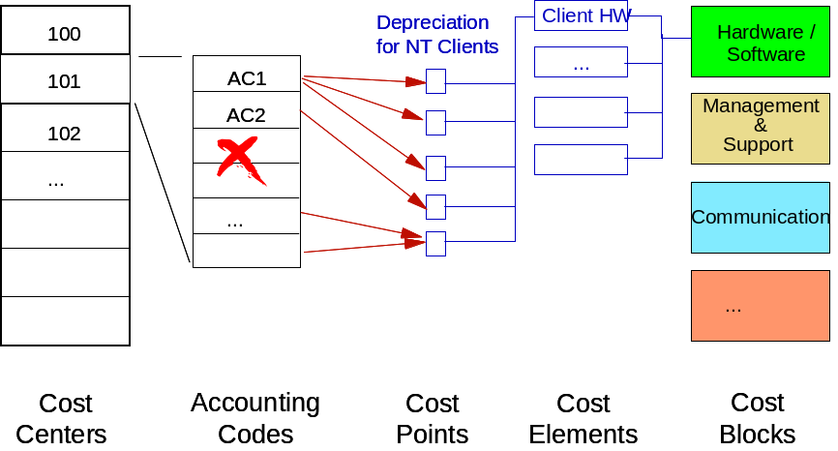
The task of mapping the cost blocks, elements and points to the accounting structure can only be done together with the client.
- Define inputs for indirect costs
If you have to consider indirect costs in the TCO analysis, you should define the inputs that you need to calculate the indirect costs, i.e. productivity losses (e.g. from downtimes) as well as the formula how to calculate the indirect costs from this input in the cost model. The basic formula for productivity losses is:
- (possible productive working hours minus actual working hours) times average salary per hour
or
- (possible productive working hours minus actual working hours) times possible earned revenue per hour
Be aware that the cost model also establishes the basis for the cost analysis as agreed upon with the client in the project initialization step. For example if you have to analyze the costs for sales force and internal staff separately, you should create the cost model in a way that cost collection is possible separately for the two organizational units, i.e. that the different cost points are fed from cost centers and accounting codes that are individual for the two different organizational units (if possible).
Output of this phase:
- Cost Model
Step 3: Cost Collection
In this phase all costs that are needed for the analysis have to be collected. It is important that you collect the right data and the right amount of data. The cost model ensures this.
The relevant activities are – in accordance with the project scope:
- Collect direct costs
A cost questionnaire supports the cost collection of the direct costs. Either the questionnaire will be filled in by client team members that are responsible for cost collection (e.g. IT Controlling, Accounting) or the cost collection happens in a workshop together with the client.
The first possibility is suitable if the required level of detail is not very high.
The latter possibility is suitable if the cost model covers a lot of detailed cost points and if the relevant cost centers and accounting codes are very complex. If you conduct a workshop it is recommended that you have online access to the client’s accounting system (e.g. SAP) in order to ensure correct data.
- Determine indirect costs
The indirect costs are calculated with the help of the results of:
- Enduser Surveys
- Help Desk Surveys
- Downtime Analysis
In order to determine the indirect costs, which occur when the end user uses IT -e.g. productivity losses due to problems –, you can for example conduct an end user survey. The advantage to just estimating the productivity losses is that you get much better results. When conducting an end user survey you have to take care that you use a representative sample of end users. The contents of the end user survey are e.g.:
- Number of problems that arise
- Type of problems that arise
- Reaction to problems that arise
- Problem solving times
- Satisfaction regarding help when problems arise
- Reaction to system breakdowns
- IT Training times
- Etc.
In addition or as a replacement for an end user survey, a help desk survey can be carried out. The contents of this survey mainly cover the statistics of the Help Desk, e.g.:
- Number of problems arising
- Number of end users affected by the problems
- Number of help desk calls
- average duration of a call
- Problem solving quota at the 1st Level
- average problem solving time by 1st Level
- average problem solving time having passed on the problem to 2nd Level
By means of an analysis of the downtimes of the end users' relevant IT systems you can also work out the amount of productivity loss suffered by the end users. Be aware that the productivity losses may differ between planned and unplanned downtimes.
- Collect system numbers
In this activity you collect the relevant system numbers, e.g. number of clients for the TCO calculation. This activity is not really cost related, but nevertheless important as it establishes the basis for analyzing the TCO.
Output of this phase:
- Populated Cost Model (spreadsheet or populated assessment database where you document and comment all collection results)
Step 4: Cost Confirmation
The importance of this phase should not be neglected as the output of this step is the confirmation of all collected cost data by the client and with this the approval to move forward to the analysis and later steps of the engagement with this cost data.
The main activities in this phase are:
- Check collected data with regard to completeness and plausibility
To check the collected cost data and system numbers with regard to completeness means that you have to check if all relevant cost blocks, elements and points from the cost model and all relevant system numbers are populated with real data or if something is missing. In the latter case you have to re-enter the cost collection phase in order to gather the missing information.
The check for plausibility means, that you check if the collected cost data “makes sense”, i.e. if you have collected similar costs for comparable business units or if the cost splits are similar in comparable business units. If not you have to check why these differences occur – either there is a reasonable explanation for the differences (provided by the client) or mistakes have been made in the cost collection phase.
- Agree on collected data with regard to correctness
Once you have collected all necessary data you should agree on the correctness of the cost data with the client. He should be able to approve your populated cost model and system numbers and needs to give you approval to move forward.
Output of this phase:
- Approved populated Cost Model
Step 5: Analysis / Comparison
This phase comprises three very important activities:
- Analyse collected costs according to selected analysis models
The collected and approved costs are evaluated according to the defined analysis models, e.g. TCO per client, TCO per client in sales force, TCO per terminal.
Basically you add up the relevant costs and divide them by the number of relevant clients.
If you have to analyze more sophisticated TCOs such as TCO per client in sales force versus TCO per client in internal operations you may have to fall back on certain assumptions about the distribution of costs on the two cases. This may be the case if you could not collect the costs separately for the two cases, but need to find certain allocation formulas (e.g. 80% of communication costs for sales force, 20% for internal operations). In the “Issue Resolution” section you will find more samples for these allocation formulas.
Addtionally, this is the activity where you calculate the indirect costs from the data you have collected about downtimes, end user productivity losses etc.
- Select and collect comparison data
In order to position the analysis results it is useful to collect some benchmark / best practices data. For this, a very important task is to selct the right benchmark data source so that the data you retrieve is really comparable to your client’s situation.
Once you have selected the data source (this may be some research institute such as GartnerGroup or some intellectual capital or a “real” benchmark partner) you have to collect or retrieve the data you want to compare against.
(see “Benchmarking” technique paper for more detail if needed)
- Identify gaps between client costs and benchmark costs
By comparing the client data to the benchmark data you will find some differences and gaps that need to be explained.
Some gaps may be easy to explain because you already have some information about the two data sources you compare, e.g. a basic understanding of the client’s and benchmark partner’s IT environment.
Other gaps that you identify may require further assessment in order to explain the differences. This will be done in the Assessment phase of the TCO analysis.
Be aware that you communicate your first analysis results to the project sponsor and leader in a very early stage in order to get their commitment – don’t surprise them with “bad news” only at the end of the project.
Outputs of this phase:
- Cost analysis
- Benchmark results
Step 6: Assessment
Starting from the gaps that you have discovered between the client’s data and the benchmark data that you cannot explain straightaway you decide which assessments of the client’s environment (and maybe the benchmark partner’s environment) you need in order to evaluate the gaps. These assessments are reflected in the following activities:
- Assess current IT processes
- Assess current IT services and the quality of their delivery
- Assess current system and application architecture
- Assess current IT organization
- Assess current end user requirements
These activities are not covered in detail here as you can find comprehensive descriptions and related work products in the “IT Management Strategy and Assessment” engagement model within IBM Global Services Method.
As in step 5 inform the project sponsor and leader about your findings.
Output of this phase:
- Relevant assessment results
Step 7: Evaluation / Final Report
The last phase in a TCO analysis is the final evaluation and interrelation of all results, the deduction of recommendations as well as their communication.
This phase has three main activities:
- Interrelate analysis, comparison and assessment results
In the analysis / comparison phase you have calculated the TCO and discovered gaps to benchmark results. By further assessing the client’s IT environment you have gathered information that you need to explain these gaps. This means that you analyze the impact of the current IT environment on the IT costs in order to identify reasons for the gaps between client data and benchmark data.
(This is basically a task from the “IT Management Strategy and Assessment” engagement model within IBM Global Services Method, but applied not only to IT assessment, but also cost and benchmark data.)
You have to update the analysis results according to the new insights that you have got from this activity.
- Identify recommendations to optimize the costs
Based on the explanations for the gaps, e.g. non-optimal IT processes, you can come up with recommendations about how to overcome the gaps (i.e. increasing effectiveness and efficiency of processes) and with this optimize the costs. This means that you translate your findings and conclusions into recommendations and initiatives.
Again, this activity is described in more detail in the “IT Management Strategy and Assessment” engagement model (phase “Initiative Definition and Transition Planning”) within IBM Global Services Method
- Communicate your results
In most cases you communicate your results to the client by presenting a final report. But before your create the final report make sure that the basic findings and recommendations are discussed with the project sponsor and leader.
The final report deliverable is the summary of all project activities and at least contains:
- Project scope
- Relevant client data: collected costs, description of IT environment, number of systems, etc.
- Analysis results (including comparison and assessment results)
- Findings and recommendations
Output of this phase:
- Cost Analysis (with incorporated comparison and assessment results)
- Final Report
- Also see work product “BUS 302 Financial Assessment”
Issue Resolution
During a TCO analysis you may encounter several issues or challenges that are not easy to resolve sometimes.
In the Project Initialization phase you have to ensure that you carefully and clearly define what you mean by terms that you use, e.g. you should clearly define and document what a PC is (if you decide on calculating the TCO per PC): For example, a PC can include all peripheral devices or you can agree on omitting peripheral devices and plug-ins.
In the Cost Modeling phase it may be difficult to map the cost blocks, elements and points to the client’s accounting structure and systems. Sometimes, the client uses more than one structure and more than one system to collect all his cost and system data – especially if you are dealing with different organizational units. But for the cost collection it is crucial that the mapping is done. Thus, there is no real resolution for this issue, but it helps if you accurately document all the cost blocks, elements and points and the respective accounting codes. It may happen that for example one cost element is fed by several accounting codes, on the other hand it may as well happen that one accounting code contributes to several cost points or elements. In the latter case you have to look at the single accounting transactions to determine which cost points or elements are affected.
The Cost Collection itself can be difficult – especially if the mapping of accounting structure and cost blocks has been difficult. In this case it is recommended that you conduct a workshop for the cost collection instead of just sending out questionnaires. During the workshop the project team can assist the client with identifying the right cost elements and points in the accounting structure.
For the Analysis phase it is important that you agree on certain assumptions or allocation formulas if you could not collect the costs in the granularity required for the analysis (e.g. because the client’s accounting structure is not as detailed as your cost blocks, elements and points). In the following sections you find sample assumption areas for cost splits:
- Hardware/Software Costs
If you have to analyze the TCO for various client types or organizational units, and you include host / mainframe or other enterprise server costs, these costs have to be shared between the client types / organizational units. You can divide the costs up by mainframe usage, e.g. analyze the number of transactions or the data volume per client type / organizational unit.
The same is applicable for network component or peripheral device costs.
- IT Personnel Costs
Personnel costs are distributed to the clients according to the amount of administration and management effort for these clients. If your cost model is so detailed that you have determined the activities and tasks of the IT personnel and the percentage to which the IT personnel does what, you may quite clearly allocate some of the tasks (and with this some of the costs) to certain clients, whereas others have to be allocated by using a percental distribution.
- Communication Costs
The communication costs will be allocated to those who have caused them. If this cannot be determined directly, you have to assume a percental distribution.
- Costs for IT and Office Space
The costs for IT and office space have to be allocated depending upon how they are utilized, i.e. divided in data center (host and network), server premises (server and network), IT office space (IT personnel). If the costs can be determined in such a way, you can use a cost distribution according to the distribution of host and server costs and of IT personnel costs (see above).
If you enter the Comparison phase the most important issue is that you take care that the selected benchmark source is really comparable to your client in order to achieve significant results.
The Assessment phase and the Evaluation phase pose the challenge to interpret and interrelate all assessment results including the cost analysis, the comparison results and the assessment results. Sometimes it is difficult to decide what you have to assess in order to explain certain gaps in you analysis. And further on, it may be difficult to connect the assessment results to the earlier analysis results. The following table may help to identify for what you should look:
Area of IT Assessment | Cost <-> IT Assessment Interrelation (sample statements / hypotheses)
IT processes | If you have done a process maturity assessment the following may be important:  - As a rule: The better the ranking of IT processes, the lower the costs. Especially: The better the general IT processes are valued (e.g. IT Strategy, Procurement), the lower the costs incurred.  - The more efficiently a process is run, the lower the costs as a rule.  - But: The more effective a process is run, the higher the costs may be (because it is done in a more sophisticated way with the need for more resources).  - The more integrated the processes are amongst each other, the more likely synergies and interfaces can be used, the lower the costs as a rule.  - The more a process is automated or supported by tools (ideally by an integrated toolset), the lower the costs as a rule, i.e. if you still have to do a lot of manual work, the costs will be higher.  - But: Make sure that you also look at the costs for the automation.  - The more precise the responsibilities are defined, the lower the costs as a rule, i.e. in case activities have to be carried out twice, the costs will be higher.  - The more the required results are supplied in the required quality, the better the end users can do their job, the smaller are the losses in productivity and therefore the indirect costs.  - Etc.
IT services | When interpreting the costs and thereby including the services, it is important which and how many services are delivered and with which service levels. In other words, the following has to be considered:  - As a basic rule: As services are tightly linked with processes, the same hypotheses are valid as for processes.  - A 24 hour - 7 day per week company is certainly more expensive than a company which is limited to certain service times, as most probably several shifts have to be run and therefore higher personnel costs are incurred.  - Fast reaction times usually result in higher costs, as more staff is needed in order to guarantee them.  - The more quality a service delivers, as a rule, the higher the direct costs, the lower the indirect costs.  (Remark: The required service quality is closely linked to the end user requirements.)  - Etc.
System and application architecture and management tools | Basically you can say that the costs are higher, the more complex the system architecture is.  In this connection 'complex' is to be understood as  - Heterogeneity of the system architecture (i.e. if there are several approaches of system architecture, e.g. terminal-host and client/server environments) as well as  - Complexity of the system architecture as such (e.g. a client/server environment is more complex than a terminal-host environment).  When interpreting the costs with regard to the system architecture you should consider the following:  The more heterogeneous the system architecture,  - The more comprehensive the management and support has to be  - The more skills the staff are expected to have  - The less synergies can be used  - The more versatile the architecture of the IT components has to be (e.g. in the network environment) - also the number of components  - The less advantage can be taken of good bargains by buying in bulk  - Etc.  The more complex the system architecture as such,  - The higher the expense of management and support for the environment  - The more vulnerable to faults the environment is (the more fallouts are incurred which in turn effect the indirect costs)  - The higher the expenses for training (for IT personnel - direct costs, as well as for the end users - indirect costs)  - Etc.  When interpreting the costs by taking into consideration the application architecture you have to consider the following:  - The less standardized the approaches in the application architecture are, as a rule, the higher the costs for operating, management and support of the applications. The same applies to the application architecture costs themselves.  - The less mechanisms for application management are integrated in the application development (especially with regard to an end-to-end view), the higher the expenses are for the management of the applications, the higher the risks for downtimes and therefore the indirect costs.  - Etc.
IT organization | - The IT organization can also influence the costs, especially if the IT personnel are spread out over several locations and the support is given decentralized. In such a case synergies can often only be obtained per location, as every location has to have certain skills.  - Furthermore, it is relevant which costing model the IT department is based on. If it is a profit center most probably lower costs are more in focus than if it is a cost center, where all costs are debited to the end user by means of a charge back system anyway.  - In addition, it is worthwhile to make an analysis of the respective outsourcing and outtasking costs as to their competitiveness or whether they are lower or higher than the respective internal costs would be.
End user requirements | In order to be able to interpret the costs with regard to end user organization and the respective requirements the following should be considered:  - Basically: The end user requirements have a tremendous effect on the whole IT infrastructure, especially the services and the system architecture. Therefore they influence the costs accordingly.  - It is important to look at the industry and the respective business processes when interpreting the costs (some industries just cannot work without IT and have to accept higher costs because of this).  - The more complex the end user requirements are (with regard to IT equipment, applications, support etc.), the higher the costs are as a rule.  - The more end user types have to be serviced (and the more this is reflected in the system and application architecture as well as in the services), the higher the costs generally are.  - The more the IT department can act proactively, i.e. the earlier the IT department is included in new requirements, the lower the costs are for new solutions, which are required by the end users.  The more decentralized the end user organization, the more decentralized the IT department has to be organized as a rule, the higher the costs.  - Etc.
- Tools
The tools that are used during a TCO analysis are mainly questionnaires for costs and the IT environment that are available through the IBM Intellectual Capital System.
You will find cost questionnaires in the IT Cost & Value Management ICM database and a lot of questionnaires for the IT environment in the IT Management Strategy & Assessment engagement model within the IBM Global Services method as well as in the Enterprise Systems Management ICM database and other ICM databases.
Additionally you find e.g. approaches for process maturity assessments (according to the IT Process Model, IBM’s process framework) in the IT Management Strategy & Assessment engagement model within the IBM Global Services method and in the IT Process Model ICM database.
If you want to use a single tool that guides you through the whole TCO engagement you may want to use the Gartner TCO Manager. This is a tool (license fee per year) to analyze costs and drive efficiency by providing a framework to collect and capture costs, highlight issues and develop findings and recommendations.
If you don’t want to use questionnaires or the Gartner TCO Manager, but have heard about the Gartner TCO Analyst, you should know that this is not a tool supporting TCO analyses. The Gartner TCO Analyst is a tool that embodies Gartner research data, so that you can easily estimate what your client’s TCO should typically be given some company parameters as an input to the tool. The Gartner TCO Analyst can also estimate the typical TCO in case you change some parameters, i.e. in case you undertake certain initiatives - but still on a very high level. This tool has to be licensed, too.
- Examples
You will find several sample proposals; cost questionnaires and final reports in the ICM database of IT Cost & Value Mgmt.
- Revision History
Version | Date | Comments
2.0 | May 2002 | Updated style, spelling and grammar check.
1.0 | July 2001 | Base Version

