ENHANCED COS – CONDITIONS OF SATISFACTION

PMDB Reference Guide

January 2009

- Default view on Tab 5 for all projects is the Enhanced COS Template. This process is required for all projects with a TSV >$500K but can be used for all projects. COS Lite (word document) is available for projects <$500K and for those who require a French version (the COS Lite process is described at the bottom of this reference guide.)
- Edit access is available to the PM, PCO, Additional Editors, Delivery and Lead Partner as indicated on Tab 1
- There are four basic steps in the COS Process
  - 1. Create/Update COS Template
  - 2. Create/Update Interim COS Review
  - 3. Create/Update Action Items
  - 4. Create/Update Closeout Review

Step 1: COS Template (Home Base)
When Tab 5 is accessed, there are two tabs immediately viewable. The “COS Template” tab can be referred to as “Home Base” as this is the starting point for documenting and updating the Conditions of Satisfaction, creating the Interim and Closeout Reviews, Print options and accessing previous Interim COS Reviews. Action Plans are accessed from the second tab. Note: If your project was entered into PMDB prior to the introduction of this new template in June 2008 you will see a third tab called Archived COSCard data where you can store and access your old COS word documents.
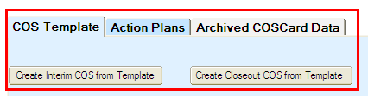
(Screenshot 1)
The COS Template is used to document the Conditions of Satisfaction that you and your client have agreed to use as a benchmark against which to measure how well IBM met their expectations regarding aspects of delivery. To begin, enter the client information and then the COS statements, date and status. The field titled “Date of Last Customer Sat Discussion” should reflect exactly that information. For example, when the COS statements were established or reviewed or an Interim or Closeout Review was held. Over the life of a project, new COS statements can be added or existing COS statements revised or moved to inactive status.
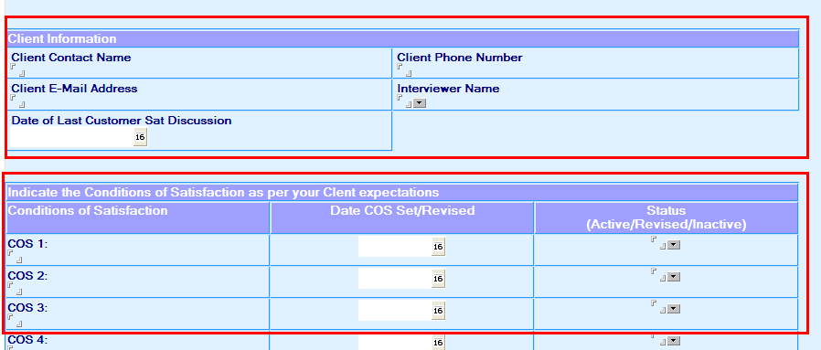

(Screenshot 2)

Step 2 – Create Interim COS Review
As a guideline, quarterly reviews of COS is recommended, however the timing should be determined by the PM and the relevancy to the project, i.e. project duration, significant milestones, etc. If a PMR (Project Management Review scheduled with the Risk Manager) is scheduled to take place within a month of your next scheduled COS review, you should reschedule the Interim Review if your client is already being interviewed.

At the Interim Review, review the COS statements with your client and obtain feedback. If any of the COS statements need to be updated, go to the COS Template (home base) to make these changes first and update the date and status fields appropriately. To document the client’s responses, you will create an Interim COS Review by clicking on the grey button at the top template which will create a copy of the base template.

When presented with this new screen, update the Review Date field and the Client Information field if required. Document the client’s comments regarding each of the Conditions of Satisfaction statements and select the appropriate summary response from the drop down box in the Client Response column.
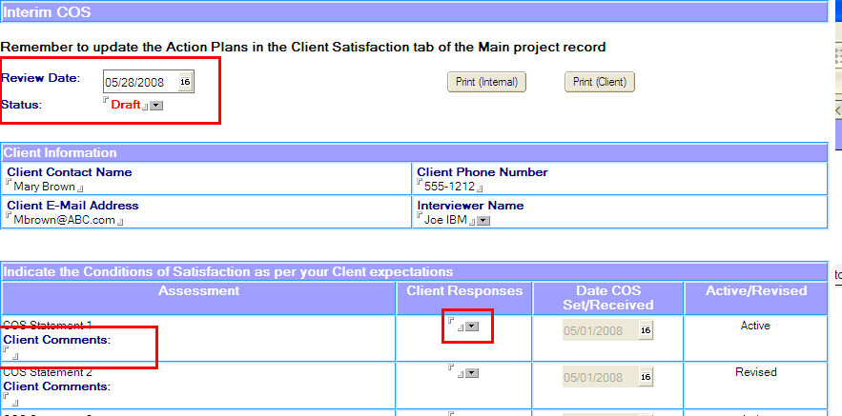
(Screenshot 3)
During your interview with the client, ensure you ask them the ISAT questions as well. It is recommended that you ask these questions at the end of the interview as a way of closing/summarizing your discussion, i.e. “I have a few general questions I would now like to ask you”. These are the same questions that the Risk Management team uses when they interview a client as part of a PMR (referred to as the Interim Client Health Check or ICHC). The specific answers to these questions will automatically produce a score between 1-10 when you enter them into the COS template. This score is referred to as an ISAT (IBM Satisfaction) rating and uses the same calculation as the ICHC. IMPORTANT NOTE: The ISAT process, a copy of the question set, calculation and metrics are IBM intellectual property and CANNOT BE SHARED WITH THE CLIENT – INTERNAL USE ONLY. The Interim COS Review can be printed and given to the Client - PLEASE ENSURE you select the “Print Client” print option which does not contain the ISAT information.

Update this section of the record, with the responses from the drop down list and calculate the ISAT score by selecting the yellow button. If the score results in a yellow or red status, update the Low ISAT field at the bottom of the screen where appropriate. Comments and attachments can be added to this view as well.

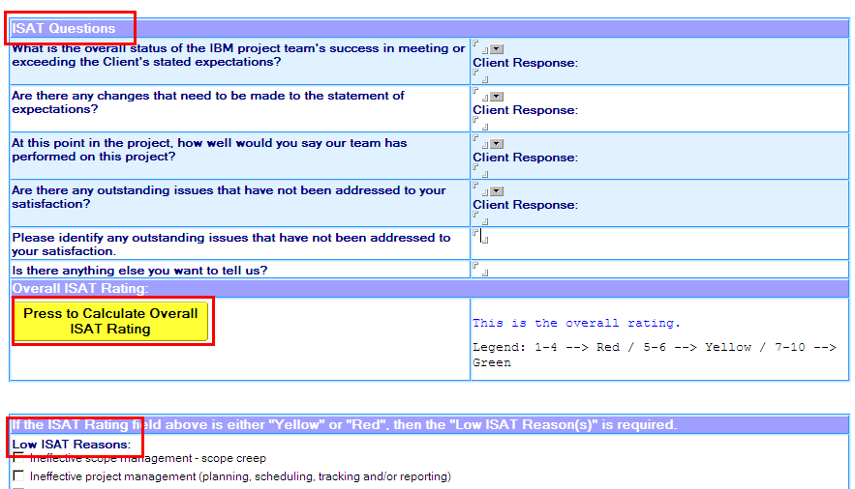
(Screenshot 4)

When the Interim COS Review is completed, change the ‘Status” field at the top of this screen to “Final”. This will automatically generate a note to the Lead and Delivery Partners advising them that this information has been updated and will also lock this Interim Review from further editing. There is no limit to the number of Interim Reviews that can be created.

Step 3 – Create Action Plans
Based on issues that may be raised in the Interim COS Review, an Action Plan(s) may be required. If so, select the “Action Plans” tab from the main screen (or home base) and update accordingly. Clicking on the “Send Notification” button will automatically generate an e-mail to the person in the ‘Assigned To’ field. Ensure that you have selected this name via the drop down box. The PM (or delegate) will update this tab based on feedback from the people that have been assigned the action.

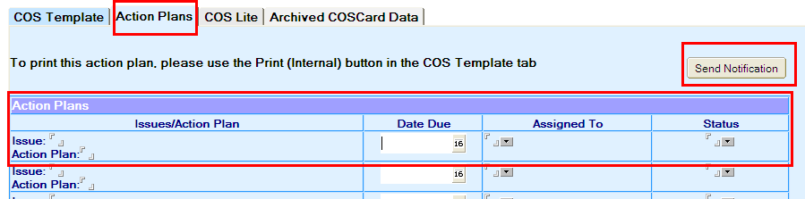
(Screenshot 5)

NOTE - Action Plans can be printed using the Print (Internal) button on the COS Template tab.

Step 4 – Create a Closeout Review
A Closeout Review is created near/at the end of the engagement. A Closeout Review is created using the same basic process as the Interim COS Review. From the COS Template (or home base) view, select the “Create Closeout COS From Template” button. There are two differences between the Interim and Closeout Reviews. The Closeout Review has:
- two additional ISAT questions (things we did well, areas for improvement)
- at the bottom of the screen, there is a “Reference” question. This question should only be asked to clients that have an ISAT rating of 7 – 10 (green).
Meet with the client and get their feedback on the COS statements, responses to the ISAT questions and record them in the Closeout Review. When the Closeout COS Review is completed, change the ‘Status” field at the top of this screen to “Final”. This will automatically generate a note to the Lead and Delivery Partners advising them that this information has been updated and will also lock this Closeout Review from further editing

Accessing Previous Interim COS Reviews
All Interim and Closeout COS Reviews can be accessed by clicking on the review at the bottom of the COS Template screen (home base).

Note – only the most recent review in Draft status can be edited. Final status reviews are uneditable.

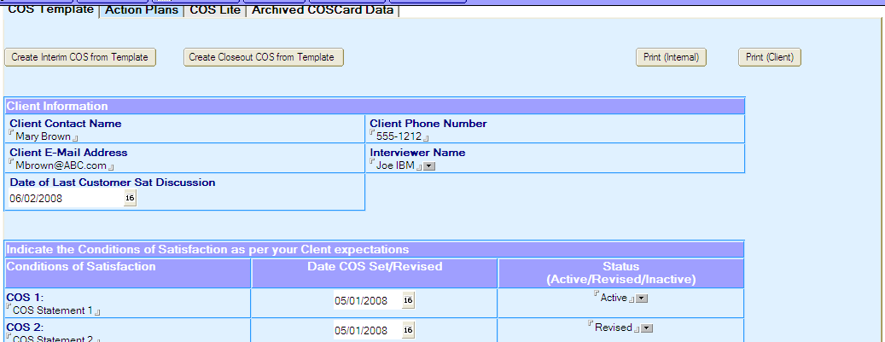
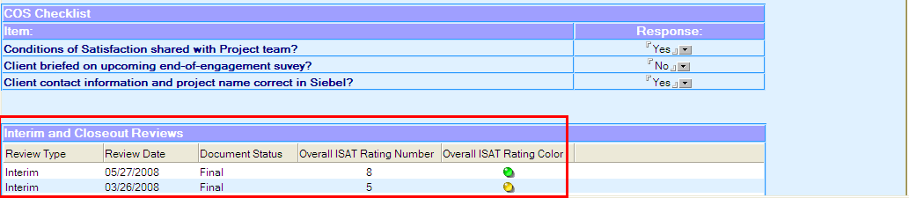

Waiver Process
In order to waive this process, you must contact your Sector Portfolio Manager (SPM) and discuss your reasons with him/her. For example, your client may refuse to participate in this process, contract negotiations are in progress, etc. If the SPM agrees to the waiver, they must check the box on the base template and document the reason for the waiver.

Creating a COS Lite Template

If your project has a TSV <$500K, you can use the “COS Lite” process. To create this view, check the box at the top of Tab 5 for COS Lite, save, close and re-open the record.
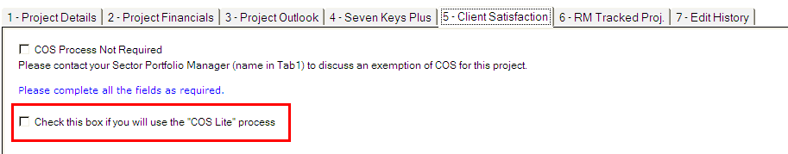

The COS Lite process uses a word document format to capture the client’s Conditions of Satisfaction, Action Plans and an overall rating from the client of Exceeded, Met or Not Met. Update the COSCard based on the conversation with your client and then update the fields in this view. Always use the most current version of this template which can be accessed at this wiki site. When complete, attach the document to your PMDB record using the attachments button on the template.

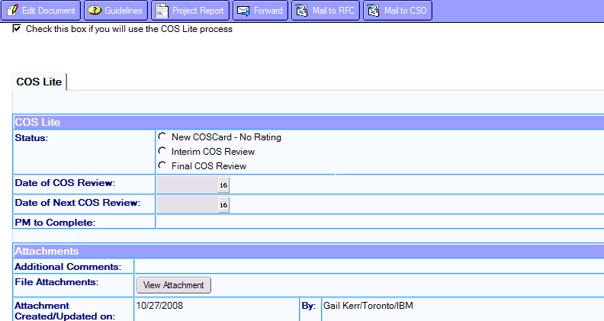

COSCard
