
Global Services

Change Management in Rational Team Concert

Document Control Page
About this document
Produced using Microsoft Word for Windows Version 2003
Doc. Owner: GBS Process, Methods and Tools team

Revision History
Version | Date | Change Description
1.0 | April 2010 | Initial version.
1.1 | October 2010 | Changes to align tool mentor with RTC configuration “IBM Opal 1.2”.
2.0 | Sep 2011 | Changes to align tool mentor with RTC configuration “IBM Opal 2.2”.

Trademarks
IBM, the IBM logo, Rational and the following product names are trademarks of IBM Corporation in the United States, other countries, or both:
IBM Rational Team Concert (RTC)
IBM Rational Quality Manager (RQM)
IBM Rational Requirement Composer (RRC)

Microsoft, Windows, Windows NT, and the Windows logo are trademarks of Microsoft Corporation in the United States, other countries, or both.
Contents

Global Services 1
Change Management in Rational Team Concert 1
Document Control Page 2
About this document 2
Revision History 2
Trademarks 2
Contents 3
1 Purpose 4
2 Scope 4
3 RTC usage 4
3.1 RTC generic usage 4
3.2 Accessing help on RTC Web client 4
3.3 Accessing help on RTC Eclipse client 4
4 Security 5
5 Change Management: Tool implementation of the OPAL Procedure 5
5.1 Process roles 5
5.2 Usage Model 6
5.3 Change Request Work Item 7
5.3.1 Change Request Form 7
5.3.1.1 Presentation layout 7
5.3.1.2 Presentation design 8
5.3.2 The Lifecycle 12
5.3.2.1 Workflow 12
5.3.2.2 Permissions to execute actions 13
5.3.2.3 States 14
5.3.2.4 Resolution codes 15
5.3.2.5 Approval tracking processes 15
5.3.2.6 Required attributes for each state 16
5.4 Change Order Work Item 17
5.4.1 Change Order Form 17
5.4.1.1 Presentation layout 17
5.4.1.2 Presentation design 18
5.4.2 The Lifecycle 20
5.4.2.1 Workflow 20
5.4.2.2 Permissions to execute actions 21
5.4.2.3 States 22
5.4.2.4 Resolution codes 23
5.4.2.5 Approval tracking processes 23
5.4.2.6 Required attributes for each state 24
5.4.2.7 Time tracking for work items 24
5.5 Queries 25
5.5.1 All Change Requests 26
6 CAPABILITY: Tool implementation 26
7 Task: Tool implementation 27

Purpose
This document provides guidance on changes within the IBM GBS Standard Delivery Solution (OPAL) configuration of IBM Rational Team Concert (RTC hereafter) in support of OPAL change management. It also provides project direction on leveraging RTC in support of change management.
This document does not replace nor cover all of the steps defined in the OPAL change management procedure. To fully understand this document, it should be read in conjunction with the procedure. Please be aware that this OPAL procedure may contain additional steps that take place outside of RTC and are not duplicated here.

Scope
The guidance assumes a basic understanding of how to use RTC and is not intended to be training material. This tool mentor references the GBS Standard Delivery Solution (OPAL) RTC configuration release 2.2. This configuration supports the OPAL change management procedure as part of OPAL release 15.3.

RTC usage

RTC generic usage
RTC may be accessed either directly via the Eclipse Client or via the Web interface. For performance reasons, the recommended interface, especially for hosted environments, is the RTC web client.

Accessing help on RTC Web client
In order to access the RTC help, hover over the Help button (the one with the question mark icon), and click the “Help Contents” option.
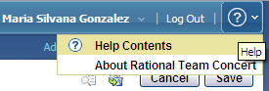
Figure 1: Help on RTC web client

Accessing help on RTC Eclipse client
In RTC Eclipse client, it is necessary to click the Help menu in order to see its different options.
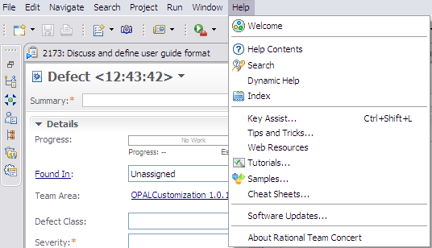
Figure 2: Help on RTC Eclipse client

Security
By default, only the members of the project area hierarchy have read access to the project area and its work items. If you grant access to members of the project area hierarchy, anyone who adds a member to any team will implicitly grant access to the entire project. The access control feature can be used to change this default and grant read access using other criteria.

Change Management: Tool implementation of the OPAL Procedure

Process roles
This solution allows the Administrator to allocate one or more RTC roles to members of your project. Each role selection may provide or deny access to specific RTC features.
The following graphic provides a list of available roles within this solution.
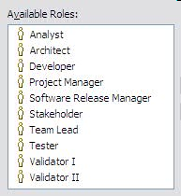
Figure 3: Predefined RTC Process Roles

The following table describes the mapping between the roles defined by the OPAL procedure and the ones implemented within the solution.
Role defined in the OPAL procedure | Roles implemented within the solution
Change Control Board (CCB) | Anyone in a RTC role could serve in a CCB. FYI, a CCB member could approve/reject a work item via the “Approval tab” and change the priority of a work item.
Project Manager | Project Manager
Project Office | Anyone in a RTC role could serve in a Project Office.
Sponsor | Anyone in a RTC role could serve as a Sponsor. FYI, a Sponsor could approve/reject a work item via the “Approval tab” and change the priority of a work item.
Stakeholder | Stakeholder
Figure 4: Process Roles mapping

Usage Model
Change Management solution within RTC is composed of two different work item types:

- Change Request
- Change Order

When a new change request is identified, a Change Request work item is created in RTC. After completing the required attributes, the change request is saved, and it is placed in “Raised” state.

The person responsible for managing change requests to closure (typically the Project Manager), proceeds to do a quick analysis to identify the size of the change (small/large). If the change request is small, then no additional estimates or analysis needs to be performed and the project manager can approve the implementation. If the change request is large, estimates and analysis are required and the project manager assigns the change request to someone else (e.g. another owner) to perform further analysis. The owner moves the change request to the “In Progress” state when the analysis starts, and moves it to the “Analysis complete” state when the analysis has completed. Once the analysis is provided, the project manager needs to decide if the change request will be: a) deferred b) requiring further analysis or revisions (“Disapprove Implementation”), or c) approved for implementation.

Once the change request moves to the “Implementation Approved” state, change orders can be scheduled and related to the current change request. The change request will be closed when all the change orders have been resolved.

From the “Raised” state, the project manager can also reject the change request, documenting the appropriate resolution code for rejection.

Each change order can be linked to one or more work items as needed.

Change Request Work Item
When a change request is identified it is documented using the “Change Request” work item.

Change Request Form

Presentation layout
The change request information is collected using the “Change Request” work item. In its form, attributes are organized into different tabs and sections, for better usability.

The screenshots below show the organization of the attributes across the tabs, using RTC Eclipse client. Note that most of the screenshots presented here are shown when you create the work item the first time so mandatory attributes (the ones with the red asterisk, *) will change based on state.
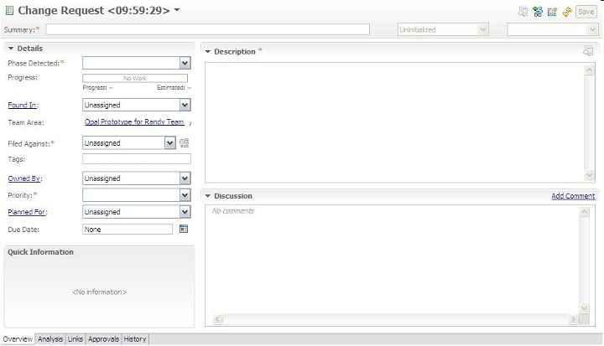
Figure 5: Change Request Work Item Presentation, Overview tab
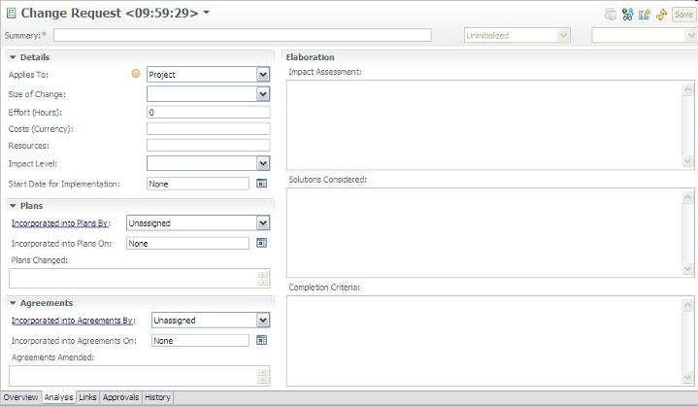
Figure 6: Change Request Work Item Presentation, Analysis tab

Screenshots related to “Links”, “Approvals” and “History” tabs are not included as they are the RTC out of the box tabs.

Presentation design
The following table shows the field mapping between the OPAL work product (e.g. Change Request template, Change Management Documentation template) and the customized Change Request work item on RTC.
OPAL field name | RTC implementation
Project Name | Timeline name / Filed Against.  The timeline name in RTC is used to group all project related artifacts together. Additionally, the project name is also defined as a category and is selected in the Filed Against attribute.
Project/Work Order No. | Project Area description.  Additional project attributes including work order, organization unit, etc. can be listed in a row format (in case of multiple projects within a project area) within the project area description.
Project Manager | Project Manager role.  The Project Manager field in Opal is represented by the Project Manager role in RTC and all Project Managers for a project can be viewed by looking at the roles assigned in the project or team area. When a Project Manager is the active owner of a work item, his/her name appears in the Owner attribute on the work item.  RTC provides ability to view individual attributes and see their respective role.
Project Phase | Phase Detected.  Enumeration.  Values:  - SRS  - Design  - Coding  - Testing  - Installation, Build and Packaging  - Other Occurrences  - Not Assessed (to represent no selected value) –default value-
Project Organizational Unit | Project Area description.  Additional project attributes including work order, organization unit, etc. can be listed in a row format (in case of multiple projects within a project area) within the project area description.
Application Name / acronym | This is set via categories.  Background: You can create a Project Name category and have sub categories for the application or components
Change ID | Id.  Automatically assigned.
Date Raised | Creation Date.  Automatically assigned when the work item is saved the first time.
Raised by | Created By.  Automatically assigned when the work item is saved the first time.
Short description | Summary (a.k.a. change request title).
Detailed Description | Description
Priority | Priority.  Enumeration.  Values:  - Critical  - High  - Medium  - Low  - Not Assessed (to represent no selected value) –default value-  Note: Opal templates do not require the “Critical” value on the “Priority” attribute, but it is included here due to the tool’s limitation.
Timescale for analysis | Due Date.  When assigning the change request during analysis time, the due date represents the timescale for analysis. Once the change request is approved, the due date can be adjusted to represent the “target date for implementation” for the whole change request.  Note: All changes are kept in the History tab so no data is lost.
Small Change? | Size of Change.  Enumeration.  Values:  - Small  - Large  - Not Assessed (to represent no selected value) –default value-  Note: The OPAL Change Management procedure says a change is considered “Large” when it impacts the schedule, cost and/or quality of the project.
Applies to | Applies to.  Enumeration.  Values:  - Contract  - Project –default value-  This attribute does not change the work item behavior. It is being included just for filtering purposes.  The solution will not limit access to specific individual(s) if the change request is defined at a contract level and requires managing confidential information.  Other considerations need to be taken into account to manage this, such as:  - Storing change requests into a different project area with restrict access  - Storing change requests on a different tool
Accepted for analysis by | History.  All changes to the work item are tracked on the History tab.
Accepted for analysis on | History.  All changes to the work item are tracked on the History tab.
Assigned to | Owned By
Assigned date | History.  All changes to the work item are tracked on the History tab.
Status | Status +  Resolution Code
Status Date | History.  All changes to the work item are tracked on the History tab.
Impact Analysis | Impact Analysis.  Text attribute.
Solutions Considered | Solutions Considered.  Text attribute.
Effort Estimate | Effort (Hours).  It stores the estimated effort before the change request is approved. Once approvals are obtained, that effort represents the “Approved Effort”.  The value should be a number greater or equal than zero.  Note: All changes are kept on the History tab so no data is lost.
Cost Estimate | Costs (Currency).  It stores the estimated costs before the change request is approved. Once approvals are obtained, this cost represents the “Approved Cost”.  The value should be a positive number with or without decimals.  Note: All changes are kept on the History tab so no data is lost.
Potential Start Date for Implementation | Start Date for Implementation.  It stores the “potential start date for implementation” before change request approval and schedule of change orders. Once approvals are obtained and change orders scheduled, this attribute becomes the “Approved Start Date for Implementation”.  Note: All changes are kept on the History tab so no data is lost.
Potential Target Date | Due Date.  When assigning the change request during analysis time, the due date represents the timescale for analysis. Once the change request is approved, the due date can be adjusted to represent the “potential target date” for the whole change request.  Note: All changes are kept on the History tab so no data is lost.
Impact level | Impact level.  Enumeration.  Values:  - Minor  - Moderate  - Significant  - Major  - Not Assessed (to represent no selected value) –default value-
Resources | Resources.  Text attribute.
Estimates validated by | History.  All changes to the work item are tracked on the History tab.
Estimates validated on | History.  All changes to the work item are tracked on the History tab.
Analyzed by | History.  All changes to the work item are tracked on the History tab.
Implementation decision | Status plus  Resolution Code
Decision date | History.  All changes to the work item are tracked on the History tab.
By whom | History.  All changes to the work item are tracked on the History tab.
Approved effort | Effort (Hours).  See above.
Approved cost | Costs (Currency).  See above.
Approved start date for implementation | Start Date for Implementation.  See above.
Target date for implementation | Due Date.  The Due Date attribute is adjusted from “Potential Target Date” to “Target date for implementation” while more accurate information is obtained.  Note: All changes are kept in on the History tab so no data is lost.
Approved on | History.  All changes to the work item are tracked on the History tab.
Approved by | History.  All changes to the work item are tracked on the History tab.
Incorporated into plans on | Incorporated into Plans On
Incorporated into plans by | Incorporated into Plans By
Plans changed | Plans Changed.  Text attribute.
Incorporated into agreements on | Incorporated into Agreements On
Incorporated into agreements by | Incorporated into Agreements By
Agreements amended | Agreements Amended.  Text attribute.
Completion criteria | Completion Criteria.  Text attribute.
Change Order ID(s) | Links.  List of related work items, including change orders and/or action items.
Date Closed | History.  RTC keeps this information on the History tab when the Close action has been performed.  See also “Date Completed”.
Date Completed | Resolution Date.
Comments | Discussion.
- | Progress.  Progress bar, based on estimated effort and time spent.
- | Project Area
- | Team Area
- | Filed Against
- | Tags
- | Resolution
- | Planned For.  Product Release/Iteration when the change request is planned for.
- | Constraint Type
- | Constraint Date
- | Planned Start Date
- | Planned End Date
- | Resolved By
- | Attachments.  List of attachments with additional information.
- | Links.  List of related work items.
- | Approvals.  List of approval cycles with the appropriate exit decisions.
- | History.
Figure 7: Description of attributes, part of change request presentation

The Lifecycle

Workflow
The following state transition diagram represents a change request lifecycle within RTC, from the “Raised” state to the final states: “Rejected” and “Closed”.
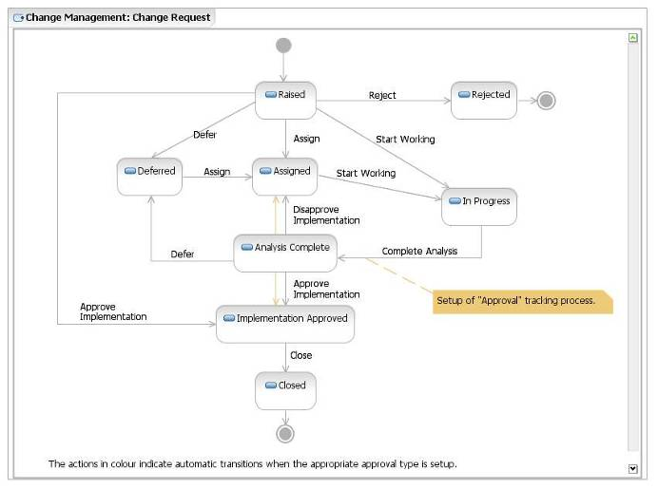
Figure 8: Change Request Workflow

Permissions to execute actions
RTC provides a way to restrict workflow actions to specific “roles”. The following restrictions are implemented:

Action | Permission
Create “Change Request” work item | Anyone, with any of the following roles:  - Analyst  - Architect  - Developer  - Project Manager  - Stakeholder  - Tester  - Team Lead  - Software Release Manager
Delete “Change Request” work item | Once a Change Request work item has been created, it cannot be deleted by anyone.
Modify “Change Request” work item | Anyone, with any of the following roles:  - Analyst  - Architect  - Developer  - Project Manager  - Stakeholder  - Tester  - Team Lead  - Software Release Manager  IMPORTANT: A work item should not be changed once it is in a final state (i.e. Closed, Rejected).
Actions associated to “Change Request” workflow:  - Reject  - Defer  - Assign  - Approve Implementation  - Disapprove Implementation  - Close | Anyone with the Project Manager role.  Note: A change request can be closed when all the associated change orders have been resolved.
Actions associated to “Change Request” workflow:  Remaining actions:  - Start Working  - Complete Analysis | Anyone within the project team with any of the following roles:  - Analyst  - Architect  - Developer  - Project Manager  - Tester  - Team Lead  - Software Release Manager
Figure 9: List of roles authorized to execute actions of change request workflow

States
The following table defines each of these states.
State | Definition
Raised | A change request is Raised if a Submitter has identified and logged it into RTC. No other action has taken place at this state.
Assigned | A change request is Assigned if it is considered as a valid change request and a Resolution Owner has been identified and assigned to work with it.
In Progress | A change request is In Progress if:  + The Resolution Owner has started with the analysis (In Analysis)  + The implementation of the change request is being performed by the Resolution Owner
Analysis Complete | A change request’s analysis is complete when the Resolution Owner has gathered and consolidated the assessments results for all solutions options. The recommended approaches are ready to be validated with identified approvers.
Implementation Approved | A change request is given an Implementation Approved status when the Project Manager has presented the approaches to the identified approvers and the change has been accepted for implementation.
Closed | A change request is Closed when: a) the work required for completing the change has finished, b) it has been implemented successfully, and c) it no longer requires attention.
Deferred | A change request is Deferred if it is out of scope for the current release(s). Change requests in the Deferred state are triaged and considered for future releases.
Rejected | A change request is Rejected if it is considered invalid.  Note: A rejection can occur for many reasons, such as:  - The change request was raised as the result of a user misunderstanding, etc.  - The change request is a duplicate
Figure 10: Description of states existing in change request workflow

Resolution codes
A resolution code completes the status information for a given change request.

The table below shows the available resolution codes for the actions were they are defined.

Action Name | Target State | Resolution Codes | Comments
Start Working | In Progress | In Progress  In Analysis
Approve Implementation | Implementation Approved | In Progress  Waiting
Close | Closed | Implemented
Reject | Rejected | Invalid  Duplicate
Defer | Deferred | Unresolved
Figure 11: List of resolution codes used in change request workflow

Approval tracking processes
RTC provides a way to customize approval tracking processes that team members follow as they work on work items. Depending on the decision taken by each team member participating in the approval cycle for a given work item, the work item can automatically be moved to a new state.

The list of approvers for a particular approval type is defined within the “Approvals” tab.

The table below describes the approval types defined for the “Change Request” workflow.

Approval Type | Decision | Action (Approval Target State) | Comments
Approval | Approved | Approve Implementation (Implementation Approved) | This approval type is used for the change request approval. If a Change Control Board is in placed, approvers from that group can also be included within this approval process.  If the change request is approved, the work item is moved to the “Implementation Approved” state (after ALL the approvers on the list approved the change). If the implementation is rejected by any approver, the work item is moved to the “Assigned” state.  If any approval is still pending, it does nothing.  This approval type is available when the work item is in the “Complete Analysis” state.
Approval | Rejected | Disapprove Implementation (Assigned)
Approval | Pending | None
Figure 12: Description of approval tracking processes related with change request workflow

Required attributes for each state
There is a minimum set of required attributes in order to submit a change request. Depending on which state the work item moves to, the user may need to complete additional required attributes. The table below describes the required attribute for each state.

To move a work item to the state… | The required attributes are…
Raised  (and all states) | Phase detected  Description  Summary  Filed Against  Priority  Important: this set of attributes is called “Default required attributes”.
Assigned | Default required attributes +  Owned By +  Size of Change
Analysis Complete | Default required attributes +  Owned By +  Size of Change
Implementation Approved | Default required attributes +  Owned By +  Size of Change
Closed | Default required attributes +  Owned By +  Size of Change
Rejected | Default required attributes
In Progress | Default required attributes +  Owned By +  Size of Change
Defer | Default required attributes
Figure 13: List of required attributes for each state in change request workflow

Change Order Work Item
Once a change request is approved, the necessary change order(s) are created as children using the “Change Order” work item.

Change Order Form

Presentation layout
The change order information is collected using the “Change Order” work item. In its form, the attributes are organized into different tabs and sections.

The screenshots below show the organization of the attributes across the tabs, using RTC Eclipse client. Note that most of the screenshots presented here are shown when you create the work item the first time so mandatory attributes (the ones with the red asterisk, *) will change based on state.
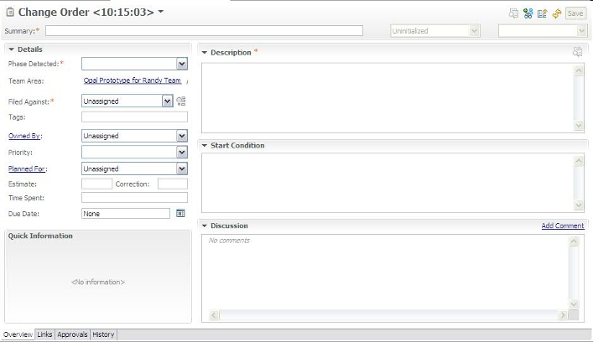
Figure 14: Change Order Work Item Presentation, Overview tab

Screenshots related to “Links”, “Approvals”, “History” and “Time Tracking” tabs are not included as they are provided out of the box in RTC.

Presentation design
The following table shows the field mapping between the OPAL work product (Change Order template) and the customized Change Order work item on RTC.
OPAL field name | RTC implementation
Project Name | Timeline name / Filed Against.  The timeline name in RTC is used to group all project related artifacts together. Additionally, the project name is also defined as a category and is selected in the Filed Against attribute.
Project Manager | Project Manager role.  The Project Manager attribute in Opal is represented by the Project Manager role in RTC and all Project Managers for a project can be viewed by looking at the roles assigned in the team area. When a Project Manager is the active owner of an work item, her/his name appears in the Owner attribute.  RTC provides an ability to view individual attributes and see their respective role.
Project Phase | Phase Detected.  Enumeration.  Values:  - SRS  - Design  - Coding  - Testing  - Installation, Build and Packaging  - Other Occurrences  - Not Assessed (to represent no selected value) –default value-
Project Organizational Unit | Project Area description.  Additional project attributes including work order, organization unit, etc. can be listed in a row format (in case of multiple projects within a project area) within the project area description.
Change Order ID | Id.  Automatically assigned.
Short description | Summary (a.k.a. change order title).
Status | Status
Associated Change Requests | Links.  List of related work items, including change requests
Change Order Description | Description
Approved by | History.  All changes to the work item are tracked on the History tab.
Date approved | History.  All changes to the work item are tracked on the History tab.
Start Condition | Start Condition.  Text attribute.
Target Date | Due Date
Associated Change Order IDs | Links.  List of related work items.
Change Order History  (Date, Comments) | History.  All changes to the work item are tracked on the History tab.
- | Owned By
- | Project Area
- | Team Area
- | Filed Against
- | Creation Date.  Automatically assigned when the work item is saved the first time.
- | Created By.  Automatically assigned when the work item is saved the first time.
- | Tags
- | Priority.  Enumeration.  Values:  - Critical  - High  - Medium  - Low  - Not Assessed (to represent no selected value) -default value-
- | Planned For.  Product Release/Iteration when the risk occurrence is planned for.
- | Estimate plus Correction
- | Time Spent
- | Constraint Type
- | Constraint Date
- | Planned Start Date
- | Planned End Date
- | Resolution Date
- | Resolved By
- | Discussion
- | Resolution
- | Attachments.  List of attachments with additional information.
- | Links.  List of related work items.
- | Approvals.  List of approval cycles with the appropriate exit decisions.
- | History.  History of changes made to the work item.
- | Time Tracking.  Feature to record time for a work item.
Figure 15: Description of attributes, part of change order presentation

The Lifecycle

Workflow
The following state transition diagram represents a change order lifecycle within RTC, from the “Open” state to the final “Closed” state.
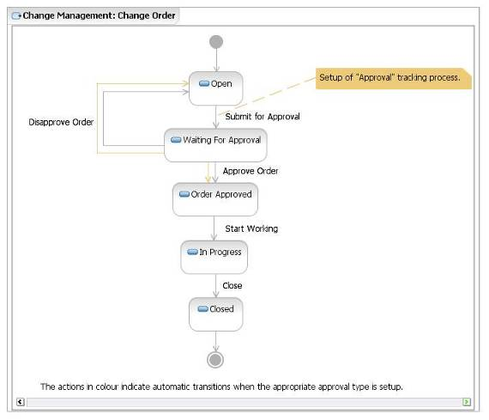
Figure 16: Change Order Workflow

Permissions to execute actions
RTC provides a way to restrict workflow actions to specific “roles”. The following restrictions are implemented:

Action | Permission
Create “Change Order” work item | Anyone within the project team, with any of the following roles:  - Analyst  - Architect  - Developer  - Project Manager  - Tester  - Team Lead  - Software Release Manager
Delete “Change Order” work item | Once a Change Order work item has been created it cannot be deleted by anybody.
Modify “Change Order” work item | Anyone, with any of the following roles:  - Analyst  - Architect  - Developer  - Project Manager  - Stakeholder  - Tester  - Team Lead  - Software Release Manager  IMPORTANT: A work item should not be changed once it is in a final state (i.e. Closed).
Actions associated to “Change Order” workflow:  - Approve Order  - Disapprove Order | Anyone with the Project Manager role.
Actions associated to “Change Order” workflow:  Remaining actions:  - Submit for Approval  - Start Working  - Close | Anyone within the project team, with any of the following roles:  - Analyst  - Architect  - Developer  - Project Manager  - Tester  - Team Lead  - Software Release Manager
Figure 17: List of roles authorized to execute actions of change order workflow

States
The following table defines each of these states.
State | Definition
Open | A change order is Open if a Submitter has logged it into RTC. No other action has taken place at this state.
Waiting for Approval | A change order is in Waiting for Approval state when the Resolution Owner has gathered and consolidated the change information and needs the Project Manager’s decision to continue, or to review the analysis.
Order Approved | A change order is given an Order Approved status when the Project Manager has accepted it for implementation.
In Progress | A change order is In Progress if:  + The Resolution Owner has started with the implementation  + The Resolution Owner is waiting for the start condition
Closed | A change order is Closed when the work required for implementing it has finished successfully and it no longer requires attention.
Figure 18: Description of states existing in change order workflow

Resolution codes
A resolution code completes the status information for a given change order.

The table below shows the available resolution codes for the actions were they are defined.

Action Name | Target State | Resolution Codes | Comments
Approve Order | Order Approved | Waiting For Start Condition
Start Working | In Progress | Ongoing  Waiting for Start Condition
Close | Closed | Implemented
Figure 19: List of resolution codes used in change order workflow

Approval tracking processes
RTC provides a way to customize approval tracking processes that team members follow as they work on work items. Depending on the decision taken by each team member participating in the approval cycle for a given work item, the work item can be moved automatically to a new state..

The list of approvers for a particular approval type is defined within the “Approvals” tab.

The table below describes the approval types defined for the “Change Order” workflow.

Approval Type | Decision | Action (Approval Target State) | Comments
Approval | Approved | Approve Order (Order Approved) | This approval type is used for the change order approval.  If the change order is approved, the work item is moved to the “Order Approved” state (after ALL the approvers on the list approved the order). If the order is rejected by any approver, the work item is moved to the “Open” state.  If any approval is still pending, it does nothing.  This approval type is available when the work item is in the “Submit For Approval” state.
Approval | Rejected | Disapprove Order (Open)
Approval | Pending | None
Figure 20: Description of approval tracking processes related with change order workflow

Required attributes for each state
There is a minimum set of required attributes in order to submit a change order. Depending on which state the work item moves to, the user may need to complete additional required attributes. The table below describes the required attribute for each state.

To move a work item to the state… | The required attributes are…
Open  (and all states) | Phase detected  Description  Summary  Filed Against  Important: This set of attributes is called “Default required attributes”.
Waiting for Approval | Default required attributes
Order Approved | Default required attributes +  Owned By
In Progress | Default required attributes +  Owned By
Closed | Default required attributes +  Owned By
Figure 21: List of required attributes for each state in change order workflow

Time tracking for work items
You can use the time tracking feature to record time for a work item.
In the work item editor, you can enter the number of hours per day that you spend on a work item. You can associate each time entry with one or more time codes. Time codes are defined categories against which you can record time for different activities of a task. For example, you might organize your regular work into these categories: development, review, and testing. If you have sufficient security access, you can add or delete time codes in the project area editor.
The Quick Information section displays the weeks for which time is entered for a work item. The total number of hours that are entered for a week and the total number of hours that are entered for a work item are also displayed in the Quick Information section. To access the time entries, click a specific week.
Remember: To enter time for a work item, you must be the owner of that work item. For example, in a work item that you own, you enter time entries. Later, the ownership of the work item is assigned to another person. You can still edit your time entries, but cannot add new entries to the week or new rows on the Time Tracking tab. If multiple owners enter time in a work item, their names are displayed against their entries.
You can control the synchronization of the time entries on the Time Tracking tab with the value in the Time Spent attribute. By default, when you enter time for a work item on the Time Tracking tab, that value is reflected in the Time Spent attribute. If you disable the synchronization option, the values in the Time Tracking tab and the Time Spent attribute become independent. If the option to synchronize time is enabled in the middle of a project, the time spent values are overwritten by the time tracking values.
This new feature has been adopted since RTC 3.0 and it is an out of the box feature that comes with RTC. For additional guidance, refer to RTC online help.

Queries
One kind of action that may be performed using RTC, is searching the changes’ database (changes’ log) using public or personal queries. “Shared queries” are available to the whole team while “Personal queries” are private and available only by the creator. As you write your own queries, you can search changes with specific criteria and create your own layout.
The predefined, shared query provided as part of the RTC process template is:
All Change Requests
It is located within the “Shared Queries” folder organized into two additional folders: the “Predefined” and the “Individually Shared” as shown below:

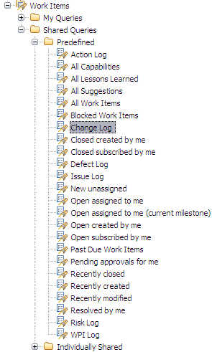
Figure 22: Change Predefined, Shared Queries

For more details on this query, please refer to the sections below.

All Change Requests
Description: A list of all of the change requests regardless of status.

The “All Change Requests” query helps practitioners with tracking and managing outstanding changes to closure. This query can be run on demand for outstanding changes throughout the project’s lifecycle, to ensure the resolution owners are taking prompt and appropriate action to bring the changes to closure.

The base query planned for the solution displays the following columns:

- Id
- Summary
- Created By
- Priority
- Creation Date
- Owned By
- Due Date
- Status
- Resolution
- Modified Date

If necessary, the practitioners can create new queries based on this base “log” to show additional columns or to change the searching criteria.

Plan Item
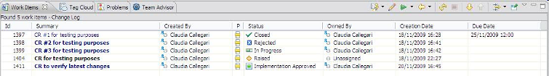
Figure 23: Change Log query results

CAPABILITY: Tool implementation
When the need of a new feature is identified, it is documented using the “Plan Item” work item.

This work item contains the definition, written in everyday language, of new functionality to be built in an iteration (or development cycle). It is used to drive the plan item’s workload and to estimate its effort. This definition is meant to help the reader to understand what the solution should accomplish.

A “Plan Item” work item could be decomposed into a set of independent and/or child work items.
These plan items can also be linked to formal requirements in Rational Requirements Composer or used independently if traceability to formal requirements is not necessary.

Task: Tool implementation
A “Task” work item allows users to define and track work. For example, to resolve a high severity defect, a set of child task work items may be defined and tracked to closure. RTC tasks include a workflow to track status and a time tracking tab to record the hours spent on that work item.

End of document

