
Global Services

Defect Management (DRM support) in Rational Team Concert in support of Defect Reduction Method (DRM)

Document Control Page
About this document
Produced using Microsoft Word for Windows Version 2003
Doc. Owner: GBS Process, Methods and Tools team

Revision History
Version | Date | Change Description
1.0 | April 2010 | Initial version.
1.1 | October 2010 | Changes to align tool mentor with RTC configuration “IBM Opal 1.2”.
2.0 | Sep 2011 | Changes to align tool mentor with RTC configuration “IBM Opal 2.2”.

Trademarks
IBM, the IBM logo, Rational and the following product names are trademarks of IBM Corporation in the United States, other countries, or both:
IBM Rational Team Concert (RTC)
IBM Rational Quality Manager (RQM)
IBM Rational Requirement Composer (RRC)

Microsoft, Windows, Windows NT, and the Windows logo are trademarks of Microsoft Corporation in the United States, other countries, or both.
Contents

Global Services 1
Defect Management in Rational Team Concert in support of Defect Reduction Method (DRM) 1
Document Control Page 2
About this document 2
Revision History 2
Trademarks 2
Contents 3
1 Purpose 4
2 Scope 4
3 RTC usage 4
3.1 RTC generic usage 4
3.2 Accessing help on RTC Web client 4
3.3 Accessing help on RTC Eclipse client 5
4 Security 5
5 Defect Management in support of DRM: Tool implementation of the OPAL Procedure 5
5.1 Process roles 5
5.2 Usage Model 7
5.3 Defect (DRM) Work Item 7
5.3.1 Defect (DRM) Form 7
5.3.1.1 Presentation layout 7
5.3.1.2 Presentation design 9
5.3.2 The Lifecycle 16
5.3.2.1 Workflow 16
5.3.2.2 Permissions to execute actions 17
5.3.2.3 States 19
5.3.2.4 Resolution codes 19
5.3.2.5 Approval tracking processes 20
5.3.2.6 Required attributes for each state 20
5.3.2.7 Time tracking for work items 22
5.4 Queries 22
5.4.1 All Defects (DRM) 22
6 Task: Tool implementation 23

Purpose
This document provides guidance on the defect management changes within the IBM GBS Standard Delivery Solution (OPAL) configuration of IBM Rational Team Concert (RTC hereafter) in support of Defect Reduction Method (DRM). It also provides project direction on leveraging RTC in support of DRM.
This document does not replace DRM. To fully understand this document, it should be read in conjunction with DRM content.
Please be aware that DRM may contain additional steps that take place outside of RTC and are not duplicated here.

Scope
The guidance assumes a basic understanding of how to use RTC and is not intended to be training material.
This tool mentor references the GBS Standard Delivery Solution (OPAL) RTC configuration release 2.2.
The GBS Standard Delivery Solution (OPAL) RTC configuration has a defect work item type and a defect (DRM) work item type. This document covers only the specific configurations in support of DRM. For any defect management features not mentioned, please refer to the non-DRM defect management tool mentor.

RTC usage

RTC generic usage
RTC may be accessed either directly via the Eclipse Client or via the Web interface. For performance reasons, the recommended interface, especially for hosted environments, is the RTC web client.

Accessing help on RTC Web client
In order to access the RTC help, hover over the Help button (the one with the question mark icon), and click the “Help Contents” option.
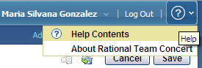
Figure 1: Help on RTC web client

Accessing help on RTC Eclipse client
In RTC Eclipse client, it is necessary to click the Help menu in order to see its different options.
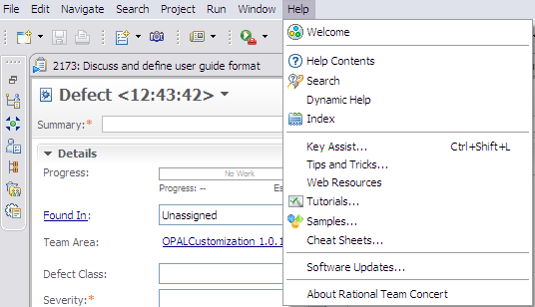
Figure 2: Help on RTC Eclipse client

Security
The solution has a security model implemented based on projects (a.k.a. “project areas”) and process roles.
For more details on how to configure security access and project roles, please refer to the appropriate documentation or deployment lead.

Defect Management in support of DRM: Tool implementation of the OPAL Procedure

Process roles
This solution allows the Administrator to allocate one or more RTC roles to members of your project. Each role selection may provide or deny access to specific RTC features.
The following graphic provides a list of available roles within this solution.
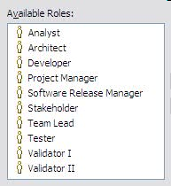
Figure 3: Predefined RTC Process Roles

The following table describes the mapping between the roles defined by the OPAL procedure and the ones implemented within the solution.
Role defined in the OPAL procedure | Roles implemented within the solution
Originator | This solution does not require an explicit role to map to the OPAL role. Any RTC role in the figure above will suffice.
Project Manager | Project Manager
Resolution Owner | This solution does not require an explicit role to map to the OPAL role. Any RTC role in the figure above will suffice.
** DRM only **  Validator | ** DRM only **  Validator I  This role performs first level validation of DRM classifications.  FYI, validators are typically expert classifiers, who receive additional training, including a detailed review of error prone areas, and an understanding of five techniques for verifying the accuracy of the classification.
** DRM only **  QA Validator | ** DRM only **  Validator II  This role performs second level validation of DRM classifications; typically spot checks or reviews based on specific patterns or concerns.  FYI, a QA Validator is an experienced IT professional with demonstrated proficiency in first-level DRM validation. The QA Validator acts as a mentor to resources in the Validator I role and examines the classified data in aggregate and over time, looking for trends or distributions that deviate from expected distributions, based on a variety of factors.
Figure 4: Process Roles mapping

Usage Model
When a new defect is identified, a “Defect (DRM)” work item is created in RTC. After completing the required attributes, the defect is saved, and it is placed in “Raised” state. From this point, the workflow for a defect (DRM) work item is identical to the standard OPAL RTC defect management workflow, until the defect reaches the “Rejected” or “Closed” states, where DRM adds a couple of additional states to include a series of validations of DRM classifications. In order to avoid duplications, we will continue the usage model explanation from that point. If you need further details, please review the non-DRM defect management tool mentor.

Once a defect has been “Rejected” or “Closed”, the “Validator I” role proceeds to validate the DRM classifications performed by the project team during the defect resolution. When the validation process is done, the person performing the “Validator I” role moves the defect to the “Validation Complete” state. At that point, the person performing the “Validator II” role reviews the classification and if everything is fine, s/he moves the defect to the “QA Validation Complete” state, which is the final state within this workflow.

Defect (DRM) Work Item

Defect (DRM) Form

Presentation layout
The defect information is collected using the “Defect (DRM)” work item. In this form, the attributes are organized into different tabs and sections, for better usability.

The screenshots below show the organization of the attributes across the work item tabs using RTC Eclipse client. Note that most of the screenshots presented here are shown when you create the work item the first time so mandatory attributes (marked with a red asterisk, *) will change based on state.
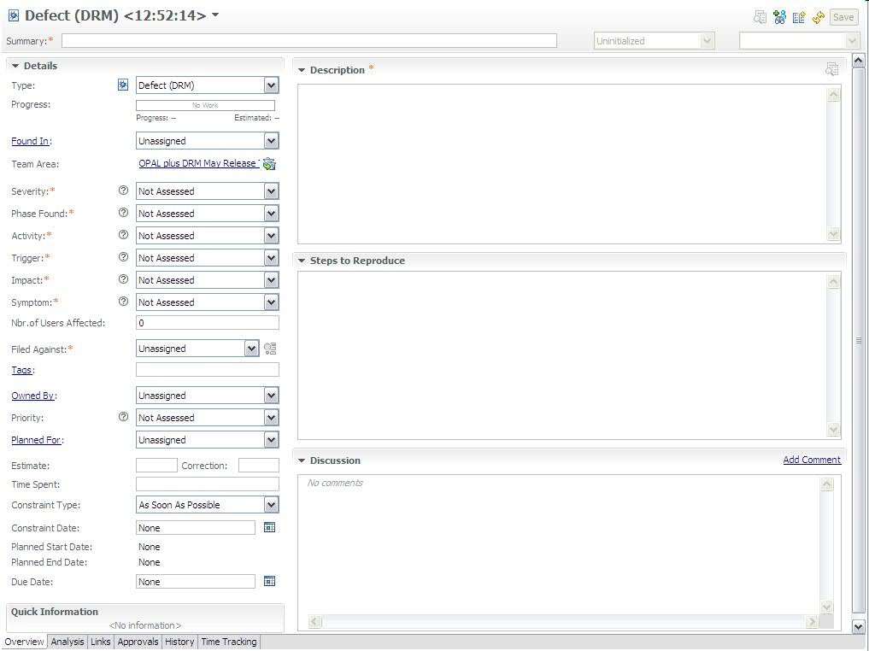
Figure 5: Defect (DRM) Work Item Presentation, Overview tab

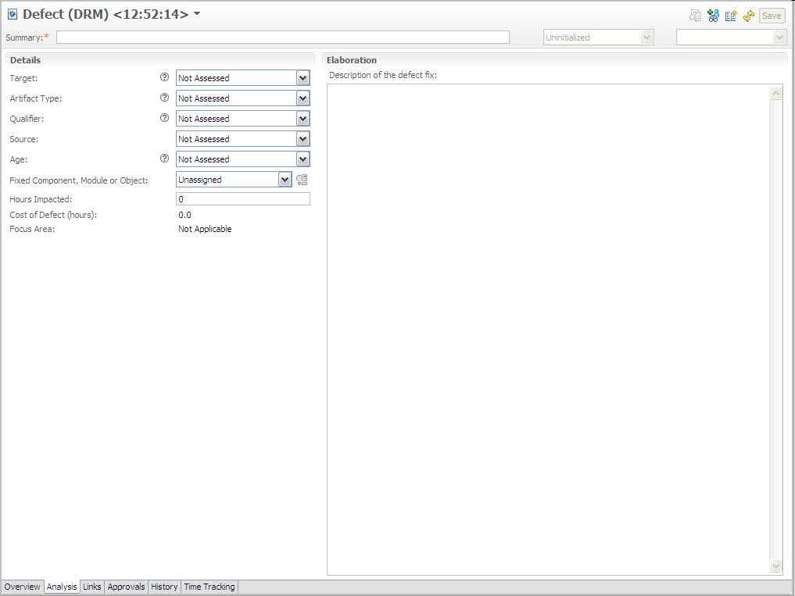
Figure 6: Defect (DRM) Work Item Presentation, Analysis tab

Screenshots related to “Links”, “Approvals”, “History” and “Time Tracking” tabs are not included as they are provided out of the box by RTC.

Presentation design
The following table shows the field mapping between the OPAL work product (Defect Log DRM template) and the customized Defect (DRM) work item in RTC.
DRM field name | RTC implementation
Project / Program Name | Timeline name / Filed Against.  The timeline name in RTC is used to group all project related artifacts together. Additionally, the project name is also defined as a category and is selected in the Filed Against attribute.
Project ID | Project Area name and description.
Sub-Project / Application / Component Name | This is set via categories.  Background: You can create a Project Name category and have sub categories for the application or components.
Application / Component Version Number | Found In
Defect ID | Id.  Note: The ID is automatically assigned in RTC.
- | Summary (a.k.a. defect title)
Defect Description | Description plus Steps to reproduce
Date Raised | Creation Date
Severity | Severity.  Enumeration.  Values:  1-Critical  2-High  3-Medium  4-Low  Not Assessed (to represent no selected value) –default value-
Originator Name | Created By
Activity | Activity.  Enumeration.  Values:  Requirements Review  Design Review  Code Review  White Box / Unit Test  Black Box / Functional Testing  System Testing  Performance Testing  Information Development Review  Graphical User Interface Review  Not Assessed (to represent no selected value) –default value-
Trigger | Trigger.  Enumeration.  Default Value: Not Assessed (to represent no selected value).  Values: the values of this dropdown list depend on the option selected on the “Activity” attribute, with the logic described below.  If Activity = Requirements Review OR Design Review OR Code Review Then  Design Conformance  Logic Flow  Backward Compatibility  Lateral Compatibility  Concurrency  Internal Document  Language Dependency  Side Effects  Rare Situations  If Activity = White Box / Unit Test Then  Simple Path  Complex Path  If Activity = Black Box / Functional Testing Then  Coverage  Variation  Sequencing  Iteraction  If Activity = System Testing Then  Workload / Stress  Recovery / Exception  Start Up / Restart  Hardware Configuration  Software Configuration  If Activity = Performance Testing Then  Coverage  Variation  Iteraction  Workload / Stress  If Activity = Information Development Review Then  Accuracy  Clarity  Completeness  Consistency  Organization  Retrievability  Style  Task Orientation  Graphic Design Aesthetics  If Activity = Graphical User Interface Review Then  Design Conformance  Icon / Widget Appearance  Screen Text / Characters  Input Devices  Navigation  Widget / GUI Behavior
Impact | Impact.  Enumeration.  Values:  Accessibility  Usability  Installability  Security  Data Integrity  Performance  Scalability  Interoperability  Maintenance  Testability  Serviceability  Migration  Documentation  Standards  Reliability  Requirements  Capability  Not Assessed (to represent no selected value) –default value-
Phase Found | Phase Found.  Enumeration.  Values:  High Level Requirement Review  High Level Design Review  Detailed Requirement Review  Detailed Design Review  Code Inspection  Unit Test  System Test  System Integration Test  Performance Test  User Acceptance Test  Not Assessed (to represent no selected value) –default value-
Originator Approval | Approvals.  RTC approvals feature leveraged for this.
Disposition | Status + Resolution Code
Status | Status
Resolution Owner | Owned By
Priority | Priority.  Enumeration.  Values:  Critical  High  Medium  Low  Not Assessed (to represent no selected value) –default value-
Date Resolved | Resolution Date
Target | Target.  Enumeration.  Values:  Requirements / Design / Code  Build / Package  National Language Support  User Documentation  Data  Environment  Not Assessed (to represent no selected value) –default value-
Artifact Type | Artifact Type.  Enumeration.  Default Value: Not Assessed (to represent no selected value).  Values: the values of this dropdown list depend on the option selected on the “Target” attribute, with the logic described below.  If Target = Requirements / Design / Code Then  Assignment / Initialization  Checking  Algorithm / Method  Function / Class / Object  Timing / Serialization  Interface / O-O Messages  Relationship  If Target = Build / Package Then  Process Conformance  Code Integration  Maintenance / Fix Dependencies  Shipped Files  Packaging Scripts  Install / Upgrade Dependencies  Media  If Target = National Language Support Then  Translation  Character Handling  User Interface  Language Expectation  Enablement  If Target = User Documentation Then  Editorial  Technical  Navigational  If Target = Data Then  Format  Master Data Configuration  Migration  Validity  Corruption  If Target = Environment Then  Configuration / Definition  System / Component Completeness  Connectivity  Security / Permissions  Capacity  Reboot / Restart / Recycle  Clear / Refresh  Maintenance  Server Down
Qualifier | Qualifier.  Enumeration.  Default Value: Not Assessed (to represent no selected value).  Values: the values of this dropdown list depend on the options selected on the “Target” and “Artifact Type” attributes, with the logic described below.  If (Target = Requirements / Design / Code OR Build / Package OR National Language Support OR User Documentation ) AND Type = * Then  Missing  Incorrect  Extraneous  If Target = Data AND Type = Format Then  Incorrect  Req. Confusing / Misleading  If Target = Data AND Type = Master Data Configuration Then  Missing  Incorrect  If Target = Data AND Type = Migration Then  Incorrect Mapping  Missing Mapping  If Target = Data AND Type = Validity Then  Incorrect  Expired  Withdrawn  If Target = Data AND Type = Corruption Then  Source Unknown  Source Known  If Target = Environment AND Type = Configuration / Definition Then  Missing Elements  Incorrect Elements  If Target = Environment AND Type = System / Component Completeness Then  Present - Incorrectly Enabled  Present - Not Enabled  Missing  If Target = Environment AND ( Type = Connectivity OR Security / Permissions  OR Capacity) Then  Missing  Incorrectly Defined  If Target = Environment AND ( Type = Reboot / Restart / Recycle OR Clear / Refresh OR Server Down) Then  Scheduled  Unscheduled  If Target = Environment AND Type = Maintenance Then  Not Applicable
Source | Source.  Enumeration.  Default Value: Not Assessed (to represent no selected value).  Values: the values of this dropdown list depend on the option selected on the “Target” attribute, with the logic described below.  If Target = Requirements / Design / Code OR Build / Package OR National Language Support OR User Documentation Then  Developed In-House  Reused from Library  Outsourced  Ported  If Target = Data Then  Client  Component Owner  System Owner  Test  If Target = Environment Then  Not Applicable
Age | Age.  Enumeration.  Default Value: Not Assessed (to represent no selected value).  Values: the values of this dropdown list depend on the option selected on the “Target” attribute, with the logic described below.  If Target = Requirements / Design / Code OR Build / Package OR National Language Support OR User Documentation Then  Base  New  Rewritten  Refixed  If Target = Data OR Environment Then  Not Applicable
Validation Flag | Implemented as a special state within the defect workflow.
QA Validation Flag | Implemented as a special state within the defect workflow.
Audit Trail for Classification | History.  History of changes made to the work item.
Failing Component, Module or Object | List of configured RTC categories.
Fixed Component, Module or Object | List of configured RTC categories.
Description of Defect Fix | Text attribute.
Estimated Effort (PH) | Estimated Effort + Correction
Actual Effort (PH) | Time Spent
Total Days | Not implemented. Can be calculated in a report with the collected data.  Background: This is the duration the defect was open, it is a calculated difference between defect closed date and defect raised date.
Symptom | Symptom.  Enumeration.  Values:  Crash / Flag / Abend  Hang / Wait  Error  Incorrect Out  Not Assessed (to represent no selection) –default value-
Number of users affected by the defect | Nbr.of users affected.  Numeric attribute; the value should be >= 0.
Productivity impact of defect | Hours impacted.  Numeric attribute; the value should be >= 0; decimals up to tenths are allowed (e.g. 1.5 but not 1.51).
Cost of defect | Calculated attribute.  Nbr.of users affected * Hours impacted.
Action Log | Related work items (Links).
Remarks | Discussion.  It maintains the history of all discussions related to the specific work item.
- | Progress.  Progress bar, based on estimated effort and time spent.
- | Project Area / Team Area
- | Filed Against
- | Tags.  List of keywords for quick search.
- | Planned For.  Product Release/Iteration when the defect is planned to be fixed.
- | Constraint Type
- | Constraint Date
- | Planned Start Date
- | Planned End Date
- | Due Date
- | Resolved By
- | Attachments
- | Links
- | Time Tracking.  Feature to record time for a work item for each day.
Figure 7: Description of attributes, part of defect presentation

The Lifecycle

Workflow
The following state transition diagram represents a defect lifecycle within RTC, with a start state of “Raised” and a final state of “QA Validation Complete”.
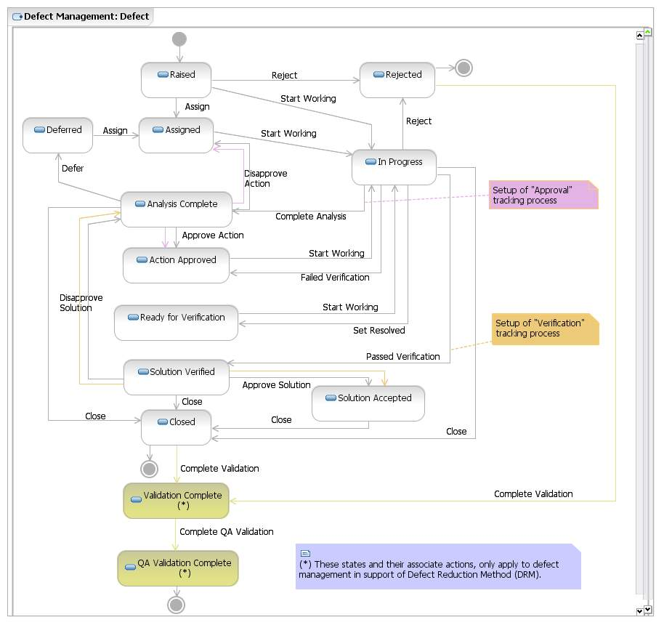
Figure 8: Defect Workflow

Permissions to execute actions
RTC provides a way to restrict workflow actions to specific “roles”. The following restrictions are implemented:

Action | Permission
Create “Defect (DRM)” work item | Anyone, this means users with any of the following roles:  - Analyst  - Architect  - Developer  - Project Manager  - Stakeholder  - Tester  - Team Lead  - Software Release Manager
Delete “Defect (DRM)” work item | Once a Defect work item has been created it cannot be deleted by anybody.
Modify “Defect (DRM)” work item | Anyone, this means users with any of the following roles:  - Analyst  - Architect  - Developer  - Project Manager  - Stakeholder  - Tester  - Team Lead  - Software Release Manager  (The person specified in the Owner attribute will be responsible for implementing specific actions).  IMPORTANT: A work item should not be changed once it is in a final state (i.e. QA Validation Complete).
Actions associated to “Defect (DRM)” workflow:  Defer  Approve Action  Disapprove Solution  Failed Verification  Assign  Start Working  Approve Solution  Set Resolved  Close  Complete Analysis  Disapprove Action  Reject  Passed Verification | These actions are limited to the following roles:  - Developer  - Project Manager  - Team Lead  (The person specified in the Owner attribute will be responsible for implementing specific actions.)
Actions associated to “Defect (DRM)” workflow:  Failed Verification  Start Working  Approve Solution  Set Resolved  Close  Passed Verification | These actions are limited to the following roles:  - Tester  (The person specified in the Owner attribute will be responsible for implementing specific actions.)
Figure 9: List of roles authorized to execute actions of the Defect workflow

States
The following table defines the additional states included for a Defect workflow in support of DRM. All the other states are not included here to avoid duplication of information. Please refer to the standard Defect Management Tool Mentor for further details.
State | Definition
Validation Complete | A defect is in the “Validation Complete” state, if the “Validator I” role has completed the first level validation of DRM classifications.
QA Validation Complete | A defect is in the “QA Validation Complete” state, if the “Validator II” role has completed the second level validation of DRM classifications. This is the final state.
Figure 10: Description of states existing in the Defect workflow

Resolution codes
A resolution code clarifies the status information for a given defect. For example, if a defect is rejected, the resolution code provides the reason of the rejection.

The table below shows the available resolution codes for the actions where they are defined. This table only provides the changes and/or additions done to the Defect workflow in support of DRM. All the other resolution codes associated to the remaining actions are not included here to avoid duplication of information. Please refer to the standard Defect Management Tool Mentor for further details.
Action Name | Target State | Resolution Codes | Comments
Reject | Rejected | Cancelled  Cannot Recreate  Duplicate  New Requirement  Out of Scope  Test Error  Won’t Fix  Working As Designed
Complete Validation | Validation Complete | Fixed  Cancelled  Cannot Recreate  Duplicate  New Requirement  Out of Scope  Test Error  Won’t Fix  Working As Designed
Complete QA Validation | QA Validation Complete | Fixed  Cancelled  Cannot Recreate  Duplicate  New Requirement  Out of Scope  Test Error  Won’t Fix  Working As Designed
Figure 11: List of resolution codes used in defect workflow

Approval tracking processes
The approval tracking processes for defect management in support of DRM are the same as the ones configured for the standard defect management. Please refer to the standard Defect Management Tool Mentor for further details.

Required attributes for each state
There is a minimum set of required attributes in order to submit a defect; and depending on which state the defect moves to, the user may need to complete additional required attributes. The table below describes the required attributes for each state.

To move a work item to the state… | The required attributes are…
Raised  (and all states) | Activity  Description  Filed Against  Impact  Phase Found  Severity  Steps to Reproduce  Summary  Symptom  Important: this set of attributes is called “Default required attributes”.
Assigned | Default required attributes +  Owned By  Priority
In Progress | Default required attributes +  Owned By  Priority
Analysis Complete | Default required attributes +  Owned By  Priority
Action Approved | Default required attributes +  Owned By  Priority
Ready for Verification | Default required attributes +  Owned By  Priority  Age  Artifact Type  Description of the defect fix  Fixed Component/Module or Object  Hours Impacted  Qualifier  Source  Target
Solution Verified | Default required attributes +  Owned By  Priority  Age  Artifact Type  Description of the defect fix  Fixed Component/Module or Object  Hours Impacted  Qualifier  Source  Target
Solution Accepted | Default required attributes +  Owned By  Priority  Age  Artifact Type  Description of the defect fix  Fixed Component/Module or Object  Hours Impacted  Qualifier  Source  Target
Closed | Default required attributes +  Age  Artifact Type  Description of the defect fix  Fixed Component/Module or Object  Hours Impacted  Qualifier  Source  Target
Deferred | Default required attributes
Rejected | Default required attributes +  Reason
Validation Complete | Default required attributes +  IF selected resolution code = “Won’t Fix” Then  Reason  IF selected resolution code = “Fixed” Then  Age  Artifact Type  Description of the defect fix  Fixed Component/Module or Object  Hours Impacted  Qualifier  Source  Target
QA Validation Complete | Default required attributes +  IF selected resolution code = “Won’t Fix” Then  Reason  IF selected resolution code = “Fixed” Then  Age  Artifact Type  Description of the defect fix  Fixed Component/Module or Object  Hours Impacted  Qualifier  Source  Target
Figure 12: List of required attributes for each state in the Defect workflow

Time tracking for work items
You can use the time tracking feature to record time for a work item. Please refer to the standard Defect Management Tool Mentor for further details.

Queries
One kind of action, that may be performed using RTC, is searching the defects’ database (defects’ log) using public or personal queries. “Shared queries”- are available to the whole team while the “Personal queries” are private and available only to the creator. When you write your own private queries, you can search defects with specific criteria and create your own query layout.
The predefined, shared query provided as part of the RTC process template is:
All Defects (DRM)
For more details on this query, please refer to the sections below.

All Defects (DRM)
Description: A list of all the defects regardless of status.

The “All Defects (DRM)” query helps practitioners with tracking and managing outstanding defects to closure. This query can be run on demand for outstanding defects throughout the project’s lifecycle, to ensure the resolution owners are taking prompt and appropriate action to bring the defects to closure.

The base query planned for the solution displays the following columns:

Id
Creation Date
Created by
Summary
Severity
Priority
Phase Found
Activity
Trigger
Impact
Symptom
Nbr.of Users Affected
Filed Against
Target
Artifact Type
Qualifier
Source
Age
Fixed Component, Module or Object
Hours Impacted
Cost of Defect
Status
Resolution
Owned By
Estimate
Corrected Estimate
Time Spent
Due Date
Resolution Date

If necessary, the practitioners can create new queries based on this base “log” to show additional columns or to change the searching criteria.

Task: Tool implementation
A “Task” work item allows users to define and track work. For example, to resolve a high severity defect, a set of child task work items may be defined and tracked to closure. RTC tasks include a workflow to track status and a time tracking tab to record the hours spent on that work item.

End of document

