
Global Services

Defect Management in Rational Team Concert

Document Control Page
About this document
Produced using Microsoft Word for Windows Version 2003
Doc. Owner: GBS Process, Methods and Tools team

Revision History
Version | Date | Change Description
1.0 | April 2010 | Initial version.
1.1 | October 2010 | Changes to align tool mentor with RTC configuration “IBM Opal 1.2”.
2.0 | Sep 2011 | Changes to align tool mentor with RTC configuration “IBM Opal 2.2”.

Trademarks
IBM, the IBM logo, Rational and the following product names are trademarks of IBM Corporation in the United States, other countries, or both:
IBM Rational Team Concert (RTC)
IBM Rational Quality Manager (RQM)
IBM Rational Requirement Composer (RRC)

Microsoft, Windows, Windows NT, and the Windows logo are trademarks of Microsoft Corporation in the United States, other countries, or both.
Contents

Global Services 1
Defect Management in Rational Team Concert 1
Document Control Page 2
About this document 2
Revision History 2
Trademarks 2
Contents 3
1 Purpose 4
2 Scope 4
3 RTC usage 4
3.1 RTC generic usage 4
3.2 Accessing help on RTC Web client 4
3.3 Accessing help on RTC Eclipse client 4
4 Security 5
5 Defect Management: Tool implementation of the OPAL Procedure 5
5.1 Process roles 5
5.2 Usage Model 6
5.3 Defect Work Item 7
5.3.1 Defect Form 7
5.3.1.1 Presentation layout 7
5.3.1.2 Presentation design 9
5.3.2 The Lifecycle 15
5.3.2.1 Workflow 15
5.3.2.2 Permissions to execute actions 15
5.3.2.3 States 17
5.3.2.4 Shortcuts 18
5.3.2.5 Resolution codes 18
5.3.2.6 Approval tracking processes 19
5.3.2.7 Required attributes for each state 20
5.3.2.8 Time tracking for work items 21
5.4 Queries 22
5.4.1 All Defects 23
6 CAPABILITY: Tool implementation 24

Purpose
This document provides guidance on changes within the IBM GBS Standard Delivery Solution (OPAL) configuration of IBM Rational Team Concert (RTC hereafter) in support of OPAL defect management. It also provides project direction on leveraging RTC in support of defect management.
This document does not replace nor cover all of the steps defined in the OPAL defect management procedure. To fully understand this document, it should be read in conjunction with the procedure. Please be aware that this OPAL procedure may contain additional steps that take place outside of RTC and are not duplicated here.

Scope
The guidance assumes a basic understanding of how to use RTC and is not intended to be training material.
This tool mentor references the GBS Standard Delivery Solution (OPAL) RTC configuration release 2.2.
This configuration supports the OPAL defect management procedure as part of OPAL release 15.3.
This tool mentor does not cover specific RTC support for Defect Reduction Method (DRM). For more information, please refer to the tool mentor for defect management in support of DRM.

RTC usage

RTC generic usage
RTC may be accessed either directly via the Eclipse Client or via the Web interface. For performance reasons, the recommended interface, especially for hosted environments, is the RTC web client.

Accessing help on RTC Web client
In order to access the RTC help, hover over the Help button (the one with the question mark icon), and click the “Help Contents” option.
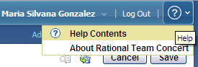
Figure 1: Help on RTC web client

Accessing help on RTC Eclipse client
In RTC Eclipse client, it is necessary to click the Help menu in order to see its different options.
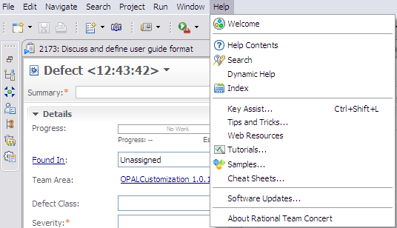
Figure 2: Help on RTC Eclipse client

Security
The solution has a security model implemented based on projects (a.k.a. “project areas”) and process roles.
For more details on how to configure security access and project roles, please refer to the appropriate documentation or deployment lead.

Defect Management: Tool implementation of the OPAL Procedure

Process roles
This solution allows the Administrator to allocate one or more RTC roles to members of your project. Each role selection may provide or deny access to specific RTC features.
The following graphic provides a list of available roles within this solution.
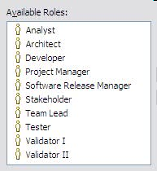
Figure 3: Predefined RTC Process Roles

The following table describes the mapping between the roles defined by the OPAL procedure and the ones implemented within the solution.
Role defined in the OPAL procedure | Roles implemented within the solution
Originator | This solution does not require an explicit role to map to the OPAL role. Any RTC role in the figure above will suffice.
Project Manager | Project Manager
Resolution Owner | This solution does not require an explicit role to map to the OPAL role. Any RTC role in the figure above will suffice.
** DRM only **  Validator | ** DRM only **  Validator I  This role performs first level validation of DRM classifications.
** DRM only **  QA Validator | ** DRM only **  Validator II  This role performs second level validation of DRM classifications; typically spot checks or reviews based on specific patterns or concerns.
Figure 4: Process Roles mapping

Usage Model
When a new defect is identified, a Defect work item is created in RTC. After completing the required attributes, the defect is saved, and it is placed in “Raised” state.

The person responsible for managing defects to closure (usually the Project Manager), validates the defect. If it is invalid, duplicate, cannot be reproduced, or it was introduced as a result of a risk occurrence, change or issue, then the defect is “Rejected” with the appropriate resolution code. If the defect is valid, but the project decides it will not be fixed, the defect is then rejected with a “won’t fix” resolution code. Otherwise, if the defect is valid and it is initially planned to be fixed, it is “Assigned” a resolution owner for further analysis.

When the resolution owner starts analyzing the defect, s/he moves the defect into the “In Progress” state. During the analysis, the resolution owner can realize that the defect is invalid and reject the defect. If the defect is valid, s/he provides the analysis, the estimations, and any actions to fix the defect. The resolution owner then moves the defect to the “Analysis Complete” state.
When the analysis is complete, the resolution owner can: a) approve the action to fix the defect, b) disapprove the action to fix the defect and require further analysis, c) defer the fix with an appropriate resolution code indicating the reason of deferring.

If the analysis is approved, then the defect moves to an “Action Approved” state, and the resolution owner is authorized to start working with the solution. When s/he starts working, the defect is moved to an “In Progress” state. Once all the actions to fix the defect have been resolved, the resolution owner set the defect as resolved, moving it to the “Ready for Verification” state.

At that point in time, when the verification starts, the defect moves to the “In Progress” state again. If it passes the verification, the defect moves to the “Solution Verified” state. Otherwise, it moves to an “Action Approved” state again, requiring addition work for the resolution owner.
Once a fix has been verified, the project may require the defect originator’s approval. In that case, an approval process is defined for the specific defect, involving the appropriate stakeholders. When all the approvals are collected, the defect is automatically moved to the “Solution Accepted” state, and will be ready to be “Closed”. If the approval process fails, the defect goes back to the “Analysis Complete” state.

Defect Work Item

Defect Form

Presentation layout
The defect information is collected using the “Defect” work item. In this form, the attributes are organized into different tabs and sections, for better usability.

The screenshots below show the organization of the attributes across the tabs, using RTC Eclipse client. Note that most of the screenshots presented here are shown when you create the work item the first time so mandatory attributes (the ones with the red asterisk, *) will change based on state.
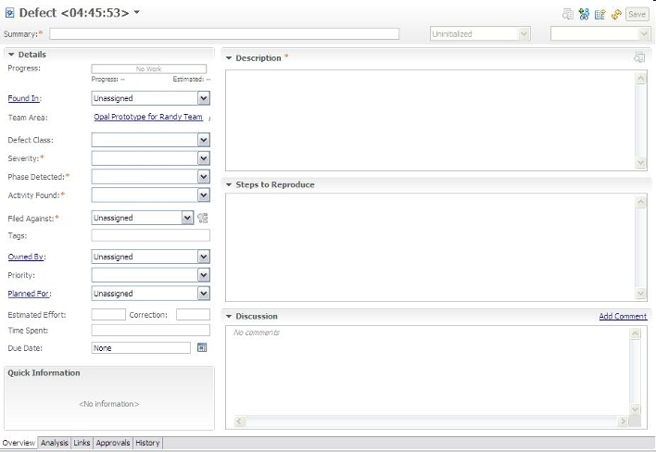
Figure 5: Defect Work Item Presentation, Overview tab

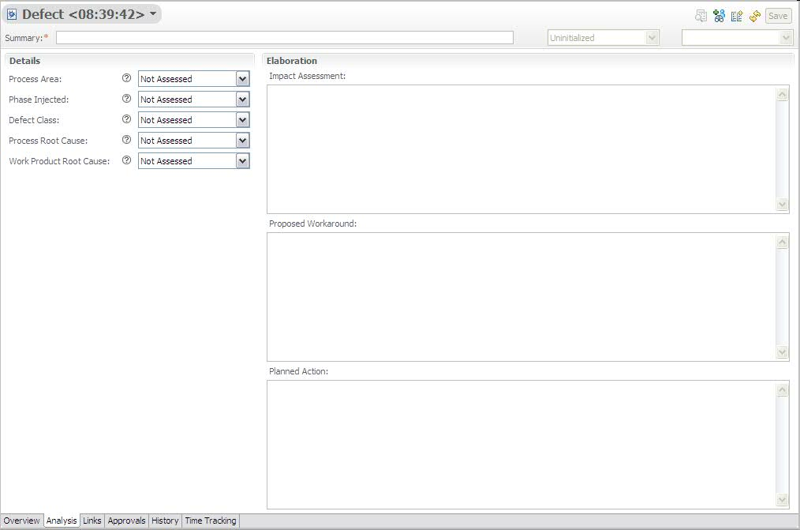
Figure 6: Defect Work Item Presentation, Analysis tab

Screenshots related to “Links”, “Approvals”, “History” and “Time Tracking” tabs are not included as they are provided out of the box by RTC.

Presentation design
The following table shows the field mapping between the OPAL work product (Defect Log template, and Defect Management Documentation template) and the customized Defect work item in RTC.
OPAL field name | RTC implementation
Project Name | Timeline name / Filed Against.  The timeline name in RTC is used to group all project related work items together. Additionally, the project name is also defined as a category and is selected in the Filed Against attribute.
Project Manager | Project Manager role.  The Project Manager field in Opal is represented by the Project Manager role in RTC and all Project Managers for a project can be viewed by looking at their roles assigned in the project or team area. When a Project Manager is the active owner of an artifact, his/her name appears in the Owner attribute on the particular work item.  RTC provides an ability to view individual attributes and see their respective role.
Project/Work Order No. | Project Area description.  Additional project attributes including work order, organization unit, etc. can be listed in a row format (in case of multiple projects within a project area) within the project area description.
Application Name / acronym | This is set via categories.  Background: You can create a Project Name category and have sub categories for the application or components
Defect No. | Id.  Automatically assigned.
Date Raised | Creation Date
Originator Name | Created By
Originator Approval | Approvals.  RTC approvals feature leveraged for this.
Defect Description | Description plus Steps to reproduce
- | Summary (a.k.a. defect title).
Severity | Severity.  Enumeration.  Values:  1-Critical  2-High  3-Medium  4-Low  Not Assessed (to represent no selected value) –default value-
Defect Type | Defect Class.  Enumeration.  Default Value: Not Assessed (to represent no selected value).  Values: the values of this dropdown list depend on the option selected on the “Phase Injected” attribute, with the logic described below.  Values:  If Phase Injected = SRS Then  Unclear / Missing / Incomplete / Faulty / Inconsistent Requirements  Documentation Error in Requirements  Inadequate / Unclear data inputs  Feasibility of Requirements  If Phase Injected = Design Then  Unclear/inadequate/incomplete design  Requirements missed in design  Documentation Error in Design  Reliability / Availability ( Robustness/ Error Tolerance) issues  Incorrect Interface Design  Logical Errors in Design  Too complex/ Error Prone/ Modularity/ Re-use  Redundancy in Design  Scalability/ Portability/ Extensibility issue  Performance/ Security issue  Incorrect Assumptions  If Phase Injected = Coding Then  Code standard violation (too few comment lines, no function/ interface headers, indentation style etc.)  Code conversion / automation error  Logical error in the code  Code is inconsistent with currently existing approved user documentation.  Does not satisfy function/performance criteria  Inadequate/Incomplete Code  Configurability/ Usability  Redundant Code  If Phase Injected = Testing Then  Missing Test Cases  Incorrect Test Case  Incomplete Test cases  Test case Implementation Error  Test procedures, standards, and methods not properly documented  Insufficient Interface testing  Inadequate / Incorrect / Unclear test data  If Phase Injected = Installation, Build and Packaging Then  Build Documentation Error  Integrated Product build error  Local build error  Migration / Porting error  Installation error  Packaging Error  If Phase Injected = Other Occurrences Then  Miscellaneous Error (not attributable to any of the above) - Project Planning for instance.  Note: This attribute has been renamed to avoid confusion with the “WI type” concept managed by RTC.
Phase Detected | Phase Detected.  Enumeration.  Values:  - SRS  - Design  - Coding  - Testing  - Installation, Build and Packaging  - Other Occurrences  - Not Assessed (to represent no selected value) –default value-
Phase Injected | Phase Injected.  Enumeration.  Values:  - SRS  - Design  - Coding  - Testing  - Installation, Build and Packaging  - Other Occurrences  - Not Assessed (to represent no selected value) –default value-
Activity Found | Activity Found.  Enumeration.  Values:  - Peer Review  - Code Conversion  - Coding  - Design  - Documentation  - Environmental Setup  - Feasibility Study  - Implementation  - Installation  - Porting/Migration  - Requirements Analysis  - Reverse Engineering  - Study Phase  - Test Case Automation  - Test Case Design  - Test Case Development  - Test Case Enhancement  - Test Planning  - Verification Plan  - Post Delivery/Acceptance Test Support  - Delivery/Release Support  - E2E Testing  - Test Case Execution  - Unit Test  - Function Test  - System Test  - Regression Test  - Integration Test  - Performance Test  - User Acceptance Test  - Other  - Not Assessed (to represent no selected value) –default value-
Process Area where found | Process Area.  Enumeration.  Values:  - Causal Analysis and Resolution  - Configuration Management  - Decision Analysis and Resolution  - Integrated Project Management  - Measurement and Analysis  - Organizational Performance Management  - Organizational Process Definition  - Organizational Process Focus  - Organizational Process Performance  - Organizational Training  - Process and Product Quality Assurance  - Product Integration  - Project Monitoring and Control  - Project Planning  - Quantitative Project Management  - Requirements Development  - Requirements Management  - Risk Management  - Supplier Agreement Management  - Technical Solution  - Validation  - Verification  - Not Assessed (to represent no selected value) –default value-
Work Product Root Cause | Work Product Root Cause.  Enumeration.  Values:  - Code  - Data / Design  - Infrastructure  - Methodology  - Process  - Rejected  - Security  - Test  - Not Assessed (to represent no selected value) –default value-
Process Root Cause | Process Root Cause.  Enumeration.  Values:  - Improper Infrastructure  - Inadequate tools / processes / Methods / Licenses  - Inadequate requirements analysis / development  - Volatile Requirements  - Inadequate Work Product Inspections  - Inadequate Testing  - Insufficient Test Data  - Skill Gap in Resource Allocation  - Inadequate Resource Fulfillment  - Inadequate Training  - Lack of Documentation  - Incorrect / Insufficient configuration control  - Incorrect data porting  - Faulty reverse-engineering  - Communication Gap  - Schedule Constraints  - Negligence  - Inadequate reporting of Project Health  - Unclear Escalation Mechanism  - Other  - Not Assessed (to represent no selected value) –default value-
Disposition | Status plus Resolution Code
Resolution Owner | Owned By
Status | Status
Resolution Code | Resolution
Estimated Effort | Estimated Effort plus Correction
Actual Effort | Time Spent
Planned Date Resolved | Due Date
Actual Date Resolved | Resolution Date
Total Days | Not implemented.  Can be calculated in a report.  Background: Number of days from when the defect was raised to when it was closed.
Comments | Discussion.  It maintains the history of all discussions related to the specific work item.
Areas / Work products impacted | Impact Assessment
Action log | Proposed Workaround plus Planned Action plus Related work items (Links)  Background: Actions to address the defect and/or any comments about the defect or its resolution. This information may be useful in trend analysis and root cause analysis. If this defect is significant and will be addressed with a Task, Issue, or Change Request, document the reference number.
- | Progress.  Progress bar, based on estimated effort and time spent.
- | Found In
- | Project Area
- | Team Area
- | Filed Against
- | Tags.  List of keywords for quick search.
- | Priority.  Enumeration.  Values:  - Critical  - High  - Medium  - Low  - Not Assessed (to represent no selected value) –default value-
- | Planned For.  Product Release/Iteration when the defect is planned to be fixed.
- | Constraint Type
- | Constraint Date
- | Planned Start Date
- | Planned End Date
- | Resolved By
- | Attachments
- | Links
- | History.  History of changes made to the work item.
- | Time Tracking.  Feature to record time for a work item.
Figure 7: Description of attributes, part of the Defect presentation

The Lifecycle

Workflow
The following state transition diagram represents a defect lifecycle within RTC, from a starting state of “Raised” to the “Reject” and “Closed” states, depending if the defect has been identified as invalid or valid.
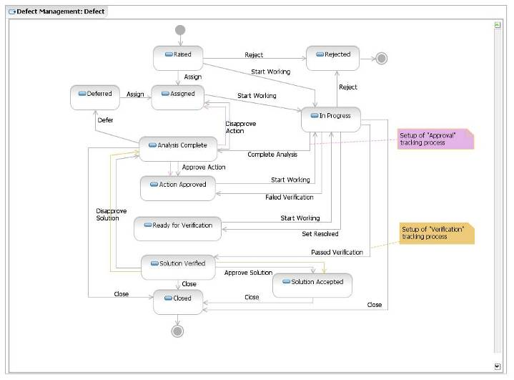
Figure 8: Defect Workflow
Most of the actions are derived directly from the OPAL procedure, but some of them are suggested as “shortcuts”, based on previous experience or project feedbacks. More details about shortcuts are provided further within this tool mentor.

Permissions to execute actions
RTC provides a way to restrict workflow actions to specific “roles”. The following restrictions are implemented:

Action | Permission
Create “Defect” work item | Anyone, with any of the following roles:  - Analyst  - Architect  - Developer  - Project Manager  - Stakeholder  - Tester  - Team Lead  - Software Release Manager
Delete “Defect” work item | Once a Defect work item has been created, it cannot be deleted by anybody.
Modify “Defect” work item | Anyone, with any of the following roles:  - Analyst  - Architect  - Developer  - Project Manager  - Stakeholder  - Tester  - Team Lead  - Software Release Manager  (The person specified in the Owner attribute will be responsible for implementing specific actions).  IMPORTANT: A work item should not be changed once it is in a final state (i.e. Closed, Rejected).
Actions associated to “Defect” workflow:  - Defer  - Reject  - Disapprove Action  - Failed Verification  - Disapprove Solution  - Assign  - Complete Analysis  - Approve Action  - Approve Solution  - Set Resolved  - Close  - Start Working  - Passed Verification | These actions are limited to the following roles:  - Developer  - Project Manager  - Team Lead  (The person specified in the Owner attribute will be responsible for implementing specific actions.)
Actions associated to “Defect” workflow:  - Failed Verification  - Approve Solution  - Set Resolved  - Close  - Start Working  - Passed Verification | These actions are limited to the following roles:  - Tester  (The person specified in the Owner attribute will be responsible for implementing specific actions.)
Figure 9: List of roles authorized to execute actions of the Defect workflow

States
The following table defines each of these states.
State | Definition
Raised | A defect is Raised if a Submitter has just identified and logged it into RTC. No other action has taken place at this state.
Assigned | A defect is Assigned if it is considered as a valid defect and a Resolution Owner has been identified and assigned to work with it.
In Progress | A defect is In Progress if one of the following is true:  + The Resolution Owner has started with the analysis (In Analysis)  + The resolution of the defect is being developed by the Resolution Owner (In Development)  + The resolution of the defect is under verification/validation (In Test)
Analysis Complete | A defect is Analyzed when the Resolution Owner has defined the schedules and planned actions required to solve the defect. The proposed solution is ready to be validated by the Project Manager.
Action Approved | A defect is given an Action Approved status when the Project Manager considers that the schedules and recommended actions defined by the Resolution Owner are appropriate. The defect’s resolution is approved to be implemented.
Ready for Verification | A defect is Ready for Verification when the testers can proceed with verification/validation.
Solution Verified | A defect is in Solution Verified state when it has passed all the verifications/validations.
Solution Accepted | A defect is given a Solution Accepted status if it has been successfully solved and the results are accepted by the Project Manager.
Closed | A defect is Closed if it has been solved successfully and it no longer requires attention.
Deferred | A defect is Deferred if it is out of scope for the current release(s). Defects in the Deferred state are triaged and reconsidered for future releases.
Rejected | A defect is Rejected if it is considered invalid.  Note: A rejection can occur for many reasons like:  - it is the result of a risk occurrence, change or issue  - it was caused by testing errors or omissions  - it was raised as the result of a user misunderstanding, etc.  - it is a duplicate of an existing one
Figure 10: Description of states existing in the Defect workflow

Shortcuts
Based on previous experience and project feedbacks, there are circumstances where the project team uses the OPAL Defect Management Procedure for internal purposes. In the majority of these cases, they need a portion of the procedure to keep defect tracking, but without walking through the whole workflow. For that reason, the previous workflow includes the following shortcuts:

Shortcut | Example of usage
Raised  In Progress | During internal functional test (no customer or stakeholder involved), a tester raises a defect. In disciplined teams, the developer does not need a formal assignment from the project manager; s/he can directly take ownership of the identified defect, and start working.
In Progress  Closed | The defect requires only a developer unit test and/or there is no formal testing.
Solution Verified  Closed | If a defect has been identified and it does not require formal customer / stakeholder approval, you can close the defect once the fix has been verified.
Figure 11: Description of shortcuts available in the Defect workflow

Resolution codes
A resolution code completes the status information for a given defect. For example, if a defect is rejected, the resolution code provides the reason of the rejection.

The table below shows the available resolution codes for the actions where they are defined.

Action Name | Target State | Resolution Codes | Comments
Approve Solution | Solution Accepted | Fixed
Close | Closed | Fixed
Defer | Deferred | Bypass  Fix in Future Release  Unresolved
Failed Verification | Action Approved | Unresolved
Passed Verification | Solution Verified | Fixed
Reject | Rejected | Change  Duplicate  Invalid  Issue  Risk  Won’t Fix  Works as Designed
Start Working | In Progress | In Analysis  In Development  In Test
Figure 12: List of resolution codes used in the Defect workflow

Approval tracking processes
RTC provides a way to customize approval tracking processes that team members follow as they work on work items. Depending on the decision taken by each team member participating in the approval cycle for a given work item, the work item can automatically be moved to a particular state through the execution of a predefined action.

The list of approvers for a particular approval type is defined within the “Approvals” tab.

The table below describes the approval types defined for the “Defect” workflow.

Approval Type | Decision | Action (Approval Target State) | Comments
Approval | Approved | Approve Action (Action Approved) | This approval type is used for the analysis’ approval.  If the analysis is approved, the work item is moved to the “Action Approved” state (after ALL the approvers approved the work item). If the analysis is rejected by any approver, the work item is moved to the “Assigned” state.  If any approval is still pending, it does nothing.  When should this approval type be setup?  This approval type is available when the work item is in the “Complete Analysis” state.
Approval | Rejected | Disapprove Action (Assigned)
Approval | Pending | None
Verification | Approved | Approve Solution (Solution Accepted) | This approval type is used for the final verification.  If the solution is approved, the work item is moved to the “Solution Accepted” state (after ALL the approvers have approved). If the solution is rejected by any approver, the work item is moved to the “Analysis Complete” state.  If any approval is still pending, the work item keeps the current state.  When should this approval type be setup?  This approval type is available when the work item is in the “Passed Verification” state.
Verification | Rejected | Disapprove Solution (Analysis Complete)
Verification | Pending | Submit For Review (Ready for Review)
Figure 13: Description of approval tracking processes related with the Defect workflow

Required attributes for each state
There is a minimum set of required attributes in order to submit a defect; and depending to which state the defect moves to, the user may need to complete additional required attributes. The table below describes the required attribute for each state.

To move a work item to the state… | The required attributes are…
Raised  (and all states) | Phase detected  Severity  Activity Found  Filed Against  Description  Summary  Important: This set of attributes is called “Default required attributes”.
Assigned | Default required attributes +  Owned By  Priority
In Progress | Default required attributes +  Owned By  Priority
Analysis Complete | Default required attributes +  Owned By  Priority  Impact Assessment  Phase Injected  Phase Detected  Process Root Cause  Work Product Root Cause  Defect Class (a.k.a. Defect Type)
Action Approved | Default required attributes +  Owned By  Priority  Impact Assessment  Phase Injected  Phase Detected  Process Root Cause  Work Product Root Cause  Defect Class (a.k.a. Defect Type)
Ready for Verification | Default required attributes +  Owned By  Priority  Impact Assessment  Phase Injected  Phase Detected  Process Root Cause  Work Product Root Cause  Defect Class (a.k.a. Defect Type)
Solution Verified | Default required attributes +  Owned By  Priority  Impact Assessment  Phase Injected  Phase Detected  Process Root Cause  Work Product Root Cause  Defect Class (a.k.a. Defect Type)
Solution Accepted | Default required attributes +  Owned By  Priority  Impact Assessment  Phase Injected  Phase Detected  Process Root Cause  Work Product Root Cause  Defect Class (a.k.a. Defect Type)
Closed | Default required attributes +  Impact Assessment  Owned By  Phase Injected  Phase Detected  Priority  Process Root Cause  Work Product Root Cause  Defect Class (a.k.a. Defect Type)
Deferred | Default required attributes
Rejected | Default required attributes
Figure 14: List of required attributes for each state in defect workflow

Time tracking for work items
You can use the time tracking feature to record time for a work item.
In the work item editor, you can enter the number of hours per day that you spend on a work item. You can associate each time entry with one or more time codes. Time codes are defined categories against which you can record time for different activities of a task. For example, you might organize your regular work into these categories: development, review, and testing. If you have sufficient security access, you can add or delete time codes in the project area editor.
The Quick Information section displays the weeks for which time is entered for a work item. The total number of hours that are entered for a week and the total number of hours that are entered for a work item are also displayed in the Quick Information section. To access the time entries, click a specific week.
Remember: To enter time for a work item, you must be the owner of that work item. For example, in a work item that you own, you enter time entries. Later, the ownership of the work item is assigned to another person. You can still edit your time entries, but cannot add new entries to the week or new rows on the Time Tracking tab. If multiple owners enter time in a work item, their names are displayed against their entries.
You can control the synchronization of the time entries on the Time Tracking tab with the value in the Time Spent attribute. By default, when you enter time for a work item on the Time Tracking tab, that value is reflected in the Time Spent attribute. If you disable the synchronization option, the values in the Time Tracking tab and the Time Spent attribute become independent. If the option to synchronize time is enabled in the middle of a project, the time spent values are overwritten by the time tracking values.
This new feature has been adopted since RTC 3.0 and it is an out of the box feature that comes with RTC. For additional guidance, refer to RTC online help.

Queries
One kind of action that may be performed using RTC, is searching the defects’ database (defects’ log) using public or personal queries. “Shared queries”- are available to the whole team while the “Personal queries” are private and available only to the creator. When you write your own queries, you can search for defects with specific criteria and create your own layout.
The predefined, shared query provided as part of this RTC template is:
All Defects
Defect Log
It is located within the “Shared Queries” folder organized into two additional folders: the “Predefined” and the “Individually Shared” as shown below:

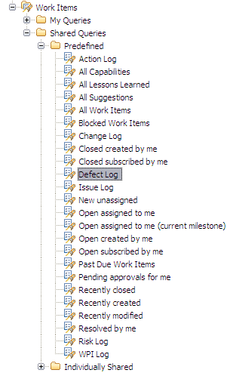
Figure 15: Defect Predefined, Shared Queries

For more details on each query, please refer to the sections below.

All Defects
Description: A list of all the defects regardless of status.

The “All Defects” query helps practitioners with tracking and managing outstanding defects to closure. This query can be run on demand for outstanding defects throughout the project’s lifecycle, to ensure the resolution owners are taking prompt and appropriate action to bring the defects to closure.

The base query planned for the solution displays the following columns:

  - Id
  - Creation Date
  - Created by
  - Summary
  - Severity
  - Type
  - Phase Detected
  - Phase Injected
  - Activity Found
  - Process Area
  - Work Product Root Cause
  - Process Root Cause
  - Status
  - Resolution
  - Owned By
  - Estimate
  - Corrected Estimate
  - Time Spent
  - Due Date
  - Resolution Date

If necessary, the practitioners can create new queries based on this base “log” to show additional columns or to change the searching criteria.

Task
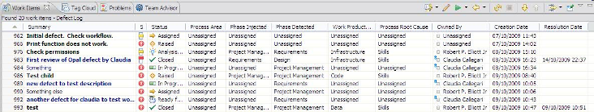
Figure 16: Defect Log query results

CAPABILITY: Tool implementation
A “Task” work item allows users to define and track work. For example, to resolve a high severity defect, a set of child task work items may be defined and tracked to closure. RTC tasks include a workflow to track status and a time tracking tab to record the hours spent on that work item.

End of document

