
Global Services

Issue Management in Rational Team Concert

Document Control Page
About this document
Produced using Microsoft Word for Windows Version 2003
Doc. Owner: GBS Process, Methods and Tools team

Revision History
Version | Date | Change Description
1.0 | April 2010 | Initial version.
1.1 | October 2010 | Changes to align tool mentor with RTC configuration “IBM Opal 1.2”.
2.0 | Sep 2011 | Changes to align tool mentor with RTC configuration “IBM Opal 2.2”.

Trademarks
IBM, the IBM logo, Rational and the following product names are trademarks of IBM Corporation in the United States, other countries, or both:
IBM Rational Team Concert (RTC)
IBM Rational Quality Manager (RQM)
IBM Rational Requirement Composer (RRC)

Microsoft, Windows, Windows NT, and the Windows logo are trademarks of Microsoft Corporation in the United States, other countries, or both.
Contents

Global Services 1
Issue Management in Rational Team Concert 1
Document Control Page 2
About this document 2
Revision History 2
Trademarks 2
Contents 3
1 Purpose 4
2 Scope 4
3 RTC usage 4
3.1 RTC generic usage 4
3.2 Accessing help on RTC Web client 4
3.3 Accessing help on RTC Eclipse client 4
4 Security 5
5 Issue Management: Tool implementation of the OPAL Procedure 5
5.1 Process roles 5
5.2 Usage Model 6
5.3 Issue Document Work Item 7
5.3.1 Issue Document Form 7
5.3.1.1 Presentation layout 7
5.3.1.2 Presentation design 9
5.3.2 The Lifecycle 12
5.3.2.1 Workflow 12
5.3.2.2 Permissions to execute actions 13
5.3.2.3 States 14
5.3.2.4 Shortcuts 14
5.3.2.5 Resolution codes 14
5.3.2.6 Approval tracking processes 15
5.3.2.7 Required attributes for each state 15
5.4 Queries 15
5.4.1 All Issues 16
6 ACTION: Tool implementation 17

Purpose
This document provides guidance on changes within the IBM GBS Standard Delivery Solution (OPAL) configuration of IBM Rational Team Concert (RTC hereafter) in support of OPAL issue management. It also provides project direction on leveraging RTC in support of issue management.
This document does not replace nor cover all of the steps defined in the OPAL issue management procedure. To fully understand this document, it should be read in conjunction with the procedure. Please be aware that this OPAL procedure may contain additional steps that take place outside of RTC and are not duplicated here.

Scope
The guidance assumes a basic understanding of how to use RTC and is not intended to be training material. This tool mentor references the GBS Standard Delivery Solution (OPAL) RTC configuration release 2.2. This configuration supports the OPAL issue management procedure as part of OPAL release 15.3.

RTC usage

RTC generic usage
RTC may be accessed either directly via the Eclipse Client or via the Web interface. For performance reasons, the recommended interface, especially for hosted environments, is the RTC web client.

Accessing help on RTC Web client
In order to access the RTC help, hover over the Help button (the one with the question mark icon), and click the “Help Contents” option.
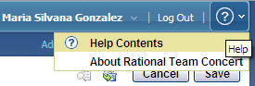
Figure 1: Help on RTC web client

Accessing help on RTC Eclipse client
In RTC Eclipse client, it is necessary to click the Help menu in order to see its different options.
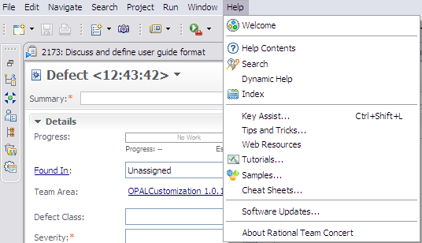
Figure 2: Help on RTC Eclipse client

Security
By default, only the members of the project area hierarchy have read access to the project area and its work items. If you grant access to members of the project area hierarchy, anyone who adds a member to any team will implicitly grant access to the entire project. The access control feature can be used to change this default and grant read access using other criteria.

Sometimes record’s creation, deletion and/or modification are restricted to specific process roles within the project. These policies are different depending on the solution. For details on this topic, please refer to the “Permissions to execute actions” section within this document.

Issue Management: Tool implementation of the OPAL Procedure

Process roles
This solution allows the Administrator to allocate one or more RTC roles to members of your project. Each role selection may provide or deny access to specific RTC features.
The following graphic provides a list of available roles within this solution.
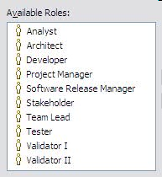
Figure 3: Predefined RTC Process Roles

The following table describes the mapping between the roles defined by the OPAL procedure and the ones implemented within the solution.
Role defined in the OPAL procedure | Roles implemented within the solution
Project Manager | Project Manager
Figure 4: Process Roles mapping

Usage Model
When a new issue is identified, an Issue Document work item is created in RTC. After completing the required attributes, the issue is saved, and it is placed in an “Open” state.

The person responsible for managing issues to closure (usually the Project Manager), validates the issue. If it was introduced as a result of a risk occurrence, change request, or defect, the issue can be “Closed” with the appropriate resolution code. If the issue needs to be transferred to another project/organization, it can also be “Closed” with the appropriate resolution code, when the new resolution owner has taken ownership.

If the issue is valid, the following options are available:
- If the action plan is quickly identified and executed, the issue can be closed with a resolution code of “Resolved”.
- If the former condition is not true and the issue requires further analysis or action, the action “Start Working” can be selected to mark the issue in the “In Progress” state. Later, it can be closed with the appropriate resolution code.

Issue Document Work Item

Issue Document Form

Presentation layout
The issue information is collected using the “Issue Document” work item. On its form, attributes are organized into different tabs and sections.

The screenshots below show the organization of the attributes across the tabs, using RTC Eclipse client. Note that most of the screenshots presented here are shown when you create the work item the first time so mandatory attributes (the ones with the red asterisk, *) will change based on state.
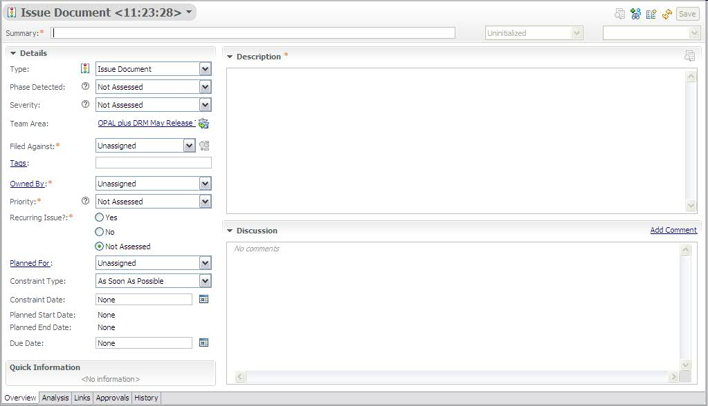
Figure 5: Issue Document Work Item Presentation, Overview tab

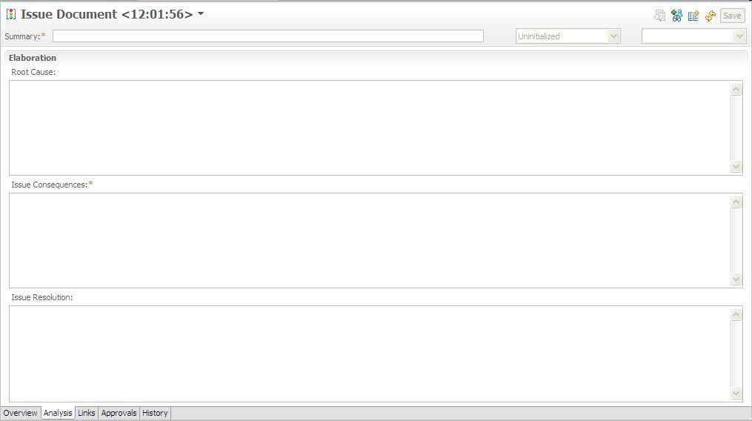
Figure 6: Issue Document Work Item Presentation, Analysis tab

Screenshots related to “Links”, “Approvals” and “History” tabs are not included as they are out of the box tabs in RTC.

Presentation design
The following table shows the field mapping between the OPAL work products (e.g. Issue Log template, Issue Documentation template) and the customized Issue Document work item in RTC.
OPAL field name | RTC implementation
Project Name | Timeline name / Filed Against.  The timeline name in RTC is used to group all project related artifacts together. Additionally, the project name is also defined as a category and is selected in the Filed Against attribute.
Project Manager | Project Manager role.  The Project Manager field in OPAL is represented by the Project Manager role in RTC and all Project Managers for a project can be viewed by looking at the roles assigned in the team area. When a Project Manager is the active owner of an artifact, their name appears in the Owner attribute on the particular artifact.  RTC provides ability to view individual attributes and see their respective role.
Project/Work Order No. | Project Area description.  Additional project attributes including work order, organization unit, etc. can be listed in a row format (in case of multiple projects within a project area) within the project area description.
Application Name / acronym | This is set via categories.  Background: You can create a Project Name category and have sub categories for the application or components
Project Phase | Phase Detected.  Enumeration.  Values:  - SRS  - Design  - Coding  - Testing  - Installation, Build and Packaging  - Other Occurrences  - Not Assessed (to represent no selected value) –default value-
Project Organizational Unit | Project Area description.  Additional project attributes including work order, organization unit, etc. can be listed in a row format (in case of multiple projects within a project area) within the project area description.
Issue ID | Id.  Automatically assigned.
Short Description | Summary (a.k.a. issue title)
Issue Consequences | Issue Consequences
Issue Description and Consequences | Description plus Issue Consequences
Recurring Issue ID | Recurring Issue? plus Related Links.  Recurring Issue?:  - Yes  - No  - Not Assessed (to represent no selected value).  It identifies if the current issue is a recurring issue.  Related Links: In RTC, work items can be related together with different relationship types. In this case a “Related” type would be appropriate to associate recurring issues.
Date Raised | Creation Date
Priority | Priority.  Enumeration.  Values:  - Critical  - High  - Medium  - Low  - Not Assessed (to represent no selected value) –default value-  Note: Opal templates do not require the “Critical” value on the “Priority” attribute, but it is included here due to tool’s limitation.
Status | Status plus Resolution Code
Status Date | History.  History maintains all changes made to the work item.
Raised By | Created By
Optimal Timeframe for Resolution | Discussion plus Issue Consequences.  Background: “Optimal timeframe for resolution” is an explanation of the impact the issue has on the project if its resolution is delayed.
Immediate resolution/Issue resolution steps | Issue Resolution plus  Links (related)
Category | Tags.  Project defined categories which can be used in later analysis and statistics of issues. Category attributes can be as follows: Technical, Project Management, Support and Organization.  As we are leveraging the “tags” attribute, where the user can define their own “keyword”, we recommend entering tags with no spaces.
Owner | Owned By
Target / Planned Resolution Date | Due Date
Actual Resolution Date | Resolution Date
Proposed resolution/Issue resolution steps | Issue Resolution plus Links (related)
Related Actions | Issue Resolution plus Links (related)
Open to Close | Not implemented.  Can be calculated in a report.  Background: It is the number of days from the date raised to the date closed.
Plan to Close | Not implemented.  Can be calculated in a report.  Background: It is the number of days from the target date to the date closed.
Issue History | History plus Discussion.  All changes to the work item are tracked on the History tab.
- | Severity.  Enumeration.  Values:  1-Critical  2-High  3-Medium  4-Low  Not Assessed (to represent no selected value) –default value-
- | Project Area
- | Team Area
- | Filed Against
- | Tags.  List of keywords for quick search.
- | Planned For.  Product Release/Iteration when the issue is planned to be resolved.
- | Constraint Type
- | Constraint Date
- | Planned Start Date
- | Planned End Date
- | Discussion.  It maintains the history of all discussions related to the specific work item.
- | Progress.  Progress bar, based on estimated effort and time spent, will not be shown for an Issue work item type.
- | Resolved By
- | Attachments.  List of attachments with additional information.
- | Links.  List of related work items.
- | Approvals.  List of approval cycles with the appropriate exit decisions.
Figure 7: Description of attributes, part of issue document presentation

The Lifecycle

Workflow
The following state transition diagram represents an issue document lifecycle within RTC, from the “Open” state to the “Closed” state, depending if the issue has been identified as invalid or valid.
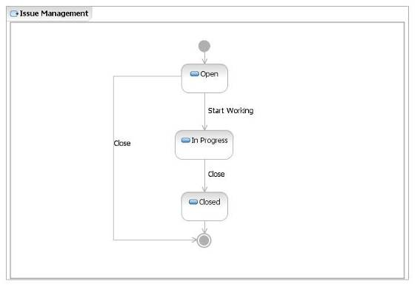
Figure 8: Issue Document Workflow

Permissions to execute actions
RTC provides a way to restrict workflow actions to specific “roles”. The following restrictions are implemented:

Action | Permission
Create “Issue Document” work item | Anyone with Project Manager role.
Delete “Issue Document” work item | Once an Issue Document work item has been created, it cannot be deleted by anybody.
Modify “Issue Document” work item | Anyone with Project Manager role.  IMPORTANT: A work item should not be changed once it is in a final state (i.e. Closed).
Actions associated to “Issue Document” workflow:  - Close | Anyone with the Project Manager role.
Actions associated to “Issue Document” workflow:  - Start Working | Anyone within the project team, with any of the following roles:  - Analyst  - Architect  - Developer  - Project Manager  - Tester  - Team Lead  - Software Release Manager
Figure 9: List of roles authorized to execute actions of issue document workflow

States
The following table defines each of these states.
State | Definition
Open | An issue document is Opened if a Project Manager has identified and logged it into RTC. No other action has taken place at this state.
In Progress | An issue document is In Progress if,  + It as valid and assigned to a Resolution Owner  + The Resolution Owner has started with the analysis (In Analysis)  + The Resolution Owner has escalated it to a level of management that has the necessary authority for its resolution (Escalated)
Closed | An issue document is Closed if:  + It has been Transferred because it is NOT within the scope of the project and the owning project or organization can be determined  + It is NOT valid and it has been rejected because is the result of a Risk Occurrence, Change or Defect  + After its analysis, the alternatives were evaluated, the Project Manager chose a resolution, and it has been implemented successfully resolving the issue. It no longer requires attention.
Figure 10: Description of states existing in issue document workflow

Shortcuts
Not applicable.

Resolution codes
A resolution code completes the status information for a given issue document.

The table below shows the available resolution codes for the actions were they are defined.

Action Name | Target State | Resolution Codes | Comments
Start Working | In Progress | In Analysis  Escalated
Close | Closed | Change  Defect  Resolved  Risk  Transferred
Figure 11: List of resolution codes used in issue workflow

Approval tracking processes
No approvals have been defined for this workflow

Required attributes for each state
There is a minimum set of required attributes in order to submit an issue document; and depending to which state the issue moves to, the user may need to complete additional required attributes. The table below describes the required attributes for each state.

To move a work item to the state… | The required attributes are…
Open  (and all states) | Summary  Filed Against  Priority  Recurring Issue?  Description  Issue Consequences  Owned By  Important: this set of attributes is called “Default required attributes”.
In Progress | Default required attributes
Closed | Default required attributes +  Issue Resolution
Figure 12: List of required attributes for each state in issue document workflow

Queries
One kind of action that may be performed using RTC, is searching the issues’ database (issues’ log) using public or personal queries. ”Shared queries” are available to the whole team while the “My queries” are private and available only by the creator. As you write your own queries, you can search issues with specific criteria and create your own layout.
The predefined, shared query provided as part of the RTC process template is:
All Issues

Issue Log
It is located within the “Shared Queries” folder organized into two additional folders: the “Predefined” and the “Individually Shared” as shown below:

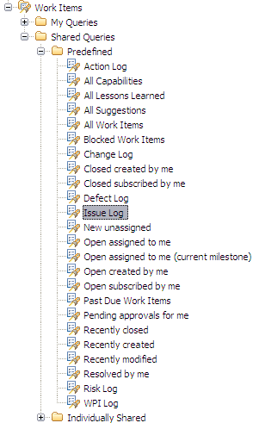
Figure 13: Issue Predefined, Shared Queries

For more details on this query, please refer to the sections below.

All Issues
Description: A list of all of the issues regardless of status.

The “All Issues” query helps practitioners with tracking and managing outstanding issues to closure. This query can be run on demand for outstanding issues throughout the project’s lifecycle, to ensure the resolution owners are taking prompt and appropriate action to bring the issues to closure.

The base query planned for the solution displays the following columns:

  - Id
  - Summary
  - Priority
  - Creation Date
  - Created By
  - Owned By
  - Due Date
  - Status
  - Resolution
  - Modified Date

If necessary, the practitioners can create new queries based on this base “log” to show additional columns or to change the searching criteria.

Task
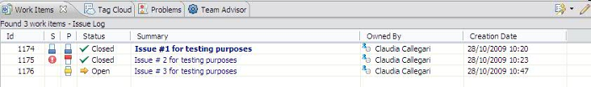
Figure 14: Issue Log query results

ACTION: Tool implementation
A “Task” work item allows users to define and track work. For example, to resolve an issue, a set of child task work items may be defined and tracked to closure. RTC tasks include a workflow to track status and a time tracking tab to record the hours spent on that work item.

End of document

