
Global Services

Risk Management in IBM Rational Team Concert

Document Control Page
About this document
Produced using Microsoft Word for Windows Version 2003
Doc. Owner: GBS Process, Methods and Tools team

Revision History
Version | Date | Change Description
1.0 | April 2010 | Initial version.
1.1 | October 2010 | Changes to align tool mentor with RTC configuration “IBM Opal 1.2”.
2.0 | Sep 2011 | Changes to align tool mentor with RTC configuration “IBM Opal 2.2”.

Trademarks
IBM, the IBM logo, Rational and the following product names are trademarks of IBM Corporation in the United States, other countries, or both:
IBM Rational Team Concert (RTC)
IBM Rational Quality Manager (RQM)
IBM Rational Requirement Composer (RRC)

Microsoft, Windows, Windows NT, and the Windows logo are trademarks of Microsoft Corporation in the United States, other countries, or both.
Contents

Global Services 1
Risk Management in IBM Rational Team Concert 1
Document Control Page 2
About this document 2
Revision History 2
Trademarks 2
Contents 3
1 Purpose 4
2 Scope 4
3 RTC usage 4
3.1 RTC generic usage 4
3.2 Accessing help on RTC Web client 4
3.3 Accessing help on RTC Eclipse client 4
4 Security 5
5 Continuous Risk Management: Tool implementation of the OPAL Procedure 5
5.1 Process roles 5
5.2 Usage Model 6
5.3 Risk Definition Work Item 7
5.3.1 Risk Definition Form 7
5.3.1.1 Presentation layout 7
5.3.1.2 Presentation design 9
5.3.2 The Lifecycle 13
5.3.2.1 Workflow 13
5.3.2.2 Permissions to execute actions 13
5.3.2.3 States 14
5.3.2.4 Resolution codes 14
5.3.2.5 Required attributes for each state 14
5.4 Risk Occurrence Work Item 15
5.4.1 The Risk Occurrence Form 15
5.4.1.1 Presentation layout 15
5.4.1.2 Presentation design 16
5.4.2 The Lifecycle 18
5.4.2.1 Workflow 18
5.4.2.2 Permissions to execute actions 19
5.4.2.3 States 20
5.4.2.4 Required attributes for each state 20
5.4.2.5 Time tracking for work items 21
5.5 Queries 21
5.5.1 All Risks 22
6 ACTION: Tool implementation 23

Purpose
This document provides guidance on changes within the IBM GBS Standard Delivery Solution (OPAL) configuration of IBM Rational Team Concert (RTC hereafter) in support of OPAL continuous risk management. It also provides project direction on leveraging RTC in support of risk management.
This document does not replace nor cover all of the steps defined in the OPAL continuous risk management procedure. To fully understand this document, it should be read in conjunction with the procedure. Please be aware that this procedure may contain additional steps that take place outside of RTC and are not duplicated here.

Scope
The guidance assumes a basic understanding of how to use RTC and is not intended to be training material. This tool mentor references the GBS Standard Delivery Solution (OPAL) RTC configuration release 2.2. This configuration supports the OPAL continuous risk management procedure as part of OPAL release 15.3.

RTC usage

RTC generic usage
RTC may be accessed either directly via the Eclipse Client or via the Web interface. For performance reasons, the recommended interface, especially for hosted environments, is the RTC web client.

Accessing help on RTC Web client
In order to access the RTC help, hover over the Help button (the one with the question mark icon), and click the “Help Contents” option.
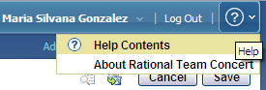
Figure 1: Help on RTC web client

Accessing help on RTC Eclipse client
In RTC Eclipse client, it is necessary to click the Help menu in order to see its different options.
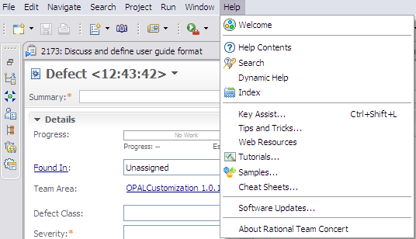
Figure 2: Help on RTC Eclipse client

Security
By default, only the members of the project area hierarchy have read access to the project area and its work items. If you grant access to members of the project area hierarchy, anyone who adds a member to any team will implicitly grant access to the entire project. The access control feature can be used to change this default and grant read access using other criteria.

Sometimes record’s creation, deletion and/or modification are restricted to specific process roles within the project. These policies are different depending on the solution. For details on this topic, please refer to the “Permissions to execute actions” section within this document.

Continuous Risk Management: Tool implementation of the OPAL Procedure

Process roles
The solution requires you to define the individuals in various predefined process roles. Having defined who will play each role in your project the solution will provide or deny access to specific actions.
On the following picture, there is a list with the available roles within the solution.
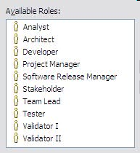
Figure 3: Predefined RTC Process Roles

The following table describes the mapping between the roles defined by the OPAL procedure and the ones implemented within the solution.
Role defined in the OPAL procedure | Roles implemented within the solution
Project Manager | Project Manager
Risk Owner | Usually any role listed above as available on the solution, except Stakeholder.
Figure 4: Process Roles mapping

Usage Model
The GBS Standard Delivery Solution (OPAL) configuration of RTC is composed of two different risk work item types:
- Risk Definition
- Risk Occurrence

When a new risk is identified, a Risk Definition work item is created in RTC. After completing the required attributes, the risk definition is saved, and it is placed in the “Open” state.

The person responsible for managing risks to closure (usually the Project Manager), proceeds to analyze the risk, providing the risk consequences, mitigation/contingency plans, related costs and other relevant information.

When a risk occurs, a Risk Occurrence (or Issue Document) work item is created in RTC, and it is associated to the appropriate Risk Definition work item to which the occurrence relates to. On the Risk Occurrence work item, the project manager documents the risk reaction together with the priority and other relevant information. The project manager defines the owner for follow-up and resolution of any associated work items (in response to the risk occurrence). If necessary, work items can be created and associated as children to a Risk Occurrence work item (e.g. associating a child Task work item to a Risk occurrence). The Risk Occurrence and any child work items may follow their own workflows until closure.

When the risk cannot possibly occur in the future, then the project manager can proceed to close it, with the appropriate resolution code.
A Risk Definition can be closed when its children (i.e. risk occurrences, issues, actions) have been closed. FYI, you cannot create children artifacts once a Risk Definition is closed.

Risk Definition Work Item
When risks are identified, they are documented using the “Risk Definition” work item.

Risk Definition Form

Presentation layout
The risk definition information is collected using the “Risk Definition Work Item”. On its form, attributes are organized into different tabs and sections.

The screenshots below show the organization of the attributes across the tabs, using RTC Eclipse client. Note that most of the screenshots presented here are shown when you create the work item the first time so mandatory attributes (the ones with the red asterisk, *) may change based on state.
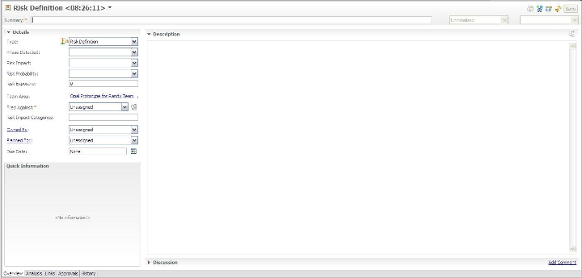
Figure 5: Definition Work Item Presentation, Overview tab
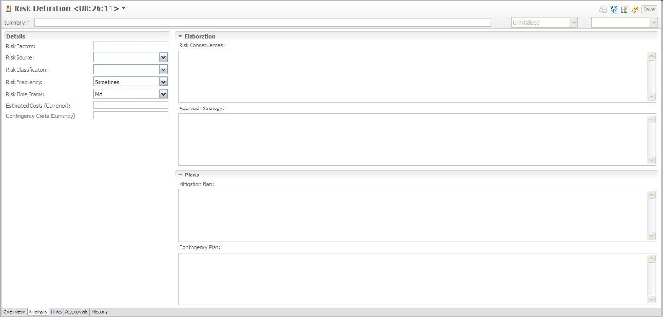
Figure 6: Risk Definition Work Item Presentation, Analysis tab

Screenshots related to “Links”, “Approvals” and “History” tabs are not included as they are provided out of the box in RTC.

Presentation design
The following table shows the field mapping between the OPAL work product (e.g. Risk Definition template, Risk Management Documentation template) and the customized Risk Definition work item in RTC.
OPAL field name | RTC implementation
Project Name | Timeline name / Filed Against.  The timeline name in RTC is used to group all project related artifacts together. Additionally, the project name is also defined as a category and is selected in the Filed Against attribute.
Project Manager | Project Manager role.  The Project Manager field in OPAL is represented by the Project Manager role in RTC and all Project Managers for a project can be viewed by looking at the roles assigned in the team area. When a Project Manager is the active owner of a work item, the person’s name appears in the Owner attribute on the work item.  RTC provides ability to view individual attributes and see their respective role.
Project/Work Order No. | Project Area description.  Additional project attributes including work order, organization unit, etc. can be listed in a row format (in case of multiple projects within a project area) within the project area description.
Application Name / acronym | This is set via categories.  Background: You can create a Project Name category and have sub categories for the application or components
Project Phase | Phase Detected.  Enumeration.  Values:  - SRS  - Design  - Coding  - Testing  - Installation, Build and Packaging  - Other Occurrences  - Not Assessed (to represent no selected value) –default value-
Project Organizational Unit | Project Area description.  Additional project attributes including work order, organization unit, etc. can be listed in a row format (in case of multiple projects within a project area) within the project area description.
Risk ID | Id.  Automatically assigned.
Date Raised | Date Raised.  Note: RTC also manages the Creation Date attribute, which is automatically completed when the work item is saved the first time. Because there can be a difference between the creation date and the raised date, two attributes are provided within the RTC customization.
Raised by | Created By.  Automatically assigned when the work item is saved the first time.
Short description | Summary (a.k.a. risk definition title).
Risk Description | Description
Priority | Priority.  Enumeration.  Values:  - Critical  - High  - Medium  - Low  - Not Assessed (represents no value specified) –default value-
Total impact | Risk impact.  Enumeration.  Values:  - Minor  - Moderate  - Significant  - Major  - Not Assessed (represents no value specified) –default value-  Internally, each option maps to a specific value, representing the impact:  Not Assessed (=0)  Minor (=1)  Moderate (=2)  Significant (=3)  Major (=4)
Probability | Risk Probability.  Enumeration.  Values:  - Highly Unlikely  - Unlikely  - Probable  - Highly Probable  - Will Occur  - Not Assessed (represents no value specified) –default value-  Internally, each option maps to a specific value, representing the probability:  Not Assessed (=0)  Highly Unlikely (=2)  Unlikely (=4)  Probable (=6)  Highly Probable (=8)  Will Occur (=10)
Exposure | Risk Exposure.  Probability * Impact.  It will be manual for RTC versions prior to 2.0.0.1 and calculated automatically for versions > 2.0.0.2  Examples of combinations:  Minor plus Highly Unlikely = 2  Minor plus Unlikely = 4  Minor plus Probable = 6  Minor plus Highly probable = 8  Minor plus Will Occur = 10  Moderate plus Highly Unlikely = 4  etc.
Impact of Risk Event | Risk Impact Categories.  Tags attribute. List of keywords for quick search.  If you need to elaborate on specifics, use the “Consequences” attribute.
Owner | Owned By
Status | Status plus  Resolution Code
Revision number | History.  All changes to the work item are tracked on the History tab.
Risk factors | Risk factors.  Tags attribute.
Consequences | Risk consequences.  Text attribute.
Risk identification source | Risk source.  Enumeration.  Values:  - Change in Competition  - Change in Major Stakeholders  - Contract Amendments  - Contractual Clauses  - Env. or Political change  - Infrastructure  - Key Milestones  - Requirements  - Analysis  - Design  - Implementation  - Testing  - Training  - Operations and Support  - Architecture  - Planning Sessions  - Reviews and/or Audits  - Risk Review Session  - Other  - Not Assessed (represents no value specified) –default value-
Risk classification | Risk classification.  Enumeration.  Values:  - Dependencies  - Financial  - Human Resources  - Use of new Technologies  - Project Phases  - Technical Environment  - Unstable Requirements  - Not Assessed (represents no value specified) –default value-
Timeframe | Risk Time Frame.  Enumeration.  Values:  - Near  - Mid –default value-  - Far
Frequency | Risk Frequency.  Enumeration.  Values:  - Frequently  - Often  - Sometimes –default value-  - Rarely
Estimated Cost | Costs (Currency).  The value should be a positive number with or without decimals.
Contingency Cost | Contingency Costs (Currency).  The value should be a positive number with or without decimals.
Analysis/Revision Date | History.  All changes to the work item are tracked on the History tab.
Date Last Updated | Modified Date
Links / Actions | Links.  List of related work items, including risk occurrences and/or other work items.
Links / Occurrence IDs | Links.  List of related work items, including risk occurrences and/or other work items.
Issue Number | Links.  List of related work items, including risk occurrences, issues and/or other work items.
Summary of Risk Mgmt Plan | Approach Strategy plus  Mitigation Plan plus  Contingency Plan
Mitigation Steps | Approach Strategy plus  Mitigation Plan plus  Contingency Plan
Reassessment History | History.  List of related work items, including risk occurrences and/or other work items.
Target Closure Date | Due Date
Date Resolved | Resolution Date
Comments | Discussion
- | Project Area
- | Team Area
- | Filed Against
- | Creation Date
- | Resolution
- | Planned For.  Product Release/Iteration when the risk is planned for.
- | Constraint Type
- | Constraint Date
- | Planned Start Date
- | Planned End Date
- | Resolved By
- | Attachments.  List of attachments with additional information.
- | Links.  List of related work items.
- | Approvals.  List of approval cycles with the appropriate exit decisions.
- | History.  History of changes made to the work item.
Figure 7: Description of attributes, part of Risk Definition presentation

The Lifecycle

Workflow
The following state transition diagram represents a risk definition lifecycle within RTC, from the “Open” state, to the “Closed” state.
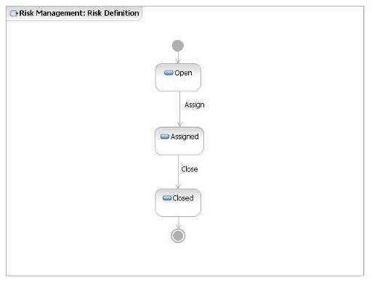
Figure 8: Risk Definition Workflow

Permissions to execute actions
RTC provides a way to restrict workflow actions to specific “roles”. The following restrictions are implemented:

Action | Permission
Create “Risk Definition” work item | Anyone with a Project Manager role.
Delete “Risk Definition” work item | Once a Risk Definition work item has been created, it cannot be deleted by anyone.
Modify “Risk Definition” work item | Anyone with a Project Manager role.  IMPORTANT: A work item should not be changed once it is in a final state (i.e. Closed). If the change is needed, it requires justification and approval from the Project Manager.
Actions associated to “Risk Definition” workflow | Anyone with Project Manager role.
Figure 9: List of roles authorized to execute actions of risk definition workflow

States
The following table defines each of these states.
State | Definition
Open | A risk definition is Open if the Project Manager has identified and logged it in RTC. No other action has taken place at this state.
Assigned | A risk definition is Assigned if a Resolution Owner has been identified and assigned to work with it.
Closed | A risk definition is Closed when:  the work required for mitigating the risk has finished  + it can be avoided  + it is not longer accurate or is obsolete  And it no longer requires attention.
Figure 10: Description of states existing in the risk definition workflow

Resolution codes
A resolution code clarifies the status provided for a risk definition work item.
The table below lists any available resolution codes for workflow actions, where they are defined.

Action Name | Target State | Resolution Codes | Comments
Close | Closed | Avoided  Obsolete  Mitigated
Figure 11: List of resolution codes used in the risk definition workflow

Required attributes for each state
There is a minimum set of required attributes in order to submit a risk definition. Depending on which state the work item moves to, the user may need to complete additional required attributes. The table below describes the required attributes for each state.

To move a work item to the state… | The required attributes are…
Open  (and all states) | Phase detected  Description  Summary  Filed Against  Priority  Risk Probability  Risk Impact  Risk Exposure  Risk Classification  Important: This set of attributes is called “Default required attributes”.
Assigned | Default required attributes +  Owned By
Closed | Default required attributes +  Owned By
Figure 12: List of required attributes for each state in the risk definition workflow

Risk Occurrence Work Item
Once a risk occurs, it is documented using the “Risk Occurrence” work item, which can be a child of the “Risk Definition” work item.

The Risk Occurrence Form

Presentation layout
Risk occurrence information is collected using the “Risk Occurrence Work Item”. On its form, the attributes are organized into different tabs and sections.

The screenshots below show the organization of the attributes across the tabs, using RTC Eclipse client. Note that most of the screenshots presented here are shown when you create the work item the first time so mandatory attributes (the ones with the red asterisk, *) may change based on state.

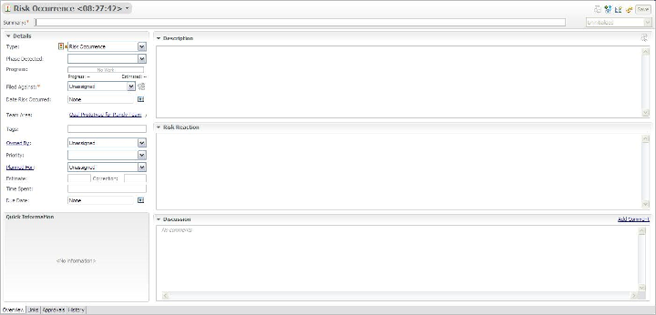
Figure 13: Risk Occurrence Work Item Presentation, Overview tab

Screenshots related to “Links”, “Approvals”, “History” and “Time Tracking” tabs are not included as they are provided out of the box in RTC.

Presentation design
The following table shows the field mapping between the OPAL work product (Risk Occurrence template) and the customized Risk Occurrence work item in RTC.
OPAL field name | RTC implementation
Project Name | Timeline name / Filed Against.  The timeline name in RTC is used to group all project related artifacts together. Additionally, the project name is also defined as a category and is selected in the Filed Against attribute.
Project/Work Order No. | Project Area description.  Additional project attributes including work order, organization unit, etc. can be listed in a row format (in case of multiple projects within a project area) within the project area description.
Application Name / acronym | This is set via categories.  Background: You can create a Project Name category and have sub categories for the application or components
Project Manager | Project Manager role.  The Project Manager field in OPAL is represented by the Project Manager role in RTC and all Project Managers for a project can be viewed by looking at the roles assigned in the project or team area. When a Project Manager is the active owner of a work item, the person’s name appears in the Owner attribute on the work item.  RTC provides ability to view individual attributes and see their respective role.
Project Phase | Phase Detected.  Enumeration.  Values:  - Code  - Design  - Install  - Maintain  - Project Management  - Requirements  - Test  - Not Assessed (represents no value specified) –default value-
Project Organizational Unit | Project Area description.  Additional project attributes including work order, organization unit, etc. can be listed in a row format (in case of multiple projects within a project area) within the project area description.
Risk Occurrence ID | Id.  Automatically assigned.
Short description | Summary (a.k.a. risk occurrence title).
Associated Risk | Links.  List of related work items, including risk definitions and/or action items.
Date Occurred | Risk Date Occurred.  Date attribute.
Status | Status plus  Resolution Code
Risk Occurrence Description | Description.  Text attribute.
Risk Reaction Description | Risk Reaction.  Text attribute.
Target Date | Due Date
Owner | Owned By
Related Actions  (#, Owner, Target Date, Comments, Completion Date) | Links.  List of related work items, including risk definitions and/or action items.
Risk Occurrence History  (Date, Comments) | History plus Discussion.  All changes to the work item are tracked on the History tab.
- | Progress.  Progress bar, based on estimated effort and time spent.
- | Filed Against
- | Project Area
- | Team Area
- | Creation Date.  Automatically assigned when the work item is saved the first time.
- | Created By.  Automatically assigned when the work item is saved the first time.
- | Tags
- | Priority.  Enumeration.  Values:  - Critical  - High  - Medium  - Low  - Not Assessed (represents no value specified) –default value-
- | Planned For.  Product Release/Iteration when the risk occurrence is planned for.
- | Estimate plus Correction
- | Time Spent
- | Constraint Type
- | Constraint Date
- | Planned Start Date
- | Planned End Date
- | Resolution Date
- | Resolved By
- | Discussion
- | Resolution
- | Attachments.  List of attachments with additional information.
- | Links.  List of related work items.
- | Approvals.  List of approval cycles with the appropriate exit decisions.
- | History.  History of changes made to the work item.
- | Time Tracking.  Feature to record time for a work item.
Figure 14: Description of attributes in a risk occurrence presentation

The Lifecycle

Workflow
The following state transition diagram represents a risk occurrence lifecycle within RTC, from the “New” state to the “Closed” state.
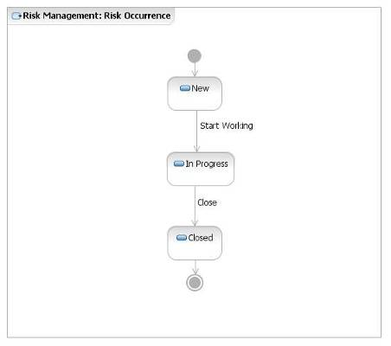
Figure 15: Risk Occurrence Workflow

Permissions to execute actions
RTC provides a way to restrict workflow actions to specific “roles”. The following restrictions are implemented:

Action | Permission
Create “Risk Occurrence” work item | Anyone with Project Manager role.
Delete “Risk Occurrence” work item | Once a Risk Occurrence work item has been created, it cannot be deleted by anyone.
Modify “Risk Occurrence” work item | Anyone within the project team, with any of the following roles:  - Analyst  - Architect  - Developer  - Project Manager  - Tester  - Team Lead  - Software Release Manager  (The person specified in the Owner attribute will be responsible for implementing specific actions.).  IMPORTANT: A work item should not be changed once it is in a final state (i.e. Closed). If the change is needed, it requires justification and approval from the Project Manager.
Actions associated to “Risk Occurrence” workflow:  - Start Working | Anyone within the project team, with any of the following roles:  - Analyst  - Architect  - Developer  - Project Manager  - Tester  - Team Lead  - Software Release Manager  (The person specified in the Owner attribute will be responsible for implementing specific actions.)
Actions associated to “Risk Occurrence” workflow:  - Close | Anyone with the Project Manager role.
Figure 16: List of roles authorized to execute actions in the risk occurrence workflow

States
The following table defines each of these states.
State | Definition
New | A risk occurrence is New if the Project Manager has identified and logged the work item in RTC. No other action has taken place at this state.
In Progress | A risk occurrence is In Progress if a Resolution Owner has been identified, assigned, and the owner is working on the work item.
Closed | A risk occurrence is Closed when the Project Manager has verified that the work item no longer requires attention.
Figure 17: Description of states existing in the risk occurrence workflow

Required attributes for each state
There is a minimum set of required attributes in order to submit a risk occurrence. Depending on which state the work item moves to, the user may need to complete additional required attributes. The table below describes the required attribute for each state.

To move a work item to the state… | The required attributes are…
New  (and all states) | Phase detected  Description  Summary  Filed Against  Important: This set of attributes is called “Default required attributes”.
In Progress | Default required attributes +  Owned By
Closed | Default required attributes +  Owned By
Figure 18: List of required attributes for each state in the risk occurrence workflow

Time tracking for work items
You can use the time tracking feature to record time for a work item.
In the work item editor, you can enter the number of hours per day that you spend on a work item. You can associate each time entry with one or more time codes. Time codes are defined categories against which you can record time for different activities of a work item. For example, you might organize your regular work into these categories: development, review, and testing. If you have sufficient security access, you can add or delete time codes in the project area editor.
The Quick Information section displays the weeks for which time is entered for a work item. The total number of hours that are entered for a week and the total number of hours that are entered for a work item are also displayed in the Quick Information section. To access the time entries, click a specific week.
Remember: To enter time for a work item, you must be the owner of that work item. For example, in a work item that you own, you enter time entries. Later, the ownership of the work item is assigned to another person. You can still edit your time entries, but cannot add new entries to the week or new rows on the Time Tracking tab. If multiple owners enter time in a work item, their names are displayed against their entries.
You can control the synchronization of the time entries on the Time Tracking tab with the value in the Time Spent attribute. By default, when you enter time for a work item on the Time Tracking tab, that value is reflected in the Time Spent attribute. If you disable the synchronization option, the values in the Time Tracking tab and the Time Spent attribute become independent. If the option to synchronize time is enabled in the middle of a project, the time spent values are overwritten by the time tracking values.

Queries
One kind of action that may be performed using RTC, is searching the risks’ database (risks’ log) using public or personal queries. “Shared queries” are available to the whole team while the ”My queries” are private and available only by the creator. As you write your own queries, you can search risks with specific criteria and create your own layout.
The predefined, shared query provided as part of the RTC process template is:
All Risks
Risk Log
It is located within the “Shared Queries” folder organized into two additional folders: the “Predefined” and the “Individually Shared” as shown below:

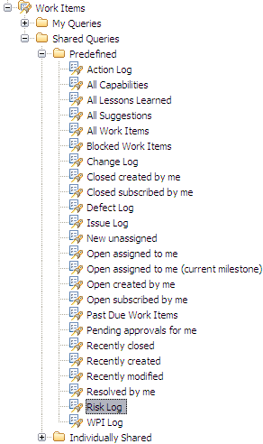
Figure 19: Risk Predefined, Shared Queries

For more details on this query, please refer to the sections below.

All Risks
Description: A list of all of the risk definitions regardless of status.

The “All Risks” query helps practitioners with tracking and managing outstanding risks to closure; so this query can be run on demand for outstanding risks throughout the project’s lifecycle, to ensure the resolution owners are taking prompt and appropriate action to bring the risks to closure.

The base query planned for the solution displays the following columns:

- Id
- Summary
- Classification
- Probability
- Impact
- Exposure
- Priority
- Status
- Resolution
- Owned By
- Modified Date
- Due Date
- Resolution Date

If necessary, the practitioners can create new queries based on this base “log” to show additional columns or to change the searching criteria.

TaskThe picture below shows an example of the “Risk Log” on the RTC Eclipse client.

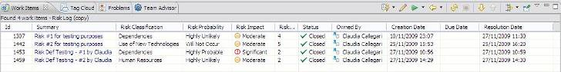
Figure 20: Risk Log query results

ACTION: Tool implementation
A “Task” work item allows users to define and track work. For example, to resolve a risk occurrence, a set of child task work items may be defined and tracked to closure. RTC tasks include a workflow to track status and a time tracking tab to record the hours spent on that work item.

End of document

