
Global Services

Work Product Inspections in Rational Team Concert

Document Control Page
About this document
Produced using Microsoft Word for Windows Version 2003
Doc. Owner: GBS Process, Methods and Tools team

Revision History
Version | Date | Change Description
1.0 | April 2010 | Initial version.
1.1 | October 2010 | Changes to align tool mentor with RTC configuration “IBM Opal 1.2”.
2.0 | Sep 2011 | Changes to align tool mentor with RTC configuration “IBM Opal 2.2”.

Trademarks
IBM, the IBM logo, Rational and the following product names are trademarks of IBM Corporation in the United States, other countries, or both:
IBM Rational Team Concert (RTC)
IBM Rational Quality Manager (RQM)
IBM Rational Requirement Composer (RRC)

Microsoft, Windows, Windows NT, and the Windows logo are trademarks of Microsoft Corporation in the United States, other countries, or both.
Contents

Global Services 1
Work Product Inspections in Rational Team Concert 1
Document Control Page 2
About this document 2
Revision History 2
Trademarks 2
Contents 3
1 Purpose 4
2 Scope 4
3 RTC usage 4
3.1 RTC generic usage 4
3.2 Accessing help on RTC Web client 4
3.3 Accessing help on RTC Eclipse client 4
4 Security 5
5 Work Product Inspections: Tool implementation of the OPAL Procedure 5
5.1 Process roles 5
5.2 Usage Model 6
5.3 Work Product Inspection Work Item 7
5.3.1 Work Product Inspection Form 7
5.3.2 The Lifecycle 14
5.4 Suggestion Work Item 19
5.4.1 Suggestion Form 19
5.4.2 The Lifecycle 21
5.5 Queries 24
5.5.1 All WPI 25
5.5.2 All Suggestions 26
6 CAPABILITY: Tool implementation 26
7 Task: Tool implementation 27

Purpose
This document provides guidance on changes within the IBM GBS Standard Delivery Solution (OPAL) configuration of IBM Rational Team Concert (RTC hereafter) in support of the OPAL work product inspection procedure. It also provides project direction on leveraging RTC in support of work product inspections.
This document does not replace nor cover all of the steps defined in the OPAL procedure. To fully understand this document, it should be read in conjunction with the procedure. Please be aware that this OPAL procedure may contain additional steps that take place outside of RTC and are not duplicated here.

Scope

The guidance assumes a basic understanding of how to use RTC and is not intended to be training material. This tool mentor references the GBS Standard Delivery Solution (OPAL) RTC configuration release 2.2. This configuration supports the OPAL work product inspection procedure as part of OPAL release 15.3.

RTC usage

RTC generic usage
RTC may be accessed either directly via the Eclipse Client or via the Web interface. For performance reasons, the recommended interface, especially for hosted environments, is the RTC web client.

Accessing help on RTC Web client
In order to access the RTC help, hover over the Help button (the one with the question mark icon), and click the “Help Contents” option.
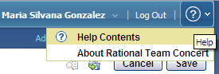
Figure 1: Help on RTC web client

Accessing help on RTC Eclipse client
In RTC Eclipse client, it is necessary to click the Help menu in order to see its different options.
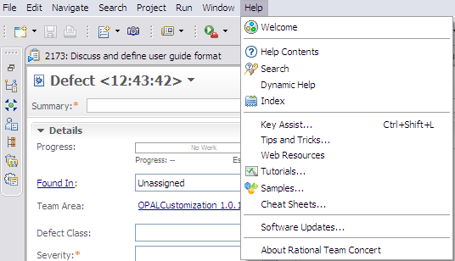
Figure 2: Help on RTC Eclipse client

Security
By default, only the members of the project area hierarchy have read access to the project area and its work items. If you grant access to members of the project area hierarchy, anyone who adds a member to any team will implicitly grant access to the entire project. The access control feature can be used to change this default and grant read access using other criteria.

Sometimes, a work item’s creation, deletion and/or modification are restricted to specific process roles within the project. These policies are different depending on the solution. For details on this topic, please refer to the “Permissions to execute actions” section within this document.

Work Product Inspections: Tool implementation of the OPAL Procedure

Process roles
This solution allows the Administrator to allocate one or more RTC roles to members of your project. Each role selection may provide or deny access to specific RTC features.
The following graphic provides a list of available roles within this solution.

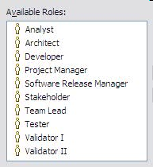
Figure 3: Predefined RTC Process Roles

The following table describes the mapping between the roles defined by the OPAL procedure and the ones implemented within the solution.
Role defined in the OPAL procedure | Roles implemented within the solution
Facilitator | Usually any role listed above as available in the solution, except Stakeholder.  The Facilitator assigned to a specific work product inspection is captured in the “Facilitator” attribute.
Inspector | Usually any role listed above as available in the solution, except Stakeholder.  The Inspectors assigned to a specific work product inspection are captured in the “Inspectors” attribute.
Project Manager | Project Manager
Project Team Member | Usually any role listed above as available in the solution, except Stakeholder.
Figure 4: Process Roles mapping

Usage Model
Work Product Inspection solution within RTC is composed of one main work item type, and others related to it:
- Work Product Inspection (the main work item type)
- Suggestion
- Other RTC work items like: Issue Document, Defect, Risk Definition, Task, etc.

When a work product needs to be reviewed, a Work Product Inspection work item is created in RTC. After completing the required attributes, the inspection is saved, and it is placed in “Draft” state.

If the Inspector has been designated and the author responsible for the work product has provided it, then the inspection can start. The objective is find defects, identify issues and risks and suggest improvements to increase the quality of the work product as early in the software development lifecycle as possible.

Once the inspection is complete, participants meet for a Peer Review. During the meeting, the material is presented for its review by the Presenter. The Facilitator leads and ensures the objectives are achieved within the scheduled time and the Recorder is responsible for taking minutes. Afterward, an exit decision can be taken.

The Work Product Inspection work item in RTC is used to:
- Detail the work product information
- State the participants and meeting arrangements
- Record the peer review details (including the creation of related Defect, Issue Document, Risk Definition and/or Suggestion work items
- Document the final decision

Last, when the inspection is finished, the Work Product Inspection work item in RTC can change its status to “Closed”.

Work Product Inspection Work Item
When an inspection starts, it is documented using the “Work Product Inspection” work item. During the review, any identified work items like issues, risks, defects, etc. are created.

Work Product Inspection Form

Presentation layout
Inspection information is collected using the “Work Product Inspection” work item. On its form, the attributes are organized into different tabs and sections.

The screenshots below show the organization of the attributes across the tabs, using RTC Eclipse client. Note that most of the screenshots presented here are shown when you create the work item the first time so mandatory attributes (the ones with the red asterisk, *) may change based on state.
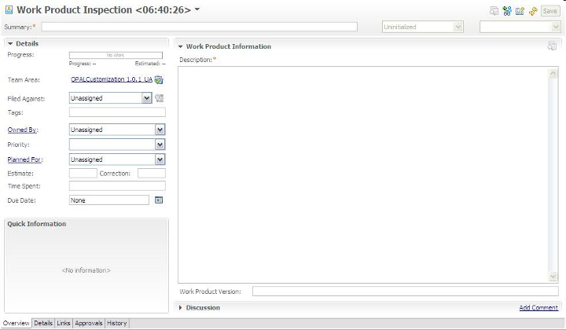
Figure 5: Work Product Inspection Work Item Presentation, Overview tab
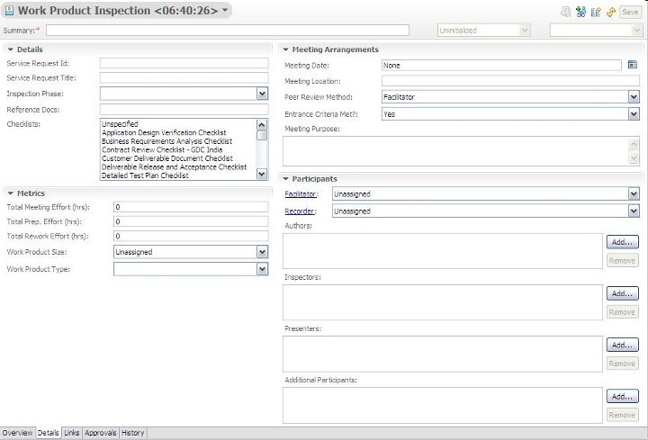
Figure 6: Work Product Inspection Work Item Presentation, Details tab

Screenshots related to “Links”, “Approvals”, “History” and “Time Tracking” tabs are not included as they are out of the box RTC tabs.

Presentation design
The following table shows the field mapping between the OPAL work product (Work Product Inspection) and the customized Work Product Inspection work item in RTC.
OPAL field name | RTC implementation
Project Name | Timeline name / Filed Against.  The timeline name in RTC is used to group all project related artifacts together. Additionally, the project name is also defined as a category and is selected in the Filed Against attribute.
Project Manager | Project Manager role.  The Project Manager field in OPAL is represented by the Project Manager role in RTC and all Project Managers for a project can be viewed by looking at the roles assigned in the team area. When a Project Manager is the active owner of the work item, the person’s name appears in the Owner attribute.  RTC provides ability to view individual attributes and see their respective role.
Author | Created By.  Automatically assigned when the work item is saved the first time.  Note: This attribute represents the person who has created the inspection work item. If different from the author, it can be documented in the “Participants” section.
Date Created | Creation Date.  Automatically assigned when the work item is saved the first time.
Meeting date | Meeting Date
Meeting start time / Meeting end time | Due to RTC limitations, it is not possible to define timestamp attributes to track start/end times. Fortunately, there is the “Total Meeting Effort” attribute, which is capturing the duration of the meeting. This attribute, together with the “Meeting date” attribute, where you can specify the meeting date using the calendar, provides a temporary workaround.
Venue | Meeting Location.  Text attribute.
Entrance Criteria Met? (Yes/No) | Entrance Criteria Met?.  Enumeration.  Values:  - Yes –default value-  - No
Purpose | Meeting Purpose.  Text attribute.Entrance Criteria Met?  Enumeration, with “Yes” as default value.  Values:  - Yes  No
Peer Review Method | Peer Review Method.  Enumeration.  Values:  - Buddy  - Facilitator –default value-  - Team  Note: As mentioned in Appendix A of the Work Product Inspection procedure:  "The Peer Review Method is a function of the size of the work product to be reviewed and the risk level of the project."  This appendix provides a table with recommended types of review for each case. Please refer to that guidance and decide the best type of review for the work product under inspection. This is a decision you have to take, and not something that the tool will automate.
Service Request/RFSPMT | Service Request id.  Text attribute.
Service Request title | Service Request Title.  Text attribute.
Project name or subject of request | Same as previous “Project Name”.
Application acronym | This is set via categories.  Background: You can create a Project Name category and have sub categories for the application or components
Inspection Phase | Inspection Phase.  Enumeration.  Values:  - Code  - Deploy  - Design  - Install  - Maintain  - Project Management  - Requirements  - Test  - Not Assessed (represents no selected value) –default value-
Work product identifier and brief description | Description
Version | Work Product Version.  Text attribute.
Checklists used for review | Checklists.  Enumeration. No value selected as default.  Values:  - Unspecified  - Application Design Verification Checklist  - Business Requirements Analysis Checklist  - Contract Review Checklist - GDC India  - Customer Deliverable Document Checklist  - Deliverable Release and Acceptance Checklist  - Detailed Test Plan Checklist  - Document Authoring Checklist - PDO  - Documentation Verification Checklist  - Estimating Considerations Checklist  - Infrastructure Architecture Verification Checklist  - Inspection Process Checklist  - Master Test Plan Checklist  - PM Structure Plans Review Checklist - AMS US  - Product Integration Checklist  - Project Monitoring and Control Checklist  - Project Plans Review Checklist  - Requirement Verification Checklist  - Source Code Verification Checklist  - Stakeholders Needs Checklist  - Systems Architecture Checklist  - Systems Engineering Management Plan Checklist  - Test Case Checklist  - Test Strategy Checklist  - Work Request Test Plan Checklist – PDO  - Other
Reference docs | Reference docs.  Text attribute.
Inspection role:  Facilitator  Author  Presenter  Recorder  Inspector | See “Name” attribute below.
Name | Facilitator  Recorder.  Each of these attributes keeps the user name performing the specific role within the review. Each user name is selected from a list of users.  Single selection.
Name | Authors  Presenters  Inspectors.  Each of these attributes keeps the user names performing the specific roles within the review. Each user name is selected from a list of users.  Multiple selections.
- | Additional Participants.  Multiple selection lists to include additional participants not considered within the previous review roles.
Technical role | Not implemented.
Signature | Approvals.  RTC approval capability leveraged for this.
Preparation effort (hs) | As the number of participants could vary, the total effort will be tracked via the “total preparation effort” attribute.
Decision | Status plus Resolution code
Remarks | Discussion plus Meeting minutes
Dates | History.
Signatures | Approvals.  RTC approval capability leveraged for this.
Date | Approvals plus History
Total preparation effort | Total Prep. Effort (hrs)  The value should be a number greater or equal than 0.
Meeting effort  (duration x nbr. Of attendees) | Total Meeting Effort (hrs)  The value should be a number greater or equal than 0.
Total rework effort | Total Rework Effort (hrs)  The value should be a number greater or equal than 0.
Work product size | This information is captured using the following attributes:  - Work Product Size (value): it tracks the value of the size itself. 0 is the default value. It should be greater or equal than 0.  - Work Product Size (unit of measure): It expresses the unit of measure for the previous value. Enumeration.  Values:  - Complexity  - Function Points (FP)  - Kilo Lines Of Code (KLOC)  - Pages  - Service Points  - Test cases  - Test scripts  - Use cases  - Other  - Not Assessed (represents no selected value) –default value-  - Other Unit of Measure: This text attribute should be completed only if the value “Other” has been selected from the “Work Product Size (unit of measure)” attribute.
Number of Sev.1 defects | This value can be calculated.  It depends on the severity one children defects related to this inspection.  When you associate a Work Product Inspection work item to a Defect work item you will have the following:  - On the Work Product Inspection form –> Links tab: A list of all associated defects, each of them showing the work item type icon plus unique id plus summary  - On the associated Defect form → Links tab: A list of all associated work product inspections, each of them showing the work item type icon plus unique id plus summary
Number of Sev.2 defects | This calculated value is similar to the previous row, but for severity two children defects.
Number of Sev.3 defects | - This calculated value is similar to the previous rows, but for severity three children defects.
Work Product Type | Work Product Type.  Enumeration.  Values:  - Code  - Detail Design  - External Design  - Installation Plan  - Internal Design  - Requirements  - Test Case  - Test Plan  - Others  - Not Assessed (represents no selected value) –default value-
Information related to identified issues | Links.
Information related to identified risks | Links.
Information related to identified suggestions | Links.
- | Id.  Automatically assigned.
- | Progress.  Progress bar, based on estimated effort and time spent.
- | Project Area
- | Team Area
- | Filed Against
- | Tags
- | Owned By
- | Priority.  Enumeration.  Values:  - Critical  - High  - Medium  - Low  - Not Assessed (represents no selected value) –default value-
- | Planned For.  Product Release/Iteration when the change request is planned for.
- | Estimate plus Correction
- | Time Spent
- | Constraint Type
- | Constraint Date
- | Planned Start Date
- | Planned End Date
- | Due Date
- | Summary (a.k.a. work product inspection title).
- | Status
- | Resolution
- | Resolved By
- | Resolution Date
- | Attachments
- | Links
- | Approvals
- | History.  History of changes made to the work item.
- | Time Tracking.  Feature to record time for a work item.
Figure 7: Description of attributes, part of work product inspection presentation

The Lifecycle

Workflow
The following state transition diagram represents a work product inspection lifecycle within RTC, from the “Draft” state to the “Closed” state.
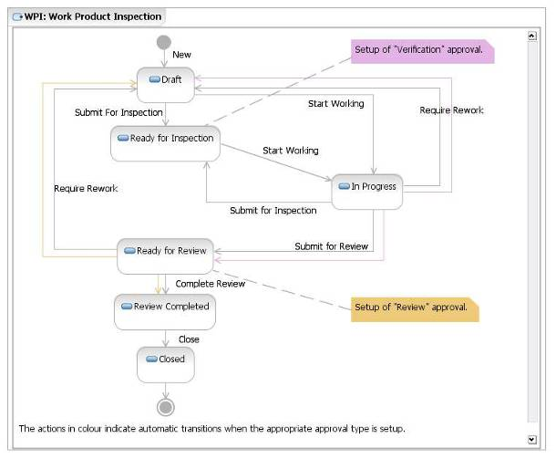
Figure 8: Work Product Inspection Workflow

Permissions to execute actions
RTC provides a way to restrict workflow actions to specific “roles”. The following restrictions are implemented:

Action | Permission
Create “Work Product Inspection” work item | Users with any of the following roles:  - Analyst  - Architect  - Developer  - Project Manager  - Tester  - Team Lead  - Software Release Manager
Delete “Work Product Inspection” work item | Once a Work Product Inspection work item has been created, it cannot be deleted by anybody.
Modify “Work Product Inspection” work item | Users with any of the following roles:  - Analyst  - Architect  - Developer  - Project Manager  - Tester  - Team Lead  - Software Release Manager  IMPORTANT: A work item should not be changed once it is in a final state (i.e. Closed).
Actions associated to “Work Product Inspection” workflow. | Users with any of the following roles:  - Analyst  - Architect  - Developer  - Project Manager  - Tester  - Team Lead  - Software Release Manager
Figure 9: List of roles authorized to execute actions of work product inspection workflow

States
The following table defines each of the inspection states.
State | Definition
Draft | A work product inspection has a Draft status if the work product is being registered but it is not ready for inspection.
Ready for Inspection | The work product inspection has a Ready for Inspection state if the work product is ready for inspection and the defined inspectors can start the revision.
In Progress | A work product inspection is In Progress if:  + The work product is being inspected (Under Inspection)  + The work product has ongoing rework, which needs to be finished before resubmitting the work product for inspection (In Rework)
Ready for Review | The work product inspection is complete and ready for peer review meeting.
Under Peer Review | The work product inspection is under peer review.
Review Completed | The work product inspection has finished the peer review and an exit decision has been taken.
Closed | The work product inspection has finished and closed.
Figure 10: Description of states existing in work product inspection workflow

Resolution codes
A resolution code completes the status information for a given inspection.

The table below shows the available resolution codes for the actions where they are defined in the inspection workflow.

Action Name | Target State | Resolution Codes | Comments
Start Working | In Progress | Under Inspection  In Rework
Require Rework | Draft | Reject & Fix Sev. 1, 2 and 3 Defects  Reject and Re-Inspect
Complete Review | Review Completed | Accept As-Is  Accept & Fix Sev. 4 Defects
Figure 11: List of resolution codes used in work product inspection workflow

Approval tracking processes
RTC provides a way to customize approval tracking processes that team members follow as they work on work items. Depending on the decision taken by each team member participating in the approval cycle for a work item, the work item’s state can automatically be moved to a new state.

The list of approvers for a particular approval type is defined within the “Approvals” tab.

The table below describes the approval types defined for the “Work Product Inspection” workflow.

Approval Type | Decision | Action (Approval Target State) | Comments
Verification | Approved | Submit for Review (Ready for Review) | This approval type is used for an inspection.  If the verification is approved, the work item is moved to the “Ready For Review” state (after ALL the inspectors approved the work item). If the verification is rejected by any inspector, the work item is moved to a “Draft” state.  If any approval is still pending, it does nothing.  This approval type is available when you are performing a “Submit for Inspection”.
Verification | Rejected | Require Rework (Draft)
Verification | Pending | None
Review | Approved | Complete Review (Review Completed) | This approval type is used for the final review.  If the review is approved, the work item is moved to the “Review Completed” state (after ALL the approvers have approved the work item). If the review is rejected by any approver, the work item is moved to a “Draft” state.  If any approval is still pending, the work item keeps the current state.  This approval type is available when you are performing a “Submit for Review”.
Review | Rejected | Require Rework (Draft)
Review | Pending | Submit For Review (Ready for Review)
Figure 12: Description of approval tracking processes related with work product inspection workflow

Required attributes for each state
There is a minimum set of required attributes in order to submit a work product inspection. Depending on which state the work item moves to, the user may need to complete additional required attributes. The table below describes the required attribute for each state.

To move a work item to the state… | The required attributes are…
Draft  (and all states) | Summary  Important: This set of attributes is called “Default required attributes”.
Ready For Inspection | Default required attributes +  Description  Filed Against  Planned For  Inspection Phase  Checklists  Work Product Type  Author  Inspector (there should be at least 1 inspector for the work product inspection regardless the peer review method)
In Progress | The same as for “Ready For Inspection”
Ready For Review | The same as for “In Progress”
Review Completed | The same as for “Ready For Review”
Closed | The same as for “Review Completed”
Figure 13: List of required fields for each state in the work product inspection workflow

Time tracking for work items
You can use the time tracking feature to record time for a work item.
In the work item editor, you can enter the number of hours per day that you spend on a work item. You can associate each time entry with one or more time codes. Time codes are defined categories against which you can record time for different activities of a work item. For example, you might organize your regular work into these categories: development, review, and testing. If you have sufficient security access, you can add or delete time codes in the project area editor.
The Quick Information section displays the weeks for which time is entered for a work item. The total number of hours that are entered for a week and the total number of hours that are entered for a work item are also displayed in the Quick Information section. To access the time entries, click a specific week.
Remember: To enter time for a work item, you must be the owner of that work item. For example, in a work item that you own, you enter time entries. Later, the ownership of the work item is assigned to another person. You can still edit your time entries, but cannot add new entries to the week or new rows on the Time Tracking tab. If multiple owners enter time in a work item, their names are displayed against their entries.
You can control the synchronization of the time entries on the Time Tracking tab with the value in the Time Spent attribute. By default, when you enter time for a work item on the Time Tracking tab, that value is reflected in the Time Spent attribute. If you disable the synchronization option, the values in the Time Tracking tab and the Time Spent attribute become independent. If the option to synchronize time is enabled in the middle of a project, the time spent values are overwritten by the time tracking values.

Suggestion Work Item
Derived from Work Product Inspection process, all the suggestions for adding value to a work product area are captured using a “Suggestion” work item.

Suggestion Form

Presentation layout
Suggestion information is collected using the “Suggestion” work item. On its form, attributes are organized into different tabs and sections.

The screenshots below show the organization of the attributes across the tabs, using RTC Eclipse client. Note that most of the screenshots presented here are shown when you create the work item the first time so mandatory attributes (the ones with the red asterisk, *) may change based on state.
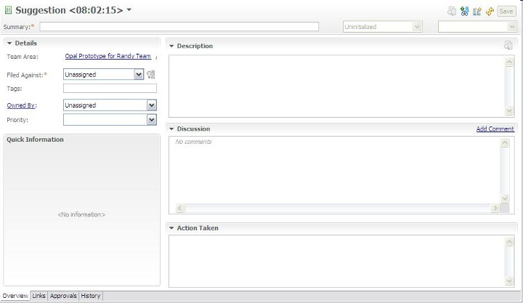
Figure 14: Suggestion Work Item Presentation, Overview tab

Screenshots related to “Links”, “Approvals” and “History” tabs are not included as they are out of the box tabs in RTC.

Presentation design
The following table shows the field mapping between the OPAL Suggestion work product and the customized Suggestion work item in RTC.
OPAL field name | RTC implementation
Suggestion Number | Id.  Automatically assigned.
Relevant location | If different to the current repository, it can be documented in the “Discussion” or “Description” attribute.
Description | Description
Originator’s name | Created By.  If different from “Created By”, it can be documented in the “Discussion” or “Description” attribute.
Action Taken | Action Taken.  Text attribute
- | Summary (a.k.a. suggestion title).
- | Project Area
- | Team Area
- | Filed Against
- | Tags
- | Owned By
- | Priority.  Enumeration.  Values:  - Critical  - High  - Medium  - Low  - Not Assessed (represents no selected value) -default value-
- | Creation Date.  Automatically assigned when the work item is saved the first time.
- | Created By.  Automatically assigned when the work item is saved the first time.
- | Status
- | Resolution Date
- | Resolved By
- | Discussion.  It maintains the history of all discussions related to the specific work item.
- | Resolution
- | Attachments.  List of attachments with additional information.
- | Links.  List of related work items.
- | Approvals.  List of approval cycles with the appropriate exit decisions.
- | History.  History of changes made to the work item.
Figure 15: Description of attributes, part of the Suggestion presentation

The Lifecycle

Workflow
The following state transition diagram represents a suggestion lifecycle within RTC, from the “Open” state to the “Closed” state.
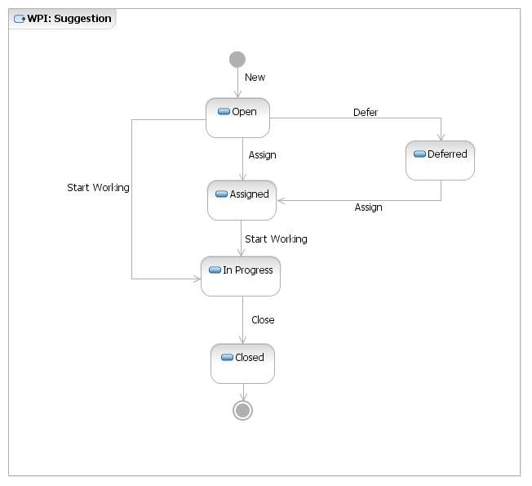
Figure 16: Suggestion Workflow

Permissions to execute actions
RTC provides a way to restrict workflow actions to specific “roles”. The following restrictions are implemented:

Action | Permission
Create “Suggestion” work item | Users with any of the following roles:  - Analyst  - Architect  - Developer  - Project Manager  - Tester  - Team Lead  - Software Release Manager
Delete “Suggestion” work item | Once a Suggestion work item has been created, it cannot be deleted by anyone.
Modify “Suggestion” work item | Users with any of the following roles:  - Analyst  - Architect  - Developer  - Project Manager  - Tester  - Team Lead  - Software Release Manager  A work item should not be changed, once it is in a final state (e.g. Closed).
Actions associated to “Suggestion” workflow. | Users with any of the following roles:  - Analyst  - Architect  - Developer  - Project Manager  - Tester  - Team Lead  - Software Release Manager
Figure 17: List of roles authorized to execute actions of the Suggestion workflow

States
The following table defines each suggestion state.
State | Definition
Open | A suggestion has Open status if an idea for adding value to a work product has been identified and logged it into RTC. No other action has taken place in this state.
Deferred | A suggestion is Deferred if it cannot be implemented for any reason (e.g. a dependency), and a final decision will take place in the future.
Assigned | A suggestion is Assigned if a Resolution Owner has been identified and assigned to work with it.
In Progress | A suggestion is In Progress if the improvement is being analyzed and/or, if it is valid, its implementation is ongoing.
Closed | A suggestion is Closed when:  - It has been rejected because it’s invalid  - It is not longer accurate or is obsolete  - The work to implement the improvement is complete  And it no longer requires attention.
Figure 18: Description of states existing in the Suggestion workflow

Resolution codes
A resolution code completes the status information for a given change order.

The table below shows the available resolution codes for the actions where they are defined in the suggestion workflow.

Action Name | Target State | Resolution Codes | Comments
Close | Closed | Complete  Obsolete  Rejected
Figure 19: List of resolution codes used in the Suggestion workflow

Required attributes for each state
There is a minimum set of required attributes in order to submit a suggestion. Depending on which state the work item moves to, the user may need to complete additional required attributes. The table below describes the required attribute for each state.

To move a work item to the state… | The required attributes are…
Open  (and all states) | Summary  Description  Filed Against  Important: this set of fields is called “Default required attributes”.
Deferred | Default required attributes
Assigned | Default required attributes +  Owned By
In Progress | Default required attributes +  Owned By
Closed | Default required fields +  Owned By plus  Action Taken
Figure 20: List of required attributes for each state in the Suggestion workflow

Queries
One kind of action that may be performed using RTC, is searching the work product inspections’ database (work product inspections’ log) using public or personal queries. “Shared queries” are available to the whole project or team while ”My queries” are private and available only to the creator. As you write your own queries, you can search for inspections and suggestions with specific criteria and create your own layout.
The predefined, shared queries provided as part of the RTC process template are:
- All WPI
- All Suggestions
It is located within the “Shared Queries” folder organized into two additional folders: the “Predefined” and the “Individually Shared” as shown below:

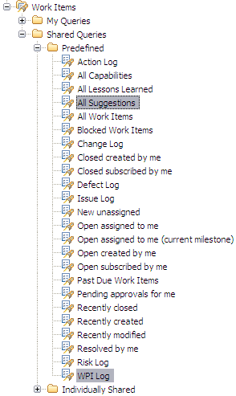
Figure 21: Work Product Inspection & Suggestion Predefined, Shared Queries

For more details on each query, please refer to the sections below.

All WPI
Description: A list of all of the work product inspections regardless of status.

The “All WPI” query helps practitioners with tracking and managing outstanding inspections to closure. This query can be run on demand for outstanding inspections throughout the project’s lifecycle, to ensure the appropriate actions are taken to bring the inspection to closure.

The base query planned for the solution displays the following columns:

  - Id
  - Summary
  - Status
  - Resolution
  - Peer Review Method
  - Total Meeting Effort (hrs
  - Total Prep. Effort (hrs)
  - Total Rework Effort (hrs)

If necessary, practitioners can create new queries based on this base “log” to show additional columns or to change the searching criteria.

The picture below shows an example of the “WPI Log” on the RTC Eclipse client.

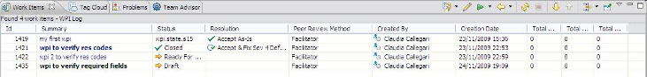
Figure 22: WPI Log query results

All Suggestions
Description: A list of all of the suggestions regardless of status.

An “All Suggestions” query helps practitioners with tracking and managing outstanding suggestions to closure. This query can be run on demand for outstanding suggestions throughout the project’s lifecycle, to ensure the appropriate actions are taken to bring the suggestion to closure.

The base query planned for the solution displays the following columns:

  - Id
  - Status
  - Priority
  - Summary
  - Owned By
  - Created By

If necessary, practitioners can create new queries based on this base “log” to show additional columns or to change the searching criteria.

Plan ItemThe picture below shows an example of the “Suggestions Log” on the RTC Eclipse client.

Figure 23: All Suggestions query results

CAPABILITY: Tool implementation
When the need for a new feature is identified, it is documented using the “Plan Item” work item.

This work item contains the definition, written in everyday language, of new functionality to be built in an iteration (or development cycle). It is used to drive the plan item’s workload and to estimate its effort. This definition is meant to help the reader to understand what the solution should accomplish.

A “Plan Item” work item could be decomposed into a set of independent and/or child work items.
These plan items can also be linked to formal requirements in Rational Requirements Composer or used independently if traceability to formal requirements is not necessary.

Task: Tool implementation
A “Task” work item allows users to define and track work. For example, to resolve a suggestion, a set of child task work items may be defined and tracked to closure. RTC tasks include a workflow to track status and a time tracking tab to record the hours spent on that work item.

End of document

