Organizational breakdown structure template
for
PROJECT / SUB-PROJECT
PROJECT / SUB-PROJECT MANAGER

Version number | N.N
Draft/Final as of | dd/mmm/yy
Printed on | dd/mmm/yy
Author | Author’s name  Author’s address  Author’s e-mail  Author’s telephone number
Owner | Owner’s name

Document information
Document source
This document is maintained as an online document. Contact the author for the latest version.
Revision history
Version number | Date | Summary of changes | Revision marks
n.n | dd mmm yy | First version | No
Approvals
This document has been approved by the following people. The signed approval forms are filed in the Project Control Book.
Name | Function | Date of approval | Signature
Distribution
This document has been distributed to:
Name | Function

- Preface
The project is organized into n project organizational units. Each project organizational unit is assigned one or both of the responsibilities of:
completing one or more sub-projects
managing one or more other project organizational units.
The Organizational breakdown structure (OBS) identifies the project organizational units and sub-projects and defines:
the hierarchical reporting relationships between the project organizational units
the sub-projects for which each project organizational unit is responsible
the structure of the teams within the project organizational units.
The purpose of the Organizational breakdown structure (OBS) is to provide an agreed definition of the division of responsibilities within the project.
- Sponsor organization
In the following sub-sections provide information about the sponsor organization as it relates to the project. This includes information about the reporting structure of the stakeholders from the sponsor’s organization.
  - Sponsor organization chart
Draw a chart that identifies the key stakeholders in the sponsor organization and shows any special reporting relationships. Note: You may be able to use existing sponsor documents to provide this information.
  - Sponsor functional interfaces
Provide information about each key stakeholder in the sponsor organization, including their name, the department within the sponsor organization to which they belong, their role, and their responsibility and authority.
Name | Department | Role | Responsibility and authority

- Project organization
Provide information about the overall project organization identifying the project organizational units, the sub-projects, and the relationships between them. A project organizational chart, like the one below, is a useful way to show this information.
  - Project organization chart

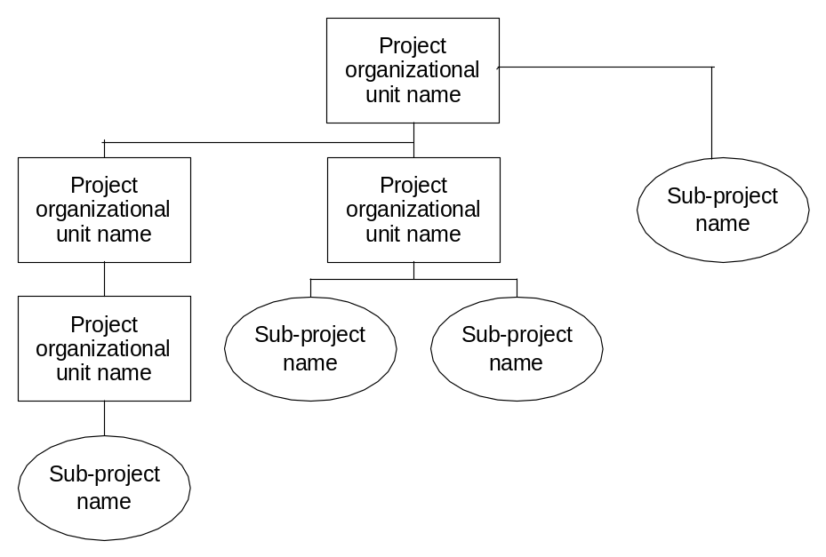

- Project organizational units
Complete one instance of the following information for each project organizational unit (POU) within the project.
  - POU organization chart
A diagram showing the team structure of the project organizational unit.
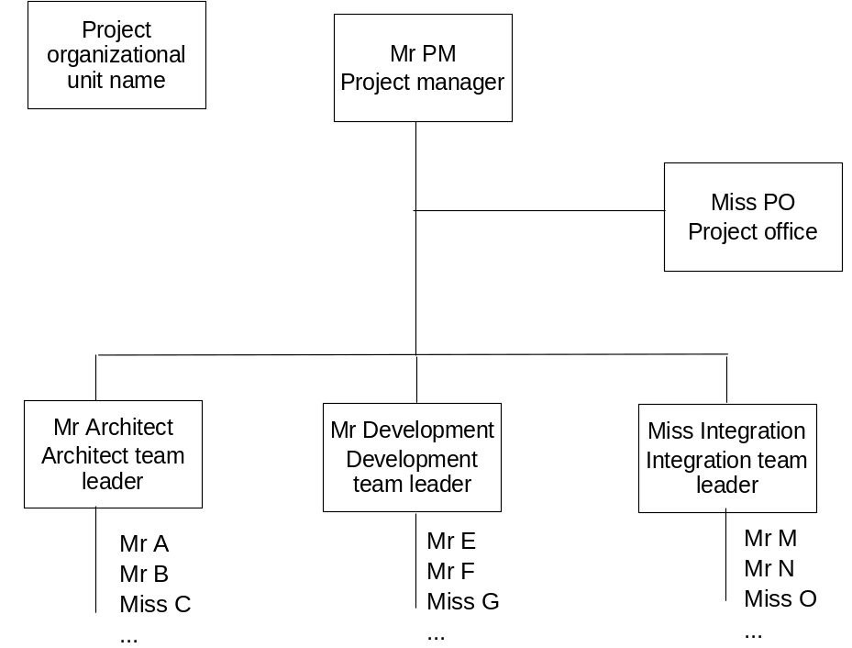

  - POU identification
Provide the following key information about the project organization unit.
Project organizational unit
Performing organization
Summary of responsibilities | Describe the major responsibilities of the project organizational unit.
Team members
Role | Name | Team | Responsibility and authority
Project manager
Architect
Business analyst

  - Sub-projects
Complete one instance of the following table for each sub-project for which the project is responsible.
Sub-project
Objectives | List the key objectives of the sub-project.
Key work products | Work product name
  - Teams
Complete one instance of the following table for each team within the project organizational unit. This is only necessary for large projects with multiple teams.
Team
Summary of responsibilities | Describe the responsibilities of the team, referring to the sub-projects if appropriate.
- Delivery organization
Provide information about each key functional interface in the delivery organization, including their name, the department within the delivery organization to which they belong, their role, and their responsibility and authority.
Name | Department | Role | Responsibility and authority
- Performing organization
Provide information about each key interface in the performing organization, including their name, the department within the delivery organization to which they belong, their role, and their responsibility and authority.
Name | Department | Role | Responsibility and authority

