Variations Model

Author: IBM
Owner: IBM

Document History
Document Location
This is a snapshot of an on-line document. Paper copies are valid only on the day they are printed. Refer to the author if you are in any doubt about the currency of this document.
The source of the document will be found in /tmp/lo/0000.doc
Revision History
Date of this revision: 10-14-2008 | Date of next revision (date)

Revision Number | Revision Date | Summary of Changes | Changes marked
3.2 | 10-14-08 | Template extracted out from WPD (Arun Thakore) | (N)
2.1 | June 2005 | Version number synchronized with TP
0.3 | April 2005 | Revised after internal review (David Janson)
0.2 | March 2005 | Modified Description and Purpose (Kavi Nithyanandam)
Prior 1.1 | May 2003 | Formatted in WPD (Ali Arsanjani)
 | June 2001 | Ali Arsanjani
Approvals
This document requires following approvals. Signed approval forms are filed in the Quality section of the PCB.
Name | Title
(name) | (title)
Distribution
This document has been distributed to
Name | Title
(name) | (title)
Contents
1. Introduction 4
1.1 Identification 4
2. Variations Model 5
2.1 Commonality and Variations 5

Introduction
(Template GSA011uk.doc version 1.0 dated 11 June 2001 based on "APP 011 System Context” version 3.0)
Please note that:
- Text in the “Editor’s comments” style (such as this) provides guidance to the editor, in conjunction with the corresponding work product description, and should be removed from the published version of the document.
- The “Reader’s comments” style (in purple) provides guidance for the (client) reader and should be modified as appropriate by the editor to reflect any customization of the template.
- The “Normal” style (in black) should be used by the editor when adding the text describing the (sub)system appropriate for this work product.
When using this template, refer to the Unified Method Framework Global Services Method work product description “Variations Model”.
Variation-oriented analysis (VOA) is a process of identifying aspects of a domain that are subject to change and variation and separating them out from the non-changing aspects of the domain. VOA is performed after modeling the business architecture and determining subsystems in subsystem analysis, defining the overall systems manners and manners for each subsystem. These variations can be captured as text or more precisely as a domain-specific language, which describes the variations of the domain. The process of designing software that supports it is called as Variation Oriented Design (VOD).
The basic principles of variation-oriented design:
1. Separate changing from non-changing aspects of a domain
2. Separate the interface from implementation
3. Reify what changes. If some element of the domain is in constant flux, then it may be warranted to reify that element into a class (or higher layer of reuse).
4. Build assets at each reuse level. The Reuse Levels are: base class, inheritance hierarchy, aggregation hierarchy, cluster, framework, component, pattern, generic architecture.
5. Each reuse element has its own rules of behavior in addition to the meta-data necessary to reflectively and adaptively self-describe the Reuse Element for run-time queries for service capabilities
Application of these rules of VOD help partition the system into changing and non-changing aspects. It makes the application of design pattern easier and enforcing the open-closed principle over the design and implementation.

Identification
This document describes the Variations Model for .

Variations Model

Commonality and Variations

Identify commonality and variability within each subsystem and across subsystems.
There are three types of variations: Process Variation, Data Variation, and Rules Variation.

Common Feature/Function | Relevant Type | Commonalities | Variations | Candidate Services

Figure 1: VOA Commonality and Variations table

The below is an example of the VOA type hierarchy. A similar one must be constructed for the project.
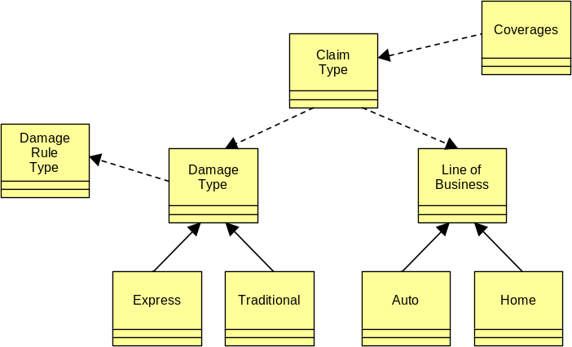
Figure 2: VOA Type Hierarchy

