Complex Systems Integration (CSI) Method Blueprint
CSI Method Adoption Guideline, v3.0

Author: Mark Palser
Owner: Mike James

Document History
Document Location
This is a snapshot of an on-line document. Paper copies are valid only on the day they are printed.
Revision History
Date of this revision: 24 Jan 2010 | Date of next revision:

Revision Number | Revision Date | Summary of Changes | Changes marked
2.1 | 14 April 2009 | First release | No
2.2 | 24 Jan 2010 | Minor revisions | No
Approvals
This document requires the following approvals.
Name | Title
Mike James | Executive ITA, UKI IMT.
Distribution
This document has been distributed to
Name | Title
Mike James | Executive ITA, Chief Architect GBS ASD, UKI IMT.
Mark Palser | Executive ITA, GBS ASD, UKI IMT.
Contents
1. Purpose and Scope 5
2. Overview 6
3. Establish Context for Method Adoption 7
3.1 Overview 7
3.1.1 Understand contracting and requirements approach 7
3.1.2 Understand solution outline 7
3.1.3 Understand method constraints 7
3.2 Understand Contracting and Requirements Approach 8
3.2.1 Requirements elaboration timeline 8
3.2.2 Contracting models 8
3.2.3 Requirements shape, form and quality 8
3.3 Understand Solution Outline 9
3.4 Understand Method Constraints 10
3.4.1 Overview 10
3.4.2 IBM’s position in the organizational structure of the overall program 10
3.4.3 Client mandate for a particular method or an agreed set of deliverables 11
3.4.4 IBM business rules, requiring a certain method for a particular type/value of project. 11
3.4.5 Tooling or (seemingly unrelated) processes being used 11
4. Adopt Method 12
4.1 Overview 12
4.1.1 Adopt CSI Method blueprint as basic structure for method adoption 12
4.1.2 Select methods to combine 12
4.1.3 Define artifacts and align with delivery 12
4.2 Adopt CSI Method Blueprint as Basic Structure for Method Adoption 13
4.3 Select Methods to Combine 15
4.4 Define Artifacts and Align with Delivery 15
4.4.1 Process overview 15
4.4.2 Start with a copy of the CSI Method blueprint 15
4.4.3 Update the blueprint to show the main solution components 15
4.4.4 Group elements of the blueprint 15
4.4.5 Map methods to each group of blueprint elements [high level] 17
4.4.6 Define the method interfaces and how interdependencies will be met [high level] 17
4.4.7 Map method artifacts to blueprint content [detailed] 18
4.4.8 Define how artifact interdependencies will be met [detailed] 18
4.4.9 Create a high level plan 19
5. Communicate and Govern Method Use 20
5.1 Document and Communicate Method-Adoption Outcome 20
5.2 Govern Use of Adopted Method 20

Purpose and Scope
This document provides guidance on adopting method for complex systems integration (CSI) programs. The characteristics and challenges of complex systems integration are set out in the presentation CSI Method Blueprint Overview (currently at version 3.0). This also introduces a framework for complex systems integration called the CSI Method Blueprint.
The focus of this method adoption document is:
- how to combine IBM’s different methods effectively and
- the decisions that drive which methods to combine,
- in the context of the CSI Method blueprint.

Overview
Adopting good method begins with establishing the right context: know the contracting and requirements approach, a basic solution outline and any method constraints, before making method adoption decisions.
Method adoption then proceeds by selecting methods and combining them in the context of the CSI Method blueprint.
To benefit from the adopted method it has to be used: this means documenting the method adoption, communicating the method-related decisions made and then governing method use to make sure it gets properly rolled out, gets traction and gets used.
The flow of activities for method adoption is shown in Figure 1: method adoption activities. This document is structured in the same way.
Establish
Context for Method Adoption
[Section 3]

Adopt
Method
[Section 4]

Communicate and Govern Method Use
[Section 5]

Understand Contracting and Requirements Approach
Understand Method Constraints
Understand Solution Outline
Adopt CSI Method Blueprint as Basic Structure for Method Adoption
Define Artifacts and Align with Delivery
Select Methods to Combine
Govern Use of Adopted Method
Document and
Communicate Method-Adoption Outcome
Figure 1: method adoption activities

Establish Context for Method Adoption

Overview
Good method adoption begins with establishing the right context: know the contracting and requirements approach, a basic solution outline and any method constraints, before making method adoption decisions. These three activities are summarized in sections 3.1.1 to 3.1.3, immediately below, and set out in more detail in sections 3.2 to 3.4, which follow.

Understand contracting and requirements approach
Good method adoption begins with establishing the right context. The way in which the customer’s requirements are defined, elaborated and prioritized will drive the release strategy in the adopted method, determining whether the solution will be delivered as a single, or multiple releases of function. The adopted requirements approach must match the contracting model. For example, if the contract is for fixed price design and build then the requirements will most likely need to be defined in detail before the design.

Understand solution outline
A solution outline partitions the solution into major components and describes the main interactions between them. The solution outline of a complex systems integration solution is a key input for successful method adoption.
Each major system component in a complex IT system could comprise a package (such as SAP), middleware (such as an ESB), an application development on a framework (such as on WebSphere Portal Server) or custom code. Viewing the solution outline as a whole, it will be possible to characterize it as being mostly of one or other type (for example, mostly a package integration engagement).
There is a natural affinity between certain types of delivery and particular methods. For example the Ascendant SAP method is often used for SAP-based engagements. Knowing the solution outline helps quickly identify a set of candidate methods to combine.
A core proposition of the CSI Method blueprint is to use the right component-level methods for each major component and integrate these into an overall method used for the end-to-end engagement.
Understanding the size, complexity and shape of the solution is also important because it will guide in the adoption of an appropriate amount of method: big complex projects need more rigorous method than simpler ones.

Understand method constraints
The client or prime contractor may constrain the method that IBM can adopt, or IBM may constrain it through choice of a particular subcontractor (including other parts of IBM). It is important to understand the organizational breakdown for the overall program, and IBM’s position within it.
There may be other method constraints not driven by the organizational structure of the engagement. The client may want a particular method, process or tool to be used even if no client team is involved in the delivery. Business rules within IBM (which may differ depending on which line-of-business owns the engagement) may mandate a particular method for certain types and value of engagement.

Understand Contracting and Requirements Approach

Requirements elaboration timeline
The timing of when the customer’s requirements are defined, elaborated and prioritized will drive the release strategy for the solution, determining whether it will be delivered as a single, or multiple releases of function. Knowing this will, in turn, guide the configuration needed on the adopted methods and their associated processes.
There are different models for when requirements are defined and elaborated, including:
- Detailed definition as an input to Solution Outline;
- High-level definition as an input to Solution Outline, detailed definition during design;
- High-level definition as an input to Solution Outline, iterative definition during design and build.

Contracting models
Each of the models in the previous section for when requirements are defined and elaborated can be the best approach, but must match the contracting model:
- Only the first approach above would support fixed price design and build from the start of Solution Outline;
- The second would require a time and materials Solution Outline phase before a fixed price contract could be signed for the remaining delivery;
- The third would require a longer period of time and materials work.

Requirements shape, form and quality
Confirming the requirements is one of the first activities in the End-to-End Delivery activity area in the CSI Method blueprint and there is an assumption that some requirements work has been done by that stage.
There are three types of requirements and it is important to understand which types are present and which are not and how these are documented. The candidate methods being considered later will make assumptions about the shape and form of the input requirements, and the way that a method assumes requirements are managed will often be related to how they are expressed. The three types are:
- Sponsor Requirements. These are the “customer’s real business problem”. They trigger the whole problem solving process and are usually expressed in business objectives and in simple terms.
- Contract Requirements. These are “what they asked us to do”. They are often associated with procurement processes and legal issues, and may be expressed as structured requirements lists.
- Delivery Requirements. These are the requirements that the solution is built to: “what we need to know to build the solution”. That is, a sufficient, coherent, consistent definition of what a work package has to achieve expressed through a combination of use cases, NFRs (non-functional requirements), interface definitions and assumptions.
It is important to form a view of the requirement quality so that the method can be tailored to address any areas of concern. The contract requirements should match the delivery requirements. Requirements are often over-specified in procurement (for example, users are encouraged to ask for everything they could want) and the level of specification/over-specification should be compared to the anticipated requirements management approach and the agreed contracting model, to make sure they are compatible. Delivery requirements should be specified at a consistent level, not mixing top-level business requirements with detailed technical solution ideas. Overall, requirements need to be clear.

Understand Solution Outline
The IT system is likely to comprise a mixture of component types for which different development models are appropriate. There is a natural affinity between each model/component type and methods.
Model | Suitable for component types … | Example Methods …
Waterfall | Custom application components with limited user interfaces, and custom databases. | UMF “SOMA for AD” process; Global Services Method “Custom Application Development (CAD)” process.
Agile | Custom application components with extensive UIs, application framework-delivered components, and reporting components. | UMF “Accelerated Development” process.
Package | Packages such as SAP, Siebel, and billing packages. | Ascendant SAP; UMF “Package Selection and Implementation” process.
Integration | Middleware / Enterprise Service Bus. | UMF “Enterprise Integration” practice.
Data migration | Data transformation components, such as ETL (extract, transform, and load) scripts. | UMF “Measurement and Performance Management for Existing Accounts” process.
Table 1: delivery models, component types and example associated method processes
A core proposition of the CSI Method blueprint is to use the right component-level methods for each major component delivery and integrate these into an overall method used for the end-to-end engagement. Knowing the solution outline helps quickly identify a set of candidate methods to combine.
The solution outline will identify:
- The main components to be delivered,
- How large and complex each is,
- The level of integration between components,
- Which components are constrained (for example, those based on packages),
- Which components are flexible (for example, those to be based on custom code) and
- Which development model is likely for each component.
An overall picture will emerge about the nature of the whole solution delivery, for example, whether it is mostly package integration but with a small amount of bespoke development. This will indicate what the relative prominence of each method should be when they are combined.
Having understood the solution outline and the requirements (see previous section) it should be possible to roughly allocate requirements against the major system components and also to decide whether this map is clear or raises any concerns.
Understanding the size, complexity and shape of the solution is also important because it will guide in the adoption of an appropriate amount of method: big complex projects need more rigorous method than simpler ones.

Understand Method Constraints

Overview
Context for method adoption also includes constraints on method choice. Two drivers for method selection have been discussed: the solution outline and the requirements and contracting approach. This section discusses constraints on method choice that may arise from the following:
- IBM’s position in the organizational structure of the overall program,
- A client mandate for a particular method to be used or an agreed set of deliverables,
- An IBM business rule, requiring a certain method for a particular type/value of project and
- Tooling or (seemingly unrelated) processes being used.

The most valuable thing to identify and understand if, say, the constraint takes the form of a mandated method, is the interface to that method – what does it assume as input and what does it assume as output. It will be important to know that later when integrating methods within the CSI Method blueprint.

IBM’s position in the organizational structure of the overall program
Seeing the organizational breakdown of the overall program highlights immediately where IBM could be subject to method constraints placed by anyone “above” IBM in the structure or agreed with anyone “below” or “to the side” of IBM in the structure. Where IBM’s plan will be part of an overall end-to-end plan, it is important to understand the different work-streams in play, and the dependencies between those work-streams. The generic nature of CSI Method blueprint enables the mapping of client and sub-contractor methods effectively.
The organizational structure may include multiple vendors and client departments, for example:
- Client,
- IBM,
- Prime contractor (in the case where this is not IBM),
- Sub-contractors including ISVs and other parts of IBM. It is common for one part of IBM to be responsible for the operation of a system that has been designed and built by another line of business, with operation also being split along application and infrastructure lines.

Using the organizational breakdown and the CSI Method blueprint, a mapping of delivery teams to major delivery activities across the delivery lifecycle phases, can be done. The CSI Method blueprint highlights the following major activities across the design, build and operation phases, so it is against these that the mapping should be done:
- Client relations,
- Delivery governance,
- e2e solution delivery,
- (multiple) Component solution deliveries,
- Delivery environment and
- Business readiness.

When this mapping has been done, it will be clear where method constraints will apply. This is because the major activities shown above from the CSI Method blueprint have dependencies on one another (not introduced by the CSI Method blueprint, but representing the realities of complex systems integration). For example, user familiarization in the “business readiness” activity will depend on prototype development in one of the component solution deliveries.
For example, if IBM is not the prime contractor, then the IBM work-stream activity will come under the governance of the client’s or another supplier’s method. The IBM method will need to fit in with the method that the prime contractor is using. The deliverable structure and artifacts required from the IBM team may differ from what IBM would otherwise choose. If IBM is the prime contractor but is not delivering all of the solution, IBM method will need to fit the method agreed that the subcontractors will use to develop their solution components.

Client mandate for a particular method or an agreed set of deliverables
The client may state in their requirements that a particular method must be used. This could be:
- One they have developed themselves or
- An “open” method such as TOGAF or OpenUP.
As with IBM methods, these external methods are likely to be most targeted at certain activities in complex systems integration, such as Delivery Governance, and at certain points in the lifecycle such as during System Operation. It is important to understand with the client what the intended scope of the method constraint is. Again, the CSI Method blueprint can be used as a positioning tool for this.
A client is likely to agree with IBM a certain set of deliverables, and the content of these deliverables – perhaps an architectural model covering all of the end-to-end architecture. These deliverables will have associated delivery dates. The adopted method will need artifacts covering the content required for the deliverables and a schedule that results in all of the artifacts needed to create a deliverable, being ready when the deliverable is due.

IBM business rules, requiring a certain method for a particular type/value of project.
Business rules within IBM may mandate a particular method for certain types and value of engagement. These rules may differ depending on which line-of-business owns the engagement. For example, a business unit may have decided that a particular method or process should be used as part of its drive to reach the next CMMI level.

Tooling or (seemingly unrelated) processes being used
Whether through IBM’s positioning in the organizational structure, or through a client mandate or an IBM business rule, the choice of method can also be affected by constraints on tooling or by processes that will be used that are seemingly unrelated to the method selection.
If a particular tool is mandated then any method or process assumptions that the tool makes or implies need to be identified. These tools could be for change management or testing, for example. Mandated tools should be positioned against the CSI Method blueprint to guide what sorts of dependencies to look for and where.
Similarly, mandated processes should be positioned against the CSI Method blueprint. If at least part of a process is inside the CSI Method blueprint then it is related to delivery. There may be some crossover between what IBM terms a method and what the client terms a process.

Adopt Method

Overview
Having understood the requirements and contracting approach, the solution outline and any constraints on method, method adoption can begin. Method adoption involves selecting methods and integrating them within the framework of the CSI Method blueprint. Method adoption is often performed in a workshop. The activities involved in method adoption are summarized in section 4.1.1 to 4.1.3, immediately below, and set out in more detail in sections 4.2 to 4.4, which follow.

Adopt CSI Method blueprint as basic structure for method adoption
The CSI Method blueprint covers design, build and operation. Adopting it provides a basis for combining IBM methods in a repeatable and organized way. This is because it ensures that all the major activities for which good method is helpful – client relations, delivery governance, e2e solution delivery, component solution delivery, delivery environment, and business readiness – are highlighted and positioned on the same diagram.
The principles embodies in the CSI Method blueprint will also guide the method adopted. These include: recognition that the solution will comprise different types of component deliveries/delivery methods that need to be integrated into an end-to-end design/method; an associate focus on interfaces between components and between methods; removing duplication; requirements allocation to components; and integration test.

Select methods to combine
Some of the more frequently used method processes within IBM are: SOMA for AD, Ascendant SAP and CAD (custom application development) delivery processes, together with the OPAL, Systems Engineering and Architecture (SE&A) and System Lifecycle Framework (SLF) practices. With an understanding of the context of method adoption and with a working knowledge of what methods are available within IBM, it should now be clearer which methods are likely to play a part in the engagement.

Define artifacts and align with delivery
In this activity, the CSI Method blueprint is marked up, highlighting which elements will be instantiated by which parts of which IBM methods. After this has been agreed, a more detailed mapping is required showing which individual artifacts and processes from each selected method are used. This second activity focuses on artifacts and processes that have dependencies that are now met by artifacts or processes in different methods.
Method adoption for CSI engagements at an artifact level focuses on those that are integration points between methods and those that are contain key content for complex systems integration. The adoption of other artifacts (for example those important inside an individual component delivery stream) may be done (perhaps in separate method adoptions) using “traditional” method adoption techniques of walking through a list of candidate artifacts and deciding whether each one is in or out etc.

Adopt CSI Method Blueprint as Basic Structure for Method Adoption
The method-adoption approach described in this document assumes that the CSI Method blueprint is accepted by the engagement team as a framework against which methods can be positioned and combined.
The characteristics and challenges of complex systems integration are set out in the UMF Concept CSI Method Blueprint Overview. This also introduces the CSI Method blueprint as a framework for complex systems integration.
The blueprint covers design, build and operation. Adopting it provides a basis for combining IBM methods in a repeatable and organized way. This is because it ensures that all the major activities for which good method is helpful – client relations, delivery governance, e2e solution delivery, component solution delivery, delivery environment, and business readiness – are highlighted and positioned on the same diagram.
The blueprint contains a granular view:
- Showing a key content produced across a CSI delivery, at a level corresponding to the typical granularity of method artifacts.
- That, at this adoption stage, should be used to look in detail at these “logical” artifacts and take a view as to which ones are likely to be relatively more or less important for this engagement and whether there are any obvious omissions or obviously superfluous items.
- Showing the approximate stage of the lifecycle where each “artifact” is needed.
- Including a small set of additional “artifacts” required if the engagement is a multiple release engagement (business roadmap, solution roadmap, delta impact assessment).
- Including detail of the contents of and end-to-end design specification artifact and how that fits together with the component delivery streams’ design specifications.
The summary view of the CSI Method blueprint is shown in Figure 2: CSI Method blueprint, Delivery Model. Note that the CSI Method blueprint also contains a summary view for use at the proposal stage of an engagement.
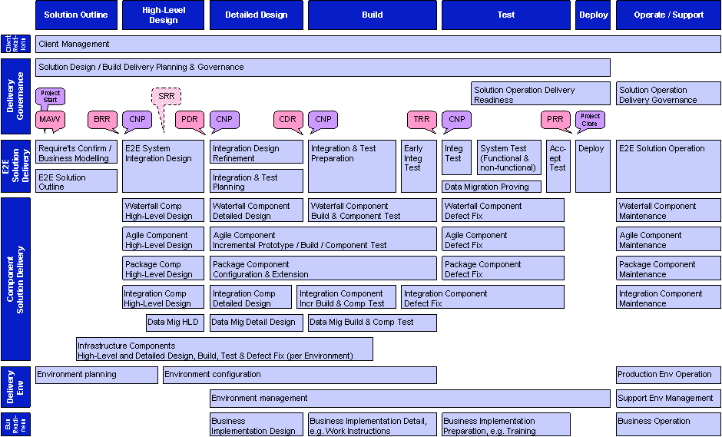
Figure 2: CSI Method blueprint, Delivery Model

Select Methods to Combine
The next step is to select the candidate methods that will be adopted, in whole or in part, and integrated with each other within the CSI Method blueprint. To recap, this is based on:
- An understanding of the requirements and contracting approach,
- An understanding of the solution outline,
- Knowledge of any method constraints,
- Knowledge of what methods are available to combine and where it is appropriate to use each.

Some of the more frequently used method processes within IBM are: SOMA for AD, Ascendant SAP and Legacy CAD delivery processes, together with the OPAL, Systems Engineering and Architecture (SE&A) and System Lifecycle Framework (SLF) practices.

Define Artifacts and Align with Delivery

Process overview
First, a slightly revised version of the CSI Method blueprint is created, with a stream for each of the main components that is to be delivered. This is marked up; highlighting which elements will be instantiated by which parts of which methods. Next, a more detailed mapping is done from individual method artifacts and processes from each selected method to the detailed content of the blueprint. This second pass focuses on artifact selection and on defining how dependencies between artifacts and processes from different methods will be satisfied. The intent is to remove holes and duplication when combining method: the former is obviously a problem, but the latter also causes ambiguity and inefficiency.

Start with a copy of the CSI Method blueprint
The CSI Method blueprint is used as a basis for the program’s own method framework. It contains proposal and delivery models, so the right one needs to be selected.

Update the blueprint to show the main solution components
Using the copy of the blueprint, the horizontal slice that shows the Component Solution Delivery is updated to reflect the main components being delivered:
- A row is created for each component,
- The appropriate template is used for this row depending on the delivery model that is intended to be used for that component (agile, waterfall, package, integration component or data migration)

Group elements of the blueprint
To prepare for the high-level mapping of methods to the CSI Method blueprint, key activities in the blueprint need to be aggregated into a small set of large groups.
The CSI Method blueprint contains a default set of such groupings. These are shown in Figure 3: suggested high-level groups to map distinct methods to. This should be used as a start point.
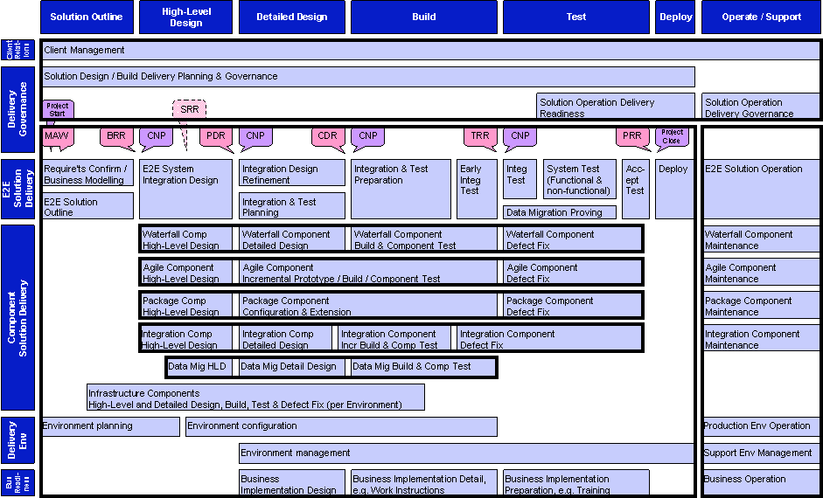
Figure 3: suggested high-level groups to map distinct methods to
Information gathered while establishing the context for the method adoption may lead to a slightly different set of groups being defined and the blueprint can now be amended based on these identified method constraints. For example, if the client requires that a method be used across one of the default groupings then it might make sense to reflect that partition as two separate groupings. Also, the blueprint groupings can be amended based on organizational or geographical distribution of the work – for example, where it has been determined that activities can beneficially be distributed to Global Delivery Centers, it might make sense to reflect this in the updated grouping structure.

Map methods to each group of blueprint elements [high level]
Using the methods selected earlier, including any identified when assessing method constraints, a high level mapping of these methods to each grouping on the blueprint is created. Typically the following decisions/mappings are required:
- An overall method for technical delivery program (that is, excluding the project management aspects of governance, and client relationships, and excluding the operation phase of the program). This selection should reflect the predominant characteristics of the delivery, for example if this project is mostly a SOA program developing business services then SOMA for AD would be a natural choice.
- Within this grouping, the CSI Method blueprint’s default recommendation is that solution and delivery are assured using SE&A checkpoint reviews: Business Requirements Review (BRR); System Requirements Review (SRR); Preliminary Design Review (PDR); Critical Design Review (CDR); Test Readiness Review (TRR); Production Readiness Review (PRR). SE&A checklists may not be appropriate for some component deliveries, such as Agile, perhaps - but an end-to-end check at the designated review points still makes sense. This would check that agile and other deliveries were still operating in their end-to-end context (rather than check that comprehensive detailed designs had been produced). For very large programs, it may be necessary to use fuller SE&A reviews (rather than just the checkpoints). This is a good example of where additional work is required at adoption time to tailor the method so that it can scale to address a big or a small engagement rather than see a method as only appropriate for a particular extreme.
- A method for each of the component solution deliveries and
- A method for operation and support.
The core CSI Method blueprint documentation contains a set of one-page method overviews which identify the key characteristics of each method and what the most likely mappings are to the CSI Method blueprint.
When mapping methods to CSI Method blueprint groups, it should be decided and documented which aspect or part of each method will be used to satisfy the requirements of the blueprint group. Any concerns or assumptions about the mapping should also be documented. For example, consider a mapping of a method that assumes testing is done largely by driving the user interface of the applications that comprise the component delivery. However, if the component delivery is for a set of SOA services then these will not have user interfaces so the testing approach of the method needs to be modified.

Define the method interfaces and how interdependencies will be met [high level]
By this stage an inspirational map has been created at a high level showing which methods will be used to satisfy a set of meaningful groupings in the blueprint. The next step is to take a view, still at a high level, of how this will be made to work, that is, a view of what the main interfaces and dependencies are between these methods, how these will be satisfied and what changes will be required to the normal way the method is used or to its content so that it will work well in the context of the container method or peer methods.
Most of the methods to be integrated will have two aspects: content (artifacts) and process. Hence, considering the dependencies and interfaces needs to address these two views: how the processes will be made to fit and how the content will be made to fit.
Methods have evolved to contain other material apart from artifacts and processes. Good examples are “guidelines” which are often quite substantial and can contain method and artifacts of their own. Interfaces from and to any significant method material which is intended to be used but is not easily categorized as a process or artifact should also be considered here.
A set of well-known combinations of methods will be documented which will summaries the key dependencies and how they are satisfied.

Map method artifacts to blueprint content [detailed]
The CSI Method blueprint contains a detailed set of the key content to be produced during a complex systems integration, and shows the approximate stage of the lifecycle where each (logical) artifact is needed.
During the “Adopt CSI Method Blueprint as Basic Structure for Method Adoption” (see section 4.2) a view will have been taken as to which ones are likely to be relatively more or less important for this engagement and whether there are any obvious omissions or obviously superfluous items. An updated and annotated view will have been created.
The following detailed mappings are required:
- Every item on the (updated) detailed blueprint View now needs to be mapped to one or more artifacts in one or more methods. Typically this would be to one artifact in one method and that method would be the one indicated by the high-level mapping from blueprint groups to methods done previously.
- Remember that even within a method that was a good overall fit for a Component Solution Delivery, the artifact fit may still need some work. For example, some solution parts that comprise a Component Solution Delivery will need the user interface-oriented artifacts envisaged by the component-level method, but for others this might be inappropriate and configuration of the method will be needed.
- Processes from adopted methods are then mapped to the blueprint – primarily to the Delivery Governance activity area.
- Also to be mapped are the additional artifacts required if the engagement is multiple release: business roadmap, solution roadmap and delta impact assessment.
- Perhaps the most important content level mapping (for a CSI engagement) is the end-to-end design specification artifact and the component delivery streams’ design specifications (which will need to be fitted together in the next step).

Define how artifact interdependencies will be met [detailed]
Method adoption for CSI engagements at an artifact level focuses on two categories of artifact:
- Those that are integration points between methods and
- Those that contain key content for complex systems integration.

Each artifact will have zero or more input artifacts which it assumes are complete (or complete to a particular level of detail) and used as input to the task of creating the new artifact. To an extent, these dependencies will be explicit: the artifact description will list the input artifacts. However, because methods are not generally written on the assumption that they need to be mixed in with other methods, it is quite likely that implicit dependencies between artifacts exist too.
There are three main tasks:
- Identify all the interfaces between methods at the artifact level: places where artifacts from one method are used as inputs to artifacts from another method. Understand whether the assumptions made about content being passed are still valid and, if not, what changes are needed.
- Identify where artifact content needs to change because the content of their use is now different from that imagined by the author. That is, the context is a hybrid engagement, not a homogeneous one. Typically, the areas that need strengthening are those that address the interfaces between system components. Perhaps the most important dependencies (for a CSI engagement) are between the end-to-end design specification artifact and the component delivery streams’ design specifications. Fitting these together is key. Update the artifact descriptions to reflect the identified new content.
- The assumed context for each artifact will be a detailed process defined by the containing method. These detailed processes also need to be aligned, and touch-points identified so that only these touch-points need to be updated to reflect the integrated process.

Create a high level plan
The high level delivery plan should reflect the shape and content of the amended blueprint.
If the engagement is a multi-release then this should be reflected on the plan (as per the guidance in the blueprint.)

Communicate and Govern Method Use

Document and Communicate Method-Adoption Outcome
This document has provided guidance on adopting method for complex systems integration programs.
Through the process outline here, a program will have:
- Effectively combined different methods in the context of the CSI Method blueprint. This will have included choosing component-level methods for each major component and integrating these into an overall method used for the end-to-end engagement;
- Made decisions with reasons about the choices made along the way. These will include the context for the method adoption: the contracting and requirements approach, the solution outline and the method constraints.
Everything needs to be written down and communicated across the program.
Note that method adoption output is not just a list of artifacts – method adoption documentation should include
- Requirements and contracting approach
- Solution outline (very high level and brief)
- Program organization outline (identifying key teams)
- Method constraints
- Elaborated CSI Method blueprint
- “Deliverable” mapping to elaborated CSI Method blueprint
- “Deliverable” content in terms of artifacts etc
- “Deliverable” mapping to producing teams
- Review checkpoints and other governance
Method adoption can be documented as part of a broader Systems Engineering Management Plan (SEMP).
A detailed method adoption can also be defined and documented using Rational Method Composer (RMC), but the complexity inherent in this approach means that programs often choose to document using more standard means.

Govern Use of Adopted Method
As the program progresses through its full lifecycle from solution outline right through to operation and support, it must be ensured that the component delivery streams (comprising package and agile deliveries, for example) operate within the end-to-end method context.
Use of the adopted method for complex system integration needs to be enforced and it needs to be consistently applied to all the major delivery activities.
The bottom line is that a method adoption will not stick unless it is governed – and this is the responsibility of both Program Management and the Design Authority (or Systems Engineering Group).

It may be that many other artifacts get adopted, for example those important inside an individual component delivery stream. In order to maintain focus on the two categories of artifact, above - the ones vital to CSI – it may be that separate method adoptions are carried out for the other artifacts. This can be done using “traditional” method adoption techniques of walking through a list of candidate artifacts and deciding whether each one is in or out etc.

