
Introduction to Estimating Best Practices at IBM
Technique Paper (TP)
© Copyright International Business Machines Corporation 1998, 2026
All Rights Reserved
Version 1.1, January 2007

Description

Purpose
The purpose of this technique paper is to introduce you to the practice of estimating at IBM, give you information about where to find resources, and to invite you to become involved in the IBM Estimating Community. The intended audience is any IBM practitioner who is interested in, or involved with, estimating as part of their work responsibilities.

Scope
The scope of this technique paper encompasses the estimating process, common terminology, recommended best practices, and references to other materials and tools. As an introductory paper, we will intentionally cover material at a high level; however, we will include a section providing references where you can find additional depth on particular topics.
This technique paper will introduce you to common terminology used by estimating practitioners. Our goal is for this terminology to:
- Act a reference point to enable practitioners to have effective conversations on estimating subjects.
- Have common terms to use in our estimating work products and reference materials.
We will describe the basic estimating process – from initial sizing estimates to a final price. This process description will give you an understanding of how estimates are introduced and refined during the project or engagement lifecycle, and will highlight estimating best practices.
➲ This symbol will be used to highlight subjects within the text that are considered “best practices” for estimating at IBM. These subjects will also be summarized in Section 4 of this paper.
Throughout this paper, we will identify other estimating material and tools that you can access. Although we will first introduce them in context, there is a complete list of these references at the end of the paper.

Content of this Technique Paper
The remainder of this technique paper is organized as follows:
- Section 2 – Introduction to Estimating at IBM. This section will introduce estimating and its importance within IBM.
- Section 3 – Key Steps in the Estimating Process. This section will introduce the key steps in the estimating process and will then provide a more detailed explanation of each step in the process.
- Section 4 - Summary of Best Practice Guidelines. This section will summarize the Best Practice guidelines identified throughout this technique paper.
  - Section 5 – Tools. This section will provide a brief description of some of the estimating tools and methods available within IBM.
  - Section 6 – Glossary. This section will provide a glossary of key terms used within this technique paper.
  - Section 7 – The IBM Estimating Community. This section will introduce you to the IBM Estimating Community whose purpose is to provide support to estimating practitioners within IBM.
  - Section 8 – References. This section will provide a list of references for additional information on estimating and links to online resources available to IBMers.

Usage Context

This section will introduce you to the subject of estimating. We will briefly discuss who performs estimating at IBM and why estimating is important to our company.

What do we mean by Estimating?
An estimate is an educated guess of what might happen in the future based on history or experience. Estimates can be made for any quantitative item of interest; some examples include the effort required to perform tasks in a project, the duration of activities within a project, or the labor, hardware, software, and services costs within a solution. Ideally, estimates include some indication of the degree of confidence or accuracy.
Two of the most frequent reasons we create estimates are to:
- Provide the basis for making choices between two or more alternatives.
- Provide a means for comparing what we actually experienced to what we thought we would experience as a way to improve our knowledge.
An important point to remember is that “all estimates are wrong, some estimates are acceptable.” No matter how much data and experience we have as a basis for making the estimate, it is still a guess. Our challenge as estimators is to bring as much data, experience, and best practice methodology as we possibly can to each estimating effort – in other words, to make our estimates as “acceptable” as we can.
➲ Using formal estimating methods and tools are one of the ways in which you, the estimating practitioner, can produce more “acceptable” estimates.
Estimating is an exercise in taking a set of requirements at a certain level of detail, understanding how those requirements are intended to be met using a given solution, and applying an estimating model. An estimate, properly prepared within the limitations of the model, is by itself neither a good estimate or a bad estimate. The estimate reflects the influences of both requirements and solution. A bad estimate occurs when the facts have been interpreted incorrectly, gaps are not identified and judgment calls are proven to be erroneous. – Cheryl den Hartog, IBM Canada
Estimates are approximations – an estimate is a way of saying “This is what I think it will be.” So, every time you give an estimate to someone else, you should also tell them the degree of confidence that you have in your estimate.
➲ The degree of confidence in an estimate is expressed as a “variance”. When communicating your estimate, you should always indicate the variance associated with it.

NOTE: Variance will be covered in more detail later in this paper.

As a practitioner, you will hear the term “estimate” used in various contexts. For example:
- “Raw estimates” provide only the total estimate derived from the estimating approach that was used. A raw estimate does not have a supporting schedule – the aspect of time has not been considered.
- “Development estimate” referrs to an estimate that is limited to the design and development efforts of a project and which excludes all other activities (such as requirements analysis, architecture, testing, project management, etc.). Development estimates are often called DCUT estimates (Design, Coding, and Unit Test).
- “Technical estimate” is an estimate that contains all technical-related aspects (including architects, developers, systems analysts, and testers) but that excludes all non-technical aspects (such as project management, technical documentation, user training, etc.). Technical estimates are often prepared by the architect and technical team and are then given to the Project Manager. The technical estimate is frequently used as input to the quality assurance review of the technical solution.

In the above examples, Development and Technical estimates are both estimates of technical activities, but each exclude different things. If you do not know what is included (or excluded) from the estimate, you may not fully understand what the estimate is really saying.
➲ When providing an estimate, you should include a description of its scope (what is included and excluded).
To summarize, an “estimate” in IBM is an educated guess of what might happen in the future, expressed with a stated degree of confidence (i.e., variance), for a specific scope of included items.

Who does Estimating in IBM?
Estimating is performed across all IBM brands and geographies, including services, software, research, development, engineering, and supply chain. Estimating is performed by many IBMers, in many different roles, at many different points within our business processes. A few examples are:
- Managers who make estimates of the resources needed to perform the work of a department.
- Technical Solution Architects who estimate the hardware, software, labor, and services required as part of a solution proposed to a client.
- Project Managers who work with subject matter experts (SMEs) to estimate the labor hours and durations for tasks and activities within their projects.
It is important to IBM that those IBMers who are asked to perform estimating as a recurring part of their job responsibilities have the resources and training available to support them in this function. It is just as important that IBM staff who perform estimating as part of their job role take it upon themselves to access these resources and to produce acceptable estimates.

How does Estimating fit within the larger IBM business context?
Producing acceptable estimates is very important to IBM. Inaccurate estimation is recognized as a major root cause of troubled projects in IBM. Industry experience over the last twenty years has shown that improving project estimates is not just a matter of finding a better method or tool; the needed improvement stems from recognition that estimation is a business process that requires proper governance and disciplined improvement methods.
Currently (2006 Q4) there are a number of initiatives underway, in areas such as Delivery Excellence, GBS UKISA, World Wide Methods and Tools group, L&K, and various other Delivery Excellence projects or programs, which are aimed at addressing issues associated with producing acceptable estimates. The IBM Estimating Community is working to establish a consistent framework for estimation process and governance, and to provide advice and support to estimating practitioners within IBM.

Where can you get more information?
You can access the IBM Estimating Community Wiki at:
https://w3.webahead.ibm.com/w3ki/display/estimating/The+IBM+Estimating+Community
For estimating in the context of project management, please visit the IBM WWPMM site at:
http://w3-03.ibm.com/transform/project/pmmethod/PMWorkPatternStep/pmw04dced16-ab00-4dcc-83ad-80f093ac4e72.html
For estimating in the context of the GSMethod, please visit the IBM MethodWeb site at:
http://method.endicott.ibm.com/MethodWeb/index.htm
For information on estimating from the Global Method Community, please visit:
http://w3-03.ibm.com/services/assets_innovation/gcd/methods/survey/join_method_commun.html
Estimation Procedures are available in the On Demand Process Asset Library (OPAL)
http://w3.e-solutions.ibm.com/opal/connect/opal/opal+home/
NOTE: Additional references are provided in Section 8 of this technique paper.

Content

Best Practices during the Estimating Process
As the basis for introducing Estimating Best Practices, we will use a “project pricing process” – that is, the process for defining and estimating so that a price can be proposed to a client. At a high level, the steps in this process are:

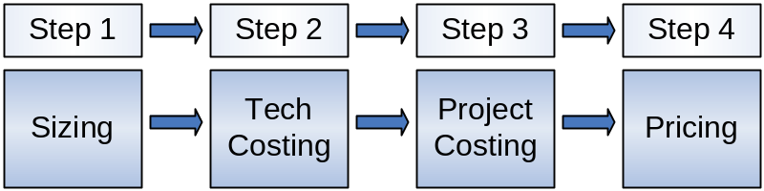

These four steps assume that there is a qualified project opportunity that we’ve identified for a client. With that as a starting point, we go through the steps of sizing the project and solution, estimating the technical costs, estimating the total costs (the combination of all technical costs plus any project or other costs), and finally creating a price that will be presented to the client. We will go through each of these steps in more detail in the sections below.
Although we are using this process as an example, the actual estimating lifecycle does not end after a price is released to the client. If the client signs the deal with IBM and the activities within the project are underway, it is important that you collect actual data at each stage or phase of the project and compare that to the original estimate. Collecting actual data gives us the ability to perform two more essential functions:
- It allows you to evaluate our original estimate and determine if the method used can be recalibrated or improved. If you believe it can, then repeat the 5 basic estimating steps for all remaining activities. This can help increase the potential for the success of the overall scope.
- It provides additional historical data for future estimating efforts.

As we walk through this process, we will focus primarily on estimating labor within the project. We will focus on estimating labor for projects because that is the most common estimating challenge faced by practitioners. Labor estimates also include a wide variety of factors or additional considerations that we can use as examples.
Although we are using a project pricing example, this is only an example! If you want to find the “official” or “approved” project estimating and pricing process used by your IBM organization, please contact your group leader or refer to the reference section of this technique paper.

Step 1 – Estimate the Size and Scope

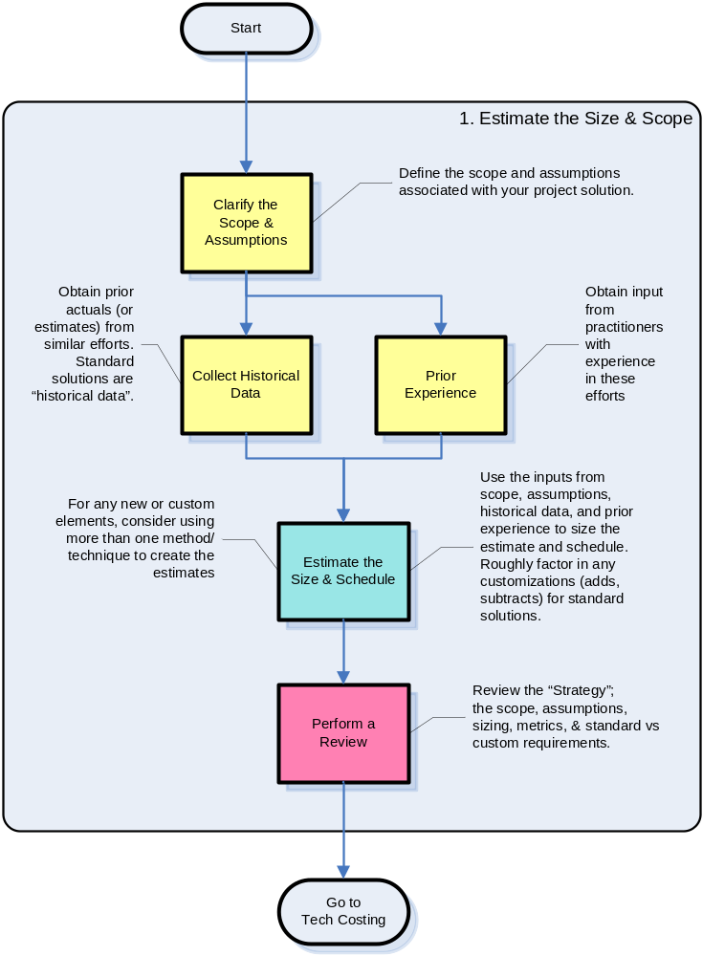

What does the estimator do during this step?
- Understand the solution and gather data.
The Estimator begins by defining the boundaries of the solution; these are usually defined in terms of a Scope and a set of Assumptions. The Scope is the definition of what is in – and what is explicitly excluded from the project. Assumptions are what you believe are “facts”, that is, what you explicitly believe to be true (or untrue). Together, the Scope and Assumptions form the basis for making the estimate.
Later in the estimating lifecycle, if you need to adjust the estimate, you will usually begin by reviewing and adjusting the Scope and Assumptions:
- You will move work or responsibilities into or out of Scope. This should change the costs down (if moving work out) or up (if adding work in).
- You will add or change assumptions. By adding assumptions, you can assert that more conditions exist that will impact the estimate (down or up). By changing assumptions, you can re-state how previously defined conditions will impact the estimate (down or up).
➲ Avoid removing assumptions from the project documentation. Instead, simply change the way the assumption is stated. This can be a very effective way of managing many of the decisions regarding the estimate (especially in its early stages).
Sources for Scope and Assumptions include draft proposals or draft project charters, standard solution descriptions, architecture reference materials, or requirements specifications. Get as much information as you can, and as you review the material, identify the elements that will be driving the costs for the solution.
In addition to information regarding the scope and assumptions, perform research to find historical data and metrics. Historical data (actuals from prior projects or previous estimates done for similar proposals) can be very helpful in sizing your new estimate. Standard solutions or sizings may be available from the IBM organization that would participate in delivering the work within the project. If no historical data or standard solutions are available, then you will have to rely on the expertise of practitioners to help you make this estimate.
When looking for historical project data, make certain that the historical data is for a project with a similar work pattern and size. You are looking to reuse data from successful projects with similar challenges. You should make it a point to research the lessons learned from earlier projects – both from successful and failed projects of a similar nature.
Search for those “things” that drive the costs or schedule within the project. These can be anything from the number of things that have to be produced (screens to produce, Lines of Code to write, GSMethod work products that have to be created) to the number and types of things that must be supported (number of users or workstations within the environment, number of mainframe LPARs, number and variety of applications, etc.).
➲ Quantify the things you are dealing with.
Always determine how you can quantify these items that are driving the costs or schedule. If you cannot quantify it, then you will have a difficult time using it as an item in your estimate. If you have historical data or estimates, identify the metrics used to track the project.

- Estimate the Size and Schedule.
Most estimating tools and techniques require some initial approximation of project size and schedule (for instance, at least a total expected project length based on the effort and optimal team size). The scope, assumptions, and any available data you’ve collected will be the basis for this estimate.
If you have historical data, this will provide you with a basis for determining if your project is larger or smaller than prior projects of a similar nature. If you do not have prior data available, you will need to use your experience to determine a rough sizing for the project. Use your network of contacts to find others in IBM who have experience in this type of project (or projects of a similar nature); talk to those experts to get their input as to the sizing for your project. Engage the support of an Estimating SMEs, via your business area, Geography etc, or the Estimating Community.
Once you have a basic approximation of “how big” and “how long” you believe your project to be, you then need to identify what sizing metric(s) you will be basing your estimate on. Choose these metrics based on:
- Your understanding of the solution.
- The data you’ve gathered.
- The metrics used in prior projects or previous estimates.
- The metrics used in the standard solutions or sizings.
- The input from your peers or other subject matter experts (SMEs).
The available sizing metric can influence your choice of technique or tool for estimating. Examples of the types of tools/methods and the metrics they use include:
- PARAMETRIC methods/tools – use the quantity of Function Points, Lines of Code, Use Cases, etc.
- ARTIFACT based methods/tools – use the quantity of artifacts that need to be produced, including such items as screens, reports, interfaces, work products, etc.
- PATTERNS and ESTIMATING FACTORS – use a particular pattern as a basis (e.g., IBM’s Patterns for e-Business) and then customize that pattern based on the number and types of entities used within the pattern.
Many tools require that you choose a project pattern, type, or engagement model, then allow you to customize the sizing based on the quantity of estimating units (using the sizing metric) associated with that project type. Your decisions about what metrics are present and what methods/tools to use are both assumptions regarding your estimate that you should document. Remember:
➲ Always document the assumptions you’ve made about the estimate.
NOTE: As the above Best Practice is one of the most important, you will see it more than once in this technique paper!

- Perform a Review.
Now that you understand the Scope and Assumptions, have gathered all the available data, and have an estimate of the size and schedule, it’s time to do a review. At this stage, a peer review (with an experienced estimating practitioner) or a high-level solution review (with practitioners experienced in similar engagements, proposals, projects, or delivery) can be very useful to validate your assumptions, sizing, and method/approach.
Throughout the estimating lifecycle:
➲ A second set of eyes is always a good thing.
Whenever you can, ask for input from other experienced professionals. You don’t have to agree with everything that these professionals say, but consider their input carefully. This input can help you clarify your assumptions. Whenever you find two (or more!) professionals whose input is different on the same item, this can be an indicator of an assumption that should be documented.

Step 2 – Estimate the Technical Costs

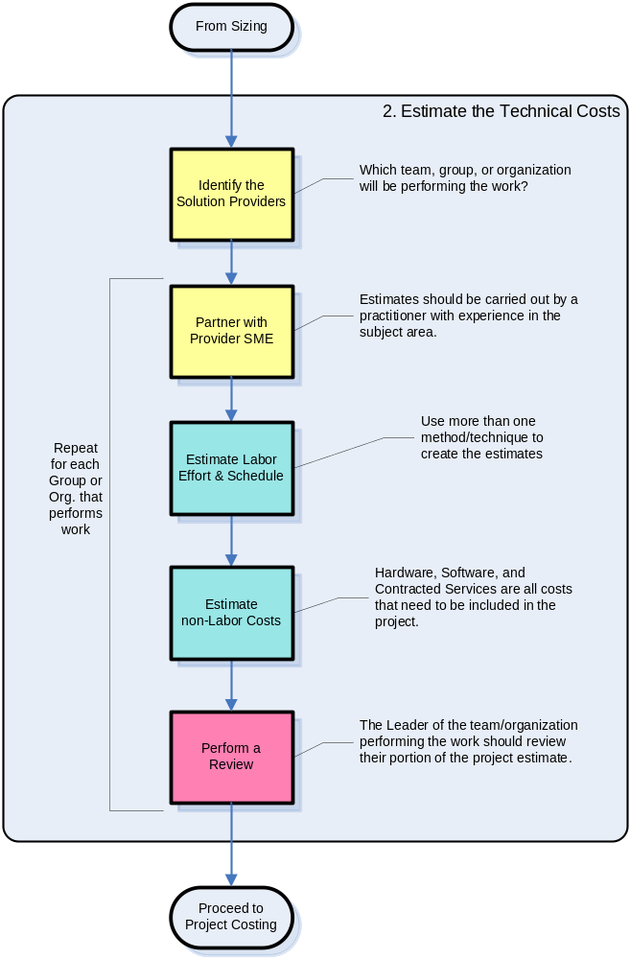

What does the estimator do during this step?
- Identify the Solution Providers.
Your project may consist of elements that must be produced or delivered by different IBM groups or organizations. For example, if your project is to develop, deliver, and support a custom software application (including the hardware platform the application runs on), then your project would involve:
- Coding/development teams who would create and deploy the application.
- Teams who would provide the hardware/platform support for the infrastructure associated with the new application.
When estimating your project, you need to identify who your providers will be, and engage those providers to assist you in creating the estimates.
➲ Estimates should be carried out by a practitioner with experience in the particular business, technology, and environment. Preferably the same ones who will be carrying out the work.
If you have a small or non-complex project, you may find it easier to bring the SMEs for all teams together to produce a single estimate for the entire scope. But, if you have a large or complex project, it is often more effective to work with each of the provider teams individually to create estimates specific to their scope within the overall project. Care should be taken to ensure no ‘gaps’ develop between the scope of each provided team for a comprehensive estimate.
NOTE: In the example shown in this technique paper, the flows assume you are creating separate estimates with each provider group, and then assembling them into a single estimate later in the process.

- Partner with a Provider Subject Matter Expert (SME) to estimate Labor Effort and Schedule.
Once you have identified the IBM group who will be performing the work, engage that group to get one (or more) SMEs to participate with you in creating the estimates. Together with the SME(s), review the scope and assumptions, any data you’ve collected, and your estimate of the size and schedule.
Once the SMEs understand the project, then work with the SMEs to agree to two (or perhaps, three) approaches you will use to create the technical estimates.
➲ Use more than one estimating approach.
Different approaches you might choose are estimating by:
- Analogy: if you have one or more sets of historical data, identify the differences between your current requirements and assumptions and those of the historical projects. Use your experience and that of the SME(s) to analyze what effect these differences will have on the estimates (or actuals) in the historical data.
- Parametrics: work with the SME(s) to determine the quantity of parametric units that your project will need to produce. Examples of parametric units include: Function Points, Lines of Code, etc. When you have determined the quantity of units, use the average ratios associated with that parametric factor to create your estimate.
- Artifacts: as with the parametric approach, work with the SME(s) to determine the type of and quantity of each artifact you will need to produce within the project. Examples of artifacts include: web pages or GUI screens, reports, interfaces between systems, etc. Using an average estimate for producing one unit of each artifact, build a spreadsheet model of the project by multiplying the total number of artifacts of a given type by the average estimate for one unit of that artifact.
- Bottom-up: work with the SME(s) to identify all of the work products that must be produced and all of the other tasks that must be performed within your scope. For each work product and task, create a specific estimate for that item. Include such considerations as the level of experience that the person performing the work will have in that task, the tools and support available to those people performing the work, etc. Use the estimates from GSMethod for work products as a guide, but determine a project-specific estimate for every task.
- Delphi: assemble a group of SMEs with experience in the work that is within your scope. Provide each SME with the estimating structure for your project. Gather a written estimate from every SME separately for each item in the estimating structure. This could be size, artifact effort, task effort, etc. Compare the estimates from the SMEs. If the estimates are the same (or roughly the same), accept the estimate as “agreed to”. If the estimates are significantly different, have the group discuss the item and “re-think” the work (which may include documenting a common assumption for the group to use). Have the SMEs separate and create a new estimate for every item that wasn’t agreed to in the prior iteration. Repeat then compare, discuss, and re-estimate iterations until estimates for all items are agreed to. This approach may be used in conjunction with many of the approaches listed above to provide an estimate of a particular variable.
There are a number of tools (both within IBM and from external sources) that are associated with the above techniques. Please see “Section 5 – Tools” later in this document for a list of some of the most frequently used.
➲ Use a recommended estimating tool whenever possible.
If you found historical data, this data may already have been associated with a particular tool or technique. You should strongly consider using that technique as one of your approaches in creating your estimates. You should also select a different approach as a means of improving the confidence of your estimate.
Once you have agreed to the approaches that you will use, begin by estimating the labor effort and schedule for performing the labor using those methods.
➲ There is no substitute for the use of actual (historic) data and metrics.
NOTE: in this context, standard IBM solutions and cost models are considered “historic” data. The IBM SAGE tool, its SSMs, SSTs, and rate tables are all means of applying metrics and formulas based on historic data to new project estimates.
There are a number of other inputs and considerations that you will want to include in developing your estimates. For each input or consideration, you need to take into account the provenance (the history of the input since its creation, including how it has changed over time and who made the changes), the accuracy (how close it conforms to actual or observed facts), its inherent variation (the extent or degree to which something deviates from a norm or standard), and its appropriateness (the quality of being specifically suitable to the purpose, situation, or conditions).
You will also want to consider the following types of factors or influences on your estimates:
- The similarities or differences in the work pattern chosen to your project.
- The expected increases in productivity of resources over the period of performance.
- The experience level of the personnel performing the work (experience in the work, experience with the tools or technology, etc.).
- Scheduling considerations for hiring and/or training staff.
- Impact on staff productivity when staff is working on more than one project at a time.
Make sure to include all of the labor that the provider will utilize in order to produce their work within the project. If the provider has made assumptions about what labor is in or out of scope, make sure you document these assumptions. If certain labor items could/will be shared across other providers (e.g., project management labor), then consider making that a project-level labor item instead of a provider-specific labor item.
Techniques exist in some tools (and as spreadsheet plug-ins) to enable you to assess the confidence level based upon the accuracy of your data input. You should use these techniques whenever possible.
➲ Use valid statistics in creating your estimates and assessing confidence.
You should consult with an estimating expert (a practitioner experienced in the use of that tool or technique). Although most tools can be learned with practice, performing a peer review of how you have applied the tool/technique and your results can improve the quality of your estimates (and may sharpen your skills as well).
➲ Avoid sensitivity to single, high-level variables.
Avoid having your estimates be sensitive to high level variables. Only use a high-level variable when there is ‘significant’ statistical justification for doing so. When using a high-level variable, a single estimate for that value (either too high or too low) can cause significant variance in your results. Results from several dozen similar projects (using a similar high-level variable) would be required to lower the variance caused by an errant value.
➲ Avoid sensitivity to subjective variables.
Avoid sensitivity to subjective variables that may be impacted by optimistic and pessimistic guesses. Whenever using subjective variables, a “team attitude” such as overconfidence or extreme conservatism can have a significant effect on the resulting estimate. The Delphi approach is an example of where a team attitude might be present. In situations where you must depend on subjective estimates (where no objective data is available), use a technique such as the beta probability distribution (aka, the “PERT’ technique). The formula for this estimate is
estimate value = (1*optimistic value + 4*most likely value + 1*pessimistic value) / 6

➲ Many packets of small numbers can reduce the variance of your estimate.
Many small estimates will offset one another and reduce the overall variance of the estimate (this is known as the “Law of Large Numbers”). For example, if you have an activity that consists of 100 tasks, you could estimate either each of the tasks or you could estimate just the overall activity. Creating six estimates for each of 100 tasks, and then summing the results will leave an overall estimate with a lower variance than simply creating six estimates for the overall activity. Using automation can help you manage the use of many packets of small estimates.
➲ In addition to providing the estimate, you need to state your confidence in the estimate.
Since your inputs contain variation, your estimate (output) MUST be an approximation. Therefore, when you present your estimate you need to state your confidence in the estimate. Examples of these types of statements are:
- “There is a 50% chance that we can deliver this project in ___ calendar days, and an 80% chance that we can deliver it in _____ calendar days.”
- “This estimate is a preliminary estimate that has a plus or minus range of 50%.”
There are a number of valid statistical techniques (e.g., the Monte Carlo technique) that enable you to state the confidence levels with any estimate you create. The variance must be portrayed to IBM management and the client to manage expectations at project inception and throughout the lifecycle. You should identify risks and create risk mitigation plans to address the areas of greatest variance as early as practical in the project schedule.
There is a paper available on the including variance in your estimate. Refer to Section 8, “References” later in this technique paper for more details on available materials.
➲ Understanding and managing variance must become second nature to our practitioners.

- Estimate the non-Labor Costs.
In addition to the labor associated with the project, there are four other types of costs you need to estimate. These are:
- Hardware – this includes computing or other equipment which would have a capital value that may depreciate over time. This would include all maintenance, refresh, and other costs associated with the hardware for the period of performance for the project.
- Software – any computing software that would need to be purchased or licensed, and would include all reoccurring maintenance or license fees associated with the software.
- Services – any consulting or other services provided by an organization other than the designated provider. This could be another IBM organization or a 3rd party provider.
- Expense items – specific expense items unique to the project and not assumed to be part of the standard labor costs for IBM employees. For example: if the project required the training of a large number of geographically dispersed users, the cost of an externally hosted web conference to train the users would be listed as an non-labor cost item; general office supplies for the IBM personnel working on the project would not be listed as a cost item because those would already be covered via the standard labor rates.
Combine your labor and non-labor costs against the schedule for the method you’ve selected to produce the Technical Estimate. You should have a Technical Estimate from each of the approaches you chose to use.
Technical estimates are the detailed estimates for the labor, hardware, and software required by the provider in order to complete their work for the project. The estimate should also include any services that the provider will have to contract for with another organization to support them in performing their work. The technical estimates must define these labor and other costs across a specific schedule (not just total estimated costs).
Technical estimates would not include overall project costs – which are any cost items that are shared across all providers within the project (and not specific to only one provider). An example of project costs is Project Management labor for the entire project.
With the help of the SMEs, compare the estimates produced using the various methods. If the estimates agree (or are very close) you can have more confidence in these estimates.
Identify any significant differences and discuss what reasons or assumptions may have driven these differences. You may need to iterate your estimates from the different methods until they start to converge. Based on this analysis and iteration, create a single Technical Estimate that you and the SMEs feel is most appropriate to your project.
Technical estimates may be done to provide Indicative (non contractual) or Proposed (one IBM is prepared to contract for) estimates. The level of confidence and rigor of the process will inevitably be less for an indicative estimate.
➲ Ideally, where a proposed estimate is required, try to aim for a variance of around 10% for a sound estimate.
And, as cannot be said often enough…
➲ Always document the assumptions you’ve made about the estimate.

- Perform a Review of the Technical Estimate with the Solution Provider.
At this point, you are now prepared to review the Technical Estimate with the Solution Provider to get their approval. The purpose of this review is to ensure that the IBM Leader responsible for providing this work is prepared to commit to performing the specified work for the costs defined in the estimate.
Hold a meeting with the appropriate IBM Leader for the IBM organization that would provide the work. Review the scope and assumptions, any solution details, and review all of the estimates (created by you and the SMEs from the provider organization). Identify each instance where this project differs from any standard model or prior projects performed by the provider.
Ensure that you have reviewed all of the labor, hardware, software, and services costs against the schedule. Be prepared to discuss how you arrived at these estimates, including any assumptions that you made to reconcile differences between estimates produced using different approaches.
If the IBM Leader requests changes to the estimates, identify the changes to the scope or assumptions which would result in the desired change. Document the changes, effect the change to the estimates, and obtain the IBM Leader’s agreement with the estimate.
Document the content of technical estimate. Document the date and name of approver who is accountable going forward as evidence of process.

Step 3 – Estimate the Project Costs

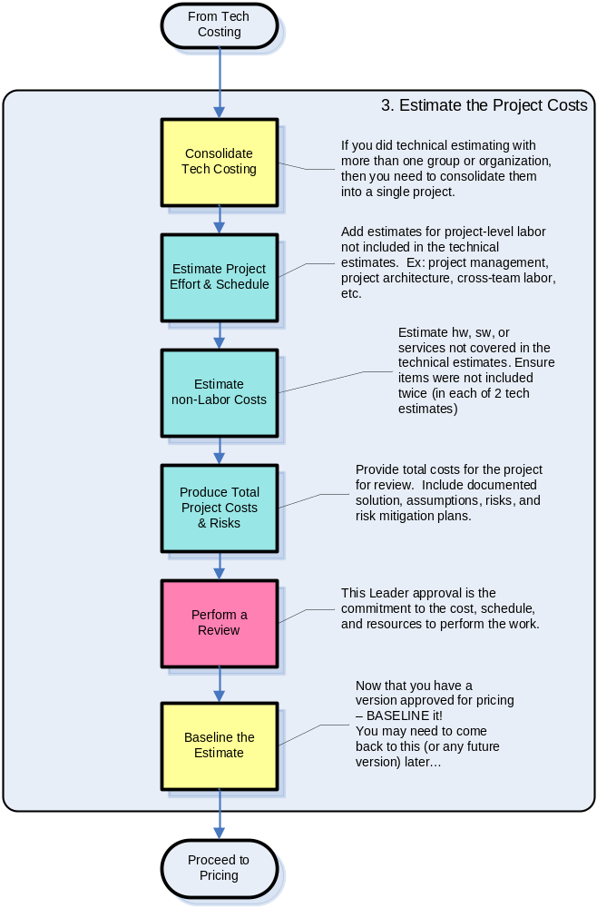

What does the estimator do during this step?
- Consolidate the Technical Estimates into a single Project Estimate.
If you worked with more than one provider to produce Technical Estimates, the next step is to consolidate those estimates into a single estimate for the project. As you consolidate the Technical Estimates, you should consider the following:
- Avoid combining line item details from several providers. The review and approval processes are easier if providers can clearly identify their portions of the estimate.
- Use “economies of scale’ cautiously. It may be tempting to assume that similar tasks performed by two or more different providers can be merged, but the actual work performed may be different enough that the work cannot be consolidated.
- Look for gaps. With the help of the SMEs, ensure that there are no gaps where both providers in an exchange were assuming that something was “the other group’s responsibility”.

- Add the Project-level Labor to the Consolidated Estimate.
Once you have consolidated the Technical Estimates into a single estimate, you then need to add those items that exist only at the project level.
Technical estimates would not include overall project costs – those cost items that are shared across all providers within the project (and not specific to only one provider). For example, the costs for the Project Manager for the overall project would not have been included in each of the Technical Estimates. You will need to identify and add the additional labor items to the estimate. Labor items that may need to be added at the project level include:
- IBM Business Unit or Delivery Management – on a small project, there may be few, if any, Project Executive or other staff management costs. However on a large project, or a project that had a period of performance of 18 months or more, you should include estimates for management resources.
- Administrative, Financial, or other staff – depending upon the nature of the project, there may be significant administrative, financial, or other “corporate” functions that have to be performed. Also, on very large projects or projects that have a period of performance of 18 months or more, there would be “standard” administrative functions that should be included in your estimate. These estimates are often easier to estimate when looking at the consolidated project instead of separate Technical Estimates. Review the details of the Technical Estimates to ensure that if any of those estimates included administrative staff, that you do not inadvertently “double-up” on these resources.
- Project Management – For every project, there should be resources included at the project level for a Project Manager. Depending upon the size and complexity, there may be more than one PM. All project management time should be estimated at the project level to make these items clearly visible during reviews. Estimates for PM resources should not be divided into the Technical Estimates unless there is a specific reason for doing so.

In creating these labor estimates, you should follow the same best practices as you did when working with the SMEs on the labor elements for the Technical Estimates. Also, as cannot be said often enough:
➲ Always document the assumptions you’ve made about the estimate.

- Add Project-Level non-Labor Costs to the Project Estimate.
After estimating the project labor, there are a number of other project-level costs that you may need to consider. These include:
- Cross-project hardware and software – this would include any hardware or software that supports multiple provider groups (and are therefore not included in Technical Estimates) or that is required to support the project-level staff.
- 3rd Party Services – if the overall project is being performed by IBM in conjunction with an external provider, then any IBM costs related to working with the provider may best be estimated at the project level. Even if there are little or no direct costs to IBM associated with the 3rd Party arrangement that have to be estimated, it is still important to review any agreements to ensure that all of the 3rd Party activities are reflected in the scope and that you have captured all of the necessary assumptions.
- Contingency – contingency is one way to mitigate risks associated with the project. Although the contingency would be added at the project level, the contingency needs to be associated with specific items/areas where uncertainty or risks exist that drive the need for that contingency.
You should use a formal method/tool (such as GSRisk) to identify and document the risks associated with the project. Risks can result from areas of uncertainty within the scope, assumptions, or solution. Risks can also be associated with instances within the solution or estimates where a provider believes we are taking an aggressive position in order to meet specific business objectives. Regardless of the source of the risk, the risk needs to be clearly articulated and a risk management plan should be put into place.
You can use contingency amounts within the estimate if there is a significant amount of risk in the project, there are items where there are a limited number of options within the risk management plan or there are areas of uncertainty that remain in the project.
➲ Do not include “blanket” contingency across all items – link specific contingencies to risks, assumptions, or areas of uncertainty.
➲ Consider grouping all contingency items together in the estimate to allow them to be clearly identified.
It is important to avoid putting “informal” contingency into the labor or non-labor items within the Technical Estimates or Project Estimate. When working with the SMEs during the estimating process, you may find any number of items where you are uncertain as to the details that you may feel you need. In those situations, it is tempting to put “a little extra – just in case” into the estimate at that item level. You should avoid doing that whenever possible. Instead, document the uncertainties as assumptions. Then, at the project level, consider the assumptions carefully during the risk assessment.

- Produce a Total Project Estimate and Perform a Consolidated Review.
As you did during the creation of the Technical Estimates, you should use more than one approach for estimating the overall project. Now, compare the estimates produced using the various approaches. If the estimates agree (or are very close) you can have more confidence in your estimates. You should review your estimates with another experienced estimator. Explaining your estimates can help you prepare for the final review.
Identify any significant differences and identify the reasons or assumptions which may have driven these differences. You may need to iterate your estimates from the different methods until they start to converge. Based on this analysis and iteration, create a single Project Estimate that you feel is most appropriate to your project.
➲ Save interim drafts of your estimates. These can be important reference points which can save you time if you have to replace or undo changes you made during the process.
After you have completed the Project Estimate, perform a consolidated review. Gather together the Leaders for each of the IBM provider groups or organizations who will be performing the work.
The purpose of this review is to get formal agreement from all IBM groups as to all aspects of the project and the estimate. Documentation used during this review often includes:
- A presentation summarizing the project objectives, scope, assumptions, summary of estimates, and overall risk rating.
- Project documentation providing the project details – including the project schedule.
- The estimate for the project – including summary reports (e.g., by schedule or provider/group). Include descriptions of the estimating approaches used. Document the content of the estimate – including all assumptions.
- A formal risk assessment and risk management plans developed for the project.
➲ Estimates require reviews, updating, and auditing. Consider using GSMethod work products ENG 421 or ENG 105 as the basis for documenting your estimate.
As you review the assumptions, make sure that you articulate how this project differs from standard solutions which may be offered by the various IBM groups. Be prepared to discuss how you arrived at your estimates, including any assumptions that you made to reconcile differences between estimates produced using different approaches. If there are changes requested as a result of the meeting, identify the adjustments to the scope or assumptions which would result in the desired change. Document the changes, effect the change to the estimates, and review the results with the IBM Leaders to complete this review.
Document the date and name of approver etc and who is accountable going forward as evidence of process.
At this point, you should baseline your estimates (including all associated project documentation) and provide this information to the IBM organization responsible for producing the contracts and pricing.
➲ Baseline your approved project estimate. Use formal release management for all future changes.

Step 4 – Participate in Pricing
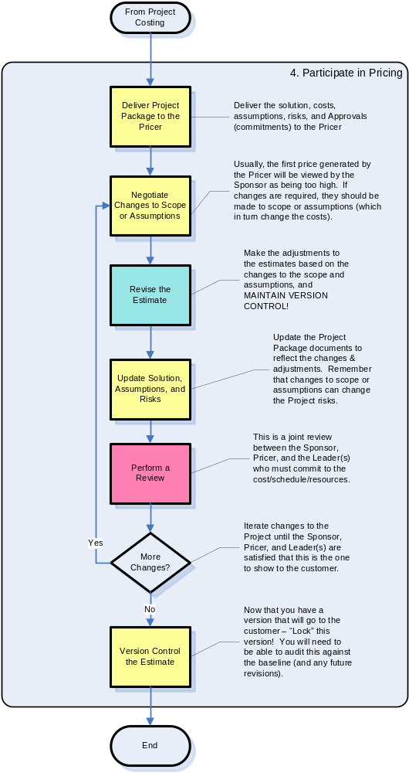

What does the estimator do during this step?
- Negotiate Changes to Scope or Assumptions.
After the version of the estimate is released, the practitioner will often be asked to revise the estimate. Reasons for being asked to revise the estimate include:
- The estimate is too high or the schedule too long to meet the Sponsor(s)’ expectations.
- Items that were included in the scope need to be moved out of scope, or additional items need to be added to the scope.
- Assumptions associated with the estimate are considered invalid, or additional assumptions must be added which will affect the estimate.
➲ Do not cut your estimate simply to meet Sponsor’s expectations! Estimates should be based on historical data or experience and should not be reduced simply because the Sponsor perceives them to be “too high”. If the Sponsor wants to lower the estimate, you should work with the Sponsor or SMEs to identify what items can be moved from scope or reduced in size. Another option is to change assumptions (add, remove, or modify) associated with the estimate.
Estimates are the basis for our business decisions. It is up to the estimator to work with the other members of the team to determine which portions of the Scope or which of the Assumptions can be modified to effect the desired changes. In many cases, entire portions of the work may need to be moved out of Scope in order to accommodate schedule or budget constraints.
Those of us at IBM who are responsible to provide estimates should be familiar with author Fred Books’ definitive work on Project Management: The Mythical Man Month (1975 and 1995):
“… false scheduling to match the patron’s desired date is much more common in our discipline than elsewhere in engineering. It is very difficult to make a vigorous, plausible, and job risking defense of an estimate that is derived by no quantitative method, supported by little data, and certified chiefly by the hunches of the managers…”
“… Until estimating is on a sounder basis, individual managers will need to stiffen their backbones and defend their estimates with the assurance that their poor hunches are better than wish-derived estimates.”

- Revise the Estimates and Update the Documentation.
At this point, the practitioner will repeat the initial estimating process to create a new version of the estimate. The practitioner will continue to produce iterations of the estimate until the requirements of the Sponsor(s) have been met, or until all members of the team agree that we have “sharpened the pencil” as far as it will go. Make sure that all changes to the Scope, Assumptions, and Estimates (cumulative changes from the baselined estimate) are clearly documented.

- Perform a Review.
At this point, you will need to prepare a revised review package and repeat the consolidated review. This is an important step. It gives each of the IBM provider groups or organizations who will be performing the work an opportunity to review the changes to the estimates and to commit to the delivery of the work.
Each of the IBM groups should be fully aware of how their responsibilities and the estimates for their work may have changed. Be prepared to discuss the reasons for any changes, and how changes to estimates are associated with changes to Scope and/or Assumptions.

- Record the Final Estimate.
After all changes (including any iterations) and all reviews have been completed, you should record the final version of the estimate. You should include copies of all documentation and estimating files and record them in a project archive. Document the date and name of approver who is accountable going forward as evidence of process.
As you continue to practice estimating, your project archive can be a useful source of historical data. Also, submitting copies of these final (proposed) estimates can help IBM continue to build its base of assets that other practitioners can use.

During the Remaining Lifecycle of the Estimate
Now that you have completed the four major steps of the estimating lifecycle, let’s summarize what a practitioner does during the estimating lifecycle:
- First, the practitioner assembles the best possible data regarding a particular subject (a scope of concern or interest) and assesses that data for the purpose of modeling the future for a period of time. An example of this is what we reviewed in Sections 3.1 through 3.4 above.
- Second, the practitioner tracks actual data about the subject over the course of time.
- Third, the practitioner compares the actual data collected to the baselined (or final) estimate for the purposes of gaining knowledge; specifically to improve the estimates remaining for the period of performance of the project and to improve our overall estimating ability and processes.
So the estimating lifecycle starts with creating the base estimate and continues until all activities associated with the scope are complete (and the actuals have been collected and stored as historical data for future use).
➲ During the lifecycle of the project, you MUST harvest your actual data in terms of your estimating metrics!
Record your project measurements in the same metrics used for developing the estimates. Matching the metrics in this way avoids allocation of data downwards or to other variables and avoids interpretive errors caused by such allocations. It is difficult to compare an estimate made at the project level with actuals collected at the task level; there is no simple way to correlate which variable at a high level had what impact at the detailed level.

Periodically through the lifecycle of the project, particularly at the end of major phases of a large project, you should review the actuals you have collected for the project and create another set of estimates for the remainder of the project.
➲ The later you are in the lifecycle process, the more you know (and the more experience you have) and therefore the more accurate your estimates will be (you should see less variance between your estimates and the actual results).
Compare your new estimates to your originals. If you find significant differences, you may identify areas within the remainder of the project that require attention or adjustment. This can help keep it from becoming a “troubled project” that is both expensive to correct and a major source of client dissatisfaction.
Finally, during the project closeout phase, you should collect all of the actuals and submit them as assets within IBM’s Intellectual Capital Management system, the IBM Project Management Center of Excellence, or to the IBM Estimating Community so that they become sources of historical data for future work.
➲ Your actual project data is an important intellectual asset of IBM.

Summary of Best Practice Guidelines

General
- Using formal estimating methods and tools are one of the ways in which you, the estimating practitioner, can produce more “acceptable” estimates.

- When providing an estimate, you should include a description of its scope (what is included and excluded).

- The degree of confidence in an estimate is expressed as a “variance”. When communicating your estimate, you should always indicate the variance associated with it.

Estimate the Size and Scope
- Quantify the things you are dealing with.

- Always document the assumptions you’ve made about the estimate.

- Avoid removing assumptions from the project documentation. Instead, simply change the way the assumption is stated. This can be a very effective way of managing many of the decisions regarding the estimate (especially in its early stages).
➲ A second set of eyes is always a good thing.

Estimate the Technical Cost
- There is no substitute for the use of actual (historic) data and metrics.

- Use more than one estimating approach.

- Use a recommended estimating tool whenever possible.

- Estimates should be carried out by a practitioner with experience in the particular business, technology, and environment. Preferably the same ones who will be carrying out the work.

- Use valid statistics in creating your estimates and assessing confidence.

- Avoid sensitivity to single, high-level variables.

➲ Avoid sensitivity to subjective variables.
➲ Many packets of small numbers can reduce the variance of your estimate.
➲ In addition to providing the estimate, you need to state your confidence in the estimate.
➲ Understanding and managing variance must become second nature to our practitioners.
➲ Ideally, where a firm estimate is required, try to aim for a variance of around 10% for a sound estimate.

Estimate the Project Costs
➲ Do not include “blanket” contingency across all items – link specific contingencies to risks, assumptions, or areas of uncertainty.
➲ Consider grouping all contingency items together in the estimate to allow them to be clearly identified.
➲ Save interim drafts of your estimates. These can be important reference points which can save you time if you have to replace or undo changes you made during the process.
➲ Estimates require reviews, updating, and auditing. Consider using GSMethod work products ENG 421 or ENG 105 as the basis for documenting your estimate.
➲ Baseline your approved project estimate. Use formal release management for all future changes.

Participate in Pricing
➲ Do not cut your estimate simply to meet Sponsor’s expectations! Estimates should be based on historical data or experience and should not be reduced simply because the Sponsor perceives them to be “too high”. If the Sponsor wants to lower the estimate, you should work with the Sponsor or SMEs to identify what items can be moved from scope or reduced in size. Another option is to change assumptions (add, remove, or modify) associated with the estimate.

During the Remaining Lifecycle of the Estimate
➲ During the lifecycle of the project, you MUST harvest your actual data in terms of your estimating metrics!
➲ The later you are in the lifecycle process, the more you know (and the more experience you have) and therefore the more accurate your estimates will be (you should see less variance between your estimates and the actual results).
➲ Your actual project data is an important intellectual asset of IBM.

Tools

When it comes to tools, we find ourselves in a situation where we have way too many and not enough at the same time. The tools that are available and used frequently at IBM vary by geography and business unit. These include:
- Engagement Support Environment (ESE) – ESE is an IBM-developed tool that automates the use of the IBM Global Services Method. It supports both the solution design and solution delivery phases of a project, including the tailoring of the method to specific engagement requirements. ESE uses the Lifecycle Estimation and Duration (LEAD) estimating technique to create the forecast the overall project effort.
- SAGE – the Solution Advisor Global Edition (SAGE) is an IBM-developed tool for quickly building, costing, and communicating complex services solutions.
- SLIM – the Software Lifecycle Management (SLIM) system available from QSM (McLean, VA) supports decision making at each stage of the software lifecycle: estimating, tracking, benchmarking and metrics analysis by modeling an organization’s historical project data. The SLIM components can work together to provide the IBM estimating community with clear data collection forms, calibrated estimation models, and a standard measurement analysis capability
- COCOMO II – this is a model that allows a practitioner to estimate the cost, effort, and schedule when planning a new software development activity. The model, produced by the Center for Software Engineering at the University of Southern California, is available in several software implementations – including the USC COCOMO II software released by the University of Southern California.
- As well as a very long list of spreadsheets and other tools used in different IBM lines of business.
The choice of tool(s) and methods used is primarily guided by the IBM Business Unit or competency organization that the IBM practitioner belongs to. For a current list of the tools and methods used by your organization, please contact your area or competency leader.
At present, the IBM Estimating Community has a Tools and Techniques Work Group which has recommended the adoption of the SLIM system as the standard estimating tool for IBM. For additional information regarding this recommendation, please refer to information available at the IBM Estimating Community Wiki (see Section 8, “References” for the URL).

Glossary

Cost | The budget (in currency, e.g., $US or $CAN) that is required to achieve the desired outcome.
Estimate | An educated guess (based on history or experience) of what might happen in the future, expressed with a stated degree of confidence (i.e., variance), for a specific scope of included items. See: Sizing Estimate, Technical Estimate, Project Estimate
Period of Performance | The total calendar duration of IBM’s involvement with the project or its components. For most projects, it is the total duration of the project. For Strategic Outsourcing (SO) engagements, it would be the total duration of the SO contract.
Plan | An organized set of decisions about how to carry out future activities and tasks to achieve a desired outcome. A plan requires input from such sources as estimates, schedules, and resource availability.
Price | The amount (in currency, e.g., $US or $CAN) that is quoted to a client. A price is usually expressed as an association with specific volumes of work, milestones or conditions achieved, or specific time periods. The price is usually different from the cost, in that the price will include such items as a margin for profit, amounts for contingency, etc.
Project Estimate | A consolidation and reconciliation of all Technical Estimates with the addition of all project-level solution and cost elements. The Project Estimate is applied across the schedule and includes a Resource Plan (resources applied across the project schedule). The Project Estimate provides the cost input data for producing a Price.
Schedule | A forecast of what is expected to happen over a specified period of time.
Sizing Estimate | An initial (or raw estimate) performed very early in the lifecycle. Often based on a standard solution or prior experience adjusted for general customization assumptions.
Technical Estimate | An estimate produced by an Estimator in partnership with the IBM group or organization that will be responsible for performing the work. This estimate takes into consideration all of the solution and cost elements associated with that group or organization (including labor, hardware, software, and contracted services). This estimate is applied across a schedule for the work and provides data necessary for the Project Estimate.

The IBM Estimating Community

The IBM Estimating Community is an organization composed of estimating practitioners across IBM who have joined together to share experiences and best practices, and to improve estimating in IBM. The goals for our community are:
- Promote an exchange of estimating experience across all IBM brands, and geographies including services, software, research, development, engineering and supply chain
- Identify and promote best practices in estimating methods, techniques, and tools
- Develop an action plan for improvements in estimating practices within IBM

The IBM Estimating Community has a number of activities underway each year to pursue our community goals. These activities include:
- In 2004 and 2005, the Community held IBM Estimating Best Practices Conferences which were sponsored by the IBM Academy of Technology and which led to Conference Reports published to the Academy and recommendations submitted to IBM’s Executive leadership.
- Work Groups which focus on extending the Estimating Body of Knowledge. At the time of this paper, there are active work groups in the following subject areas: Governance, Techniques and Tools, Education, Data Gathering and Analysis, and Asset Impact.
- The IBM Estimating Community Wiki – an online resource for information and knowledge sharing on Best Practices, Education, Tools, and Techniques.
- Proposals, white papers, online courses, technique papers, and other materials generated by members of the Estimating Community with the help and support of the Estimating Community Leaders and Core Team.

Since its inception in 2005, the Estimating Community has worked on an ad hoc, best effort basis to accomplish our goals. Please consider joining our community and become part of the dedicated team of estimating practitioners here at IBM. For more information, please visit the IBM Estimating Community Wiki at:
https://w3.webahead.ibm.com/w3ki/display/estimating/The+IBM+Estimating+Community

Key Considerations

None

References

Acknowledgements
The author of this technique paper summarized (and often shamelessly “re-used”) the thoughts, descriptions, and expertise of the many outstanding individuals who are provide the leadership and drive to excellence for Estimating within IBM. I would like to specifically recognize and thank a few these individuals for their contributions to this paper.
Tom Bridge – Markham, IBMCA
STSM, Leader WW GS Rational Center of Excellence
IBM Estimating Community Leader
Cheryl den Hartog – Markham, IBMCA
Sr. Project Manager, Estimating Specialist
IBM Estimating Community Leader
Pete Ellis – Portsmouth, IBMUK
Estimating Enablement Leader, Project Enablement Services, Europe

IBM Online Resources
Resource | URL
IBM Global Method Community | http://w3-03.ibm.com/services/assets_innovation/gcd/methods/survey/ join_method_commun.html
IBM Project Management COE | http://w3-03.ibm.com/transform/project/home_0301.html
IBM Estimating Community Wiki | https://w3.webahead.ibm.com/w3ki/display/estimating/The+IBM+Estimating+Community
On Demand Process Asset Library (OPAL) | http://w3.e-solutions.ibm.com/opal/connect/opal/opal+home/
IBM Worldwide Project Management Methodology | http://w3-03.ibm.com/transform/project/pmmethod/
IBM Global Services Method | http://method.endicott.ibm.com/MethodWeb/index.htm
Learning at IBM | http://w3.ibm.com/wps/myportal/learning/home

Other References and Resources
Publications
Introduction to Simulation and Risk Analysis, 2nd Edition, by James R. Evans and David L. Olson, 2001
Simulation Modeling and Analysis, 3rd Edition, by Averill M. Law and David Kelton, 2000
Understanding Variation: The Key to Managing Chaos, by Donald J. Wheeler, 2000

Education
A number of online education courses related to estimating are available through IBM Global Campus via Learning at IBM:
http://w3.ibm.com/wps/myportal/learning/home
Available courses include:
- BLG0366 - Estimating Best Practices: Part 1
- TE6PJM08 – Client Estimating Through the Eyes of a Project Manager
- TM6PJM24 – Early Lifecycle (Top Down) Estimating using Function Points
- PROJ551 – Estimating Activity Costs
- LTU10039 – Global Delivery Estimating Web Lecture
- TE61TR04 – Estimating from Use Cases
- LTU8281F – Improving Estimating Accuracy: Understanding and Leveraging
- PJ202 – Project Activity Duration Estimating
- PJ204 – Project Cost Estimating and Budget
- PM74D – Preparing a Detailed Estimate for Projects

Revision History

Revision Number | Revision Date | Summary of Changes | Authors
Version 1.1 | Dec 2006 | Initial draft | Christopher Voigt – Minneapolis, IBMUS  Sr. IT Architect, IBM Global Technology Services

