

IBM Global Services

Monitoring Project Progress through Estimation Factors

Technique Paper (TP)

© Copyright International Business Machines Corporation 2007

All Rights Reserved
Version 4.1.0, July 2007
- Description
The purpose of this technique paper is to outline some simple methods to help you, as a Team Lead, verify that the scope and assumptions on which the baseline estimate was based on are holding true as the project progresses. Simple tools created by the IBM Estimating Community make this easy.
The intended audience is any IBM practitioner who is responsible for creating initial estimates for projects, and who needs to monitor the progress of a project to a baselined estimate.
We will describe the basic estimating process used during project execution. This process description will give you an understanding of how estimates are used during the project or engagement lifecycle.
- This symbol will be used to highlight subjects within the text that are considered “best practices” for estimating at IBM.
Throughout this paper, we will identify other estimating material and tools that you can access. Although we will first introduce them in context, there is a complete list of these references at the end of the paper.
We also invite you to become involved in the IBM Estimating Community and contribute to the further development of these tools.
- Usage Context
When an estimate is created it is, by default, an approximation and will be quoted as a nominal figure with an associated confidence level. The Estimating with Variance technique paper strongly suggests that when reporting results of any estimation process, you should aim for a statement of this nature:
The nominal (expected) value of the effort estimate is 4,000 person hours. There is a 90% chance of the actual effort being between 3,600 person hours and 5,000 person hour, with a 50% likely-hood of achieving the nominal figure.
- The degree of confidence in an estimate is expressed as a variance. When communicating your estimate, you should always indicate the variance associated with it.
At the beginning of the project, this is the only information available. As the project progresses, key questions are posed to the delivery team:
- How is the project progressing?
- Will the project come in close to the original estimate?
This technique paper provides the background to the techniques of tracking estimation variance throughout the course of the project in order to confidently answer those questions.
As an aid to the delivery team, these techniques are supported in the spreadsheets used for the Estimation Report, Estimation Checkpoint Report, and Estimation Factors Report work products. This removes the need for statistical calculations on the part of the project leadership team.
The Estimation Checkpoint Report is focused on meeting the needs of the project manager and is discussed in a companion technique paper – Managing using Estimation Variance.
The Estimation Factors Report is focused on meeting the needs of the various team leads such as the lead business analyst, technical development lead, and test team lead and is discussed in this technique paper.
These estimation variance tracking techniques leverage information and techniques introduced in the Estimating with Variance technique paper to make the most of information the team has already produced.
- Understanding and managing variance must become second nature to our practitioners.
Educational material that discusses estimation variance is provided in the References section of this technique paper.
- Content
The Estimation Factors Report has two primary purposes:
- To indicate to project teams during delivery whether the baseline sizing or estimate is wrong. Is the size materializing as estimated? Is the unit of production assumed in the estimate being achieved?
- To collect actual data from closed projects for use by estimators in the future and to support callibration of IBM’s estimating tools in the future.
Issues to Monitor during project execution
Prior to a project starting, an estimate was prepared and base lined, risk mitigation plans were built and contractual arrangements were put in place. When the estimate was prepared, certain assumptions were made and the variance inherent in that estimate was assessed using techniques described in Estimating with Variance.
At the beginning of the project, the estimation variance reflects the uncertainty surrounding the upcoming delivery. Such uncertainty can include, but is not limited to, the following areas:
- Was the scope properly understood?
- Was the sizing done correctly?
- Is the team delivering as expected?
- Do the planned risk mitigations address areas of uncertainty in the estimate?
These questions on scope, size, performance, and risk are really different ways to monitor progress on the project, and build confidence that the project when completed will come in close to the original estimate.
As the project progresses, the estimation variance due to these factors reduce as the project eliminates uncertainty within the estimate. Successful projects have a high variance at the start, and a variance near zero at the end. This progression over time is represented by the Cone of Uncertainty in Figure 1.
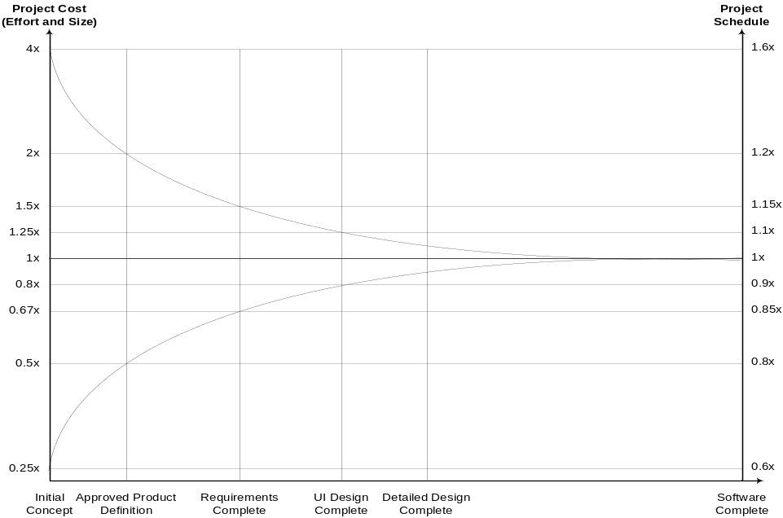
Figure 1 - Cone of Uncertainty
It should be noted that the Cone of Uncertainty illustrates the best accuracy possible at the phase of the project you are at. If your project is not managed in a way to remove the uncertainty, then you can certainly do worse than the Cone would otherwise suggest.
- Don’t assume that the Cone of Uncertainty will narrow itself. You must force the Cone to narrow by removing sources of variability from your project.
The intent of the techniques described in this paper is to confirm that the actions taken by the project are in fact not only eliminating uncertainty in the project, but also reducing the variance in the estimates.
The specific areas of uncertainty that can be measured by the team leads are the understanding of the scope, the sizing of the project based on that scope, and the amount of effort required by the delivery team performing the work. Actively measuring and monitoring these areas assists the team in effectively reducing the estimation variance inherent in the project. Measuring that the risk mitigation actions are being effective in reducing estimation variance is discussed in the Managing using Estimation Variance technique paper.
Was the scope properly understood? Was the sizing done correctly?
In an estimate, scope and size are tightly integrated. The scope question is really about any difference between what was included and excluded from the estimate, and what will be included and excluded from the final deliverable. From an estimation point of view, this scope is defined by the estimation factors used in the original estimate.
The original estimate captures the scope, sizing and effort quantification of the project in the Estimation Report in the Project Estimate Baseline and the associated assumptions. However, it is possible that the estimate may have been prepared using a top-down rather than a bottom-up approach. It is also possible that not all estimation factors would have been identified in the baseline estimate, even though the effort to produce them would have been included in the top-down estimate.
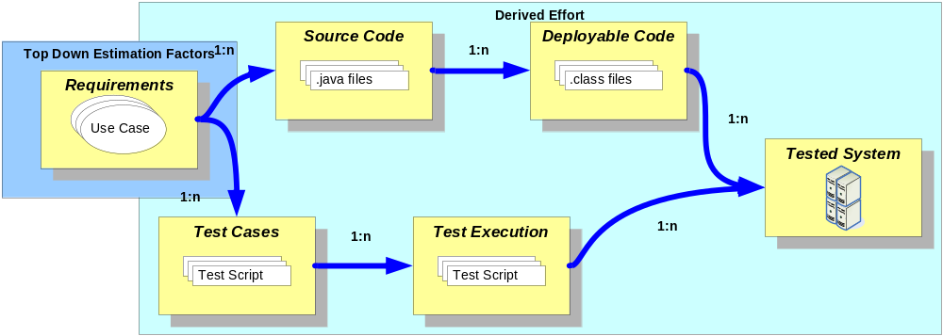
Figure 2 - A simple view of top-down estimation factors
A top-down approach provides a count of estimation factors that can be known early in the project, and derives the remainder of the estimate based on prior similar project analysis. This type of approach can be applied during the proposal stage of a project.
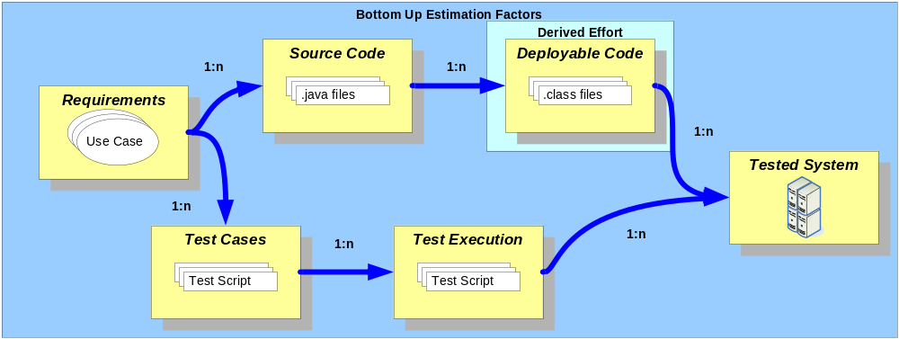
Figure 3 - A simple view of bottom-up estimation factors
A bottom-up approach is tailored towards a project during delivery. It provides more detailed counts of several estimation factors that can only be known during project delivery and minimizes the amount of derived effort.
Since each of the estimation factors to be tracked is associated to some particular role and phase in the project, then as the project moves into delivery each team lead should perform a more detailed estimate based on the typical estimation factors relevant to their domain of expertise.
- Quantify the things you are dealing with.
Estimation factors are one of the parameters that were used to prepare the estimate. Examples of such estimation factors are Function Points, number of use cases, number of logical entities, number of help line calls per month, number of servers, etc. Any factor that is directly related in some way to effort, and is easily measured, may be selected as an estimation factor.
Effort = Estimation Factor Count X Assumed Unit Production Effort per Estimation Factor
The estimate for a particular estimation factor was calculated by counting the estimation factors and multiplying that count by the effort to produce one unit. For example, the effort to write all the test cases for a project is the number of test cases expected to be written times the effort to write one typical test case.
If the scope is misunderstood from the beginning, the estimation factor count will be wrong. The scope and estimate should be validated to be complete by using the Estimating Considerations Checklist.
During the course of the project, it is possible to discover new requirements which will increase the number of estimation factors yet to start. The Estimation Factors Report tracks the baselined count against the estimated count at completion for each estimation factor. It is important to track the number yet to start separate from the established baseline so you can detect deviations from the baseline, which are changes in scope.
For example, the test lead should quantify the expected number of test cases, test scripts, and test execution cycles to develop a detailed estimate of the overall testing effort, and enter these numbers into the Estimation Factors Report as the baseline for testing related effort.
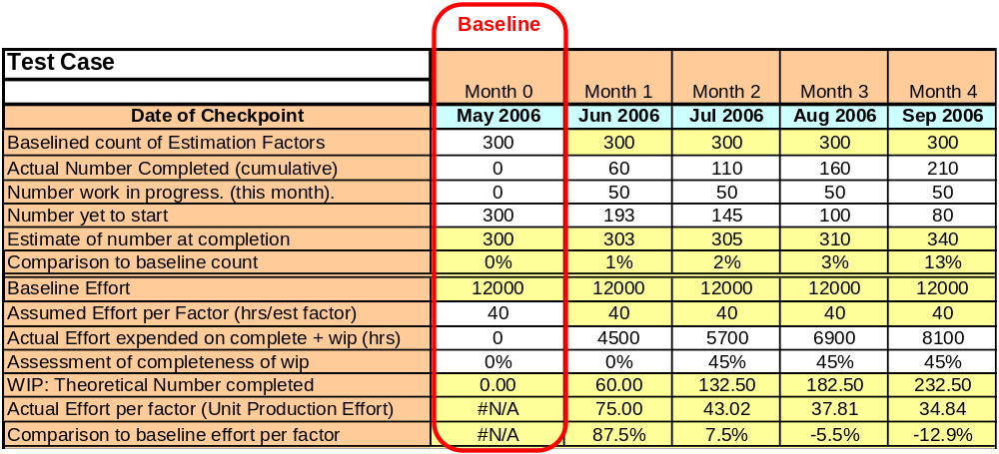
Figure 4 - Estimation Factors Report
Each month, the test lead counts the number of test cases completed thus far, the number that are started but not complete (work in progress), and the number yet to be started. This determines the estimated number at completion and provides a mechanism to detect scope changes from the project as originally estimated. The other team leads perform an identical task for their area of expertise.
Similarly, the other team leads perform an identical task for their area of expertise. The lead business analyst would enter the baseline for use cases, or other requirement related estimation factors, and the technical development lead would enter their baseline for software components to be developed.
The Estimation Factors Report allows the team leads on the project to track the estimation variance in the counts of the estimation factors from the baseline on which the estimate was based.
- Significant variance in the Estimation Factors indicates possible scope creep, missing or misunderstood requirements.
The Estimation Factors Report charts these numbers as shown in Figure 6.
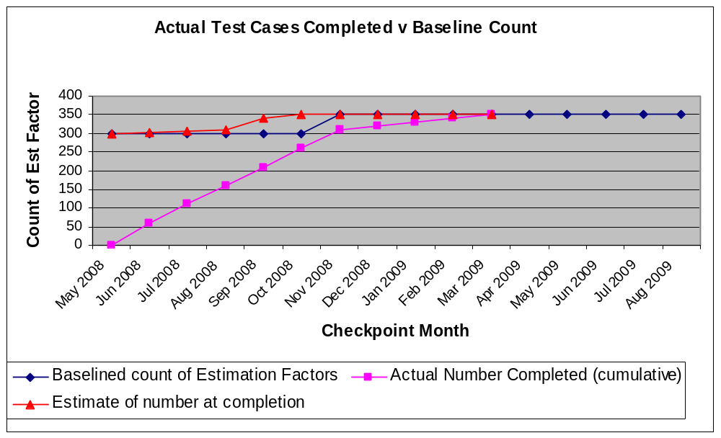
Figure 5 - Estimation Factors Report – Actual v Baseline
If the estimate at completion is increasing without a corresponding adjustment to the baseline, then scope creep relative to the baseline is occurring and must be corrected. By charting both the baselined count, and the estimate at completion, one can easily detect when these changes are occurring.
In the example shown, the project decided to modify the baseline via a change request, bringing the baseline back in line with the estimate at completion. Equally valid would have been a decision to defer some functionality to a future release via a change request, which would have adjusted the estimate at completion back to the baseline, or confirm that the newly identified requirements are out of scope.
If the scope was well understood at the beginning of the project, the count of test cases in this example would not have increased.
Is the team delivering as expected?
Whether the team is delivering as expected is a question about the difference between the assumed unit production effort contained in the original estimate, and the real unit production effort of the delivery team over the course of the project. It should be noted that mathematically, the unit production effort, or the effort to produce one unit, is the reciprocal of productivity, or the number of units produced in a set amount of effort.
- There is no substitute for the use of actual (historic) data and metrics.
- Estimates should be carried out by a practitioner with experience in the particular business, technology, and environment. Preferably the same one who will be carrying out the work.
The assumed unit production effort from the estimate of each team lead is entered as the Assumed Effort per Factor in the baseline of the Estimation Factors Report. This assumed unit production effort is the amount of effort required to deliver one unit of the estimation factor in question.
Effort = Estimation Factor Count X Assumed Unit Production Effort per Estimation Factor
The Assumed Unit Production Effort per Estimation Factor is the other parameter used to prepare the estimate. The Assumed Unit Production Effort per Factor is the historical data on which the estimate is based and the team lead has confirmed, based on historical data from other similar projects, that the effort this project should expect to expend is this number.
If the historical project is not similar to the current project, or the team delivering the project is not similar to the team from which the assumed unit production effort was gathered, the assumed effort will be wrong.
- Collect and compare actual project unit production effort to historical unit production effort to improve your individual estimates. Submit this data at project close to improve IBM’s estimates on future projects.
As the project performs the work, the team leads will enter the actual effort used to generate the work item associated with the estimation factor to validate the assumed unit production effort.
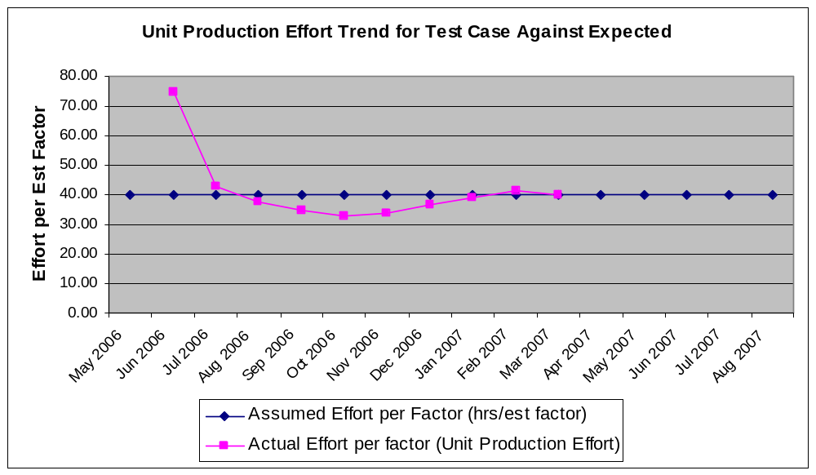
Figure 6 - Estimation Factors Report – Unit Production Effort Trend
Each month, the test lead enters the effort expended on test cases completed and in progress thus far, and an estimate of how complete the work in progress is. This determines the actual unit production effort of test cases.
For example, if the estimation factor is test cases, and the historical data suggests that a typical test case can be delivered in 40 hours of effort, then the assumed unit production effort in the estimate will be 40 hours. When the project starts, it delivers 60 test cases in 4,500 hours in the first month, which is unit production effort of 75 hours per test case.
By the end of the second month, the project has delivered 110 completed test cases plus 50 test cases that are 45% complete in 5,700 hours of effort. The project is now producing each test case in 43 hours.
By the fourth month, the project’s unit production effort for test case production is 34.84 hours.
The Estimation Factors Report charts this metric for each estimation factor for the team leads and compares the actual unit production effort of the team to the historical baseline – the assumed unit production effort – used to produce the estimate. Significant deviations indicate that the historical effort used in the estimate is not consistent with the team actually performing the work and should be investigated.
This comparison allows you to improve your estimates over time by validating or invalidating the unit production effort assumptions used in your estimates based on actual project data. Indeed, at project close IBM’s Estimating Community is very interested in collecting this data from many projects to improve the organization’s historical data.
By entering five numbers for each estimation factor – actual number completed, number currently in progress, number yet to be started, actual effort expended, and the assessment of completeness for the work in progress – the unit production effort of the project for this estimation factor can be calculated, and the progress compared to the baseline charted to clearly indicate how closely the project is tracking to the established baseline.
Deviations from the baseline need to be investigated to determine the root cause, and action taken as determined. In some situations, re-baselining may be indicated. In other situations, a de-scoping activity may bring the project back in line with the estimate. In still other situations, a change in resource performing the work may be required.
Re-baselining
The Estimation Factors Report supports re-baselining during the project.
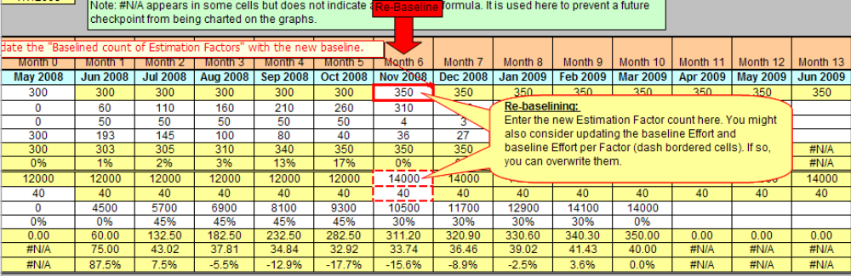
Figure 7 - Estimation Factors Report – Re-baselining a Project
When re-baselining occurs, the new estimate is updated in the Estimation Factors Report in the month in which the re-baselining has occurred. The original baseline data is left unchanged to preserve historical accuracy.
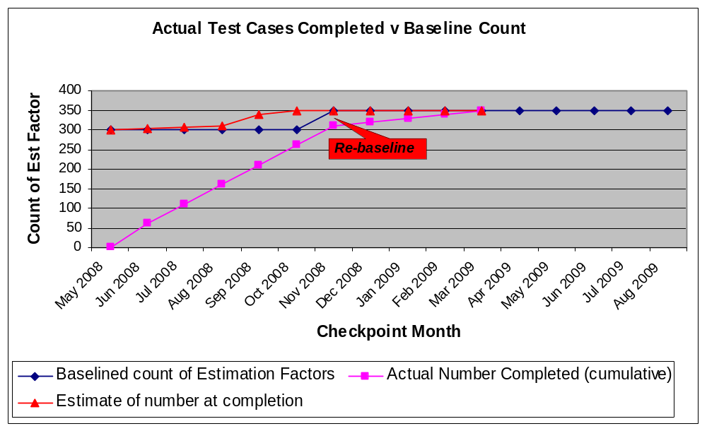
Figure 8 - Estimation Factors Report - Re-baselining
This new baseline is reflected in the charts in the report.
At Project Close
The Estimation Factors Report provides information on both the type of project from the project details, and size of projects from the estimation factors – leading to the ability to compare projects of similar type and size. The estimation factors provide a way to quantify scope.
- Your actual project data is an important intellectual asset of IBM.
The Estimation Factors Report includes a section to be completed when the project ends. This allows IBM to collect actual data from projects with minimal work by the project. IBM can then analyze the data to validate and calibrate our estimation tools. For example, data from actual projects was used to calibrate the Use Case Estimation Worksheet (UCEW). Additional data will further refine tools such as this.
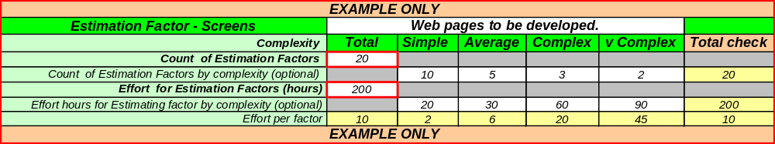
Figure 9 - Estimation Factors Report – Project Close Data
At project close, the final actual counts and effort associated with each estimation factor is entered into the report. This activity can be as simple as copying the data from the final checkpoint into the Project Close portion of the report.
If possible, a breakdown of the factors by complexity – simple, average, complex, very complex – is desired as this helps to further calibrate IBM’s estimation models and tools.
- Key Considerations
Whether or not the scope is properly understood is measured directly by changes in the counts of the estimation factors over time. Discovering additional requirements will increase the counts. De-scoping requirements would reduce the count. The project then needs to decide whether it will absorb the change in scope, issue a change request, or defer the newly discovered requirements.
Understanding of the scope can also be measured indirectly by deviations from the expected unit production effort. This could arise from not allocating sufficient effort in the estimate to account for the real complexity of the estimation factor. For example, discovering during delivery that the requirements are more complex than anticipated will invalidate the assumed unit production effort factor. While you have not discovered additional requirements in the form of new counts of requirements, you have discovered that the effort required to define the requirements is greater than anticipated. Again, the project needs to decide how it will react to this situation.
Improperly sized projects would typically be measured by changes in the counts of the estimation factors, or changes in the assumed unit production effort. Rather than discovering new requirements, assumptions about what the requirement meant can cause changes to the counts or unit production effort assumptions. Requirements that reasonably should have been included are discovered to be missing, or understated, or the calculations of size are found to be in error.
The delivery of the team can be measured directly by the unit production effort trend. Deviations from the assumed unit production effort could indicate the use of resources operating at a different level of productivity than the historical projects used as references for the assumed unit production effort. The performance of the team can also be measured indirectly through the completed work. This is charted on the Actual Completed v Baseline Count chart. If the unit production effort trend appears to be the same as the assumed unit production effort, but work is not being completed, then further investigation is required to determine the root cause.
The Estimation Factors Report is expected to capture the progress of the entire team for a particular project, and capture this data for use in improving IBM’s future estimates. How the team manages to enter their data into the report is up to the team. Several possibilities exist.
The report could be located on a shared directory, and the common report updated by each team lead in turn. The lead estimating practitioner could schedule a regular reporting meeting with each team lead at which time the inputs to the report could be captured. Each team lead could complete their own report, with the lead estimating practitioner on the project consolidating the various reports into a single report for the project.
- References
IBM Resources
- The IBM Estimating Community wiki contains estimating related documents, hints, tips and further reading: https://w3.webahead.ibm.com/w3ki/display/estimating/Estimating+Home
- Introduction to Estimating Best Practices at IBM – Technique Paper
- Estimating with Variance – Technique Paper
- Managing with Estimation Variance– Technique Paper
- Estimating Considerations Checklist (ENG430) – Work Product
- Estimation Variance and Governance, by Murray Cantor: http://www-128.ibm.com/developerworks/rational/library/mar06/cantor/index.html

Non-IBM Resources
- Probabilities and normal distributions: http://davidmlane.com/hyperstat/z_table.html

Publications
The following publications provide an easy introduction to the concepts of estimation variance and come highly recommended.
- Understanding Variation: The Key to Managing Chaos, by Donald J. Wheeler, SPC Press, 2000.
- Software Estimation: Demystifying the Black Art, by Steve McConnell, Microsoft Press, 2006.

- Revision History
Revision Number | Revision Date | Summary of Changes | Authors
4.1.0 | 20 July 2007 | First OPAL release. | Estimating Content Team
4.1.2 | April 2007 | 3rd draft based on peer review. | Estimating Content Team
4.1.1 | March 2007 | 2nd draft | Estimating Content Team
1.0 | September 2006 | Initial draft | Estimating Content Team

Diagram courtesy of Bob Obsieger. Based on Software Estimation: Demystifying the Black Art, Steve McConnell, 2006.
Software Estimation: Demystifying the Black Art, Pg. 40, Steve McConnell, 2006

