

<Project Name>

System and/or Component Architecture

Prepared by: <Project Name> SE&A Team

Document Owner: <Name>
Revision: <2.1>
© Copyright IBM Corp. 2002, 2003 All Rights Reserved

Document Control
Table 1 Document Control General Information
Type of Information | Document Data
Title | <Project Name> Architecture Document
File name | <FilenameVersion.extension>
File Location | <File location – database, website, contact person>
Current Version | <Current Version>
Original Release Date | <Date>
Current Release Date | <Date>
Document Owner | <Name or Organization>
Document Reviewers | <Name(s) or Organization>
Document Approval | <Name>

Table 2 Document Control Version History
Version | Version Date | Nature of Change | Pages Effected | Date Approved
<Version> | <Date> | <Description> | <pg #s> | <Date>
Table of Contents
1. Architecture Overview 6
1.1. Opportunity Description 6
1.2. System Context 6
2. System Architecture Description 8
2.1. Operational/Dynamic View of the Architecture 8
2.2. Functional/Static View of the Architecture 8
2.3. Physical/Static View of the Architecture 9
3. Component Architecture Description 10
3.1. Operational/Dynamic View of the Component Architecture 10
3.1.1. <Operational Capability Descriptor Number 1> 10
3.1.2. < Operational Capability Descriptor Number N> 10
3.2. Functional/Static View of the Component Architecture 10
3.2.1. <Functional Component Descriptor Number 1> 11
3.2.2. <Functional Component Descriptor Number N> 11
3.3. Physical/Static View of the Component Architecture 11
3.3.1. <Physical Component Descriptor Number 1> 12
3.3.2. <Physical Component Descriptor Number N> 12
4. Appendix A – Acronyms 13
5. Appendix B – Document Reference Information 14
6. Appendix C – Template Document Control 15

Table of Figures
Figure 1 Architecture Views 4
Figure 2 Context Diagram Example 7

Table of Tables
Table 1 Document Control General Information 2
Table 2 Document Control Version History 2
Table 6 Template Document Control General Information 15
Table 7 Template Document Control Version History 15

<Template Description- PAGE TO BE DELETED WHEN COMPLETE>
<Purpose and Scope
This purpose of this document is to describe a high level system architecture in compliance with the requirements for a Systems Requirement Review or a Preliminary Design Review. The scope of this document is to present an appropriate level of information to convey a high level understanding and architecture plan necessary to meet the requirements established in the associated systems requirements specification or component requirements specification document.
Document Structure
This document is organized into three main sections:
- Architecture Overview
- System Architecture Description
- Component Architecture Description
The architecture overview section provides an overall description and scope of the required solution and an establishment of the context of the proposed architecture.

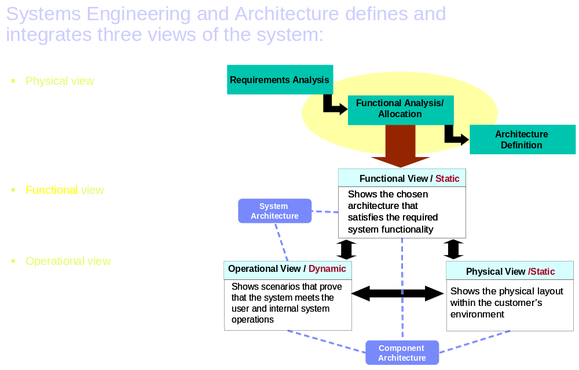
The System and Component architecture sections define the high level processes and system elements required for realizing the architecture. When this document is used for the Systems Requirements Review, the System-level architecture is described, and when used for the Preliminary Design Review, the Component or Application architecture(s) are described. These sections are further divided into dynamic and static views. The dynamic views describe at a high level the Operational processes, process dependencies, and process interfaces associated with the required solution. The static views describe at a high level the Physical layout and Functional allocation to systems, system dependencies and system interfaces associated with the required solution.
Figure 1 Architecture Views

Guidelines and Instructions
The lead systems engineer for the project is responsible for completing this document in preparation for the Systems Requirement Review or the Preliminary Design Review. For the SRR, the target length of this document should be 3 – 6 pages and should not exceed 20 pages. For the PDR, it may be significantly larger. This document should undergo a “peer review” 3-5 days before the SRR to allow sufficient time to incorporate any necessary modifications, per the systems engineering and architecture method guidelines.

When used in conjunction with the QIC Architecture Modeling Methodology, sections of this template should be sourced directly from the Capability Model.

GS Method Work Products are listed as potential sources of the information in each section. The Work Product Descriptions (WPD’s) identified are widely used among the Method Engagement Families. These work products are provided as guidance for the development of the deliverable. The work products are not required for completion of the deliverable, and other work products may be utilized, if project characteristics warrant. Some of these work products apply to multiple sections.

Work products may be completely developed across multiple project phases (as part of multiple deliverables). Preliminary or high level information may be provided in a work product at one project phase, and more detail is provided at later phases. Thus, a work product may be partially filled out in early project phases, but not completed until later phases.

Potential corresponding WPD’s are presented in the following manner:

Potential Corresponding Work Product Descriptions (WPD) from GS Method
Work product ID - work product title - URL to WPD

When using this template for the SRR, this is the preliminary architecture document, whose primary focus is on demonstrating a high level understanding of the required processes, systems and interfaces (external and internal to the in-scope system) through a preliminary architecture design plan. When using this template for the PDR, this document must evolve to become a detailed description of the type of systems, applications, etc needed to build the solution. Sections that should be completed based on the project scope of work are summarized below.

SRR – Complete Section 2
PDR – Complete Section 3

Architecture Overview
<Objective: The focus of this section is to describe the overall architecture plan for the specific in scope systems engineering effort. The proposed plan must be in compliance with the associated systems requirement specification. This is accomplished by completing the two primary subsections of the architecture section:
- Opportunity Description
- Architecture Context
Reviewers should be able to read this section and understand the opportunity and the high level proposed solution that will meet the requirements of the opportunity.

Guidance: All sections should be completed for all systems engineering supported projects. The use of figures and tables to accurately and succinctly convey information is strongly encouraged. Avoid unnecessary duplication of information. Instead provide links to reference documentation in Appendix B. The target length of this section should be 1- 2 pages depending on the scope of work. >
< DO NOT ENTER TEXT HERE>

Opportunity Description
< Objective: Reviewers should be able to identify at a high-level three elements:
- Solution opportunity and scope
- Proposed approach
- Solution constraints and dependencies
Guidance: In approximately three to four paragraphs describe:
- The summary of the solution opportunity (scope of what is trying to be solved) without repeating all requirements listed in systems requirement specifications. Included within this section should be the identification of scope of project – system development, system enhancement, or hybrid solution.
- A summary of the proposed solution approach listing the known major components that will be required,
- A summary listing or description of any known architecture constraints or dependencies >
<ENTER TEXT HERE>

System Context
Potential Corresponding Work Product Descriptions (WPD) from GS Method
APP 011 – System Context - URL

< Objective: Reviewers should be able to identify at a high-level:
- The environment context within which the solution is to be deployed from both a logical and physical perspective
Guidance: Primary information should be conveyed in a context diagram that represents the entire system as a single object or process and identifies the interfaces between the system and external entities, see Error: Reference source not found below. Text and tables should be included to summarize information succinctly. Text should not exceed two to three paragraphs.
<DELETE FIGURE BELOW WHEN COMPLETE>
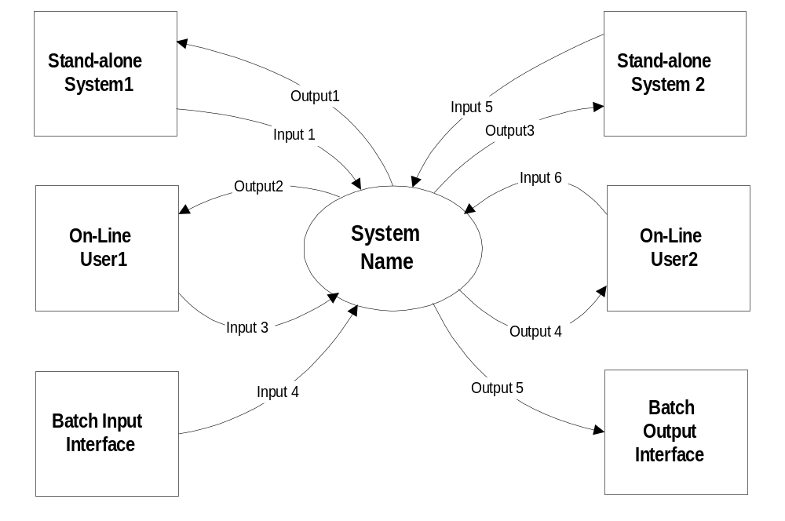
Figure 2 Context Diagram Example
<ENTER TEXT HERE>

System Architecture Description
<Objective: The focus of this section is to describe the overall architecture plan at the system level. Reviewers must be able to understand the logical landscape of major components to comply with the requirements of an SRR or PDR and peer review. Information should provide a clear understanding of the associated interaction interfaces and dependencies. Additional information related to the physical landscape of major components should be provided when available based on project scope.

Guidance: see individual sections below.
<DO NOT ENTER TEXT HERE>

Operational/Dynamic View of the Architecture
Potential Corresponding Work Product Descriptions (WPD) from GS Method
APP 108 Interaction Diagram - URL
APP 130 Use Case Model - URL
APP 013 Data Migration Maps - URL
APP 017 Data Migration Plan - URL
OPS 316 Security Architecture - URL
ARC 107 Architectural Template - URL
APP 112 Process Data Usage - URL
ARC 118 Change Cases - URL

<Guidance:
Heavy use of figures and tables should be included to convey information on external and internal interactions, interaction dependencies and interaction interfaces associated with the proposed solution. At a minimum, identify each major interaction and associated inputs/outputs to show the overall operational capabilities integration in a single figure. If applicable and appropriate, break the overall integrated logical major functions into sub-functions. The key is to remain at the highest feasible component level to convey information without losing key interdependency information. Identification of those elements that are out of scope of the current effort should be clearly highlighted. >
<ENTER OPERATIONAL CAPABILITIES DESCRIPTION HERE>

Functional/Static View of the Architecture
Potential Corresponding Work Product Descriptions (WPD) from GS Method
APP 315 – DFD Application Model - URL
ARC 301 – Current IT Environment - URL
APP 107 Class Diagram - URL
OPS 316 Security Architecture - URL
ARC 107 Architectural Template - URL
APP 112 Process Data Usage - URL
ARC 118 Change Cases - URL

<Guidance:
Heavy use of figures and tables should be included to convey information on external and internal systems, system dependencies and system interfaces associated with the proposed solution. At a minimum, identify each functional major component and associated inputs/outputs to show the overall system integration of these processes in a single landscape diagram. If applicable and appropriate, break the overall integrated functional major component into subcomponents with appropriate figures, using level three sections within the document, see below. The key is to remain at the highest feasible component level to convey information without losing key interdependency information. Identification of those elements that are out of scope of the current effort should be clearly highlighted.>

Physical/Static View of the Architecture
Potential Corresponding Work Product Descriptions (WPD) from GS Method
ARC 101- Architecture Overview Diagram- URL
ARC 302 Application Function Model - URL (optional)
ARC 301 – Current IT Environment - URL
OPS 316 Security Architecture - URL
ARC 118 Change Cases - URL

<Guidance:

The Physical/Static View of the Architecture should be developed at a high overview level for the SRR. It mainly consists of an Architecture Overview Diagram, with physical details where known.

Component Architecture Description
<Objective: The focus of this section is to describe the overall architecture plan at the component level. It is not necessary for the SRR. Reviewers must be able to understand the logical landscape of major components to comply with the requirements of a PDR and peer review. Information should provide a clear understanding of the associated interaction interfaces and dependencies. Additional information related to the physical landscape of major components should be provided when available based on project scope.

Guidance: see individual sections below.
<DO NOT ENTER TEXT HERE>

Operational/Dynamic View of the Component Architecture
Potential Corresponding Work Product Descriptions (WPD) from GS Method
APP 108 Interaction Diagram - URL
APP 130 Use Case Model - URL
APP 017 Data Migration Plan - URL
OPS 316 Security Architecture - URL
ARC 107 Architectural Template - URL
APP 112 Process Data Usage - URL

<Guidance:
Heavy use of figures and tables should be included to convey information on external and internal interactions, interaction dependencies and interaction interfaces associated with the proposed solution. At a minimum, identify each major interaction and associated inputs/outputs to show the overall operational capabilities integration in a single figure. If applicable and appropriate, break the overall integrated logical major functions into sub-functions. The key is to remain at the highest feasible component level to convey information without losing key interdependency information. Identification of those elements that are out of scope of the current effort should be clearly highlighted. >
<ENTER OPERATIONAL CAPABILITIES DESCRIPTION HERE>

<Operational Capability Descriptor Number 1>

< Operational Capability Descriptor Number N>

Functional/Static View of the Component Architecture
Potential Corresponding Work Product Descriptions (WPD) from GS Method
APP 315 – DFD Application Model - URL
ARC 108 Component Model - URL
ARC 104 Application Programming Interface - URL
APP 110 Logical Data Model - URL
ARC 306 Data Stores - URL
APP 107 Class Diagram - URL
ARC 107 Architectural Template - URL
OPS 316 Security Architecture - URL
ARC 103 Technical Prototype - URL
APP 112 Process Data Usage - URL

<Guidance:
Heavy use of figures and tables should be included to convey information on external and internal systems, system dependencies and system interfaces associated with the proposed solution. At a minimum, identify each functional major component and associated inputs/outputs to show the overall system integration of these processes in a single landscape diagram. If applicable and appropriate, break the overall integrated functional major component into subcomponents with appropriate figures, using level three sections within the document, see below. The key is to remain at the highest feasible component level to convey information without losing key interdependency information. Identification of those elements that are out of scope of the current effort should be clearly highlighted.>
<ENTER FUNCTIONAL LANDSCAPE COMPONENT DESCRIPTION HERE>

<Functional Component Descriptor Number 1>

<Functional Component Descriptor Number N>

Physical/Static View of the Component Architecture
Potential Corresponding Work Product Descriptions (WPD) from GS Method
ARC 302 Application Function Model - URL (if further detail needed from System Level)
ARC 111- Deployment Unit- URL
ARC 113 – Operational Model - URL
ARC 322 - Network Conceptual Design - URL (may also be considered)
ARC 317 – Network Node Design - URL (may also be considered)
ARC 319 – Performance Model - URL (may also be considered)
OPS 316 Security Architecture - URL
ARC 103 Technical Prototype - URL

<Guidance:

The Physical/Static View of the Architecture should be developed at a high overview level for the SRR and at a more detailed (70% complete) level for the PDR.

An Operational Model work product may include the following:
- One or more diagrams that show the topology and geographic distribution of the system, the definition of the nodes (computer platforms) and network connections, and where and how users and external systems interact with the system being developed.
- A detailed description of each node, which usually includes a table or box diagram that identifies and classifies the software components that run on the node. For convenience, components (which may not all be software) are often grouped into deployment units for ease of placement. The description includes the node’s availability, performance, security and other nonfunctional characteristics.
- A detailed description of the networks that connect the nodes, together with their protocol layers and services.
- A mapping matrix of deployment units to nodes, if a significant number of deployment units appear in more than one node (for example, if there is complex data segmentation and replication). Each deployment unit is a convenient grouping of components from the software architecture.
- A description of the systems management strategy, including decisions about centralized vs. distributed managing stations, backup and recovery strategy, software distribution models and approach, change control, configuration management, and other systems management processes.
- A description of middleware services and products and the key middleware choices (includes security, Object Request Brokers, etc.).

The Deployment Unit work product describes components that are grouped together for deployment purposes (i.e., they execute, get stored, or are installed together on a node). Deployment Units aggregate components with similar service level requirements. Consequently, a component could end up in multiple Deployment Units for each of the above-mentioned deployment purposes. A Deployment Unit is considered as a single unit for placement considerations.

A Deployment Unit identifies the grouped components and adds or references other information (e.g., resource requirements, service level requirements, and technical dependencies) that is relevant for their subsequent placement

The deployment Units should be shown mapped on the Operational Model. During the initial phases of the project when this document is created the diagram should show the landscape of existing deployment units on existing operational nodes as well as future enhancements (both future deployment units and future operational nodes). As project progresses this diagram should be updated.>
<ENTER PHYSICAL LANDSCAPE MAJOR COMPONENT DESCRIPTION HERE>

<Physical Component Descriptor Number 1>

<Physical Component Descriptor Number N>

4. Appendix A – Acronyms
Table 3: List of Acronyms
Acronym | Definition

Appendix B – Document Reference Information
Table 4: Document Reference Information
Reference # | Document | Description | Location or Contact
 | <SRSProject1.ext and Current Version> | System Requirement Specification | <owner of project specification and where file is located, database, website, personal files system>
 | <RTVMProject1.ext and Current Version> | Requirements Traceability and, Verification Matrix | <owner of project specification and where file is located, database, website, personal files system>

Appendix C – Template Document Control
Table 3 Template Document Control General Information
Type of Information | Document Data
Title | Architecture Document Template
File name | Architecture Document Template v2.0.doc
Source Location | SE TeamRoom: Section: Document Work Products
Current Version | 2.0
Original Release Date | December 6, 2002
Last Release Date
Document Owner | Systems Engineering and Architecture Team (SEA)
Current Editor | Vinny Buscher
Document Reviewers | Systems Engineering and Architecture Team
Document Approval | Paul Popick, Systems Engineering and Architecture

Table 4 Template Document Control Version History
Version | Version Date | Nature of Change | Pages Effected | Date Approved
V1.n | December 6, 2002 | Draft Release | All | N/A
V2.0 | December 17, 2002 | Revisions from Peer Review | All
V2.0 | December 19, 2002 | Updates from peer review | All
V2.1 | August 21, 2003 | Update WPDs | All

