

< Project Name >

System Requirements Specification Version 2.3

Prepared By:
< Project Name > SE&A Team

Document Owner: < Name >
Version Level: 2.3
© Copyright IBM Corp. 2002, 2003 All Rights Reserved

General Instructions:

    - Replace < Project Name > with the name of your project or system
    - Replace < Customer > with the name of your customer
    - Items in this font and color are instructions and should be removed from the final document.
    - This page should be deleted from the final document.

IGS Method Reference:

The System Requirements Specification is derived from many IGS Method Work Products. Assembling the SRS may include pointing to specific work product instances and/or synthesizing material from work product instances.

The Work Product Descriptions (WPD’s) identified are widely used among the Method Engagement Families. These work products are provided as guidance for the development of the deliverable. The work products are not require for completion of the deliverable, and other work products may be utilized, if project characteristics warrant. Some of these work products apply to multiple sections.

Work products may be completely developed across multiple project phases (as part of multiple deliverables). Preliminary or high level information may be provided in a work product at one project phase, and more detail is provided at later phases. Thus, a work product may be partially filled out in early project phases, but not completed until later phases.

Potential corresponding WPD’s are presented in the following manner:

Potential Corresponding Work Product Descriptions (WPD) from GS Method
Work product ID - work product title - URL to WPD

Table of Contents
1 Introduction 1
1.1 Scope 1
1.2 Management Summary 1
1.3 Revision History 1
1.4 Stakeholder Approvers 2
1.5 Reviewers 2
1.6 System Objectives / Overview 3
1.7 < Project Name > Definitions 3
2 References 5
2.1 Customer Documents 5
2.2 Non-Customer Documents 5
2.3 Updating this Specification 6
3 Requirements 7
3.1 Functional Requirements 7
3.1.1 Functional Requirement 1 - <Title> 7
3.1.2 Functional Requirement 2 - <Title> 8
3.2 Usability Requirements 8
3.2.1 Usability Requirement 1 - <Title> 9
3.2.2 Usability Requirement 2 - <Title> 9
3.3 Non-Function Requirements 9
3.4 System External Interface Requirements 10
3.4.1 Interface Identification and Diagrams 10
3.5 Other Requirements 10
3.5.1 User Support Specifications 10
3.5.2 Data Migration Specifications 11
3.5.3 Report Specifications 11
3.5.4 Change Cases 11
3.6 Priority of requirements 11
3.7 Assumptions, Issues and Constraints 12
4 Acceptance Criteria 13
5 Appendix A - <Title> 14
6 Appendix Z - Non Functional Requirements considerations 15

Introduction

Scope
This specification establishes the requirements for the < Project Name > project.
Potential Corresponding Work Product Descriptions (WPD) from GS Method
ENG 343 - Project Definition - URL

Management Summary
Potential Corresponding Work Product Descriptions (WPD) from GS Method
ENG 343 - Project Definition - URL

In this section summarize project’s scope. This is usually extracted from the scope or project definition document. Describe the customer's needs / opportunities for the project and provide a high level overview of the < Project Name > which includes the purpose of the system, stakeholders including sponsor, geographies to be covered and where this system is going to be installed.

Revision History
This section is used to track updates made to this document.

All suggestions, comments, and requests for changes to this document should be directed to the document owner.

Date of Revision | Section Revised | Nature of Revision
mm/dd/yy |  | Initial Release
12/11/02 | Entire document | Release 2.0 – updated document to support GS Method work products and to begin alignment with AMS MS
12/12/02 | General Instructions and WDP tables | Provided further guidance on use of WPDs
04/29/03 | Updated Appendix Z | Additional nonfunctional requirements from Performance Engineering team
08/21/03 | Entire document | Updated the WPD list to match the SE Capability Pattern

Stakeholder Approvers
The following are the Stakeholder Approvers of this Systems Requirement Specification (SRS).

Stakeholder Approvers | Representing Area | Date Approved
 | < Stakeholder 1>
 | < Stakeholder 2>
 | < Stakeholder 3>
 | ...
 | < Stakeholder n>

Reviewers
This section is used to track the people who review this document to verify its completion.

Reviewers | Representing Area
< Reviewer 1>
< Reviewer 2>
< Reviewer 3>
...
< Reviewer n>

System Objectives / Overview
Potential Corresponding Work Product Descriptions (WPD) from GS Method
APP 011- System Context - URL
ARC 101 – Architectural Overview Diagram - URL
Provide a brief description of the system objectives and constrains including legacy systems that may exist and influence the system. Also , provide a system context diagram (see example below) which is used to graphically summarize the scope of the system.

(Create the System Context Diagram and insert it here)

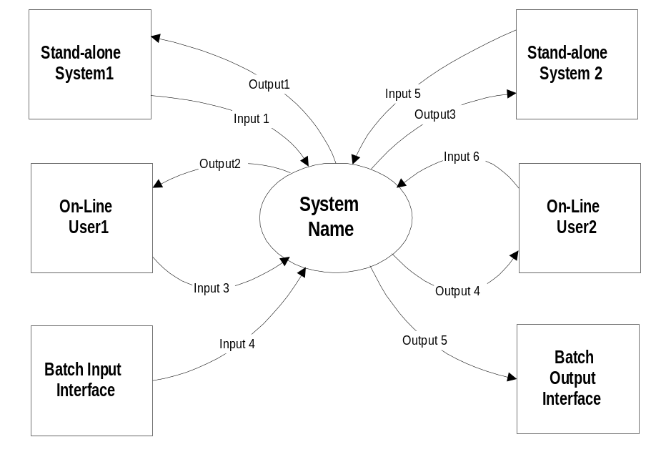

Figure 1 - System Context Diagram
Provide brief overview of the architecture. Summarize the description of the main conceptual elements and relationships in architecture, which frequently include candidate subsystems, components, nodes, connections, data stores, users and external systems. Provide reference to the Architectural Overview Diagram work product, which should be treated as a living document on the project.

< Project Name > Definitions
Potential Corresponding Work Product Descriptions (WPD) from GS Method
APP 301 - Classified Business Terms - URL
ENG 103 - Glossary - URL

Provide any project definitions.
Term | Definition
< Term 1> | < Definition 1>
< Term 2> | < Definition 2>
< Term 3> | < Definition 3>
... | ...
< Term n> | < Definition n>
Table 1 - Definitions

References

Customer Documents

Potential Corresponding Work Product Descriptions (WPD) from GS Method
APP 147 - User Interface Design Guidelines - URL
APP 300 - Business Rules Catalog - URL
ARC 310 - Standards - URL
OPS 313 - Privacy Data Profile - URL
OPS 314 - Security and Privacy Policy - URL

Document Number / Location / Links | Reference Description/Name
 | Statement of Work / Scope for the < Project Name >
 | Process flows
 | Top Level Requirements
w3-1.ibm.com/transform/sas/as-web.nsf | Architecture Standards
 | List any other relevant documents referenced in this Requirements Specification

Non-Customer Documents
Potential Corresponding Work Product Descriptions (WPD) from GS Method
APP 147 - User Interface Design Guidelines - URL
APP 300 - Business Rules Catalog - URL
ARC 310 - Standards - URL
OPS 313 - Privacy Data Profile - URL
OPS 314 - Security and Privacy Policy - URL
APP 130 - Use Case Model - URL
APP 150 User Profiles - URL
ARC 100 Architectural Decision - URL

Document Number / Location / URL | Reference Description/Name
 | List any other relevant documents referenced in this Requirements Specification

Updating this Specification
This document will be put under formal change control by the SE&A organization after stakeholder approvers sign off this document. This usually occurs after SRR.

Requirements
The purpose of this section is to specify the system level requirements, which are the characteristics of the system that are conditions for its acceptance. Each requirement is assigned a unique identifier (reference) to support testing and traceability and it is stated in such a way that an objective test can be defined for it. Each requirement shall be annotated with a qualification / acceptance method(s) (Please see acceptance criteria under the requirements traceability matrix template).
Requirements are identified by the following categories:
Functional
Usability
Non-functional
External Interface
Other
The degree of detail to be provided shall be guided by the following rule: include those characteristics of the system that are condition for system acceptance, defer to design descriptions those characteristics that the customer is willing to leave up to the developer. If there are no requirements in a given paragraph, the paragraph shall so state. If a given requirement fits into more than one paragraph, it may be stated once and referenced from the other paragraphs.

Functional Requirements
Potential Corresponding Work Product Descriptions (WPD) from GS Method
APP 130 - Use Case Model - URL
APP 300 - Business Rules Catalog - URL
APP 150 User Profiles - URL
APP 107 - Class Diagram - URL

The purpose of this section is to identify the system functional requirements (a.k.a. system capabilities). A functional requirement is a business function or capability to be included in the solution to be developed.

Functional requirements should be summarized as "verbs" that specify a required behavior of the system. A good functional requirement should be unambiguous and testable. Attributes that make a good set of functional requirements are: being unambiguous, understandable, concise, traceable, unique, complete, consistent, comparable, modifiable, attainable and design independent.

Functional Requirement 1 - <Title>

This should be either a written functional requirement or a use case.
For a functional requirement, it shall itemize the system requirements associated with the capability. If one functional requirement can be more clearly specified by dividing it into constituent functional requirements or capabilities, specify these in subparagraphs.

The Use Case Model describes the functional requirements of the system under development. The model uses graphical symbols (see Figure below) and text to specify how users in specific roles will use the system (i.e., use cases). The textual descriptions describing the use cases are from a user’s point of view; they do not describe how the system works internally or its internal structure or mechanisms.
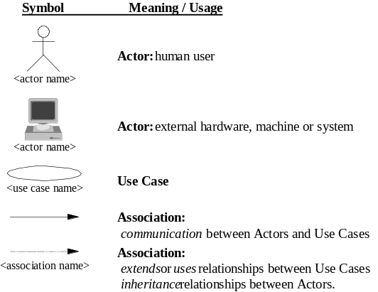

Functional Requirement 2 - <Title>

Usability Requirements
Potential Corresponding Work Product Descriptions (WPD) from GS Method
APP 129 – Usability Requirements - URL

The purpose of this section is to identify the usability requirements that define the usability attributes and measurable requirements that facilitate ease-of-use with the system. These include the attributes of interaction (e.g., navigation), display (e.g., screen layout), affective (e.g., aesthetic) as well as measurable requirements for user performance or productivity (e.g., 2 minutes to complete a transaction)

Also included shall be the human factors engineering requirements, if any, imposed on the system. These requirements shall include, as applicable, considerations for the capabilities and limitations of humans, foreseeable human errors, and specific areas where the effects of human error would be particularly serious. Examples include requirements for adjustable-height workstations, color and duration of error messages, physical placement of critical indicators or buttons, and use of auditory, signals.

Usability Requirement 1 - <Title>

Usability Requirement 2 - <Title>

Non-Function Requirements
Potential Corresponding Work Product Descriptions (WPD) from GS Method
ARC 119 – Non Functional Requirements - URL
The purpose of this section is to identify the non-functional requirements which address those aspects of the system that, while not directly affecting the functionality of the system as seen by the users, can have a profound effect on how that business system is accepted by both the users and the people responsible for supporting that system.

The non-functional aspects of a business system cover a broad range of themes. The major non-functional themes identified by the Application Enabling Design (AED) Technical Council are listed below:
Performance (including Capacity)
Scalability
Availability (including Recoverability and Reliability)
Maintainability (including Flexibility and Portability)
Security
Manageability
Environmental (including Safety)
Data Integrity (including Currency, Locality of Updating, Data Retention)

In summary, non functional requirements shall specify required behavior of the system and shall include applicable parameters, such as response times, throughput times, other timing constraints, sequencing, accuracy, capabilities (how much/how many), continuous operation requirements, and allowable deviations based on operating conditions.

Please notice that previous list is only a guideline that defines non-functional requirement. For instance, disaster recovery is one of the major non-functional requirements that is usually overlooked or not considered due to project’s budget and it is not explicitly stated in the previous list. Appendix Z presents a checklist of non-functional requirements usually considered in projects.

System External Interface Requirements

Potential Corresponding Work Product Descriptions (WPD) from GS Method
APP 011- System Context - URL

The purpose of this section is to identify the External Interface requirements.

If the external system interfaces are complex, they may be alternatively defined in a System Interface Requirements Specification (SIRS) document.

Interface Identification and Diagrams

Potential Corresponding Work Product Descriptions (WPD) from GS Method
APP 030- Interface Specification- URL
APP 108 - Interaction Diagram - URL

The identification shall state which entities have fixed interface characteristics (and therefore impose interface requirements on interfacing entities) and which are being developed or modified (thus having interface requirements imposed on them). One or more interface diagrams shall be provided to depict the interfaces. Use the following table to document external interfaces. Alternatively, use APP 030 Interface Specification Work Product or use both. The SE for a given project should decide the customization of the work product.

External interface | Input | Outputs | Requirement | Frequency | Size
<Ext. interface 1>
<Ext. interface 2>
<Ext. interface 3>
<Ext. interface n>

Other Requirements
This section specifies additional requirements, if any, not covered in the previous sections.

User Support Specifications
Potential Corresponding Work Product Descriptions (WPD) from GS Method
ORG 017 - User Support Specifications - URL

The User Support Specifications are specifications of the content, structure, audience, media, and format, of the documentation of the system to be used by the users. The specifications are the work descriptions for the development of the various units of user documentation.

Data Migration Specifications
Potential Corresponding Work Product Descriptions (WPD) from GS Method
APP 013 - Data Migration Maps - URL
APP 017 - Data Migration Plan - URL

The Data Migration Specifications are specifications that define a transfer of data from one reference to another. The data movement (or migration) may be manual or automatic, and it may occur once (data initialization) or on an ongoing basis.

Report Specifications
Potential Corresponding Work Product Descriptions (WPD) from GS Method
APP 027 – Report Specifications - URL

Report Specifications describe new reports and enhancements to existing reports to be produced by the system. Report Specifications may be defined separately in this section or they may be included in the Functional Requirements or the Usability Requirements sections.

Change Cases
Potential Corresponding Work Product Descriptions (WPD) from GS Method
ARC 118 Change Cases - URL

Change Cases document future changes to:
- The system capabilities and properties
- The way the system is used
- The system operating and support environments
- Changes are relevant and deserve to be included if they affect the architecture and design now

Priority of requirements
Potential Corresponding Work Product Descriptions (WPD) from GS Method
BUS 019 - Decision Model - URL
ARC 100 – Architectural Decisions - URL

This section shall specify the priority of the requirements (the order of precedence, criticality, or assigned weights indicating the relative importance of the requirements in this specification
Requirement ID | Requirement | Priority
<Reqt ID 1> | <Reqt 1> | <Priority>
<Reqt ID 2> | <Reqt 2> | <Priority>
<Reqt ID 3> | <Reqt 3> | <Priority>

The actual priority of the requirements can be defined here or documented elsewhere (for example, in the requirements definition above or in the Requirements Traceability and Verification Matrix), but all requirements must be prioritized.
The following definitions (sourced from the IEEE Standards Collection, Std 830-1998) may be used for priority:
1. Essential - This implies that the software will not be acceptable unless these requirements are provided in an agreed manner.
2. Conditional - This implies that these are requirements that would enhance the software product, but would not make the product unacceptable if they are absent.
3. Optional - This implies a class of functions that may or may not be worthwhile.

The definition and meaning of each priority must be agreed to with the customer.

The priority enables a proposed solution to be defined, which will satisfy the more important requirements ahead of those of lesser importance. Requirements are usually prioritized to descope a system to meet budget, time or resources constraints. It also provides information for later project decisions.

The Decision model work product helps to improve consistency on weights and requirement priority. The requirement decisions should be logged in the same fashion as architectural decisions are logged in ARCH 100 – Architectural Decisions. The Decision Model work product shall be adapted and extended to document the rationale for each critical decision.

Assumptions, Issues and Constraints
This section shall record all critical assumptions, Issues and Constraints under which the system architecture is designed. It should also record implications for each. For example if the constraint is about network speed, the possible implication for response time may be discussed..

Acceptance Criteria
Complete the acceptance criteria under the Requirements Traceability and Verification Matrix template. This deliverable shall be completed before a SRR (System Requirements Review). Acceptance criteria is incorporated into the Requirements Traceability and Verification Matrix template to simplify this document and increase consistency and accuracy during requirements traceability.
As a guidance, it is considered most effective to write acceptance criteria at the same time requirements are being written. Notice, this is also an iterative process that helps getting requirements clearly stated. If acceptance criteria are documented in this document, then it is usually best to document the acceptance criteria with the definition of the requirement (in Section 3 above).

Appendix A - <Title>
Appendices may be used to provide information published separately for convenience in document maintenance (e.g., charts classified data). As applicable, each appendix shall be referenced in the main body of the document where the data would normally have been provided. Appendixes may be bound as separate documents for ease in handling. Appendixes shall be lettered alphabetically (A, B, etc.)

Appendix Z - Non Functional Requirements considerations

The purpose of the following list if to provide a list of non functional requirements that are usually considered in both internal (within IBM) and external projects. Notice that this list is not complete.
Non functional requirements to consider:
Performance, they are usually a combination of four separate sets of sub-requirements:
A) Response Time Requirements. They are related to the response times to complete specific processes. It is important to focus on the requirements of the business when setting response time targets, rather than getting seduced by the ‘apparent’ nirvana of sub second IT transaction response. For example: the end to end response time associated with a specific user-system interaction, e.g. the time between a user selecting the ’process button’ within a desktop window, and the result set data from the associated query being displayed back to the user.
B) Throughput Requirements (Dynamic Volumetric Requirements). They are related to the ability of the business system to execute a given number of businesses or system related processes within a given unit of time. For example: The number of new orders processed per day etc.
C) Utilization Requirements. They are related to the maximum acceptable loading of the nodes on which the business system is to be implemented when running the Design Point workload. In some situations, the contract will stipulate that one or more of the delivered system components should not exceed a certain utilization threshold when supporting the Design Point workload. For example, the network bandwidth utilization shall not exceed 20%, or the database server shall be no more than 60% utilized.
Static Volumetric Requirements . They are related to the volumetric for the data entities that exist within the target system that, although relatively static, are likely to have a significant effect on the overall sizing of the target system. For example, the number of business system users by type, number of different user locations, number of customers, etc.
Scalability is usually related to the ability for a system to continue to function well as it (or its context) is changed in size or volume in order to meet a user need.
Capacity refers to the system’s ability to maintain TBD storage for the user’s data

Availability refers to a system or component that is continuously operational for a desirably long length of time. Availability can be measured relative to "100% operational" or "never failing." A widely-held but difficult-to-achieve standard of availability for a system or product is known as "five 9s" (99.999% percent) availability.
Reliability refers to the system’s ability to remain operational under abnormal conditions
Recoverability refers to the system’s ability to recover from a disaster with minimal loss of time or data

Maintainability (including Flexibility and Portability) refers to the system’s ability to be serviced after initial configuration, setup, and startup tasks have been completed.
Serviceability refers to the system’s ability to support hardware and software upgrades once the system has been deployed.

Security is related to legal, regulatory, privacy and security considerations. For example, policies and procedures that system shall follow, compliance with privacy act in different Geo., audits, etc.

Regulatory refers to the system’s ability to meet country-specific (or related) statutes and regulations

Manageability is related to management procedures defined for the following environments - development, testing, staging, deployment, life cycle etc. It usually addresses roles and responsibilities, configuration and change control, monitoring and controlling activities (such as reports that need to be produced), etc.

Environmental (including Safety) requirements usually describe different environments, their configuration and other constrains such as cost, schedule and resources.
Development environment (i.e. hardware and software constrains such as operating systems and hardware to use in this environment. Use of customer - fumished property, use of particular design or constructions standards, use of particular data standards, use of a particular programming language etc.)
Testing environment (i.e. hardware and software constrains such as operating systems and hardware to use in this environment, etc.)
Staging environment (i.e. hardware and software constrains such as operating systems and hardware to use in this environment, etc.)
Rollout / deployment / production environment (i.e. hardware and software constrains such as operating systems and hardware to use in this environment, etc.)
Life cycle environment (including a disaster recovery environment) (i.e. hardware and software constrains such as operating systems and hardware to use in this environment, etc.)
System Monitoring, Measuring, and Management Processes (i.e. the ability to monitor, measure, and manage the customer’s processes and the system’s performance
Physical characteristics of the system in terms of hardware, software, data communication etc. (i.e. Hardware examples are weight limits, size, power etc. Software examples are number of users or volumes expected. Data communication examples are medium to use, the amount of data / network capacity to handle etc.).
Costs (i.e. project budgets)
Schedule
Resources

Data Integrity (including Currency, Locality of Updating, Data Retention)
Usability refers to the system’s ability to provide a User Interface that is simple to use.
Interoperability refers to the system’s ability to inter-operate with related systems.

For more detail if you are in an internal project, review the BT/CIO site under the following URLs: Application Development and Maintenance , Performance, Scalability, and Availability (PSA) Overview

For more detail if you are in an external project, review the work product ARC-119 (Non functional requirements) under the following URL. Also consider the following work product descriptions from GS Method

Potential Additional Work Product Descriptions (WPD) from GS Method that are related to non functional requirements
APP 110 - Logic Data Model - URL
APP 150 - User Profiles - URL
ARC 113 - Operational Model - URL
ARC 315 - Network Requirements - URL
OPS 315 - Security and Privacy Requirements - URL

