

<Project Name>
DCD 229: System Test Architecture

Prepared by: <Project Name> IBM

Document Owner: <Name>
Revision: <2.0>
© Copyright IBM Corp. 2002, 2003, 2007 All Rights Reserved

Document Control
Table 1 Document Control General Information
Type of Information | Document Data
Title | <Project Name> Architecture Document
File name | <FilenameVersion.extension>
File Location | <File location – database, website, contact person>
Current Version | <Current Version>
Original Release Date | <Date>
Current Release Date | <Date>
Document Owner | <Name or Organization>
Document Reviewers | <Name(s) or Organization>
Document Approval | <Name>

Table 2 Document Control Version History
Version | Version Date | Nature of Change | Pages Effected | Date Approved
<Version> | <Date> | <Description> | <pg #s> | <Date>
Table of Contents
1. System Test Architecture Scope 8
2. System Test Architecture Description 9
2.1. Functional / Static View of the Architecture 9
2.1.1. <Functional Component Descriptor Number 1> 9
2.1.2. <Functional Component Descriptor Number N>> 9
2.2. Physical / Static View of the Architecture 9
2.2.1. <Physical Component Descriptor Number 1> 10
2.2.2. <Physical Component Descriptor Number N> 10
3. Appendix A – Acronyms 11
4. Appendix B – Document Reference Information 12
5. Appendix C – Template Document Control 13

Table of Tables
Table 1 Document Control General Information 2
Table 2 Document Control Version History 2

<Template Description- PAGES TO BE DELETED BY PROJECT TEAM>
<Purpose and Scope
This purpose of this document is to describe the System Test architecture(s) to allow for verification/ validation of all requirements as defined in the project’s Requirements Traceability and Verification matrix. The System Test Architecture is reviewed at the Preliminary Design Review.

The System Test Architecture document should describe the architecture needed to perform all “end-to-end” system testing, as defined by the project plan. The document is not expected to include the test architecture needed for testing performed by the application development teams. Those teams will define their own test environments. The document is expected to cover the test environment(s) needed to perform system testing (that is normally performed by an independent test team.

Examples of the test phases that can be covered by a System Test Architecture include:
- Systems Integration Tests
- Performance / Stress Tests
- User Acceptance Tests
- Operability Tests
- Pre-Production Tests
- Other similar test phases, which are part of your project.

The Systems Engineering team should develop this document in conjunction with the System Test Program Manager and his/her team.

Document Structure
This document is organized into two main sections:
- System Test Architecture Scope
- System Test Architecture Description

The System Test Architecture Scope section provides an explanation of the document’s scope – which test phases the document is supporting.

The System Test Architecture Description provides a definition of the architecture for the test phases (the scope) defined in the previous section.

The following chart describes the different views of the architecture. As described in the chart, the System Level architecture will show two views: a static / functional view of the system and a dynamic / operational view of the system. The Component Level architecture will decompose the System Level architecture into three views: a static / functional view of the system, a static / physical view of the system, and a dynamic / operational view of the system.

The System Test Architecture will be a subset of the Component Level architecture. It will take the two static views of the Component Level architecture (functional and physical), and alter these views as necessary to perform the testing needed.
Some simple examples to illustrate this point:
- If the system testing is going to include all of the system components (truly ‘end-to-end) and the test is going to be performed in the production environment, then the System Test Architecture will be exactly the same as the Component Level static (functional and physical) architecture views.
- If the system test is going to include all of the system components (truly ‘end-to-end), but is going to be performed in a test environment, then the System Test Architecture’s functional view will be the same as the Component Level Architecture’s functional view, but the physical views will be different. You will need to create a different physical architecture view for the test system.
- If some system components are not going to be included in the System Test (i.e., Performance Testing is usually only performed on critical aspects of the architecture), then the System Test Architecture is a subset of the Component Level Architecture’s functional view. The physical view may be the same or different that the one in the Component Level Architecture (depending on whether the test is performed on the production hardware or not).

In all cases, the System Test Architecture should be created from the project’s Component Level Architecture (the static / functional and physical views)
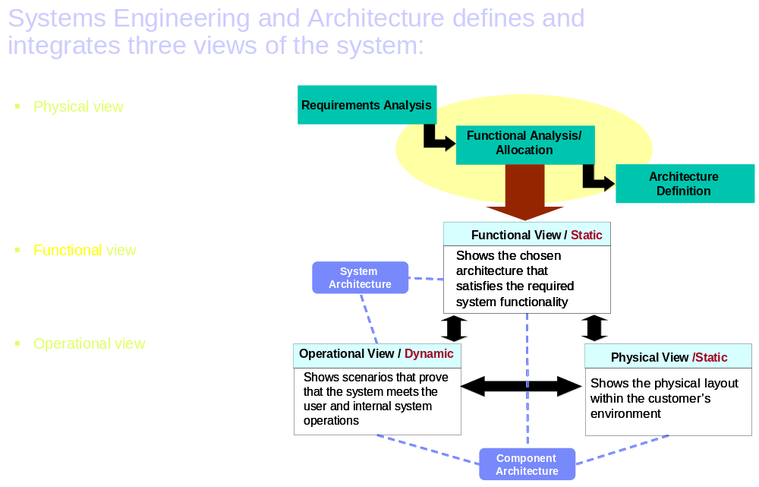
- Physical view - ensures the system responds to the physical system requirements, addresses all hardware and software-oriented activities and addresses the physical fit of the system into the customer's environment.

- Functional view - ensures the system provides the required system functionality and required capabilities.

- Operational view - ensures the system responds to the system operability needs, projects both user and internal system operations, and verifies that user scenarios can be satisfied.
Guidelines and Instructions
The team should remove all “guidance” and “objectives” information from the document as it is completed. Also, any documentation in brackets should be deleted when the document is completed. For example, delete the following documentation: < Enter any physical component descriptions that are different than what is defined in the component level architecture here.>

No solution engineering methodology artifacts are referenced in this guidance, as the Component Architecture document already has these listed as potential sources of the information in each section.

System Test Architecture Scope
<Objective: The focus of this section is to describe the system test phases that will be covered by this document.

Depending on the project and the customer (internal organization versus an external customer), examples of the test phases that can be covered by a System Test Architecture include: Systems Integration Tests, Performance / Stress Tests, User Acceptance Tests, Operability Tests, Pre-Production Tests, and so on. The tests to be performed for a project should be defined in the Requirements Traceability and Verification Matrix.

Based on the tests to be performed as defined by the matrix, the Systems Engineering team should work with the System Test Program Manager / the Test Team to create the System Test Architecture.

The architecture for all system test phases applicable to a project may be documented within one System Test Architecture document or the test architecture for each test phase may be documented in separate System Test Architecture document.

Guidance: All sections should be completed for all systems engineering supported projects. The use of figures and tables to accurately and succinctly convey information is strongly encouraged. Avoid unnecessary duplication of information. Instead provide links to reference documentation in Appendix B. The target length of this section should be 1 page depending on the scope of work. >

<ENTER TEXT HERE TO DOCUMENT THE TEST PHASES COVERED BY THIS DOCUMENT>

System Test Architecture Description

Functional / Static View of the Architecture

<Guidance: if there are no changes to the Component Level Architecture, than this section is optional; “See Component Level Architecture Document”.
Potential Corresponding Artifacts
APP 011 – System Context - URL
APP 315 – DFD Application Model - URL
ARC 108 Component Model - URL
APP 110 Logical Data Model - URL

Start with the Component Level Architecture and modify if necessary.

< INSERT DIAGRAMS AND TEXT HERE>

<Functional Component Descriptor Number 1>

< Enter any functional component descriptions that are different than what is defined in the component level architecture here. An example is: a test is simulating an application rather than using the actual application>

<Functional Component Descriptor Number N>>

Physical / Static View of the Architecture

<Guidance: if there are no changes to the Component Level Architecture, than this section is optional; “See Component Level Architecture Document”.
Potential Corresponding Artifacts
ARC 302 Application Function Model - URL
ARC 111- Deployment Unit- URL
ARC 113 – Operational Model - URL
ARC 322 - Network Conceptual Design - URL
ARC 317 – Network Node Design - URL

Start with the Component Level Architecture and modify as necessary.

< INSERT DIAGRAMS AND TEXT HERE>

<Physical Component Descriptor Number 1>

<Enter any physical component descriptions that are different than what is defined in the component level architecture here. >

<Physical Component Descriptor Number N>

Appendix A – Acronyms
Table 3: List of Acronyms
Acronym | Definition

Appendix B – Document Reference Information
Table 4: Document Reference Information
Reference # | Document | Description | Location or Contact
 | <Requirement Specification for the project> | System and Component Requirement Specification | <Owner of project specification and where file is located, database, website, personal files system>
 | <RTVM for the project> | Requirements Traceability & Verification Matrix | <Owner of project specification and where file is located, database, website, personal files system>
 | <Architecture for the project> | Architectures | <Owner of project specification and where file is located, database, website, personal files system>

End of document – DCD 229: System Test Architecture
Document Control
Version History
Version Number | Revision Date | Author | Comments
1.0 | 12/13/02 | Content Team | Initial Release
1.1 | 12/18/02 | Content Team | Updated from peer review
1.2 | 08/21/03 | Content Team | Updated WPDs
2.0 | 08/17/07 | Content Team | Release 12.1: Initial Licensed Version

