

IBM Global Services

Performance Engineering Activities Supporting the Component Baseline

Technique Paper (TP)

© Copyright International Business Machines Corporation 2006
All Rights Reserved
Version 4.1.1, December 2006
- Description
In an Enterprise SE&A project, the Component Baseline contains the component requirements for the system described in the System Baseline. The Preliminary Design Review (PDR) ensures that the overall system design and resulting component requirements appropriately address the system (and customer) requirements selected for implementation, are well understood and are agreed to by all parties, after which a baseline is established for both future reference and change control.
Figure 1 - Component Baseline major activities in SE Capability Pattern
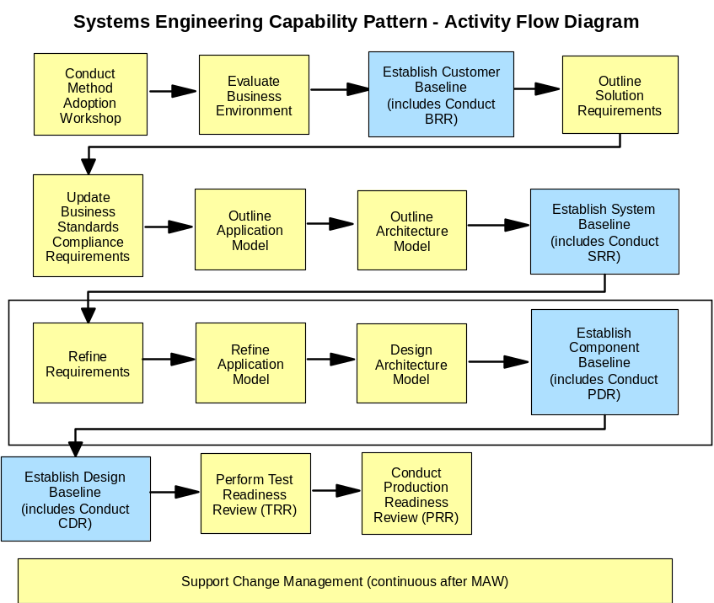

In the SE Capability Pattern, a number of work products are developed before it is time to review the Component Baseline, as shown below:
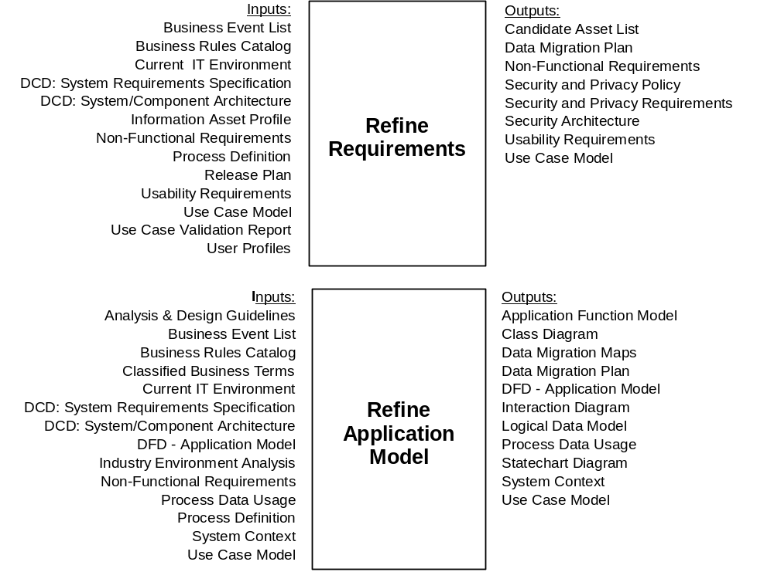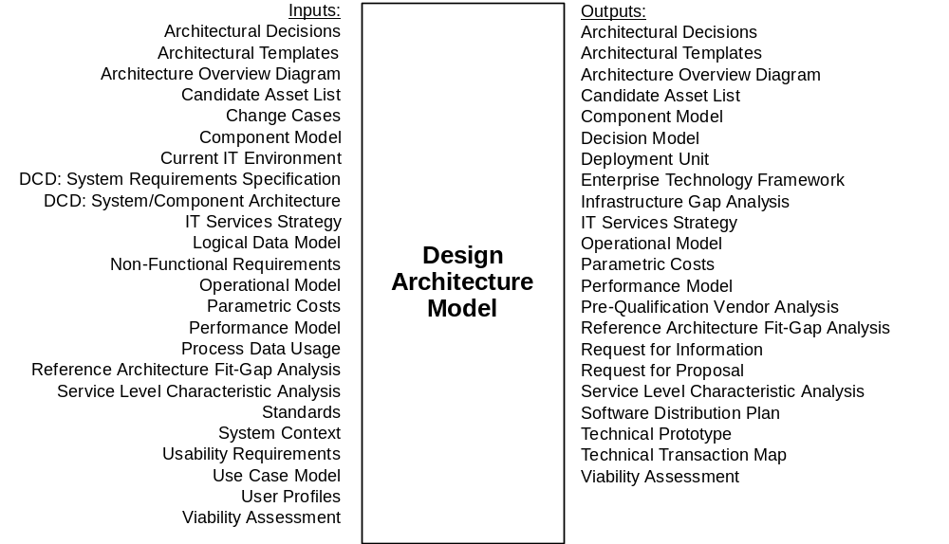
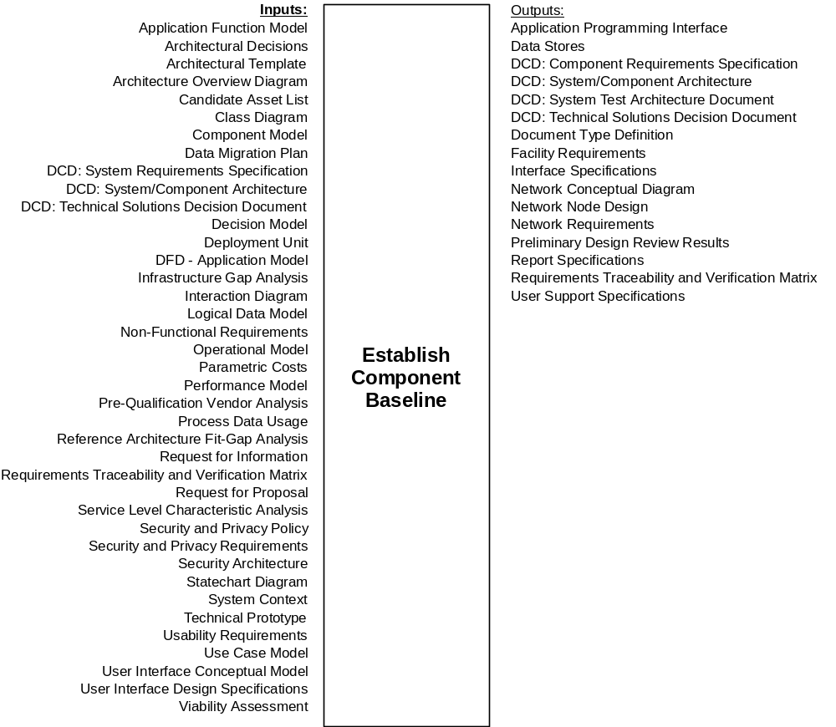
The performance engineering team has a vested interest in ensuring that the performance and capacity aspects of the system design are well-conceived and capable of meeting requirements. This will prove helpful to the later SE&A baselines as the components are designed, implemented, tested and deployed, which will in turn enhance the likelihood that the overall project will satisfy the customer’s requirements. Deliverables which are deemed deficient from a performance and capacity standpoint may lead to the entry of a defect, which is then taken into account during the PDR Scorecard process.
At this time, the PE team should be actively executing the elements of the PE plan. There may be a need for more detailed plans covering specific aspects of the PE plan, such as estimation and modeling, performance testing, capacity and performance management and so on. Since the responsibility for many of these plans will fall outside of the PE and SE&A teams, careful coordination and teamwork is required to achieve synergy on the part of the extended PE team.

- Usage Context
This technique paper should be used as guidance on applying PE activities and techniques in support of the Component Baseline Phase.
- Content
Organizing the PE Effort during the Component Baseline Phase
During this stage of the project, the PE team is typically concerned with activities such as the following.
- Beginning / continuing execution of the PE plan – This involves both the direct activities of the performance engineering team and the supporting activities of other teams (design, development, test, delivery / operations, etc.)
- Performance / capacity assessment of the component architecture – Since more information is now available about the components which make up the system, this should make it possible to more accurately assess the solution’s performance and capacity along with any associated risks and issues.
- Initial capacity sizing and Service Level Requirements – Non-functional requirements (NFRs) place obligations not only on the development organization, but also on the delivery / operations organization as well. As such, the delivery / operations team will typically require early work to be done on capacity sizing and defining the service level requirements, which describe the commitment the operations team is making on behalf of the delivered system in support of the NFRs.
- Well understood, well defined component requirements – As the design of the overall system is established, requirements will be created at the component level. This applies to the NFRs as well, as each component in the system will have a role in determining whether the overall system can meet its performance requirements.
- Refined business and technical volumes – As time has passed, new business volume information must be taken into account, and further understanding of the technical volumetrics, especially in terms of the interactions between components, must be considered as well.
- Refined assumptions and parameters for performance estimation – Previous performance estimates and models can be updated with the additional design information which is now available.
- Development team commitment to support PE plan – Since development plans have been further defined, those plans should now start to show how the development team will do their part to support the overall performance engineering plan.
- Test team commitment to support PE plan - Since test plans have been further defined, those plans should now start to show how the test team will do their part to support the overall performance engineering plan.
Risk and Performance Management Focus during the Component Baseline Phase
Now that a PE plan is in place, the execution of the activities in the PE plan is largely for the purpose of containing any performance-related risks associated with the project. While such risks may become more apparent later in the project when there is a solution ready to be tested, early performance assessments are a vital component in the management of these risks. Therefore, ongoing risk assessment and performance management will continue to be important throughout the development life cycle.
Performance management treats performance as a manageable attribute of a system, whether the system exists conceptually, in development, in test or in production. Performance is managed by
- Ensuring that the performance requirements for the future solution are understood, well-defined, objectively measurable and agreed to by all stakeholders
- Assessing the ability of the proposed solution to meet those requirements during architecture, design and development
- Measuring the actual performance of the implemented solution
- Taking appropriate action whenever assessment or measurement indicates an actual or potential performance problem needs to be addressed.
During the component baseline phase, the PE team will be concerned with the performance and capacity assessment of component architecture. If the results of estimation and modeling indicate that there is a high risk of not meeting the performance requirements, or if performance cannot be assessed because of a lack of information which should be available by now, technical or project risks should be documented in the appropriate risk log and handled according to the project’s risk management procedures. If the risks continue to be a matter of concern by the time of the PDR, they should be documented as PDR issues to be taken into account as part of the PDR scorecard.
One frequent source of risk is the changing of project volumetrics. The area of volumetrics tends to be one of the most unstable factors in PE, largely because volumetrics are based on forecasts of future business and/or system activity for which there is a great deal of uncertainty. By this stage of the project, some level of volumetrics will have been captured, and they need to be maintained as part of the project requirements baseline. Significant changes in volumetrics need to be subject to change management, as the changing of volumetric assumptions could entail significant investments in infrastructure, redesign of key solution components and modification of performance estimates.
Another means of managing risk is by PE team participation in peer reviews, both for PDR-required component baseline work products and deliverables, and PE team work products such as component NFRs, volumetrics analysis, performance estimates and models and follow-on work products. Many of the work products produced by the PE team are very detailed, quantitative and computational in nature, and even a small error can lead to vastly different results. Having a co-worker review what has been produced provides a level of independence that leads to higher quality in the work products and deliverables of both the PE team and the greater development team.
Preparing for Production during the Component Baseline Phase
Even at this early stage, there is a great deal of value to be gained by involving the delivery / operations team in the project, and it may even be a deployment requirement. Since the delivery / operations team must plan for the required infrastructure, the PE team may be involved with assisting the architecture and design teams in preparing an initial capacity sizing of the infrastructure requirements. The performance estimation and modeling methods and tools may prove to be valuable in validating such a sizing.
The delivery / operations team will also be concerned with the solution’s service level requirements (SLRs). SLRs describe the level of service that users expect to receive from the deployed system, and may address operational factors such as availability, response time, recovery time, scheduled outages and so on. The finalized SLRs are typically incorporated into what is known as a Service Level Agreement (SLA), which represents a commitment by the deployment / operations team to supply those levels of service once the system has been deployed in production. Therefore, it is in the interest of the deployment / operations team to ensure themselves that the solution can meet the SLRs, and the PE team should work in close partnership with them to make sure that this happens. If the SLRs require some level of enabling of “on demand” features, such as orchestration and provisioning, this may affect how the system is developed, tested and assessed for performance.
Defining Component Performance Requirements
Just as the system requirements elaborate upon the business requirements and specify the solution at a greater level of detail, so the component requirements elaborate upon the system requirements and specify the solution even further. As the RTVM will show, there will generally be many component requirements for each system requirement. The PE team should carefully review the updated RTVM to ensure that requirements traceability is carefully maintained.
Many times this means that the performance requirements and other NFRs, can be taken to another level of detail as well. In systems engineering and architecture terms, the process of taking a high-level requirement and assigning parts of that requirement to lower level components is referred to as allocation. The principle of allocation can be applied to performance requirements as well. For example, if a batch process must complete the processing of a certain volume of data in 7 hours, and the batch process consists of three major steps handled by different components, then each of those components may be allocated a certain amount of the time (e.g. 2 hours, 3 hours and 2 hours respectively) within which they must complete their part of the process.
During the component baseline phase, the volumetrics should be revisited as well. Changes in the business volumes should be taken into account, and the model for the technical volumetrics may need to be refined to represent the emerging understanding of how the system’s components are to interact.
Estimating Component Performance
The concept of performance estimation and modeling has already been discussed. The information available as part of the component baseline will make it possible to refine estimates and build performance models which incorporate a more complete understanding of the details of the emerging solution. Here, three techniques for refining performance estimates and models are considered: technical transaction maps, detailed performance models and technical prototyping.
- Developing a Technical Transaction Map
The technical transaction map is a GS Method work product for developing technical volumetrics. The diagram below shows where the use of technical transaction mapping can fit into the overall performance modeling process.

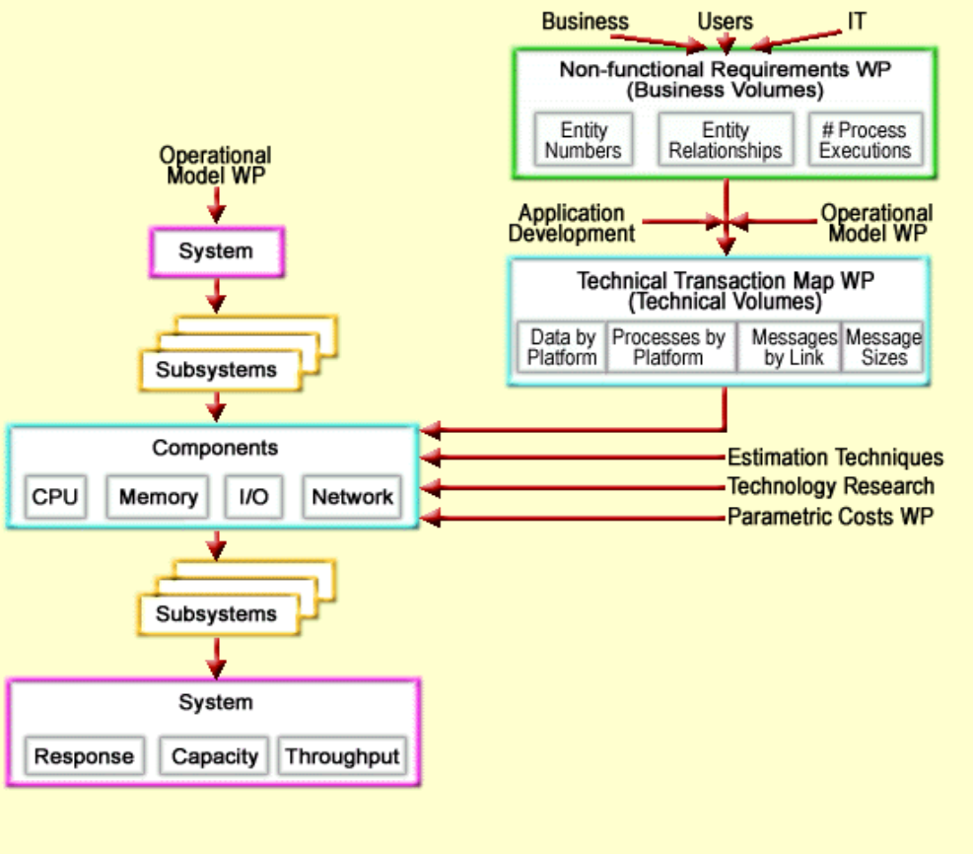

The technical transaction map decomposes each transaction into its constituent system activities, such as messages between nodes/components, system resource used while processing in each node and so on. As such, the technical transaction map provides much of the raw material needed for populating a detailed performance model.
- Developing a Detailed Performance Model
Performance models developed during the system baseline phase are typically developed at a high level of detail, since information about component design, parametric costs and volumetrics may have been incomplete at that time. However, a model built during the component baseline phase can incorporate more complete information in each of these areas.
While the selection of an estimation method must still be made based on the trade-offs between timeliness, cost and accuracy, by the time of the component baseline, more serious consideration can be given to the use of simulation modeling. Simulation modeling is performed using specialized software tools which estimate performance and resource utilization by simulating the workloads and performance behaviors of the modeled system. Simulation modeling tools generally come in two categories:
- discrete event modeling tools which represent each transaction as an internally generated data element moving from process to process and queue to queue over a simulated period of chronological time, and
- analytical modeling tools which rely more on mathematical equations to account for time spent waiting for a resource and system resource utilization.
Simulation modeling tools often have high costs in terms of licensing, education and model development. However, even such costs may be small in comparison to the costs of the inability to deploy a system or the loss of revenue from system down time or poor performance. Simulation modeling adds value in that it can be used to analyze performance and resource utilization over time, to conduct “what if” analysis of multiple infrastructure and workload combinations, and to gather more accurate predictions than are possible using the high level modeling methods earlier, all without having to deploy a live test system. Later, when a test system is available, performance test results can be used to calibrate the simulation model, thus making it more accurate for future tests.
A word of caution is in order. There is never sufficient time or resources to model everything in a complex system, any more than there is time to completely test every possibility in a complex system. Be judicious in the scope and the level of detail to which a model is developed, to ensure that modeling can be done in a cost-effective manner.
- Technical Prototyping
There may be times that the only good way to predict some aspect of a future system’s performance is to implement a part of that system and then measure its behavior when executing. This method of gathering performance information is referred to as technical prototyping. Typically, this kind prototype does not actually implement useful functionality. Rather, the intent of this prototype is to exercise patterns of resource utilization similar to those of the proposed solution.
As an example, in one project the objective was to assess three different mechanisms for propagating disk updates from a live system to a “hot backup” system in a remote location. The technical prototype developed exercised a repeating pattern of database update and read operations. The technical prototype was then executed once for each of the three propagation mechanisms, and the database performance was measured in each case. The results of executing the technical prototype were then presented to the project’s architecture team to help them finalize the decision of the most appropriate propagation mechanism.
- Using the Results of Modeling
The use of modeling results for initial capacity sizing, feasibility analysis and risk assessment has already been discussed. However, getting the most out of a detailed performance model requires a certain amount of planning, both for the modeling scenarios to be executed and the presentation and application of the modeling results. A performance model can be compared to a performance test environment, in that it is the use of multiple scenarios and the thoughtful analysis of modeling results that delivers business value.
GS Method includes a work product known as the Service Level Characteristics Analysis (SLCA) report which, among other things, can be used to summarize the results of multiple modeling passes and make recommendations. For example, the architecture team may have developed the physical version of the Operational Model (POM) for a system which must handle a key batch process within a given batch window, but the POM may not yet have been sized. The SLCA report may summarize the results of multiple modeled batch runs, each with a different number of batch servers, and then recommend a sizing that meets the batch window requirement in a cost-effective manner.
In view of this example, it is helpful to remember that the delivery / operations team will be responsible for assembling a capacity plan, which must take into account the system resource needs of the solution over time. The trend towards cross-industry approaches to capacity management (such as ITIL and COBIT) will make it increasingly important for PE teams to cooperate with their delivery / operations counterparts on such matters.
Interacting with the Development Team during the Component Baseline Phase
This is the time to turn development buy-in to PE into development commitment to PE. As more of the project effort is now moving towards component requirements and design, achieving the goals of PE will become increasingly dependent on the cooperation of the development team. Depending on the criticality of the performance requirements and the emerging areas of performance risk, the development team will need to make plans to do one or more of the following:
- Ensure that applicable performance “best practices” for their development and deployment platforms are followed during design and code phases
- Ensure that appropriate development-level performance tools are being acquired (profilers, debuggers, monitors, etc.)
- Ensure that techniques such as performance budgeting and tracking are being used where critical component-level performance requirements have been allocated.
The point is that designing for performance, rather than hoping for performance, is needed if critical performance requirements are to be met. As much as possible, performance should be prevented from emerging as a “nasty surprise” at test or production time.
Interacting with the Test Team during the Component Baseline Phase
This is the time to turn test buy-in to PE into test commitment to PE. While estimating, modeling and designing for performance are all worthwhile PE practices, for complex systems they cannot totally take the place of doing performance tests on the solution that is finally delivered.
As the RTVM is being updated with the component level requirements, this is a good time for the PE team and the performance test team to revisit earlier decisions which may have been made on how to balance the use of modeling and testing with respect to performance requirements. This dialog between the two teams will prove very useful in helping to leverage the strengths of both teams and achieve synergy.
The PE team may be in a position to give guidance and direction as the performance test team is putting together its own strategy and plan. For example, the PE team may be able to point to areas of unusual performance risk that might require performance test attention, especially areas which the PE team has not been able to model. In any event, the PE team should be represented as performance test strategies, plans and environments are being reviewed.
Participating in the Preliminary Design Review (PDR)
The following excerpt from the Preliminary Review scorecard denotes the PDR criteria which apply to performance matters.
1. Static Architecture Definition
1.4 Business monitoring tools (volume and volume projections) identified and agreed to.
4. Test Architecture Definition
4.1 Test architecture, approach, and the test data will sufficiently facilitate the verification of the system acceptance criteria and the system requirements, including the to-be business processes.
Note: In addition to these, there are other PDR Scorecard items for things on which performance engineers have dependencies.
Below are some examples of questions that the PE team can be asking above and beyond the standard PDR scorecard criteria.
- Are the component performance requirements understood?
- Are the component acceptance criteria for performance understood?
- Has an initial sizing of the component solution been performed and fed into the overall system sizing?
- Has the performance feasibility and risk for the component been assessed?
- Have requirements for performance tools which will be required for development and for live monitoring of the solution been defined.
- Have business volumetrics changed? Will they change our technical volumetrics or other performance-critical assumptions?
- Are both system and component technical volumetrics available?
- What implementation specifics will require technology research with respect to their performance characteristics?
- What results are available for the system performance estimation and modeling activities done to date?
- What component areas will require performance estimation and/or modeling to address areas of performance risk?
- Has the capacity plan been updated to take into account the system estimation/modeling done so far?
- Are the Service Level Requirements (SLRs) complete? Does the system estimation/modeling work done so far give us an idea of whether these SLRs can be met with the proposed solution?
- What performance techniques (performance budgeting, profiling tools, etc.) will be used by the component design/development teams?
- Has a performance test strategy been defined?
- Has the performance risk been reassessed since the SRR?
- Key Considerations
None
- References
None
- Revision History
Revision Number | Revision Date | Summary of Changes | Author(s)
4.1.1 | December 2006 | Initial Version | David Jewell

From an architecture perspective, the design of a higher level of the system will create a requirement against the next lower level component of the system. This means that the “Preliminary Design” of the overall system will include the requirements against each of that system’s components.

