

IBM Global Services

Performance Engineering Activities Supporting the System Baseline

Technique Paper (TP)

© Copyright International Business Machines Corporation 2006
All Rights Reserved
Version 4.1.1, December 2006
- Description
In an Enterprise SE&A project, the System Baseline contains the overall requirements for the system to be developed or enhanced to meet the customer requirements articulated in the Customer Baseline. The System Requirements Review (SRR) ensures that these requirements appropriately address the customer requirements selected for implementation, are well understood and are agreed to by all parties, after which a baseline is established for both future reference and change control.
Figure 1 - System Baseline major activities in SE Capability Pattern
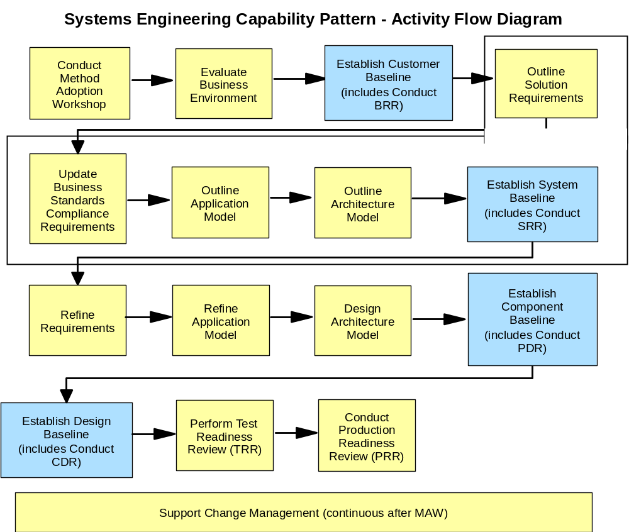

In the SE Capability Pattern, a number of work products are developed before it is time to prepare the System Baseline, as shown below.
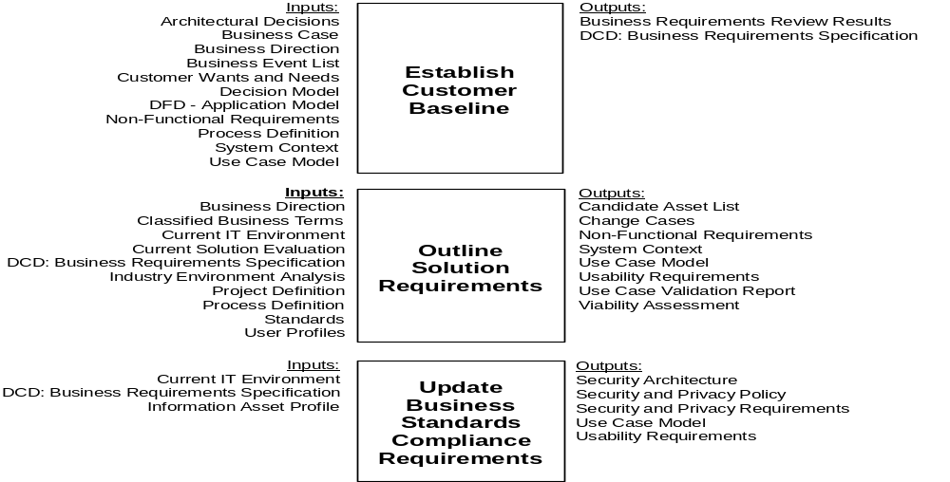

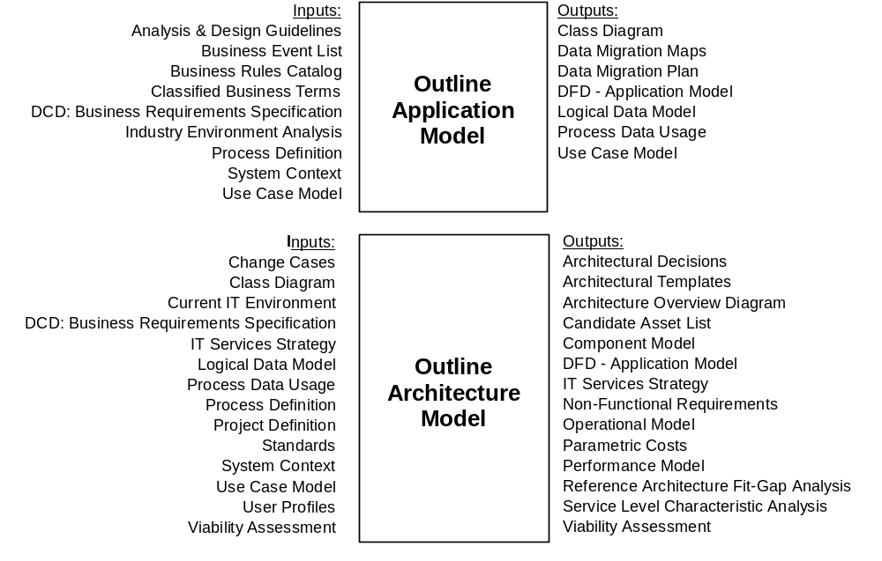

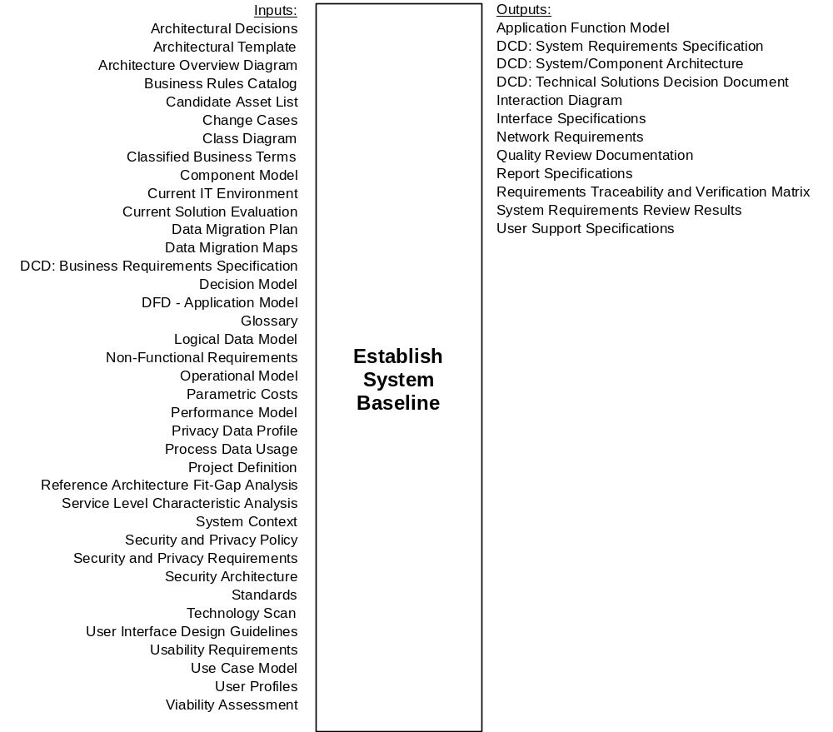

The performance engineering team has a vested interest in ensuring that the performance and capacity aspects of the system requirements are well-defined, measurable, verifiable and achievable. This will prove helpful to the later SE&A baselines as the requirements are elaborated and implemented by component, which will in turn enhance the likelihood that the overall project will satisfy the customer’s requirements. Deliverables which are deemed deficient from a performance and capacity standpoint may lead to the entry of a defect, which is then taken into account during the SRR Scorecard process.
Around this time, the PE team should be developing an overall plan for applying PE throughout the life of the project, documenting specific tasks, work products, deliverables, strategies and resources needed to implement the PE strategy. This plan should not only take into account PE work done in support of SE&A activities (i.e. requirements and design participation, volumetric and technical research, early estimation and modeling), but also PE work done in support of implementation, testing and deployment activities as well.
- Usage Context
This technique paper should be used as a guidance on applying PE activities and techniques in support of System Baseline Phase.
- Content
Organizing the PE Effort during the System Baseline Phase
During this stage of the project, the PE team is typically concerned with activities such as the following.

- Contributing to and reviewing the System Baseline documents – These work products and deliverables must be completed and go through the SRR process before the overall project can proceed.
- Developing the PE Plan – This plan will document performance engineering activities both within and outside the scope of the SE&A which are intended to contribute to a well-performing solution.
- Initial Sizing - Performing an initial estimate of likely capacity and performance of the delivered solution, as a part of contract assurance and / or for budgetary purposes.
- Performance Estimation and Modeling - Selecting appropriate modeling technique(s) on the basis of cost / effort / benefit / accuracy, and use to provide a prediction of the key performance and capacity metrics for the system. The performance estimates can be compared against the required targets.
- Feasibility / Contract Assurance and Risk Assessment - Identifying significant risks that would impact either the ability to deliver the solution, or the cost of the solution.
- Performance tool requirements for development and live monitoring phases - Selecting which performance tools will be required for use in performance engineering during the project and for monitoring of the production application after deployment.
- Technical Volumetrics - Transforming the business volumetrics into a form that will be the basis for performance and capacity estimation and modeling. For example, transform "process an order" into a set of system level transactions and message pairs required to process it.
- Technology Research - Identification of system components about which there is insufficient performance and capacity information and the gathering of appropriate metrics (e.g. parametric costs, rules of thumb, technical design and performance characteristics) for these components.
- Overall Design for Performance - Proactive involvement in the solution design process, to ensure that performance requirements are reflected alongside functional requirements during the high level design of both the application and infrastructure. This will start with the development of performance specifications early on in the solution design process, through to detailed design work for performance critical areas.
- Ongoing Risk and Performance Management - The process by which identified performance risks are assessed for their impact, suitable containment plans are agreed, and the risks tracked until they cease to be risks; this includes the ongoing management of performance activities, such as the tracking of problems / defects through change processes, reviewing of changes to the system, the raising of changes by the PE team on others, interfacing to the other project managers, the production of progress reports / communications, the monitoring and finalising of SLAs, the definition of ad-hoc performance testing / investigations, etc.). Essentially, this is the project management of the PE sub-project.
The System Baseline is developed as a standard part of the SE&A baseline review process. However, the PE Plan needs to be spelled out in more detail, since it will address performance engineering activities which go beyond the standard SE&A baseline review process.
Developing the PE Plan
The Performance Engineering Plan (PE plan) is a document of understanding on performance engineering between the various stakeholders of the project. It documents the “what” (scope and objectives), the “why” (purpose), the “when” (key milestones), and the “who” (organizational roles and responsibilities) for performance engineering across the project phases.
By now, the PE strategy document should provide a starting point for developing the PE plan document. Remember, however, that the PE Strategy was largely intended to acquaint project stakeholders and participants with the PE methods available. The PE strategy does not in and of itself constitute a plan. Also, it should be evident by now that while there may be one or more people constituting the “official” PE team for a project, in actuality the success of performance engineering efforts depends upon the cooperative efforts of an extended, cross-functional team including architects, designers, developers, testers, delivery/operations people and so on. This means that while there may be one “master” PE plan for the project, it will make reference to detailed plans produced in other areas.
The PE plan document should contain the following.
- PE Goals: Set the direction for performance engineering efforts.
- PE Focus Areas: Areas of performance- and capacity-related non-functional requirements (NFRs) which are of special concern, such as response time, throughput, volume assumptions, scalability, etc.
- Development phases: The phases of development which will be used to manage the larger development project, whether it is a traditional “waterfall” project or an iterative development project.
- PE Themes and Activities: Overarching performance engineering areas of concern which may span multiple areas, as documented in the Performance Engineering and Management Method (PEMM), along with the activities encompassed in those themes.
- Organizational responsibility: Based on project deliverables and interdependence of teams delivering performance-centric work products and defined so that boundaries for hand-off or hand-over are clear.
- Performance Decision Checkpoints (DCPs): Defined for different project phases and for their importance to project success.
- PE Methods and Tools: Any performance method or tools strategy, at the client organization or IBM, relevant to the project.
- Metrics: Any organization, business unit, competency metrics program or measurements strategy relevant to performance acceptance criteria for the project.
- PE Decision Checkpoints (DCPs): clearly defined for each phase of the project.
- PE Data Management Strategy: Approach for PE data gathering, analysis and maintenance.
- PE Milestones: lists major PE schedule targets.
- PE Management Procedures: describe how the PE activities and plan will be managed.
- PE Reporting Procedures: describe how and when PE progress will be reported.
It is highly recommended that the development of the PE plan be carried out as a team effort, with the continued involvement of the teams which were represented at the PE PDW and/or the PE strategy review. The PE plan document should be reviewed and input from the various areas should be taken into account before it is considered final.
Defining System Performance Requirements
- Understanding Functional Requirements via Use Case Models
Functional requirements supply an important part of the context within which the performance NFRs apply. Very often these functional requirements will be expressed in part by a use case model, depicting typical sequence interactions between “actors” (i.e. users and systems). Consider the following example of an ATM withdrawal use case.
- The customer puts a credit card into the ATM.
- The ATM asks for a PIN code.
- The customer supplies the PIN code.
- The ATM machine validates the PIN code.
- The ATM offers the customer the allowed banking functions.
- The customer requests a cash withdrawal.
- The ATM asks for the amount to be withdrawn.
- The customer supplies the amount to be withdrawn.
- The ATM validates the amount to be withdrawn, the available credit limit of the customer and the amount of cash available in the ATM for withdrawal.
- The ATM dispenses the cash, prints a receipt and returns the credit card to the customer.
Given this understanding of a typical transaction flow, there are many questions about performance requirements which can now be asked. For example, is there a response time requirement for validating the PIN code, or for completing the withdrawal once requested? Is the ATM located in a busy place where many people may want to use it, and would this lead to an expected throughput rate based on average end-to-end processing times? As the use case model is developed and refined, any associated changes to the performance requirements should be reflected as well.
- Technical Non-Functional Requirements (NFRs)
As was stated earlier, the non-functional requirements (NFRs) that are of particular interest to performance engineers are those having to do with performance (e.g. throughput, response time, utilization, and static volumetric requirements), scalability and availability. Whereas the NFRs stated as part of the Customer Baseline would be expressed in business terms, technical NFRs would interpret or restate those business NFRs in more granular, implementation-specific terms. For example, if a business NFR for our ATM withdrawal example says:
“The system shall process a typical end-to-end ATM withdrawal request in two minutes or less.”
A technical NFR might elaborate as follows:
- The customer puts a credit card into the ATM. (15 seconds)
- The ATM asks for a PIN code. (5 seconds)
- The customer supplies the PIN code. (15 seconds)
- The ATM machine validates the PIN code. (5 seconds)
- The ATM offers the customer the allowed banking functions. (5 seconds)
- The customer requests a cash withdrawal. (15 seconds)
- The ATM asks for the amount to be withdrawn. (5 seconds)
- The customer supplies the amount to be withdrawn. (15 seconds)
- The ATM validates the amount to be withdrawn, the available credit limit of the customer and the amount of cash available in the ATM for withdrawal. (10 seconds)
- The ATM dispenses the cash, prints a receipt and returns the credit card to the customer. (20 seconds)
This kind of requirements elaboration will continue through the SE&A baseline phases, ultimately to the point that the system components themselves have well-defined performance requirements established. It is imperative that performance-related requirements remain clear, unambiguous and appropriately detailed to their level of elaboration as the project proceeds.
- Technical Volumetrics
As is the case with the other technical NFRs, the technical volumetrics are in large measure derived by combining business level assumptions with additional knowledge about the implementation specifics. For example, if the business volumetrics say:
“The regional ATM network shall support 10,000 customer transactions per day.”
The technical volumetrics could say the following:
- The regional ATM network must be able to support 20% of the daily maximum load (2,000 customers) during a peak hour.
- During the peak hour, the regional ATM network must be able to support 2,500 ATM-to-Authorization Server PIN validation requests, 1,400 ATM-to-Accounts Server withdrawal requests, 500 ATM-to-Accounts Server deposit requests and 1,000 ATM-to-Accounts Server balance inquiry requests.
Since both the business and technical assumptions underlying volumetrics tend to be subject to change, volumetrics assumptions should be revalidated as the project proceeds.
- Requirements Traceability and Verification Matrix (RTVM)
In SE&A-managed projects, the Requirements Traceability and Verification Matrix (RTVM) provides an outline view of the major business, system and component requirements and, displays their status and maps each one to the verification methods which will be applied to them. The figure below depicts the typical structure of the RTVM.
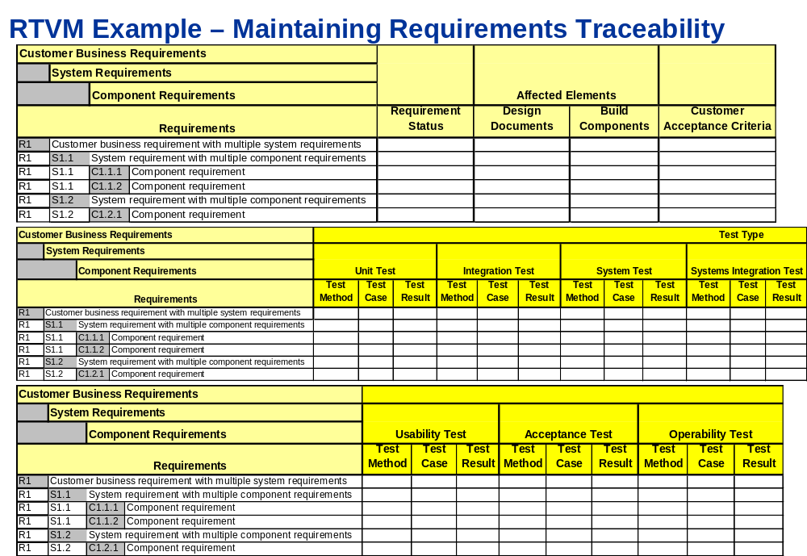

The purpose of the RTVM is to maintain requirements traceability throughout the development process and to plan for appropriate levels of verification for each requirement. For each requirement in each stage of test, there is the opportunity to select one of the following methods of testing:
- A - Analysis
- D - Demonstration
- I - Inspection
- S/M - Simulation / Modeling
- T - Testing
Since there are trade-offs to be made in determining the best way to verify that performance requirements are being met (i.e. modeling vs. Testing), the performance engineer should be very familiar with the requirements and provide guidance to the SE team as the RTVM is being filled out and updated. The performance engineer should also assist the SE team with the development of acceptance criteria which will be used to determine whether a given requirement has been met.

Estimating the Performance of the System Baseline Solution
Look at the figure below that shows the performance centric work products:
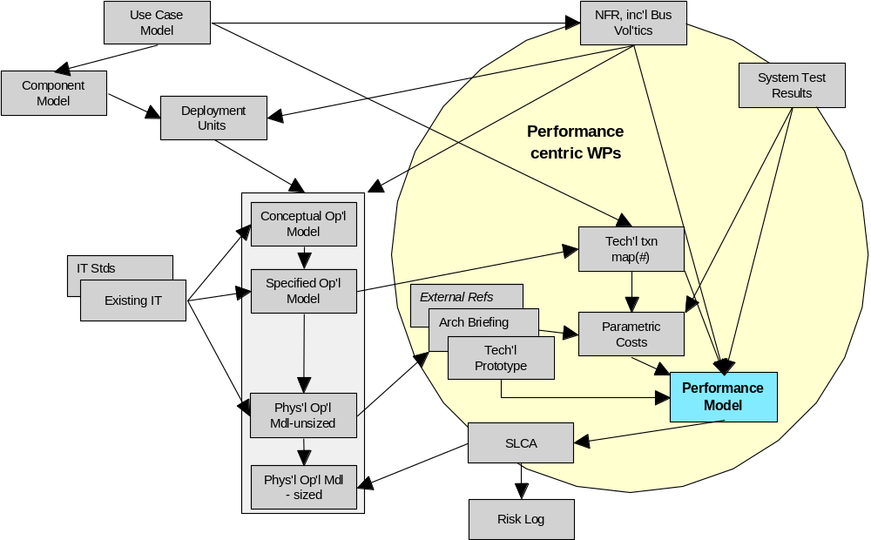

As the System, Component and Design Baselines are being developed, Performance Estimation and Modeling becomes a key PE theme, as it is the early sizing and estimation efforts that allow performance risks to be identified early in the project. However, to do this kind of modeling, the PE team is dependent on information from other sources whose earliest versions are first available during this phase of the project. The following sections will describe the role of many of the work products shown in the diagram above.
- Understanding the Architechtural Context
Estimating performance requires not only an understanding of the functional and non-functional requirements, but also an understanding of the emerging architecture. Typically this will begin with the definition of a component model, depicting the software components of the system and their interactions. As the development process continues, each component will have its operational aspects, known as deployment units, defined. The elaborated components will be assigned to nodes in the operational model, which will ultimately describe the set of components, nodes, connections and interactions selected to satisfy both the functional and non-functional requirements of the solution.
- Preparing the Estimation and Modeling
While it is useful to develop early estimates of the system’s capacity requirements and expected performance, such estimates have very little value if they are purely the result of guesswork. If the estimates are dealing with a complex system and time allows, a model of the system’s performance behavior may need to be assembled to assess performance properly.
Performance models such as these require additional information gathering to be built properly. One of the PEMM themes, technology research, deals with the gathering of unknown information to support the estimating and modeling effort, especially where it concerns the deployment of new technology or the comparison of technology options. A typical example would be to compare two servers to each other based on their ratings using industry benchmarks such as SPECint or rPerf. Another example would be researching seek time of various disk models. While technology research may not answer all of the questions raised when attempting to model a complex system, it still improves the quality of the model and raises awareness of the performance issues and trade-offs which must be considered.
Another PEMM theme, parametric costs, deals with the incremental estimated cost, in time or system resource, required to process a transaction or unit of work. Performance models use measured or estimated parametric costs, together with technical volumetrics, workload scenarios, descriptions of processing resources and sequences, and in some cases applications of queuing theory to produce performance and resource utilization estimates.
- Developing a Performance Model
As shown in the chart below, there are various estimating and modeling techniques that can be applied in developing performance estimates.
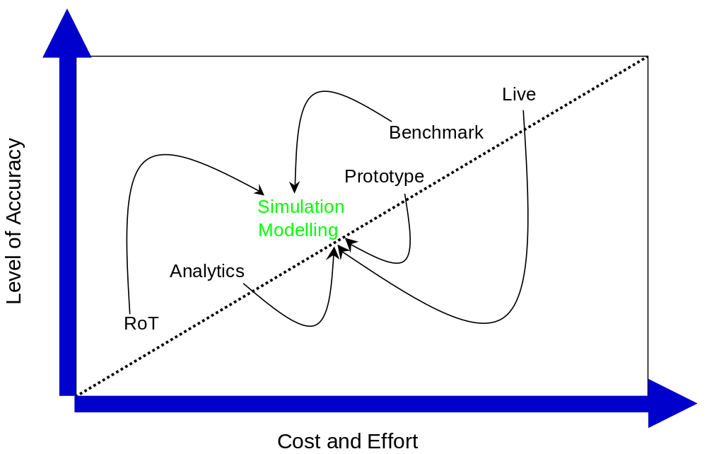

Selecting an estimating technique comes down to managing the trade-off of how quickly and cheaply the model must be built with how accurate the model must be. Typically, rudimentary estimates can be made quickly by using “rules-of-thumb” (RoT), or with some more time and effort, by developing more elaborate analytical spreadsheets (e.g. RUMPUS model). During the development of the System Baseline prior to the SRR, this may be the best approach to take. There are other techniques, which are:
- Using simulation modeling tools (e.g. HyPerformix Workbench or IPS, OpNet, IBM AMBIENCE) which make performance and resource estimates based on a rather detailed description of the system resources and behavior
- Using prototypes to simulate aspects of a future system before the actual system is built.
- Using benchmark workloads (typically simulated) to measure the performance of a system in a performance test environment
- Measuring the performance of the live production system itself.
- Using the Performance Model to Estimate Performance and Make Recommendations
The purpose of using a performance model at this stage is to develop the means to properly assess the system baseline. Whatever modeling technique is selected, the model built should be flexible enough to take into account multiple workloads, parametric costs and system configuration scenarios. This allows the modeler to conduct “what-if” analysis on the proposed solution, to identify potential areas of performance risk and to make recommendations. Typically this is done by designing the model in a parameterized fashion, so that different scenarios can be exercised simply by changing parameter values and not making fundamental changes to the model itself.
There are two important factors that may play into the decision about estimating and modeling techniques selected.
- The need to supply or validate an initial sizing of the solution – Typically some kind of estimate must be made of the solution costs, and hence initial estimates must be made of system resources and configurations required. Performance estimating and modeling can help to determine whether such a sizing is reasonable.
- The need to assess solution feasibility, risk and contractual compliance – If there is a risk that a solution cannot meet the stated performance requirements or expectations, this needs to be identified and called out early. At the very least, performance risks identified and mitigated early will increase the chances of meeting the requirements on time and within budget. In some cases there will actually be contractual penalties for not meeting performance requirements, so this may call for earlier application of more rigorous modeling approaches.
Interacting with the Development Team during the Component Baseline Phase
As PE team members become more engaged in the product, they will typically interact with members of the development team at various times:
- while attending requirements review meetings
- while reviewing architecture and application work product review meetings
- while developing the PE strategy and plan
If the PE team and/or PE processes are new to the development team, some time may be required before the PE team has developed the credibility it needs to make a difference in how the system is developed. This is best done by PE team members
- becoming informed about the requirements, architecture and the design of the existing and emerging solutions,
- adding value to work product and deliverable reviews,
- treating their peers in other groups with respect, and
- presenting the goals of PE as a shared objective that will benefit all concerned.
During later phases of the project, the PE team will require the assistance of the development team to be successful. If the development team members feel that their perspective has been fairly considered while the PE strategy and plan is defined, they are more likely to cooperate when the PE plan is being executed.
Interacting with the Test Team during the System Baseline Phase
Similarly, the PE team should be careful to cultivate a strong working relationship with the performance test team as well. In actuality, the PE team and the performance test team will have a great deal in common. Both teams will be very interested in having well-defined, verifiable performance requirements, as they both have some level of responsibility in validating that the solution can meet those performance requirements, albeit by different means.
Some examples of cooperation opportunities:
- The PE team can use the results of its estimation and modeling to give guidance or direction to the performance test team of areas where there seems to be the most performance risk.
- Similarly, the performance test team can supply test results back to the PE team to help validate and calibrate performance models produced earlier.
- As the Requirements Traceability and Verification Matrix (RTVM) is developed and reviewed, the PE and performance test teams should work together to advise the Systems Engineering team on making the right trade-offs between performance modeling and performance testing when considering how to validate specific requirements.
The PE plan should include items which exploit these opportunities for synergy and collaboration.
Participating in the System Requirements Review (SRR)
The following excerpt from the System Requirements Review scorecard denotes the SRR criteria which are applied to NFRs in general (and performance requirements in particular).
1. Business Requirements and Process Definition
1.5 Business requirements (functional and non-functional) defined and prioritized
4. Requirements Traceability
4.1 Requirements Traceability Matrix maps business requirements to systems requirements.
4.2 Customer concurs with the business requirements and their mapping to system requirements.
5. Acceptance Criteria
5.1 Acceptance Criteria, test methods, and test types have been added to Requirements Traceability Matrix.
5.2 Customer concurs with the Acceptance Criteria, test methods, and test types.
It is possible that the SRR will be held before there is adequate time or information to assemble performance requirements that meet these criteria. If this is the case, during the SRR scoring process, issues which clearly identify the requirements shortcomings or other areas of performance-related risk may need to be addressed. Depending on the seriousness of the issue, there may or may not be a resolution before exiting the System Baseline, but at the very least the issue is captured and can be addressed as the project moves forward.
Below are some examples of questions that the PE team can be asking above and beyond the standard SRR scorecard criteria.
- Is the existing (or previous) PE strategy understood?
- Are the system performance requirements understood?
- Are the system acceptance criteria for performance understood?
- Has an initial sizing of the system solution been performed?
- Has the performance feasibility and risk for the system been assessed?
- Are business and technical volumetrics available?
- What system components will require technology research with respect to their performance characteristics?
- What system areas will require performance estimation and/or modeling to address areas of performance risk?
- Is there an initial version of a capacity plan available?
- Has work begun on defining the Service Level Requirements (SLRs)?
- Does the Requirements Traceability & Verification Matrix (RTVM) reflect wise choices on when to use estimation, when to use modeling and when to use test to validate performance requirement compliance?
- Key Considerations
Nond
- References
None
- Revision History
Revision Number | Revision Date | Summary of Changes | Author(s)
4.1.1 | December 2006 | Initial Release | David Jewell

If the PE team is engaged after the System Baseline has already been established, developing the PE plan may actually take place during another phase. However, it is helpful to develop the PE plan as soon as possible, so that the customer, sponsor and other stakeholders and participants can understand and agree to the PE activities and schedules being proposed.
The PE plan table of contents shown here borrows many ideas from that of the GS Method “Master Test Plan” work product.
From an SE or governance perspective, critical requirements such as these may have corresponding Technical Performance Measures (TPMs) instituted to increase their visibility across the project team. Typically, TPMs will be identified as part of the Systems Engineering Management Plan and will require more attention than normal requirements due to their criticality.

