
s

Conducting a Business Requirement Review

Guidance/Guideline

© Copyright International Business Machines Corporation 2002, 2007
Version 5.0 July 2007
- Description
The Business Requirements Review (BRR) is conducted to establish the business/customer requirements baseline. The BRR is the first of a sequence of Systems Engineering (SE) reviews, as depicted in Figure 1 below.
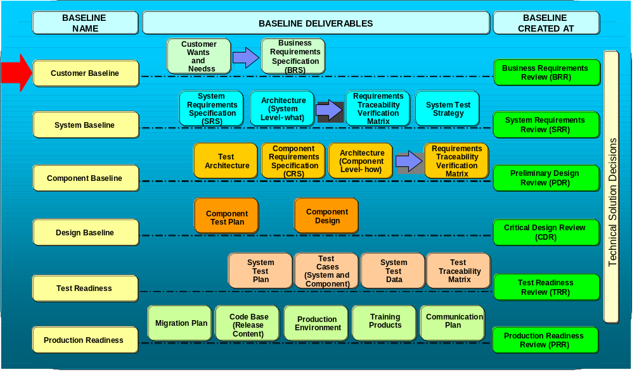

Figure 1 - Systems Engineering Reviews and the BRR

The objectives of the BRR are:
- Review business requirements and acceptance criteria with customers and stakeholders
- Establish traceability and set baseline
- Verify and validate "as is" process flows exist and are complete
- Review project plan milestones
- Review known Risks (risk mitigation) / Issues / Dependencies / Defects
- Capture new Risks / Issues / Dependencies / Defects

- Context
The various Business Transformation Management System (BTMS) project phases and decision checkpoints (DCPs) correspond closely to the Systems Engineering Capability Pattern phases and technical reviews (see Figure 2). At the end of the Pre-Concept phase, the Systems Engineer leads the Business Requirement Review (BRR). If the project skipped the Pre-Concept phase, then the BRR should be conducted at the beginning of the Concept phase.
During the Pre-Concept phase of a project, the Systems Engineer holds a series of meetings with the business and development teams to gather and document the business scope, objectives, and requirements that pertain to the project, along with the associated acceptance / success criteria. In addition, the current, “as is”, business process and the proposed, “to be”, business process are documented, with the changes highlighted. After the documents are completed, they are reviewed and approved during the BRR by the business and development stakeholders. A baseline is thereby established for the business requirements and associated acceptance / success criteria and any changes to the baseline documents are managed by a change control process.
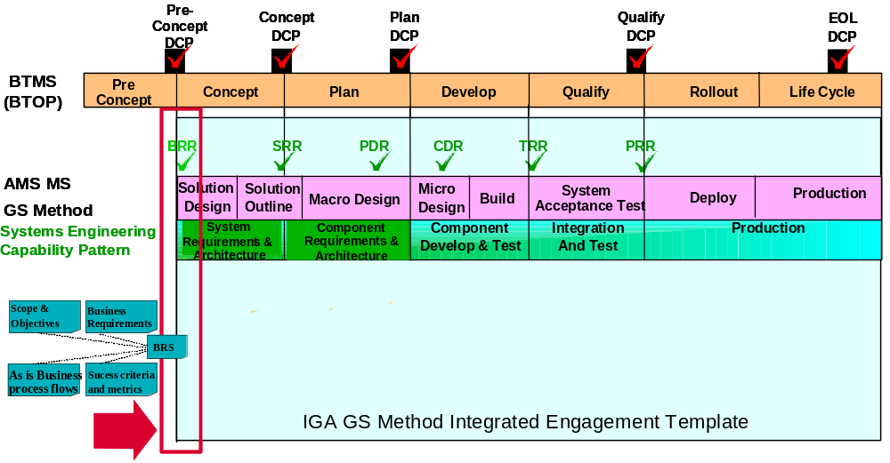

Figure 2- Relationship between BTMS phases, decision checkpoints (DCPs) and SE phases, reviews
- Business Requirements
Business requirements
Business requirements can be identified by the following characteristics:
- They support a business scope and / or objective, usually reviewed by executives
- They have a business purpose / focus
- They state "what" needs to be accomplished using business language
- They are non-technical
Key questions to ask when reviewing business requirements:
- What am I solving with this business requirement?
- Is this business requirement feasible?
- What scope and / or objectives is this business requirement addressing?
- What is the acceptance criterion for this business requirement?
- How do I measure the acceptance criteria?

Relationship between Business, System, and Component Requirements
Business Requirements are provided by the customer / business team. Each Business Requirement typically expands into 3-5 high-level technical System Requirements that specifies what is required of the systems to support the Business Requirement. Each System Requirement typically expands into 3-5 low-level technical Component Requirements that specifies what is required of the components to support the System Requirement.
Business Requirements are developed during the Pre-Concept Phase and reviewed during the BRR.
System Requirements are developed during the Concept Phase and reviewed during the System Requirements Review (SRR).
Component Requirements are developed during the Plan Phase and reviewed during the Preliminary Design Review (PDR).
It is vital to trace the Business Requirements to the System Requirements to the Component Requirements. The Systems Engineer maintains the requirements and their traceability throughout the project life cycle.

Examples of Business, System, and Component Requirements
- BR1 Provide the ability to specify the supplier with whom the Agreement is being created.
  - SR1.1 The system shall present the list of names of suppliers, as contained in the Master Supplier List.
    - CR1.1.1 The user shall be able to select an option to view the list of suppliers.
    - CR1.1.2 The user shall be able to select one supplier from the list.
- BR2 Provide the ability to route the pre-signed contract from one Approver to another.
  - SR2.1 The system shall allow a user of specific type (Contract Administrator) to designate approvers for a contract.
    - CR2.1.1 The Contract Administrator shall be able to view a list of approvers associated to a contract.
    - CR2.1.2 The Contract Administrator shall be able to assign a priority code to each approver, to designate order of routing.

- Details of the BRR
  - BRR Participants
In order for the BRR to be successful, it is critical that key stakeholders have been identified and have confirmed they will attend the review. Required stakeholders influence or are affected by the business requirements. They are also responsible for the quality and completeness of the content of the deliverables. Examples of stakeholders involved with the BRR are:
  - Customer / Business Team:
    - Customer Program / Project Manager (PM) – Responsible for identifying required customer’s stakeholders and ensuring sign-off of the main deliverables.
    - Customer’s business process owner
    - Customer’s Application / System Managers or Customer’s Application Subject Matter Expert (SME)
    - End-user from each community that is impacted by the project
  - IBM Development / Delivery Team:
    - IBM Project Manager (PM) – Sometimes called the Solution Project Manager (SPM). Responsible for identifying required IBM stakeholders and ensuring sign-off of the main deliverables.
    - IBM Systems Engineer (SE)
    - IBM IT Architect
    - IBM Application Manager or IBM Application Subject Matter Expert (SME)
    - Other required stakeholders may be identified by the IBM Project Manager or IBM Systems Engineer.
Best Practice Suggestions:
- Notify the key stakeholders well in advance of the BRR since it is often difficult to find time that they are available. Confirm that they will attend the BRR.
- In order to work together effectively, it is important for each team member to understand the role and responsibility of every other team member. It must be clear who is responsible for each task and deliverable (document). For a specific topic, everybody should know whom to ask for help or to answer questions.
- It is confusing to distinguish between the Development Team and the Customer / Business Team when the Customer is also IBM. This is the case, for example, in which IBM Human Resources (HR) engages IBM Global Business Services (GBS) – Application Services (AS) to develop an application for HR (e.g., to manage IBM employees’ skills profiles).
- At the start of an engagement, the Systems Engineer should work closely with the IBM Development PM to clearly identify and document the role and responsibility of each team member. This documentation should be accessible by all team members (e.g., stored in the project TeamRoom or wiki) and maintained as new members are added and/or as roles and responsibilities change. Organization charts should also be documented and maintained.

  - BRR Responsbilities
Normally, the following roles have the responsibility to present the material at the BRR. Depending on the project, some of the review material may be presented by different roles.
Customer
- Business objectives and scope
- Business Wants and Needs
- Business process flow (e.g., “swim lane” diagram) – Current (“as is”) and Proposed (“to be”)
IT Architect
- System Context Diagram – Current (“as is”) (The Proposed (“to be”) diagram is usually developed during the Concept Phase.)
Systems Engineer
- Business Requirements and Acceptance Criteria (developed with input from the team)
- Technical Assumptions, Risks, Issues, Dependencies
Project Manager
- Project Plan – detailed for Concept Phase, approximate for the rest of the project life cycle
  - BRR Workbook
The BRR Workbook is used to assist SE’s in developing the Business Requirements baseline. This is a critical document used for planning the BRR, recording issues/risks, and serves as the basis for scoring the BRR. The workbook covers the following objectives:
  - Provide guidance to Project SE’s (instructions, terminology)
  - Provide a version control (Revision History)
  - Document and track stakeholders (Stakeholders)
  - Document and track defects, issues, risks, and associated dependencies (Review Log)
  - Score the review (Calculate, BRR Scorecard, Maturity)
The BRR Workbook includes the following tabs:
Instructions: This Tab summarizes how to use the BRR Workbook in carrying out the BRR Process.
Revision History: Provides an audit trail of updates to the BRR Workbook
General Information: This tab records general information about the BRR Workbook, including the author of the BRR Workbook and a unique Project identifier.
Terminology: This tab provides definitions of terms used in the BRR Workbook, including metrics definitions.
Standard Criteria: Provides the standard evaluation criteria used to determine the completeness of the business requirements and the associated acceptance criteria.
Stakeholders: This tab is used to identify the stakeholders and the dates for reviewing and approving the deliverables with the stakeholders.
Review Log: Records the issues, risks, recommended actions, and responsibilities recorded during the BRR.
Calculate: Determines a BRR score based on review log
BRR Scorecard: Displays results from the review log that corresponds to the standard evaluation criteria
Maturity: Provides graphic representation of normalized scores from the BRR.
Template History: This tab is used to record updates made to the workbook template.
Best Practice Suggestions:
-The critical tab in the BRR Workbook is the Review Log. Before the formal BRR, identify who will record the input to the Review Log during the BRR. A review should be conducted prior to the BRR to determine how the data will be recorded (issue, risk, etc.) and when the data will be entered The Review Log should be updated as soon as possible after each session.

  - Steps for Conducting the Review
The BRR is structured in such a way to allow for the ordered planning, preparation and execution of the review in a logical sequence. Figure 2 below highlights the key activities in conducting the BRR.
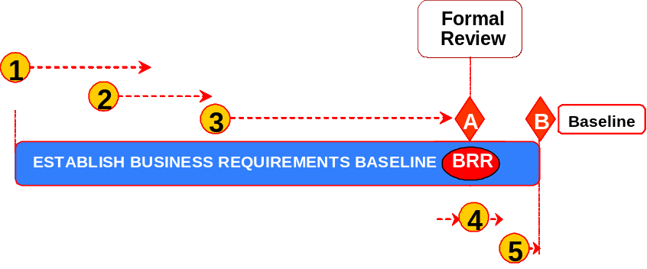

Figure 3. BRR Process Steps

The major steps in the BRR review process are:
- Planning for the Preliminary Reviews of the Deliverables
- Inspecting Deliverables
- Preparing for the Formal BRR Review
- Conduct the BRR
- Establishing the Business Requirements Baseline
These are described in detail below:
- Planning for Preliminary Reviews of the Deliverables
Below are the primary steps in the planning of the BRR. The key inputs that should be considered as part of the planning phase are:
- Project Information
- Date when draft of deliverable (s) will be provided
Phase steps:
  - IBM PM, Customer’s PM, and IBM Project SE identify the required stakeholders.
  - IBM Project SE schedules preliminary review(s) of deliverables.
  - Schedule preliminary reviews based on the date when draft of deliverable will be provided
  - Schedule preliminary reviews with stakeholders to be completed in time for a formal review to be held and for the deliverable to be baseline on time
  - Notify stakeholders about preliminary review(s).
Upon completion of the planning phase, the key outputs are:
- Deliverables ready for formal review
- Review Workbook including scores
Best Practice Suggestions:
- Communicate to the project and client participants early in the Pre-Concept Phase the goals of the BRR, resource demands, and who will be at part of the BRR. Participants should be aware that their deliverables will need to be completed before the BRR is conducted.
- Inspecting Deliverables
As part of this step, the key inputs are:
- Review Workbook
- Draft of deliverables
- Stakeholders list and dates for preliminary reviews
- Project schedule with plan date to baseline deliverables
Phase Steps:
  - Preliminary Review of deliverables with stakeholders
  - Document defects, issues, risks, and related dependencies (Review Log)
  - Determine severity / impact of items in the review log
  - Score Preliminary Review
  - Once all the preliminary reviews with stakeholders have been completed, IBM PM and IBM Project SE share preliminary score with stakeholders and the development team.
  - Address defects, issues, risks, and related dependencies documented in Review Log
  - IBM Project SE works with IBM PM to assign owners and due dates to items in Review Log.
  - Track and update Review Log (Review Workbook)
The key outputs of the Deliverable assessment phase are:
- Deliverables ready for formal review
- Review Workbook including scores
Best Practice Suggestions:
- Attend key deliverable peer reviews in order to get a sense of who is working on the deliverables, the quality of the documents, and if they will be completed in time for the BRR.
- Review the deliverables at a high level to ensure they are of sufficient quality for the formal BRR. This does not take the place of the normal deliverable peer review.

- Preparing for the BRR Formal Review
When preparing for the formal review, the following inputs should be considered:
- Stakeholders list and dates for preliminary reviews
- Project schedule with plan date to baseline deliverables
Phase steps:
  - Schedule Formal Review
    - Ensure all required stakeholders are invited
  - Send BRR material to required stakeholders
    - Prepare BRR agenda and presentation.
Upon completion and preparation of the formal BRR review, the following output should be produced:
- Planned formal review date
Best Practice Suggestions:
- Be sure to coordinate with each participant who will present in the BRR specifically what the expectations are for their section. The amount of time required by the participants to prepare for the BRR is often underestimated.
-Leverage the presentation material from pre-existing documentation as much as possible
-Use the BRR Entry/Exit criteria (Attachment A) as a guideline for the presentation material. Also review the BRR scorecard to ensure the evaluation criteria is covered in the review.
--Perform a dry run of the material with the appropriate resources before the formal BRR
-Allow enough time after scheduling the BRR to correct major issues before exiting the Pre-Concept phase
-Ensure the key stakeholders are invited and will attend the BRR.

-

- Conduct the Formal BRR
Conducting the formal BRR is the culmination of the planning and review phases. The key inputs are:
- Deliverables ready for formal review
- Review Workbook and pre-review score (s)
Phase Steps:
  - Ensure all stakeholders participate in formal review
- Track participation of required stakeholders - Stakeholders Tab
(Review Workbook)
- If required stakeholders are missing, create issue or risk in Review Log.
  - Conduct the Formal Review
  - Validate status of open items recorded in the Review Log (Review workbook)
  - For deliverables submitted for review:
    - Document defects, issues, risks, and related dependencies in Review Log
    - Determine severity/impact of items in the Review Log
    - Ensure BRR standard criteria and required data is entered in Review Log
    - Request and track approval of deliverables (Stakeholders Tab)
  - Score the Formal Review
  - Communicate BRR metrics to required stakeholders and SEAT team
  - Communicate the review workbook and review score
Upon completion of the BRR formal Review, the following outputs are expected:
    - BRR Workbook including scores

Best Practice Suggestions:
-Be sure to follow good meeting management practices (scribe, facilitator, etc). The BRR can often get sidetracked into extended discussions.
-Consider assigning someone to log the comments/issues/risks on Sametime as the meeting progresses. This allows remote callers to follow the meeting more closely and it can be used as an audit trail to document the BRR Workbook Review Log.
-Note defects, assumptions, issues, risks, and dependencies for all sections as you review the sections
-Gain signoffs for each section, as you review the section
-Review the signoff sheet, the risks, the defects, the issues, and the action items so that everyone agrees with the review results.

- Establishing the Business Requirements Baseline
The input for the BRR Baseline is:
  - Review Workbook including scores
  - Work and close items in the Review Log (Review Workbook)
  - IBM SE works with IBM PM to assign owners and due dates to items in Review Log.
  - Track items to closure and update them in Review Log.
  - Re-score the review (if applicable)
  - Re-score if the BRR score is red or yellow (less than 85).
  - Confirm that the Review Log is up-to-date with respect to all identified defects, issues, risks, and related dependencies being entered into the log.
  - Communicate review metrics from the re-score to required stakeholders.
The output for the BRR Baseline is:
  - BRR Workbook including scores
- Tools and associated files
The BRS template is the main deliverable that establishes the customer baseline.
- BRS TEMPLATE
The BRR template is a simplified version of this document that is used to produce an agenda during a review.
- BRR TEMPLATE
The readiness tool is used to determine if a BRR should schedule or not.
- BRR READINESS
There is a BRR scorecard template contained in the BRR Workbook.
- BRR WORKBOOK

- Revision History
Revision Number | Revision Date | Summary of Changes | Changes Marked?
1.0a | 10/23/2002 | Initial release of technique paper | NA
1.0 | 12/03/2002 | Updates to initial release to include M3, Business Requirement Specification and references to SEA process release 2.0 | NA
1.1 | 05/31/2005 | Changed “BRR is an optional…” to “BRR is a review…” in the Description section on page 1. This change became part of the process with the April 2005 release of AMS IGA and AMS process. (Change done by Ron Nutt) | NA
5.0 | 08/08/2007 | Add new diagrams showing Systems Engineering reviews and relationships with requirements baselines and the Business Transformation Management System (BTMS) phases and decision checkpoints (DCP’s). Incorporate “Steps for Conducting the Review”. Add Best Practices. (Changed by Peter Lew) | NA

Appendix A - BRR Entry/Exit Criteria, Presentation List, and SE Considerations
Entry Criteria | Presentation | Exit Criteria | SE Considerations
Business Objectives and Scope  There is a scope and objectives document  Top sheet | Business Objectives and Scope  Present business scope and objectives  Present overview of business case | Business Objectives and Scope  Validated and verified business scope and objectives (identify defects, issues and risks)  Business case reviewed (top sheet, business case etc)  Identified dependencies that are causing defects, issues or risk related to business objectives and scope | Business Objectives and Scope  Assumptions should also be documented during the Pre-Concept Phase and reviewed during the BRR.
"As is" Business Process Flows  “As is” business process flows are defined and documented  Review processes that are required to be monitored, measured and managed | "As is" Business Process Flows  Present list of "as is" process flows  Present identified gaps in "as is" process flows  Present the plan to complete "to be" process flows | "As is" Business Process Flows  Validated current (AS-IS) manual procedures (identify defects, issues, and risks)  Validated current (AS-IS) legacy business process scenarios – base functions, exceptions  Validated current (AS-IS) end to end legacy architecture – system, applications, interfaces  Validated gaps in process flows and ensured plans to address them  Validated that SMEs were involved in creation of “as is”  Identified dependencies that are causing defects, issues or risks related to business process flows and procedures  Reviewed Plan to complete solution process | "As is" Business Process Flows  The current, “as is”, process is known and should be already documented.  Based on the business objectives, scope, wants and needs, the customer will have a fair idea of the proposed, “to be”, process. If not completed during the Pre-Concept Phase, the “to be” process should be completed during the early part of the next phase, the Concept Phase.  The System Context Diagram for the current, “as is”, process should also be reviewed during the BRR. The proposed System Context Diagram should be developed early during the Concept Phase.
Business Requirements  Business requirements are defined, documented, and prioritized  Business requirements mapped to Scope and Objectives  Known issues, risks, and dependencies are defined and documented | Business Requirements  Present business requirements  Present business requirements priorities  Present mapping of business requirements to scope and objectives  Present known issues, risks, and dependencies | Business Requirements  Validated that business functional /non functional requirements were defined  Ensured that agreed to business functional/non functional requirements are clear and unambiguous  Ensured Stakeholders and Customer signed off on functional/non functional requirements and associated priority  Ensured Business functional/non functional requirements are traceable to business scope and objectives  Identified dependencies that cause defects, issues or risks related to business functional/non functional requirements | Business Requirements  The Customer team provides business requirements input to the SE. The SE may need to reorganize and reword the requirements so they are clear, unambiguous and traceable.  The SE is responsible for maintaining the requirements throughout the project life cycle.
Success Criteria & Associated Metrics  Success criteria and associated metrics are defined and documented | Success Criteria & Associated Metrics  Present success criteria and associated metrics  Present measurement methodology | Success Criteria & Associated Metrics  Validated agreed to success criteria and associated metrics were defined (identify defects, issues and risks)  Ensured approval of acceptance / success criteria from customers and stakeholders  Ensured that acceptance / success criteria is clear and unambiguous  Identified dependencies that are causing defects, issues or risks related to success criteria and associated metrics. | Success Criteria & Associated Metrics  A success criterion is another name for an acceptance criterion.

Appendix B – Agenda and Steps for Conducting the BRR
Agenda
- BRR Goals and objectives
- Ground rules
- Scope and objectives validation and verification
- Validate "as is" process flows exist and are complete (not applicable for all projects)
- Review business requirements and acceptance criteria with customers and stakeholders.
- Score the review
- Review signoffs, plans, risk, issues, defects, and dependencies

- Describe BRR Goals and objectives
- To assess whether to move into next phase
- Acquire official approval to proceed from Stakeholders
- Explain BRR ground rules
- Seek approval
- Do not solve issues
- Validate and verify scope and objectives
- Present business scope and objectives
- Present overview of business case
- Validate "as is" process flows exist and are complete
- This step is not always applicable for all projects
- Review list of "as is" process flows
- Review identified gaps in "as is" process flows
- Review the plan to complete "to be" process flows
- Verify and validate "as is" manual touch point desk-level procedures.
- Verify and validate "as is" business process process flow definitions.
- Verify and validate "as is" architecture.
- Identify gaps in process flows and ensure plans to address them.
- Review, identify and document existing/current business process issues and defects associated non-functional requirements (these may drive additional business requirements).

- Review business requirements and acceptance criteria with customers and stakeholders
- Review that business requirements are mapped to scope and objectives. Business requirements are documented in a business requirements specification (BRS). This is produced by customers and stakeholders. A BRS template to assist customers and stakeholder is provided. This template will work also for a requirements management tool.
- Ensure that agreed to business requirements and acceptance / success criteria are clear and unambiguous.
- Check functional and non-functional requirements.
- Document existing business process issues and defects associated with non-functional requirements as new BRR requirement line items (as appropriate).
- Ensure clear understanding of the business/stakeholder needs, rationale, and priorities.
- Gain approval of business requirements and acceptance / success criteria from customers and stakeholders.

- Score the review
- Use scorecard in the Workbook to score a review. Make sure you have completed the BRR assessment before scheduling a review.
- Review signoffs, plans, risk, issues, defects and dependencies
- Sign off on business requirements
- Put them under change control
- Review known risks, risk mitigation, issues, defects and dependencies for business requirements. The Solution Project Manager (SPM) usually performs this task. During this phase, SPMs are usually focused on budget, resources, schedule constrains, technology and standards to comply, business requirements and acceptance criteria ambiguity, etc.
- Capture new risks, issues, defects and dependencies for business requirements. Examples of these dependencies are “business dependencies” (external or internal organizations, baselines, etc.)

