

IBM Global Services

Conducting a Preliminary Design Review

Technique Paper (TP)

© Copyright International Business Machines Corporation 2003
All Rights Reserved
Version 5.0.0, June, 2007
- Description
The Preliminary Design Review (PDR) is conducted in order to develop a component requirements/design baseline. Figure 1 below shows the relationship of the PDR with the other SE reviews.
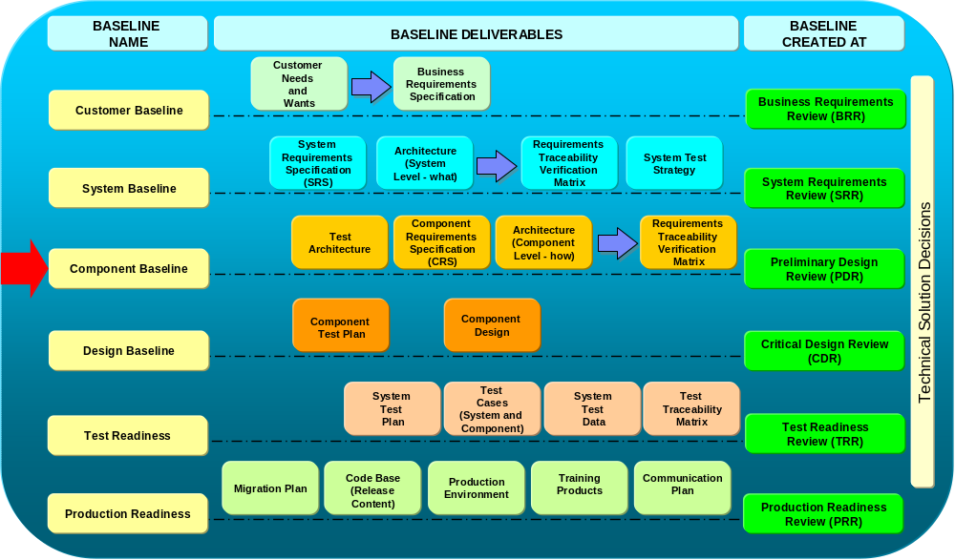
Figure 1. SE Reviews and the PDR

The objectives of the PDR are:
- Establish the architecture and component baselines
- Review system and component architectures
- Verify system and component architectures against allocated system requirements
- Review test architecture (software and hardware)
- Review and approve the allocated component requirements and business scenarios
- Establish traceability from system requirements to component requirements
- Identify/review technical risks and mitigation plans
- Identify/review technical dependencies.
- Details
  - PDR Participants
The required stakeholders are critical for inclusion in the PDR in that they influence business, system, component requirements or are impacted by the deliverables created to establish a component baseline. They are also responsible for the quality and completeness of the content of the deliverables. Examples of stakeholders are:
- IBM:
  - IBM Project Systems Engineer
  - IBM IT Architect
  - IBM Test Manager
  - IBM Project Manager - He/she is responsible for identifying required IBM stakeholders and ensuring sign-off of the required deliverables
  - IBM Application Manager or IBM Application Subject Matter Expert (SME)
  - Other required stakeholders may be identified by the IBM Project Manager or IBM Project Systems Engineer
  - Managed Operations Team
- Customer:
  - Customer Program / Project Manager – He/she is responsible for identifying required customer’s stakeholders and ensuring sign-off of the required deliverables.
  - Customer’s Application / System Managers or Customer’s Application Subject Matter Expert (SME)
  - End-user from each community that is impacted by the project.

  - PDR Responsibilites
The Systems Engineering and Architecture teams generate and present all of the materials for the PDR. It is common for the IT Architect(s) to prepare and present the architecture artifacts as described in Appendix A- PDR Entry/Exit Criteria with SE Considerations. The Test team may present the Test Architecture materials. The SE leads the Preliminary Design Review; thus he/she must prepare the PDR package. Refer to the SEAT Teamroom for the current PDR template.
  - PDR Workbook
The PDR Workbook is used to assist the SE in creating the component baseline. This is a critical document used for planning the PDR, recording issues/risks, and serves as the basis for scoring the PDR. The latest copy of the workbook can be found in the SEAT Teamroom. The workbook also helps the SE by:
  - Providing guidance to Project SE’s (instructions, terminology)
  - Providing version control (Revision History)
  - Documenting and tracking stakeholders (Stakeholders)
  - Documenting and tracking defects, issues, risks, and associated dependencies (Review Log)
  - Scoring the review (Calculate, PDR Scorecard, Maturity)
The PDR template includes the following tabs:
Instructions: This Tab summarizes how to use the PDR Workbook in carrying out the PDR Process.
Revision History: Contains the audit trail of changes made to the Workbook
General Information: This tab records general information about the PDR Workbook, including the author of the PDR Workbook and a unique Project identifier.
Terminology: Critical terms and definitions for the PDR
Standard Criteria: Provides the standard criteria used to determine the production readiness of the project
Stakeholders: This tab is used to identify the stakeholders and the dates for reviewing and approving the deliverables with the stakeholders.
Review Log: Records the issues, risks, recommended actions, and responsibilities recorded during the PDR.
Calculate: Determines a PDR score based on review log
PDR Scorecard: Displays results from the review log that corresponds to the evaluation criteria
Maturity: Provides graphic representation of normalized scores from the PDR.
Template History: Provides an audit trail of updates to the PDR Workbook
Best Practice Suggestions:
-The critical tab in the PDR Workbook is the Review Log. Before the PDR, identify who will record the input to the Review Log during the PDR. A review should be conducted prior to the PDR to determine how the data will be recorded (issue, risk, etc.) and when the data will be entered. The Review Log should be updated as soon as possible after each session.

  - Steps for Conducting the PDR Review
Figure 2 shows a high level overview of the process of conducting the PDR. Before the formal PDR is conducted, it is important for the SE and IT Architect to conduct a preliminary PDR in order to ensure the proper deliverables are ready for review. An initial score is established to determine the overall readiness for the formal PDR.
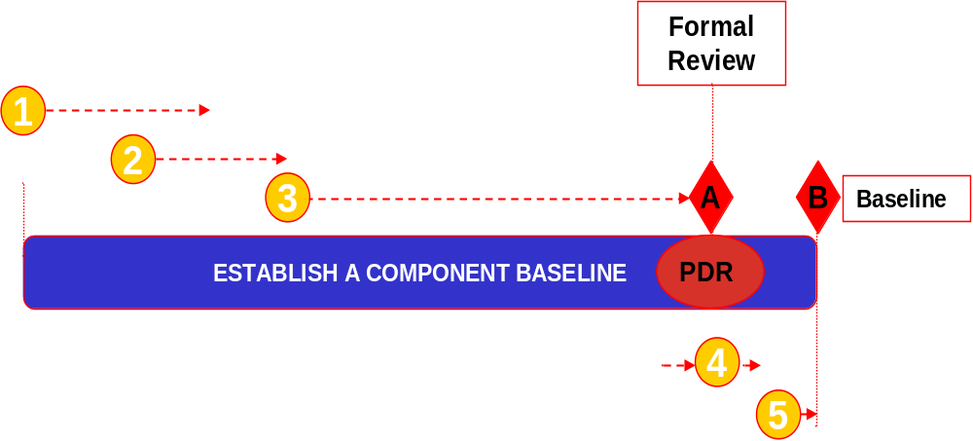
Figure 2 PDR Review Process
The key steps of the process include:
- Assemble Deliverables and Plan for Preliminary Reviews
2. Inspect Deliverables
3. Preparing for Preliminary Design Review
4. Conducting a Preliminary Design Review
5. Establishing the Component Baseline
These steps are detailed below with the key inputs and outputs:
Assemble Deliverables and Plan for Preliminary Reviews
Below are the key inputs that should be considered as part of the planning phase are:
- Project Information
- Date when draft of deliverable (s) will be provided
Phase Steps:
  - IBM PM, Customer’s PM and IBM Project SE identify the required stakeholders
  - IBM Project SE schedules preliminary review(s) of deliverables
- Schedule preliminary reviews based on the date when draft of deliverable will be provided
- Schedule preliminary reviews with stakeholders to be completed in time for a
formal review to be held and for the deliverable to be baselined on time.
  - Notify stakeholders about preliminary review(s)
Upon completion of the planning phase, the key outputs are:
- Deliverables ready for formal review
- Review Workbook including scores
Best Practice Suggestions:
-The PDR often occurs shortly after the Systems Requirements Review (SRR) is conducted. The SE should begin planning for the PDR soon after the SRR is completed due to the compressed lead time between reviews.

Inspect Deliverables As part of the inspecting deliverables phase, several artifacts are needed to assist in this activity. The key inputs are:
- Review Workbook
- Draft of deliverables
- Stakeholders list and dates for preliminary reviews
- Project schedule with plan date to baseline deliverables
Phase Steps:
  - Preliminary Review of deliverables with stakeholders
  - Document defects, issues, risks, and related dependencies (Review Log)
  - Determine severity / impact of items in the review log
  - Score Preliminary Review
  - Once all the preliminary reviews with stakeholders have been completed, IBM PM and IBM Project SE share preliminary score with stakeholders and SEAT team.
  - Address defects, issues, risks, and related dependencies documented in Review Log
  - IBM Project SE works with IBM PM to assign owners and due dates to items in Review Log.
  - Track and update Review Log (Review Workbook)
The key outputs of the Deliverable assessment phases are:
- Deliverables ready for formal review
- Review Workbook including scores
Best Practice Suggestions:
-Attend the key deliverable peer reviews in order to get a sense of who is working on the deliverables, review the quality of the documents, and if they will be completed in time for the PDR.
-The SE should be familiar with the various types of architecture artifacts (static, dynamic, component models, etc.) and notation techniques (such as UML, etc).
-Review the architecture artifacts to ensure non-functional requirements have been taken into account.
-During the deliverable review, look for any major open architectural issues or documentation of key decisions made.
-For Testing, the key deliverable is the Test Strategy. The SE should ensure the test levels/types, test data strategy, and environments are appropriately addressed.
-Inspecting (step 2) and preparing (step 3) for a formal PDR are the most critical tasks in defining PDR.

Preparing for Preliminary Design Review Conducting the formal PDR is the culmination of the planning and inspecting phases. The key inputs are:
- Deliverables ready for formal review
- Review Workbook and pre-review score (s)
Phase Steps:
  - Schedule Formal Review
- Ensure all required stakeholders are invited
  - Send (PDR) materials to required stakeholders
Upon completion of preparation of the formal PDR, the following output should be produced:
- Planned formal review date

Best Practice Suggestions:
- Be sure to coordinate with each participant who will present in the PDR specifically what the expectations are for their section. It is often underestimated the amount of time required by the participants in the preparation of the PDR.
-Ensure the architecture artifacts are of presentation quality. Often, these are difficult to view at the PDR.
-Leverage the presentation material from pre-existing documentation as much as possible
-Perform a dry run of the material with the appropriate resources before the PDR.
-Use the PDR Entry/Exit criteria (Attachment A) as a guideline for the presentation material.
-Ensure the key stakeholders are invited and will attend the PDR.

-

Conducting a Preliminary Design Review Conducting the formal PDR is the culmination of the preparing phase. The key inputs are:
- Deliverables ready for formal review
- Review Workbook and pre-review score (s)
Phase Steps:
  - Ensure all stakeholders participate in formal review
- Track participation of required stakeholders - Stakeholders Tab
(Review Workbook)
- If required stakeholders are missing, create issue or risk in Review Log.
  - Conduct the Formal Review
  - Validate status of open items recorded in the Review Log (Review workbook)
  - For deliverables submitted for review:
    - Document defects, issues, risks, and related dependencies in Review Log
    - Determine severity/impact of items in the Review Log
    - Ensure PDR standard criteria and required data is entered in Review Log
    - Request and track approval of deliverables (Stakeholders Tab)
  - Score the Formal Review
  - Communicate PDR metrics to required stakeholders and SEAT team
  - Communicate the review workbook and review score
Upon completion of the PDR formal Review, the following outputs are expected:
    - PDR Workbook including scores
Best Practice Suggestions:
-Be sure to follow good meeting management practices (scribe, facilitator, etc). The PDR can often get sidetracked into extended discussions.
-Consider assigning someone to log the comments/issues/risks on Sametime as the meeting progresses. This allows remote callers to follow the meeting more closely and it can be used as an audit trail to document the PDR Workbook Review Log.
-Review all system requirements, focusing on the requirements that were defined after the system requirements baseline was defined at the SRR. Provide a list of all requirements; this will define the requirements baseline for the review. Review any Business Process changes since it was baselined at the SRR.
-Review the system architectures to ensure that the architectures satisfy all system requirements. If the project is a modification to a current system (not building a new system), then the current (the 'As-Is') architectures as well as the future (the 'To-Be') architectures should be reviewed. Obtain approval that the 'To-Be' architecture meets the customer needs and the system requirements.
-For each system requirement, review all of the component requirements and the business process changes that are needed to satisfy the system requirement. Verify the priority of the Component Requirements. Obtain approval that the component requirements and the updated business processes fully satisfy the system requirement. Also, review the acceptance test criteria for each of the component requirements.
-Note defects, issues, risks, and dependencies for all sections as you review the sections
-Gain signoffs for each section as you review the section
-Review the signoff sheet, the risks, the defects, the issues, and the action items so that everyone agrees with the review results.

Establishing the Component Baseline The input for the PDR Baseline is:
  - Review Workbook including scores
Phase Steps:
  - Work and close items in the Review Log (Review Workbook)
  - IBM project SE works with IBM PM to assign owners and due dates to items in Review Log.
  - Track items to closure and update them in Review Log.
  - Re-score the review (if applicable)
  - Re-score if the PDR score is red or yellow (under 85).
  - Confirm that the Review Log is up-to-date with respect to all identified defects, issues, risks, and related dependencies being entered into the log.
  - Communicate review metrics from the re-score to required stakeholders.
The output for the PDR Baseline is:
  - PDR Workbook including scores

- Examples
See PDR template <PDR Template 120902.PRZ>
- Revision History
Revision Number | Revision Date | Summary of Changes | Changes Marked?
4.1.1 | April 2003 | Baseline version
5.0.0 | June 2007 | Revised technique paper to align with Boot Camp approach

Appendix A- PDR Entry/Exit Criteria with SE Considerations
Entry Criteria | Presentation | Exit Criteria | SE Considerations
1. Static Architecture Definition:  - All system requirements allocated to elements of the logical architecture  - All system requirements allocated to elements of the physical architecture  - All external and internal logical interfaces defined  - The system bill of material presented (List of system physical architecture elements, both hardware and software) | - System logical architecture - logical blocks, interfaces, requirements allocation  - System physical architecture showing all the elements/components, physical interfaces, requirements allocation  - Present efforts and results with regard to: Enhancing system modularity, reducing system complexity and reduction in number and types of interfaces, adherence to open standards, ease of technology refreshment, commonality  - Present considerations with regard to footprint, packaging, power, volume  - Technical risks, dependencies, & mitigation plans | - Completeness in the system logical and physical architecture presented and agreed to  - Completeness with the allocation of system requirements to architecture components agreed to  - Completeness with regard to the external and internal logical and physical interfaces agreed to  - Business monitoring tools (volume and volume projections) identified and agreed to | - Verify RTVM mapping from system requirements to architecture components  - Verify Interface Agreements and/or Interface Specifications  - Verify system BOM for completeness  - Confirm artifacts represent project scope and interfaces  - Confirm action plan/responsibilities for technical issues
2. Dynamic Architecture Definition:  - The application level use case scenarios and interaction diagrams are defined | - Application level use case diagrams  - Present tracing of selected and key business processes  - Specify how users in specific roles will interact with the applications in the system.  - Application level interaction diagrams  - Graphical representation of what depicts the internal behavior of the applications. It shows how resources collaborate by sending messages and returning responses to each other.  - Data architecture / model (data definition, data flow diagrams, and data migration)  - Technical risks, dependencies, & mitigation plans | - Completeness in the use case diagrams - showing tracing of scenarios through the system at the application level  - Completeness of the interaction diagrams - showing application level interactions / interfaces  - Completeness of data architecture / model (data flow, data definition, and data | - Confirm allocation and traceability of requirements within Use Cases  - Confirm artifacts represent project scope and interfaces  - Confirm data migration plan and test data approach  - Confirm action plan/responsibilities for technical issues
3. Architecture Element/ Component Definition:  - Requirements decomposed, allocated, and traced to each architectural element/component (hardware and software)  - Hardware and software have been sized  - Internal interface and packaging standards identified and used  - Message and message formats identified  - Technology Assurance Board reviewed component definition | - Prioritized requirements (functional and non-functional) allocated and traced to architecture elements, captured and presented in a requirements toolkit  - Key architectural components and interfaces presented - sizing, key allocated requirements, standards and protocols, message and message formats  - Present the updated TPMs and Acceptance Criteria for the system and system elements  - Any changes to the system requirements baseline since PLSRR | - Development team (hardware and software) concurrence with the completeness of the component definitions  - Verification of system requirements - through the consolidation of architectural element requirements  - Technology Assurance Board approved component definition | - Verify component requirements traceability on RTVM to system requirements  - Verify component requirements mapped to architecture component on RTVM  - Verify acceptance criteria on RTVM at component requirements level
4. Test Architecture Definition:  - System requirements and acceptance criteria allocated to the test architecture | - Allocation of acceptance criteria and system requirements to test architecture  - Testing approaches at various levels in the system and for the various to-be business processes and requirements  - Test architecture diagram  - Test data requirements  - Dependencies, risks, and mitigation approaches  - Performance and volume monitoring requirements and verification approaches | - Test architecture, approach, and the test data will sufficiently facilitate the verification of the system acceptance criteria and the system requirements, including the to-be business processes migration models) | - Verify system requirements traced to appropriate test levels on the RTVM  - Confirm test environment approach for possible contention with other projects/workstreams  - Confirm test data refresh approach  - Confirm performance engineering approach for appropriate test level

