

IBM Global Services

Conducting a Production Readiness Review

Technique Paper (TP)

© Copyright International Business Machines Corporation 2003, 2007
All Rights Reserved
Version 5.0.0, June 2007
- Description
The Production Readiness Review (PRR) is held prior to system installation to verify that the system is ready to be installed into production. It is the final Systems Engineering review and draws from inputs from Test, Program/Release Management, Performance Engineering, and the Infrastructure groups.
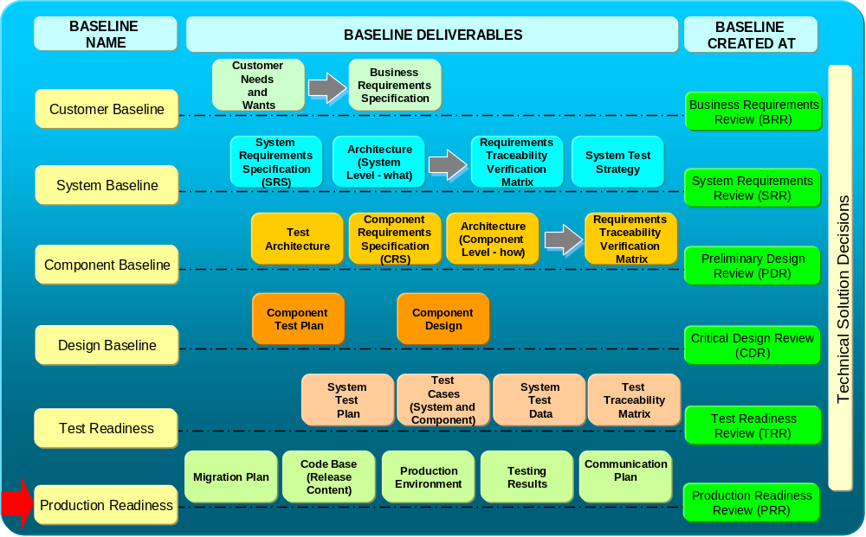
Figure 1. SE Reviews and the PRR
Figure 1 depicts the SE sequence of reviews and the deliverables used to support the PRR. The objective of the PRR is to ensure all the entrance criteria are in place to support on-time system deployment and verify the readiness of the post-production lifecycle support organizations.
In particular, the PRR objectives include:
- Verify the release content,
- Verify the test results,
- Functional tests,
- Performance tests,
- Pre-Production tests,
- Verify the expected System Availability / Performance / Response times,
- Verify the Move To Production Plan,
- Verify the Data Migration Plan,
- Verify the Deployment Plan.
- Details
  - PRR Participants
In order for the PRR to be successful, it is critical that key stakeholders are identified and confirmed they will attend the review. Required stakeholders influence business, system, component requirements, or are impacted by the deliverables created to establish a component baseline. They are also responsible for the quality and completeness of the content of the deliverables. Examples of stakeholders are:
  - IBM:
    - IBM Project Systems Engineer
    - IBM IT Architect
    - IBM Test Manager
    - IBM Project Manager - He/she is responsible for identifying required IBM stakeholders and ensuring sign-off of the main deliverables (CRS, CLA, RTVM, etc.).
    - IBM Application Manager or IBM Application Subject Matter Expert (SME)
    - Other required stakeholders may be identified by the IBM Project Manager or IBM Project Systems Engineer.
    - Managed Operations Team
    - Deployment Manager
  - Customer:
    - Customer Program / Project Manager – He/she is responsible for identifying required customer’s stakeholders and ensuring sign-off of the main deliverables.
    - Customer’s Application / System Managers or Customer’s Application Subject Matter Expert (SME)
    - End-user from each community that is impacted by the project.
Best Practice Suggestions:
-Notify the key business stakeholders well in advance of the PRR since often they are often difficult to schedule. Confirm that they will attend the PRR.

  - PRR Responsbilities
Normally, the following roles have the responsibility to present the material at the PRR. Depending on the project, some of the review material may be presented by different roles.
-Systems Engineer
- Reviews Release Content
- Reviews expected System Availability / Performance / Response Times
-Project Manager
- Leads the PRR
-Service Delivery or Deployment Lead
- Move to Production document (including back-out plan)
- Data Migration Plan
- Communication Plan (Internal)
-Testing
- Test Results Summary
- Open Issues
-Customer
- Deployment Plan
- Communication Plan (External)

  - PRR Workbook
The PRR Workbook is used to assist SE’s in developing the Production Readiness baseline. This is a critical document used for planning the PRR, recording issues/risks, and serves as the basis for scoring the PRR. The workbook covers the following objectives:
  - Provide guidance to Project SEs (instructions, terminology)
  - Provide a version control (Revision History)
  - Document and track stakeholders (Stakeholders)
  - Document and track defects, issues, risks, and associated dependencies (Review Log)
  - Score the review (Calculate, PRR Scorecard, Maturity)
The PRR Workbook includes the following tabs:
Instructions: This Tab summarizes how to use the PRR Workbook in carrying out the PRR Process.
General Information: This tab records general information about the PRR Workbook, including the author of the PRR Workbook and a unique Project identifier.
Stakeholders: This tab is used to identify the stakeholders and the dates for reviewing and approving the deliverables with the stakeholders.
Evaluation Criteria: Provides the standard criteria used to determine the production readiness of the project.
Review Log: Records the issues, risks, recommended actions, and responsibilities recorded during the PRR.
Calculate: Determines a PRR score based on review log
PRR Scorecard: Displays results from the review log that corresponds to the evaluation criteria
Maturity: Provides graphic representation of normalized scores from the PRR.
Revision History: Provides an audit trail of updates to the PRR Workbook
Best Practice Suggestions:
-The critical tab in the PRR Workbook is the Review Log. Before the formal PRR, identify who will record the input to the Review Log during the PRR. A review should be conducted prior to the PRR to determine how the data will be recorded (issue, risk, etc.) and when the data will be entered. At a minimum, each days input should be entered at the end of the session.

  - Steps for Conducting the Review
The PRR is structured in such a way to allow for the ordered planning, preparation and execution of the review in a logical sequence. Figure 2 below highlights the key activities in conducting the PRR.
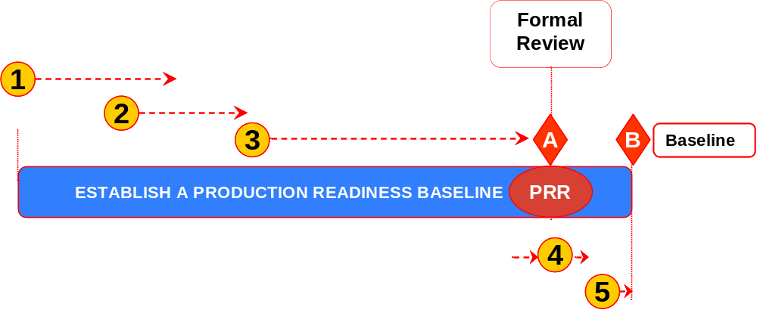

Figure 2. PRR Process Flow
The major steps in the PRR review process are:
- Planning for the Preliminary Reviews of the Deliverables
- Inspecting Deliverables
- Preparing for the Formal PRR Review
- Conduct the PRR
- Establishing the Production Readiness Baseline
These are described in detail below:
- Planning for Preliminary Reviews of the Deliverables
Below are the primary steps in the planning of the PRR. The key inputs that should be considered as part of the planning phase are:
- Project Information
- Date when draft of deliverable (s) will be provided
Phase steps:
  - IBM PM, Customer’s PM, and IBM Project SE identify the required stakeholders.
  - IBM Project SE schedules preliminary review(s) of deliverables.
  - Schedule preliminary reviews based on the date when draft of deliverable will be provided
  - Schedule preliminary reviews with stakeholders to be completed in time for a formal review to be held and for the deliverable to be baseline on time
  - Notify stakeholders about preliminary review(s).
Upon completion of the planning phase, the key outputs are:
- Deliverables ready for formal review
- Review Workbook including scores
Best Practice Suggestions:
-Communicate to the project and client participants early in the Test Phase the goals of the PRR, resource demands, and who will be at part of the PRR. Participants should be aware that their deliverables will need to be completed before the PRR is conducted.
- Inspecting Deliverables
As part of this step, the key inputs are:
- Review Workbook
- Draft of deliverables
- Stakeholders list and dates for preliminary reviews
- Project schedule with plan date to baseline deliverables
Phase Steps:
  - Preliminary Review of deliverables with stakeholders
  - Document defects, issues, risks, and related dependencies (Review Log)
  - Determine severity / impact of items in the review log
  - Score Preliminary Review
  - Once all the preliminary reviews with stakeholders have been completed, IBM PM and IBM Project SE share preliminary score with stakeholders and SEAT team.
  - Address defects, issues, risks, and related dependencies documented in Review Log
  - IBM Project SE works with IBM PM to assign owners and due dates to items in Review Log.
  - Track and update Review Log (Review Workbook)
The key outputs of the Deliverable assessment phase are:
- Deliverables ready for formal review
- Review Workbook including scores
Best Practice Suggestions:
-Attend key deliverable peer reviews in order to get a sense of who is working on the deliverables, the quality of the documents, and if they will be completed in time for the PRR.
-Pay close attention to the Move to Production deliverable. It must be of sufficient detail for the steps required, responsible resources assigned, and include a well-developed back-out plan.
-Review the deliverables at a high level to ensure they are of sufficient quality for the formal PRR. This does not take the place of the normal deliverable peer review.
-The SE should be working with Performance Engineering well in advance of the PRR. It is recommended that the PE PRR checklist (attachment B) be completed along with the Performance Engineers in preparation for the PRR.
-Inspecting (step 2) and preparing (step 3) for a formal PRR are the most critical tasks in defining production readiness

- Preparing for the PRR Formal Review
When preparing for the formal review, the following inputs should be considered:
- Stakeholders list and dates for preliminary reviews
- Project schedule with plan date to baseline deliverables
Phase steps:
  - Schedule Formal Review
    - Ensure all required stakeholders are invited
    - Schedule Formal Review
  - Send meeting invite and Review (PRR) material to required stakeholders
    - Prepare PRR agenda and presentation. The current PRR agenda and presentation format can be found in the SEAT Teamroom.
Upon completion and preparation of the formal PRR review, the following output should be produced:
- Planned formal review date
Best Practice Suggestions:
- Be sure to coordinate with each participant who will present in the PRR specifically what the expectations are for their section. It is often underestimated the amount of time required by the participants in the preparation of the PRR.
-Leverage the presentation material from pre-existing documentation as much as possible
-Use the PRR Entry/Exit criteria (Attachment A) as a guideline for the presentation material. Also review the PRR scorecard to ensure the evaluation criteria is covered in the review.
-The Performance Engineering PRR Checklist (Attachment B) should be considered as a guide for scoring the Availability, Performance, and Response Times readiness.
-Perform a dry run of the material with the appropriate resources before the formal PRR
-Allow enough time after scheduling the PRR to correct major issues before production go live
-Ensure the key stakeholders are invited and will attend the PRR.

-

- Conduct the Formal PRR
Conducting the formal PRR is the culmination of the planning and review phases. The key inputs are:
- Deliverables ready for formal review
- Review Workbook and pre-review score (s)
Phase Steps:
  - Ensure all stakeholders participate in formal review
- Track participation of required stakeholders - Stakeholders Tab
(Review Workbook)
- If required stakeholders are missing, create issue or risk in Review Log.
  - Conduct the Formal Review
  - Validate status of open items recorded in the Review Log (Review workbook)
  - For deliverables submitted for review:
    - Document defects, issues, risks, and related dependencies in Review Log
    - Determine severity/impact of items in the Review Log
    - Ensure PRR standard criteria and required data is entered in Review Log
    - Request and track approval of deliverables (Stakeholders Tab)
  - Score the Formal Review
  - Communicate PRR metrics to required stakeholders and SEAT team
  - Communicate the review workbook and review score
Upon completion of the PRR formal Review, the following outputs are expected:
    - PRR Workbook including scores
Best Practice Suggestions:
-Be sure to follow good meeting management practices (scribe, facilitator, etc). The PRR can often get sidetracked into extended discussions.
-Consider assigning someone to log the comments/issues/risks on Sametime as the meeting progresses. This allows remote callers to follow the meeting more closely and it can be used as an audit trail to document the PRR Workbook Review Log.
-Note defects, issues, risks, and dependencies for all sections as you review the sections
-Gain signoffs for each section, as you review the section
-Review the signoff sheet, the risks, the defects, the issues, and the action items so that everyone agrees with the review results.

- Establishing the Production Readiness Baseline
The input for the PRR Baseline is:
  - Review Workbook including scores
  - Work and close items in the Review Log (Review Workbook)
  - IBM project SE works with IBM PM to assign owners and due dates to items in Review Log.
  - Track items to closure and update them in Review Log.
  - Re-score the review (if applicable)
  - Re-score if the PRR score is red or yellow (under 85).
  - Confirm that the Review Log is up-to-date with respect to all identified defects, issues, risks, and related dependencies being entered into the log.
  - Communicate review metrics from the re-score to required stakeholders.
The output for the PRR Baseline is:
  - PRR Workbook including scores
- Examples
See PRR template <PRR Template .ppt>
- Revision History
Revision Number | Revision Date | Summary of Changes | Changes Marked?
4.1.1 | April 2003 | Baseline version
5.0.0 | June, 2007 | Reworked document to include SE Boot Camp material

Appendix A- PRR Entry/Exit Criteria with SE Considerations
Entry Criteria | Presentation | Exit Criteria | SE Considerations
Requirement and Architecture  The requirements and architecture contained in the delivery | Delivered versus Baseline Capabilities  Comparison of the functional and non-functional requirements being delivered versus the baseline requirements  Comparison of change requests delivered versus the baseline change requests | Delivered versus Baseline Capabilities  Customer accepts the delivered capabilities | -Verify RTVM for completeness  -Verify acceptance criteria met  -Audit changes against requirements baseline
Testing Results  Results of all testing and open problems | Testing Results  Results of testing with open problems identified by severity  Analysis of open problems and impacts on delivered system | Testing Results  Customer accepts results of testing and plan for resolving open problems  Customer accepts impact to delivered system by open problems | -Verify exit criteria from UAT has been met  -Verify RTVM that all test cases have been executed.  -Verify resolution of any sev 1 or 2 defects and action plan  -Review Test Results Summary reports
Availability, Performance, and Response Times  Availability, performance, and response times.  Infrastructure changes. | Availability, Performance, and Response Times  Expected end-to-end availability in production  Expected system response times and other performance data (if not covered in performance and stress test results)  Changes made to infrastructure | Availability, Performance, and Response Times  Customer accepts availability, expected performance, and response time.  Customer accepts changes in infrastructure to meet requirements. | -Complete Performance Engineering Checklist (Attachment B)  -Verify performance testing was conducted at the planned test level (i.e. Systems Integration Test, UAT,etc)  -Review non-functional performance requirements and SLA’s against performance testing results  (NOTE: This analysis should be conducted well before the test phase is completed.)
Move to Production  Move to production plan | Move to Production  -Detailed MTP Weekend plan  -Back-out plan  -Service Delivery / Operations readiness  -Customer support  -Installation support  - Operations support  -Individual application installation plans  -Verify inspection / build (fresh) restart criteria  -System management / monitoring  -Versions of COTS installed  -Analysis of server and software APARs and Fixpaks installed  -Verification of audit of system parameters (queue settings, IDs, etc.) | Move to Production  Customer accepts planning and details for move to production. | -Verify completeness of plan  -Ensure back-out plan has been well detailed  -Verify roles and responsibilities are clear.  -Verify that that there are no environmental issues.  -Confirm with Release Manager proper communications have been broadcasted
Deployment Plan  Results of all testing and open problems | Deployment Plan  Results of testing with open problems identified by severity  Analysis of open problems and impacts on delivered system | Deployment Plan  Customer accepts results of testing and plan for resolving open problems.  Customer accepts impact to delivered system by open problems. | -Review critical or high priority open issues for resolution or escalation
Data Migration  Data migration plans established | Data Migration  Plans for initial load of data  Plans data refresh  Plan for incremental data updates | Data Migration  Customer accepts data migration plans and processes. | -Verify migration testing results for any sev 1 or 2 defects  -Verify Test Results Summary reports
Communications Plan / Training Products  Communication plan established  User support material established  Training plans established | Communications Plan / Training Products  Communication plan including notification to end users of cut-over to new system, training end user and support personnel  Education and training plan and end user support material include  Training materials, online help, user’s guides, reference cards, help desk material and training, what has changed from earlier releases, installation guides, restart guides. | Communications Plan / Training Products  Customer accepts that communications plan, communication materials and methods, education, educational materials / training, operations support materials and guides all support the release and are adequate to ensure a successful move to production. | -Verify if an external communication plan is required (customers, government agencies, etc.) and who is responsible

Appendix B. Performance Engineering Checklist for the PRR (from the SE Capability Technique Paper)
The following PE specific items should be verified during the PRR:
PRR Preparation
- PE work products / deliverables from earlier phases are revisited based on any new information from development
- Performance estimates
- Performance models
- Resulting performance reports (SLCA, Operational Model updates, sizing)
- Key performance risks areas in developed solution were evaluated using selected estimation / modeling techniques
- Results of estimation forwarded to appropriate areas (e.g. development, test team, stakeholders, etc.)
- Component baseline materials reviewed by PE team, especially
- Test results
- Deployment / production management plans

PRR Performance Questions
- Do the performance test results indicate that the solution will meet the performance requirements, SLRs within the constraints of the capacity plan?
- Is there (or are there plans to develop) a Service Level Agreement (SLA) for the deployed solution?
- Have the tuning recommendations from test been communicated to the deployment team and planned for implementation?
- Have all tests been completed and all performance requirements been met within acceptable tolerances?
- Is there documented evidence of the performance acceptance criteria having been met? If not, will the stakeholder sign off on any exceptions to allow deployment to continue?
- Did the performance test team rehearse the live monitoring and performance/capacity management tools and processes that will be used by the production support team? If so, have the results of this rehearsal been communicated to production support, or were they involved in the rehearsal process?
- Has the production support implemented the live monitoring and reporting tools and processes that will be needed to support the deployed solution with respect to performance and capacity?
- Has the performance risk been reassessed since the TRR and are those risks being adequately addressed?
- Are there plans that will allow for a backout staged implementation or extra capacity should unforeseen critical performance or capacity issues occur?
⇨ Will the performance-centric items satisfy the applicable TRR scorecard criteria, i.e.
- 1. Requirements and Architecture (Content)
  - Requirements in the baseline versus requirements being delivered - Non functional requirements defined, enumerated, traced
  - Gaps or risks identified and mitigated or transferred (Exclusions)
- 2. Test Results
  - Non-functional testing complete or projected
  - Gaps or risks identified and mitigated or transferred (Exclusions)
- 3. Expected Availability, Performance, and Response Times
  - Expected end-to-end availability in production
  - Expected system response times and other performance criteria (if not covered in performance or stress test results)
  - Infrastructure changes made to the production systems to meet requirements
  - Gaps or risks identified and mitigated or transferred (Exclusions)
- 4. Deployment / Production Readiness
  - Install Plans defined
  - Dependencies, Issues and Risks defined

PRR Actions
- PRR issues are raised for concerns which may affect PRR scorecard findings.

