
s

Conducting a System Requirement Review

Guidance/Guideline

© Copyright International Business Machines Corporation 2002, 2007
Version 5.0 July 2007
- Description
The System Requirements Review (SRR) is conducted to establish the System Requirements and Architecture baseline. The SRR is the second of a sequence of Systems Engineering (SE) reviews, as depicted in Figure 1 below.

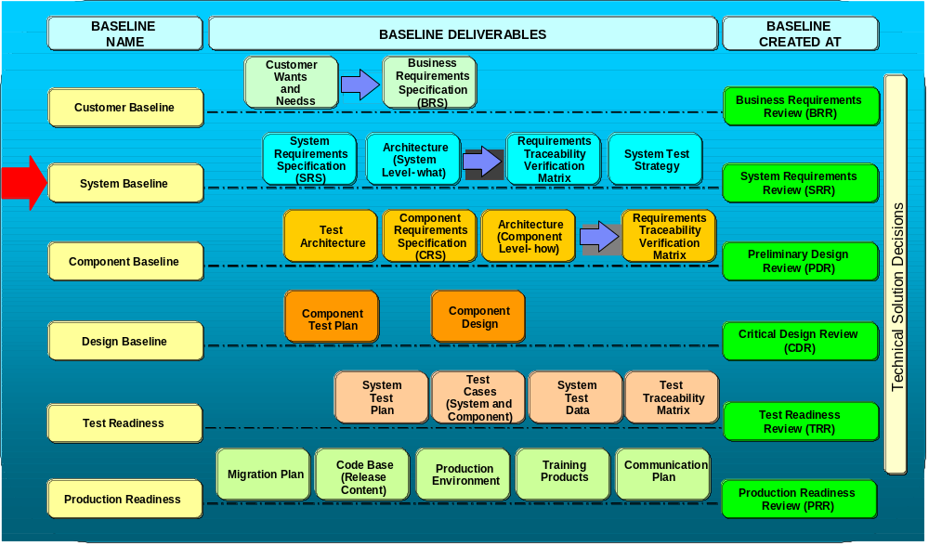

Figure 1 - Systems Engineering Reviews and the SRR

The goals of the SRR are:
- Convey a clear understanding of the business/stakeholder needs, rationale and priorities
- Review the system level solution requirements and the IT solution approach
- Get customer concurrence on the system requirements, the associated acceptance / success criteria and the system architecture

The objectives of the SRR are:
- Review and approve the documented System Requirements and Architecture
- Establish Traceability
- Establish the Technical Baseline
- Identify Technical Risks
- Review Mitigation Plans
- Identify Dependencies (External - Technology, Baselines, Interfaces)
- Establish Plans
- Identify Technical Performance Measures (TPMs)

- Context
The various Business Transformation Management System (BTMS) project phases and decision checkpoints (DCPs) correspond closely to the Systems Engineering Capability Pattern phases and technical reviews (see Figure 2). At the end of the Concept phase, the Systems Engineer leads the Systems Requirement Review (SRR).
During the Concept phase of a project, the Systems Engineer holds a series of meetings with the business and development teams to develop and document the system requirements and architecture. After the documents are completed, they are reviewed and approved during the SRR by the business and development stakeholders. A baseline is thereby established for the system requirements and associated acceptance / success criteria and any changes to the baseline documents are managed by a change control process.
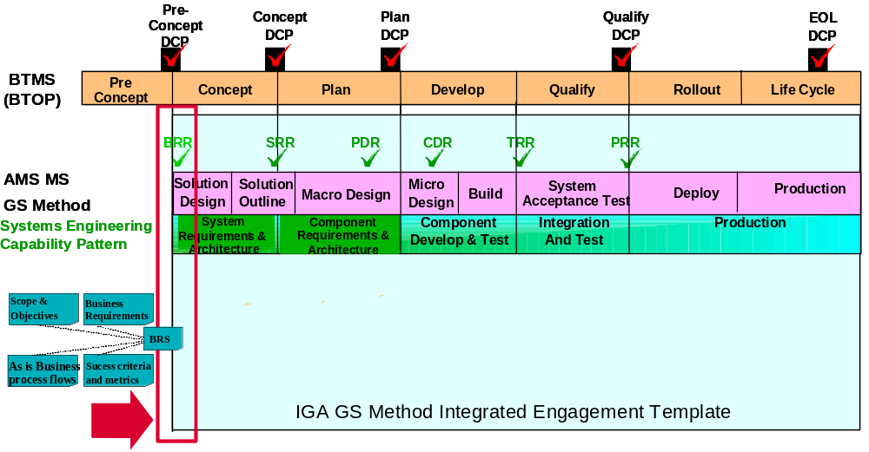
This diagram needs to be updated to reflect the SRR.

Figure 2- Relationship between BTMS phases, decision checkpoints (DCPs) and SE phases, reviews

- Details of the SRR
  - SRR Participants
In order for the SRR to be successful, it is critical that key stakeholders have been identified and have confirmed they will attend the review. Required stakeholders influence or are affected by the system requirements and architecture. They are also responsible for the quality and completeness of the content of the deliverables. Examples of stakeholders involved with the SRR are:
  - Customer / Business Team:
    - Customer Program / Project Manager (PM) – Responsible for identifying required customer’s stakeholders and ensuring sign-off of the main deliverables.
    - Customer’s business process owner
    - Customer’s Application / System Managers or Customer’s Application Subject Matter Expert (SME)
    - End-user from each community that is impacted by the project
  - IBM Development / Delivery Team:
    - IBM Project Manager (PM) – Sometimes called the Solution Project Manager (SPM). Responsible for identifying required IBM stakeholders and ensuring sign-off of the main deliverables.
    - IBM Systems Engineer (SE)
    - IBM IT Architect
    - IBM Application Manager or IBM Application Subject Matter Expert (SME)
    - IBM Test Manager is sometimes engaged towards the end of the Concept Phase (or at the beginning of the Plan Phase.)
    - Other required stakeholders may be identified by the IBM Project Manager or IBM Systems Engineer.
Best Practice Suggestions:
- Notify the key stakeholders well in advance of the SRR since it is often difficult to find time that they are available. Confirm that they will attend the SRR.
- In order to work together effectively, it is important for each team member to understand the role and responsibility of every other team member. It must be clear who is responsible for each task and deliverable (document). For a specific topic, everybody should know whom to ask for help or to answer questions.
- It is confusing to distinguish between the Development Team and the Customer / Business Team when the Customer is also IBM. This is the case, for example, in which IBM Human Resources (HR) engages IBM Global Business Services (GBS) – Application Services (AS) to develop an application for HR (e.g., to manage IBM employees’ skills profiles).
- At the start of an engagement, the Systems Engineer should work closely with the IBM Development PM to clearly identify and document the role and responsibility of each team member. This documentation should be accessible by all team members (e.g., stored in the project TeamRoom or wiki) and maintained as new members are added and/or as roles and responsibilities change. Organization charts should also be documented and maintained.

  - SRR Responsbilities
Normally, the following roles have the responsibility to present the material at the SRR. Depending on the project, some of the review material may be presented by different roles.
Customer
- Business process flow (e.g., “swim lane” diagram) – Current (“as is”) and Proposed (“to be”)
- Use Cases, including Business Rules – how specific user role interacts with the systems at various steps of the process. The textual descriptions describing the use cases are from a user’s point of view; they do not describe how the system works internally or its internal structure or mechanisms.
- User profiles / roles / attributes and User capabilities / authorizations / entitlements
- Reports specifications – data elements, order, links, searchable fields
IT Architect or Lead Developer
- System Context Diagram – Current (“as is”) and Proposed (“to be”)
- System Interface Specification – source, target, protocol, input, output, size, frequency of transactions
- Data architecture – name, definition, source, target, transformation, business rules
- Data migration plan – Plan to migrate existing production data and/or sensitive data to the new application. Identify if migration is manual or automated, one-time or ongoing.
- Architectural Decisions – including assumptions, tradeoffs
- Much of this material is documented in the Architecture Proposal Document (APD)
Systems Engineer
- Any changes to the Business Requirements and Acceptance Criteria since the BRR
- System Requirements and Acceptance Criteria
- Requirements Traceability and Verification Matrix (RTVM)
- Technical Assumptions, Risks, Issues, Dependencies
Test Manager (who typically joins the team towards the end of the Concept Phase or at the beginning of the Plan Phase)
- Test strategy
Project Manager
- Project Plan – detailed for Plan Phase, milestone target dates for the rest of the project life cycle

  - SRR Workbook
The SRR Workbook is used to assist SE’s in developing the System Requirements and Architecture baseline. This is a critical document used for planning the SRR, recording issues/risks, and serves as the basis for scoring the SRR. The workbook covers the following objectives:
  - Provide guidance to Project SE’s (instructions, terminology)
  - Provide a version control (Revision History)
  - Document and track stakeholders (Stakeholders)
  - Document and track defects, issues, risks, and associated dependencies (Review Log)
  - Score the review (Calculate, SRR Scorecard, Maturity)
The SRR Workbook includes the following tabs:
Instructions: This Tab summarizes how to use the SRR Workbook in carrying out the SRR Process.
Revision History: Provides an audit trail of updates to the SRR Workbook
General Information: This tab records general information about the SRR Workbook, including the author of the SRR Workbook and a unique Project identifier.
Terminology: This tab provides definitions of terms used in the SRR Workbook, including metrics definitions.
Standard Criteria: Provides the standard evaluation criteria used to determine the completeness of the system requirements and the associated acceptance criteria.
Stakeholders: This tab is used to identify the stakeholders and the dates for reviewing and approving the deliverables with the stakeholders.
Review Log: Records the issues, risks, recommended actions, and responsibilities recorded during the SRR.
Calculate: Determines a SRR score based on review log
SRR Scorecard: Displays results from the review log that corresponds to the standard evaluation criteria
Maturity: Provides graphic representation of normalized scores from the SRR.
Template History: This tab is used to record updates made to the workbook template.
Best Practice Suggestions:
-The critical tab in the SRR Workbook is the Review Log. Before the formal SRR, identify who will record the input to the Review Log during the SRR. A review should be conducted prior to the SRR to determine how the data will be recorded (issue, risk, etc.) and when the data will be entered The Review Log should be updated as soon as possible after each session.

  - Steps for Conducting the Review
The SRR is structured in such a way to allow for the ordered planning, preparation and execution of the review in a logical sequence. Figure 3 below highlights the key activities in conducting the SRR.
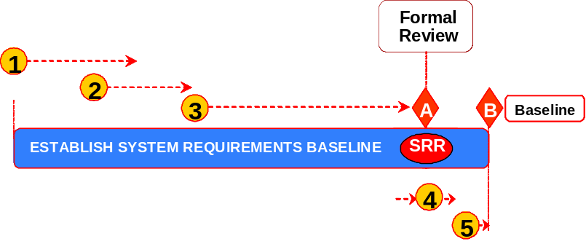

Figure 3. SRR Process Steps

The major steps in the SRR review process are:
- Planning for the Preliminary Reviews of the Deliverables
- Inspecting Deliverables
- Preparing for the Formal SRR Review
- Conduct the SRR
- Establishing the System Requirements and Architecture Baseline
These are described in detail below:
- Planning for Preliminary Reviews of the Deliverables
Below are the primary steps in the planning of the SRR. The key inputs that should be considered as part of the planning phase are:
- Project Information
- Date when draft of deliverable (s) will be provided
Phase steps:
  - IBM PM, Customer’s PM, and IBM Project SE identify the required stakeholders.
  - IBM Project SE schedules preliminary review(s) of deliverables.
  - Schedule preliminary reviews based on the date when draft of deliverable will be provided
  - Schedule preliminary reviews with stakeholders to be completed in time for a formal review to be held and for the deliverable to be baseline on time
  - Notify stakeholders about preliminary review(s).
Upon completion of the planning phase, the key outputs are:
- Deliverables ready for formal review
- Review Workbook including scores
Best Practice Suggestions:
- Communicate to the project and client participants early in the Concept Phase the goals of the SRR, resource demands, and who will be at part of the SRR. Participants should be aware that their deliverables will need to be completed before the SRR is conducted.
- Inspecting Deliverables
As part of this step, the key inputs are:
- Review Workbook
- Draft of deliverables
- Stakeholders list and dates for preliminary reviews
- Project schedule with plan date to baseline deliverables
Phase Steps:
  - Preliminary Review of deliverables with stakeholders
  - Document defects, issues, risks, and related dependencies (Review Log)
  - Determine severity / impact of items in the review log
  - Score Preliminary Review
  - Once all the preliminary reviews with stakeholders have been completed, IBM PM and IBM Project SE share preliminary score with stakeholders and the development team.
  - Address defects, issues, risks, and related dependencies documented in Review Log
  - IBM Project SE works with IBM PM to assign owners and due dates to items in Review Log.
  - Track and update Review Log (Review Workbook)
The key outputs of the Deliverable assessment phase are:
- Deliverables ready for formal review
- Review Workbook including scores
Best Practice Suggestions:
- Attend key deliverable peer reviews in order to get a sense of who is working on the deliverables, the quality of the documents, and if they will be completed in time for the SRR.
- Review the deliverables at a high level to ensure they are of sufficient quality for the formal SRR. This does not take the place of the normal deliverable peer review.

- Preparing for the SRR Formal Review
When preparing for the formal review, the following inputs should be considered:
- Stakeholders list and dates for preliminary reviews
- Project schedule with plan date to baseline deliverables
Phase steps:
  - Schedule Formal Review
    - Ensure all required stakeholders are invited
  - Send SRR material to required stakeholders
    - Prepare SRR agenda and presentation.
Upon completion and preparation of the formal SRR review, the following output should be produced:
- Planned formal review date
Best Practice Suggestions:
- Be sure to coordinate with each participant who will present in the SRR specifically what the expectations are for their section. The amount of time required by the participants to prepare for the SRR is often underestimated.
-Leverage the presentation material from pre-existing documentation as much as possible
-Use the SRR Entry/Exit criteria (Appendix A) as a guideline for the presentation material. Also review the SRR scorecard to ensure the evaluation criteria is covered in the review.
--Perform a dry run of the material with the appropriate resources before the formal SRR
-Allow enough time after scheduling the SRR to correct major issues before exiting the Concept phase
-Ensure the key stakeholders are invited and will attend the SRR.

-

- Conduct the Formal SRR
Conducting the formal SRR is the culmination of the planning and review phases. The key inputs are:
- Deliverables ready for formal review
- Review Workbook and pre-review score (s)
Phase Steps:
  - Ensure all stakeholders participate in formal review
- Track participation of required stakeholders - Stakeholders Tab
(Review Workbook)
- If required stakeholders are missing, create issue or risk in Review Log.
  - Conduct the Formal Review
  - Validate status of open items recorded in the Review Log (Review workbook)
  - For deliverables submitted for review:
    - Document defects, issues, risks, and related dependencies in Review Log
    - Determine severity/impact of items in the Review Log
    - Ensure SRR standard criteria and required data is entered in Review Log
    - Request and track approval of deliverables (Stakeholders Tab)
  - Score the Formal Review
  - Communicate SRR metrics to required stakeholders
  - Communicate the review workbook and review score
Upon completion of the SRR formal Review, the following outputs are expected:
    - SRR Workbook including scores

Best Practice Suggestions:
-Be sure to follow good meeting management practices (scribe, facilitator, etc). The SRR can often get sidetracked into extended discussions.
-Consider assigning someone to log the comments/issues/risks in a Sametime group chat session as the meeting progresses. This allows remote callers to follow the meeting more closely and it can be used as an audit trail to document the SRR Workbook Review Log.
-Note defects, assumptions, issues, risks, and dependencies for all sections as you review the sections
-Gain signoffs for each section, as you review the section
-Review the signoff sheet, the risks, the defects, the issues, and the action items so that everyone agrees with the review results.

- Establishing the System Requirements and Architecture Baseline
The input for the SRR Baseline is:
  - Review Workbook including scores
  - Work and close items in the Review Log (Review Workbook)
  - IBM SE works with IBM PM to assign owners and due dates to items in Review Log.
  - Track items to closure and update them in Review Log.
  - Re-score the review (if applicable)
  - Re-score if the SRR score is red or yellow (less than 85).
  - Confirm that the Review Log is up-to-date with respect to all identified defects, issues, risks, and related dependencies being entered into the log.
  - Communicate review metrics from the re-score to required stakeholders.
The output for the SRR Baseline is:
  - SRR Workbook including scores
- Tools and associated files
The SRS template is the main deliverable that establishes the system requirements and architecture baseline.
- SRS TEMPLATE
The SRR template is a simplified version of this document that is used to produce an agenda during a review.
- SRR TEMPLATE
The readiness tool is used to determine if a SRR should schedule or not.
- SRR READINESS
There is a SRR scorecard template contained in the SRR Workbook.
- SRR WORKBOOK

- Revision History
Revision Number | Revision Date | Summary of Changes | Changes Marked?
1.0a | 10/23/2002 | Initial release of technique paper | NA
1.0 | 12/03/2002 | Updates to initial release to include M3, Business Requirement Specification and references to SEA process release 2.0 | NA
1.1 | 05/31/2005 | Changed “BRR is an optional…” to “BRR is a review…” in the Description section on page 1. This change became part of the process with the April 2005 release of AMS IGA and AMS process. (Change done by Ron Nutt) | NA
5.0 | 07/31/2007 | Update to match SE Boot Camp | NA

Appendix A - SRR Entry/Exit Criteria, Presentation List, and SE Considerations
Entry Criteria | Presentation | Exit Criteria | SE Considerations
Business Requirements & Process Definition  Business Objectives and Scope are defined  “As Is” business process flows are defined  Business requirements are defined (functional and non-functional)  Success criteria and associated metrics are defined | Business Requirements & Process Definition  Present Scope and Objectives  Present “as is” business process flows, gaps and plan to complete the “to be” process flows  Present business requirements  Present success criteria and associated metrics  Present measurement methodology | Business Requirements & Process Definition  Business requirements are clear and unambiguous and (functional and non-functional)  Business requirements are traced to the agreed scope and business objectives for project  ”As is" manual touch point desk-level procedures defined  ”As is" legacy business process scenarios (base functions, variant, exceptions) and architecture (system, applications, interfaces) defined  Gaps in process flows defined and plans to address them ensured  Business requirements (functional and nonfunctional) defined and prioritized  Acceptance criteria clearly defined and agreed to | Business Requirements & Process Definition  The Business Requirements and Business Process Flows were reviewed during the BRR and a baseline was established. The focus at the SRR should be on any changes that have occurred since the BRR.  The following items should also be presented for review:  Business process flow (e.g., “swim lane” diagram) – Current (“as is”) and Proposed (“to be”)  Use Cases, including Business Rules – how specific user role interacts with the systems at various steps of the process. The textual descriptions describing the use cases are from a user’s point of view; they do not describe how the system works internally or its internal structure or mechanisms.  User profiles / roles / attributes and User capabilities / authorizations / entitlements  Reports specifications – data elements, order, links, searchable fields
Systems Requirements Definition  Customer scope and objective document is completed and agreed to by project manager  Technical baseline is completed defined  Baseline requirements and change requests are in a requirements management toolkit  Affected legacy application changes are identified in a requirements management toolkit | Systems Requirements Definition  - Functional Requirements and Functions to be Performed  - Non-Functional Requirements  - Performance Requirements  - Volume Estimations  - Performance and Volume Monitoring  - Languages and Location Requirements  - Growth and Data Migration Requirements  - Disaster Recovery Requirements  - Availability and Reliability  - Security  - Application/Business Processes Monitoring, Measuring, and Management requirements (e2e M3)  - Performance Monitoring and Availability  - Volume Monitoring  - Other Specialty Requirements - Application Monitoring, Custom Measurements, Custom Reports  - Fault Tolerance, Probes  - Centralized Monitoring and Reporting  - Cost and Schedule  - Testing, Verification, and Validation Requirements  - External Interface Requirements  - Usability Requirements  - Other  - Technology Constraints/Customer Desires  - Standards and Protocols  - Dependencies and Assumptions | Systems Requirements Definition  Each requirement has unique name or reference number  Only one requirement per statement  System requirements are prioritized. Stakeholder conflicts presented and resolved  System requirements are solution independent (Address the “what” rather than the “how” at that level)  System requirements are complete (allow the architecture development to begin)  System requirements are testable  System requirements are understandable (Glossary and data items defined)  System requirements are decoupled (minimum dependency on other requirements)  Alternative implementation approaches considered, and rationale for selection documented  Technology trade-offs conducted and presented | Systems Requirements Definition  Assumptions should also be documented during the Concept Phase and reviewed during the SRR.
System Level Architecture Definition  Static and dynamic system-level architecture to satisfy the customer requirements are defined | System Level Architecture Definition  Present the system-level architecture | System Level Architecture Definition  Customer concurs that the defined system-level architecture satisfies the business requirements  Dynamic and static architectures are defined and complete (Including data architecture)  System level architecture matches system requirements  “To be” system landscape (static or logical view of the architecture) is defined  “To be” business process flows (dynamic or operational view of the architecture) is defined | System Level Architecture Definition  The IT Architect should also present the following:  System Context Diagram – Current (“as is”) and Proposed (“to be”)  System Interface Specification – source, target, protocol, input, output, size, frequency of transactions  Data architecture – name, definition, source, target, transformation, business rules  Data migration plan – Plan to migrate existing production data and/or sensitive data to the new application. Identify if migration is manual or automated, one-time or ongoing.  Architectural Decisions – including assumptions, tradeoffs
System Requirements Traceability  Each business requirement traces to one or more system requirements | System Requirements Traceability  Complete the Requirements Traceability Matrix (RTM) portion of the Requirements Matrix | System Requirements Traceability  Requirements Traceability Matrix maps business requirements to system requirements  Customer concurs with the business requirements and their mapping to system requirements  Business process/Stakeholder requirements and System Requirements are baselined in a requirements management toolkit | System Requirements Traceability  The SE is responsible for maintaining the requirements, including traceability, throughout the project life cycle.
Acceptance Criteria  Acceptance criteria, test methods, and test types for all business processes and system requirements are defined | Acceptance Criteria  Complete the Requirements Verification Matrix (RVM) portion of the Requirements Matrix | Acceptance Criteria  Acceptance Criteria, test methods and test types have been added to the Requirements Traceability Matrix  Customer concurs with the Acceptance Criteria, test methods and test types | Acceptance Criteria  If the Test Manager has been engaged, the Test Manager should review the Acceptance Criteria prior to the SRR and present this portion of the SRR.

