Supplemental Materials — Leps-P: Probabilistic Strength Envelopes with Dilatancy-Bounded Curvature for Rockfill and Mine Waste Rock
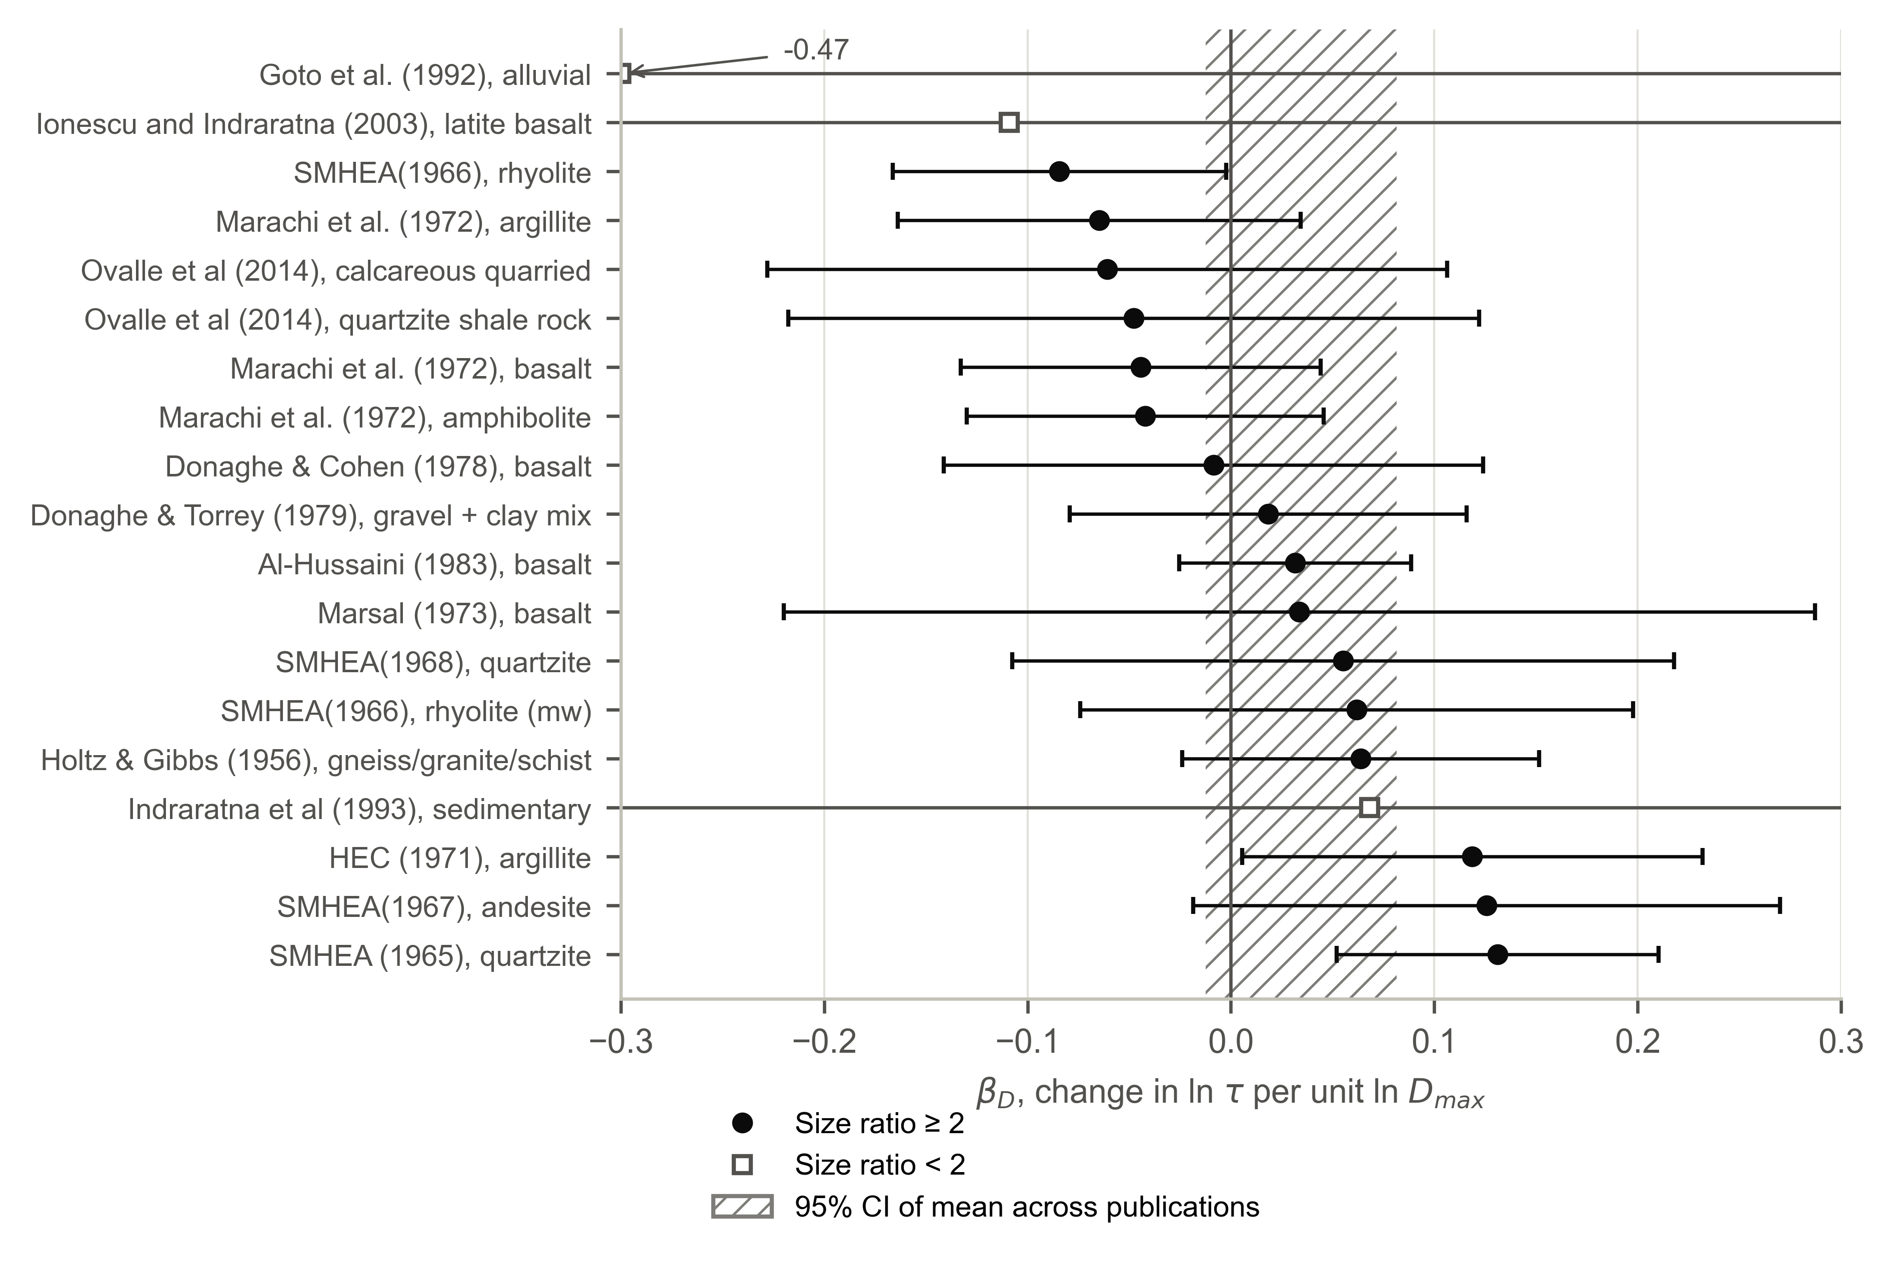
Fig. S1. Within-material specimen-size coefficient βD for materials of the database tested at more than one maximum particle size (bars: 95% confidence intervals; set intercepts adjusted for void ratio, with the between-set variance unrelated to size added). Hatched band: Knapp–Hartung 95% confidence interval of the random-effects mean across 12 publications with size ratio ≥ 2 (+0.035; -0.012 to +0.082). One value outside the axis is annotated.
Table S1. Mode B: every procedure evaluated (held-out tests at σ′n ≥ 2 MPa predicted from tests at σ′n ≤ 1.5 MPa of the same set)
Envelope form | Procedure | 80% coverage | Below P10 | CRPS
Bounded (round 3) | Level-only update (prespecified primary) | 95% | 5% | 0.0278
Bounded (round 3) | Prior, no site tests | 97% | 3% | 0.0397
Bounded (round 3) | Joint update of level and slope | 92% | 3% | 0.0345
Bounded (round 3) | Level-only update after discarding flagged sets | 92% | 8% | 0.0313
Bounded (round 3) | Least-squares fit of φ′1, m = 0.90 | 81% | 17% | 0.0407
Bounded (round 3) | Least-squares fit of φ′1, m = median within-set slope of training data | 81% | 2% | 0.0369
Quadratic (earlier analysis) | Joint update of level and slope | 88% | 3% | 0.0371
Quadratic (earlier analysis) | Level-only update | 92% | 3% | 0.0298
Quadratic (earlier analysis) | Least-squares fit of φ′1, m = 0.86 (full-data estimate) | 81% | 2% | 0.0363
Quadratic (earlier analysis) | Least-squares fit of φ′1, m = 0.90 | 81% | 17% | 0.0407
Quadratic (earlier analysis) | Mixed rule: joint update if stress ratio ≥ 2 and p ≥ 0.01, else level-only | 91% | 3% | 0.0289
Quadratic (earlier analysis) | Mixed rule: joint update if stress ratio ≥ 2 and p ≥ 0.05, else level-only | 91% | 3% | 0.0294
Quadratic (earlier analysis) | Mixed rule: joint update if stress ratio ≥ 2 and p ≥ 0.1, else level-only | 91% | 3% | 0.0294
Quadratic (earlier analysis) | Mixed rule: joint update if stress ratio ≥ 3 and p ≥ 0.01, else level-only | 91% | 3% | 0.0305
Quadratic (earlier analysis) | Mixed rule: joint update if stress ratio ≥ 3 and p ≥ 0.05, else level-only | 91% | 3% | 0.0305
Quadratic (earlier analysis) | Mixed rule: joint update if stress ratio ≥ 3 and p ≥ 0.1, else level-only | 91% | 3% | 0.0305
Quadratic (earlier analysis) | Mixed rule: joint update if stress ratio ≥ 4 and p ≥ 0.01, else level-only | 91% | 3% | 0.0305
Quadratic (earlier analysis) | Mixed rule: joint update if stress ratio ≥ 4 and p ≥ 0.05, else level-only | 91% | 3% | 0.0305
Quadratic (earlier analysis) | Mixed rule: joint update if stress ratio ≥ 4 and p ≥ 0.1, else level-only | 91% | 3% | 0.0305
Note: The bounded-form procedures were specified before the bounded form was evaluated; the level-only update was the primary procedure. The quadratic-form results are from an earlier analysis in which the rule thresholds were explored; they are reported for completeness and were not used to select the primary procedure of the bounded form. CRPS in units of ln τ.

