Supplemental Materials — Leps-P: Probabilistic Strength Envelopes with Stress-Decaying Curvature for Rockfill and Mine Waste Rock
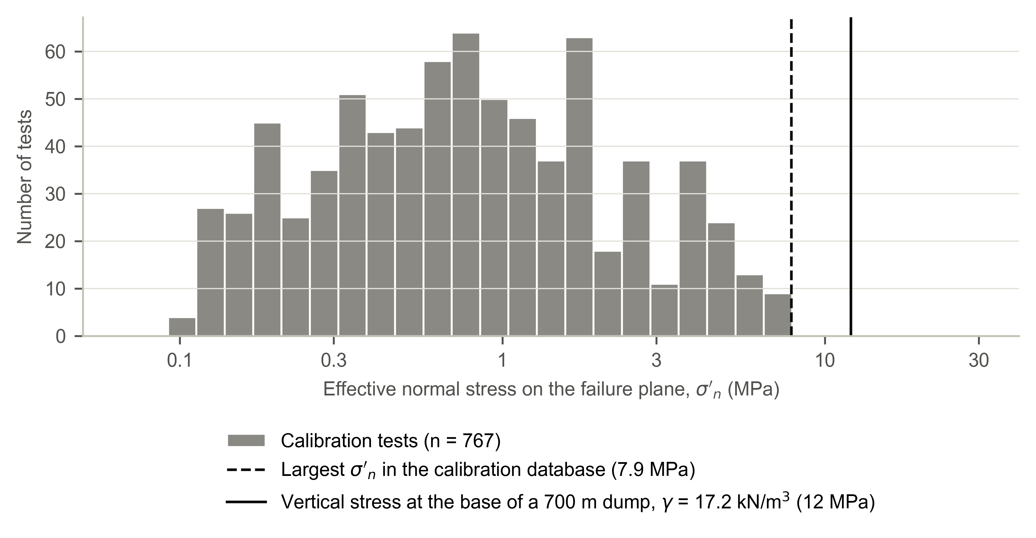
Fig. S1. Distribution of effective normal stress on the failure plane in the calibration database.
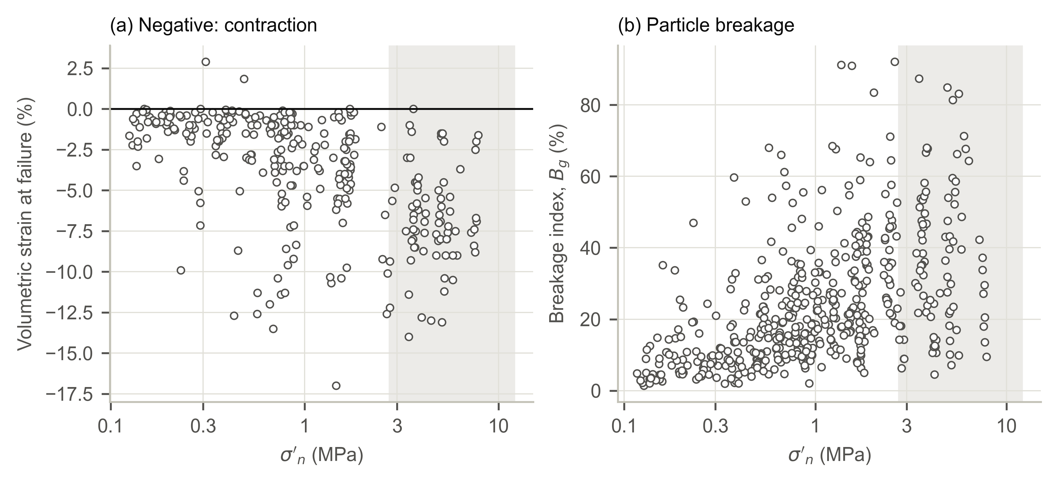
Fig. S2. Net volumetric strain at the maximum deviator (negative: contraction) and breakage index of Marsal (1973) versus σ′n in the calibration database; shaded: σ′n > 2.75 MPa. Reported breakage indices above 100%, which are impossible by definition, were excluded (4 tests). Above 2.75 MPa the residuals of Leps-P were unrelated to the breakage index (Spearman ρ = −0.00, n = 91).
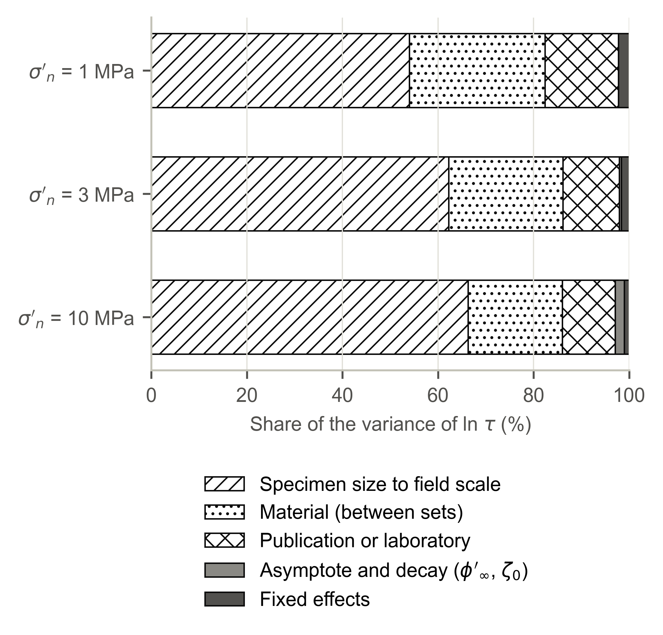
Fig. S3. Shares of the variance of the mean-envelope ln τ for an untested material of low rock quality placed at e = 0.65, scaled from 0.18 m to 1 m maximum particle size.
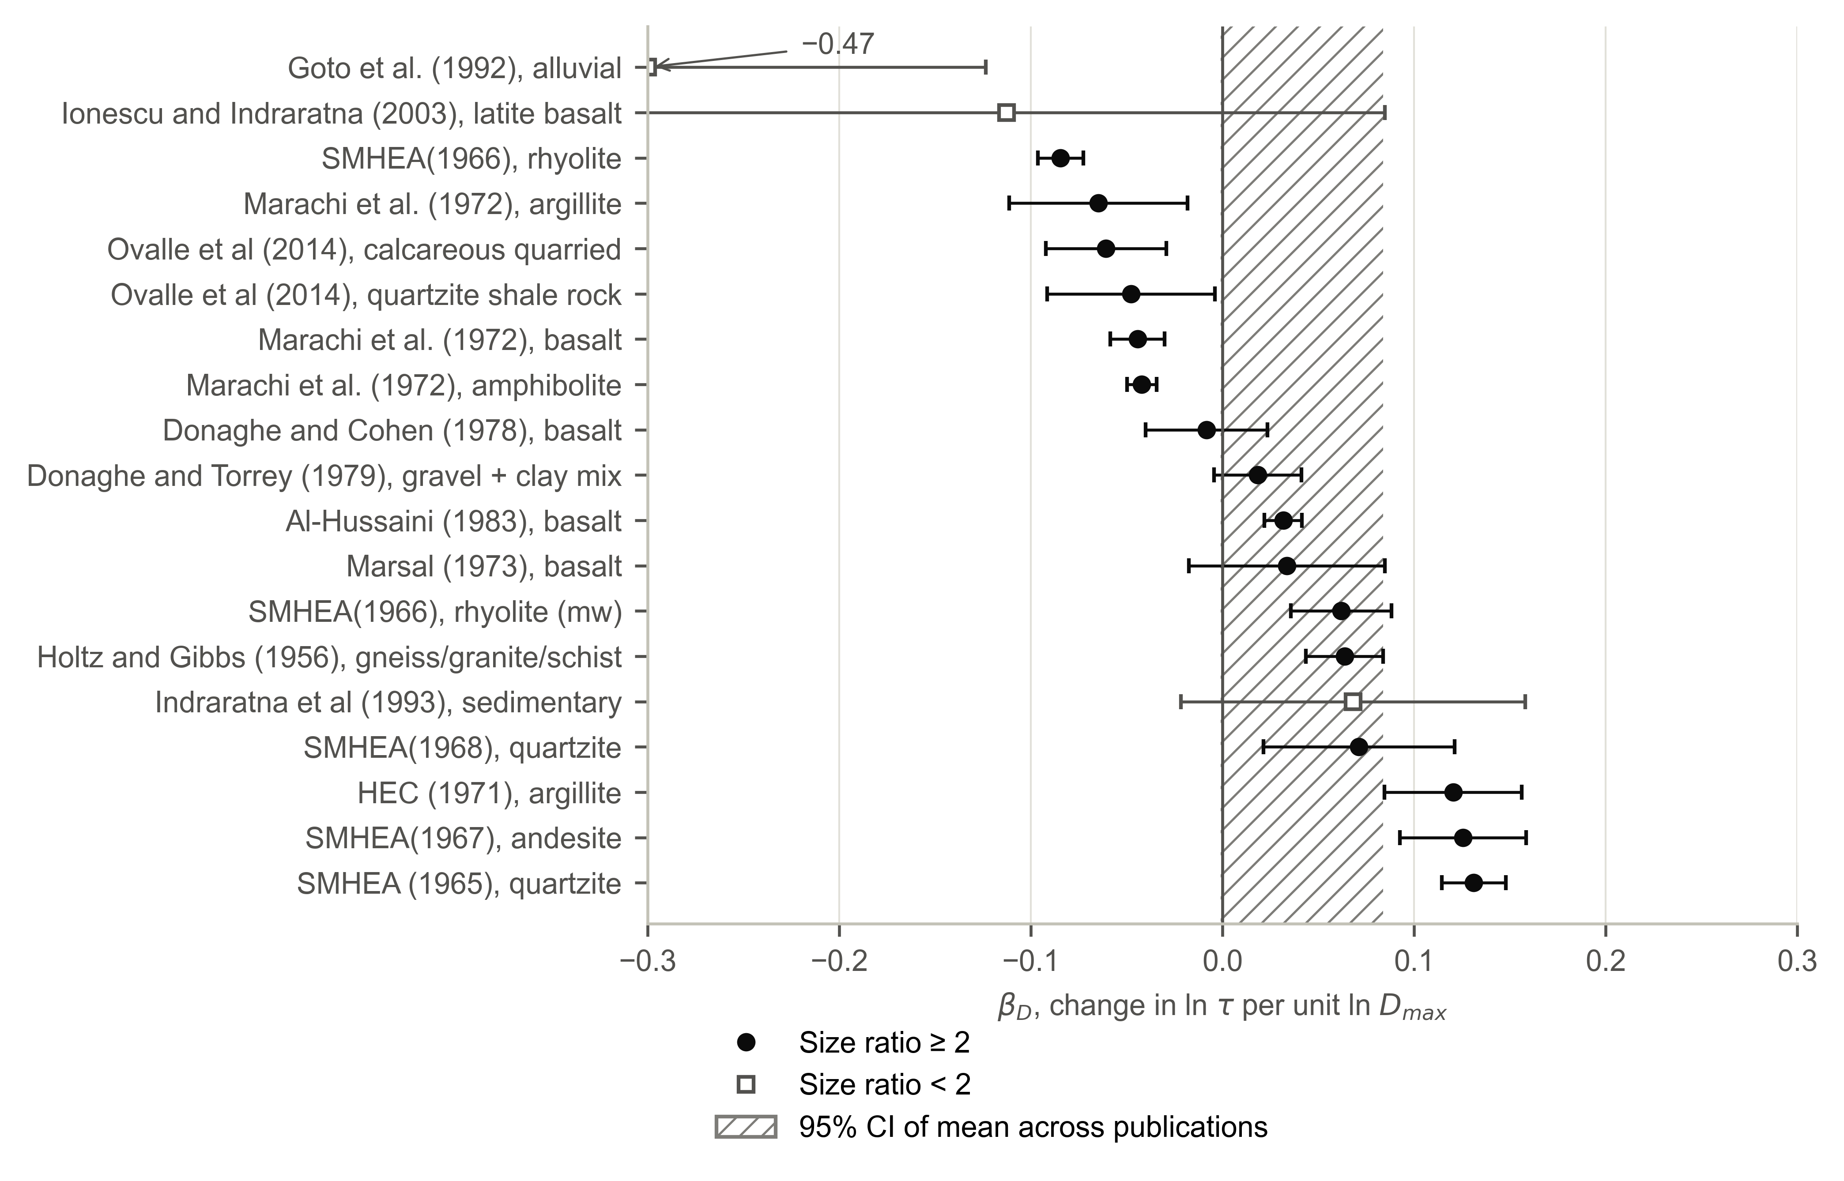
Fig. S4. Within-material specimen-size coefficient βD (bars: 95% confidence intervals; set intercepts adjusted for void ratio). Hatched band: Knapp–Hartung 95% confidence interval of the random-effects mean across 12 publications with size ratio ≥ 2 (+0.041; −0.001 to +0.084). One value outside the axis is annotated.
Table S1. Mode B: every procedure evaluated (held-out tests at σ′n ≥ 2 MPa predicted from tests at σ′n ≤ 1.5 MPa of the same set)
Procedure | 80% coverage | Below P10 | SD of z | CRPS | Δ vs level update (95% CI) | Holm-adjusted p
Prior, no site tests | 95% | 3% | 0.76 | 0.0424 | +0.0115 (+0.0043 to +0.0179) | 0.48
Least-squares fit of φ′1, m = 0.90 | 81% | 17% | 0.86 | 0.0407 | +0.0098 (−0.0011 to +0.0165) | 1.00
Least-squares fit of φ′1, m = median within-set slope of training data | 81% | 2% | 1.00 | 0.0369 | +0.0061 (−0.0021 to +0.0207) | 0.74
Joint update of both random effects | 80% | 12% | 1.34 | 0.0330 | +0.0022 (−0.0056 to +0.0200) | 1.00
Level update of each set (Eq. 8) | 83% | 9% | 0.91 | 0.0308 | — | —
Level update after discarding flagged sets | 83% | 12% | 0.97 | 0.0345 | +0.0036 (−0.0041 to +0.0106) | 1.00
Recommended procedure: discard flagged sets, joint update with shared laboratory effect | 83% | 12% | 0.98 | 0.0344 | +0.0036 (−0.0044 to +0.0104) | 1.00
Note: 64 tests, 46 sets, 13 publications. The procedures were developed while examining earlier versions of the model on the same held-out sets; the comparisons are exploratory. p-values from exact sign-flip tests on publication means, Holm-adjusted within Mode B. CRPS in units of ln τ.

