Supplemental Materials — Leps-P: Probabilistic Strength Envelopes with Stress-Decaying Curvature for Rockfill and Mine Waste Rock
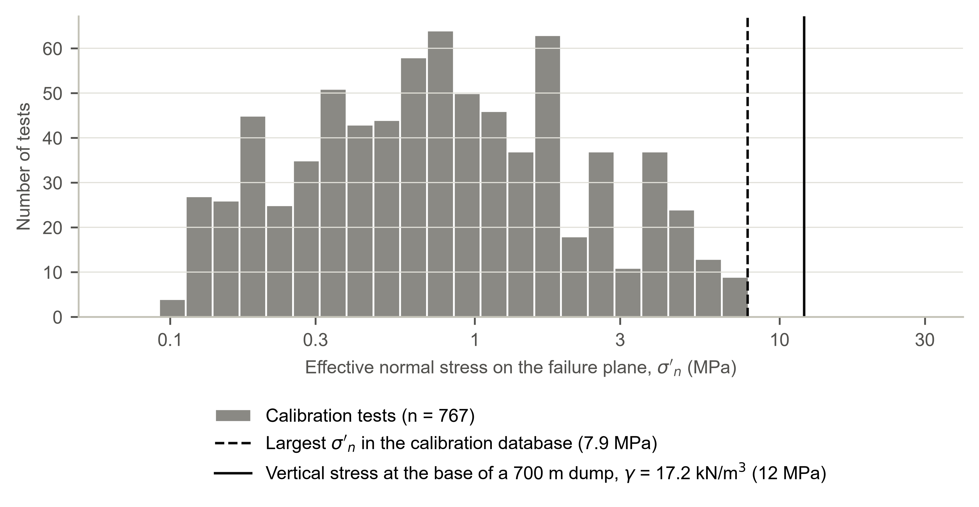
Fig. S1. Distribution of effective normal stress on the failure plane in the calibration database.
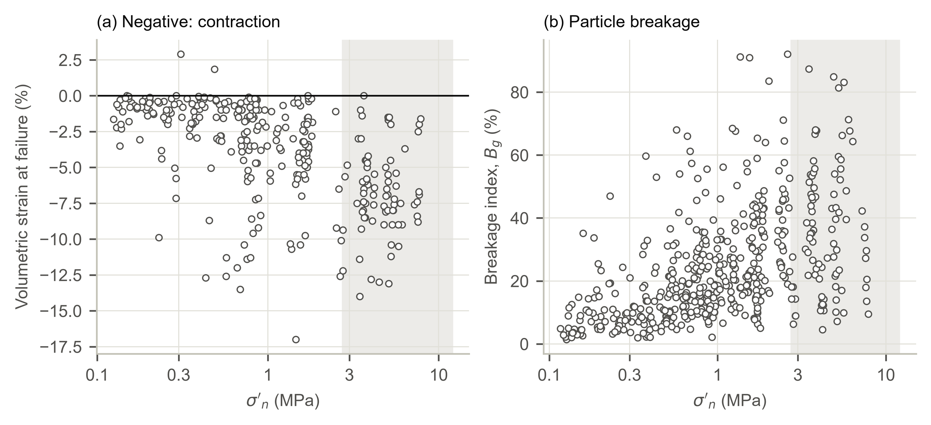
Fig. S2. Net volumetric strain at the maximum deviator (negative: contraction) and breakage index of Marsal (1973) versus σ′n in the calibration database; shaded: σ′n > 2.75 MPa. Reported breakage indices above 100%, which are impossible by definition, were excluded (4 tests). Above 2.75 MPa the residuals of Leps-P were unrelated to the breakage index (Spearman ρ = 0.00, n = 91).
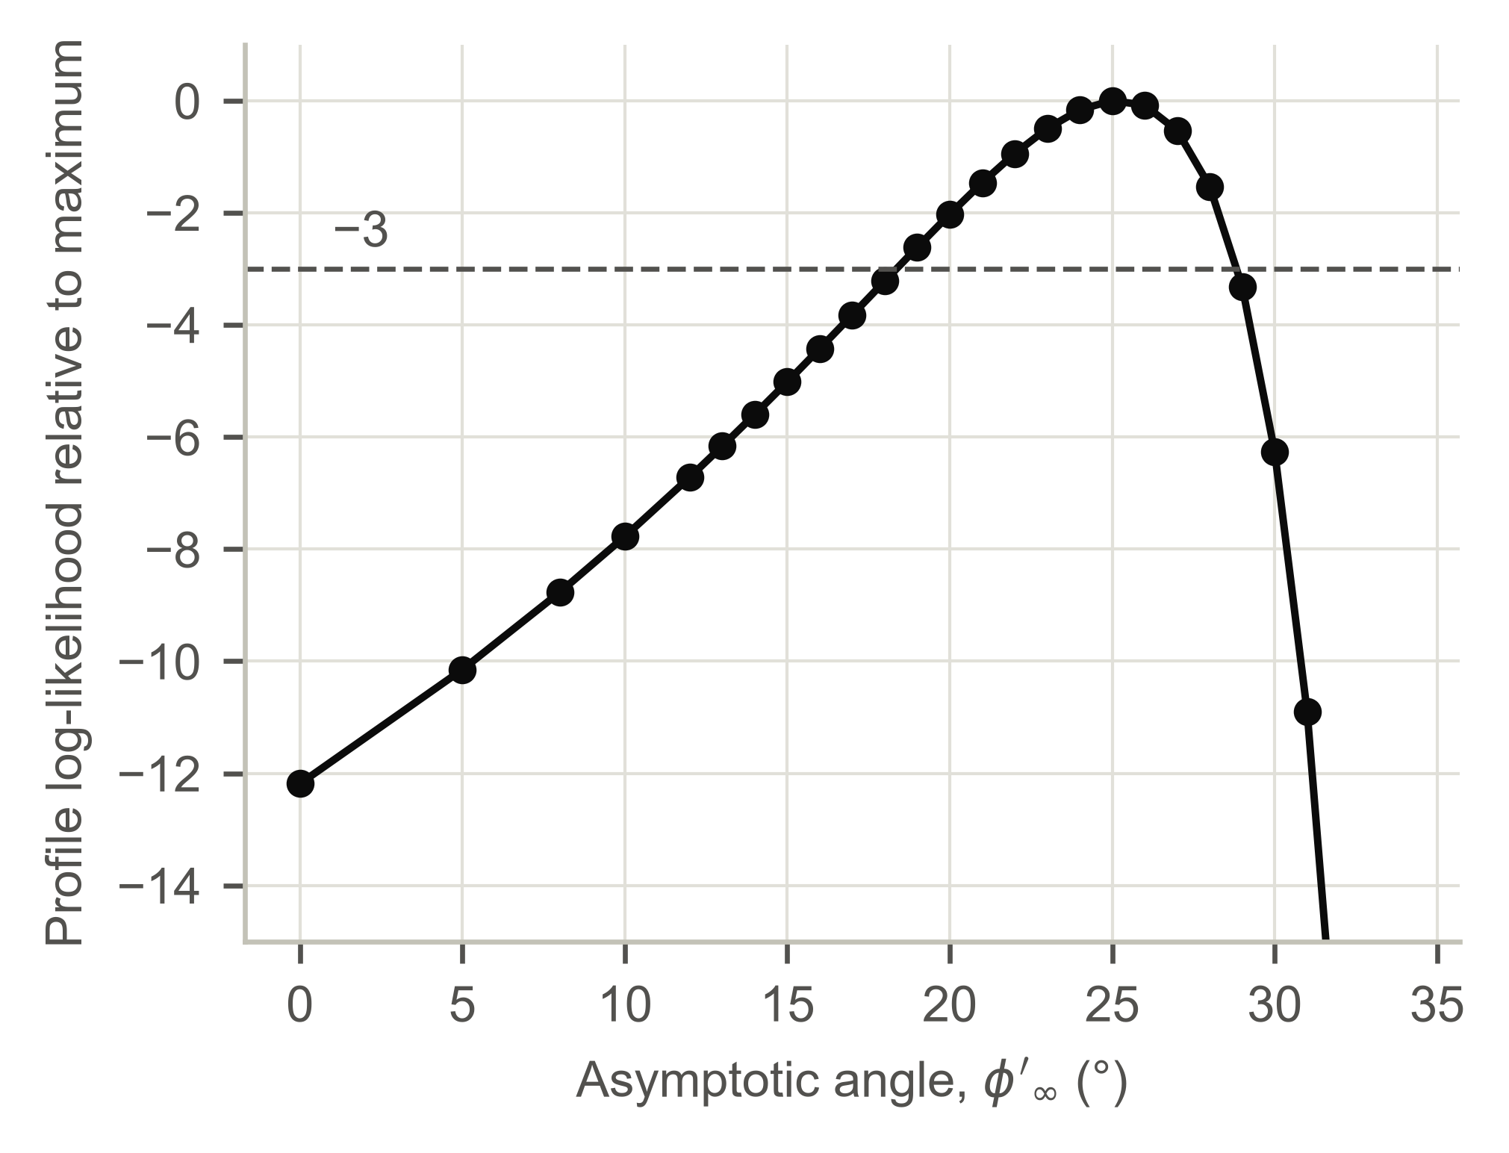
Fig. S3. Profile log-likelihood of the asymptotic angle φ′∞ relative to its maximum (1685.51); at each angle the population decay rate ζ0 and the variance parameters were re-estimated by maximum likelihood. φ′∞ = 0 corresponds to the form without an asymptote. Dashed: 3 log-likelihood units below the maximum.
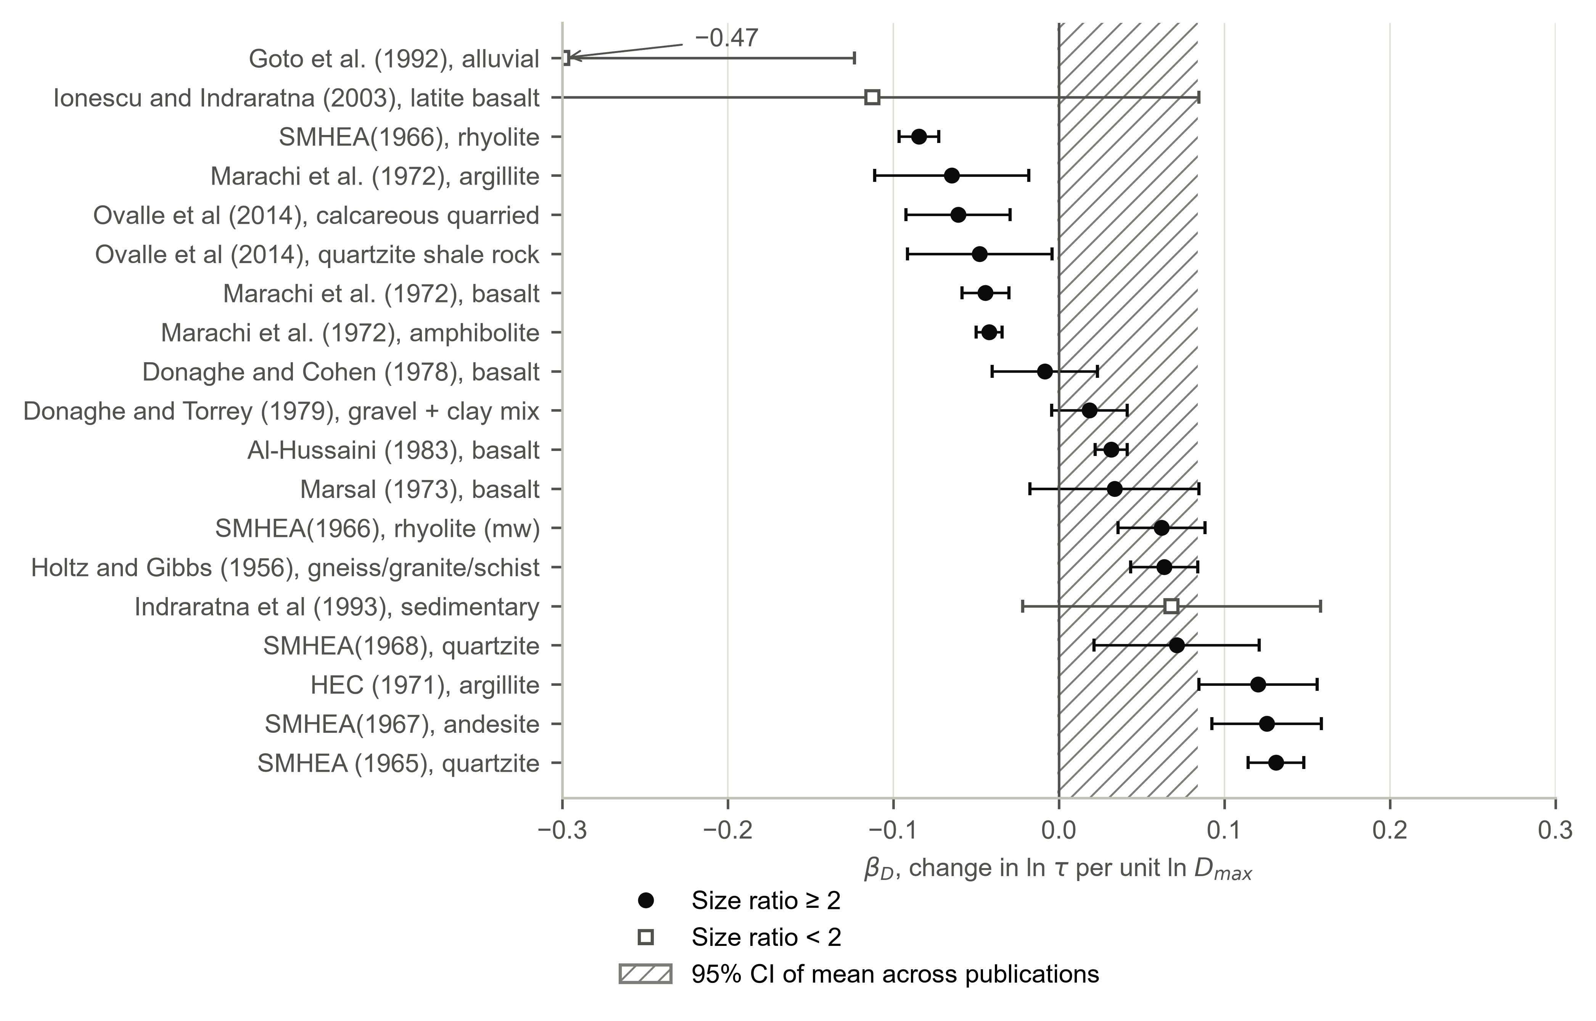
Fig. S4. Within-material specimen-size coefficient β_D (bars: 95% confidence intervals; set intercepts adjusted for void ratio). Hatched band: Knapp–Hartung 95% confidence interval of the random-effects mean across 12 publications with size ratio ≥ 2 (+0.041; −0.001 to +0.084). One value outside the axis is annotated.
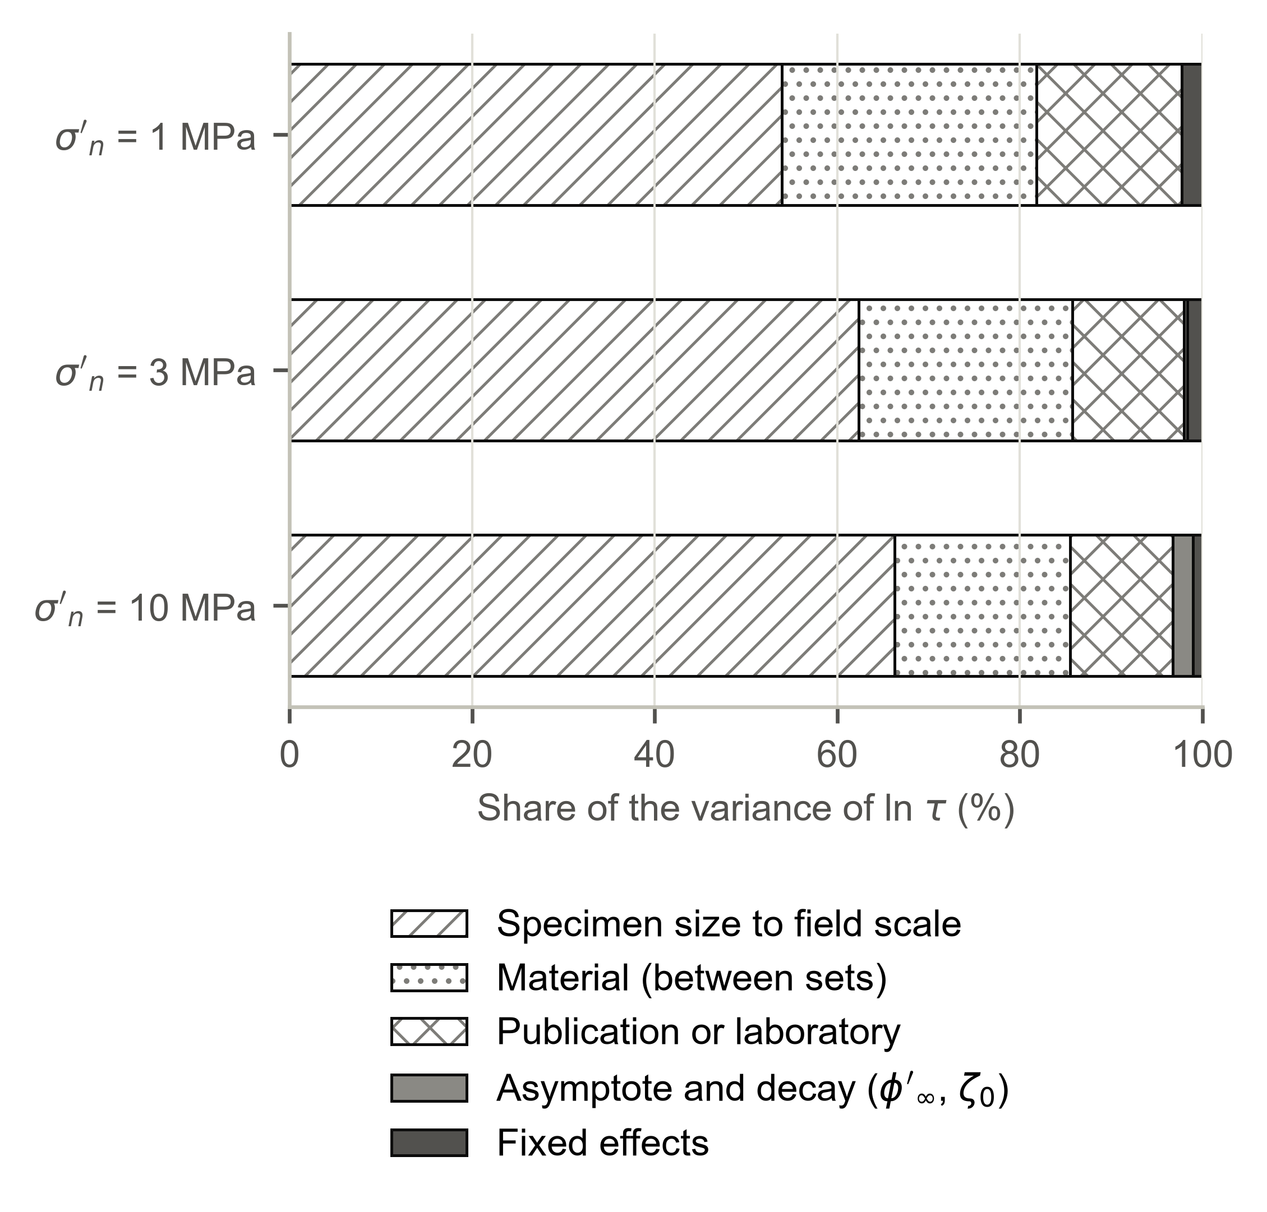
Fig. S5. Shares of the variance of the mean-envelope ln τ for an untested material of low rock quality placed at e = 0.65, scaled from 0.18 m to 1 m maximum particle size.
Table S1. Mode B: every procedure evaluated (held-out tests at σ′n ≥ 2 MPa predicted from tests at σ′n ≤ 1.5 MPa of the same set)
Procedure | 80% coverage | Below P10 | SD of z | CRPS | Δ vs level update (95% CI) | Holm-adjusted p
Prior, no site tests | 95% | 3% | 0.76 | 0.0424 | +0.0115 (+0.0043 to +0.0179) | 0.48
Least-squares fit of φ′1, m = 0.90 | 81% | 17% | 0.86 | 0.0407 | +0.0098 (−0.0011 to +0.0165) | 1.00
Least-squares fit of φ′1, m = median within-set slope of training data | 81% | 2% | 1.00 | 0.0369 | +0.0061 (−0.0021 to +0.0207) | 0.74
Joint update of both random effects | 80% | 12% | 1.34 | 0.0330 | +0.0022 (−0.0056 to +0.0200) | 1.00
Level update of each set (Eq. 8) | 83% | 9% | 0.91 | 0.0308 | — | —
Level update after discarding flagged sets | 83% | 12% | 0.97 | 0.0345 | +0.0036 (−0.0041 to +0.0106) | 1.00
Recommended procedure: discard flagged sets, joint update with shared laboratory effect | 83% | 12% | 0.98 | 0.0344 | +0.0036 (−0.0044 to +0.0104) | 1.00
Note: 64 tests, 46 sets, 13 publications. The procedures were developed while examining earlier versions of the model on the same held-out sets; the comparisons are exploratory. p-values from exact sign-flip tests on publication means, Holm-adjusted within Mode B. CRPS in units of ln τ.
Table S2. Secant friction angle φ′s (°) of the waste rock of the example, median / 5th percentile of the mean envelope
Material | Laboratory, 1 MPa | Placed, 1 MPa | Placed, 2 MPa
Rock type A | 40.5 / 39.1 | 35.3 / 30.3 | 33.4 / 28.6
Rock type B | 43.1 / 38.6 | 38.2 / 31.5 | 35.9 / 29.8
Rock type C | 41.7 / 40.3 | 37.2 / 32.0 | 35.2 / 30.2
Rock type D (untested) | 40.9 / 36.6 | 36.1 / 29.5 | 34.2 / 28.0
Rock type E (untested) | 40.9 / 36.5 | 33.9 / 27.4 | 32.3 / 26.3
Dump average, model correlation | 41.5 / 39.7 | 36.4 / 31.1 | 34.4 / 29.4
Dump average, full correlation | 41.5 / 38.7 | 36.4 / 30.6 | 34.4 / 29.0
Note: Laboratory: specimen void ratio and size. Placed: void ratio 0.65 (rock type E, 0.80), maximum particle size 1 m, size effect with zero mean. The full-correlation case sorts the samples of each rock type at every stress, an upper bound on dependence. No site tests above σ′n ≈ 4.6 MPa. The critical surfaces of Table 4 of the paper mobilize σ′n of up to about 2 MPa.

