A Reproducible Data Workflow over Structured Bible Data

Arturo Ramos
Udacity
Master's Degree in AI Capstone — Project 1: AI Programming Foundations
Udacity Project Review Team
September 23, 2026

A Reproducible Data Workflow over Structured Bible Data
Overview
This project builds a complete and reproducible data workflow in Python over BibleData, a public dataset of structured tables extracted from the Bible (Stephenson, 2026), available at https://github.com/BradyStephenson/bible-data. The notebook data_workflow.ipynb ingests three tables (people, person–verse mentions, and books), cleans and joins them into one tidy person–verse–book table, and explores who is mentioned most, how mentions are distributed across people, and how much of each book and testament names anyone at all. The result is a reusable data foundation for the content pipeline of a Bible trivia application, in which knowing which people appear in a chapter is what makes a question well anchored and its wrong answers plausible.
Dataset Description
BibleData is a collection of hand-curated, machine-readable tables published under a Creative Commons Attribution 4.0 license (Stephenson, 2026). The workflow uses three of its files: BibleData-Person.csv, with 3,009 rows and 9 columns describing every named individual (person_id, person_name, sex, tribe, a disambiguating unique_attribute and a name_instance counter for people who share a name); BibleData-PersonVerse.csv, with 44,267 rows and 8 columns linking a person to every verse in which the person is named, through a reference string such as GEN 24:20 and a person_label with the exact name or title used in that verse; and BibleData-Book.csv, with 66 rows and 18 columns of book metadata, including the USX code, the canonical order (christian_sequence) and the number of chapters and verses. A fourth file, BibleData-Event.csv (572 rows), is loaded to document the full release but is not analyzed. The key variables in the analysis are person_id, sex, reference_id, book_code, chapter, testament and, derived from them, the number of distinct verses per person and the share of each book's verses that name at least one person.
Workflow Description
The notebook is organized in six sections with Markdown headings so that it reads as a narrative and runs top to bottom without manual steps, following the model of reproducible data science in which code, outputs and explanation live together in an executable notebook and the computing environment is recorded so that others can rerun the analysis (Danchev, 2022). Ingestion reads the four CSV files with pandas after checking their first bytes, because three of them start with a UTF-8 byte-order mark; the first rows, data types and missing values of each table are displayed. Cleaning is implemented as five small functions with docstrings: clean_column_names normalizes column names, clean_persons tidies the people table, add_book_from_reference parses the reference string into book code, chapter and verse, clean_person_verse removes placeholder rows and collapses repeated labels, and attach_book_metadata joins the book table and derives the testament. Exploratory analysis is implemented as four functions: eda_summary (grouped statistics), mentions_per_person (distinct verses per person), book_coverage (share of verses that name someone, per book) and people_in_chapter (who appears in a given chapter). Visualization produces three figures saved to the figures folder, each with a title and labeled axes, and the notebook ends with a written summary and interpretation.
Key Decisions and Assumptions
The most consequential cleaning decision concerns the 14,733 rows of the person–verse table that have no person_id. Inspection showed that they carry no label at all and that their identifier ends in __NA, so they are placeholders for verses in which nobody is named rather than corrupted records. Keeping them would add 14,733 fake mentions and break the join with the people table, so they are removed. A second decision was to collapse the 2,135 rows in which the same person is labeled more than once in the same verse (for example, Jacob and Israel), so that every row of the final table is exactly one person in one verse; this follows the tidy-data principle that each row should be one observation and each column one variable, which is what makes grouping and joining straightforward (Wickham, 2014). Missing tribe values (46.6 % of people) are filled with the explicit category unknown instead of being dropped, and the surname column, missing in 99.7 % of rows, is dropped rather than imputed. All grouping is keyed on person_id and never on the name, because 1,702 people share their name with someone else; a boolean is_homonym flag makes the ambiguity visible whenever names are displayed. Reference parsing and the book join end with assertions, so a malformed reference or an unmatched book code stops the notebook instead of producing silent missing values; this is a deliberate choice to avoid the manual, undocumented fixes that make analyses hard to reproduce (Sandve et al., 2013). The exploratory analysis focuses on three questions relevant to question writing: who is mentioned most, how mentions are distributed, and which books name people at all. Figure 1 was designed to show the head of the distribution (the 15 most-mentioned people, with the YHVH entries excluded because they are labels for God rather than human characters), Figure 2 to compare books and testaments on a length-normalized scale, and Figure 3 to show the long tail of people who are named only once or twice. It is assumed that books 1 to 39 in the canonical order are the Old Testament and 40 to 66 the New Testament.
Results and Interpretation
After cleaning, the joined table contains 27,399 person–verse pairs linking 2,993 people to 16,484 verses across all 66 books. Mentions are highly concentrated. Figure 1 shows that Jacob (1,003 distinct verses), David (954) and Moses (786) lead by a wide margin, the fourth place (Saul, 336) has less than half of Moses's count, and the top 15 is entirely male. Thirteen of the 15 are Old Testament figures; the only New Testament figures are the apostle Paul (tenth, 178 verses) and Peter (eleventh, 176 verses). Jacob's lead is partly an artifact of the tagging: 750 of his 1,003 verses carry the label Israel and only 243 the label Jacob, so his count mixes the patriarch with the nation named after him. Figure 3 shows the other end of the distribution: 1,547 of the 2,993 people (52 %) appear in exactly one verse and 2,362 (79 %) in three or fewer, while only 51 reach 50 verses and 22 reach 100; the mean of 9.2 verses per person is nine times the median of 1, and the top 10 entries hold 52 % of all pairs. Figure 2 shows that whether a verse names anyone depends on literary genre more than on testament. Genealogical and historical books lead, with 1 Chronicles naming someone in 89 % of its verses and introducing 1,323 distinct people, followed by 1 Samuel (81 %), 2 Samuel (79 %) and 2 Kings (77 %); wisdom and poetic books trail, with Song of Solomon at 9 %, Proverbs at 11 %, Job at 18 % and Ecclesiastes at 20 %. On average the Old Testament names a person in 55 % of its verses and the New Testament in 47 %, with the New Testament books spread more narrowly, from James (27 %) to 2 Thessalonians (62 %). Book length explains the number of verses that name someone (Pearson r = 0.92 between verse count and tagged verses) but not the number of distinct people (r = 0.31). Finally, the chapter view illustrates why a person–verse index is useful for content generation: Genesis 24:20 describes an action without naming the actor, and the chapter-level list recovers Rebekah (present in 12 verses of the chapter) together with Abram (Abraham), Isaac, Bethuel, Nahor, Laban, Milcah and Sarai (Sarah) as the other people of the scene.
Figure 1
Top 15 Most-Mentioned People in the Bible (Distinct Verses per Person)
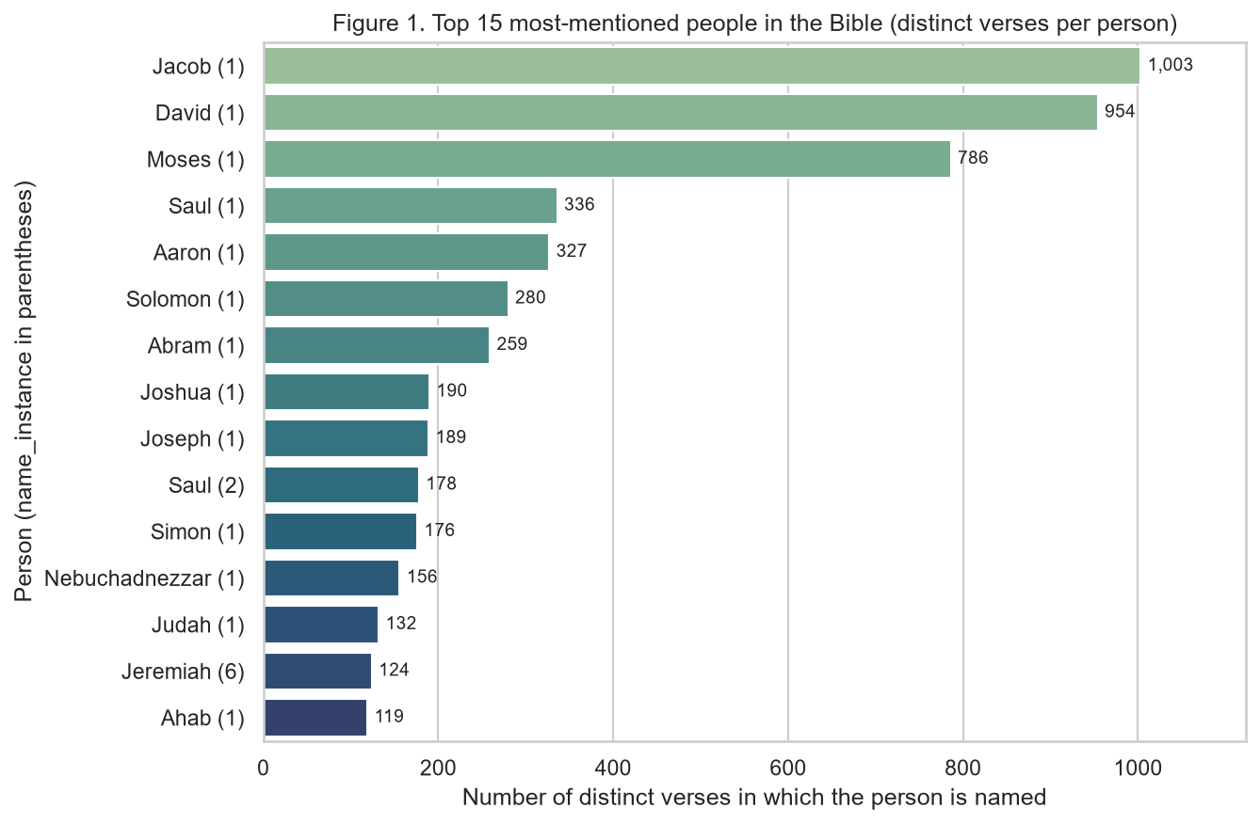
Note. YHVH entries excluded; the number in parentheses is the name_instance that distinguishes people who share a name.
Figure 2
Share of Verses That Name at Least One Person, by Book (Canonical Order)
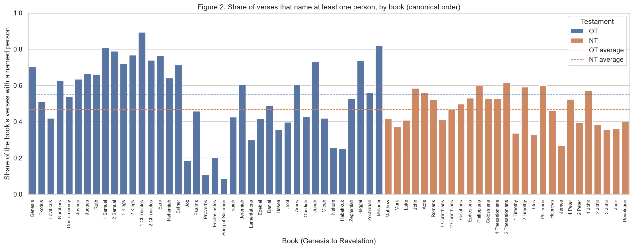
Note. Dashed lines mark the Old Testament (55 %) and New Testament (47 %) averages.
Figure 3
Distribution of the Number of Verses per Person (Log–Log Scale)
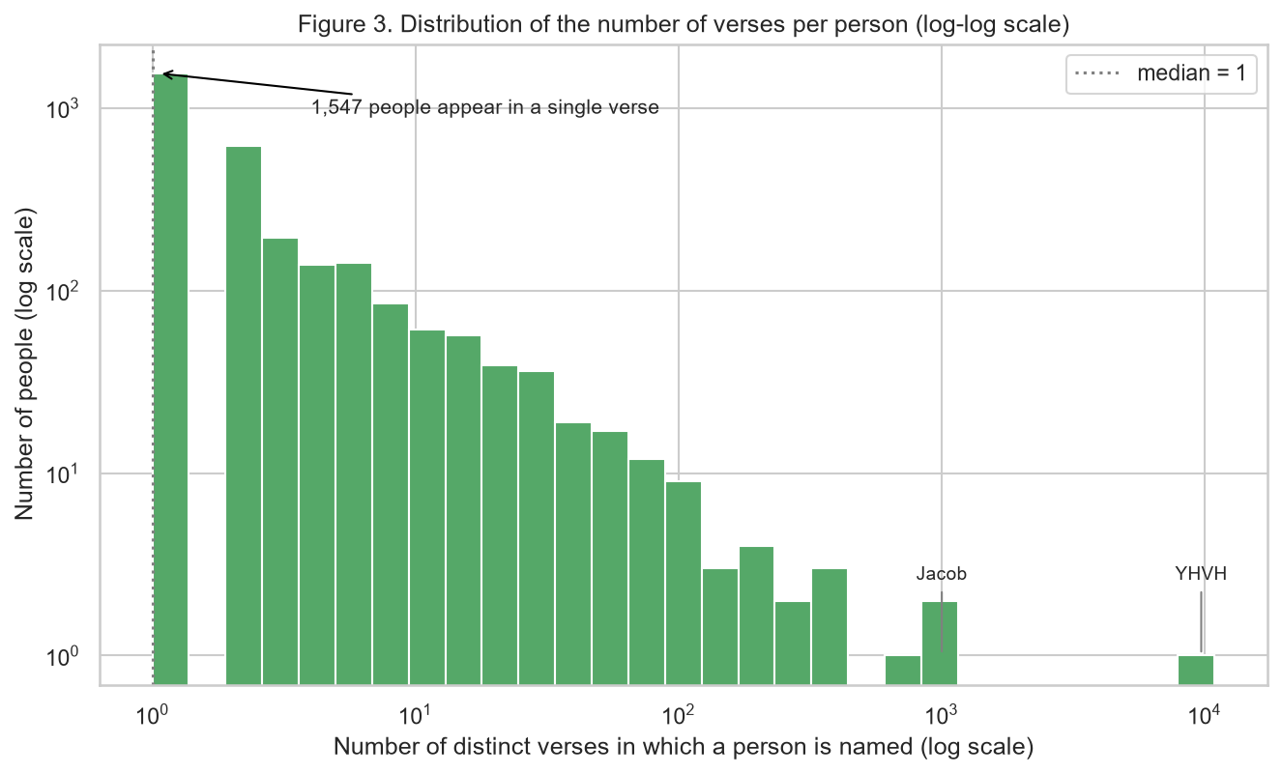
Note. 1,547 of 2,993 people appear in a single verse; the median is 1 and the mean is 9.2.
Responsible Practice (Bias and Data Quality)
The dataset is a curated interpretation of the text, not the text itself, and every downstream use inherits its curation decisions: which person a pronoun refers to, whether the nation Israel counts as a mention of Jacob, how name changes such as Abram and Abraham or Sarai and Sarah are folded into a single identifier, the use of a 66-book Protestant canon, and English spellings of names. Documenting these decisions alongside the data, in the spirit of a datasheet that records how a dataset was collected and what it should and should not be used for, is the first safeguard against misinterpreting the counts (Gebru et al., 2021). In this project the cleaning steps themselves were the main place where bias could enter. Deduplicating by name would have merged the six women called Mary and the 23 men called Zechariah, producing wrong answers in a trivia setting; dropping people without a recorded tribe would have removed most New Testament characters and skewed tribe-level statistics toward Old Testament genealogies; and counting the placeholder rows would have inflated every mention statistic. Beyond cleaning, the data carries a representation imbalance that the analysis makes measurable: only 172 of the 2,993 people mentioned are women (5.7 %), they account for 3 % of all person–verse pairs, and the most-mentioned woman, Sarai (Sarah), appears in 48 verses against 1,003 for Jacob. A question generator that samples characters in proportion to their mentions would therefore almost never ask about women or about the 1,547 single-verse people. The mitigation applied here is to keep the unknown category visible, key everything on person_id, expose the is_homonym flag, and report the imbalance explicitly; the next step for a production system would be stratified sampling by sex, book and mention frequency when questions are generated.
Reproducibility
Anyone can rerun the work by cloning the public repository, creating a virtual environment, installing the exact package versions listed in requirements.txt (generated with pip freeze; the pinned versions require Python 3.12 or newer) and running the notebook from top to bottom; the CSV files ship in the data folder with their license and citation file, and the three figures are regenerated by the notebook itself. Recording the exact software versions and keeping every transformation in code rather than in manual edits are two of the basic rules that make a computational analysis reproducible (Sandve et al., 2013), and publishing the notebook, the data and the environment together is the practice that Danchev (2022) proposes for open and reproducible data science. Version control follows the same logic: the repository has a main branch and a dev branch, each task of the project was committed separately on dev (ingestion, cleaning functions, exploratory analysis, visualizations, summary, README, report), and dev was merged into main for submission, so the history shows how the workflow was built.

References
Danchev, V. (2022). Reproducible data science with Python: An open learning resource. Journal of Open Source Education, 5(56), 156. https://doi.org/10.21105/jose.00156
Gebru, T., Morgenstern, J., Vecchione, B., Vaughan, J. W., Wallach, H., Daumé III, H., & Crawford, K. (2021). Datasheets for datasets. Communications of the ACM, 64(12), 86–92. https://doi.org/10.1145/3458723
Sandve, G. K., Nekrutenko, A., Taylor, J., & Hovig, E. (2013). Ten simple rules for reproducible computational research. PLOS Computational Biology, 9(10), e1003285. https://doi.org/10.1371/journal.pcbi.1003285
Stephenson, B. (2026). BibleData: Structured datasets from the Holy Bible (Version 1.0) [Data set]. Zenodo. https://doi.org/10.5281/zenodo.19539956
Wickham, H. (2014). Tidy data. Journal of Statistical Software, 59(10), 1–23. https://doi.org/10.18637/jss.v059.i10

