Identifying the Source Book of Wisdom Literature Passages with Supervised Text Classification

Arturo Ramos
Udacity
Master's Degree in AI Capstone — Project 3: Applied Machine Learning
Udacity Project Review Team
September 24, 2026

Identifying the Source Book of Wisdom Literature Passages with Supervised Text Classification
Overview
This project addresses a supervised, multi-class classification problem: given the vocabulary of a passage from a wisdom book, predict which of eight books it comes from. The data are the dataset A Study of Asian Religious and Biblical Texts from the UCI Machine Learning Repository (2019), available at https://doi.org/10.24432/C55S4W, which covers four biblical books and four Asian religious texts. The notebook modeling.ipynb compares a majority-class baseline, a Multinomial Naive Bayes classifier and a regularized logistic regression on TF-IDF features, selects the logistic regression by cross-validation, and evaluates it on held-out passages.
Dataset Description
The dataset represents 590 passages, each a chapter-sized chunk of one of eight wisdom texts in English translation: the biblical books of Proverbs, Ecclesiastes, Ecclesiasticus and the Book of Wisdom, and the Asian texts of the Upanishads, the Yoga Sutras, the Buddhist Sutras and the Tao Te Ching. The file has 590 rows and 8,267 columns: a label such as Buddhism_Ch1 and 8,266 integer columns that count how many times each word of the vocabulary occurs in the passage. The target variable is the source book, parsed from the label; it has eight classes and is strongly imbalanced, from 189 passages of the Yoga Sutras to 12 of Ecclesiastes. The features form an extremely sparse document-term matrix (99.1 % zeros), and 3,872 words occur in only one passage. There are no missing values, but one passage contains no words and one book name is misspelled in the source labels.
Modeling Approach
Data preparation parsed the book from each label into a readable class name, removed the one empty passage, and split the remaining 589 passages into a training set (441) and a test set (148) with a stratified 75/25 split, so that even the smallest books keep passages in both sets (Ecclesiastes has 9 in training and 3 in testing). Raw word counts were not used directly by the logistic regression, because passage length varies from a median of 26 words for the Upanishads to between 236 and 296 for the biblical books. Instead, counts were transformed with TF-IDF, which weights a term by its frequency in the passage and down-weights terms that occur in many passages (Salton & Buckley, 1988); a sublinear term frequency and unit-length normalization make passages of different length comparable. The TF-IDF step was placed inside a scikit-learn pipeline (Pedregosa et al., 2011), so that document frequencies are learned from the training folds only and no information from validation or test passages leaks into training.
Logistic regression was selected because it is a well-understood linear classifier whose L2 penalty controls variance in high-dimensional settings, where the number of features (8,266) far exceeds the number of training examples (441) and an unregularized model would fit noise (Hastie et al., 2009). It also produces one coefficient per word and book, which makes the model interpretable. Class weights were set inversely proportional to class frequency so that errors on small books are not ignored. Multinomial Naive Bayes, a standard baseline for word-count data, and a model that always predicts the most frequent book were trained for comparison. Hyperparameters (the regularization strength C for logistic regression and the smoothing alpha for Naive Bayes) were tuned by repeated stratified cross-validation on the training set only (5 folds repeated 5 times), and the test set was used once at the end; choosing hyperparameters on the same data used to report performance produces optimistically biased estimates (Cawley & Talbot, 2010).
The main evaluation metric is the macro-averaged F1 score, the unweighted mean of the per-class F1 scores. With imbalanced classes, accuracy and micro-averaged measures are dominated by the large classes, whereas macro-averaging gives each class the same weight (Sokolova & Lapalme, 2009); this matters here because a model could reach high accuracy by recognizing only the three large Asian texts. Accuracy, balanced accuracy, per-class precision and recall, and a confusion matrix are reported alongside. The model assumes that passages are independent and that each class is separable by a linear combination of TF-IDF-weighted word frequencies, it ignores word order (bag of words), and it assumes that the vocabulary seen in training is representative of new passages from the same books.
Results
In repeated cross-validation (Figure 1), the tuned logistic regression reached a mean macro-F1 of 0.920 (SD 0.041), ahead of Naive Bayes (0.872) and far above the baseline (0.061), which only predicts the Yoga Sutras. The training macro-F1 of both real models was close to 1 (0.999 and 1.000), so the models fit the training passages almost perfectly; the tuning selected the strongest regularization tested (C = 0.01), while C = 0.03 and C = 0.1 scored almost the same (0.916 and 0.919) and weaker regularization (C of 1 or more) lowered the score to about 0.89, which shows regularization controlling overfitting. On the held-out test set, the selected model reached an accuracy of 0.939, a balanced accuracy of 0.887 and a macro-F1 of 0.863. The confusion matrix (Figure 2) shows that it misclassified 9 of 148 passages and never confused a biblical passage with an Asian one. Six of the errors are among the biblical books, mostly proverb-style passages of Ecclesiasticus predicted as Proverbs or the Book of Wisdom (Ecclesiasticus recall 0.692), and three are short Asian passages predicted as Buddhist Sutras. The most indicative words (Figure 3) are meaningful: vanity, sun and labour for Ecclesiastes; wicked, lips and fool for Proverbs; tao and sage for the Tao Te Ching; and brahman, atman and Nachiketas for the Upanishads.
The single test score is not very stable. On this split Naive Bayes reached a macro-F1 of 0.867, slightly above the selected model, but across 20 different stratified splits (Figure 4) logistic regression averaged 0.911 (SD 0.038, range 0.830–0.969) against 0.878 for Naive Bayes and was better on 15 of the 20 splits. The spread comes from the smallest books: with 3 test passages for Ecclesiastes, one error changes that class's F1 by about a third. This supports the decision to choose the model by repeated cross-validation rather than by one test result, and to report the test score as an estimate with uncertainty.
Figure 1
Cross-Validated Macro-F1 of the Three Models on the Training Set
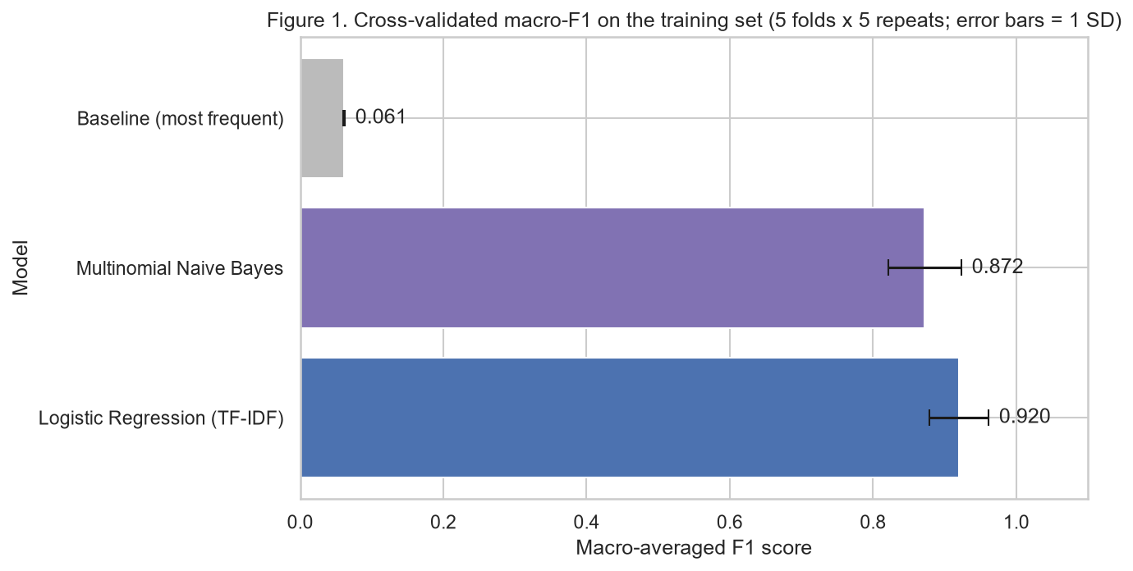
Note. Repeated stratified cross-validation, 5 folds × 5 repetitions; error bars show one standard deviation.
Figure 2
Confusion Matrix of the Selected Logistic Regression on the Test Set
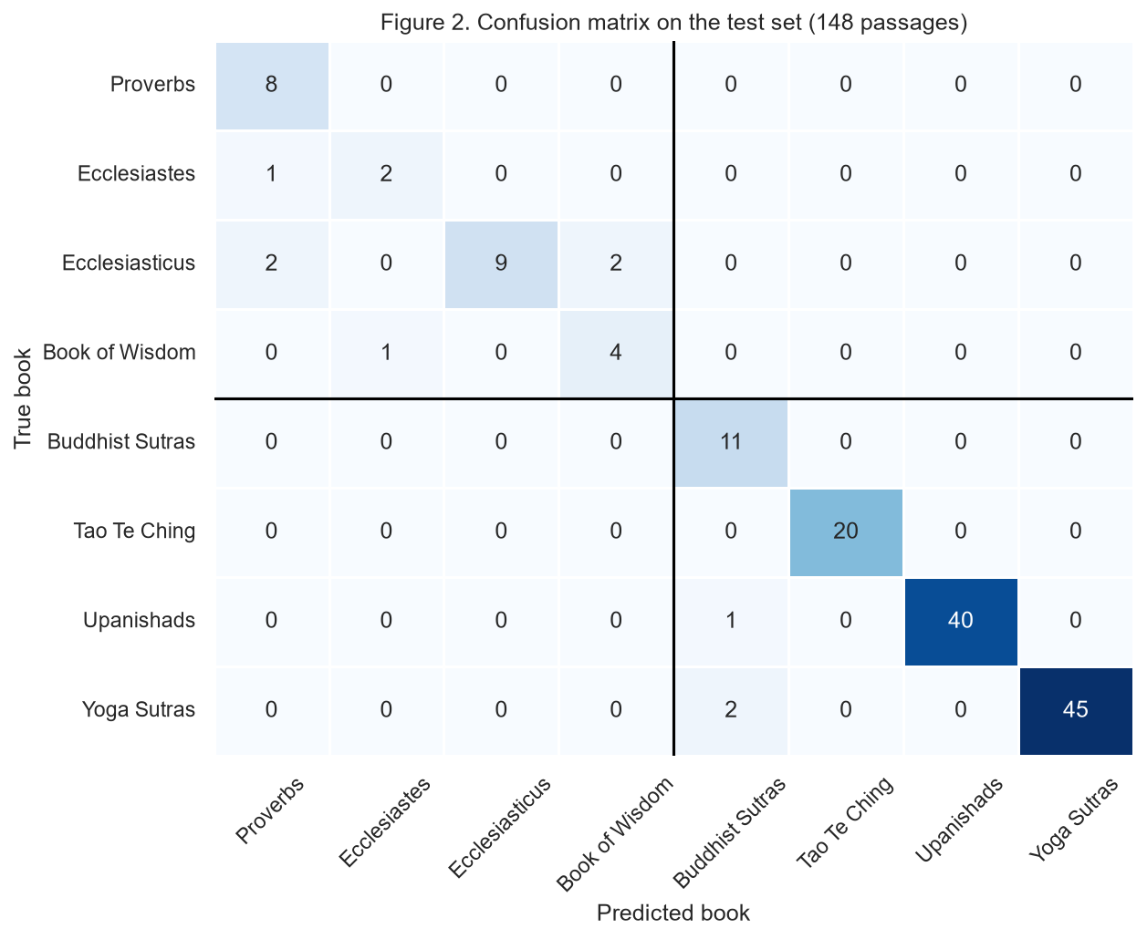
Note. 148 test passages; the black lines separate the four biblical books (top left) from the four Asian texts.
Figure 3
Eight Most Indicative Words per Book
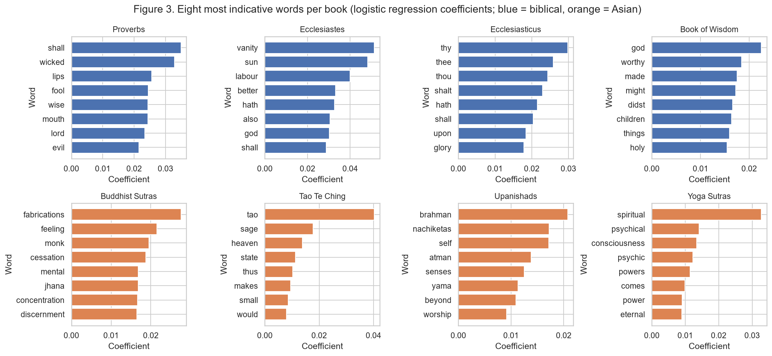
Note. Largest positive logistic regression coefficients for each class.
Figure 4
Test Macro-F1 Over 20 Stratified Train/Test Splits
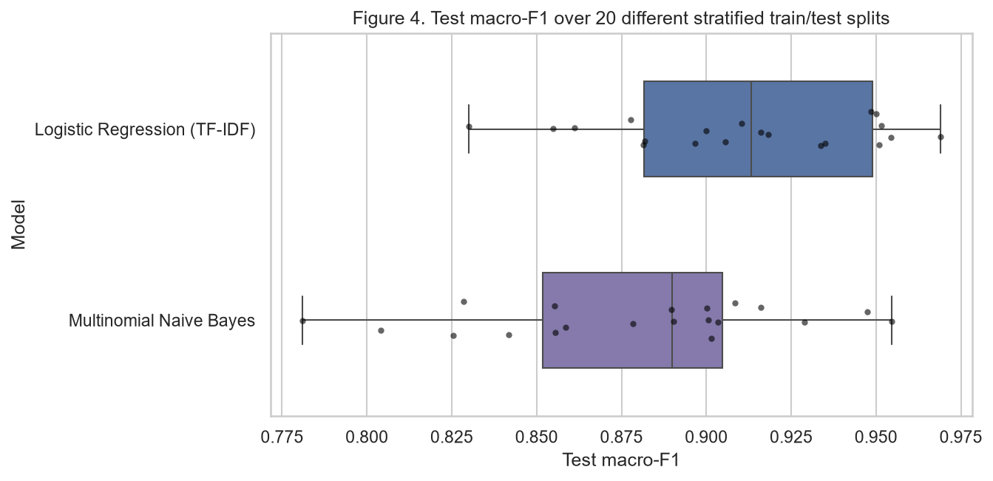
Note. Both models are retrained with their tuned hyperparameters on each split; points are individual splits.
Interpretation for a Non-Technical Audience
The model reads a passage the way a word counter would, without understanding sentences, and guesses which of eight ancient wisdom books it comes from. It is right about 94 times out of 100 on passages it has never seen. It never mistakes a biblical passage for a Hindu, Buddhist or Taoist one; when it makes a mistake, it is between books that really do sound alike, such as the collections of short sayings in Proverbs and Ecclesiasticus. The words it relies on are the ones a reader would expect, such as vanity and sun for Ecclesiastes or tao and sage for the Tao Te Ching. The main caveat is that some books are represented by very few passages, so the exact score depends on which passages happen to be set aside for testing; a fair summary is that the model identifies the right book roughly nine times out of ten, and that it is least reliable for the smallest biblical books.
Limitations and Potential Bias
The main limitation is data size and imbalance: only 12 passages of Ecclesiastes and 19 of the Book of Wisdom exist, so the per-class scores for these books rest on 3 and 5 test passages and vary widely between splits. The bag-of-words representation ignores word order and meaning, so the model cannot distinguish passages that use the same vocabulary in different ways, and it can only recognize the eight books it was trained on. A second limitation is that every passage is an English translation, and the translations differ systematically: all four biblical books use early-modern English, while the Asian texts come from modern translations. This creates a risk of bias in which the model learns the translation style instead of the content. The notebook measured it: 404 archaic forms (such as thee, thou, hath and verbs ending in -eth) occur in every biblical passage but in at most 23 % of the passages of any Asian text, and some of them appear among the most indicative words for Ecclesiasticus. As a mitigation step, all 404 forms were removed and the model was retrained with the same procedure; performance did not drop (test macro-F1 0.930, and still no confusion between the two traditions), which indicates that the model relies on content words. Even so, the model would likely fail on a biblical passage in modern English, which is an important uncertainty for any real use.
There is also an ethical dimension. The dataset places sacred texts of several religious traditions side by side, and a model that classifies them could be misused to present one tradition's texts as "more distinctive" or to label passages out of context; its coefficients describe word usage in specific translations, not the value or meaning of any tradition. Because the model is intended as a component for organizing religious study content, its purpose, training data, known failure cases (small books, archaic-versus-modern translation) and evaluation across splits should be documented with it, as proposed by model cards for model reporting (Mitchell et al., 2019), so that users know where its predictions can and cannot be trusted.

References
Cawley, G. C., & Talbot, N. L. C. (2010). On over-fitting in model selection and subsequent selection bias in performance evaluation. Journal of Machine Learning Research, 11, 2079–2107. https://jmlr.org/papers/v11/cawley10a.html
Hastie, T., Tibshirani, R., & Friedman, J. (2009). The elements of statistical learning: Data mining, inference, and prediction (2nd ed.). Springer. https://doi.org/10.1007/978-0-387-84858-7
Mitchell, M., Wu, S., Zaldivar, A., Barnes, P., Vasserman, L., Hutchinson, B., Spitzer, E., Raji, I. D., & Gebru, T. (2019). Model cards for model reporting. In Proceedings of the Conference on Fairness, Accountability, and Transparency (pp. 220–229). ACM. https://doi.org/10.1145/3287560.3287596
Pedregosa, F., Varoquaux, G., Gramfort, A., Michel, V., Thirion, B., Grisel, O., Blondel, M., Prettenhofer, P., Weiss, R., Dubourg, V., Vanderplas, J., Passos, A., Cournapeau, D., Brucher, M., Perrot, M., & Duchesnay, É. (2011). Scikit-learn: Machine learning in Python. Journal of Machine Learning Research, 12, 2825–2830. https://jmlr.org/papers/v12/pedregosa11a.html
Salton, G., & Buckley, C. (1988). Term-weighting approaches in automatic text retrieval. Information Processing & Management, 24(5), 513–523. https://doi.org/10.1016/0306-4573(88)90021-0
Sokolova, M., & Lapalme, G. (2009). A systematic analysis of performance measures for classification tasks. Information Processing & Management, 45(4), 427–437. https://doi.org/10.1016/j.ipm.2009.03.002
UCI Machine Learning Repository. (2019). A study of Asian religious and biblical texts [Data set]. https://doi.org/10.24432/C55S4W

