Imitating the Voice of the Psalms and Proverbs: A Character-Level GPT Trained on the 1909 Reina-Valera Bible

Arturo Ramos
Udacity
Master's Degree in AI Capstone — Project 5: Generative AI Applications
Udacity Project Review Team
September 25, 2026

Imitating the Voice of the Psalms and Proverbs: A Character-Level GPT Trained on the 1909 Reina-Valera Bible
Overview
This project builds a small generative text system: a decoder-only Transformer language model, in the style of the GPT family, trained from scratch to generate new Spanish verses that imitate the Psalms and Proverbs of the 1909 Reina-Valera Bible. The data are the public-domain Santa Biblia — Reina Valera 1909, in the verse-per-line edition published by eBible.org (https://ebible.org/find/details.php?id=spaRV1909). The model works at the level of characters, is pre-trained on the whole Bible and then fine-tuned on the two target books, and generates text one character at a time from a short prompt that names the book whose style is wanted. The goal is not to produce usable religious text but to study how well a generative model can imitate a sacred text, where it fails, and what risks that imitation creates.
Dataset or Prompt Description
The corpus is the complete 1909 Reina-Valera Bible in Spanish, a translation in the public domain, distributed by eBible.org as plain text with one verse per line and all headings and notes removed. It contains 31,102 verses from the 66 books, about 3.8 million characters, and only 83 distinct characters. The two target books are a small part of it: the Psalms have 2,461 verses and Proverbs 915, together about 283,000 characters or 7 % of the corpus. The text keeps the 1909 orthography, for example the preposition á written with an accent (19,320 times) and fué with an accent (1,650 times), which is part of the style the model should learn and was therefore not modernized. Preprocessing was minimal: Unicode normalization, removal of the square brackets that mark words added by the translators, and whitespace cleanup. Each verse became one training line prefixed with its book code (for example PRO: followed by the verse), so that the book code acts as a conditioning prompt at generation time and the newline marks the end of a verse. The data were split by chapter, 90 % for training and 10 % for validation, because verses of the same chapter share wording (every verse of Psalm 136 contains the refrain "porque para siempre es su misericordia"), and the fine-tuning splits are the Psalms and Proverbs chapters of those same two splits, so that no validation chapter is ever trained on.
Model Design and Training Approach
The model is a decoder-only Transformer (Vaswani et al., 2017) trained as a language model, the approach behind the GPT family, in which a stack of masked self-attention layers predicts each token from all previous ones and text is generated by sampling one token at a time (Radford et al., 2019). Characters were chosen as tokens because the vocabulary is tiny, no word can be out of vocabulary, and the model can learn the archaic spellings of the 1909 text directly. The implementation, written from scratch in PyTorch, has 6 Transformer blocks with 6 attention heads, an embedding size of 384, a context of 192 characters, pre-layer normalization, GELU feed-forward layers, dropout of 0.1 and tied input and output embeddings, for 10,753,920 trainable parameters. It is trained to minimize the cross-entropy of the next character with the AdamW optimizer (Loshchilov & Hutter, 2019), weight decay of 0.1, gradient clipping, and a learning rate with linear warm-up and cosine decay.
Training has two phases, following the practice of pre-training a language model on a large general corpus and then fine-tuning it on the target domain, which has been shown to improve performance on the target text (Howard & Ruder, 2018; Gururangan et al., 2020). Phase 1 pre-trained the model for 4,000 steps on the whole Bible (peak learning rate 0.001), reaching a validation loss of 0.9194 nats per character after 12.5 minutes on the GPU. Phase 2 fine-tuned it on Psalms and Proverbs only, with a lower learning rate of 0.0001 to adapt the style without erasing what was learned. Because the fine-tuning text is small, the validation loss was checked every 25 steps and early stopping kept the weights with the lowest validation loss; the weights at the end of 600 steps were kept as well, to study the effect of overfitting.
Figure 1
Training and Validation Loss in Pre-Training and Fine-Tuning
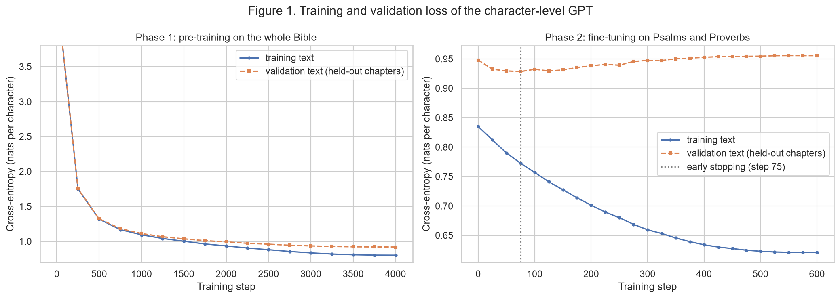
Note. Fine-tuning validation loss reaches its minimum at step 75 (early stopping) and rises afterwards.
Output Evaluation and Interpretation
The training curves (Figure 1) show that pre-training converged smoothly, with training and validation loss close together. Fine-tuning lowered the validation loss on Psalms and Proverbs from 0.9479 to 0.9283 in only 75 steps, after which it rose steadily to 0.9555 at step 600 while the training loss kept falling to 0.6209: a clear case of overfitting to a small corpus that early stopping avoided. Because generated text has no single correct answer, the outputs were evaluated both by reading them and with simple automatic diagnostics computed on 150 generated verses per setting (Figure 2 and Figure 3): the share of generated words that never occur in the Bible, the share of generated six-word sequences found verbatim in the training text, and distinct-2, the ratio of unique to total word pairs, a standard measure of repetition in generated text (Li et al., 2016). The temperature, which rescales the model's probabilities before sampling, controls the trade-off between repetitive and incoherent text (Holtzman et al., 2020).
Fine-tuning changed the style, not only the loss. With the same prompts and random seeds, the pre-trained-only model wrote narrative or prophetic lines, such as "Y acontecerá que como los siervos de Adullam invocan á ellos, dice Jehová", while the fine-tuned model adopted the first-person, prayer-like voice of the Psalms ("Porque yo he alegrado en tu socorro; júbilo en tu generación, y en tu buena guarda mi alma") and the address formula of Proverbs ("Oye, hijo mío, amigo mío"). The median length of generated verses moved from 95 characters to 76, close to the 79 characters of real Psalms and Proverbs. The strengths are formal: the model reproduces the 1909 spelling, the colon-and-semicolon structure of Hebrew parallelism and the antithetic parallelism of Proverbs introduced by mas ("mas el que se encubre la palabra, será cortado"). At temperature 0.8, only 1.9 % of its words are invented and its distinct-2 score (0.720) is close to that of real held-out verses (0.728). It also does not recite scripture: only 0.6 % of its six-word sequences appear verbatim in the training text, fewer than the 2.2 % that real held-out verses share with the training text through formulaic phrases.
The failure cases are just as clear. Most lines are grammatical but meaningless as a whole ("Porque Jehová es al malo en mi afrenta, y para sus saludes"), because a character-level model learns local patterns, not meaning. At temperature 0.5 the model falls into loops ("El hijo sabio del hombre sabio es el hombre sabio"), its distinct-2 drops to 0.526 and copying rises to 4.1 %, with a longest copied span of 10 words; the overfitted model also repeats the refrain of Psalm 136 within a single line. At temperature 1.3, 11 % of the words are invented ("encruelto", "juzgadoría") and formatting breaks. The most important failure is not technical: at temperature 0.5 the model produced "Y en Israel respondió: No hay Dios en toda la tierra", a statement that contradicts the text it was trained on but is written in a perfectly scriptural register. Temperature 0.8 gave the best balance, and the fine-tuned, early-stopped model was the best of the three models compared.
Figure 2
Invented Words, Verbatim Copying and Repetition by Sampling Temperature
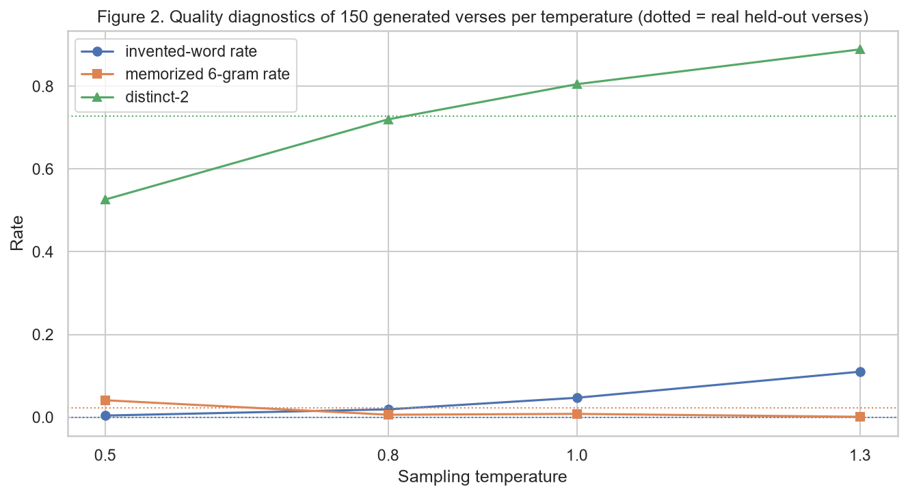
Note. 150 verses generated per temperature by the early-stopped fine-tuned model; dotted lines are real held-out verses.
Figure 3
Diagnostics for the Three Models at Temperature 0.8
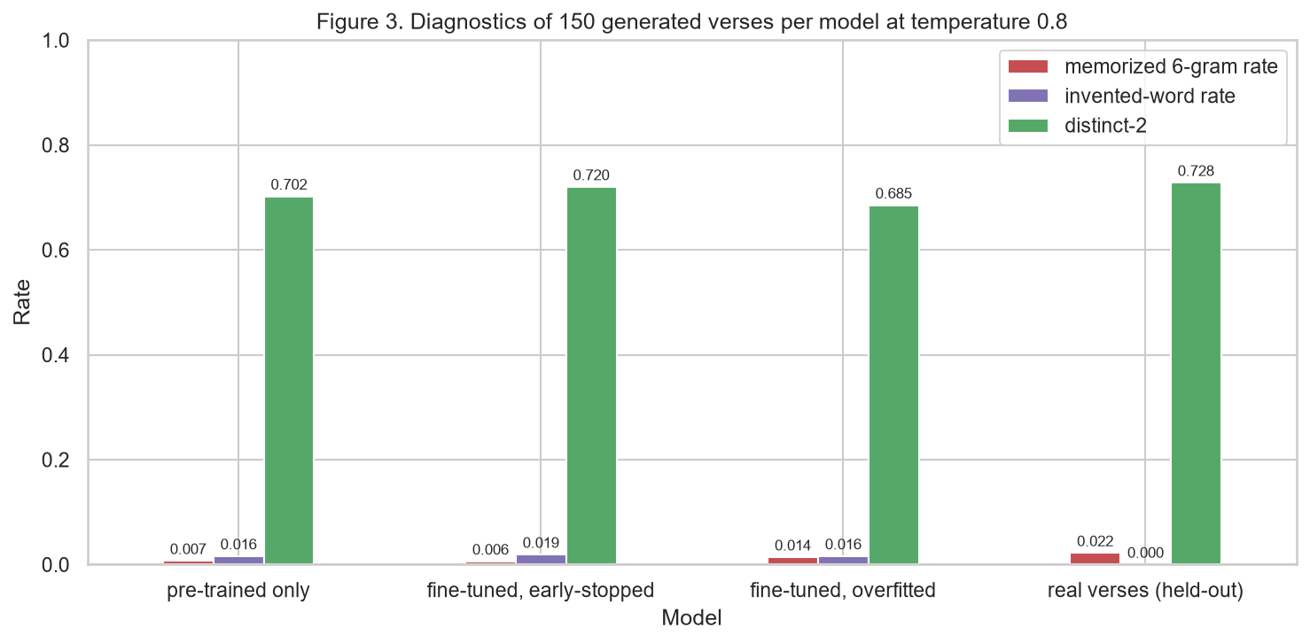
Note. Pre-trained only, fine-tuned with early stopping and fine-tuned for 600 steps (overfitted), compared with real verses.
Ethical Considerations and Responsible Use
The central ethical concern of this system is misattribution. A language model generates fluent text by reproducing the statistical form of its training data without any grounding in meaning or truth, so fluent output can easily be mistaken for authoritative content (Bender et al., 2021). Here the training data is scripture, and the model learned its form so well that its output reads like a real verse even when it says the opposite of the Bible, as in "No hay Dios en toda la tierra". If such lines were shown without a label, for example in a devotional app, a quiz or a social media post, readers could believe they are quoting the Bible, which would mislead believers, spread false quotations and disrespect the communities for whom the text is sacred. A second concern is memorization. Language models can reproduce parts of their training data verbatim (Carlini et al., 2021); with a public-domain Bible this is not a privacy or copyright problem, but the same design applied to a copyrighted modern translation would reproduce protected text, and the measured copy rate shows that copying increases with greedy sampling (4.1 % of six-word sequences at temperature 0.5 against 0.6 % at 0.8) and with overfitting. A third concern is creative ownership and authority: the output belongs to no author and no tradition, and presenting it as inspired text would be deceptive.
These risks shaped the design and should shape any use. The model was trained only on a public-domain translation, its copy rate was measured and kept low with early stopping and a moderate temperature, and the notebook describes it as a study of imitation rather than a content generator. Responsible use would require clearly labeling every generated line as machine-generated and never presenting it as a Bible verse or with a chapter-and-verse reference, keeping generated text out of any product that shows real scripture, and adding a verification step that rejects generated lines that match or contradict real verses before anything is shown to users.
Limitations and Future Improvements
The model is small and was trained on a single, archaic translation, so it learns surface form but not meaning, and its output cannot be trusted to be coherent or consistent with the text. The fine-tuning corpus is small (269,000 characters), which made overfitting appear after only 75 steps and limits how much of the target style the model can learn. The automatic diagnostics are proxies: they detect invented words, copying and repetition, but not whether a line is meaningful or theologically sound, which still required reading the samples, and the evaluation used one training run and one random seed per setting. Several realistic improvements follow. A subword tokenizer and a larger model trained longer would improve coherence; stronger regularization or data augmentation could delay overfitting; a small panel of human readers could rate fluency, style and meaning to complement the automatic metrics; and, most importantly for responsible use, a filter could compare each generated line with the real Bible and reject lines that copy it verbatim or state its opposite before any output is shown.

References
Bender, E. M., Gebru, T., McMillan-Major, A., & Shmitchell, S. (2021). On the dangers of stochastic parrots: Can language models be too big? In Proceedings of the 2021 ACM Conference on Fairness, Accountability, and Transparency (pp. 610–623). ACM. https://doi.org/10.1145/3442188.3445922
Carlini, N., Tramèr, F., Wallace, E., Jagielski, M., Herbert-Voss, A., Lee, K., Roberts, A., Brown, T., Song, D., Erlingsson, Ú., Oprea, A., & Raffel, C. (2021). Extracting training data from large language models. In 30th USENIX Security Symposium (pp. 2633–2650). USENIX Association. https://www.usenix.org/conference/usenixsecurity21/presentation/carlini-extracting
eBible.org. (2013). Santa Biblia — Reina Valera 1909 [Data set]. https://ebible.org/find/details.php?id=spaRV1909
Gururangan, S., Marasović, A., Swayamdipta, S., Lo, K., Beltagy, I., Downey, D., & Smith, N. A. (2020). Don't stop pretraining: Adapt language models to domains and tasks. In Proceedings of the 58th Annual Meeting of the Association for Computational Linguistics (pp. 8342–8360). Association for Computational Linguistics. https://doi.org/10.18653/v1/2020.acl-main.740
Holtzman, A., Buys, J., Du, L., Forbes, M., & Choi, Y. (2020). The curious case of neural text degeneration. In International Conference on Learning Representations. https://openreview.net/forum?id=rygGQyrFvH
Howard, J., & Ruder, S. (2018). Universal language model fine-tuning for text classification. In Proceedings of the 56th Annual Meeting of the Association for Computational Linguistics (Volume 1: Long Papers) (pp. 328–339). Association for Computational Linguistics. https://doi.org/10.18653/v1/P18-1031
Li, J., Galley, M., Brockett, C., Gao, J., & Dolan, B. (2016). A diversity-promoting objective function for neural conversation models. In Proceedings of the 2016 Conference of the North American Chapter of the Association for Computational Linguistics: Human Language Technologies (pp. 110–119). Association for Computational Linguistics. https://doi.org/10.18653/v1/N16-1014
Loshchilov, I., & Hutter, F. (2019). Decoupled weight decay regularization. In International Conference on Learning Representations. https://openreview.net/forum?id=Bkg6RiCqY7
Radford, A., Wu, J., Child, R., Luan, D., Amodei, D., & Sutskever, I. (2019). Language models are unsupervised multitask learners [Technical report]. OpenAI. https://cdn.openai.com/better-language-models/language_models_are_unsupervised_multitask_learners.pdf
Vaswani, A., Shazeer, N., Parmar, N., Uszkoreit, J., Jones, L., Gomez, A. N., Kaiser, L., & Polosukhin, I. (2017). Attention is all you need. In Advances in Neural Information Processing Systems 30 (pp. 5998–6008). Curran Associates. https://papers.nips.cc/paper_files/paper/2017/hash/3f5ee243547dee91fbd053c1c4a845aa-Abstract.html

