# Chapter 4: The Italian Political Belief System

### Abstract

Political scientists have long recognized that political beliefs are not held in isolation. Building on Converse's work, research has demonstrated that high political interest enhances the interdependence between political attitudes, resulting in *tighter* belief systems. However, most of this research estimates belief systems using zero-order correlations between political attitudes, which can be spurious. Additionally, previous studies have not explored whether voters of different parties organize their support for parties and issues in markedly different ways. To address these shortcomings, I apply three types of network models to survey data from the 2022 Italian general election. The findings reveal that the tightness of belief systems depends on individual levels of political interest but not on education levels. Despite diverging on the normative positions they adopt, voters of the two biggest Italian political forces (left and right-wing coalitions) organize their attitudes in a comparable way. However, voters of the 5 Star Movement possess a belief system that differs significantly from the others.

**Link to data and code:** https://github.com/arturobertero/IPBS_ggm

## 1. Introduction

Political scientists have long explored the *levels* of public attitudes. Many scholars have investigated the links between political attitudes and voting behaviors (e.g.: Sandri & Seddone, 2015; Schoen & Schumann, 2007). Others have isolated the determinants of attitudes toward political institutions, such as the European Union (Conti & Memoli, 2015; Tucker et al., 2002). A parallel strand of research examined attitudes towards hot socio-political issues like the environment (Benedetta & Vincenzo, 2020), conspiracy theories (Mancosu & Vassallo, 2022; Vezzoni et al., 2022), and political violence (Vegetti & Littvay, 2022). However, most of the literature has overlooked the broader *structure* in which political attitudes are embedded, which is the focus of this article. Political beliefs are not held in isolation, as individuals are at least partially motivated to assume coherent stances on the political issues gravitating in the public arena. Converse (2006) first noted this in his notorious study of the North American belief system. Since his contribution, scholars from different disciplines have made great advancements in the field. These improvements have often been triggered by methodological innovations, such as network models in which political attitudes measured through surveys are treated as nodes of a weighted network representing the associations among these beliefs. Studies have shown that the amount of organization of a belief system is related to individual levels of political information and that political attitudes are organized around political identities (Boutyline & Vaisey, 2017), which are central to this system (Brandt et al., 2019). Two intertwined limitations characterize this body of work. Firstly, the majority of research within political science has relied on modeling belief systems by computing zero-order correlation coefficients between political attitudes (Boutyline & Vaisey, 2017; DellaPosta, 2020; Keskintürk, 2022b, 2022a). This approach primarily captures manifest associations between attitudes without ensuring that these relationships hold when statistically controlling for other intervening variables. Secondly, much of the progress in this area has been driven by studies focused on the bipolar political system of the United States (Baldassarri & Gelman, 2008; Baldassarri & Goldberg, 2014; Boutyline & Vaisey, 2017; DellaPosta, 2020; Fishman & Davis, 2022), which might not be representative of other political landscapes. This focus has potentially caused researchers to overlook critical questions about how belief systems vary among voters of different parties in more pluralized political systems. In a bipartisan setting, stark contrasts in issue ownership and political cues limit the emergence of significant differences among voter groups. However, this dynamic might shift dramatically in multiparty systems, where the political landscape is more complex and varied. To address these limitations, I investigate the nature and structure of the Italian political belief system through the adoption of network models. These procedures allow me to conceptualize several Italian political attitudes as nodes of a weighted network whose edges are estimated from survey data. The article is organized as follows: Section 2 provides a review of Converse’s (2006) theory of social constraint and explores the methodological toolbox of network approaches to political attitudes. This section emphasizes the significance of distinguishing the impact of sociodemographic factors (such as political interest and education) and political factors (such as vote choice) on the Italian political belief system. Section 3 outlines the analytical strategy employed in this study and details the research hypotheses. I utilize network models to assess whether the belief systems of individuals with high levels of political interest and education are more tightly structured than those of individuals with lower levels of interest and education. Additionally, I examine whether the belief systems of voters from the left-wing, right-wing coalitions**,** and Five Star Movement [M5S]**[1]** structurally differ. The results show that the organization of the Italian belief system is largely driven by political interest. While the belief systems of left- and right-wing coalition voters do differ, these differences are primarily linked to how individuals perceive their closeness to political parties. However, M5S voters organize political issues in the Italian political landscape in a distinctly different manner.

## 2. Theory

### 2.1 The theory of social constraint and its empirical scrutiny

Political belief systems are cognitive structures that shape how individuals interpret political issues, labels, and actors. Converse (2006) defined a belief system as “a configuration of ideas and attitudes in which the elements are bound together by some form of constraint or functional interdependence” (p. 3). This foundational concept suggests that political attitudes are not held in isolation but influence one another, forming interconnected structures that guide political reasoning and behaviors. Converse further distinguished between two types of constraint. Static constraint refers to the degree to which an individual’s stance on one political issue predicts their stance on another at a given point in time. Dynamic constraint captures the extent to which changes in one political belief lead to systematic adjustments in related beliefs. Empirical studies have largely focused on static constraint, seeking to understand why belief systems vary in consistency—that is, the extent to which attitudes within a system are interrelated.

The dominant explanation for belief system tightness is the theory of social constraint, a socio-centric model that attributes constraint to exposure to elite discourse. Indeed, Converse (2006) found that most citizens held weakly structured political beliefs, as their attitudes correlated weakly with one another. However, belief constraint was substantially stronger among individuals with high levels of political knowledge. He proposed that political elites serve as cognitive authorities that organize political discourse, and that politically engaged citizens internalize these elite-driven structures more effectively. This framework aligns with the top-down model of public opinion formation, which posits that partisanship and ideological labels serve as heuristics that structure attitudes on policy issues (Zaller, 1992). Experimental evidence confirms that individuals adjust their positions in response to partisan cues (Cohen, 2003; Malka & Lelkes, 2010), reinforcing the idea that political engagement fosters attitudinal consistency.

Being developed in 1964, the work of Converse suffered from methodological limitations. His empirical analyses primarily relied on bivariate correlations between political attitudes of low versus high knowledgeable individuals, a crude method given his claim that belief systems function as mental structures following network dynamics. In response, Boutyline and Vaisey (2017) developed Belief Network Analysis (BNA), a methodology that conceptualizes belief systems as networks of interrelated attitudes. BNA models attitudes as nodes and their relationships as weighted edges, where edge strength corresponds to the squared correlation between two attitudes. This approach demonstrated that belief tightness increases with political knowledge, as politically sophisticated individuals exhibit stronger interconnections between attitudes. Subsequent studies have expanded BNA in two directions. Comparative research has shown that belief tightness varies cross-nationally, with stronger constraint emerging in countries where political parties are more institutionalized (Keskintürk, 2022b). Other applications have examined ideological polarization, revealing that belief systems in the U.S. have become increasingly compartmentalized over time (DellaPosta, 2020). However, evidence suggests that partisan sorting does not necessarily translate into more internally coherent belief structures. Baldassarri and Gelman (2008) found that while partisan alignment with issue attitudes has strengthened in the U.S., issue constraint itself has remained relatively weak, indicating that political engagement fosters partisan sorting rather than ideological coherence.

Although BNA advanced the empirical study of belief systems, its reliance on simple correlations posed key limitations. First, BNA model attitudinal relationships as unsigned, meaning it cannot distinguish between positive and negative associations. Second, the adoption of squared zero-order correlations entails working with possibly spurious associations, which might not hold when considering confounding factors.

To address these shortcomings, Brandt et al. (2019) proposed modeling belief systems using partial correlation networks, which estimate the unique variance shared between each pair of attitudes while controlling for all others. Unlike correlational networks, these models identify robust attitudinal relationships and filter out spurious associations. Subsequent research has confirmed that symbolic beliefs, such as ideological self-identification, tend to be more structurally central within belief networks than specific policy preferences (Fishman & Davis, 2022). Moreover, studies have shown that belief systems are not reducible to a single left-right dimension but instead vary across multiple ideological dimensions (Di Cicco et al., 2023). Gonthier and Guerra (2023) demonstrate that party polarization enhances ideological consistency, fostering more structured belief systems even among less politically sophisticated citizens. Similarly, Van Noord et al. (2024) show that European belief systems differ in both constraint and dimensionality, with some populations exhibiting ideologically cohesive attitudes while others organize beliefs along alternative axes.

Together, these findings highlight that belief systems are structured yet heterogeneous across individuals and contexts. While early research viewed constraint as a unidimensional construct, more recent approaches demonstrate that belief networks vary in complexity, ideological structure, and susceptibility to elite polarization. However, despite these advances, most studies implicitly assume that belief constraint is homogeneous within populations, overlooking the possibility that different social or political groups may organize their attitudes in fundamentally distinct ways. The next section addresses this limitation by introducing a bidimensional conceptualization of belief constraint

### 2.2 Decomposing belief constraint

The theory of social constraint conceptualizes belief systems as cognitive structures that can be modelled as networks of interconnected political attitudes. However, prior research has implicitly treated this structure as homogeneous across individuals, overlooking the possibility that belief systems may exhibit different forms of organization across population strata. Converse (2006) suggested that attitudinal constraint emerges primarily among politically sophisticated individuals who integrate elite cues into coherent belief structures. However, subsequent work has demonstrated that belief systems do not necessarily follow a uniform pattern across electorates.

A key distinction in cultural sociology is between construals—shared structures of meaning—and positions—individual normative beliefs on specific issues (DiMaggio & Goldberg, 2018). This distinction implies that individuals can interpret political attitudes in similar ways even if they hold opposite normative positions. For instance, both conservatives and liberals may agree that support for redistribution is linked to left-wing ideology, even though they diverge in their personal stance on redistribution. This introduces two sources of heterogeneity in survey data: relational heterogeneity, where individuals interpret attitudinal items differently based on their broader worldviews, and population heterogeneity, where belief structures differ systematically across social groups.

This insight challenges the assumption that belief systems can be captured solely through mean constraint. Indeed, this metric can be interpreted as a measure of belief consistency, which refers to the degree to which attitudes predict one another. If belief consistency alone were sufficient to describe attitudinal constraint, we should observe uniformity in belief structures across different population strata. However, empirical studies show that belief systems can be heterogeneous, structured differently depending on an individual’s partisan alignment, political interest, or ideological exposure. For instance, Baldassarri and Gelman (2008) analyzed political polarization in the U.S. and found that ideological coherence increased primarily among politically engaged elites, while the general public exhibited weak and inconsistent linkages between political attitudes.

To illustrate how belief systems vary across political groups, Figure 1 presents an example focusing on the relationship between support for homosexual adoption, support for a minimum wage, and party affiliation. This typology distinguishes between tightness (how strongly attitudes are interconnected) and consensus (how similarly different political groups structure their beliefs). In the bottom-left panel, we see high tightness and high consensus—the two attitudes are strongly correlated, and this relationship holds consistently across supporters of both parties, meaning individuals structure their beliefs in the same way. The bottom-right panel still shows high consensus, as attitudes are organized similarly across groups, but the association is weaker, indicating low tightness. In contrast, the top-left panel demonstrates a case where the aggregate correlation suggests low tightness, but this masks an underlying pattern: within each party’s electorate separately, attitudes are strongly connected but in opposite directions, leading to high tightness but low consensus. Finally, the top-right panel represents low tightness and low consensus, where not only are attitudes weakly connected within individuals, but party supporters structure them in conflicting ways, preventing the emergence of a shared belief system. This framework highlights how constraint cannot be captured by tightness alone, as belief systems may be structured differently across electorates, even within the same country.

This distinction is evident in European politics, where parties adopt different stances on minimum wage and same-sex adoption, shaping the belief structures of their supporters. Some left-wing parties, such as Sinistra Italiana (Italy), Bloco de Esquerda (Portugal) and La France Insoumise (France), advocate for both policies, providing clear ideological cues that promote high tightness and high consensus—their supporters strongly associate social and economic progressivism, reinforcing a coherent belief system. However, in cases where parties support these issues but do not actively campaign on their connection, such as the German Greens, their electorates may agree on both topics but without perceiving a strong link, leading to low tightness and high consensus. Conversely, some parties endorse only one of these policies while rejecting the other, creating more fragmented belief structures. For instance, Freedom and Solidarity (Slovakia) champions same-sex adoption rights while opposing the minimum wage, while Fidesz (Hungary) has raised minimum wages but actively blocks same-sex adoption. If these parties emphasize these issues in their political messaging, their supporters may develop high tightness but low consensus, tightly associating social and economic attitudes in opposing ways. On the other hand, if these issues receive little attention in their platforms, voters may hold unstructured or weakly correlated beliefs, resulting in low tightness and low consensus. These examples illustrate how party-driven *issue bundling* influences belief system organization, reinforcing the need to distinguish between tightness and consensus when analyzing political attitudes.

This distinction has important theoretical and methodological implications. In bipolar political systems, where party competition follows a clear left-right divide, voters receive consistent signals about issue alignment, leading to high consensus. However, in multi-party systems, where voters are exposed to competing partisan cues, consensus may be lower, biasing aggregate measures of belief tightness. As a result, political attitudes that appear weakly correlated at the population level may, in fact, be highly structured within specific subgroups.

Existing network models of belief systems often overlook this multi-dimensional nature of constraint. Prior research has relied on mean constraint (Boutyline & Vaisey, 2017) or node-wise centrality (Brandt et al., 2019) to infer the structure of belief systems. However, these approaches assume that constraint is a uniform, within-group phenomenon rather than a function of broader social processes that may vary across electorates. Recent studies confirm that belief systems differ across ideological subgroups (Bertero et al., 2024). Thus, analyzing political belief systems requires distinguishing between within-group coherence (tightness) and between-group structure (consensus).

By explicitly considering both tightness and consensus, we gain a more nuanced understanding of belief constraint. While tightness captures how attitudes reinforce each other within individuals, consensus reflects whether different electorates share a common cognitive structure for organizing their beliefs. This distinction is crucial for understanding belief systems across polarized and fragmented political environments, where different subgroups may develop parallel but conflicting ways of structuring political attitudes.

*Figure 1: Decomposing belief constraint in tightness and consensus*

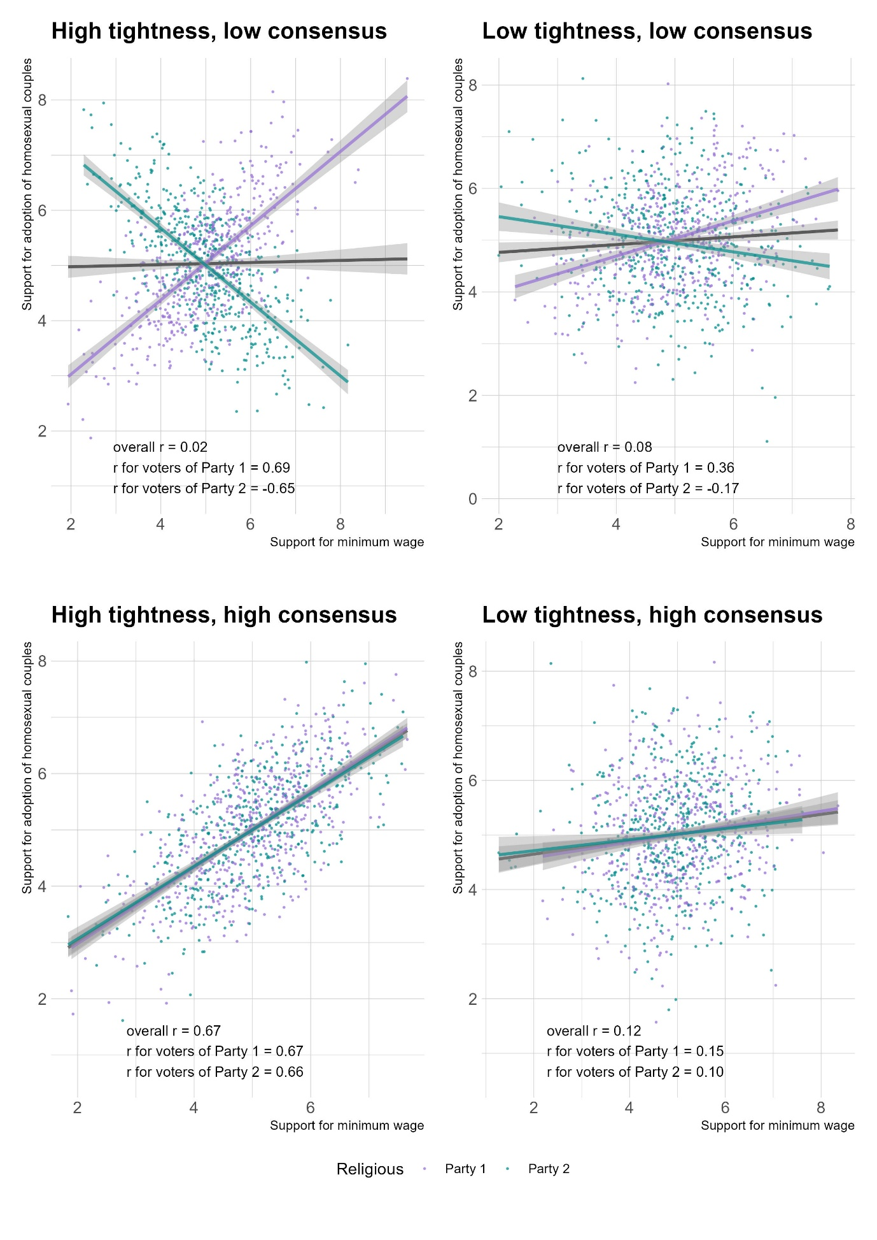

*Caption:* A typology of belief constraint. Belief tightness occurs when political attitudes are highly predictive of each other. Belief tightness occurs when social groups structure their political attitudes in a similar way.

### 2.3 Research hypotheses

Although prior research has examined belief system constraint cross-nationally (Keskintürk, 2022b), no empirical study has directly analyzed the Italian political belief system. Italy presents a compelling case for investigating belief structure, as its multiparty system fosters intense electoral competition and shifting ideological alignments. This environment provides an ideal setting to explore the interplay between the two dimensions of belief constraint: tightness and consensus.

This study analyzes Italian political attitudes following the September 2022 general election, in which the right-wing coalition—composed of Fratelli d’Italia (Brothers of Italy [FDI]), Lega (League [L]), and Forza Italia (Go Italy [FI])—secured a relative majority with 43.8% of the parliamentary vote. The primary left-wing coalition, including Partito Democratico (Democratic Party [PD]), Alleanza Verdi e Sinistra Italiana (Green and Left Alliance [AVS]), and +Europa (+Europe [+E]), won 26.1%. Meanwhile, the Movimento 5 Stelle (Five Star Movement [M5S]) ran independently, winning 15.4%, and a centrist alliance garnered 7.8% (Giovannini et al., 2023).

Building on the political belief systems literature, this research tests three hypotheses. The first concerns belief tightness, which refers to the extent to which attitudes are interrelated and mutually predictive. The theory of social constraint suggests that political knowledge fosters more structured belief systems, as politically engaged individuals internalize elite cues and organize their attitudes accordingly (Converse, 2006; Zaller, 1992). While this mechanism has been documented in the U.S. (Boutyline & Vaisey, 2017; Fishman & Davis, 2020), its generalizability to multiparty systems remains understudied. Thus, I propose:

*H1: Tightness hypothesis.* The belief system of people with high political knowledge is tighter than that of people with low political knowledge.

Second, I examine an alternative explanation for belief system organization. While political knowledge is a well-established predictor of attitudinal constraint, Converse (2006) acknowledged that education might play a similar role. Education and political knowledge are highly correlated in Western societies (Grönlund & Milner, 2006), making it crucial to distinguish their respective effects. Prior research using non-network methodologies has found that highly educated individuals exhibit greater attitudinal stability and consistency than the general public (Judd & Krosnick, 1982; Judd & Milburn, 1980; Peffley & Hurwitz, 1985). This suggests that belief system organization could stem not only from exposure to political discourse but also from cognitive skills associated with education, such as abstract reasoning and pattern recognition.

However, recent studies employing network approaches have produced mixed findings. Boutyline and Vaisey (2017) found that educational attainment does not significantly differentiate belief system tightness in the U.S., while Keskintürk (2022b) showed that a country’s average level of education is not reliably associated with attitudinal constraint. These results raise doubts about the direct role of education in structuring belief systems. Nevertheless, it remains important to test this possibility, as education could serve as an alternative pathway to belief constraint. In this scenario, attitudes would be strongly organized not due to exposure to elite cues but rather because higher cognitive abilities enable individuals to recognize and structure relationships between political beliefs.

*H2: Rival tightness hypothesis*. The belief system of individuals with high educational attainment is tighter than that of individuals with low educational attainment.

Finally, this study investigates a previously overlooked source of variation in political belief systems: the role of vote choice in shaping attitudinal structures. While scholars frequently stratify samples based on sociodemographic characteristics to examine how belief systems vary across population strata (e.g., Boutyline & Vaisey, 2017; Franetovic & Bertero, 2023; Schlicht-Schmälzle et al., 2018), they have largely excluded vote choice from this analysis. Methodologically, stratification is equivalent to a moderation approach, where the selected variable is assumed to shape the relationships between political attitudes (see Method section for details). Given this, the absence of vote choice as a moderating factor in past research is striking—perhaps reflecting the North American focus of most studies in this field.

In a two-party system like the U.S., where issue ownership (Petrocik, 1966) is clearly divided between Republicans and Democrats, belief systems are likely to be relatively uniform within each ideological camp. However, in multiparty systems, different electorates may interpret political competition in distinct ways, leading to meaningful variation in how political attitudes relate to one another. Some parties may issue conflicting cues on certain issues, while others may attempt to integrate diverse ideological positions into a single narrative. Examining belief networks across electorates thus allows us to assess whether different voters structure their political beliefs in similar ways or whether they fundamentally disagree on how issues should be bundled.

To test this possibility, I estimate the belief systems of supporters of the three largest political factions in the 2022 Italian general election: the right-wing coalition (FDI, L, FI), the left-wing coalition (PD, AVS, +E), and the Five Star Movement (M5S). If vote choice plays a structuring role, we should observe systematic differences in attitudinal associations across electorates. Within the framework of social constraint theory, public attitudes are shaped by party cues. When parties provide conflicting cues on key issues, this should lead to low consensus at the public level, resulting in heterogeneous belief structures across electorates.

*H3: Consensus hypothesis*. The associations between political attitudes are moderated by self-reported vote choice.

## 3. Method

### 3.1 Data and variables

Analyses are based on the fifth wave of ResPOnsE data, an Italian dataset endowed with a Rolling Cross-Sectional design (Vezzoni et al., 2020)[2]. The sample is obtained with quotas by area of residence, gender, and age group. Wave five was fielded between October 20 to December 15, 2022, through a multipurpose CAWI questionnaire. The other waves of this dataset mostly focus on the pandemic. However, this wave was polled one month after the general elections of September 25, 2022, and thus included numerous variables tapping into symbolic and operational components of the Italian political belief system. ResPOnsE is composed of a core module, filled out by all respondents, and other thematic sections shown to smaller sample partitions where participants are randomly assigned. This work features dedicated survey batteries that were supplied to a total of 1850 respondents. List-wise deletion reduced the sample to 1149 respondents[3].

Table 1 (below) reports labels and survey questions for each attitudinal variable featured in the analyses. Descriptives are provided in Table 1 of the Supplement. Variables are measured on different scales, and their polarity is aligned to have high values indicating support for all issues and attachment to parties. Attitudes were considered symbolic when they measured support or attachment to political labels and parties, and operational when they measured endorsement of policy proposals that could be implemented by political parties (Ellis & Stimson, 2012; Free & Cantril, 1968)[4]. Symbolic components were surveyed through left-right self-placement and Propensity to Vote [PTV] items and are labeled in capital letters. The first item is the most established assessment of individuals’ positions on the left-right spectrum. Another set of variables measures the attachment to the five major Italian parties (FDI, L, and FI; PD; M5S). The PTVs prompt respondents to report their likelihood of voting for a particular party in a future election. These items capture the electoral utility respondents gain by voting for a party. Compared to vote choice, PTVs have the advantage of creating continuous data with high variance (see Table 1, Supplement) on the antecedents of vote choice (van der Eijk et al., 2006).

Consistent with previous research, most of the selected variables are operational issues (Boutyline & Vaisey, 2017; Brandt et al., 2019; Keskintürk, 2022b). Four variables tap into the ethical issues of adoptions by homosexual couples, abortion, euthanasia, and homosexual marriage, as they have all been salient in recent years in the Italian context. The recognition of same-sex couples in Italy was achieved in 2016 with the Cirinnà law, which excluded any reference to adoption by same-sex couples (Di Nicola, 2016). Abortion has been formally permitted in Italy since 1978 (Caldwell, 1981), but the conspicuous number of abstentionist doctors often impedes the practical availability of this right. Finally, the possibility of legalizing euthanasia has recently entered the Italian political arena, as the *political entrepreneur* Marco Cappato politicized the issue by assisting an Italian citizen willing to pursue it in Switzerland (Vergallo, 2019). Four other variables regard economic attitudes: income redistribution, the preferred role of the government (interventionist versus liberal), the desired policies to fight unemployment (subsidizing people versus aiding businesses), and a general evaluation of globalization. These attitudes are expected to be prominent in the political belief system, as inequality is described as the main issue informing left and right self-placement (Bobbio, 1996). I further designed a survey battery measuring attitudes towards the *flat tax*, minimum wage, citizenship income, and immigration since they were respectively the flagship proposals of the right-wing coalition, PD, and M5S during the 2022 electoral campaign (Bertero & Scaduto, 2023). Lastly, an item examines preferences for the supply of arms to Ukraine, as the Ukrainian war has recently shaken Italian public opinion. In addition to attitudinal items, the analyses require data on individual education, self-reported vote choice, and a four-point scale of political interest. Their frequency distribution is provided in Table 2 of the Supplement.

### 3.2 Analytical strategy

The analytical strategy is divided into network estimation (detailed in Section 3.3) and hypothesis testing (Section 3.4). Figure 1 (below) summarizes these steps. I fit two kinds of network models. First, I estimate partial correlational networks on the subsamples of individuals with low and high levels of political interest and education. Second, I adopt moderated network models to investigate the impact of vote choice using moderation analyses rather than stratificational approaches.

*Figure 2: Analytical strategy*

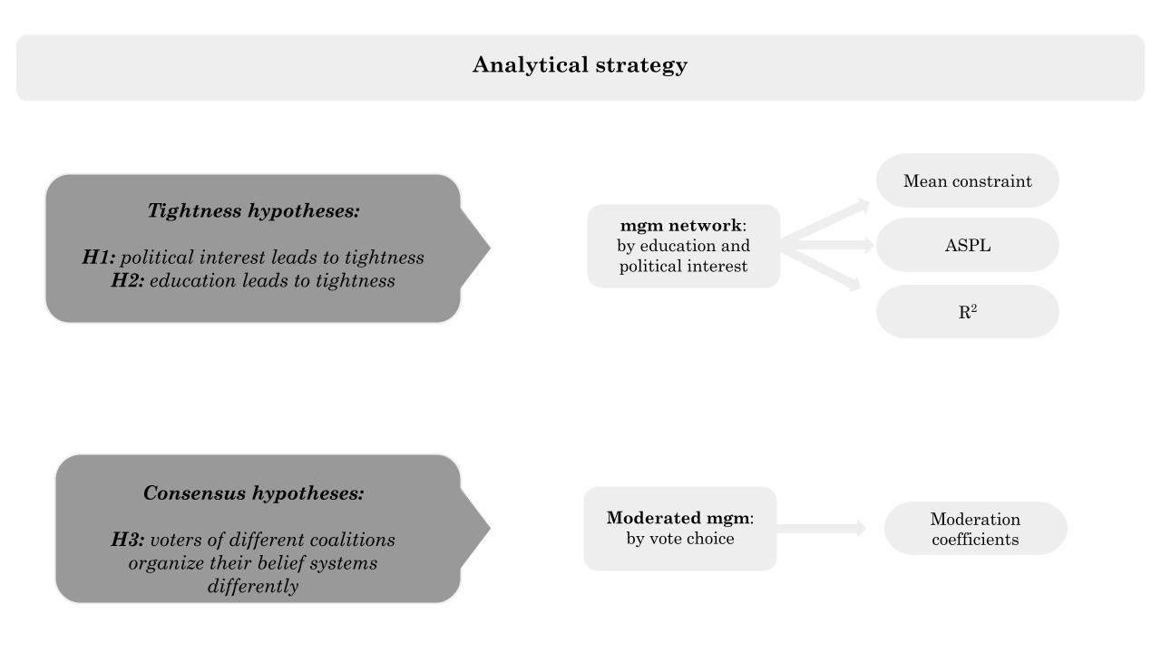

*Table 1: Label and survey questions*

|  |  |  |
| --- | --- | --- |
| **Label** | **Question** | **Scale** |
| L_R | Many people when talking about politics use the terms "left" and "right." Thinking about your political views, where do you stand? | 0 (Left)  10 (right) |
| PTV_PD | [Among the various parties we have in Italy, each would like to have your vote in the future. Regardless of how you plan to vote in the next election,] how likely are you to vote for the Partito Democratico in the future? | 0 (Not likely)  10 (Very likely) |
| PTV_FI | [...] how likely are you to vote for Forza Italia in the future? | 0 (Not likely)  10 (Very likely) |
| PTV_L | [...] how likely are you to vote for Lega in the future? | 0 (Not likely)  10 (Very likely) |
| PTV_M5S | [...] how likely are you to vote for Movimento 5 Stelle in the future? | 0 (Not likely)  10 (Very likely) |
| PTV_FDI | [...] how likely are you to vote for Fratelli d’Italia in the future? | 0 (Not likely)  10 (Very likely) |
| adopt | [On political issues people have different opinions. What is your level of agreement with the following statements? Do you strongly agree, somewhat agree, slightly agree, or strongly disagree?] Gay and lesbian couples should have the same right to adopt a child as heterosexual couples | 1 (Disagree)  4 (Agree) |
| abort* | [...] Abortion must be made more difficult | 1 (Disagree)  4 (Agree) |
| eutha | [...] Euthanasia should be legal | 1 (Disagree)  4 (Agree) |
| marria | [...] Legalization of same-sex marriage is a good thing | 1 (Disagree)  4 (Agree) |
| redis | [Now we would like to know your opinion on some political issues. For each of the following statements, indicate your position on a scale ranging from 1=completely disagree, to 6=completely agree. If your opinion is roughly in the middle between the two, you may choose any other point on the scale.] It is necessary to reduce income differences between those with high incomes and those with low incomes. | 1 (Disagree)  6 (Agree) |
| flat_t | [...] It is necessary to introduce a flat tax (fixed tax rate, regardless of income). | 1 (Disagree)  6 (Agree) |
| m_wage | [...] A minimum hourly wage must be introduced by law. | 1 (Disagree)  6 (Agree) |
| cit_in | [...] It is necessary to maintain a guaranteed citizenship income for those below the poverty line. | 1 (Disagree)  6 (Agree) |
| globa* | [...] It is necessary to limit economic globalization. | 1 (Disagree)  6 (Agree) |
| immig | [...] It is necessary to give citizenship more easily to the children of legal immigrants born and raised in Italy. | 1 (Disagree)  6 (Agree) |
| big_go | Some say taxes should be reduced even at the cost of reducing public services. Others say services should be expanded even at the cost of raising taxes. Where would you place your opinion on a scale of 1 to 7? | 1 (Lower taxes)  7 (Extend ublic services) |
| pub_pri* | Resources to counter the negative effects of unemployment are limited. In such a situation, do you think it is more effective to give subsidies to people in economic hardship or to help businesses that hire? Please indicate where you would place your opinion on a scale of 1 to 7. | 1 (people)  7 (businesses) |
| ukrai* | Thinking about the war in Ukraine, do you favor or oppose supplying arms to Ukraine | 1 (Favor)  4 (Oppose) |

*Caption:* Survey variables and labels. The polarity of items marked with an asterisk was inverted. High scores indicate support for an issue or attachment to a label. Squared brackets replace prompts common to multiple questions.

### 3.3 Network models

I estimate two classes of Pairwise Markov Random Field models [PMRFs] (Lauritzen, 1996). These models render survey variables as nodes of a weighted network. The main difference between these models is edge estimation.

**Mixed Graphical Model [mgm].** The mgm uses survey data to estimate the unique variance shared between each pair variable in the analyses. The result is a weighted and signed adjency matrix, which informs the network visualization. This models encodes conditional independences as absent edges in the network plot (Lauritzen, 1996). Unlike correlational networks, PMRF produces sparse graphs. This has the advantage of closing the gap between the network theory of belief system —which posits causality between political beliefs— and their empirical examination in political science —which is currently anchored to plain correlational approaches. Testing H1 and H2 requires node-wise and aggregated estimates or R2. Hence, I adopt a mixed graphical model in which all variables are considered quasi-continuous ([mgm]; Epskamp, Waldorp, et al., 2018). This model involves a loop of node-wise regularized regressions. The resulting regression coefficients are plotted as network edges. The regularization technique of choice is a variant of the least absolute shrinkage and selection operator called graphical LASSO (Tibshirani, 1996). The appropriate level of the tuning parameter of the regularization procedure is found by minimizing the Extended Bayesian Information Criteria (Chen & Chen, 2008). By treating all variables as quasi-continuous, the mgm reduces to a Gaussian Graphical Model ([GGM] Epskamp, Waldorp, et al., 2018; Haslbeck & Waldorp, 2020), whose edges are interpretable as signed, regularized partial correlations (Burger et al., 2023). In this way, this research cumulates on the most recent work on belief systems in political psychology (Brandt et al., 2019; Brandt & Sleegers, 2021). I fit four mgm models, one on each same sample partition I obtain by stratifying the pool of individuals at the median levels of political interest and education.

**Moderated Network Model [MNM].** Estimating mgm models on the four sample partitions equals traditional moderation analyses, where researchers observe variations of pair-wise statistical associations at varying levels of a third intervening variable. However, this modeling strategy reduces statistical power by fitting separate models on smaller sample sizes. I thus use a second variant of the mgm, which estimates a moderated network model (mnm) (Haslbeck, 2022). This consists of a GGM in which each pairwise interaction is modified to include a possible moderation effect of an external variable. Significant moderators are again isolated through the combination of the graphical Lasso and EBIC. I fit the mnm on the full sample, specifying self-reported vote choice (left-wing, right-wing coalition, and M5S) as the moderator. I adopt the mnm to avoid the Berkson bias (Westreich, 2012). When stratifying the sample by the sociodemographic variables, I obtain subsamples where the variance of political attitudes is preserved. Yet, the vote-choice stratification would restrict their variance, violating the assumptions of the resulting network models (De Ron et al., 2021).

### 3.4 Hypothesis testing

In this Section, I detail the hypothesis testing phase. I test H1 and H2 using four mgm, each fitted on the sample partitions of political interest and education. Then, I test H3 using the MNM, in which self-reported vote choice is the moderator. In the remainder of the Section, I detail and motivate the strategies with which I test the main proposition of the belief system theory.

**Mean constraint.** Mean constraint is the most widely used measure of belief system tightness in the social sciences (Boutyline & Vaisey, 2017; Keskintürk, 2022a, 2022b). It is defined as the average value of network edges. In Belief Network Analysis, edges are typically estimated by squaring zero-order correlation coefficients or taking their absolute values (DellaPosta, 2020). However, applying this measure to test H1 and H2 in mgm networks requires adjustments, as partial correlation models are sparser and contain many null associations. To account for this, mean constraint is computed as the mean absolute value of non-zero edges, ensuring an unbiased test of H1 and H2 using a conventional belief tightness metric.

To statistically evaluate H1 and H2, I employ nonparametric bootstrapping (Efron, 1979). I generate 10,000 bootstrap samples within each of the four sample partitions, yielding a total of 40,000 resampled datasets. For each bootstrapped sample, I re-estimate both correlational and mgm networks, producing four bootstrapped distributions of mean constraint. I first assess the suitability of these distributions for ANOVA. If assumptions are violated, I use the Mann-Whitney U test, a nonparametric alternative. By comparing mean constraint values across correlational and mgm networks, I assess whether political interest and education primarily increase raw shared variance or unique associations among Italian political attitudes.

**ASPL.** Mean constraint provides a raw measure of connectivity by summarizing edge strength without considering their positions in the network. While high constraint values indicate stronger average connections, networks with identical constraint scores can exhibit drastically different structures. For instance, one network may have uniformly distributed edge weights, while another may display a bimodal distribution, leading to significant differences in overall connectivity. In extreme cases, these structural variations can result in vastly different levels of network integration. To address this, I conduct an additional test of H1 and H2 by computing the Average Shortest Path Length (ASPL) for the stratified mgm networks. ASPL is calculated as the mean shortest path between all nodes, weighted by the absolute magnitude of their connections (Opsahl et al., 2010). Higher ASPL values indicate a sparser network, where beliefs are more loosely connected. As with the mean constraint test, I evaluate H1 and H2 by comparing the bootstrapped ASPL distributions between high and low groups, assessing whether political interest and education shape the structural cohesion of belief networks.

**R2.** The decomposition of constraint into tightness and consensus enables an additional test of the organization of the Italian political belief system. If belief systems are tighter, political attitudes should be more embedded within the network, making them more predictive of each other. To assess this, I compute node-wise R² values for the mgm networks (Haslbeck & Waldorp, 2018). This metric, derived from regularized OLS regression, is conceptually and computationally analogous to standard R², quantifying how well a given node is predicted by the rest of the network. I compare two key statistics. First, I examine whether R² values are higher in the high-interest and high-education groups than in their low counterparts. This node-wise comparison reveals whether any observed increase in explained variance is driven by a small subset of nodes or is evenly distributed across the network. Second, I compute the bootstrapped distribution of mean node-wise R² to statistically test H1 and H2. This approach provides a rigorous assessment of whether political interest and education enhance the predictability of attitudes within the belief network.

**Moderation coefficients.** Testing H3 requires a comparison of the belief systems of different electorates. However, stratifying the sample by self-reported vote choice would undermine the assumption of the mgm, as it would produce partitions where political attitudes exhibit reduced variance. Instead, I implement the MNM described in Section 3.3. This approach allows for a direct test of H3 by identifying network edges significantly moderated by party choice, revealing how political alignment influences the structure of belief systems.

## 4. Results

Figure 2 presents the results of the mgm network estimation for different sample partitions based on political interest and education levels. Nodes represent political attitudes (labeled according to Table 1) and are colored based on their classification into symbolic or operational attitudes. Yellow pies around nodes indicate R2. Edges represent regularized partial correlations (Burger et al., 2023), where blue edges indicate positive and red edges indicate negative associations. Edge thickness reflects association strength. The spatial arrangement follows a force-directed algorithm, and the network layout is standardized to ease comparison (Fruchterman & Reingold, 1991).

The top left panel shows the belief system of individuals with low political interest. The strongest associations are between the support for homosexual marriage and adoption rights (β = 0.51), while the weakest is between the support for citizenship income and the propensity to vote for FDI (β = 0.02). The top right panel illustrates the belief system of individuals with high political interest, which is denser. The strongest connection is again the support of homosexual marriage and adoption rights (β = 0.51), whereas the weakest association is between the preference for big government and support for euthanasia (β = 0.01).

The bottom left panel represents low education levels. The strongest connection occur again between support for homosexual marriage and adoption rights (β = 0.52), while the weakest association is between big government and adoption rights (β = 0.01). The bottom right panel depicts the belief system of highly educated individuals, where the strongest association remains the one between homosexual marriage and adoption rights (β = 0.51), and the weakest involves big government and euthanasia (β = 0.02). Across all networks, weaker associations tend to involve Ukraine policy and economic attitudes, which are peripheral in the belief systems.

Mean constraint, the most common measure of belief system tightness, is lowest among individuals with low political interest (0.08) and highest among those with high political interest (0.11), while education-based partitions fall in between (Low: 0.09, High: 0.10). Node-wise R² values indicate that far-right party preferences (PTV_FDI, PTV_L) are the most structurally embedded attitudes, whereas PTV_M5S remains the least integrated across all networks. Additionally, belief systems stratified by education exhibit a comparable number of edges (58 vs. 66), whereas those of politically disengaged individuals contain nearly half the connections found in the belief systems of politically engaged individuals (39 vs. 74). These findings preliminarily support H1 and H2, suggesting that political engagement and education enhance the internal consistency of belief systems and increase the predictiveness of political attitudes.

*Figure 3: Italian belief systems by Political Interest and Education*

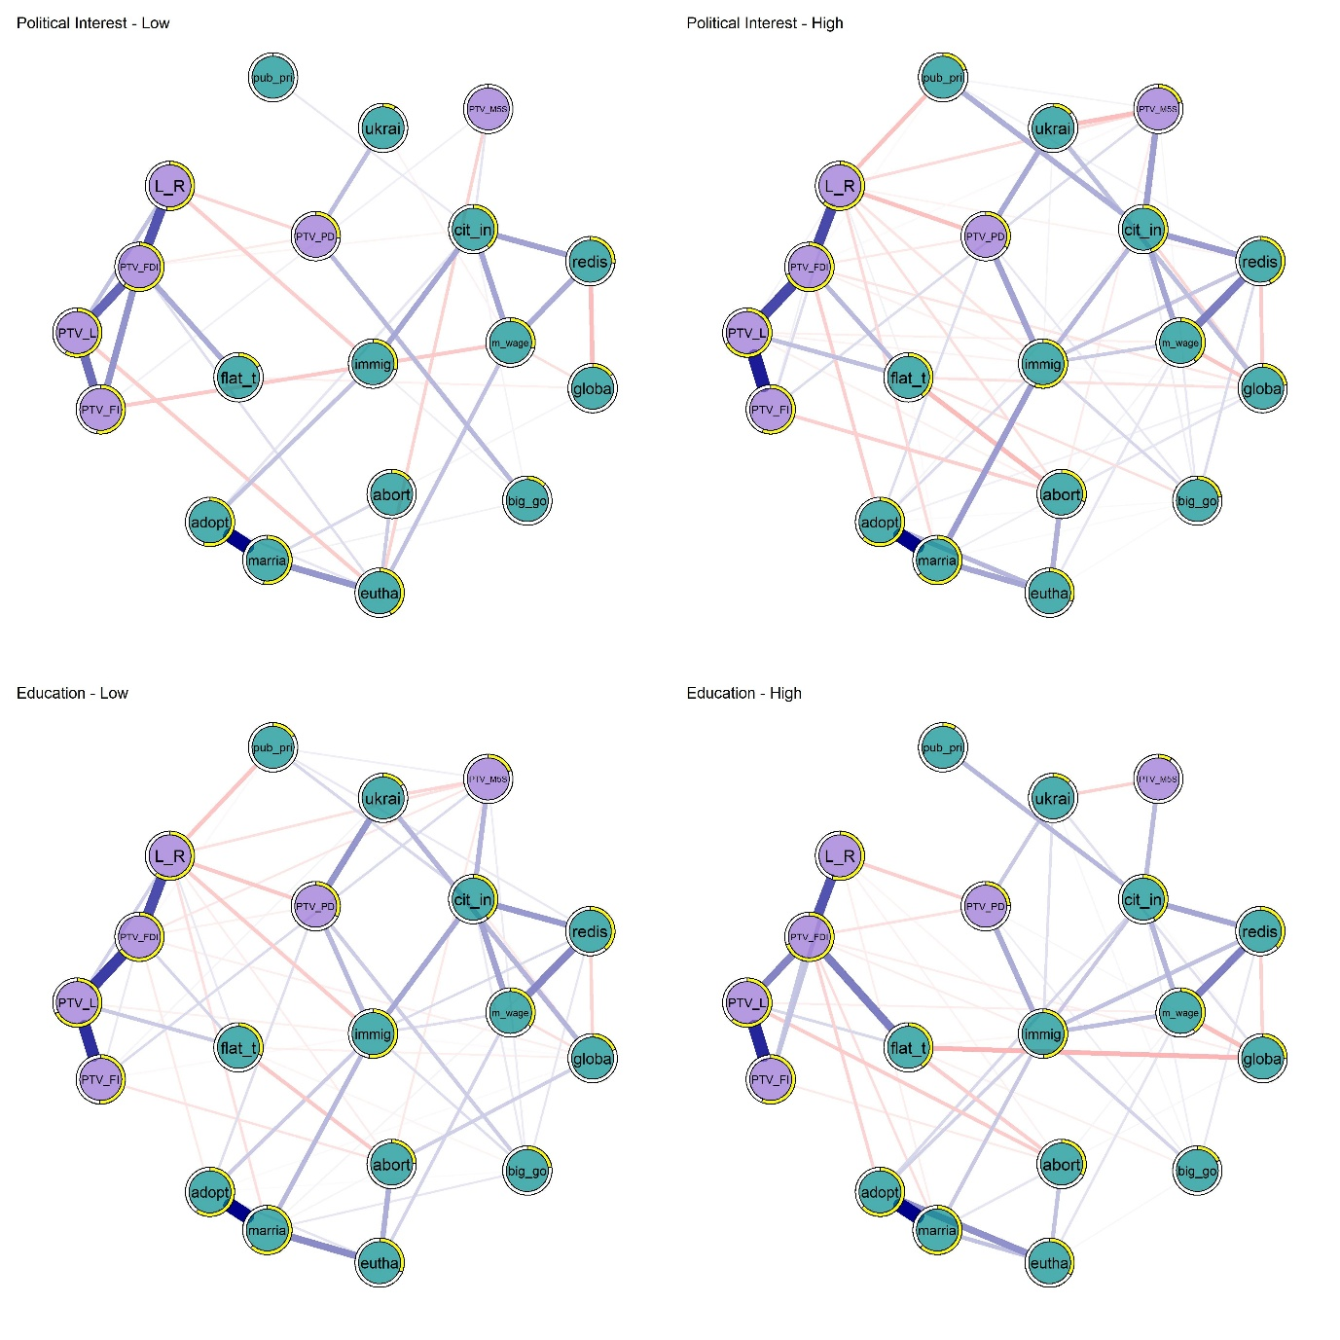

*Caption:* Political belief systems of Italians with low versus high political interest (top panels) and low versus high education (bottom panels). The plot shows mgm networks, where nodes are colored according to variable type (symbolic or operational). The yellow borders of the nodes indicate R2 values. Edges indicate regularized partial correlations, with blue [red] colors for positive [negative] associations. Node labels follow Table 1: *L_R* = Left right self-placement; *PTV_PD* = Propensity to vote for PD; *PTV_FI* = Propensity to vote for FI; *PTV_L* = Propensity to vote for L; *PTV_M5S* = Propensity to vote for M5S; *PTV_FDI* = Propensity to vote for FDI; *adopt* = Stepchild adoption; *abort* = Abortion; *eutha* = Euthanasia; *marria* = Homosexual marriage; *redis* = Redistribution; *flat_t =* Flat tax; *m_wage* = Minimum wage; *cit_in* = Citizenship income; *globa =* Globalization; *immig* = Immigration; *big_go* = Big government;  *pub_pri =* Public vs private; *ukrai* = Weapons to Ukraine

*Table 2: Tests of H1 and H2*

| **Comparison** | **W** | **p** | **Δ** | **Lower CI** | **Upper CI** | **Rank** | **CLES** |
| --- | --- | --- | --- | --- | --- | --- | --- |
| Mean Constraint - Political Interest | 94,315 | 0.000 | 0.998 | 0.998 | 0.998 | 0.998 | 0.999 |
| Mean Constraint - Education | 18,745,672 | 0.000 | 0.625 | 0.613 | 0.637 | 0.625 | 0.813 |
| ASPL - Political Interest | 19,608,272 | 0.000 | 0.608 | 0.596 | 0.620 | 0.608 | 0.804 |
| ASPL - Education | 65,438,508 | 1.000 | -0.309 | -0.324 | -0.294 | -0.309 | 0.346 |
| R² - Political Interest | 153,666,612 | 0.000 | 0.149 | 0.137 | 0.160 | 0.149 | 0.574 |
| R² - Education | 179,265,932 | 0.124 | 0.007 | -0.005 | 0.019 | 0.007 | 0.503 |

Caption: Results of the one tail Mann-Whitney U tests comparing network properties between low and high groups for political interest and education. The table reports W-statistics, p-values, and effect sizes, including Cliff’s Delta (Δ), 95% confidence intervals (CI), rank-biserial correlations, and the Common Language Effect Size (CLES).

To evaluate H1 and H2, I bootstrap 10,000 samples starting from each of the original partitions. I then re-estimate networks on the 40,000 samples to compare the belief system structures of individuals with high versus low political interest and high versus low education. Specifically, I analyze differences in mean constraint, ASPL, and node-wise R², using Mann-Whitney U tests when parametric assumptions are violated. I assess normality with the Shapiro-Wilk test, and homogeneity of variance with Levene’s test. The results, summarized in Table 3 (Supplement), indicate significant deviations from normality across all measures (p < .001), except for ASPL in high-education groups (p = .108). Additionally, Levene’s test suggests violations of homogeneity for most comparisons (p < .001), apart from R² in education-based partitions (p = .384).

These violations suggest proceeding with the non-parametric Mann-Whitney U tests rather than ANOVA to compare the distribution of network properties across groups. Given my theoretical expectations, I tested for higher mean constraint and R² in high groups, while for ASPL, I expected lower values in the high groups, indicating greater network density. Table 2 provides the results of these one-tailed tests. In line with H1, politically engaged individuals develop more structured, interconnected, and predictable belief systems. Mean constraint is indeed significantly higher in the high-interest group (W = 94,315, p < .001, Δ = 0.998), suggesting that politically engaged individuals hold attitudes that are more tightly integrated. The higher R² (W = 153,666,612, p < .001, Δ = 0.149) indicates that their political beliefs are more mutually reinforcing and predictive of one another. Additionally, ASPL is significantly lower in the high-interest group (W = 19,608,272, p < .001, Δ = 0.608), meaning their belief systems are more densely connected. For education, results provide only partial support for H2. Mean constraint is significantly higher in the high-education group (W = 18,745,672, p < .001, Δ = 0.625), but the effect is smaller than for political interest, indicating that education contributes to belief system tightness but to a lesser extent than engagement. However, neither ASPL nor R² showed significant differences between education groups, suggesting that education alone does not fundamentally alter the density or predictability of belief systems.

To ensure the robustness of the findings for H1, I conducted additional analyses using an alternative dichotomization of political interest. While the primary sample partitions were based on a median split (1–3 vs. 4), I re-estimated the bootstrapped distributions of mean constraint, ASPL, and R² using a more restrictive threshold, defining the low-interest group as 1–2 and the high-interest group as 3–4. The results, reported in Table S4 (Supplement), confirm the stability of the effects. Mean constraint remains significantly higher in the high-interest group (W = 94,315, p < .001, Δ = 0.998), reaffirming that politically engaged individuals hold more tightly integrated attitudes. The lower ASPL in the high-interest group (W = 19,608,272, p < .001, Δ = 0.608) further supports the notion that their belief systems are denser and more interconnected. Finally, R² values remain significantly greater for high-interest individuals (W = 153,666,612, p < .001, Δ = 0.149), indicating that political attitudes in this group are more predictive of one another.

Together, these results confirm that political interest plays a dominant and robust role in structuring belief systems, as its effects are consistent across all measures of belief system organization (mean constraint, ASPL, and R²). In contrast, the impact of education is only robust for mean constraint but does not extend to ASPL or R².

To gain a deeper understanding on R² results, Figure 3 visualizes node-wise differences between high and low political interest and education groups. Precise values are reported in Table S5 (Supplement). This descriptive visualization re-confirms H1 and further rejects H2. Political interest systematically increases R² values, with an average node-wise difference of 0.108, meaning political attitudes are 10.8% more predictable of each other in the high-interest group. The largest effects emerge for the support of immigration (Δ = 0.26) and flat tax (Δ = 0.23), indicating that politically engaged individuals hold more structured attitudes on key cultural and economic issues. In contrast, education does not systematically increase R² values. In fact, in 9 out of 19 cases, R² values are higher in the low-education group, contradicting expectations. While flat tax (Δ = 0.10) shows a notable increase, the overall pattern is inconsistent, suggesting that education alone does not reliably enhance the integration of political attitudes within belief systems.

*Figure 4: Beliefs’ constraint by levels of political interest and education*

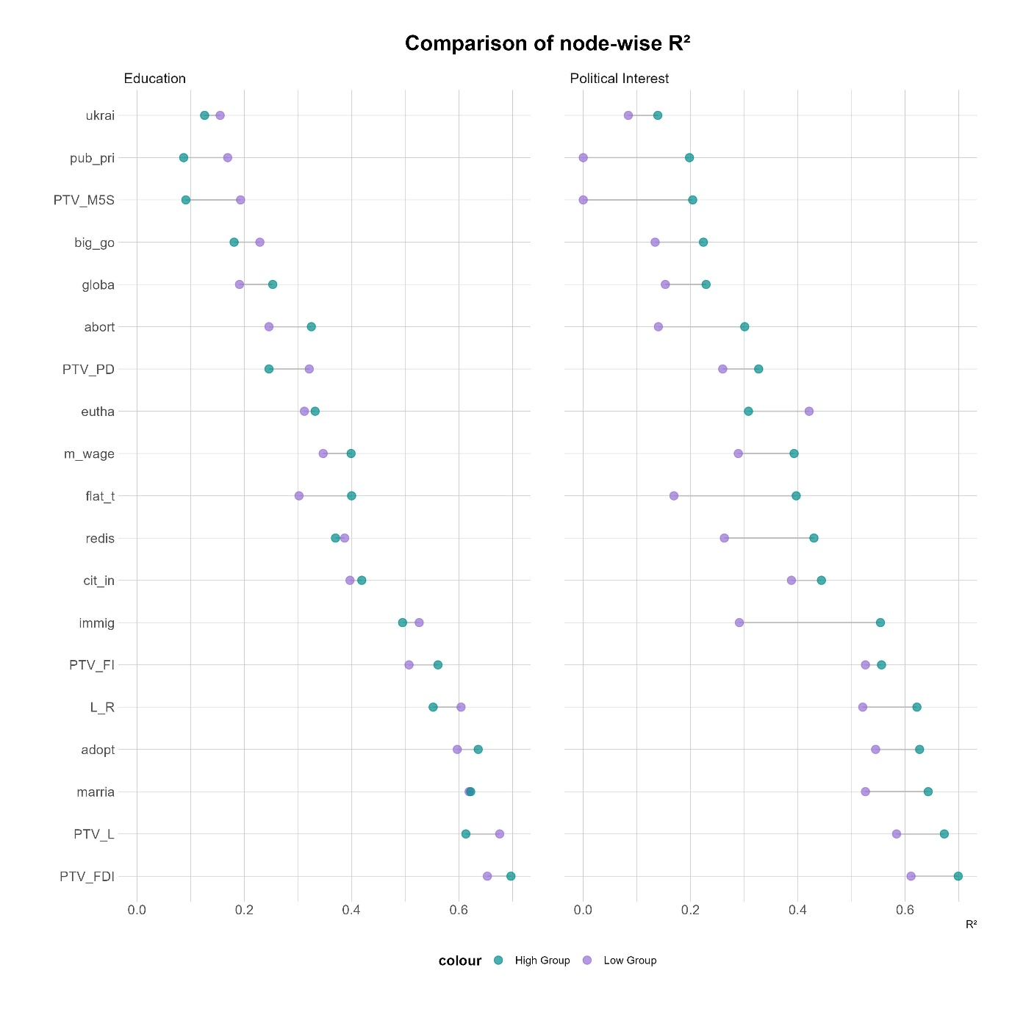

*Caption:* Comparison of node-wise R2 across the belief systems of people with different levels of education (left) and political interest (right panel). Violet dots represent the values nodes score in the low groups; green indicate the node-wise R2 values in the belief systems of the high education and interest groups. Dots are linked by lines, which visualizes the gap in the portion of explained variance of these variables.

Finally, I evaluate whether voters of different political coalitions possess heterogeneous belief systems. The consensus hypothesis predicts the relationships between the Italian political attitudes are moderated by self-reported vote choice. In the presence of drastic moderations, the belief systems of Italian voters would be so heterogeneous to bias the estimation of tightness. Figure 5 (below) shows the results of the MNM where self-reported vote choice (Left, M5S, or right-wing coalition) is specified as the moderating variable. Each panel of the figure is obtained by conditioning all pairwise associations by different levels of the moderator (1,2,3). Similarly to Figure 1, the edges of the plot represent conditional dependences, and absent edges mean two attitudes are independent if controlling for the rest of other nodes. Unlike in the previous plot, I added the yellow node *vote_cat*, which signals vote choice was specified as the moderator. It is important to remark that the three panels represent the prediction of the same moderated network model, for different levels of vote choice. Node layout is standardized to ease the comparison of edge strength, and edges are plotted with reduced width to facilitate the detection of the moderation effect —which occurs when a given edge is estimated with a different magnitude in the three panels.

The three belief systems mildly differ. Out of 171 possible edges in the model, fourteen edges are significantly moderated by self-reported vote choice between the belief systems of the left and of the M5S; eleven edges differ between the belief systems of the left and of the right; twenty-three pairwise associations significantly differ when comparing the network of the right-wing voters and of the M5S. Thus, left and right-wing voters show the highest similarity, the belief systems of the rightist voters and those of the supporters of the M5S differ the least, and the networks of the left and of the M5S are in the middle position. This comparison provides information on the sheer number of identical —that is, un-moderated— edges in the network models. To gain a deeper understanding of the patterns of moderation, I contrast the three belief systems specifying the edges that differ the most.

When comparing leftist and rightist belief systems, the most important differences regard the associations between symbolic components of the network. According to the leftist, high intentions to vote for the M5S are detached from favorable vote intentions for the left-wing coalition (wPTV_M5S-PTV_PD = 0.000). Yet, right-wing voters perceive that voting for these two political factions is likely to satisfy the same electoral utilities (wPTV_M5S-PTV_PD = 0.473). The same pattern occurs when considering the propensity to vote for FDI and PD. In the belief systems of the left, these two items are conditionally independent (wPTV_FDI-PTV_PD = 0.000); in the belief system of the right, this association is significant and negative (wPTV_FDI-PTV_PD = -0.120).

*Figure 5: moderated network model, by self-reported vote choice*

Caption: Moderated Network Model with self-reported vote choice specified as the moderator. Blue edges represent positive regularized partial correlations, and red negative ones. A significant moderation effect occurs when an edge possesses a different width across the three panels. Node labels: *L_R* = Left right self-placement; *PTV_PD* = Propensity to vote for PD; *PTV_FI* = Propensity to vote for FI; *PTV_L* = Propensity to vote for L; *PTV_M5S* = Propensity to vote for M5S; *PTV_FDI* = Propensity to vote for FDI; *adopt* = Stepchild adoption; *abort* = Abortion; *eutha* = Euthanasia; *marria* = Homosexual marriage; *redis* = Redistribution; *flat_t =* Flat tax; *m_wage* = Minimum wage; *cit_in* = Citizenship income; *globa =* Globalization; *immig* = Immigration; *big_go* = Big government;  *pub_pri =* Public vs private; *ukrai* = Weapons to Ukraine. *Vote_cat* represents the moderator.

Similarly, the belief systems of the supporters of M5S and the left-wing coalition mainly differ concerning the associations between symbolic attitudes. For example, the propensity to vote for PD and FI are uncorrelated in the network of the left (wPTV_FI-PTV_PD = 0.000), and positively correlated for the voters of the movement (wPTV_FI-PTV_PD = 0.690). However, these belief systems also differ in how symbolic and operational attitudes are packed together. For example, M5S supporters perceive a stronger association between a high propensity to vote for their political faction and supporting their flagship proposal, the citizenship income (wPTV_M5S-cit_in = 0.052 for the left; 0.150 for the M5S). Also, left-wing voters do not perceive an association between a preference for giving subsidies to people in economic hardship rather than to private companies and the propensity to vote for their party (wPTV_PD-pub_pri = 0.000). Instead, the supporters of the movement think that voting for the PD relates to the desire to subsidize companies over citizens (wPTV_PD-pub_pri = -0.174).

When comparing the belief systems of the voters of the right-wing coalition with those of M5S voters, I retrieve important differences regarding associations between symbolic components, and between symbolic and operational ones. As in the previous comparison, these voters conceptualize the space of the political competition in different ways. The most striking difference regards the associations between the propensity to vote for the Movement and the PD (wPTV_PD-PTV_M5S = 0.000 for the supporter of the Movement; 0.473 in the belief system of the right). Moreover, these electorates pack together symbolic and operational components differently. For example, the supporters of the movement, unlike those of the right-wing coalition, believe that being in favor of the flat tax implies the approval of sending weapons to Ukraine (wflat_t-ukrai = 0.084).

As a final test for the tightness hypothesis, I fit two moderated network models where I specify political interest and education (low versus high, again with the median split) as the moderator. H1 and H2 predict increased tightness of the belief systems of the high groups. In Table 2, I have shown that the belief systems estimated on the high interest and high education partitions are characterized by higher mean constraint than those of the low groups. Yet only political interest produces significant differences regarding ASPL and R2. This should translate into several significant moderation effects for the moderated network model of political interest, and a few significant moderations in the model of education. Figure S1 (Supplement) plots the predicted edge weights of significantly moderated network edges for the low and high groups. The results support the anticipated pattern. Education only moderates two edges in a meaningful way (moderation coefficients greater than 0.03). Contrary to the more educated (wPTV_L-abort = -0.040), Italians with low education manifest no association between a high propensity to vote for the Lega and favoring restriction to abortion (wPTV_L-abort = 0.000). Moreover, people with higher education display a stronger association between the endorsement of the flat tax and a favorable view of globalization (Low group: wflat_t-globa: -0.053. High: wflat_t-globa h: -0.093). Political interest significantly moderates twenty-three associations. The strongest moderations involve *PTV_M5S* and *ukrai* (moderation coefficient: -0.086), *marria* and *immi* (coefficient: 0.061), and *L-R* and *pub_pri* (coefficient: -0.050). Out of these moderations, eleven involve the relationships between one symbolic and one operational attitude (44.44%), eleven feature two operational attitudes (44.44%), and only one regards two symbolic attitudes (4.35%).

## 5. Discussion and Conclusions

In this article, I have addressed both a methodological and a theoretical gap in the literature on belief systems. Converse’s (2006) theory of social constraint posits that political attitudes causally interact, yet empirical examinations have predominantly relied on simple correlational approaches (Boutyline & Vaisey, 2017; DellaPosta, 2020b; Keskintürk, 2022a, 2022b). To attenuate this limitation, I have embraced insights from recent works in political psychology by implementing regularized partial correlation network models (Brandt et al., 2019). These models enhance the analysis of zero-order correlations by isolating the shared variance between pairs of political attitudes. This approach has enabled me to conceptualize the Italian belief system as a sparse network founded on the non-spurious interactions between symbolic and operational political attitudes. Theoretically, I have extended the socio-centric theory of belief systems by introducing a bi-dimensional conceptualization of constraint: belief tightness and consensus. A belief system exhibits tightness when political attitudes are closely connected, thereby being highly predictive of each other. Following Converse, I propose that political interest and education level determine the extent to which voters assimilate cues from political parties, and I investigate whether individuals with high political interest and education have tighter belief systems compared to those less engaged or educated. The dimension of consensus assesses the degree to which belief systems vary across different population segments. This differentiation is crucial in multiparty systems, where voters from different coalitions receive conflicting cues from their parties, potentially leading them to organize their political attitudes in fundamentally different ways. Therefore, I explore the consensus within the Italian political belief system by analyzing how the belief systems of left-wing, right-wing coalition, and M5S voters compare.

I have evaluated the tightness hypotheses using multiple analytical tests. Building upon the political science literature on belief systems, I first compared the mean constraint —the mean edge value— of belief systems among individuals with differing levels of political interest and education. The findings clearly indicate that political interest significantly influences this measure of tightness. Secondly, I examined two other measure of belief tightness: ASPL and node-wise R2. Results showed that political interest significantly increases the connectivity of the belief systems, and that it also enhances the mean portion of explained variance of political attitudes. However, educational levels did not produce significant changes. This suggests that the political belief system of individuals with high political interests are more tightly structured and connected than those of individuals with low interest. Furthermore, the political attitudes of people with high interest are more predictive of each other. As a final test, I explored H1 and H2 with two MNM where I specified education and political interest as the moderators. Unlike educational level, political interest was found to significantly moderate the relationships among Italian political attitudes. Collectively, these results strongly support Hypothesis 1 and largely reject Hypothesis 2, affirming the foundational premise of the social constraint theory. Individuals with higher education levels exhibit well-structured belief systems, where attitudes are deeply embedded and highly predictive of one another. This indicates that politically informed individuals’ positions on various political attitudes are strongly influenced by their stances on other issues and by their symbolic attachment to Italian parties, rather than being dictated by other socio-psychological factors.

I have framed the consensus hypothesis in terms of moderation effects, with the expectation of identifying multiple instances where the relationship between political attitudes is moderated by self-reported vote choice—a proxy for the types of party cues voters are likely to receive. Generally, the most significant moderation effects relate to how different electorates consolidate their support for political parties. However, when comparing the belief systems across the three major political forces in Italy, I observed distinctive moderation patterns. Specifically, in comparing the belief systems of the left and the right, differences almost exclusively manifest in how they structure their voting intentions for political parties. In contrast, when comparing these two belief systems with that of the electorate of the M5S, I also detected moderation effects impacting the associations both between operational attitudes and between symbolic and operational attitudes. Nonetheless, the magnitude of these moderations was consistently smaller than those observed between symbolic components of the belief system. This suggests that while the belief systems of different electorates do indeed differ structurally, these differences are primarily attributed to how individuals endorse political parties rather than their support for specific operational issues within the Italian political landscape.

The results of this research have two main implications. Methodologically, I advocate for the adoption of ASPL and R2 as measures of belief tightness. Mean constraint is a raw measure of the coherence of a belief system, in that it detaches edges from their topological position in the network. ASPL, a measure of connectivity imported from network science, improves this operationalization by considering the precise location of edges within their belief system. Moreover, mean constraint was designed as proxy for testing the key idea of Converse, namely that the belief systems of the most educated are composed of political attitudes that are more predictive of each other, due to their higher reciprocal influence. R improves this measure, as it focuses explicitly on the portion of explained variance that the network model can account for in each belief. Theoretically, these results support the need to distinguish between tightness and consensus within belief systems. These systems are shaped not merely by the level of interdependence among political attitudes but also by the nature of the party cues received from preferred political parties. This distinction might be particularly salient in polarized multiparty systems.

This article acknowledges three significant limitations that future research should address. First, the quality of this paper would have been enhanced by employing a more representative sample of the Italian population. Secondly, future studies might rely on multiple indicators of political interest, and also investigate the impact of political knowledge. Finally, there is still room to intervene on the mismatch between the causal theory of belief systems and their predominantly cross-sectional empirical investigations. Possible strategies to bridge this gap are the adoption of longitudinal network models (Epskamp, 2020) or experimental research designs (Fishman & Davis, 2022; Turner-Zwinkels & Brandt, 2022).

## 6. References

Baldassarri, D., & Gelman, A. (2008). Partisans Without Constraint: Political Polarization and Trends in American Public Opinion. *SSRN Electronic Journal*. https://doi.org/10.2139/ssrn.1010098

Baldassarri, D., & Goldberg, A. (2014). Neither Ideologues nor Agnostics: Alternative Voters’ Belief System in an Age of Partisan Politics. *American Journal of Sociology*, *120*(1), 45–95. https://doi.org/10.1086/676042

Benedetta, C., & Vincenzo, M. (2020). Do environmental preferences in wealthy nations persist in times of crisis? The European environmental attitudes (2008-2017). *Italian Political Science Review/Rivista Italiana Di Scienza Politica*, *50*(1), 1–16. https://doi.org/10.1017/ipo.2019.3

Bertero, A., & Scaduto, G. (2023). A midsummer’s night dream: Political communication during the Italian 2022 electoral campaign. *Italian Journal of Electoral Studies QOE-IJES*. https://doi.org/10.36253/qoe-14224

Bobbio, N. (1996). *Left and right: The significance of a political distinction*. University of Chicago Press.

Boutyline, A., & Vaisey, S. (2017). Belief Network Analysis: A Relational Approach to Understanding the Structure of Attitudes. *American Journal of Sociology*, *122*(5), 1371–1447. https://doi.org/10.1086/691274

Brandt, M. J., Sibley, C. G., & Osborne, D. (2019). What Is Central to Political Belief System Networks? *Personality and Social Psychology Bulletin*, *45*(9), 1352–1364. https://doi.org/10.1177/0146167218824354

Brandt, M. J., & Sleegers, W. W. A. (2021). Evaluating Belief System Networks as a Theory of Political Belief System Dynamics. *Personality and Social Psychology Review*, *25*(2), 159–185. https://doi.org/10.1177/1088868321993751

Burger, J., Isvoranu, A.-M., Lunansky, G., Haslbeck, J. M. B., Epskamp, S., Hoekstra, R. H. A., Fried, E. I., Borsboom, D., & Blanken, T. F. (2023). Reporting standards for psychological network analyses in cross-sectional data. *Psychological Methods*, *28*(4), 806–824. https://doi.org/10.1037/met0000471

Caldwell, L. (1981). Abortion in Italy. *Feminist Review*, *7*(1), 49–63. https://doi.org/10.1057/fr.1981.4

Chen, J., & Chen, Z. (2008). Extended Bayesian information criteria for model selection with large model spaces. *Biometrika*, *95*(3), 759–771. https://doi.org/10.1093/biomet/asn034

Cicco, G. D., Renzib, A., Marianib, R., Negric, A., Tranib, M. D., & Lauriola, M. (2023). Between populism and egalitarianism: Mapping attitudes toward social and political issues during the Draghi government using exploratory graph analysis. *Psychology Hub*. https://doi.org/10.13133/2724-2943/17982

Cohen, G. L. (2003). Party Over Policy: The Dominating Impact of Group Influence on Political Beliefs. *Journal of Personality and Social Psychology*, *85*(5), 808–822. https://doi.org/10.1037/0022-3514.85.5.808

Conti, N., & Memoli, V. (2015). Show the money first! Recent public attitudes towards the EU in Italy. *Italian Political Science Review/Rivista Italiana Di Scienza Politica*, *45*(2), 203–222. https://doi.org/10.1017/ipo.2015.11

Converse, P. E. (2006). The nature of belief systems in mass publics (1964). *Critical Review*, *18*(1–3), 1–74. https://doi.org/10.1080/08913810608443650

De Ron, J., Fried, E. I., & Epskamp, S. (2021). Psychological networks in clinical populations: Investigating the consequences of Berkson’s bias. *Psychological Medicine*, *51*(1), 168–176. https://doi.org/10.1017/S0033291719003209

DellaPosta, D. (2020). Pluralistic Collapse: The “Oil Spill” Model of Mass Opinion Polarization. *American Sociological Review*, *85*(3), 507–536. https://doi.org/10.1177/0003122420922989

Di Nicola, P. (2016). Babies are not Born under a Cabbage Leaf. *Italian Sociological Review*, *Vol 6*, 293 Pages. https://doi.org/10.13136/ISR.V6I2.135

Efron, B. (1979). Bootstrap Methods: Another Look at the Jackknife. *The Annals of Statistics*, *7*(1). https://doi.org/10.1214/aos/1176344552

Ellis, C., & Stimson, J. A. (2012). *Ideology in America* (1st ed.). Cambridge University Press. https://doi.org/10.1017/CBO9781139094009

Epskamp, S. (2020). Psychometric network models from time-series and panel data. *Psychometrika*, *85*(1), 206–231. https://doi.org/10.1007/s11336-020-09697-3

Epskamp, S., Borsboom, D., & Fried, E. I. (2018). Estimating psychological networks and their accuracy: A tutorial paper. *Behavior Research Methods*, *50*(1), 195–212. https://doi.org/10.3758/s13428-017-0862-1

Epskamp, S., Waldorp, L. J., Mõttus, R., & Borsboom, D. (2018). The Gaussian Graphical Model in Cross-Sectional and Time-Series Data. *Multivariate Behavioral Research*, *53*(4), 453–480. https://doi.org/10.1080/00273171.2018.1454823

Fishman, N., & Davis, N. T. (2022). Change We Can Believe In: Structural and Content Dynamics within Belief Networks. *American Journal of Political Science*, *66*(3), 648–663. https://doi.org/10.1111/ajps.12626

Franetovic, G., & Bertero, A. (2023). How do people understand inequality in Chile? A study through attitude network analysis. *AWARI*, *4*. https://doi.org/10.47909/awari.42

Free, L., & Cantril, H. (1968). The Political Beliefs of Americans: A Study of Public Opinion. By Lloyd A. Free and Hadley Cantril. (New Brunswick: Rutgers University Press, 1967. Pp. 239. $10.00.). *American Political Science Review*, *62*(4), 1345–1346.

Fruchterman, T. M. J., & Reingold, E. M. (1991). Graph drawing by force‐directed placement. *Software: Practice and Experience*, *21*(11), 1129–1164. https://doi.org/10.1002/spe.4380211102

Giovannini, A., Valbruzzi, M., & Vampa, D. (2023). Special Issue Introduction – The 2022 Italian general election: A political shock or the new normal? *Italian Journal of Electoral Studies QOE-IJES*. https://doi.org/10.36253/qoe-14809

Grönlund, K., & Milner, H. (2006). The Determinants of Political Knowledge in Comparative Perspective. *Scandinavian Political Studies*, *29*(4), 386–406. https://doi.org/10.1111/j.1467-9477.2006.00157.x

Haslbeck, J. M. B. (2022). Estimating group differences in network models using moderation analysis. *Behavior Research Methods*, *54*(1), 522–540. https://doi.org/10.3758/s13428-021-01637-y

Haslbeck, J. M. B., & Waldorp, L. J. (2018). How well do network models predict observations? On the importance of predictability in network models. *Behavior Research Methods*, *50*(2), 853–861. https://doi.org/10.3758/s13428-017-0910-x

Haslbeck, J. M. B., & Waldorp, L. J. (2020). **mgm**: Estimating Time-Varying Mixed Graphical Models in High-Dimensional Data. *Journal of Statistical Software*, *93*(8). https://doi.org/10.18637/jss.v093.i08

Jost, J. T. (2006). The end of the end of ideology. *American Psychologist*, *61*(7), 651–670. https://doi.org/10.1037/0003-066X.61.7.651

Judd, C. M., & Krosnick, J. A. (1982). Attitude centrality, organization, and measurement. *Journal of Personality and Social Psychology*, *42*(3), 436–447. https://doi.org/10.1037/0022-3514.42.3.436

Judd, C. M., & Milburn, M. A. (1980). The Structure of Attitude Systems in the General Public: Comparisons of a Structural Equation Model. *American Sociological Review*, *45*(4), 627. https://doi.org/10.2307/2095012

Keskintürk, T. (2022a). Religious belief alignment: The structure of cultural beliefs from adolescence to emerging adulthood. *Poetics*, *90*, 101591. https://doi.org/10.1016/j.poetic.2021.101591

Keskintürk, T. (2022b). The organization of political belief networks: A cross-country analysis. *Social Science Research*, *107*, 102742. https://doi.org/10.1016/j.ssresearch.2022.102742

Lauritzen, S. L. (1996). *Graphical models* (Vol. 17). Clarendon Press.

Lavrakas, P. (2008). *Encyclopedia of Survey Research Methods*. Sage Publications, Inc. https://doi.org/10.4135/9781412963947

Malka, A., & Lelkes, Y. (2010). More than Ideology: Conservative–Liberal Identity and Receptivity to Political Cues. *Social Justice Research*, *23*(2–3), 156–188. https://doi.org/10.1007/s11211-010-0114-3

Mancosu, M., & Vassallo, S. (2022). The life cycle of conspiracy theories: Evidence from a long-term panel survey on conspiracy beliefs in Italy. *Italian Political Science Review/Rivista Italiana Di Scienza Politica*, *52*(1), 1–17. https://doi.org/10.1017/ipo.2021.57

Martin, J. L. (2002). Power, Authority, and the Constraint of Belief Systems. *American Journal of Sociology*, *107*(4), 861–904. https://doi.org/10.1086/343192

Opsahl, T., Agneessens, F., & Skvoretz, J. (2010). Node centrality in weighted networks: Generalizing degree and shortest paths. *Social Networks*, *32*(3), 245–251. https://doi.org/10.1016/j.socnet.2010.03.006

Peffley, M. A., & Hurwitz, J. (1985). A Hierarchical Model of Attitude Constraint. *American Journal of Political Science*, *29*(4), 871. https://doi.org/10.2307/2111185

Petrocik, J. R. (1996). Issue ownership in presidential elections, with a 1980 case study. *American Journal of Political Science*, 825–850.

Sandri, G., & Seddone, A. (2015). Sense or sensibility? Political attitudes and voting behaviour of party members, voters, and supporters of the Italian centre-left. *Italian Political Science Review/Rivista Italiana Di Scienza Politica*, *45*(1), 25–51. https://doi.org/10.1017/ipo.2015.2

Schlicht-Schmälzle, R., Chykina, V., & Schmälzle, R. (2018). An attitude network analysis of post-national citizenship identities. *PLoS ONE*, *13*(12), e0208241. https://doi.org/10.1371/journal.pone.0208241

Schoen, H., & Schumann, S. (2007). Personality Traits, Partisan Attitudes, and Voting Behavior. Evidence from Germany. *Political Psychology*, *28*(4), 471–498. https://doi.org/10.1111/j.1467-9221.2007.00582.x

Sindermann, Rozgonjuk, D., Kannen, C., & Montag, and Christian. (n.d.). How many Dimensions underlie Political Attitudes? An Exploratory Graph Analysis Approach. *OSF Preprints*. https://doi.org/10.31219/osf.io/98rhs

Tibshirani, R. (1996). Regression Shrinkage and Selection Via the Lasso. *Journal of the Royal Statistical Society: Series B (Methodological)*, *58*(1), 267–288. https://doi.org/10.1111/j.2517-6161.1996.tb02080.x

Tucker, J. A., Pacek, A. C., & Berinsky, A. J. (2002). Transitional Winners and Losers: Attitudes toward EU Membership in Post-Communist Countries. *American Journal of Political Science*, *46*(3), 557. https://doi.org/10.2307/3088399

Turner-Zwinkels, F. M., & Brandt, M. J. (2022). Belief system networks can be used to predict where to expect dynamic constraint. *Journal of Experimental Social Psychology*, *100*, 104279. https://doi.org/10.1016/j.jesp.2021.104279

van der Eijk, C., Brug, W. van der, Kroh, M., & Franklin, M. (2006). Rethinking the dependent variable in voting behavior: On the measurement and analysis of electoral utilities. *Electoral Studies*, *25*(3), 424–447. https://doi.org/10.1016/j.electstud.2005.06.012

Vegetti, F., & Littvay, L. (2022). Belief in conspiracy theories and attitudes toward political violence. *Italian Political Science Review/Rivista Italiana Di Scienza Politica*, *52*(1), 18–32. https://doi.org/10.1017/ipo.2021.17

Vergallo, G. M. (2019). The Marco Cappato and Fabiano Antoniani (dj Fabo) Case Paves the Way for New Assisted Suicide Legislation in Italy: An Overview of Statutes from Several European Countries. *European Journal of Health Law*, *26*(3), 221–239. https://doi.org/10.1163/15718093-12261428

Vezzoni, C., Ladini, R., Molteni, F., Dotti Sani, G. M., Biolcati, F., Chiesi, A., Maraffi, M., Guglielmi, S., Pedrazzani, A., & Segatti, P. (2020). Investigating the social, economic and political consequences of Covid-19: A rolling cross-section approach. *Survey Research Methods*, 187-194 Pages. https://doi.org/10.18148/SRM/2020.V14I2.7745

Vezzoni, C., & Mancosu, M. (2016). Diffusion Processes and Discussion Networks: An Analysis of the Propensity to Vote for the 5 Star Movement in the 2013 Italian Election. *Journal of Elections, Public Opinion and Parties*, *26*(1), 1–21. https://doi.org/10.1080/17457289.2015.1102145

Vezzoni, C., Sani, G. M. D., Chiesi, A. M., Ladini, R., Biolcati, F., Guglielmi, S., Maggini, N., Maraffi, M., Molteni, F., Pedrazzani, A., & Segatti, P. (2022). Where does the Coronavirus come from? On the mechanisms underlying the endorsement of conspiracy theories on the origin of SARS-CoV-2. *Italian Political Science Review/Rivista Italiana Di Scienza Politica*, *52*(1), 51–65. https://doi.org/10.1017/ipo.2021.19

Westreich, D. (2012). Berkson’s bias, selection bias, and missing data. *Epidemiology (Cambridge, Mass.)*, *23*(1), 159–164.

Zaller, J. R. (1992). *The Nature and Origins of Mass Opinion* (1st ed.). Cambridge University Press. https://doi.org/10.1017/CBO9780511818691

1. M5S is a populist party that refuses to take a position on the left-right continuum (Vezzoni & Mancosu, 2016)
2. The potential of the rolling cross-sectional design was not exploited in this work. The final sample is obtained by merging the responses of all individuals who participated in the data collection. This is methodologically feasible due to the random assignment of respondents to the day of completion, which assures time is a random variable (for a thorough discussion of this survey design see Vezzoni et al., 2020).
3. The sample overrepresents males (639 respondents are males, 510 are women), is skewed towards an older sociodemographic profile (mean age in the sample is 53 years, against the national mean of 46.4), and presents severe disproportions regarding self-reported vote choice (359 individuals reported voting for the rightist coalition, 450 for the leftist, 195 for the M5S).
4. The distinction between operational and symbolic beliefs involves a margin of subjectivity. To mitigate this limitation, one contribution classified attitudes into symbolic, operational, and “cross-level” categories (Keskintürk, 2022b). This paper adopts the binary scheme, as it is more consistent with the theory behind this distinction, and as these labels have here a descriptive purpose only.