# Tightness and Consensus of Italian Political Attitudes

## Abstract

Political scientists have long recognized that political beliefs are not held in isolation. Building on Converse's work, research has demonstrated that high political interest enhances the interdependence between political attitudes, resulting in *tighter* belief systems. However, most of this research estimates belief systems using zero-order correlations between political attitudes, which can be spurious. Additionally, previous studies have not explored whether voters of different parties organize their support for parties and issues in markedly different ways. To address these shortcomings, I apply three types of network models to survey data from the 2022 Italian general election. The findings reveal that the tightness of belief systems depends on individual levels of political interest but not on education levels. Despite diverging on the normative positions they adopt, voters of the three biggest Italian political forces (M5S left and right-wing coalitions) organize their attitudes in a comparable way.

**Link to data and code:** https://github.com/arturobertero/IPBS_ggm

## 1. Introduction

Political scientists have long explored the *levels* of public attitudes. Many scholars have investigated the links between political attitudes and voting behaviors (e.g.: Sandri & Seddone, 2015; Schoen & Schumann, 2007). Others have isolated the determinants of attitudes toward political institutions, such as the European Union (Conti & Memoli, 2015; Tucker et al., 2002). A parallel strand of research examined attitudes towards hot socio-political issues like the environment (Benedetta & Vincenzo, 2020), conspiracy theories (Mancosu & Vassallo, 2022; Vezzoni et al., 2022), and political violence (Vegetti & Littvay, 2022). However, most of the literature has overlooked the broader *structure* in which political attitudes are embedded, which is the focus of this article. Political beliefs are not held in isolation, as individuals are at least partially motivated to assume coherent stances on the political issues gravitating in the public arena. This was first noted by Converse in his notorious study of the North American belief system (2006). Since his contribution, scholars from different disciplines have made great advancements in the field. These improvements have often been triggered by methodological innovations, such as network models in which political attitudes measured through surveys are treated as nodes of a weighted network representing the associations among these beliefs. Studies have shown that the amount of organization of a belief system is related to individual levels of political information and that political attitudes are organized around political identities (Boutyline & Vaisey, 2017), which are central to this system (Brandt et al., 2019). I argue that this body of work is characterized by two intertwined limitations. Firstly, the majority of research within political science has relied on modeling belief systems by computing zero-order correlation coefficients between political attitudes (Boutyline & Vaisey, 2017; DellaPosta, 2020a; Keskintürk, 2022b, 2022a). This approach primarily captures manifest associations between attitudes without ensuring that these relationships hold when statistically controlling for other intervening variables. Secondly, much of the progress in this area has been driven by studies focused on the bipolar political system of the United States (Baldassarri & Gelman, 2008; Baldassarri & Goldberg, 2014; Boutyline & Vaisey, 2017; DellaPosta, 2020a), which might not be representative of other political landscapes. This focus has potentially caused researchers to overlook critical questions about how belief systems vary among voters from different parties in more pluralized political systems. In a bipartisan setting, stark contrasts in issue ownership and political cues limit the emergence of significant differences among voter groups. However, this dynamic might shift dramatically in multiparty systems, where the political landscape is more complex and varied. To address these limitations, I investigate the nature and structure of the Italian political belief system through the adoption of network models. These procedures allow me to conceptualize several Italian political attitudes as nodes of a weighted network whose edges are estimated from survey data.

## The article is organized as follows: Section 2 provides a review of Converse's (2006) theory of social constraint and explores the methodological toolbox of network approaches to analyzing political attitudes. This section emphasizes the significance of distinguishing the influences of sociodemographic factors (such as political interest and education) and political factors (such as vote choice) on the Italian political belief system. Section 3 outlines the analytical strategy employed in this study and details the research hypotheses. I utilize three distinct types of network models to assess whether the belief systems of individuals with high levels of political interest and education are more tightly structured than those of individuals with lower levels of interest and education. Additionally, I examine whether the belief systems of voters from the left-wing, right-wing coalitions and M5S structurally differ. The results indicate that the organization of the Italian belief system is predominantly influenced by political interest, and while the belief systems of voters from different parties do differ, these differences are almost exclusivelly related to how people percieve their closeness to political parties.

## 2. Theory

### 2.1 The theory of social constraint

In his seminal contribution, Converse (2006) examined attitudes toward a wide range of issues central to U.S. public debate to study the nature and functioning of the attitudinal structure in which political beliefs are embedded. The author named this structure as a political belief system, noting that other potential labels, first and foremost that of ideology, were already polluted by their adoption in lay political jargon, and widely contested within political philosophy. He defined a political belief system “as a configuration of ideas and attitudes in which the elements are bound together by some form of constraint or functional interdependence” (Converse, 2006; p.3). Although this work has attracted academic interest from disciplines as disparate as sociology, political psychology, and network science, subsequent work on this topic is substantially dependent on Converse's definition (Boutyline & Vaisey, 2017; Brandt et al., 2019; Jost, 2006; Keskintürk, 2022b). Central to this definition are two elements. First, belief systems are composed of attitudes, which are “general evaluation[s] that people hold regarding a particular entity”, known as the attitude objects (Lavrakas, 2008; p.38). This article focuses on political attitudes, which are evaluations of politically denoted attitudes objects. Second, political beliefs are causally connected. Indeed, Converse posited that the positions individuals adopt on political attitudes are influenced by the positions they hold on other political attitudes (static constraint) and that a change of opinion on one political belief is likely to be followed by readjustments on other related issues (dynamic constraint). Most of Converse's work has dealt with the sources of static constraint. His empirical scrutiny of North Americans’ attitudes led him to conclude these sources are “much less logical [...] than they are psychological – and less psychological than social” (Converse, 2006; p. 5). Converse found that correlations between political beliefs were very low at the aggregate level, with individuals declaring liberals (conservatives) failing to express higher preferences for liberal (conservative) policies. Correlations were higher, and political attitudes were more stable, only for the *ideologues*, who represented about 3% of the population. In addition, ideologues and the lay public differed greatly in political knowledge and, relatedly, educational levels. Converse proposed that political attitudes are tightly structured within a belief system primarily among individuals with high levels of political knowledge. These individuals are more likely to be informed about key political issues and the positions held by their preferred political party, enabling greater constraint in their belief systems. This socio-centric[1] explanation of attitudinal constraint constitutes another important legacy of Converse’s work. Indeed, subsequent empirical evidence fits Converse’s top-down theoretical model in which public attitudes are shaped by political elites. Voters have been found to rely on partisan heuristics when assuming their stances on political attitudes (Zaller, 1992), and experimental evidence confirms that framing a policy proposal as praised by a particular party substantially increases the likelihood that supporters of that party will endorse it and that voters of different parties will ostracize it (Cohen, 2003; Malka & Lelkes, 2010).

The socio-centric theory of belief systems can be expanded in an underexplored direction, leading to a bi-dimensional conceptualization of belief constraint. According to this view, political parties serve as cognitive authorities that influence public discourse through their political messaging (Martin, 2002). Political knowledge is thus essential for a well-organized belief system, as only the most informed individuals can process and respond to political cues delivered by elites. In this top-down model, political interest plays a critical role in determining the coherence of a belief system. Individuals with higher political knowledge are expected to exhibit more interconnected belief systems, resulting in political attitudes that are more *predictive* of each other. I label this dimension of constraint as *belief tightness*. However, when voters receive conflicting party cues about how to support central political issues, the relationships between political attitudes are likely *moderated* by vote choice. I label this dimension of constraint as *consensus.* When consensus is high, voters of different parties organize their support for political parties and political issues similarly. In such a situation, voters might possess belief systems with varying degrees of tightness, most likely depending on their level of political interest. Yet, voters largely agree on the pattern of relationships between political ideas, being able to clearly distinguish between rightist or leftist parties, and between right and left-owned political issues. Conversely, when political elites disseminate divergent messages—reflecting low consensus—voters disagree on how party and issue support should be structured. In such cases, measuring belief tightness becomes problematic, as voters from different parties organize their political beliefs in fundamentally different ways.

**2.1 Modelling a belief system: from BNA to partial correlation networks**

Furthermore, the seminal study of Converse is characterized by a severe methodological limitation, which lies in the marked discrepancy between his theoretical account and his empirical investigation of political belief systems. Political belief systems are described as *networks* of *causally interacting* beliefs. However, Converse backed his theory with simple bivariate analyses of correlation coefficients between political attitudes and other qualitative data.

A more rigorous test of the constraint hypothesis was provided about fifty years later by Boutyline and Vaisey, who developed Belief Network Analysis [BNA] (Boutyline & Vaisey, 2017). BNA renders attitudes as nodes of a network whose weighted edges are estimated from survey data. In correlational networks, edge thickness corresponds to the squared value of pairwise correlations between the selected attitudinal items. Their work has shown that belief tightness varies across levels of political knowledge, as the average correlation between political attitudes is higher for more informed North American voters. More recent applications of BNA have followed two main directions. One contribution tested the tightness hypothesis comparatively, finding that political attitudes are more correlated in countries where parties are more institutionalized, and individuals are more politically active (Keskintürk, 2022b). Another contribution employed correlational networks in combination with community detection techniques to show that socio-political attitudes of the U.S. public have become more polarized in recent years (DellaPosta, 2020a). BNA has advanced the field by testing Converse’s theory with network models. However, these works remain anchored to a correlational approach.

To address the tension between the causal assumptions underlying intra-attitudinal relationships and their examination using simple correlational methods, Brandt and colleagues suggested utilizing recent advancements in psychometric modeling (Brandt et al., 2019). These models are based on partial correlations and differ in two substantial aspects from BNA’s correlational networks. First, the edges of correlational networks represent the squared value of the correlation coefficient observed between a set of survey items. This entails that edges are weighted, but not signed. Thus, these models are not able to capture the heterogeneities that may occur between belief systems of different social groups[2]. Second, many of the edges modeled in BNA are likely to be spurious, as pairwise correlations do not consider the role of any possible confounding factor. Thus, the adoption of partial correlation models improves the validity of the empirical scrutiny of belief systems, as they allow researchers to focus on the portion of unique variance shared by each pair of beliefs[3]. Cross-sectional studies within this second wave of studies developed along two lines of research. Some scholars have addressed the structural features of belief systems. Scholars have found that *symbolic* beliefs are more central than *operational* ones (Brandt et al., 2019; Fishman & Davis, 2022). These concepts derive from public opinion research, wherein scholars have distinguished between attitudes that tap into abstract and affective political labels (symbolic beliefs) and opinions regarding more concrete political issues, such as policy proposals that could be implemented by political actors (Ellis & Stimson, 2012; Free & Cantril, 1968). Other studies have focused on the dimensionality of belief systems, showing that they are not reducible to a single latent factor featuring the left-right poles, but rather composed of three (Cicco et al., 2023) to five (Sindermann et al., in press) dimensions.

### 2.3 Research hypotheses

Although one contribution has analyzed belief systems comparatively (Keskintürk, 2022b), no empirical contribution has explored the Italian political belief system directly. Moreover, Italy is an interesting case study, as it is a multiparty system characterized by intense political competition among several political actors. Hence, this country offers the perfect setting to evaluate the interplays between the two dimensions of constraint: tightness and consensus. This research examines Italian political attitudes in the aftermath of the September 2022 general election, when the rightist coalition formed by Fratelli d’Italia (*Brothers of Italy* [FDI]), Lega (*League* [L]), and Forza Italia (*Go Italy* [FI]) won the relative majority of parliamentary seats (43,8%). The second biggest coalition was the leftist one, composed of Partito Democratico (*Democratic Party* [PD]), Alleanza Verdi e Sinistra Italiana (*Green and Left Alliance* [GLA]), and +Europa *(+Europe* [+E]). This coalition won 26,1% of valid votes. Finally, the Movimento 5 Stelle (*Five Stars Movement* [M5S]) ran alone winning 15,4 % of votes, and a centrist alliance gathered 7,8% of valid preferences (Giovannini et al., 2023).

This research will test three hypotheses that can be derived from the political belief systems literature. First, I examine the tightness of Italian political attitudes. The theory of social constraint posits beliefs are more interconnected, and thus more predictive of each, in the presence of high political knowledge. However, this account necessitates further examination in other countries. Thus:

*H1: Tightness hypothesis.* The belief system of people with high political knowledge is tighter than that of people with low political knowledge.

Second, I investigate an alternative hypothesis explaining the degree of organization of belief systems. Indeed, as already recognized by Converse (2006), the role of education could be similar to that of political knowledge, and the two variables are *de facto* highly correlated in Western societies (Grönlund & Milner, 2006). Consistently, prior studies based on non-network methodologies have found that attitudes of the highly educated respondents are more stable and consistent than those of the average public (Judd & Krosnick, 1982; Judd & Milburn, 1980; Peffley & Hurwitz, 1985). However, recent contributions have also examined this issue with a network approach, finding mixed results. Scholars found that the belief systems of people with diverse educational levels do not differ meaningfully in the U.S. (Boutyline & Vaisey, 2017) and that a country's mean level of education is not reliably associated with the tightness of political beliefs of its inhabitants (Keskintürk, 2022b). Still, it is important to test this path, as it might be the source of a strong alternative mechanism leading to belief constraint. Attitudes could be strongly organized not because of the reception of party cues, but rather because of individual levels of education, which determine the ability of respondents to recognize associations between the survey items they have to fill in. Thus:

*H2: Rival tightness hypothesis*. The belief system of people with high educational levels is tighter than that of people with low educational levels.

Finally, this article investigates an additional source of potential variation in political belief systems, which has always been overlooked in past research. It is common practice for researchers in this field to stratify the sample by sociodemographic characteristics, to observe variations in the belief systems of different population strata (e.g.: Boutyline & Vaisey, 2017; Franetovic & Bertero, 2023; Schlicht-Schmälzle et al., 2018). Effectively, this methodological strategy is equivalent to traditional moderation analysis, where stratificational measures are assumed to mediate the relationships between the selected attitudes (see Method section for details). In so doing, researchers have always excluded vote choice from the set of examined intervening factors. Perhaps, this exclusion is due to the North American focus of scholars in this field. While striking differences are unlikely to emerge in a bipolar party system like the U.S., where issue ownership is quite clearly divided between the red and blue parties, important differences might emerge in multiparty systems. Fitting network models on different electorates gives the possibility to understand whether different voters construe the political competition in different ways and whether they agree on which political issues go together. Thus, the paper examines the three biggest political factions in the 2023 election, to test:

*H3: Consensus hypothesis*. The associations between political attitudes are moderated by self-reported vote choice.

**3. Method**

### 3.1 Data and variables

Analyses are based on the fifth wave of ResPOnsE data, an Italian dataset endowed with a Rolling Cross-Sectional design (Vezzoni et al., 2020)[4]. The sample is obtained with quotas by area of residence, gender, and age group. Wave five was fielded between October 20 to December 15, 2022, through a multipurpose CAWI questionnaire. The other waves of this dataset mostly focus on the pandemic. However, this wave was polled one month after the general elections of September 25, 2022, and thus included numerous variables tapping into symbolic and operational components of the Italian political belief system. ResPOnsE is composed of a core module, filled out by all respondents, and other thematic sections shown to smaller sample partitions where participants are randomly assigned. This work features survey batteries that were supplied to a total of 1850 respondents. List-wise deletion reduced the sample to 1149 respondents[5].

Table 1 (below) reports labels and survey questions for each attitudinal variable featured in the analyses. Descriptives are provided in Table 1 of the Supplement. Variables are measured on different scales, and their polarity is aligned to have high values indicating support for all issues and attachment to parties. Attitudes were considered symbolic when they measured support or attachment to political labels and parties, and operational when they measured endorsement of policy proposals that could be implemented by political parties (Ellis & Stimson, 2012; Free & Cantril, 1968)[6]. Symbolic components were surveyed through left-right self-placement and Propensity to Vote [PTV] items and are labeled in capital letters. The first item is the most established assessment of left-right political labels. Another set of variables measures the attachment to the five major Italian parties (FDI, L, and FI; PD; M5S). The PTVs prompt respondents to report their likelihood of voting for a particular party in a generic and future election. These items capture the electoral utility respondents gain by voting for a party. Compared to vote choice, PTVs have the advantage of creating continuous data with high variance (see Table 1, Supplement) on the antecedents of vote choice (van der Eijk et al., 2006).

Consistent with previous research, most of the selected variables are operational issues (Boutyline & Vaisey, 2017; Brandt et al., 2019; Keskintürk, 2022b). Four variables tap into the ethical issues of adoptions by homosexual couples, abortion, euthanasia, and homosexual marriage, as they have all been salient in recent years in the Italian context. The recognition of same-sex couples in Italy was achieved in 2016 with the Cirinnà law, which excluded any reference to adoption by same-sex couples (Di Nicola, 2016). Abortion has been formally permitted in Italy since 1978 (Caldwell, 1981), but the conspicuous number of abstentionist doctors often impedes the practical availability of this right. Finally, the possibility of legalizing euthanasia has recently entered the Italian political arena, as the *political entrepreneur* Marco Cappato politicized the issue by assisting an Italian citizen willing to pursue it in Switzerland (Vergallo, 2019). Four other variables regard economic attitudes: income redistribution, the preferred role of the government (interventionist versus liberal), the desired policies to fight unemployment (subsidizing people versus aiding businesses), and a general evaluation of globalization. These attitudes are expected to be prominent in the political belief system, as inequality is described as the main issue informing left and right self-placement (Bobbio, 1996). I further designed a survey battery measuring attitudes towards the *flat tax*, minimum wage, citizenship income, and immigration since they were respectively the flagship proposals of the right-wing coalition, PD, and 5SM during the 2022 electoral campaign (Bertero & Scaduto, 2023). Lastly, an item examines preferences for the supply of arms to Ukraine, as the Ukrainian war has recently shaken Italian public opinion. In addition to attitudinal items, the analyses require data on individual education, self-reported vote choice, and a four-point scale of political interest. Their frequency distribution is provided in Table 2 of the Supplement.

*Table 1: Label and survey questions*

|  |  |  |
| --- | --- | --- |
| **Label** | **Question** | **Scale** |
| L_R | Many people when talking about politics use the terms "left" and "right." Thinking about your political views, where do you stand? | 0 (Left)  10 (right) |
| PTV_PD | [Among the various parties we have in Italy, each would like to have your vote in the future. Regardless of how you plan to vote in the next election,] how likely are you to vote for the Partito Democratico in the future? | 0 (Not likely)  10 (Very likely) |
| PTV_FI | [...] how likely are you to vote for Forza Italia in the future? | 0 (Not likely)  10 (Very likely) |
| PTV_L | [...] how likely are you to vote for Lega in the future? | 0 (Not likely)  10 (Very likely) |
| PTV_M5S | [...] how likely are you to vote for Movimento 5 Stelle in the future? | 0 (Not likely)  10 (Very likely) |
| PTV_FDI | [...] how likely are you to vote for Fratelli d’Italia in the future? | 0 (Not likely)  10 (Very likely) |
| adopt | [On political issues people have different opinions. What is your level of agreement with the following statements? Do you strongly agree, somewhat agree, slightly agree, or strongly disagree?] Gay and lesbian couples should have the same right to adopt a child as heterosexual couples | 1 (Disagree)  4 (Agree) |
| abort* | [...] Abortion must be made more difficult | 1 (Disagree)  4 (Agree) |
| eutha | [...] Euthanasia should be legal | 1 (Disagree)  4 (Agree) |
| marria | [...] Legalization of same-sex marriage is a good thing | 1 (Disagree)  4 (Agree) |
| redis | [Now we would like to know your opinion on some political issues. For each of the following statements, indicate your position on a scale ranging from 1=completely disagree, to 6=completely agree. If your opinion is roughly in the middle between the two, you may choose any other point on the scale.] It is necessary to reduce income differences between those with high incomes and those with low incomes. | 1 (Disagree)  6 (Agree) |
| flat_t | [...] It is necessary to introduce a flat tax (fixed tax rate, regardless of income). | 1 (Disagree)  6 (Agree) |
| m_wage | [...] A minimum hourly wage must be introduced by law. | 1 (Disagree)  6 (Agree) |
| cit_in | [...] It is necessary to maintain a guaranteed citizenship income for those below the poverty line. | 1 (Disagree)  6 (Agree) |
| globa* | [...] It is necessary to limit economic globalization. | 1 (Disagree)  6 (Agree) |
| immig | [...] It is necessary to give citizenship more easily to the children of legal immigrants born and raised in Italy. | 1 (Disagree)  6 (Agree) |
| big_go | Some say taxes should be reduced even at the cost of reducing public services. Others say services should be expanded even at the cost of raising taxes. Where would you place your opinion on a scale of 1 to 7? | 1 (Lower taxes)  7 (Extend ublic services) |
| pub_pri* | Resources to counter the negative effects of unemployment are limited. In such a situation, do you think it is more effective to give subsidies to people in economic hardship or to help businesses that hire? Please indicate where you would place your opinion on a scale of 1 to 7. | 1 (people)  7 (businesses) |
| ukrai* | Thinking about the war in Ukraine, do you favor or oppose supplying arms to Ukraine | 1 (Favor)  4 (Oppose) |

*Caption:* Survey variables and labels. The polarity of items marked with an asterisk was inverted. High scores indicate support for an issue or attachment to a label. Squared brackets replace prompts common to multiple questions.

### 3.2 Analytical strategy

The analytical strategy is divided into network estimation (detailed in Section 3.3) and hypothesis testing (Section 3.4). Figure 1 (below) summarizes these steps. I fit three kinds of network models. First, I estimate plain correlational networks on the subsamples of individuals with low and high levels of political interest and education. Second, I fit four mixed graphical models on the same subsamples. Finally, I adopt moderated network models to investigate the impact of vote-choice using moderation analyses rather than stratificational approaches.

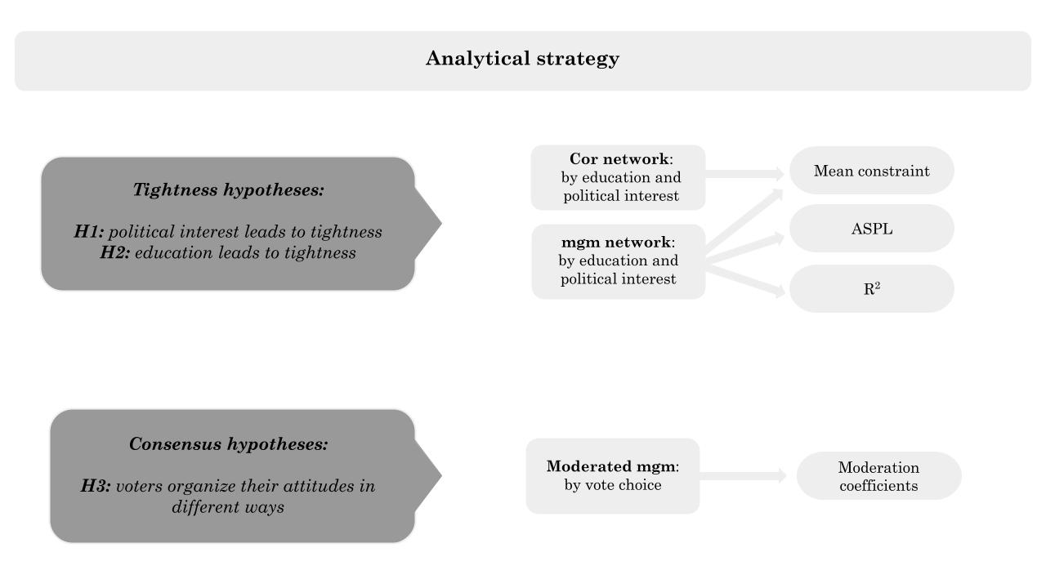*Figure 1: Analytical strategy*

### 3.3 Network models

All network models adopted in this article render survey variables as nodes of a weighted network. The main difference between these models is edge estimation.

**Correlational networks.** To cumulate with past research adopting a network approach in social sciences, I begin with the estimation of correlational networks (Boutyline & Vaisey, 2017; DellaPosta, 2020a; Keskintürk, 2022b, 2022a). I stratify by low (911 individuals) and high levels (238) of political interest and education, performing median splits for political interest (see Table 1, Supplement), and distinguishing between people without (706) and with university degrees (443). Next, I compute zero-order correlation coefficients[7] for each pair of political attitudes, in each of the four subsamples. Counter to the majority of work adopting BNA (Boutyline & Vaisey, 2017; Keskintürk, 2022b, 2022a), but in line with more recent contributions adopting a network approach in political science (DellaPosta, 2020), network edges are equal to the absolute correlation coefficients. The rival approach involves squared coefficients. This artificially reduces the magnitude of originally negative edges, biasing the estimation of mean constraint (see Section 3.4).

**Mixed Graphical Model.** Next, I estimate two classes of Pairwise Markov Random Field models [PMRFs]. Similarly to correlational networks, PMRFs output weighted networks. However, these models produce signed edges and encode conditional independences as absent edges in the network plot (Lauritzen, 1996). Unlike correlational networks, PMRF produces sparse graphs. This has the advantage of closing the gap between the network theory of belief system —which posits causality between political beliefs— and their empirical examination in political science —which is currently anchored to plain correlational approaches. Testing H1 and H2 requires node-wise and aggregated estimates or R2. Hence, I adopt a mixed graphical model in which all variables are considered quasi-continuous ([mgm]; Epskamp, Waldorp, et al., 2018). This model involves a loop of node-wise regularized regressions. The resulting regression coefficients are plotted as network edges. The regularization technique of choice is a variant of the least absolute shrinkage and selection operator called graphical LASSO (Tibshirani, 1996). The appropriate level of the tuning parameter of the regularization procedure is found by minimizing the Extended Bayesian Information Criteria (Chen & Chen, 2008). By treating all variables as quasi-continuous, the mgm reduces to a Gaussian Graphical Model ([GGM] Epskamp, Waldorp, et al., 2018; Haslbeck & Waldorp, 2020), whose edges are interpretable as signed, regularized partial correlations (Burger et al., 2023). In this way, this research cumulates on the most recent work on belief systems in political psychology (Brandt et al., 2019; Brandt & Sleegers, 2021). I fit four mgm models, on the same sample partitions on which I estimate the correlational networks.

**Moderated Network Model.** Estimating mgm models on the four sample partitions equals traditional moderation analyses, where researchers observe variations of pair-wise statistical associations at varying levels of a third intervening variable. However, this modeling strategy reduces statistical power by fitting separate models on smaller sample sizes. I thus use a second variant of the mgm, which estimates a moderated network model (mnm) (Haslbeck, 2022). This consists of a GGM in which each pairwise interaction is modified to include a possible moderation effect of an external variable. Significant moderators are again isolated through the combination of the graphical Lasso and EBIC. I fit the mnm on the full sample, specifying self-reported vote choice (left-wing, right-wing coalition, and M5S) as the moderator. I adopt the mnm because it attenuates the Berkson bias (Westreich, 2012). When stratifying the sample by the sociodemographic variables, I obtain subsamples where the variance of political attitudes is preserved. Yet, the vote-choice stratification would restrict their variance, violating the assumptions of the resulting network models (De Ron et al., 2021).

### 3.4 Hypothesis testing

In this Section, I detail the hypothesis testing phase. I test H1 and H2 with correlational and mgm networks fitted on the sample partitions of political interest and education. Then, I test H3 using the moderator network model. In the remainder of the Section, I detail and motivate the strategies with which I test the main proposition of the belief system theory.

**Mean constraint.** In social sciences, mean constraint is the most widely adopted measure of the tightness of a belief system (Boutyline & Vaisey, 2017; Keskintürk, 2022a, 2022b). This measure is equal to the average value of network edges. The works adopting BNA estimate network edges by squaring zero-order correlation coefficients. However, this unfairly penalizes the negative correlations, which become smaller by design. Hence, I follow DellaPosta’s approach (2020), adopting absolute correlation coefficients as a modeling strategy. I then operationalize the mean constraint in the usual fashion by calculating the average values of edges in the networks. To perform a direct comparison between correlational networks and mgms, I further adapt the measure for the mgms. Their mean constraint is calculated by averaging the mean absolute value of non-zero edges. This allows for an unbiased test of H1 and H2 on both model types. To allow for statistical testing of H1 and H2, I perform nonparametric bootstrap (Efron, 1979). Starting from the four sample partitions, I perform ten thousand bootstrap iterations by resampling with replacement, creating forty thousand bootstrapped samples in total. Re-estimating the correlational and mgm networks on the bootstrapped samples yields four bootstrapped distributions of mean constraint. I then build 95% bootstrapped CIs by considering the central 95% of the distributions (Epskamp, Borsboom, et al., 2018). By comparing the mean constraint of correlational and mgm networks, I aim to understand whether political interest and education increase respectively the raw or unique variances shared between Italian political attitudes.

**ASPL.** The mean constraint is similar to a global measure of connectivity in that it detaches edges from their positions in the network. High values of constraint imply that the belief system has high mean values of network edges. However, two networks may have identical values of constraint, but drastically different configurations, such as when one score is due to homogeneous edge weight in the model, and the other is due to a bimodal distribution of edge weights. In extreme cases, this can lead to marked differences between their connectivities. To account for this, I perform an additional test of H1 and H2 by calculating the ASPL of the stratified mgm networks. This measure is obtained by averaging the shortest paths between all network nodes, weighted by the absolute magnitude of their connections (Opsahl et al., 2010). High ASPL values indicate a network is sparser. Just like for the mean constraint test, I evaluate H1 and H2 by comparing the bootstrapped distribution of ASPL of the high versus low groups.

**R2.** The decomposition of constraint into tightness and consensus allows for an additional test regarding the organization of the Italian political belief system. When belief systems are tighter, political attitudes should be more embedded in the network, thus more predictive of each other. To test for this, I calculate node-wise R2 on the mgm networks (Haslbeck & Waldorp, 2018). This metric is calculated and interpretable like in standard regression analysis, as the edges of an mgm result from regularized OLS. I compare two statistics. First, I investigate whether the R2 of each network node in the mgm is greater in the high subsamples than in the low ones. This allows me to appreciate node-wise differences in explained variance to verify if the eventual increase is due to a minority of nodes or if it is evenly distributed. Second, I calculate the bootstrapped distribution of the mean node-wise R2. This allows for a more rigorous statistical test of H1 and H2.

**Moderation coefficients.** Testing H3 requires a comparison of the belief systems of different electorates. The stratification of the sample is not a viable option, as it would result in partitions in which political attitudes have low variance. Hence, I adopt the moderated network model detailed in Section 3.3. Within this framework, I can directly test H3 by examining the edges of the model that are significantly moderated by self-reported vote choice.

## 4. Results

Before testing the research hypotheses, I report on the drastic differences between correlational and mgm networks. Figure 2 (below) shows the results of a full sample estimation of a correlational network (left) and a mgm (right panel). Nodes represent the political attitudes and are labeled according to Table 1. Edge interpretation varies according to the model (Burger et al., 2023). Edges of the correlational network represent squared zero-order correlation coefficients. The signed ties of the mgm represent node-wise and regularized regression coefficients on a -1 to +1 scale. However, since I modeled all attitudes as quasi-continuous, these signed edges can be interpreted as regularized partial correlation coefficients (Haslbeck & Waldorp, 2020). Red edges represent negative associations, blue positive ones. The nodes are colored based on their classification into symbolic and operational categories, while their spatial arrangement is determined using the Fruchterman Reingold force-directed algorithm (Fruchterman & Reingold, 1991). The two network models differ importantly. First, the 19 political beliefs can generate a maximum of 171 associations[8]. The correlational network is a fully connected graph with only 4 edges lower than 0.001; many edges are not visible in Figure 2 due to the scaling of edges. The mgm is a sparse network featuring 94 null associations. These conditional independencies are encoded as absent edges in the right panel of Figure 2. As a second point, although being on the same scale, regularization shrinks mgm’s edges to substantially smaller values. Correlation coefficients range from nearly zero (fourteen associations) to 0.841 (for the association[9] wmarria-adopt). Regularized partial correlations range between -0.132 (wPTV_M5S-ukrai) to 0.521 (wmarria-adopt). As a consequence, the two networks show different levels of tightness. The mean constraint of the correlational network is 0.323, and that of the mgm is only 0.101. Despite these differences, the networks show important similarities. Symbolic components are particularly embedded in both networks, as PTV items and left-right self-placement tend to correlate strongly. The only exception to this pattern is the node *PTV_M5S,* which clusters away from the other propensity to vote. Finally, the two models converge in signaling the low centrality of the attitudes *ukrai* and *globa*. In sum, the estimation technique impacts the resulting networks, as the mgm shows fewer connections and lower mean constraint.

*Figure 2: Network of political attitudes of the full sample*

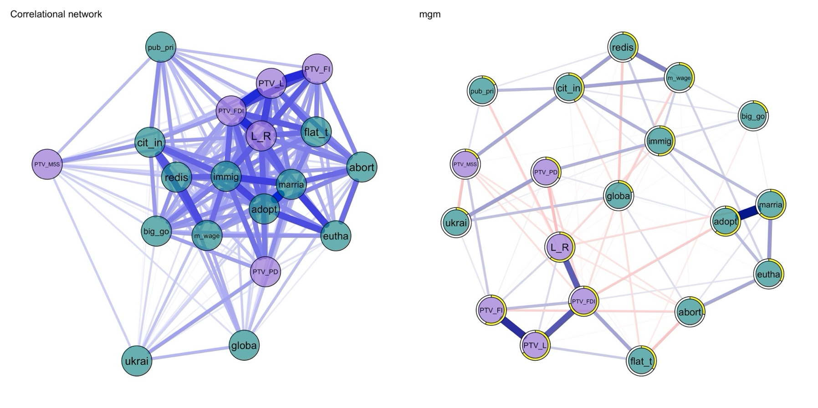

*Caption:* Correlational (left) and mgm network (right) of the Italian political belief system. Nodes are colored according to variable type (symbolic or operational). The yellow borders of the nodes indicate R2 values. Edges indicate absolute correlations (left) and regularized partial correlations (right). The former are signed (red = negative associations). Node labels: *L_R* = Left right self-placement; *PTV_PD* = Propensity to vote for PD; *PTV_FI* = Propensity to vote for Forza Italia; *PTV_L* = Propensity to vote for the Lega; *PTV_M5S* = Propensity to vote for M5S; *PTV_FDI* = Propensity to vote for Fratelli d’Italia; *adopt* = Stepchild adoption; *abort* = Abortion; *eutha* = Euthanasia; *marria* = Homosexual marriage; *redis* = Redistribution; *flat_t =* Flat tax; *m_wage* = Minimum wage; *cit_in* = Citizenship income; *globa =* Globalization; *immig* = Immigration; *big_go* = Big government;  *pub_pri =* Public vs private; *ukrai* = Weapons to Ukraine.

The top and bottom panels of Figure 3 (below) report the results for H1 and H2, respectively. Each panel has two violin plots, one for the correlational (violet) and one for the mgm networks (green shapes). Each violin comprises ten-thousand-point estimates of belief tightness, operationalized as the mean constraint (plotted on the y-axis). These estimates are obtained after the stratification of the original sample in high versus low levels and by bootstrapping the results of network estimation. The four correlational networks (one for each category of political interest and education) and the four mgm networks are visualized in Figures S1 and S2 (Supplement). Bootstrapped CIs encapsulate the central 95% of the distribution. In line with H1, political interest and mean constraint are positively and significantly associated. The top left panel of the figure shows that the belief system of people with high political interest is significantly tighter than those of people with lower interest (High group: bootstrapped μ = 0.328; bootstrapped CI: 0.295 - 0.361. Low group: μ = 0.281; bootstrapped CI: 0.263 - 0.294). The results replicate on mgm bootstrapped data (High group: bootstrapped μ = 0.105; bootstrapped CI: 0.097 - 0.115. Low group: μ = 0.088; bootstrapped CI: 0.082 - 0.094). As observed while commenting on Figure 1, the adoption of regularization shrinks the estimated values of mgm constraint to smaller values. Additional analyses show that the relationship between constraint and political interest is especially stable for correlational networks. Figure S3 (Supplement) replicates the violin plots with different operationalizations of political interest. For correlational data, the belief systems of people with low interest (μ = 0.233; bootstrapped CI: 0.221 - 0.256) is significantly less tight than those of people with medium (μ = 0.302; CI: 0.282 - 0.323) and high (μ = 0.33; CI: 0.29 - 0.36) interest. Furthermore, results hold even if splitting political interest at the middle point of the scale (Low group: μ = 0.233; CI: 0.212 - 0.255. High group: μ = 0.311; CI: 0.294 - 0.328). The results of mgm networks do not overcome these additional tests. Figure S3 confirms that H2 is rejected, as overlapping CIs indicate that education and mean constraint are not significantly associated. Additional analyses reveal that the impact of education is not significant even if adopting other coding strategies.

*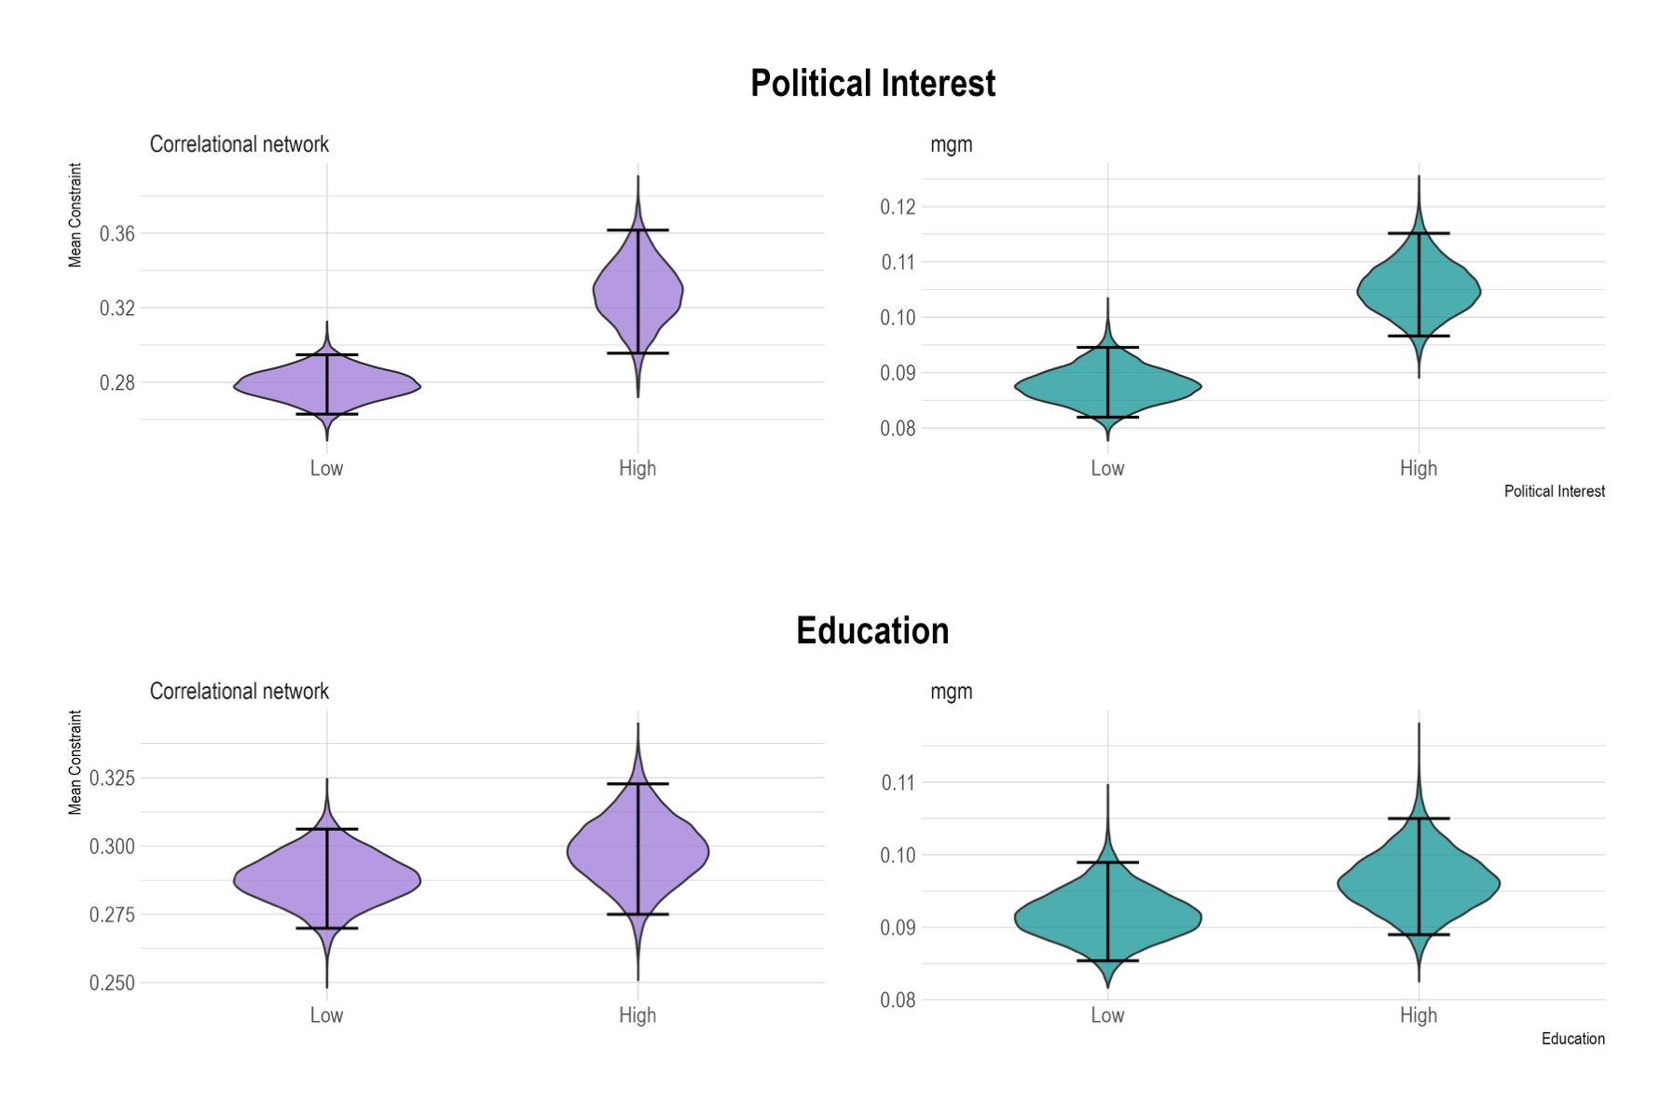Figure 3: Beliefs’ constraint by levels of political interest and education*

*Caption:* Relationship between political interest and education with belief tightness. Violins represent the bootstrapped distributions of mean constraints across different levels of political interest (top) and education (bottom panel). Violet violins show results obtained with correlational network estimation, green refers to mgm networks. Black bars show bootstrapped confidence intervals (95%). Political interest is positively correlated with mean constraint, regardless of network estimation type. Education and mean constraint are not significantly related.

Mean constraint is one of the possible operationalizations of the tightness of a belief system. Stronger connections between political attitudes should produce differences in the connectivity of the network, in the proportion of node-wise explained variance, and in the mean predictability of network nodes in the model. I thus test for these different declinations of H1 and H2 in Figure 4 (below). The top panel of the figure shows the bootstrapped distributions of the ASPL of mgm networks (x-axis) estimated on the high (green violin) versus low (purple) education and political interest samples (y-axis). The whiskers of the box plots within each violin are adapted to display 90% bootstrapped CIs, whereas the borders of the boxplot canonically represent the first and third quartiles. H1 and H2 would predict *lower* values for the high groups, as ASPL is a measure of distance. Yet, CIs always overlap, even if calculated at the 90% level. The means of the bootstrapped distributions of political interest are at least in line with H1 (Low political interest: μ = 14.481; CI: 13.271 – 15.852. High: μ = 13.458; CI: 11.423 – 15.419), whereas the ones of education are in the reverse direction (Low education: μ = 14.012; CI: 12.761– 15.440. High: μ = 14.407; CI: 12.962– 15. 918).

The central panel of Figure 4 offers a comparison of node-wise R2. Table 3 in the Supplement presents the precise values behind the lollipop plot. If the belief systems of the high groups are tighter than those of the low groups, the R2 values of the former should be higher. In line with H1 and against H2, this pattern systematically occurs for political interest, but not for education. Indeed, the node-wise R2 of the attitudes of the education networks are not clearly aligned with higher values for the high gropup. As a consequence, the average node-wise difference between R2 is -0.002, indicating that the attitudes of the lowly educated Italians are even *less* embedded in the belief system. The strongest gap between these values regards *flat_t* and is equal to 0.100 (Low group: R2 = 0.300. High: R2 = 0.400). In the networks estimated on the partitions of political interest, all node-wise R2 values of the highly interested are greater than those of the lowly interested in politics. The only exception to this pattern is the node *eutha.* Therefore, the average node-wise gap in R2 is 0.108. This means political attitudes are on average 10% more predictive of each other in the high group compared to the low group. The biggest changes in R2 regard the nodes *immig* (Low group: R2 = 0.290. High: R2 = 0.550. Δ = 0.260) and *flat_t* (Low group: R2 = 0.170. High: R2 = 0.400. Δ = 0.230).

The lollipop plot highlights differences in point-estimate values of node-wise R2. To complement this finding, I bootstrap the mean R2 of the mgm models. This results in the bottom panel of Figure 4, which investigates the distributions of the average node-wise R2 (x-axis) across variable type (education, political interest) and level (y-axis). Similar to the top panel, boxplots are modified to plot 90% bootstrapped CIs. The distributions regarding education drastically overlap (Low education: μ = 0.460; CI: 0.408– 0.517. High: μ = 0.431; CI: 0.392– 0.489). The relationship between political interest and mean node predictability is only significant at the fourth decimal, and at the 90% level (Low: μ = 0. .378; CI: 0.301– 0.435*2*. High: μ = 0.431; CI: 0.435 – 0.489). However, the medians of the two distributions are well differentiated and in line with H1 (Low: x͂ = 0.378; High: x͂ = 0.464). Moreover, this panel highlights an interesting finding regarding the stability of these estimates. Despite having similair —and substantially low— SD, the bootstrapped distribution of the mean R2 has outliers on both sides of the violin, whereas the high group only skews to the right (Low: SD = 0.039. High: SD = 0.025). Finally, it is important to remark on the interplays of the results of the central and bottom panels of Figure 4. The central panel plots differences in the point-estimates values of node-wise R2. Here, the unit of analysis is the node-wise gap in explained variance, and results show that there is substantial variation in the entity of these differences. The bottom panel tests the R2 operationalization of the tightness hypothesis at the aggregate level. This means that the unit of analysis is the mean R2 of all nodes. The marginal significance of the test presented in the bottom panel can thus be interpreted as (i) a signal of considerable variation of node-wise R2 gaps —in line with the node-wise test— or, (ii) a signal of high instability of the network estimation in the lowly informed subsample.

*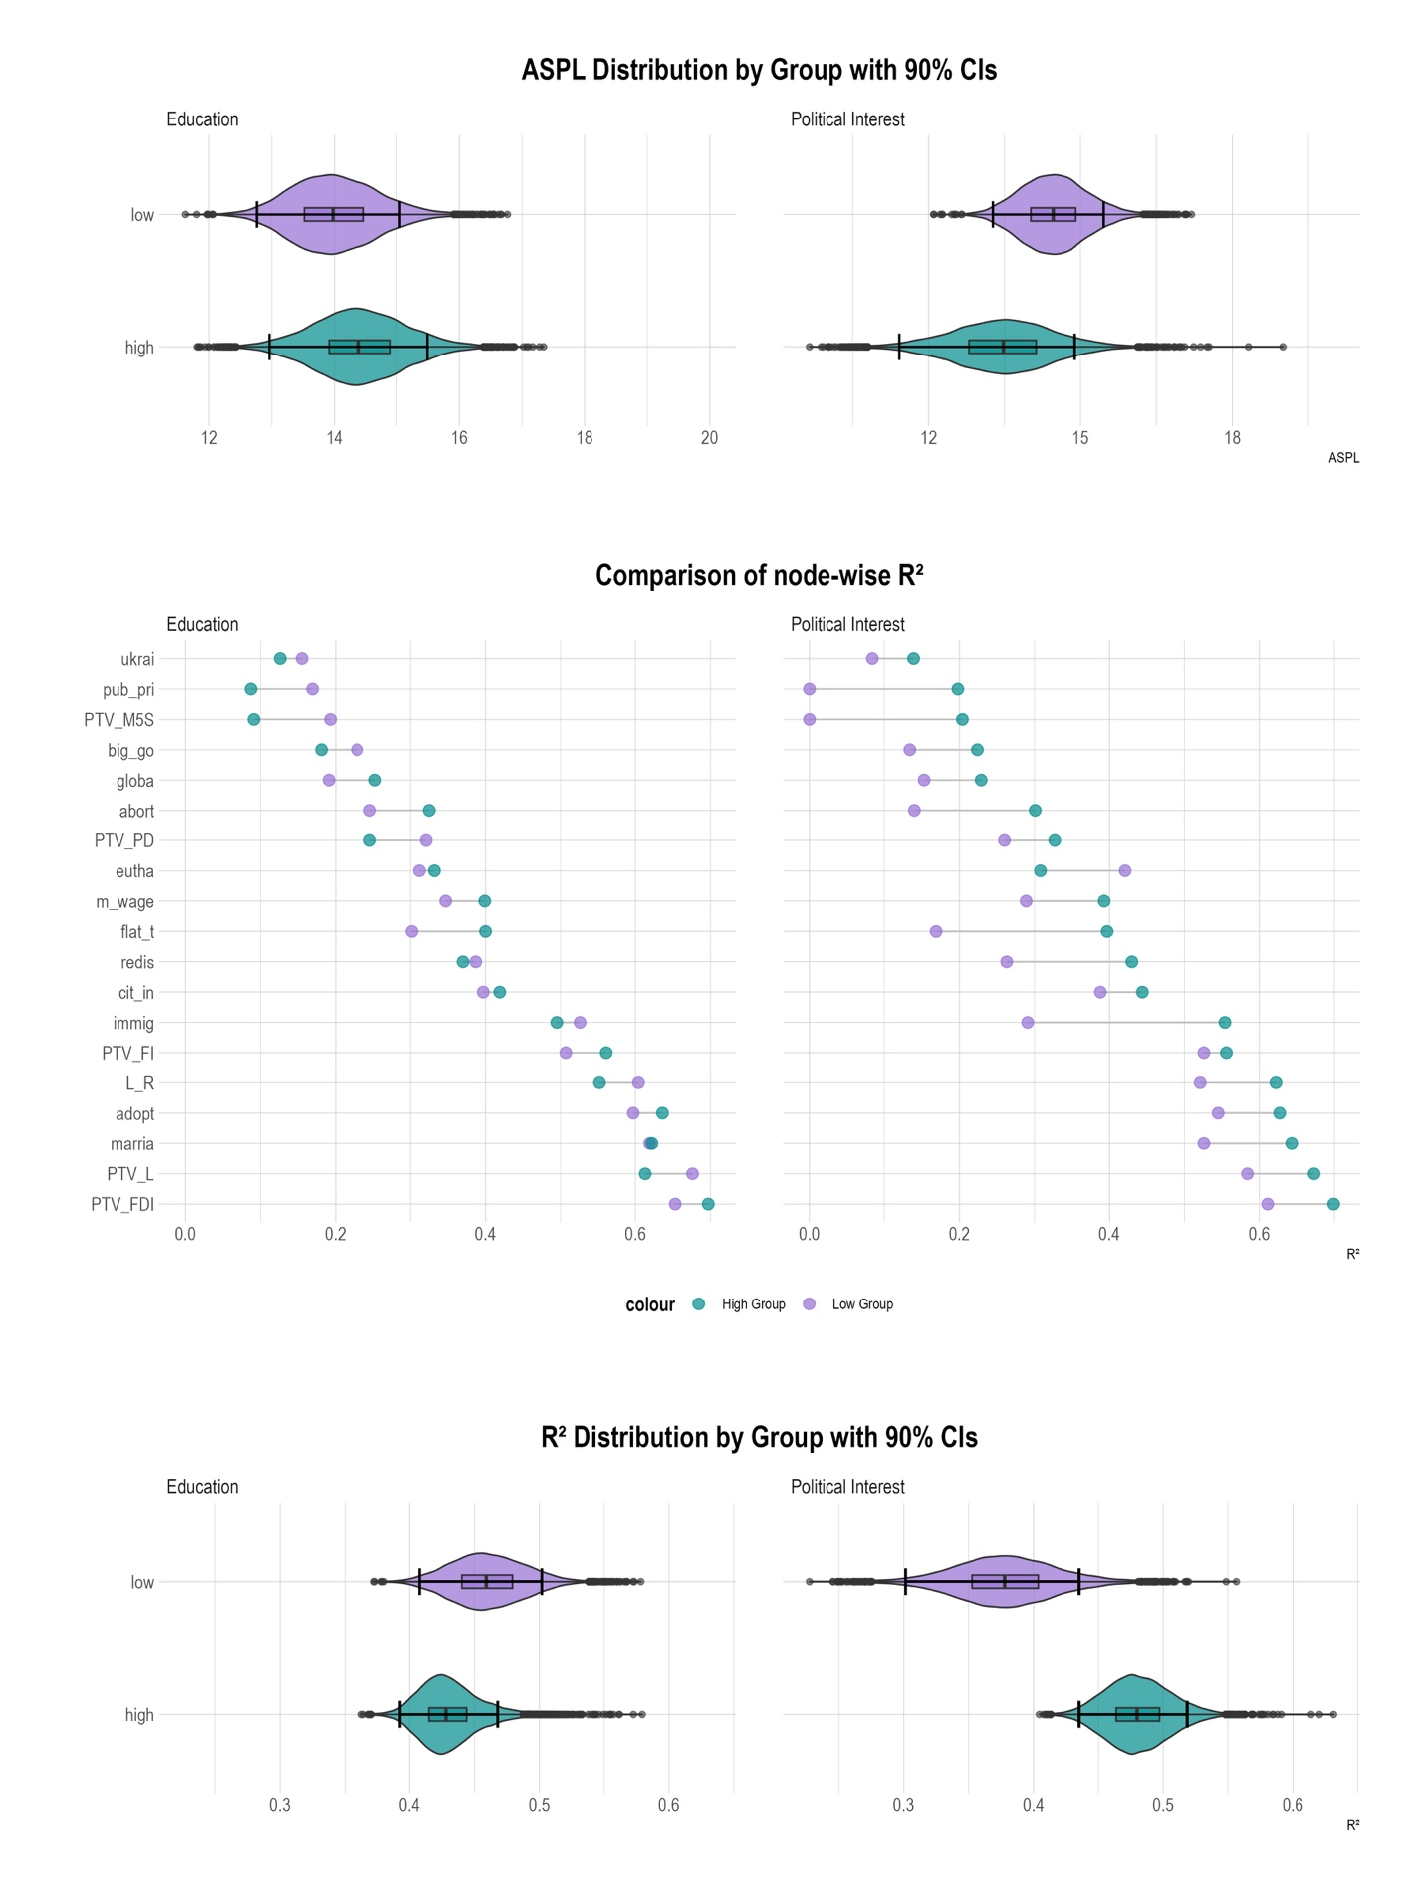Figure 4: Tests of H1 and H2*

Caption: Top: bootstrapped distributions of the ASPL of mgm networks. Center: node-wise differences in the R2 of mgm networks. Bottom: bootstrapped distributions of the mean R2 in mgm networks. Each panel is faceted by education and political interest, with green (purple) violins/dots indicating high (low) gropus.

Finally, I evaluate whether voters of different political coalitions possess heterogeneous belief systems. The consensus hypothesis predicts the relationships between the Italian political attitudes are moderated by self-reported vote choice. In the presence of drastic moderations, the belief systms of Italian voters would be so heterogeneous to bias the estimation of tightness. Figure 5 (below) shows the results of the moderated network model where self-reported vote choice (Left, M5S, or right-wing coalition) is specified as the moderating variable. Each panel of the figure is obtained by conditioning all pairwise associations by different levels of the moderator. Similarly to Figure 1, the edges of the plot represent conditional dependences, and absent edges mean two attitudes are independent if controlling for the rest of other nodes. Unlike in the previous plot, I added the yellow node *vote_cat*, which signals vote choice was specified as the moderator. It is important to remark that the three panels represent the prediction of the same moderated network model, for different levels of vote choice. Node layout is standardized to ease the comparison of edge strength, and edges are plotted with reduced width to facilitate the detection of the moderation effect —which occurs when a given edge is estimated with a different magnitude in the three panels.

The three belief systems mildly differ. Out of 171 possible edges in the model, fourteen edges are significantly moderated by self-reported vote choice between the belief systems of the left and of the 5SM; eleven edges differ between the belief systems of the left and of the right; twenty-three pairwise associations significantly differ when comparing the network of the right-wing voters and of the M5S. Thus, left and right-wing voters show the highest similarity, the belief systems of the rightist voters and those of the supporters of the M5S differ the least, and the networks of the left and of the M5S are in the middle position. This comparison provides information on the sheer number of identical —that is, un-moderated— edges in the network models. To gain a deeper understanding of the patterns of moderation, I contrast the three belief systems specifying the edges that differ the most.

When comparing leftist and rightist belief systems, the most important differences regard the associations between symbolic components of the network. According to the leftist, high intentions to vote for the M5S are detached from favorable vote intentions for the left-wing coalition (wPTV_M5S-PTV_PD = 0.000). Yet, right-wing voters perceive that voting for these two political factions is likely to satisfy the same electoral utilities (wPTV_M5S-PTV_PD = 0.473). The same pattern occurs when considering the propensity to vote for FDI and PD. In the belief systems of the left, these two items are conditionally independent (wPTV_FDI-PTV_PD = 0.000); in the belief system of the right, this association is significant and negative (wPTV_FDI-PTV_PD = -0.120).

Similarly, the belief systems of the supporters of M5S and the left-wing coalition mainly differ concerning the associations between symbolic attitudes. For example, the propensity to vote for PD and FI are uncorrelated in the network of the left (wPTV_FI-PTV_PD = 0.000), and positively correlated for the voters of the movement (wPTV_FI-PTV_PD = 0.690). These belief systems also differ in how symbolic and operational attitudes are packed together. For example, M5S supporters perceive a stronger association between a high propensity to vote for their political faction and supporting their flagship proposal, the citizenship income (wPTV_M5S-cit_in = 0.052 for the left; 0.150 for the M5S). Also, left-wing voters do not perceive an association between a preference for giving subsidies to people in economic hardship rather than to private companies and the propensity to vote for their party (wPTV_PD-pub_pri = 0.000). Instead, the supporters of the movement think that voting for the PD relates to the desire to subsidize companies over citizens (wPTV_PD-pub_pri = -0.174).

When comparing the belief systems of the voters of the right-wing coalition with those of M5S voters, I retrieve important differences regarding associations between symbolic components, and between symbolic and operational ones. As in the previous comparison, these voters conceptualize the space of the political competition in different ways. The most striking difference regards the associations between the propensity to vote for the Movement and the PD (wPTV_PD-PTV_M5S = 0.000 for the supporter of the Movement; 0.473 in the belief system of the right). Moreover, these electorates pack together symbolic and operational components differently. For example, the supporters of the movement, unlike those of the right-wing coalition, believe that being in favor of the flat tax implies the approval of sending weapons to Ukraine (wflat_t-ukrai = 0.084).

As a final test for the tightness hypothesis, I fit two moderated network models where I specify political interest and education (low versus high, again with the median split) as the moderator. H1 and H2 predict increased tightness of the belief systems of the high groups. In Figure 3, I have shown that the mean constraint of the correlational and mgm networks estimated on the high interest partition is characterized by a higher mean constraint. In Figure 4 I have shown that their ASPLs do not statistically differ, although there is evidence that node-wise and aggregated R2 increases. Both Figures converged in rejecting H2. This should translate into several significant moderation effects for the moderated network model of political interest, and a few significant moderations in the model of education. Figure S4 (Supplement) plots the predicted edge weights of significantly moderated network edges for the low and high groups. The results support the anticipated pattern. Education only moderates two edges in a meaninfull way (moderation coefficients greater than 0.03). Countrary to the more educated (wPTV_L-abort = -0.040), Italians with low education manifest no association between a high propensity to vote for the Lega and favoring restriction to abortion (wPTV_L-abort = 0.000). Moreover, people with higher education display a stronger association between the endorsement of the flat tax and a favorable view of globalization (Low group: wflat_t-globa: -0.053. High: wflat_t-globa h: -0.093). Political interest significantly moderates twenty-three associations. The strongest moderations involve *PTV_M5S* and *ukrai* (moderation coefficient: -0.086), *marria* and *immi* (coefficient: 0.061), and *L-R* and *pub_pri* (coefficient: -0.050). Out of these moderations, eleven involve the relationships between one symbolic and one operational attitude (44.44%), eleven feature two operational attitudes (44.44%), and only one regards two symbolic attitudes (4.35%).

*Figure 5: moderated network model, by self-reported vote choice*

Caption: Moderated Network Model with self-reported vote choice specified as the moderator. Blue edges represent positive regularized partial correlations, and red negative ones. A significant moderation effect occurs when an edge possesses a different width across the three panels. Node labels: *L_R* = Left right self-placement; *PTV_PD* = Propensity to vote for PD; *PTV_FI* = Propensity to vote for Forza Italia; *PTV_L* = Propensity to vote for the Lega; *PTV_M5S* = Propensity to vote for M5S; *PTV_FDI* = Propensity to vote for Fratelli d’Italia; *adopt* = Stepchild adoption; *abort* = Abortion; *eutha* = Euthanasia; *marria* = Homosexual marriage; *redis* = Redistribution; *flat_t =* Flat tax; *m_wage* = Minimum wage; *cit_in* = Citizenship income; *globa =* Globalization; *immig* = Immigration; *big_go* = Big government;  *pub_pri =* Public vs private; *ukrai* = Weapons to Ukraine. *Vote_cat* represents the moderator.

## 5. Discussion and conclusions

In this article, I have addressed both a methodological and a theoretical gap in the literature on belief systems. Converse’s (2006) theory of social constraint posits that political attitudes causally interact, yet empirical examinations have predominantly relied on simple correlational approaches (Boutyline & Vaisey, 2017; DellaPosta, 2020b; Keskintürk, 2022a, 2022b). To attenuate this limitation, I have embraced insights from recent works in political psychology by implementing regularized partial correlation network models (Brandt et al., 2019). These models enhance the analysis of zero-order correlations by isolating the shared variance between pairs of political attitudes. This approach has enabled me to conceptualize the Italian belief system as a sparse network founded on the non-spurious interactions between symbolic and operational political attitudes. Theoretically, I have extended the socio-centric theory of belief systems by introducing a bi-dimensional conceptualization of constraint: belief tightness and consensus. A belief system exhibits tightness when political attitudes are closely connected, thereby being highly predictive of each other. Following Converse, I propose that political interest and education level determine the extent to which voters assimilate cues from political parties, and I investigate whether individuals with high political interest and education have tighter belief systems compared to those less engaged or educated. The dimension of consensus assesses the degree to which belief systems vary across different population segments. This differentiation is crucial in multiparty systems, where voters from different coalitions receive conflicting cues from their parties, potentially leading them to organize their political attitudes in fundamentally different ways. Therefore, I explore the consensus within the Italian political belief system by analyzing how the belief systems of left-wing, right-wing coalition, and M5S voters compare.

I have evaluated the tightness hypotheses using multiple analytical tests. Building upon the political science literature on belief systems, I first compared the mean constraint —the mean edge value— of belief systems among individuals with differing levels of political interest and education. This comparison was conducted using both correlational and partial correlation network analyses. The findings clearly indicate that political interest significantly influences this measure of tightness, with especially consistent results observed in correlational networks.

Secondly, I examined another measure of connectivity of these belief systems, such as the Average Shortest Path Length (ASPL), and found no substantial differences. However, significant disparities emerged in the node-wise explained variance of political attitudes within the belief systems of individuals with varying educational levels. These disparities were also significant, albeit at the 90% confidence level, when considering the mean R-squared values of network nodes. This suggests that the political attitudes of individuals with high political interests are more predictive of each other, if compared to the attitudes of the lowly interested. Lastly, I explored significant moderation effects across different population strata. Unlike educational level, political interest was found to significantly moderate the relationships among Italian political attitudes. Collectively, these results strongly support Hypothesis 1 and largely reject Hypothesis 2, affirming the foundational premise of the social constraint theory. Individuals with higher education levels exhibit well-structured belief systems, where attitudes are deeply embedded and highly predictive of one another. This indicates that politically informed individuals’ positions on various political attitudes are strongly influenced by their stances on other issues, rather than being dictated by other socio-psychological factors.

I have framed the consensus hypothesis in terms of moderation effects, with the expectation of identifying multiple instances where the relationship between political attitudes is moderated by self-reported vote choice—a proxy for the types of party cues voters are likely to receive. Generally, the most significant moderation effects relate to how different electorates consolidate their support for political parties. However, when comparing the belief systems across the three major political forces in Italy, I observed distinctive moderation patterns. Specifically, in comparing the belief systems of the left and the right, differences almost exclusively manifest in how they structure their voting intentions for political parties. In contrast, when comparing these two belief systems with that of the electorate of the M5S, I also detected moderation effects impacting the associations both between operational attitudes and between symbolic and operational attitudes. Nonetheless, the magnitude of these moderations was consistently smaller than those observed between symbolic components of the belief system. This suggests that while the belief systems of different electorates do indeed differ structurally, these differences are primarily attributed to how individuals endorse political parties rather than their support for specific operational issues within the Italian political landscape.

The results of this research have two main implications. Methodologically, I advocate for the adoption of partial correlation networks over plain correlational approaches. The belief system theory, which posits that political attitudes are causally interconnected, necessitates methodologies at least capable of isolating *non-spurious* attitudinal connections. Indeed, relying solely on the mean absolute zero-order correlation coefficient to measure tightness limits the analysis to evaluating whether *manifest* associations between political attitudes strengthen among politically interested individuals. Theoretically, these results support the need to distinguish between tightness and consensus within belief systems. These systems are shaped not merely by the level of interdependence among political attitudes but also by the nature of the party cues received from preferred political parties. This distinction might be particularly salient in polarized multiparty systems.

This article acknowledges three significant limitations that future research should address. First, the quality of this paper would have been enhanced by employing a more representative sample of the Italian population. Secondly, future studies might rely on multiple indicators of political interest, and also investigate the impact of political knowledge. Finally, there is still room to intervene on the mismatch between the causal theory of belief systems and their predominantly cross-sectional empirical investigations. Possible strategies to bridge this gap are the adoption of longitudinal network models (Epskamp, 2020) or experimental research designs (Fishman & Davis, 2022; Turner-Zwinkels & Brandt, 2022).

## 6. References

Baldassarri, D., & Gelman, A. (2008). Partisans Without Constraint: Political Polarization and Trends in American Public Opinion. *SSRN Electronic Journal*. https://doi.org/10.2139/ssrn.1010098

Baldassarri, D., & Goldberg, A. (2014). Neither Ideologues nor Agnostics: Alternative Voters’ Belief System in an Age of Partisan Politics. *American Journal of Sociology*, *120*(1), 45–95. https://doi.org/10.1086/676042

Benedetta, C., & Vincenzo, M. (2020). Do environmental preferences in wealthy nations persist in times of crisis? The European environmental attitudes (2008-2017). *Italian Political Science Review/Rivista Italiana Di Scienza Politica*, *50*(1), 1–16. https://doi.org/10.1017/ipo.2019.3

Bertero, A., & Scaduto, G. (2023). A midsummer’s night dream: Political communication during the Italian 2022 electoral campaign. *Italian Journal of Electoral Studies QOE-IJES*. https://doi.org/10.36253/qoe-14224

Bobbio, N. (1996). *Left and right: The significance of a political distinction*. University of Chicago Press.

Boutyline, A., & Vaisey, S. (2017). Belief Network Analysis: A Relational Approach to Understanding the Structure of Attitudes. *American Journal of Sociology*, *122*(5), 1371–1447. https://doi.org/10.1086/691274

Brandt, M. J., Sibley, C. G., & Osborne, D. (2019). What Is Central to Political Belief System Networks? *Personality and Social Psychology Bulletin*, *45*(9), 1352–1364. https://doi.org/10.1177/0146167218824354

Brandt, M. J., & Sleegers, W. W. A. (2021). Evaluating Belief System Networks as a Theory of Political Belief System Dynamics. *Personality and Social Psychology Review*, *25*(2), 159–185. https://doi.org/10.1177/1088868321993751

Burger, J., Isvoranu, A.-M., Lunansky, G., Haslbeck, J. M. B., Epskamp, S., Hoekstra, R. H. A., Fried, E. I., Borsboom, D., & Blanken, T. F. (2023). Reporting standards for psychological network analyses in cross-sectional data. *Psychological Methods*, *28*(4), 806–824. https://doi.org/10.1037/met0000471

Caldwell, L. (1981). Abortion in Italy. *Feminist Review*, *7*(1), 49–63. https://doi.org/10.1057/fr.1981.4

Chen, J., & Chen, Z. (2008). Extended Bayesian information criteria for model selection with large model spaces. *Biometrika*, *95*(3), 759–771. https://doi.org/10.1093/biomet/asn034

Cicco, G. D., Renzib, A., Marianib, R., Negric, A., Tranib, M. D., & Lauriola, M. (2023). Between populism and egalitarianism: Mapping attitudes toward social and political issues during the Draghi government using exploratory graph analysis. *Psychology Hub*. https://doi.org/10.13133/2724-2943/17982

Cohen, G. L. (2003). Party Over Policy: The Dominating Impact of Group Influence on Political Beliefs. *Journal of Personality and Social Psychology*, *85*(5), 808–822. https://doi.org/10.1037/0022-3514.85.5.808

Conti, N., & Memoli, V. (2015). Show the money first! Recent public attitudes towards the EU in Italy. *Italian Political Science Review/Rivista Italiana Di Scienza Politica*, *45*(2), 203–222. https://doi.org/10.1017/ipo.2015.11

Converse, P. E. (2006). The nature of belief systems in mass publics (1964). *Critical Review*, *18*(1–3), 1–74. https://doi.org/10.1080/08913810608443650

De Ron, J., Fried, E. I., & Epskamp, S. (2021). Psychological networks in clinical populations: Investigating the consequences of Berkson’s bias. *Psychological Medicine*, *51*(1), 168–176. https://doi.org/10.1017/S0033291719003209

DellaPosta, D. (2020a). Pluralistic Collapse: The “Oil Spill” Model of Mass Opinion Polarization. *American Sociological Review*, *85*(3), 507–536. https://doi.org/10.1177/0003122420922989

DellaPosta, D. (2020b). Pluralistic Collapse: The “Oil Spill” Model of Mass Opinion Polarization. *American Sociological Review*, *85*(3), 507–536. https://doi.org/10.1177/0003122420922989

Di Nicola, P. (2016). Babies are not Born under a Cabbage Leaf. *Italian Sociological Review*, *Vol 6*, 293 Pages. https://doi.org/10.13136/ISR.V6I2.135

Efron, B. (1979). Bootstrap Methods: Another Look at the Jackknife. *The Annals of Statistics*, *7*(1). https://doi.org/10.1214/aos/1176344552

Ellis, C., & Stimson, J. A. (2012). *Ideology in America* (1st ed.). Cambridge University Press. https://doi.org/10.1017/CBO9781139094009

Epskamp, S. (2020). Psychometric network models from time-series and panel data. *Psychometrika*, *85*(1), 206–231. https://doi.org/10.1007/s11336-020-09697-3

Epskamp, S., Borsboom, D., & Fried, E. I. (2018). Estimating psychological networks and their accuracy: A tutorial paper. *Behavior Research Methods*, *50*(1), 195–212. https://doi.org/10.3758/s13428-017-0862-1

Epskamp, S., Waldorp, L. J., Mõttus, R., & Borsboom, D. (2018). The Gaussian Graphical Model in Cross-Sectional and Time-Series Data. *Multivariate Behavioral Research*, *53*(4), 453–480. https://doi.org/10.1080/00273171.2018.1454823

Fishman, N., & Davis, N. T. (2022). Change We Can Believe In: Structural and Content Dynamics within Belief Networks. *American Journal of Political Science*, *66*(3), 648–663. https://doi.org/10.1111/ajps.12626

Franetovic, G., & Bertero, A. (2023). How do people understand inequality in Chile? A study through attitude network analysis. *AWARI*, *4*. https://doi.org/10.47909/awari.42

Free, L., & Cantril, H. (1968). The Political Beliefs of Americans: A Study of Public Opinion. By Lloyd A. Free and Hadley Cantril. (New Brunswick: Rutgers University Press, 1967. Pp. 239. $10.00.). *American Political Science Review*, *62*(4), 1345–1346.

Fruchterman, T. M. J., & Reingold, E. M. (1991). Graph drawing by force‐directed placement. *Software: Practice and Experience*, *21*(11), 1129–1164. https://doi.org/10.1002/spe.4380211102

Giovannini, A., Valbruzzi, M., & Vampa, D. (2023). Special Issue Introduction – The 2022 Italian general election: A political shock or the new normal? *Italian Journal of Electoral Studies QOE-IJES*. https://doi.org/10.36253/qoe-14809

Grönlund, K., & Milner, H. (2006). The Determinants of Political Knowledge in Comparative Perspective. *Scandinavian Political Studies*, *29*(4), 386–406. https://doi.org/10.1111/j.1467-9477.2006.00157.x

Haslbeck, J. M. B. (2022). Estimating group differences in network models using moderation analysis. *Behavior Research Methods*, *54*(1), 522–540. https://doi.org/10.3758/s13428-021-01637-y

Haslbeck, J. M. B., & Waldorp, L. J. (2018). How well do network models predict observations? On the importance of predictability in network models. *Behavior Research Methods*, *50*(2), 853–861. https://doi.org/10.3758/s13428-017-0910-x

Haslbeck, J. M. B., & Waldorp, L. J. (2020). **mgm**: Estimating Time-Varying Mixed Graphical Models in High-Dimensional Data. *Journal of Statistical Software*, *93*(8). https://doi.org/10.18637/jss.v093.i08

Jost, J. T. (2006). The end of the end of ideology. *American Psychologist*, *61*(7), 651–670. https://doi.org/10.1037/0003-066X.61.7.651

Judd, C. M., & Krosnick, J. A. (1982). Attitude centrality, organization, and measurement. *Journal of Personality and Social Psychology*, *42*(3), 436–447. https://doi.org/10.1037/0022-3514.42.3.436

Judd, C. M., & Milburn, M. A. (1980). The Structure of Attitude Systems in the General Public: Comparisons of a Structural Equation Model. *American Sociological Review*, *45*(4), 627. https://doi.org/10.2307/2095012

Keskintürk, T. (2022a). Religious belief alignment: The structure of cultural beliefs from adolescence to emerging adulthood. *Poetics*, *90*, 101591. https://doi.org/10.1016/j.poetic.2021.101591

Keskintürk, T. (2022b). The organization of political belief networks: A cross-country analysis. *Social Science Research*, *107*, 102742. https://doi.org/10.1016/j.ssresearch.2022.102742

Lauritzen, S. L. (1996). *Graphical models* (Vol. 17). Clarendon Press.

Lavrakas, P. (2008). *Encyclopedia of Survey Research Methods*. Sage Publications, Inc. https://doi.org/10.4135/9781412963947

Malka, A., & Lelkes, Y. (2010). More than Ideology: Conservative–Liberal Identity and Receptivity to Political Cues. *Social Justice Research*, *23*(2–3), 156–188. https://doi.org/10.1007/s11211-010-0114-3

Mancosu, M., & Vassallo, S. (2022). The life cycle of conspiracy theories: Evidence from a long-term panel survey on conspiracy beliefs in Italy. *Italian Political Science Review/Rivista Italiana Di Scienza Politica*, *52*(1), 1–17. https://doi.org/10.1017/ipo.2021.57

Martin, J. L. (2002). Power, Authority, and the Constraint of Belief Systems. *American Journal of Sociology*, *107*(4), 861–904. https://doi.org/10.1086/343192

Opsahl, T., Agneessens, F., & Skvoretz, J. (2010). Node centrality in weighted networks: Generalizing degree and shortest paths. *Social Networks*, *32*(3), 245–251. https://doi.org/10.1016/j.socnet.2010.03.006

Peffley, M. A., & Hurwitz, J. (1985). A Hierarchical Model of Attitude Constraint. *American Journal of Political Science*, *29*(4), 871. https://doi.org/10.2307/2111185

Sandri, G., & Seddone, A. (2015). Sense or sensibility? Political attitudes and voting behaviour of party members, voters, and supporters of the Italian centre-left. *Italian Political Science Review/Rivista Italiana Di Scienza Politica*, *45*(1), 25–51. https://doi.org/10.1017/ipo.2015.2

Schlicht-Schmälzle, R., Chykina, V., & Schmälzle, R. (2018). An attitude network analysis of post-national citizenship identities. *PLoS ONE*, *13*(12), e0208241. https://doi.org/10.1371/journal.pone.0208241

Schoen, H., & Schumann, S. (2007). Personality Traits, Partisan Attitudes, and Voting Behavior. Evidence from Germany. *Political Psychology*, *28*(4), 471–498. https://doi.org/10.1111/j.1467-9221.2007.00582.x

Sindermann, Rozgonjuk, D., Kannen, C., & Montag, and Christian. (n.d.). How many Dimensions underlie Political Attitudes? An Exploratory Graph Analysis Approach. *OSF Preprints*. https://doi.org/10.31219/osf.io/98rhs

Tibshirani, R. (1996). Regression Shrinkage and Selection Via the Lasso. *Journal of the Royal Statistical Society: Series B (Methodological)*, *58*(1), 267–288. https://doi.org/10.1111/j.2517-6161.1996.tb02080.x

Tucker, J. A., Pacek, A. C., & Berinsky, A. J. (2002). Transitional Winners and Losers: Attitudes toward EU Membership in Post-Communist Countries. *American Journal of Political Science*, *46*(3), 557. https://doi.org/10.2307/3088399

Turner-Zwinkels, F. M., & Brandt, M. J. (2022). Belief system networks can be used to predict where to expect dynamic constraint. *Journal of Experimental Social Psychology*, *100*, 104279. https://doi.org/10.1016/j.jesp.2021.104279

van der Eijk, C., Brug, W. van der, Kroh, M., & Franklin, M. (2006). Rethinking the dependent variable in voting behavior: On the measurement and analysis of electoral utilities. *Electoral Studies*, *25*(3), 424–447. https://doi.org/10.1016/j.electstud.2005.06.012

Vegetti, F., & Littvay, L. (2022). Belief in conspiracy theories and attitudes toward political violence. *Italian Political Science Review/Rivista Italiana Di Scienza Politica*, *52*(1), 18–32. https://doi.org/10.1017/ipo.2021.17

Vergallo, G. M. (2019). The Marco Cappato and Fabiano Antoniani (dj Fabo) Case Paves the Way for New Assisted Suicide Legislation in Italy: An Overview of Statutes from Several European Countries. *European Journal of Health Law*, *26*(3), 221–239. https://doi.org/10.1163/15718093-12261428

Vezzoni, C., Ladini, R., Molteni, F., Dotti Sani, G. M., Biolcati, F., Chiesi, A., Maraffi, M., Guglielmi, S., Pedrazzani, A., & Segatti, P. (2020). Investigating the social, economic and political consequences of Covid-19: A rolling cross-section approach. *Survey Research Methods*, 187-194 Pages. https://doi.org/10.18148/SRM/2020.V14I2.7745

Vezzoni, C., Sani, G. M. D., Chiesi, A. M., Ladini, R., Biolcati, F., Guglielmi, S., Maggini, N., Maraffi, M., Molteni, F., Pedrazzani, A., & Segatti, P. (2022). Where does the Coronavirus come from? On the mechanisms underlying the endorsement of conspiracy theories on the origin of SARS-CoV-2. *Italian Political Science Review/Rivista Italiana Di Scienza Politica*, *52*(1), 51–65. https://doi.org/10.1017/ipo.2021.19

Westreich, D. (2012). Berkson’s bias, selection bias, and missing data. *Epidemiology (Cambridge, Mass.)*, *23*(1), 159–164.

Zaller, J. R. (1992). *The Nature and Origins of Mass Opinion* (1st ed.). Cambridge University Press. https://doi.org/10.1017/CBO9780511818691

1. This theory is socio-centric in that differences in constraint are traced to stratificational (political information, education) rather than psychological variables (e.g.: personality traits).
2. It can be shown that correlational networks can correctly isolate differences in edge weights only if the corresponding relationships have the same sign. Indeed, suppose that two beliefs, (e.g., support for redistribution and support for increased government spending) are positively correlated at the population level. It might be the case that, partitioning the sample by levels of political knowledge, the retrieved associations differ in sign, being positive for the more knowledgeable and negative for the other subsample. In this case, the BNA approach would fail to estimate the magnitude of this difference, since the edges it estimates correspond to the squared values of each correlation coefficient.
3. This is not the equivalent of claiming that these models completely resolve the mismatch, since correlations -even if partial- can not lead to causal inference. Isolating causality should be the goal of the desirable third wave of belief systems studies, as argued in the Discussion.
4. The potential of the rolling cross-sectional design was not exploited in this work. The final sample is obtained by merging the responses of all individuals who participated in the data collection. This is methodologically feasible due to the random assignment of respondents to the day of completion, which assures time is a random variable (for a thorough discussion of this survey design see Vezzoni et al., 2020).
5. The sample overrepresents males (639 respondents are males, 510 are women), is skewed towards an older sociodemographic profile (mean age in the sample is 53 years, against the national mean of 46.4), and presents severe disproportions regarding self-reported vote choice (359 individuals reported voting for the rightist coalition, 450 for the leftist, 195 for the 5SM).
6. The distinction between operational and symbolic beliefs involves a margin of subjectivity. To mitigate this limitation, one contribution classified attitudes into symbolic, operational, and "cross-level" categories (Keskintürk, 2022b). This paper adopts the binary scheme, as it is more consistent with the theory behind this distinction, and as these labels have here a descriptive purpose only.
7. Variables with seven or fewer response options are treated as ordinal (Boutyline & Vaisey, 2017; Keskintürk, 2022b). I compute Polychoric correlations for ordinal variables, Pearson correlations for quasi-continuous ones, and polyserial correlations for ordinal and quasi-continuous items.
8. In an undirected network, the maximum number of edges is equal to n(n-1)/2, where n is the number of network nodes.
9. In the remainder of the article, network nodes will be referred to in italics, and “w” indicates an edge weight.