# Beyond Constraint: Tightness and Consensus of Political Belief Systems

## Abstract

Political scientists and psychologists agree that political attitudes are not held in isolation but are constrained within belief systems. Research shows that politically interested and highly educated individuals exhibit stronger attitudinal correlations, suggesting their beliefs are more internally consistent and ideologically structured. However, less attention has been given to how belief systems vary not just in connectedness but in their overall structure across social groups. This study introduces a bidimensional framework for belief constraint, distinguishing between *tightness*—the extent to which individuals’ attitudes are interconnected—and *consensus*—the structural similarity of belief systems across electorates. Using network models on post-electoral survey data from Italy (2022, n=1,149), I find that politically engaged individuals exhibit significantly more consistent and interconnected belief systems, with attitudes being, on average, 42% more predictive of each other than among disengaged individuals. Conversely, education shows a weaker and inconsistent effect. Regarding consensus, while left- and right-wing voters share similar belief structures, supporters of the Five Star Movement (M5S) display a distinct attitudinal organization, reinforcing the party’s role as an ideological outlier. These findings highlight the need to move beyond unidimensional approaches to belief constraint, emphasizing how partisan competition shapes both the coherence and the internal logic of political belief systems.

**Keywords:** Belief systems; Constraint; Political Attitudes; Network; Party Cues; Theory of Social Constraint

## 1. Introduction

Political beliefs are embedded in belief systems, cognitive structures shaped by socio-political contexts (Converse, 2006). Research has shown that politically knowledgeable individuals exhibit more constrained (i.e.: interconnected and consistent) belief systems (Boutyline & Vaisey, 2017; Fishman & Davis, 2022). The role of education in shaping belief constraint remains contested, with studies reporting mixed findings (Keskintürk, 2022b; Van Noord et al., 2024). Furthermore, recent work in political science and political psychology suggest that the backbone of belief systems may vary significantly across social groups, raising questions about whether constraint should be treated as a uniform construct (Baldassarri & Goldberg, 2014; Barbet, 2020).

This study builds on these insights by introducing a bidimensional framework of belief constraint, distinguishing between belief tightness (the internal consistency and the predictiveness of political attitudes) and belief consensus (the extent to which different electorates share a common belief system structure). Using post-electoral data, I investigate both dimensions using network models in Italy, a key case for understanding belief organization due to its multiparty system and the presence of an anti-establishment party that explicitly rejects traditional left-right ideological alignments (Chiaramonte et al., 2018). I innovate by measuring belief tightness trough node-wise R², which directly assess the predictiveness of political attitudes. I show political interest is the strongest predictor of belief tightness, significantly enhancing belief consistency, interconnectedness, and predictability. In contrast, education has a weaker and inconsistent effect. Moreover, Italian voters structure their political attitudes in distinct ways, with left- and right-wing electorates displaying high consensus, while M5S supporters exhibit a unique issue-bundling pattern.

## 2. Theory

### 2.1 The Theory of Social Constraint and the Structure of Belief Systems

Political belief systems are cognitive structures that shape how individuals interpret political issues and actors. Converse (2006, p. 3) defined a belief system as “a configuration of ideas and attitudes in which the elements are bound together by some form of constraint or functional interdependence”. This work suggests political attitudes are interconnected rather than held in isolation. Converse distinguished between static constraint, where positions on one issue predict positions on another at a given point in time, and dynamic constraint, where changes in one belief trigger shifts in others. Research has mostly focused on static constraint, seeking to understand why belief systems vary in consistency across individuals and societies.

The theory of social constraint explains attitudinal consistency as a product of exposure to elite discourse. Converse (2006) showed most citizens hold weakly organized political beliefs, with feeble correlations between attitudes. However, belief constraint was significantly stronger among politically knowledgeable individuals, suggesting that political elites act as cognitive authorities who structure discourse, and engaged citizens are more likely to internalize their framing (Keskintürk, 2022b). This aligns with the top-down model of public opinion formation, where partisanship and ideological labels function as heuristics shaping policy attitudes (Zaller, 1992). Experimental evidence further confirms that individuals adjust their positions in response to partisan cues (Cohen, 2003; Malka & Lelkes, 2010).

Despite its influence, Converse’s work had methodological limitations, relying on simple bivariate correlations despite conceptualizing belief systems as networks. To address this, Belief Network Analysis [BNA] was developed to model belief systems as networks of attitudes, where nodes represent political beliefs and edges their squared correlations (Boutyline & Vaisey, 2017). Studies adopting BNA or related techniques consistently find that political engagement enhances constraint, as politically knowledgeable individuals exhibit belief systems characterized by stronger correlations (Baldassarri & Gelman, 2008; Boutyline & Vaisey, 2017). Moreover, comparative research provide support for the social theory of constraint, as in highly polarized countries (Gonthier & Guerra, 2023) or where parties are highly institutionalized (Keskintürk, 2022b), citizens develop more structured beliefs. Another study has shown that the constraint of European belief systems is also influenced by educational levels (Van Noord et al., 2024), although evidence on this point is mixed (Keskintürk, 2022b). BNA has two key limitations. First, it models attitudinal associations as unsigned (Boutyline & Vaisey, 2017). Second, its reliance on zero-order correlations risks capturing spurious associations (Brandt, 2022). Partial correlation methodologies mitigate these limitations by isolating the unique variance shared between each pair of attitudes (Brandt et al., 2019). This approach parsimoniously maps belief systems by filtering out spurious associations. Research using these models find that symbolic beliefs (i.e.: partisanships) are structurally central and exert great influence on policy preferences (Brandt et al., 2019; Fishman & Davis, 2022). These studies also confirm political engagement as a predictor of belief constraint (Dalege et al., 2017, 2019), and that individuals extreme to the left-right continuum tend to organize their political attitudes more coherently (Bentall et al., 2023). This pattern extends to religious attitudes, which become increasingly constrained from adolescence to adulthood (Keskintürk, 2022a), and economic attitudes, since individuals with lower SES hold more tightly connected inequality belief systems (Franetovic & Bertero, 2023).

In sum, politically knowledgeable individuals usually hold more structured belief systems, supporting a socio-centric view of constraint. However, aggregate measures may obscure structural differences in belief systems across social groups.

### 2.2 Decomposing Constraint: Tightness and Consensus of Political Beliefs

Measuring constraint at the aggregate level entails assuming that belief systems are homogeneous across individuals, differing only in the strength of attitudinal associations rather than in their fundamental organization. Evidence from cultural sociology and political psychology challenges this assumption.

Studies using Correlational ([CCA]; Boutyline, 2017) or Relational Class Analysis ([RCA]; Goldberg, 2011) show that belief systems vary in their correlational structure. Baldassarri and Goldberg (2014) identified three distinct belief structures in the U.S.: ideologues, who align attitudes along the conventional left-right divisions; alternatives, who mix conservative and progressive stances; and agnostics, whose attitudes exhibit weak correlations. Van Noord et al. (2024) found that while some Europeans organize their beliefs along traditional economic and cultural dimensions, others structure them around alternative axes. Barbet (2020) further demonstrated that attitudes toward government policies are structured heterogeneously across European electorates, reflecting differences in party competition and issue salience. Daenekindt and colleagues (2017) applied CCA to cultural attitudes and found that some individuals structure their views around a single cultural axis, while others exhibit fragmented or multidimensional belief systems. Another study showed support for European integration is structured differently across social groups, with some viewing the EU primarily in economic terms and others framing it through a cultural or sovereignty-based lens (Van Den Hoogen et al., 2022). This heterogeneity expands beyond political beliefs. DiMaggio and Goldberg (DiMaggio & Goldberg, 2018) applied RCA to economic attitudes in the U.S., identifying multiple belief structures differing in how individuals relate support for profit-seeking, redistribution, and state intervention. Likewise, in both the U.S. and the Netherlands, inequality belief systems have two distinct structures (Bertero et al., 2024). For some, meritocratic beliefs align positively with support for equality and diversity, while for others they are negatively associated.

Therefore, population-level measures of belief constraint obscure structural variations in how different groups conceptualize political issues. If all individuals were exposed to consistent partisan cues, variation in belief systems would be limited to differences in how strongly individuals internalize these associations. In bipolar systems parties likely provide opposing cues (e.g., one party supports two policies, while the other opposes both). Hence, citizens likely exhibit similar belief structures, as both groups would display a positive correlation between the two issues. However, in multiparty systems, individuals are often exposed to conflicting elite signals (Adams et al., 2021; Macdonald et al., 1991), where different parties promote divergent issue alignments (Arndt, 2016). This might lead to variation not just in the strength of associations but also in which attitudes are linked, the direction of these connections, and whether certain associations emerge at all.

To illustrate these differences, Figure 1 presents a typology of belief systems along two dimensions: *tightness* (the strength of associations between attitudes) and *consensus[1]* (the extent to which different political groups structure beliefs similarly). The bottom-left panel depicts high tightness and high consensus, where attitudes are strongly interconnected, and the correlation is consistent across voters. The bottom-right panel shows low tightness but high consensus, where attitudes are organized similarly across electorates but with weaker magnitude. In contrast, the top-left panel illustrates high tightness but low consensus: within each partisan group, attitudes are strongly linked, yet voters reach no consensus on how they organize their support for these two issues. Finally, the top-right panel shows low tightness and consensus, where the *predictiveness* of the two issues is low, and where this association is *moderated* by party choice. The typology shows low consensus might bias aggregated measures of belief consistency.

*Figure 1: A typology of belief constraint*

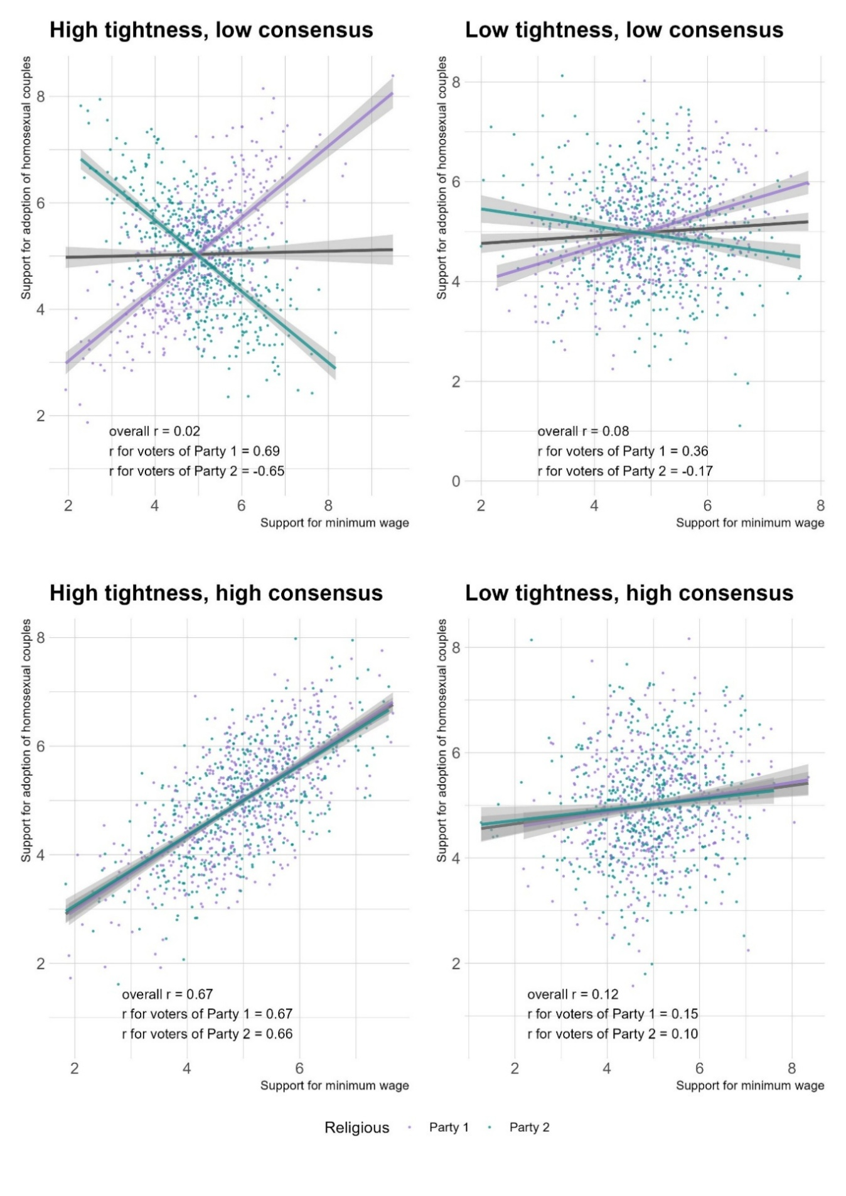

*Caption:* A typology of belief constraint, based on simulated data. Belief tightness occurs when political attitudes are highly associated. Belief consensus occurs when social groups structure their political attitudes in a similar way.

### 2.3 Research Hypotheses

This study analyzes Italian political attitudes following the September 2022 general election. Building on prior research, this study tests three hypotheses regarding belief constraint. The first concerns belief tightness, which refers to the extent to which political attitudes are interconnected and mutually predictive. Political interest has emerged as a key predictor, as politically engaged individuals are more likely to internalize elite discourse and develop structured belief systems (Converse, 2006; Zaller, 1992). Network models confirm that politically knowledgeable individuals exhibit stronger attitudinal associations (Boutyline & Vaisey, 2017; Dalege et al., 2017, 2017; Fishman & Davis, 2022; Keskintürk, 2022b). However, most of this evidence comes from bipartisan political contexts, leaving open questions about whether these findings generalize to multiparty systems.

*H1: Tightness hypothesis*. The belief system of people with high political interest is tighter than that of people with low political interest.

Converse (2006) acknowledged that education might play a similar role. Since education and political knowledge are highly correlated in Western societies (Grönlund & Milner, 2006), distinguishing their effects is crucial. Prior studies using non-network methodologies found that highly educated individuals exhibit great attitudinal stability and consistency (Judd & Krosnick, 1982; Judd & Milburn, 1980; Peffley & Hurwitz, 1985). This suggests that belief tightness may stem not only from political exposure but also from cognitive skills associated with education. However, network-based evidence remains inconclusive. Boutyline and Vaisey (2017) and Keskintürk (2022b) found education is unrelated to belief constraint. In contrast, Van Noord et al. (2024) found that education plays a key role in reinforcing ideological consistency. These findings challenge the social theory of constraint. If education fosters constraint independently of political engagement, belief tightness would arise from an individual’s ability to recognize similar political issues, rather than from exposure to ideological discourse.

*H2: Rival tightness hypothesis*. The belief system of individuals with high educational attainment is tighter than that of individuals with low educational attainment.

While researchers frequently stratify samples by sociodemographic variables to analyze variation in belief systems structures (e.g.: Boutyline & Vaisey, 2017; Franetovic & Bertero, 2023; Schlicht-Schmälzle et al., 2018), partisan alignment has been surprisingly ignored as a moderating factor. In bipartisan systems like the U.S., where issue ownership (Petrocik, 1996) is clearly divided between Republicans and Democrats, belief structures are likely to be uniform within each ideological camp. However, in multiparty contexts, partisan cues may conflict, leading to heterogeneous belief systems across electorates (Adams et al., 2021; Arndt, 2016; Macdonald et al., 1991). European research confirms that citizens do not uniformly structure their attitudes along a left-right divide (Barbet, 2020; Van Noord et al., 2024), and partisan competition further shapes these differences (Daenekindt et al., 2017; Van Den Hoogen et al., 2022). Italy provides a particularly salient case, as it features multiple ideologically distinct parties and one of its largest forces, the M5S, explicitly rejects the left-right framework (Benasaglio Berlucchi, 2022), potentially promoting low consensus on how political attitudes should be structured.

To test this, I estimate belief systems for supporters of the three largest political factions in the 2022 Italian general election: the right-wing coalition (FDI, L, FI), the left-wing coalition (PD, AVS, +E), and the Five Star Movement (M5S). If vote choice structures belief systems, I should observe systematic differences in attitudinal associations across electorates.

*H3: Consensus hypothesis*. The associations between political attitudes are moderated by self-reported vote choice.

## 3. Method

### 3.1 Data and variables

Analyses rely on the fifth wave of the ResPOnsE dataset, an Italian Rolling Cross-Sectional survey (Vezzoni et al., 2020). The sample was drawn using quota sampling based on residence, gender, and age group. Data collection occurred between October 20 and December 15, 2022, through a CAWI questionnaire. Earlier waves focused on the pandemic, but the fifth was fielded one month after the 2022 general elections. It includes a thematic section measuring several Italian political attitudes. I analyze a final sample of 1,149 respondents following list-wise deletion. Attrition was primarily due to missing data on vote choice.

Table 1 (below) lists the variables used in this study, while descriptive statistics appear in Table S1 (Supplement). Table S2 provides descriptives on stratificational measures (political interest, education, vote choice). Variables are recoded for directional consistency (higher values indicate support). Following past research (Brandt et al., 2019; Ellis & Stimson, 2012; Fishman & Davis, 2022; Free & Cantril, 1967)[2], attitudes are categorized as symbolic (political identities) or operational (policy preferences). Symbolic variables include left-right self-placement and Propensity to Vote [PTV] (Van Der Eijk et al., 2006) scores for Italy’s five major parties (FDI, L, FI; PD; M5S). Most variables are operational. Four capture ethical issues: same-sex adoption, abortion, euthanasia, and same-sex marriage, all of which have been politically salient in Italy (Caldwell, 1981; Di Nicola, 2016; Vergallo, 2019). Other four measure economic attitudes: income redistribution, state interventionism, unemployment policy (business vs. individual subsidies), and globalization views. These attitudes are fundamental components of political belief systems, as they are important in determining individuals’ positioning on the left-right spectrum (Bobbio, 1996). Given their prominence in the 2022 electoral campaign, additional items measure attitudes toward the flat tax, minimum wage, and citizenship income, which were central to the political communication of the right-wing coalition, PD, and M5S respectively (Bertero & Scaduto, 2023). Finally, two items survey recent socio-political issues: supplying arms to Ukraine and attitudes toward migration.

### 3.2 Analytical strategy

Figure 2 summarizes my analytical strategy, which is divided into network estimation (detailed in Section 3.3) and hypothesis testing (Section 3.4).

*Figure 2: Analytical strategy*

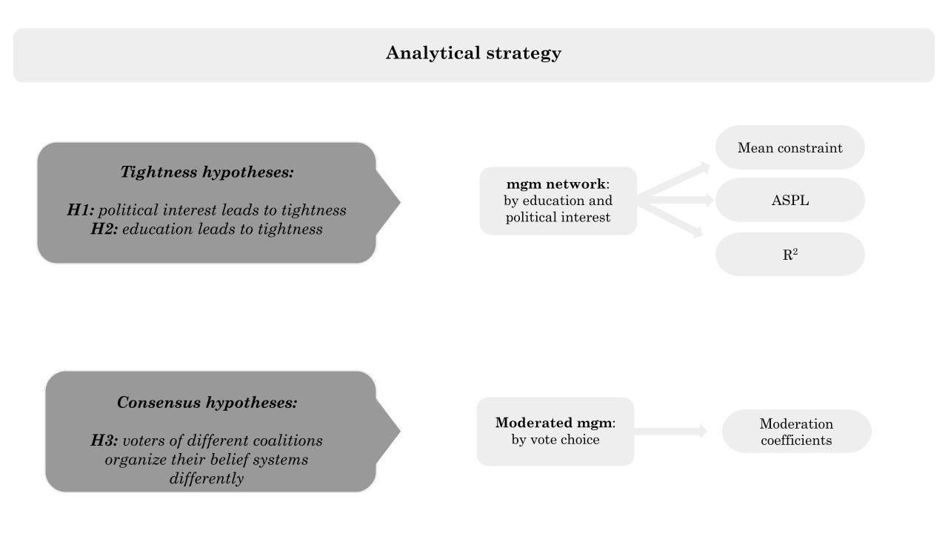

*Caption:* I address the tightness hypotheses by fitting network models on sample partitions with low versus high political interest and education. I perform bootstrap on each sample partition to test if the mean constraint, ASPL, and R2 of these networks differ significantly. I test H3 with a moderated network model, observing if self-reported vote choice moderates the network structure.

*Table 1: Label and survey questions*

|  |  |  |
| --- | --- | --- |
| **Label** | **Question** | **Scale** |
| L_R | Many people when talking about politics use the terms “left” and “right.” Thinking about your political views, where do you stand? | 0 (Left)  10 (right) |
| PTV_PD | [Among the various parties we have in Italy, each would like to have your vote in the future. Regardless of how you plan to vote in the next election,] how likely are you to vote for the Partito Democratico in the future? | 0 (Not likely)  10 (Very likely) |
| PTV_FI | [...] how likely are you to vote for Forza Italia in the future? | 0 (Not likely)  10 (Very likely) |
| PTV_L | [...] how likely are you to vote for Lega in the future? | 0 (Not likely)  10 (Very likely) |
| PTV_M5S | [...] how likely are you to vote for Movimento 5 Stelle in the future? | 0 (Not likely)  10 (Very likely) |
| PTV_FDI | [...] how likely are you to vote for Fratelli d’Italia in the future? | 0 (Not likely)  10 (Very likely) |
| adopt | [On political issues people have different opinions. What is your level of agreement with the following statements? Do you strongly agree, somewhat agree, slightly agree, or strongly disagree?] Gay and lesbian couples should have the same right to adopt a child as heterosexual couples | 1 (Disagree)  4 (Agree) |
| abort* | [...] Abortion must be made more difficult | 1 (Disagree)  4 (Agree) |
| eutha | [...] Euthanasia should be legal | 1 (Disagree)  4 (Agree) |
| marria | [...] Legalization of same-sex marriage is a good thing | 1 (Disagree)  4 (Agree) |
| redis | [Now we would like to know your opinion on some political issues. For each of the following statements, indicate your position on a scale ranging from 1=completely disagree, to 6=completely agree. If your opinion is roughly in the middle between the two, you may choose any other point on the scale.] It is necessary to reduce income differences between those with high incomes and those with low incomes. | 1 (Disagree)  6 (Agree) |
| flat_t | [...] It is necessary to introduce a flat tax (fixed tax rate, regardless of income). | 1 (Disagree)  6 (Agree) |
| m_wage | [...] A minimum hourly wage must be introduced by law. | 1 (Disagree)  6 (Agree) |
| cit_in | [...] It is necessary to maintain a guaranteed citizenship income for those below the poverty line. | 1 (Disagree)  6 (Agree) |
| globa* | [...] It is necessary to limit economic globalization. | 1 (Disagree)  6 (Agree) |
| immig | [...] It is necessary to give citizenship more easily to the children of legal immigrants born and raised in Italy. | 1 (Disagree)  6 (Agree) |
| big_go | Some say taxes should be reduced even at the cost of reducing public services. Others say services should be expanded even at the cost of raising taxes. Where would you place your opinion on a scale of 1 to 7? | 1 (Lower taxes)  7 (Extend ublic services) |
| pub_pri* | Resources to counter the negative effects of unemployment are limited. In such a situation, do you think it is more effective to give subsidies to people in economic hardship or to help businesses that hire? Please indicate where you would place your opinion on a scale of 1 to 7. | 1 (people)  7 (businesses) |
| ukrai* | Thinking about the war in Ukraine, do you favor or oppose supplying arms to Ukraine | 1 (Favor)  4 (Oppose) |

*Caption:* Survey variables and labels. The polarity of asterisked items was inverted. High scores indicate support for an issue or attachment to a party. Squared brackets replace prompts common to multiple questions.

### 3.3 Network models

I estimate belief systems with two types of network models which render variables as nodes of a network where edges denote statistical associations (Lauritzen, 1996). H1 and H2 are assessed through mixed graphical models. H3 is tested with a Moderated Network Model.

**Mixed Graphical Model [mgm].** This model uses survey data to estimate weighted and signed networks of political attitudes, where edges represent regularized partial associations (Haslbeck & Waldorp, 2020). This approach isolate the unique variance shared between attitudes (Epskamp & Fried, 2018). The mgm is estimated using nodewise regularized regressions, where each attitude is regressed on all others using the graphical least absolute shrinkage and selection operator (graphical LASSO) (Tibshirani, 1996). This method ensures sparse networks and excludes spurious associations. The level of regularization is determined via the Extended Bayesian Information Criterion (EBIC), a widely used model selection criterion that balances fit and complexity (Chen & Chen, 2008). Following recent works (e.g.: Brandt et al., 2019), attitudinal variables are treated as quasi-continuous, reducing the mgm to a Gaussian Graphical Model [GGM] (Epskamp et al., 2018). This allows for an interpretable network representation, where edges indicate signed, regularized partial correlations (Burger et al., 2023).

**Moderated Network Model [MNM].** This model extend the mgm by fitting moderation effects in the belief network (Haslbeck et al., 2021). Instead of splitting the sample, I specify self-reported vote choice as a moderator. The MNM mitigates the Berkson bias (Westreich, 2012), which could arise if vote choice were used as a stratification variable, artificially reducing the variance of political attitudes within subgroups (De Ron et al., 2021). The MNM follows the same combination of graphical LASSO and EBIC model selection, but incorporates an additional layer where moderation effects are estimated through nodewise regressions with interaction terms (Haslbeck, 2022). Significant moderation coefficients indicate party affiliation significantly alters the attitudinal relationships.

### 3.4 Hypothesis testing and measures

Prior studies operationalized tightness through mean constraint -the average absolute edge weight (Boutyline & Vaisey, 2017; Keskintürk, 2022b; Gonthier & Guerra, 2023). This measure assumes that tighter belief systems exhibit stronger manifest associations. Hence, mean constraint measures the *consistency* of belief systems. However, mean constraint does not account for the structural position of attitudes within the network. To address this limitation, some scholars have employed Average Shortest Path Lengths [ASPL] (Dalege et al., 2017, 2019). Thus, I calculate weighted ASPL, measuring the average shortest path between all attitudes, considering edge weights (Opsahl et al., 2010). This metric assesses how dense and *interconnected* networks are, with lower values indicating tighter belief structures.

I advance the belief system literature by introducing node-wise R² a theoretically grounded measure of tightness. Converse’s (2006) foundational theory suggests that constrained belief systems exhibit internal coherence, meaning that attitudes are highly predictive of one another. If belief systems are indeed structured, then an individual’s position on one issue should strongly determine their stance on other political attitudes. Node-wise R² directly quantifies the *predictiveness* of political attitudes (Haslbeck & Waldorp, 2018).

I tests H1 and H2 by estimating bootstrapped distributions (Efron, 1987) for all three measures: mean constraint, ASPL, and node-wise R². I bootstrap 10,000 samples starting from the four sample partitions obtained splitting the original one at medians of education and political interest. Then, I calculate these three measures on each of the 40,000 networks. This distributions for each measure of tightness, and for each level of stratificational variables. If normality assumptions hold, the comparisons between these distributions are assessed using ANOVA, else, with the nonparametric Mann-Whitney U test (McKnight & Najab, 2010).

H3 affirms vote choice moderates attitudinal relationships. Direct stratification by vote choice would reduce within-group variance. Thus, I employ a MNM by self-reported vote choice. H3 is supported in case of significant moderations.

## 4. Results

Figure 3 presents the political belief systems obtained stratifying the sample. Nodes represent political attitudes, with yellow pies indicating R² values. Edges denote regularized regression coefficients, with blue (red) indicating positive (negative) associations; thickness reflects strength. The spatial arrangement of the network is standardized for comparability and follows a force-directed algorithm (Fruchterman & Reingold, 1991). Absent edges indicate two variables (e.g.: *big_go* and *globa*) are conditionally independent (i.e.: uncorrelated if controlling for the others).

In all networks, the strongest association is between the support for homosexual marriage and adoption rights. Mean constraint is lowest among politically disengaged individuals (0.08) and highest among politically engaged individuals (0.11), with education-based partitions falling in between (Low: 0.09, High: 0.10). Node-wise R² values indicate that party preferences are the most embedded, whereas views on Ukraine and economy are the least integrated. The belief systems of politically disengaged individuals contain nearly half as many connections (39 vs. 74) as those of engaged individuals, while education-based partitions exhibit similar edge counts (58 vs. 66).

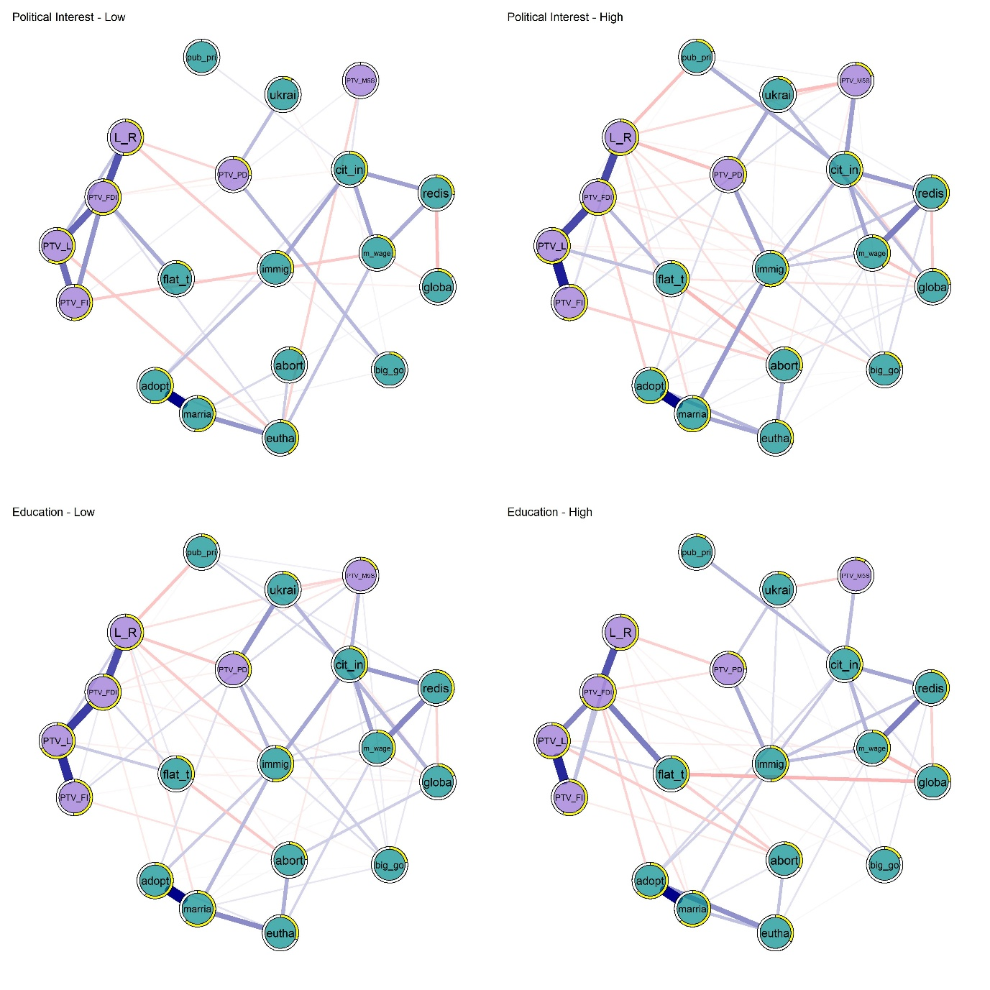*Figure 3: Italian belief systems by Political Interest and Education*

*Caption:* Political belief systems (mgm) of Italians with low versus high political interest (top panels) and low versus high education (bottom panels). Nodes are colored according to variable type (symbolic or operational). Yellow node borders indicate R2 values, edges represent regularized partial correlations (blue [red] for positive [negative]).

Figure 4 visualizes node-wise R2 differences between high and low political interest and education groups. Political interest systematically increases R², with an average node-wise difference of 0.108. The largest gaps emerge for the support of immigration (Δ = 0.26) and flat tax (Δ = 0.23). Education does not systematically increase tightness. In 9 out of 19 cases, R² values are higher in the low-education group, contradicting expectations.

To statistically evaluate H1 and H2, I analyze differences in the bootstrapped distributions of mean constraint, ASPL, and node-wise R². The Shapiro-Wilk and Levene’s tests indicate significant deviations from normality across all measures, except for ASPL in high-education groups (Table S3). Thus, I fit the Mann-Whitney U tests. Since higher tightness is expected in politically engaged and highly educated individuals, I specify one-tailed tests. Table 2 presents the results.

*Table 2: Tests of H1 and H2*

| **Comparison** | **W** | **p** | **Δ** | **Lower CI** | **Upper CI** | **Rank** | **CLES** |
| --- | --- | --- | --- | --- | --- | --- | --- |
| Mean Constraint - Political Interest | 94,315 | 0.000 | 0.998 | 0.998 | 0.998 | 0.998 | 0.999 |
| Mean Constraint - Education | 18,745,672 | 0.000 | 0.625 | 0.613 | 0.637 | 0.625 | 0.813 |
| ASPL - Political Interest | 19,608,272 | 0.000 | 0.608 | 0.596 | 0.620 | 0.608 | 0.804 |
| ASPL - Education | 65,438,508 | 1.000 | -0.309 | -0.324 | -0.294 | -0.309 | 0.346 |
| R² - Political Interest | 153,666,612 | 0.000 | 0.149 | 0.137 | 0.160 | 0.149 | 0.574 |
| R² - Education | 179,265,932 | 0.124 | 0.007 | -0.005 | 0.019 | 0.007 | 0.503 |

Caption: Results of the one tail Mann-Whitney U tests comparing network properties between low and high groups for political interest and education. The table reports W-statistics, p-values, and effect sizes, including Cliff’s Delta (Δ), 95% confidence intervals (CI), rank-biserial correlations (Rank), and the Common Language Effect Size (CLES).

*Figure 4: Beliefs’ constraint by levels of political interest and education*

*Caption:* Comparison of node-wise R2 across the belief systems of people with different levels of education (left) and political interest (right panel). Violet (green) dots are for the low (high) group. Dots are linked by lines visualizing the gap in predictiveness.

In line with H1, individuals with higher political interest exhibit significantly more structured, interconnected, and predictable belief systems. Mean constraint is higher in the high-interest group (W = 94,315, p < .001, Δ = 0.998), indicating that politically engaged individuals hold attitudes that are more tightly integrated. The higher R² in this group (W = 153,666,612, p < .001, Δ = 0.149) further supports this pattern, as their political attitudes are more mutually reinforcing and predictive of one another. Additionally, ASPL is significantly lower in the high-interest group (W = 19,608,272, p < .001, Δ = 0.608), meaning that their belief systems are more densely connected, with shorter paths between attitudes. Results provide only partial support for H2. Mean constraint is significantly higher among the high-education group (W = 18,745,672, p < .001, Δ = 0.625), but with smaller effect size. Neither ASPL nor R² showed significant differences between education groups (p = .124 for R²; p = 1.000 for ASPL).

To ensure the robustness of the findings for H1, I conduct additional analyses using an alternative dichotomization of political interest. While the primary sample partitions were based on a median split (1–3 vs. 4), I re-estimated the bootstrapped distributions of mean constraint, ASPL, and R² using a more restrictive threshold (low-interest group for 1–2 scores). The results (Table S4) confirm the stability of the effects.

Finally, I assess whether Italian electorates exhibit structurally distinct belief systems. Figure 5 presents the results of the MNM, where vote choice (Left, M5S, or Right coalition) is specified as the moderator. Each panel depicts the belief system of each voting group and is obtained by conditioning the model on one of its values. Significant moderation effects occur when a given edge is estimated with a different magnitude in the three panels.

In line with H3, the three belief systems exhibit notable differences. Of 171 possible associations, 14 are significantly moderated when comparing left-wing and M5S voters, 11 differ between left-wing and right-wing voters, and 23 are moderated when comparing right-wing and M5S voters. The most pronounced differences emerge in the association between the propensity to vote for M5S and PD. Right-wing voters perceive these choices as positively related (β = 0.474), suggesting they view M5S as part of the broader left-wing bloc. However, M5S and PD voters reject this categorization, seeing no connection between their parties. A similar pattern appears in the relationship between PD and FDI: left-wing voters see no link between these parties, while right-wing voters perceive them as negatively associated (β = -0.120), and M5S voters perceive a weak but positive association (β = 0.111).

The differences between M5S and left-wing voters extend beyond symbolic attitudes to issue bundling patterns. M5S voters strongly associate their party support with backing the citizenship income (β = 0.150), whereas left-wing voters show a weaker connection (β = 0.052). Furthermore, M5S voters perceive a relationship between the preference for subsidies to businesses versus individuals and PD support (β = -0.174), whereas left-wing voters show no such association. This suggests that M5S voters see PD as more aligned with pro-business subsidy policies, contradicting conventional leftist economic positions. Additionally, M5S supporters display stronger connections between policies such as minimum wage and citizenship income (β = 0.071), whereas this link is absent for left-wing voters.

The largest discrepancies appear between right-wing and M5S voters, with strong differences in symbolic attitudes, operational attitudes, and their interaction. As in the previous comparison, right-wing voters see PD and M5S as positively related choices (β = 0.474), while M5S voters see them as independent. Thus, right-wing voters categorize M5S as part of an outsider bloc -composed by the Movement and the leftist alliance- whereas M5S supporters resist this classification. Unlike right-wing voters, M5S supporters uniquely associate support for the flat tax with backing military aid to Ukraine (β = 0.084), a pattern absent in the other belief systems. Further evidence of their distinct issue bundling is the association between immigration policy and citizenship income (β = 0.075), which is absent among right-wing voters. Additionally, M5S voters perceive a stronger association between support for abortion and euthanasia (β = 0.035) compared to left and right-wing voters.

As a final robustness check, I fit two additional MNMs, where I specify political interest and education (split at the median) as moderators. If political interest and education increase belief tightness, we should observe numerous significant moderation effects in their respective models. Figure S1 presents these results. Education produces only two meaningful moderation effects (coefficients > 0.03), while political interest moderates 23 associations. Among these moderations, nearly half (44.44%) involve symbolic vs. operational attitudes, another 44.44% affect relationships between operational attitudes, and only 4.35% involve symbolic-symbolic associations. This pattern shows that political interest fosters greater ideological consistency by reinforcing connections between symbolic and policy attitudes.

*Figure 5: moderated network model, by self-reported vote choice*

Caption: Moderated Network Model with self-reported vote choice specified as the moderator. Blue edges represent positive regularized partial correlations, and red negative ones. A significant moderation effect occurs when an edge possesses a different width across the three panels. *Vote_cat* represents the moderator.

## 5. Discussion and Conclusions

This study built on the theory of social constraint, which conceptualized belief systems as cognitive structures shaped by elite discourse (Converse, 2006). Prior research showed that politically engaged individuals develop more constrained belief systems (Zaller, 1992; Boutyline & Vaisey, 2017; Fishman & Davis, 2022). However, this literature relied on mono-dimensional measures of constraint, assuming belief systems differ only in the strength of associations (tightness), while neglecting their structural variation across social groups (consensus). To address this gap, this study introduced a bidimensional framework, positing that belief constraint varies both in internal consistency and correlational structure.

Italy offered a compelling case to examine belief tightness and consensus due to its multiparty system and the presence of M5S, an anti-establishment party (Chiaramonte et al., 2018) rejecting traditional left-right alignments (Benasaglio Berlucchi, 2022). Unlike bipolar systems, where voters receive consistent elite signals, multiparty competition introduces conflicting cues (Adams, 2020; Macdonald, 1991; Arndt, 2016), which might foster low belief consensus. Moreover, the M5S attracts young voters who resist ideological categorization (Improta et al., 2022). Therefore, it is important to observe whether these voters conceptualize political issues in radically different ways.

Prior research has either relied on mean constraint (Boutyline & Vaisey, 2017; Keskintürk, 2022b; Gonthier & Guerra, 2023) or ASPL (Dalege et al., 2017, 2019). Mean constraint captures consistency, but overlooks the broader network structure. ASPL assesses connectivity with a network approach. However, neither explicitly quantifies how well political attitudes predict each other, a core tenet of Converse’s (2006) theory. To fill this gap, I introduced node-wise R² as a theoretically grounded measure of attitudes’ predictiveness.

Findings support H1, confirming political interest as a key predictor of belief tightness across all three measures. Politically engaged individuals exhibit significantly more consistent and interconnected belief systems, with effect sizes of extraordinary magnitude (mean constraint: Δ = 0.998, CLES = 0.999; ASPL: Δ = 0.608, CLES = 0.804), indicating that in nearly every bootstrapped sample, high-interest individuals displayed greater tightness. These results align with prior network-based research (Boutyline & Vaisey, 2017; Fishman & Davis, 2022; Dalege et al., 2019). Moreover, political attitudes in the high-interest group were substantially more predictive of each other. Node-wise R² values increased from an average of 0.26 in the low-interest group to 0.37 in the high-interest group—a 42% rise in belief predictability. This suggests that for highly engaged individuals, political attitudes are largely structured by their interconnections and/or by symbolic party attachments. In contrast, the variances of the attitudes of disengaged individuals are determined to a greater extent by variables exogenous to the belief system (see Haslbeck, 2021). This reinforces the argument that belief systems become more self-reinforcing with higher political interest, as the positions individuals adopt on certain issues are increasingly constrained by their broader ideological framework.

In contrast, education exhibits weaker effects. While mean constraint is higher among highly educated individuals (Δ = 0.625, CLES = 0.813), its impact on ASPL (-0.309, CLES = 0.346) and R² (Δ = 0.007, p = .124) is non-significant. Prior research has shown that highly educated individuals hold more stable and coherent attitudes (Judd & Krosnick, 1982; Judd & Milburn, 1980; Peffley & Hurwitz, 1985), yet these results suggest that the tightness of political beliefs primarily stems from engagement with political discourse rather than general cognitive abilities (Converse, 2006; Zaller, 1992). The inconsistent effects of education further stress the need for multiple operationalizations of belief tightness.

The consensus hypothesis (H3) anticipated that vote choice would moderate belief system structures. The results confirm that belief systems are not uniform across electorates, with left- and right-wing voters exhibiting relatively high consensus, while M5S supporters display a structurally distinct belief network. The strongest moderation effects involve symbolic issues, particularly the propensity to vote for M5S and PD. Right-wing voters display strong and positive associations between the propensity to vote for these parties (β = 0.474), suggesting they see no differences between the electoral utilities they satisfy. However, this association vanishes among M5S and PD voters, who show no connection between the propensity to vote for their parties. A similar pattern appears in the relationship between the PTV for PD and FDI: left-wing voters detach their vote intentions for these parties, while right-wing voters perceive them as negatively associated (β = -0.120).

Beyond symbolic attitudes, M5S supporters structure political issues differently. They exhibit a stronger association between support for the citizenship income and vote propensity for their party (β = 0.150) compared to left-wing voters (β = 0.052), reinforcing M5S’s distinct policy identity. Additionally, they uniquely link support for the flat tax with military aid to Ukraine (β = 0.084), a pattern absent among other electorates. These findings indicate that M5S voters not only differ in their perceptions of the electoral space but also bundle economic and cultural issues in ways that diverge from other voters.

These findings align with research showing that belief systems are heterogeneous (Baldassarri & Goldberg, 2014; Bertero et al., 2024; Van Noord et al., 2024; Barbet, 2020; Daenekindt et al., 2017; Van Den Hoogen et al., 2022). These substantive variations suggest relying on a single model for entire populations risks overlooking structural differences. The role of party systems in shaping belief structures remains largely underexplored. Comparative research could clarify how tightness and consensus vary across electorates and political contexts. For instance, parties like Bloco de Esquerda in Portugal and La France Insoumise in France, which strongly advocate both economic redistribution and cultural progressivism, may promote high tightness and high consensus. In contrast, parties such as the German Greens, despite supporting both issues, might avoid framing them as interconnected, leading to low tightness but high consensus. Meanwhile, right-wing parties like Fidesz in Hungary and Freedom and Solidarity in Slovakia, which selectively endorse economic conservatism while rejecting social liberalism, could foster low consensus in their political contexts. If political interest drives belief tightness, these examples suggest that features of the political competition such as the Effective Number of Electoral Parties, or their strategies in issue bundling, may influence consensus.

This study has three key limitations. First, the proposed extension of the theory of social constraint requires further validation with comparative data. Second, future research might incorporate multiple indicators of political interest and knowledge. Finally, there remains a gap between the causal theory of belief systems and their cross-sectional empirical examination. While Converse theorized belief systems as individual-level constructs, most studies analyze them at the population level (Brandt & Morgan, 2022). Bridging this gap may require adopting longitudinal network models (Epskamp et al., 2018) to track changes in belief constraint over time or experimental designs to isolate mechanisms (Brandt & Vallabha, 2023; Fishman & Davis, 2022; Turner-Zwinkels & Brandt, 2022).

## 6. Bibliography

Adams, J., Weschle, S., & Wlezien, C. (2021). Elite Interactions and Voters’ Perceptions of Parties’ Policy Positions. *American Journal of Political Science*, *65*(1), 101–114. https://doi.org/10.1111/ajps.12510

Arndt, C. (2016). Issue evolution and partisan polarization in a European multiparty system: Elite and mass repositioning in Denmark 1968–2011. *European Union Politics*, *17*(4), 660–682. https://doi.org/10.1177/1465116516658359

Baldassarri, D., & Gelman, A. (2008). Partisans Without Constraint: Political Polarization and Trends in American Public Opinion. *SSRN Electronic Journal*. https://doi.org/10.2139/ssrn.1010098

Baldassarri, D., & Goldberg, A. (2014). Neither Ideologues nor Agnostics: Alternative Voters’ Belief System in an Age of Partisan Politics. *American Journal of Sociology*, *120*(1), 45–95. https://doi.org/10.1086/676042

Barbet, B. (2020). Nobody seems to be fully representing me: Differential inter-attitudinal cohesion systems and their effects on satisfaction with the political system. *Electoral Studies*, *64*, 102116. https://doi.org/10.1016/j.electstud.2019.102116

Benasaglio Berlucchi, A. (2022). Populism without host ideologies: A new home for voters with exclusionary attitudes in Italy’s Five Star Movement? *Party Politics*, *28*(5), 811–825.

Bentall, R., Zavlis, O., Hyland, P., McBride, O., Bennett, K. M., & Hartman, T. K. (2023). *The structure of mass political belief systems: A network approach to understanding the Left-Right spectrum*. https://doi.org/10.31234/osf.io/w5pmx

Bertero, A., Franetovic, G., & Mijs, J. J. B. (2024). Inequality Belief Systems: What They Look Like, How to Study Them, and Why They Matter. *Social Indicators Research*. https://doi.org/10.1007/s11205-024-03352-5

Bertero, A., & Scaduto, G. (2023). A midsummer’s night dream: Political communication during the Italian 2022 electoral campaign. *Quaderni Dell Osservatorio Elettorale QOE - IJES*. https://doi.org/10.36253/qoe-14224

Bobbio, N. (1996). *Left and right: The significance of a political distinction*. University of Chicago Press.

Boutyline, A. (2017). Improving the Measurement of Shared Cultural Schemas with Correlational Class Analysis: Theory and Method. *Sociological Science*, *4*, 353–393. https://doi.org/10.15195/v4.a15

Boutyline, A., & Vaisey, S. (2017). Belief Network Analysis: A Relational Approach to Understanding the Structure of Attitudes. *American Journal of Sociology*, *122*(5), 1371–1447. https://doi.org/10.1086/691274

Brandt, M. J. (2022). Measuring the belief system of a person. *Journal of Personality and Social Psychology*, *123*(4), 830–853. https://doi.org/10.1037/pspp0000416

Brandt, M. J., & Morgan, G. S. (2022). Between-person methods provide limited insight about within-person belief systems. *Journal of Personality and Social Psychology*, *123*(3), 621–635. https://doi.org/10.1037/pspp0000404

Brandt, M. J., Sibley, C. G., & Osborne, D. (2019). What Is Central to Political Belief System Networks? *Personality and Social Psychology Bulletin*.

Brandt, M. J., & Vallabha, S. (2023). Inter‐attitude centrality does not appear to reduce persuasion for political attitudes. *European Journal of Social Psychology*, *53*(7), 1342–1358. https://doi.org/10.1002/ejsp.2980

Burger, J., Isvoranu, A.-M., Lunansky, G., Haslbeck, J. M. B., Epskamp, S., Hoekstra, R. H. A., Fried, E. I., Borsboom, D., & Blanken, T. F. (2023). Reporting standards for psychological network analyses in cross-sectional data. *Psychological Methods*, *28*(4), 806–824. https://doi.org/10.1037/met0000471

Caldwell, L. (1981). Abortion in Italy. *Feminist Review*, *7*(1), 49–63. https://doi.org/10.1057/fr.1981.4

Chen, J., & Chen, Z. (2008). Extended Bayesian information criteria for model selection with large model spaces. *Biometrika*, *95*(3), 759–771. https://doi.org/10.1093/biomet/asn034

Chiaramonte, A., Emanuele, V., Maggini, N., & Paparo, A. (2018). Populist Success in a Hung Parliament: The 2018 General Election in Italy. *South European Society and Politics*, *23*(4), 479–501. https://doi.org/10.1080/13608746.2018.1506513

Cohen, G. L. (2003). Party over policy: The dominating impact of group influence on political beliefs. *Journal of Personality and Social Psychology*, *85*(5), 808.

Converse, P. E. (2006). The nature of belief systems in mass publics (1964). *Critical Review*, *18*(1–3), 1–74. https://doi.org/10.1080/08913810608443650

Daenekindt, S., De Koster, W., & Van Der Waal, J. (2017). How people organise cultural attitudes: Cultural belief systems and the populist radical right. *West European Politics*, *40*(4), 791–811. https://doi.org/10.1080/01402382.2016.1271970

Dalege, J., Borsboom, D., Van Harreveld, F., & Van Der Maas, H. L. J. (2019). A Network Perspective on Attitude Strength: Testing the Connectivity Hypothesis. *Social Psychological and Personality Science*, *10*(6), 746–756. https://doi.org/10.1177/1948550618781062

Dalege, J., Borsboom, D., Van Harreveld, F., Waldorp, L. J., & Van Der Maas, H. L. J. (2017). Network Structure Explains the Impact of Attitudes on Voting Decisions. *Scientific Reports*, *7*(1), 4909. https://doi.org/10.1038/s41598-017-05048-y

De Ron, J., Fried, E. I., & Epskamp, S. (2021). Psychological networks in clinical populations: Investigating the consequences of Berkson’s bias. *Psychological Medicine*, *51*(1), 168–176. https://doi.org/10.1017/S0033291719003209

Di Nicola, P. (2016). Babies are not Born under a Cabbage Leaf. *Italian Sociological Review*, *Vol 6*, 293 Pages. https://doi.org/10.13136/ISR.V6I2.135

DiMaggio, P., & Goldberg, A. (2018). Searching for *Homo Economicus*: Variation in Americans’ Construals of and Attitudes toward Markets. *European Journal of Sociology*, *59*(2), 151–189. https://doi.org/10.1017/S0003975617000558

Efron, B. (1987). Better bootstrap confidence intervals. *Journal of the American Statistical Association*, *82*(397), 171–185.

Ellis, C., & Stimson, J. A. (2012). *Ideology in America* (1st ed.). Cambridge University Press. https://doi.org/10.1017/CBO9781139094009

Epskamp, S., & Fried, E. I. (2018). A tutorial on regularized partial correlation networks. *Psychological Methods*, *23*(4), 617–634. https://doi.org/10.1037/met0000167

Epskamp, S., Waldorp, L. J., Mõttus, R., & Borsboom, D. (2018). The Gaussian Graphical Model in Cross-Sectional and Time-Series Data. *Multivariate Behavioral Research*, *53*(4), 453–480. https://doi.org/10.1080/00273171.2018.1454823

Fishman, N., & Davis, N. T. (2022). Change We Can Believe In: Structural and Content Dynamics within Belief Networks. *American Journal of Political Science*, *66*(3), 648–663. https://doi.org/10.1111/ajps.12626

Franetovic, G., & Bertero, A. (2023). How do people understand inequality in Chile? A study through attitude network analysis. *AWARI*, *4*.

Free, L. A., & Cantril, H. (1967). The political beliefs of Americans: A study of public opinion. *(No Title)*.

Fruchterman, T. M. J., & Reingold, E. M. (1991). Graph drawing by force‐directed placement. *Software: Practice and Experience*, *21*(11), 1129–1164. https://doi.org/10.1002/spe.4380211102

Goldberg, A. (2011). Mapping Shared Understandings Using Relational Class Analysis: The Case of the Cultural Omnivore Reexamined. *American Journal of Sociology*, *116*(5), 1397–1436. https://doi.org/10.1086/657976

Gonthier, F., & Guerra, T. (2023). How party polarization shapes the structuring of policy preferences in Europe. *Party Politics*, *29*(2), 384–393. https://doi.org/10.1177/13540688211064606

Grönlund, K., & Milner, H. (2006). The Determinants of Political Knowledge in Comparative Perspective. *Scandinavian Political Studies*, *29*(4), 386–406. https://doi.org/10.1111/j.1467-9477.2006.00157.x

Haslbeck, J. M. B. (2022). Estimating group differences in network models using moderation analysis. *Behavior Research Methods*, *54*(1), 522–540. https://doi.org/10.3758/s13428-021-01637-y

Haslbeck, J. M. B., Borsboom, D., & Waldorp, L. J. (2021). Moderated Network Models. *Multivariate Behavioral Research*, *56*(2), 256–287. https://doi.org/10.1080/00273171.2019.1677207

Haslbeck, J. M. B., & Waldorp, L. J. (2018). How well do network models predict observations? On the importance of predictability in network models. *Behavior Research Methods*, *50*(2), 853–861. https://doi.org/10.3758/s13428-017-0910-x

Haslbeck, J. M. B., & Waldorp, L. J. (2020). mgm: Estimating Time-Varying Mixed Graphical Models in High-Dimensional Data. *Journal of Statistical Software*, *93*(8). https://doi.org/10.18637/jss.v093.i08

Improta, M., Mannoni, E., Marcellino, C., & Trastulli, F. (2022). Voters, issues, and party loyalty: The 2022 Italian election under the magnifying glass. *Quaderni Dell’Osservatorio Elettorale QOE - IJES*. https://doi.org/10.36253/qoe-13956

Judd, C. M., & Krosnick, J. A. (1982). Attitude centrality, organization, and measurement. *Journal of Personality and Social Psychology*, *42*(3), 436–447. https://doi.org/10.1037/0022-3514.42.3.436

Judd, C. M., & Milburn, M. A. (1980). The Structure of Attitude Systems in the General Public: Comparisons of a Structural Equation Model. *American Sociological Review*, *45*(4), 627. https://doi.org/10.2307/2095012

Keskintürk, T. (2022a). Religious belief alignment: The structure of cultural beliefs from adolescence to emerging adulthood. *Poetics*, *90*, 101591. https://doi.org/10.1016/j.poetic.2021.101591

Keskintürk, T. (2022b). The organization of political belief networks: A cross-country analysis. *Social Science Research*, *107*, 102742. https://doi.org/10.1016/j.ssresearch.2022.102742

Keskintürk, T. (2022c). The organization of political belief networks: A cross-country analysis. *Social Science Research*, *107*, 102742. https://doi.org/10.1016/j.ssresearch.2022.102742

Lauritzen, S. L. (1996). *Graphical models* (Vol. 17). Clarendon Press.

Macdonald, S. E., Listhaug, O., & Rabinowitz, G. (1991). Issues and Party Support in Multiparty Systems. *American Political Science Review*, *85*(4), 1107–1131. https://doi.org/10.2307/1963938

Malka, A., & Lelkes, Y. (2010). More than Ideology: Conservative–Liberal Identity and Receptivity to Political Cues. *Social Justice Research*, *23*(2–3), 156–188. https://doi.org/10.1007/s11211-010-0114-3

Martin, J. L. (2000). The relation of aggregate statistics on beliefs to culture and cognition. *Poetics*, *28*(1), 5–20. https://doi.org/10.1016/S0304-422X(00)00010-3

Martin, J. L. (2002). Power, Authority, and the Constraint of Belief Systems. *American Journal of Sociology*, *107*(4), 861–904. https://doi.org/10.1086/343192

McKnight, P. E., & Najab, J. (2010). Mann‐Whitney U Test. In I. B. Weiner & W. E. Craighead (Eds.), *The Corsini Encyclopedia of Psychology* (1st ed., pp. 1–1). Wiley. https://doi.org/10.1002/9780470479216.corpsy0524

Opsahl, T., Agneessens, F., & Skvoretz, J. (2010). Node centrality in weighted networks: Generalizing degree and shortest paths. *Social Networks*, *32*(3), 245–251. https://doi.org/10.1016/j.socnet.2010.03.006

Peffley, M. A., & Hurwitz, J. (1985). A Hierarchical Model of Attitude Constraint. *American Journal of Political Science*, *29*(4), 871. https://doi.org/10.2307/2111185

Petrocik, J. R. (1996). Issue ownership in presidential elections, with a 1980 case study. *American Journal of Political Science*, 825–850.

Schlicht-Schmälzle, R., Chykina, V., & Schmälzle, R. (2018). An attitude network analysis of post-national citizenship identities. *PLOS ONE*, *13*(12), e0208241. https://doi.org/10.1371/journal.pone.0208241

Tibshirani, R. (1996). Regression Shrinkage and Selection Via the Lasso. *Journal of the Royal Statistical Society Series B: Statistical Methodology*, *58*(1), 267–288. https://doi.org/10.1111/j.2517-6161.1996.tb02080.x

Turner-Zwinkels, F. M., & Brandt, M. J. (2022). Belief system networks can be used to predict where to expect dynamic constraint. *Journal of Experimental Social Psychology*, *100*, 104279. https://doi.org/10.1016/j.jesp.2021.104279

Van Den Hoogen, E., Daenekindt, S., De Koster, W., & Van Der Waal, J. (2022). Support for European Union membership comes in various guises: Evidence from a Correlational Class Analysis of novel Dutch survey data. *European Union Politics*, *23*(3), 489–508. https://doi.org/10.1177/14651165221101505

Van Der Eijk, C., Van Der Brug, W., Kroh, M., & Franklin, M. (2006). Rethinking the dependent variable in voting behavior: On the measurement and analysis of electoral utilities. *Electoral Studies*, *25*(3), 424–447. https://doi.org/10.1016/j.electstud.2005.06.012

Van Noord, J., Turner-Zwinkels, F. M., Kesberg, R., Brandt, M. J., Easterbrook, M. J., Kuppens, T., & Spruyt, B. (2024). The nature and structure of European belief systems: Exploring the varieties of belief systems across 23 European countries. *European Sociological Review*, jcae011. https://doi.org/10.1093/esr/jcae011

Vergallo, G. M. (2019). The Marco Cappato and Fabiano Antoniani (dj Fabo) case paves the way for new assisted suicide legislation in Italy: An overview of statutes from several European countries. *European Journal of Health Law*, *26*(3), 221–239.

Vezzoni, C., Ladini, R., Molteni, F., Dotti Sani, G. M., Biolcati, F., Chiesi, A., Maraffi, M., Guglielmi, S., Pedrazzani, A., & Segatti, P. (2020). Investigating the social, economic and political consequences of Covid-19: A rolling cross-section approach. *Survey Research Methods*, 187-194 Pages. https://doi.org/10.18148/SRM/2020.V14I2.7745

Westreich, D. (2012). Berkson’s bias, selection bias, and missing data. *Epidemiology (Cambridge, Mass.)*, *23*(1), 159–164.

Zaller, J. (1992). *The nature and origins of mass opinion*. Cambridge university press.

1. The term consensus has been previously used to describe the likelihood that any two individuals in a given group will hold the same normative position on a set of attitudes (Martin, 2000, 2002). However, this definition conflates consensus with constraint, as individuals with highly correlated attitudes are necessarily more likely to agree on specific positions. In contrast, this study conceptualizes constraint as a bi-dimensional construct composed of tightness and consensus.
2. The distinction between operational and symbolic beliefs involves a margin of subjectivity. To mitigate this limitation, one contribution classified attitudes into symbolic, operational, and “cross-level” categories (Keskintürk, 2022b). This paper adopts the binary scheme, as it is more consistent with the theory behind this distinction, and as these labels have here a descriptive purpose only.