# The political belief systems of Italian voters

## Abstract

This article investigates the Italian political belief system, which is the structure of meaning in which political attitudes are embedded. Two kinds of correlational models are employed to scrutinize belief systems, representing beliefs as nodes in a weighted network. Their weighted edges are derived from survey data collected following the 2022 Italian general election. Consistently with the theory of social constraint, results show that the amount of organization of belief systems is positively correlated with individual levels of political interest. Notably, belief constraint is not linked to individual levels of education. Additionally, the article reveals substantial differences in the belief systems of voters aligned with the left, right, and the Five Star Movement. These electorates construe political competition in different ways and associate political parties with distinct political issues. The article enhances the understanding of the structure of Italian political attitudes and bridges the gap between two categories of network models that have been applied in separate research domains so far.

## 1. Introduction

Political scientists have long explored the *levels* of public attitudes. Many scholars have investigated the links between political attitudes and voting behaviors (e.g.: Sandri & Seddone, 2015; Schoen & Schumann, 2007). Others have isolated the determinants of attitudes toward political institutions, such as the European Union (Conti & Memoli, 2015; Tucker et al., 2002). A parallel strand of research examined attitudes towards hot socio-political issues like the environment (Benedetta & Vincenzo, 2020), conspiracy theories (Vezzoni et al., 2022), and political violence (Vegetti & Littvay, 2022). However, most of the literature has overlooked the broader *structure* in which political attitudes are embedded, which is the focus of this article. Political beliefs are not held in isolation, as individuals are at least partially motivated to assume coherent stances on the political issues gravitating in the public arena. This was first noted by Converse in his notorious study of the North American belief system (2006). Since his contribution, scholars from different disciplines have made great advancements in the field. These improvements have often been triggered by methodological innovations, such as network models in which political attitudes measured through surveys are treated as nodes of a weighted network representing the associations among these beliefs. Studies have shown that the amount of organization of a belief system is related to individual levels of political information and that political attitudes are organized around political identities (Boutyline & Vaisey, 2017), which are central to this system (Brandt et al., 2019). It can be argued that this body of work is characterized by two intertwined limitations. First, most of the research in this field analyzed North American attitudes exclusively. This entails that belief systems theory necessitates confirmation from other research settings. Second, the focus on the United States may have led to overlooking an important research question: how do belief systems vary among voters of different parties? In a bipartisan political system, huge differences are unlikely to emerge, as issue ownership is sharper and political cues clearer. However, the situation could change dramatically in more pluralized party systems.

The remainder of the article aims to address these open questions. Section 2 reviews the findings and methodological strategies adopted by scholars of the three waves of studies on political belief systems. Section 3 details the twofold analytical strategy of this contribution. First, correlational networks are estimated to evaluate whether the amount of organization of belief systems varies according to political interest and educational levels. Second, newer models coming from political psychology are fitted to the electorates of the main Italian political formations. Results show that the amount of organization of the Italian belief system is mostly determined by political interest and that voters of different parties possess markedly different belief systems. The Conclusions stress the limitations and contributions of the research while suggesting future directions for the fourth wave of studies on the topic.

## 2. Theory

### 2.1 Attitudinal networks

In his seminal contribution, Converse (2006) examined attitudes toward a wide range of issues central to U.S. public debate to study the nature and functioning of the attitudinal structure in which political beliefs are embedded. The author named this structure as a political belief system, noting that other potential labels, first and foremost that of ideology, were already polluted by their adoption in lay political jargon, and widely contested within political philosophy. He defined a political belief system “as a configuration of ideas and attitudes in which the elements are bound together by some form of constraint or functional interdependence” (Converse, 2006; p.3). Although this work has attracted academic interest from disciplines as disparate as sociology, political psychology, and network science, subsequent work on this topic is substantially dependent on Converse's definition (Boutyline & Vaisey, 2017; Brandt et al., 2019; Jost, 2006; Keskintürk, 2022b). Central to this definition are two elements. First, belief systems are composed of attitudes, which are “general evaluation[s] that people hold regarding a particular entity”, known as the attitude objects (Lavrakas, 2008; p.38). This article focuses on political attitudes, which are evaluations of politically denoted attitudes objects. Second, political beliefs are both *statically* and *dynamically* constrained. Indeed, the positions individuals adopt on political attitudes are influenced by the positions they hold on other political attitudes (static constraint), and a change of opinion on one political belief is likely to be followed by readjustments on other related issues (dynamic constraint). Most of Converse's work has dealt with the sources of static constraint. His empirical scrutiny of North Americans’ attitudes led him to conclude these sources are “much less logical [...] than they are psychological – and less psychological than social” (Converse, 2006; p. 5). Converse found that correlations between political beliefs were very low at the aggregate level, with individuals declaring liberals (conservatives) failing to express higher preferences for liberal (conservative) policies. Correlations were higher, and political attitudes were more stable, only for the *ideologues*, who represented about 3% of the population. In addition, ideologues and the lay public differed greatly in political knowledge and, relatedly, educational levels. Therefore, Converse theorized that political attitudes are strongly constrained in a belief system only for the portion of the electorate scoring high in political knowledge, as only these individuals are aware of the political issues central to the public debate, and of the positions adopted by their party. This socio-centric[1] explanation of attitudinal constraint constitutes another important legacy of Converse’s work. Indeed, subsequent empirical evidence fits Converse’s top-down theoretical model in which public attitudes are shaped by political elites. Voters have been found to rely on partisan heuristics when assuming their stances on political attitudes (Zaller, 1992), and experimental evidence confirms that framing a policy proposal as praised by a particular party substantially increases the likelihood that supporters of that party will endorse it and that voters of different parties will ostracize it (Cohen, 2003; Malka & Lelkes, 2010). Therefore, parties act as cognitive authorities that shape public debate through their political discourse (Martin, 2002), and political knowledge is a prerequisite for a well-structured belief system, as only the most informed will be able to receive, interpret, and act upon the political cues disseminated by political elites.

A key limitation of the work of Converse lies in the marked discrepancy between his theoretical account and his empirical investigation of political belief systems. Indeed, at the theoretical level, political belief systems are described as *networks* of beliefs. Interestingly, this is also true for the wider label of ideology, which elsewhere has been defined as a “network of beliefs, opinions and values” (Jost et al., 2009; p. 310), or as an “interrelated set of attitudes and values about the proper goals of society and how they should be achieved” (Tedin, 1987; p. 65). However, at the methodological level, Converse backed his theory with simple bivariate analyses of correlation coefficients between political attitudes and other qualitative data. A more rigorous test of the constraint hypothesis was provided about fifty years later by Boutyline and Vaisey, who developed Belief Network Analysis [BNA] (Boutyline & Vaisey, 2017). BNA renders attitudes as nodes of a network whose weighted edges are estimated from survey data. In correlational networks, edge thickness corresponds to the squared value of pairwise correlations between the selected attitudinal items. The authors studied the amount of organization of belief systems and their organizational principles. Regarding the former, they showed that static constraint varies across levels of political knowledge, as the average correlation between political attitudes is higher for more informed North American voters. Regardless of the levels of political knowledge, however, the authors showed that the organizing principle of belief systems centered on political identities in general, and on the left-right dimension in particular. Variables concerning support for political parties and self-positioning on the left-right continuum were central in the attitudinal networks. Boutyline and Vaisey interpreted their high centrality as evidence of their embryonic role in the formation and development of political attitudes, arguing that peripheral beliefs likely align with central ones. This entails that individuals’ positions on political attitudes are informed by their political identities. To examine for possible changes in the organizing principles governing belief systems, they partitioned the sample along sociodemographic lines (education, area of residence, income, occupation, and sex), and re-estimated correlational networks. The authors showed that associations between attitudes (the edges of correlational networks) do not vary significantly among these subgroups, and that the left-right dimension remained the organizing principle of their attitudes (the left-right variable was the most central node). More recent applications of BNA have followed two main directions. One contribution tested the constraint hypothesis comparatively, finding that political attitudes are more constrained in countries where parties are more institutionalized, and individuals are more politically active and educated (Keskintürk, 2022b). Another contribution employed correlational networks in combination with community detection techniques to show that socio-political attitudes of the U.S. public have become more polarized in recent years (DellaPosta, 2020). Indeed, the author found that the number of network communities has decreased over time, signaling that an increasing number of socio-political attitudes are now part of an intense conflict organized along political identity lines.

In sum, the first wave of works regarding political belief systems aimed to test Converse’s theoretical account with models of increasing complexity. These works showed that political beliefs are constrained by social factors. Among this, political knowledge plays a fundamental role, as it represents the prerequisite for receiving party cues. However, there was still room for improvement in the fit between a networked theoretical account of political belief systems and their empirical examination, which was anchored to the estimation of correlational networks.

### 2.2 Modeling a belief system

Empirical and theoretical works on belief systems assume political attitudes interact causally. This is evident in the early work of Converse, where he theorized dynamic constraint (Converse, 2006). Boutyline and Vaisey also posited causality, speculating that peripheral nodes are influenced by more central ones, which are related to political identities (Boutyline & Vaisey, 2017). The causal assumption is also evident in many theoretical accounts of belief systems, as they are defined as a “cohesive organization of interdependent political views, with some elements exerting causal force on other elements in the belief system” (Kalmoe, 2020; p. 2), or as a set of political attitudes that interact causally while being shaped by exogenous influences, such as electoral campaigns and interpersonal communication (Brandt & Sleegers, 2021). However, until recent years, belief systems have been studied through the correlational network approach suggested by BNA.

To alleviate the tension between the causal assumption of intra-attitudinal relationships and their investigation through plain correlational techniques, Brandt and colleagues proposed to leverage recent advancements in psychometric modeling (Brandt et al., 2019). These models are based on partial correlations and differ in two substantial aspects from BNA’s correlational networks. First, the edges of correlational networks represent the squared value of the correlation coefficient observed between a set of survey items. This entails that edges are weighted, but not signed. Thus, these models are not able to capture the heterogeneities that may occur between belief systems of different population strata[2]. Second, many of the edges modeled in BNA are likely to be spurious, as pairwise correlations do not consider the role of any possible confounding factor. Thus, the adoption of partial correlation models improves the validity of the empirical scrutiny of belief systems, as they allow researchers to focus on the portion of unique variance shared by each pair of beliefs[3].

This second wave of studies developed along two lines of research. Some scholars have addressed the structural features of belief systems. Confirming and extending BNA’s earlier findings, scholars have found that *symbolic* beliefs are more central than *operational* ones (Brandt et al., 2019; Fishman & Davis, 2022). These concepts derive from public opinion research, wherein scholars have distinguished between attitudes that tap into abstract and affective political labels (symbolic beliefs) and opinions regarding more concrete political issues, such as policy proposals that could be implemented by political actors (Ellis & Stimson, 2012; Free & Cantril, 1968). Other studies have focused on the dimensionality of belief systems, showing that they are not reducible to a single latent factor featuring the left-right poles, but rather composed of three (Cicco et al., 2023) to five (Sindermann et al., in press) dimensions. The second strand of literature focused on the dynamics of belief systems. One contribution compared the belief systems of U.S. voters at the beginning and the end of the 2008 electoral campaign (Fishman & Davis, 2022). Results showed that, between January and October, static constraint increased only among the high-knowledge voters, and that symbolic components were reliably more central than operational ones only for low-knowledge electors. Other studies have employed an experimental research design. On one occasion, researchers successfully manipulated a political attitude, despite finding no evidence of opinion change in other components of the system (Coppock & Green, 2022). Another effort designed a survey experiment in which respondents reported their political attitudes, were assigned to a control or experimental condition in which an attitude was targeted with a manipulation attempt, and the attitudes were assessed again (Turner-Zwinkels & Brandt, 2022). The intensity of changes in non-targeted attitudes was moderated by the distance between targeted and not-targeted components of the belief system.

### 2.3 Research hypotheses

Although one contribution has analyzed belief systems comparatively (Keskintürk, 2022b), no empirical contribution has explored the Italian political belief system directly. Italy is an interesting case study, as it is a multiparty system characterized by intense political competition among several political actors. This research examines Italian political attitudes in the aftermath of the September 2022 general election, when the rightist coalition formed by Fratelli d’Italia (*Brothers of Italy* [FDI]), Lega (*League* [L]), and Forza Italia (*Go Italy* [FI]) won the relative majority of parliamentary seats (43,8%). The second biggest coalition was the leftist one, composed of Partito Democratico (*Democratic Party* [PD]), Alleanza Verdi e Sinistra Italiana (*Green and Left Alliance* [GLA]), and +Europa *(+Europe* [+E]). This coalition won 26,1% of valid votes. Finally, the Movimento 5 Stelle (*Five Stars Movement* [M5S]) ran alone winning 15,4 % of votes, and a centrist alliance gathered 7,8% of valid preferences (Giovannini et al., 2023).

This research will test three hypotheses derived from the political belief systems literature. First, the static constraint of Italian political attitudes is examined. The theory of social constraint posits beliefs are constrained only for people with high political knowledge. However, this account necessitates further examination in other countries. Thus:

*H1: Constraint hypothesis.* The attitudinal network[4] of people with high political knowledge is more constrained than that of people with low political knowledge.

Second, an alternative hypothesis explaining the degree of organization of belief systems is investigated. Indeed, as already recognized by Converse (1964), the role of education could be similar to that of political knowledge, and the two variables are *de facto* highly correlated in Western societies (Grönlund & Milner, 2006). Consistently, prior studies based on non-network methodologies have found that attitudes of the highly educated respondents are more stable and consistent than those of the average public (Judd & Krosnick, 1982; Judd & Milburn, 1980; Peffley & Hurwitz, 1985). However, recent contributions have also examined this issue with a network approach, finding mixed results. Scholars found that the belief systems of people with diverse educational levels do not differ meaningfully in the U.S. (Boutyline & Vaisey, 2017) and that a country's mean level of education is not reliably associated with higher belief constraints of its inhabitants (Keskintürk, 2022b). It is important to test this path, as it might be the source of a strong alternative mechanism leading to belief constraint. Attitudes could be strongly organized not because of the reception of party cues, but rather because of individual levels of education, which determine the ability of respondents to recognize associations between the survey items they have to fill in. Thus:

*H2: Rival constraint hypothesis*. The attitudinal network of people with high educational levels is more constrained than that of people with low educational levels.

Finally, this article investigates an additional source of potential variation in political belief systems, which has always been overlooked in past research. It is common practice for researchers in this field to stratify the sample by sociodemographic characteristics, to observe variations in the belief systems of different population strata (e.g.: Boutyline & Vaisey, 2017; Franetovic & Bertero, 2023; Schlicht-Schmälzle et al., 2018). Effectively, this methodological strategy is equivalent to traditional moderation analysis, where stratificational measures are assumed to mediate the relationships between the selected attitudes (see Method section for details). In so doing, researchers unjustly excluded vote choice from the set of examined intervening factors. Perhaps, this exclusion is due to the North American focus of scholars in this field. While striking differences are unlikely to emerge in a bipolar party system like the U.S., where issue ownership is quite clearly divided between the red and blue parties, important differences might emerge in multiparty systems. Fitting network models on different electorates gives the possibility to understand whether different voters construe the political competition in different ways and whether they agree on which political issues go together. Thus, the paper examines the three biggest political factions in the 2023 election, to test:

*H3: Heterogeneity hypothesis*. The belief systems of people who voted for the right-wing coalition, PD, and 5SM structurally differ.

## 3. Method

### 3.1 Data and variables

Analyses are based on the fifth wave of ResPOnsE data, an Italian dataset endowed with a Rolling Cross-Sectional design (Vezzoni et al., 2020)[5]. The sample is obtained with quotas by area of residence, gender, and age group. Wave five was fielded between October 20 to December 15, 2022, through a multipurpose CAWI questionnaire. The other waves of this dataset mostly focus on the pandemic. However, this wave was polled one month after the general elections of September 25, 2022, and thus included numerous variables tapping into symbolic and operational components of the Italian political belief system. ResPOnsE is composed of a core module, filled out by all respondents, and other thematic sections that are shown to smaller sample partitions where participants are randomly assigned. The former section of the questionnaire was shown to 9273 individuals, while some questions were supplied to 1850 respondents only. List-wise deletion reduced the sample to 1149 respondents. The sample overrepresents males (639 respondents are males, 510 are women), is skewed towards an older sociodemographic profile (the mean age in the sample is 53 years, against the national mean of 46.4[6]), and presents marked disproportions in the voting variable (359 individuals reported voting for the rightist coalition, 450 for the leftist, 195 for the 5SM). On the one hand, this represents an obstacle to straightforward inference to the Italian population. On the other hand, this study aims at exploring the belief systems of different voters, and not directly their electoral choices. Thus, the peculiarities of this sample are less critical than they would be in a work explaining voting behavior.

Table 1: Label and survey questions

|  |  |  |
| --- | --- | --- |
| **Label** | **Question** | **Scale** |
| L_R | Many people when talking about politics use the terms "left" and "right." Thinking about your political views, where do you stand? | 0 (Left)  10 (right) |
| PTV_PD | [Among the various parties we have in Italy, each would like to have your vote in the future. Regardless of how you plan to vote in the next election,] how likely are you to vote for the Partito Democratico in the future? | 0 (Not likely)  10 (Very likely) |
| PTV_FI | [...] how likely are you to vote for Forza Italia in the future? | 0 (Not likely)  10 (Very likely) |
| PTV_L | [...] how likely are you to vote for Lega in the future? | 0 (Not likely)  10 (Very likely) |
| PTV_M5S | [...] how likely are you to vote for the 5 Stars Movement in the future? | 0 (Not likely)  10 (Very likely) |
| PTV_FDI | [...] how likely are you to vote for Fratelli d’Italia in the future? | 0 (Not likely)  10 (Very likely) |
| adopt | [On political issues people have different opinions. What is your level of agreement with the following statements? Do you strongly agree, somewhat agree, slightly agree, or strongly disagree?] Gay and lesbian couples should have the same right to adopt a child as heterosexual couples | 1 (Disagree)  4 (Agree) |
| abort* | [...] Abortion must be made more difficult | 1 (Disagree)  4 (Agree) |
| eutha | [...] Euthanasia should be legal | 1 (Disagree)  4 (Agree) |
| marria | [...] Legalization of same-sex marriage is a good thing | 1 (Disagree)  4 (Agree) |
| redis | [Now we would like to know your opinion on some political issues. For each of the following statements, indicate your position on a scale ranging from 1=completely disagree, to 6=completely agree. If your opinion is roughly in the middle between the two, you may choose any other point on the scale.] It is necessary to reduce income differences between those with high incomes and those with low incomes. | 1 (Disagree)  6 (Agree) |
| flat_t | [...] It is necessary to introduce a flat tax (fixed tax rate, regardless of income). | 1 (Disagree)  6 (Agree) |
| m_wage | [...] A minimum hourly wage must be introduced by law. | 1 (Disagree)  6 (Agree) |
| cit_in | [...] It is necessary to maintain a guaranteed citizenship income for those below the poverty line. | 1 (Disagree)  6 (Agree) |
| globa* | [...] It is necessary to limit economic globalization. | 1 (Disagree)  6 (Agree) |
| immig | [...] It is necessary to give citizenship more easily to the children of legal immigrants born and raised in Italy. | 1 (Disagree)  6 (Agree) |
| big_go | Some say taxes should be reduced even at the cost of reducing public services. Others say services should be expanded even at the cost of raising taxes. Where would you place your opinion on a scale of 1 to 7? | 1 (Lower taxes)  7 (Extend ublic services) |
| pub_pri* | Resources to counter the negative effects of unemployment are limited. In such a situation, do you think it is more effective to give subsidies to people in economic hardship or to help businesses that hire? Please indicate where you would place your opinion on a scale of 1 to 7. | 1 (people)  7 (businesses) |
| ukrai* | Thinking about the war in Ukraine, do you favor or oppose supplying arms to Ukraine | 1 (Favor)  4 (Oppose) |

*Caption:* the polarity of items marked with an asterisk was inverted. High scores indicate support for an issue or attachment to a label. Prompts common to multiple questions are replaced by squared brackets.

Table 1 reports labels and survey questions for each attitudinal variable featured in the analyses. Descriptives are provided in Table 1 of the Supplement. Variables are measured on different scales, and their polarity is uniformed to have high values indicating support or attachment to all attitude objects. Attitudes were considered symbolic when they measured support or attachment to political labels and parties, and operational when they measured endorsement of policy proposals that could be implemented by political parties (Ellis & Stimson, 2012; Free & Cantril, 1968)[7]. Symbolic components were surveyed through left-right self-placement and Propensity to Vote [PTV] items and are labeled in capital letters. The first item is the most established assessment of left-right political labels. Another set of variables measures the attachment to the five major Italian parties (FDI, L, and FI; PD; M5S). The PTVs prompt respondents to report their likelihood of voting for a particular party in a generic and future election. These items capture the electoral utility respondents gain by voting for a party (van der Eijk et al., 2006).

Consistent with previous research, most of the selected variables are operational issues (Boutyline & Vaisey, 2017; Brandt et al., 2019; Keskintürk, 2022b). Four variables tap into the ethical issues of adoptions by homosexual couples, abortion, euthanasia, and homosexual marriage, as they have all been salient in recent years in the Italian context. The recognition of same-sex couples in Italy was achieved in 2016 with the Cirinnà law, which excluded any reference to adoption by same-sex couples (Di Nicola, 2016). Abortion has been formally permitted in Italy since 1978 (Caldwell, 1981), but the conspicuous number of abstentionist doctors often impedes the practical availability of this right. Finally, the possibility of legalizing euthanasia has recently entered the Italian political arena, as the *political entrepreneur* Marco Cappato politicized the issue by assisting an Italian citizen willing to pursue it in Switzerland (Vergallo, 2019). Four other variables regard economic attitudes: income redistribution, the preferred role of the government (interventionist versus liberal), the desired policies to fight unemployment (subsidizing people versus aiding businesses), and a general evaluation of globalization. These attitudes are expected to be prominent in the political belief system, as inequality is described as the main issue informing left and right self-placement (Bobbio, 1996). Four survey questions measure attitudes towards the *flat tax*, minimum wage, citizenship income, and immigration since they were respectively the flagship proposals of the right-wing coalition, PD, and 5SM during the 2022 electoral campaign (Bertero & Scaduto, 2023). Lastly, an item examines preferences for the supply of arms to Ukraine, as the Ukrainian war has recently shaken Italian public opinion. In addition to attitudinal items, the analyses require the measurement of individual education, self-reported vote choice, and a four-point scale of political interest, as a proxy for political knowledge. Their frequency distribution is provided in Table 2 of the Supplement.

### 3.2 Analytical strategy

The research hypotheses are tested through a twofold analytical strategy. First, the attitudinal network of the aggregate sample is estimated. Then, plain correlational models are applied to subsamples of individuals with different levels of political interest and education. To formally test H1 and H2, a non-parametric bootstrap procedure is implemented (see Section 3.3). Second, H3 deals with the differences emerging between the political belief systems of different voters. The sample is split by self-reported vote choice, differentiating between the three major shareholders: the rightist coalition, the left-wing one, and the 5SM. A partial correlation network is fitted on each subgroup, and the evaluation of their structural differences is performed with a permutation-based test (see Section 3.4). Figure 1 summarizes these steps.

Figure 1: Analytical strategy

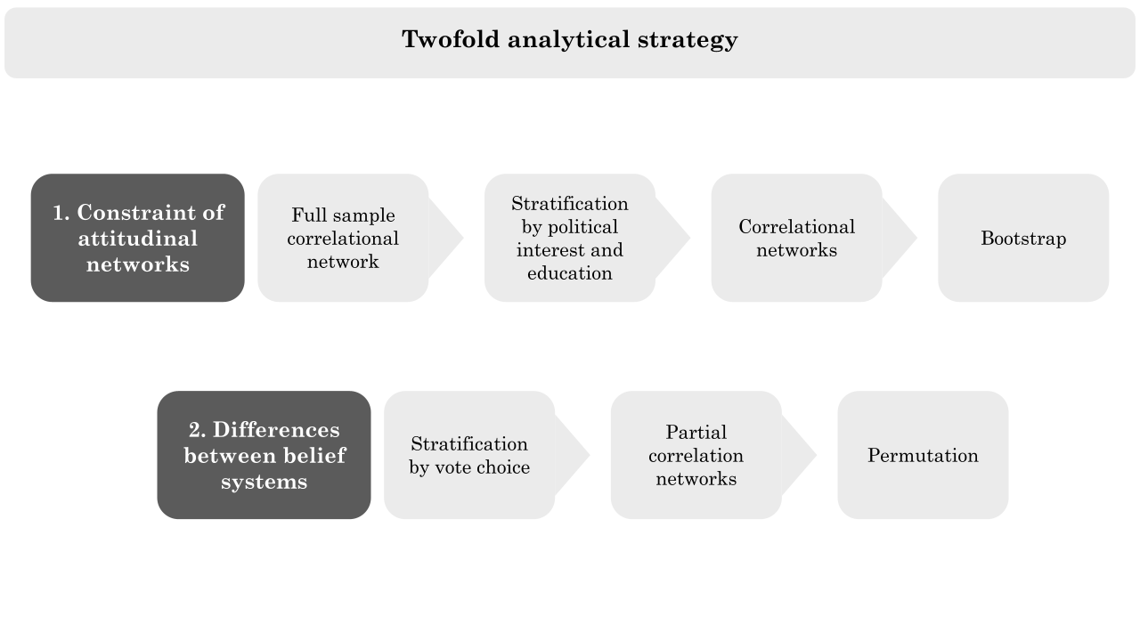

### 3.3 Measuring the constraint of attitudinal networks

The first stage of this research focuses on the degree of organization of the attitudinal network. To investigate this, correlational networks are fitted first at the population level, and then to five other sample partitions. The full sample network constitutes a benchmark for the comparison of these attitudinal structures. The estimation procedure involves the following steps (Boutyline & Vaisey, 2017; DellaPosta, 2020; Keskintürk, 2022b, 2022a). First, the original sample is stratified by levels of political interest and education (less than university, degree or more). Analyses distinguish people with low (1 and 2), medium (3), and high (4) interest. Five subsamples are obtained, three for political interest (n=277, 634, and 238) and two for education (n=706 and 443). Second, each item in Table 1 is labeled as quasi-continuous or ordinal. To cumulate with past research, variables with seven or fewer response options are considered as ordinal (Boutyline & Vaisey, 2017; Keskintürk, 2022b). Next, zero-order correlation coefficients are calculated for each pair of political attitudes, in each of the five subsamples. Polychoric correlations are estimated for ordinal variables, Pearson correlations for quasi-continuous ones, and polyserial correlations for ordinal and quasi-continuous items. Lastly, the correlation coefficients are squared to obtain the absolute strength of each correlation, and these values are plotted as edges of the network.

Building upon Converse's work (2006), past research operationalized the constraint of political attitudes as the mean value of the edge weights of a correlational network (Boutyline & Vaisey, 2017; Keskintürk, 2022b, 2022a). This metric is calculated for the five subgroups, generating distinct values representing the constraint of their political beliefs. These five point estimates can not be directly compared to formal tests for hypotheses H1 and H2. This limitation is addressed through non-parametric bootstrap, a resampling technique used for statistical inference (Efron, 1979). In each of the five sample partitions, ten thousand bootstrap iterations are performed by resampling with replacement, creating fifty thousand bootstrapped samples in total. In each of these iterations, the correlational networks and their constraints are re-estimated, yielding five bootstrapped distributions of belief constraints. Subsequently, bootstrapped confidence intervals are built for each of the five distributions, employing a conservative strategy. These intervals encapsulate the 95% range of the ten thousand point estimates of constraints obtained in each set of bootstrapped samples (Epskamp, Borsboom, et al., 2018). Differences in the measures of constraint are statistically significant when bootstrapped confidence intervals do not overlap. Thus, H1 and H2 are validated if the bootstrapped distributions of constraints for individuals with lower education and political interest center on smaller values than that of their highly educated and politically interested counterparts.

### 3.4 Capturing differences in the belief systems of different electorates

Correlational networks give insights into the amount of organization of attitudinal networks. However, this modeling strategy is prone to the inclusion of spurious association and is blind regarding the sign of the edges. To overcome these limitations, the analyses model the belief systems of different electorates, trying to assess whether their meaningfully differ. As shown in Figure 1, the second part of this research relies on three partial correlation network models fitted on voters of the right, left, and 5SM. These models are part of the broader class of Pairwise Markov Random Fileds [PMRFs]. PMRFs are network models rendering variables as nodes of a network whose weighted and signed edges encode conditional dependence and independence (Lauritzen, 1996). Indeed, nodes of a PMRF are linked when the corresponding variables are correlated, even after controlling for all other items. Conversely, nodes of a PMRF are untied if the corresponding variables are independent, after conditioning on all other items.

Drawing from the literature on political belief systems (Brandt et al., 2019; Brandt & Sleegers, 2021) this paper applies a PMRF called Gaussian Graphical Models [GGM] (Epskamp, Waldorp, et al., 2018). In a GGM, edges represent regularized partial correlations. Coefficients are *partial* because they measure the degree of association between each pair of beliefs while controlling for the effect of every other node of the network. They are *regularized* because GGM involves statistical regularization techniques. The GGM models are applied to each sample partition with the following steps. First, a matrix of correlation coefficients is computed as specified in Section 3.3. Second, as GGM assumes multivariate normality (Epskamp, Waldorp, et al., 2018), a nonparanormal transformation of each variable is implemented (Keskintürk, 2022b, 2022a). Third, partial correlations are obtained by inverting the variance–covariance matrix of the selected variables (Epskamp, Waldorp, et al., 2018). This step ensures edges are indicative of the unique variance shared by each belief pair. Fourth, the application of regularization techniques excludes weaker edges from the model, increasing its parsimony (Dalege et al., 2017). The regularization technique of choice is a variant of the least absolute shrinkage and selection operator (Tibshirani, 1996) called graphical LASSO, which directly penalizes elements of the inverse variance-covariance matrix (Friedman et al., 2008). The graphical LASSO relies on a tuning parameter that regulates the level of edge *shrinkage* (Epskamp, Waldorp, et al., 2018). Its appropriate value is found by minimizing the Extended Bayesian Information Criteria (Chen & Chen, 2008). This procedure was extensively validated in dedicated studies (Epskamp, Waldorp, et al., 2018; Epskamp & Fried, 2018; Foygel & Drton, 2010). It is important to notice that estimating GGMs on three different electorates equals traditional moderation analyses (Haslbeck, 2022). The aim is to study variations in the values of partial correlations between political attitudes. Thus, H3 investigates whether the associations between beliefs are mediated by vote choice.

The three different political belief systems are compared with a hybrid approach. First, a visual comparison will emphasize the edges that differ the most across the networks. Second, the statistical significance of these differences is evaluated by implementing three Network Comparison Test [NCT] (Borkulo et al., 2022), one for each comparison of interest (right-left; left-5SM; 5SM-right). The NCT is a statistical method used to compare network structures derived from independent datasets. It takes as input the observed differences in edge weights of two GGMs. Then, it performs permutation testing to evaluate whether differences are statistically significant. For each of the three comparisons, the NCT creates alternative network structures by permuting elements of the observed networks. These permuted networks serve as a null distribution against which the observed networks are compared. The permutation process is repeated ten thousand times to generate a distribution of test statistics under the null hypothesis. The observed test statistic, derived from the actual network, is then compared to this distribution to assess the statistical significance of any observed differences between the networks. H3 will be confirmed in case the political belief systems of different voters show at least one edge differing in a statistically significant way.

## 4. Results

Figure 2 shows the correlational network of political beliefs estimated on the full sample. Nodes represent political beliefs and unsigned, weighted edges plot the absolute values of their correlation coefficients. Nodes are colored according to their classification into symbolic and operational categories, and their geographical position is determined by the Fruchterman Reingold force-directed algorithm (Fruchterman & Reingold, 1991).

Figure 2: Network of political attitudes of the full sample

Caption: Correlational network of Italian political attitudes. Nodes represent survey variables and edge the absolute values of their correlation coefficients. Nodes are colored according to variable type (symbolic or operational). The topology of the network is dictated by a force-directed algorithm placing nodes that are strongly interacting closer to each other.

The 19 political beliefs can generate a maximum of 171 associations[8]. Correlation coefficients range from nearly zero (fourteen associations) to 0.71 (for the association between approval of homosexual marriage and adoption for homosexual couples). Symbolic components are particularly embedded in the network, as PTV items and left-right selfplacement tend to correlate strongly. The only exception to this pattern is the node *PTV_M5S[9]* which is rather peripheral to the network, together with *globa* and *ukrai*. This correlational network reports a fuzzy picture of the associations occurring between the political attitudes of the Italian electorate. Nodes differ in importance, and edges differ in their strength, but a visual inspection of this plot is doomed to be rather impressionistic.

Figure 3: Beliefs’ constraint by levels of political interest and education

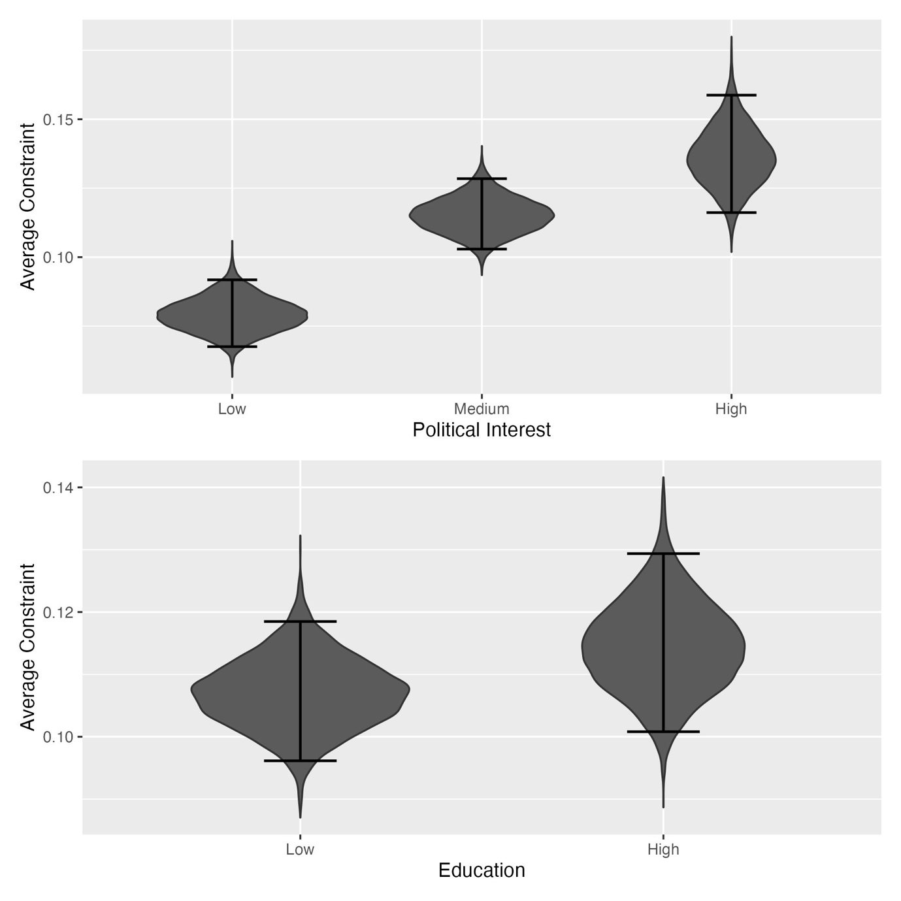

Caption: Dark grey shapes portray bootstrapped distributions of belief constraints across different levels of political interest and education. Black bars show bootstrapped confidence intervals. Political interest is positively correlated with belief constraint, but educational levels do not generate differences in constraint.

The top and bottom panels of Figure 3 report the results for H1 and H2 respectively. The y-axis plots the constraint of the bootstrapped networks, and the x-axis the two stratificational measures. The dark gray shapes depict the bootstrapped sampling distributions of the estimates of belief constraints obtained in each subsample. H1 is confirmed, as political interest and constraint are positively related. The constraint of the attitudinal network of the lowly educated (bootstrapped μ = 0.08; bootstrapped CI: 0.07 - 0.09) is significantly different from that of the medium (μ = 0.11; CI: 0.10 - 0.13) and high sample (μ = 0.14; CI: 0.12 - 0.16). However, the bootstrapped confidence intervals of the medium and high groups overlap. To rule out the possibility that H1 holds as a mere consequence of coding choices, two series of bootstrapping with the medium category being part of the low and high groups are implemented. Results are shown in Figure 4 of the Supplement. In both cases, H1 is confirmed. The bottom panel shows that the alternative hypothesis regarding the role of education is rejected. Additional analysis showed that other coding schemes do not provide support for H2.

Testing H3 requires the estimation of a GGM on each group that is obtained by stratifying the sample for vote choice. Figure 4 presents a visual comparison of the three models. In this plot, nodes represent operational and symbolic components of the Italian political belief systems and are placed through the force-directed algorithm. Weighted and signed edges are indicative of regularized partial correlations between political beliefs, with positive associations depicted in blue and negative ones in red. Figure 4 shows differences at the structural and local levels. The description of structural differences can not rely on the measure of constraint, as partial correlation networks contain several null associations which would bias the average of edge weights. However, it can rely on an edge count of each belief system[10]. The number of retrieved associations varies across the different belief systems. 85, 72, and 64 edges are found in the network of the left, M5S, and rightist supporters respectively. Network density[11] confirms that the belief systems of the left (density = 15.55) and of the supporter of the 5SM (density = 15.93) are more densely connected than that of the rightist (12.31).

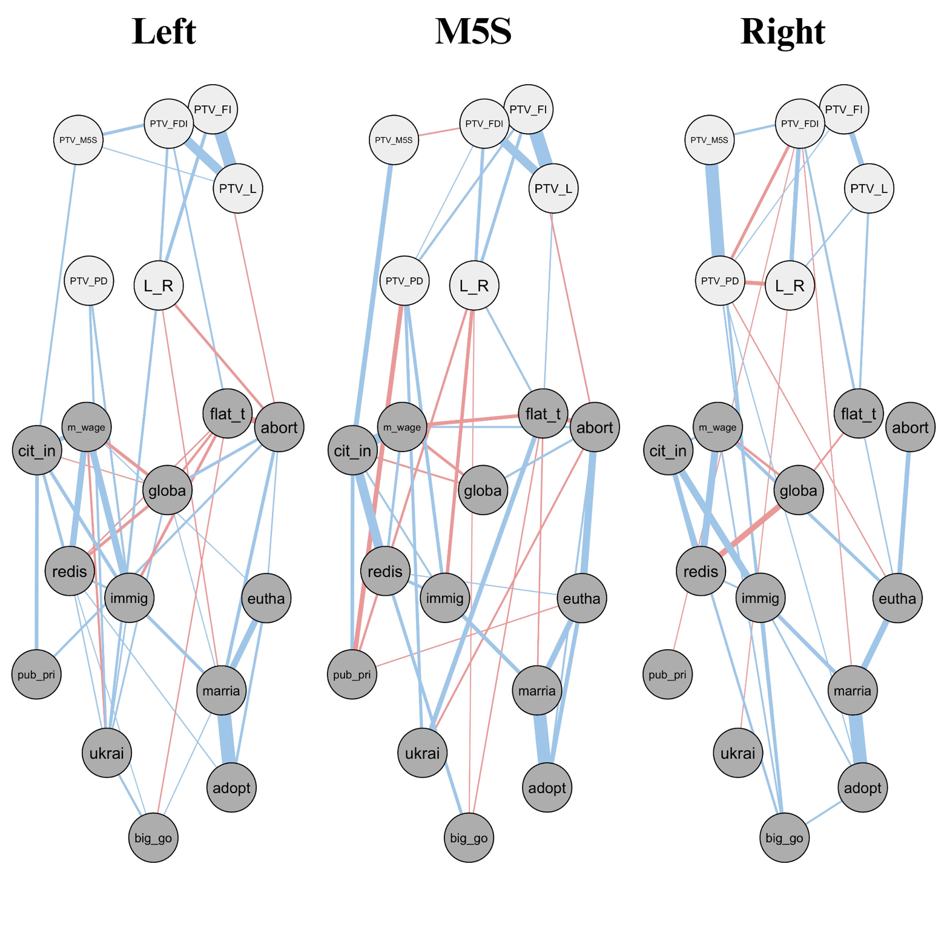Figure 4: Political belief system of different voters

Caption: political belief systems of right-wing, 5SM, and left-wing voters. Nodes represent operational and symbolic political attitudes. Edges are weighted and signed. Red (blue) edges represent negative (positive) regularized partial correlations. Edge width is proportional to correlational strength.

Local differences concern network edges. An inspection of the PTV items reveals that voters construe the political competition in different ways, depending on their vote choices. Voters of the left think that supporting the PD is not correlated to support for any other party and tend to recognize that voting for any rightist party increases the likelihood of voting for any other component of that coalition. In the same fashion, voters of the 5SM perceive the rightist coalition as composed of similar parties, but they are likely to think that supporting their political formation implies distancing from FDI. Finally, the electors of the right-wing coalition think that voting for the M5S and the PD is likely to satisfy similar electoral utilities, and they are better able to differentiate between the three rightist parties. Operational issues are more densely connected than symbolic components, across all subsamples. In all belief systems, support for homosexual marriage, euthanasia, abortion, and adoption are all positively correlated, meaning that voters of the three political formations perceive these issues as a unique bundle.

The results of the NCTs confirm H3, as numerous differences isolated by Figure 4 overcome the test of permutation. 52 edges significantly differ between the belief system of the right and the 5SM, 42 differ between the left and the right, and 38 between the left and the 5SM. Starting from the comparison between the average belief system of the left and M5S, the NCT isolates important differences that are also visible in Figure 4. Most of these differences concern the mediation of the relationships between operational items. The edge differing the most between these belief systems is *immig – m_wage* (Δ = 0.29). This relationship is strongly positive in the belief system of the left (w = 0.29), whereas according to the supporter of the 5SM, endorsing the ease of citizenship for children of legal immigrants is not related to higher support for the minimum wage. Moreover, the positive association between support for citizenship income and support for redistribution is very strong among the supporters of the 5SM (w = 0.39), and weaker for the leftist (w = 0.13). Also, the relationship between *m_wage* and *cit_in* varies greatly between the two belief systems (Δ = 0.22), being moderately positive among the leftists (w = 0.20) and even stronger among the supporters of the movement (w = 0.42). Another important difference concerns the association between *euth* and *abort* (Δ = 0.24). Indeed, this relationship is stronger in the mind of the supporter of the movement (w = 0.30), and weaker among the leftist (w = 0.06).

Comparing the networks of left and right voters, the most important differences concern the propensity to vote items. Indeed, the highest difference (Δ = 0.52) is relative to the edge *PTV_PD - PTV_5SM*, as this partial correlation is absent in the belief system of the left (w = 0.00), and very strong among the supporters of the rightist coalition (w = 0.52). Complementary, the relationship between *PTV_FDI and PTV_L* varies greatly (Δ = 0.38), as voters of the left think that voting for these parties satisfies similar utilities (w = 0.41), whereas rightist voters can better differentiate between them (w = 0.03). Importantly, the other associations between the other PTVs of the rightist party follow the same pattern, being very strong in the eye of the leftist (wPTV_L – PTV_FI = 0.53; wPTV_FDI – PTV_FI = 0.25), and considerably weaker, or even absent, for the rightist voters (wPTV_L – PTV_FI = 0.22; wPTV_FDI – PTV_FI = 0.00). Moreover, smaller differences emerge also regarding operational issues. In particular, the relationship between support for minimum wage and citizenship to immigrant’s child, and the one between abortion and flat_tax, are strongly moderated by vote choice (with Δ equal to 0.29 and 0.27 respectively). Indeed, leftists think that support for immigrants goes hand in hand with support for the minimum wage (w = 0.29), whereas the other voters do not perceive this association (w = 0.00). In the same fashion, leftist voters think that supporting the flat tax implies being against the ease of abortion (w = -0.27), whereas rightists do not show this partial correlation (w = 0.00).

The comparison of the belief systems of the right and the 5SM highlights three sets of striking differences in the relationships between (i) symbolic components, (ii) operational beliefs, and (iii) the associations between symbolic and operational items. Regarding the first dimension, the edges differing the most are the ones between *PTV_M5S* and *PTV_PD* (Δ = 0.53), *PTV_FI* and *PTV_L* (Δ = 0. 36), *PTV_FDI* and *PTV_L* (Δ = 0. 34), and between *PTV_FDI* and *PTV_FI* (Δ = 0.25). These differences are due to two patterns. On the one hand, voters of the Movement fail to distinguish between rightist parties, thinking that voting for one of them increases the likelihood of voting for any other (wPTV_L – PTV_FI = 0.58; wPTV_FDI – PTV_FI = 0.25; wPTV_FDI – PTV_L = 0.38); at the contrary, supporters of the rightist coalition exhibit much more nuanced relationships, as discussed in the previous paragraph (wPTV_L – PTV_FI = 0.22; wPTV_FDI – PTV_FI = 0.00; wPTV_FDI – PTV_L = 0.03). On the other hand, the delta of the association *PTV_M5S – PTV_PD* is the strongest because it reverses in sign across the different voters’ belief systems (w = 0.52 for the rightist; w = -0.01 for the others). Secondly, important differences emerge regarding the associations between operational issues. For example, the edges *cit_in – m_wage, ukrai – flat_t,* and *cit_in – immig* show remarkable moderation effects (with deltas of 0.32, 0.21, 0.20). These differences are because voters of the right-wing coalition think that supporting the citizenship income is only marginally related to support for the minimum wage (w = 0.09), that being willing to send weapons to Ukraine is not related to an endorsement of the flat tax (w = 0.00), and that approval of citizenship income is associated with the preference for helping migrants (0.29). Conversely, voters of the Movement think that endorsing the citizenship income is a signal of higher endorsement for minimum wage (w = 0.42) it is only partially indicative of support for ease of migrants’ conditions (0.09), and that supporters of the flat tax also approve sending weapons to Ukraine (0.20). Thirdly, these electorates show differences also regarding the links between symbolic and operational issues. For example, in the eyes of the rightists, supporting the M5S is unrelated to the approval of citizenship income (w = 0.00), and being rightist means being slightly against sending weapons to Ukraine (w = -0.05), and that this is unrelated to the migrant issue (w = 0.00). On the opposite, supporters of the M5S think that their vote choice is highly associated with the approval of citizenship income (w = 0.21), and that being rightist means being in favor of sending weapons to Ukraine (w = 0.03), and against migrants (w = -0.15).

Figure 4: Heterogeneity of political belief systems of different voters

*Caption*: The left panel shows the magnitude of retrieved differences in edge weights. The right one shows the correlation between network matrices.

To better interpret the results of the three NCTs, two paths can be taken. The first route is to select all significantly different edges and to calculate the sum of the absolute values of these differences. Results are shown in the left panel of Figure 4. The second route is to calculate the correlation between each pair of network matrices (right panel). The strategies are complementary. The first quantifies the differences between edges that are significantly different according to the NCT, thus performing a conservative but reliable comparison. The second gauges the extent to which the association between each pair of beliefs differs across the electorates. This strategy risks elevating small -and possibly insignificant- variations as elements of difference but allows performing a macro comparison of the three networks. Results are specular. The belief systems of the voters of the right-wing coalition and the of the 5SM are those differing the most and correlate the least. Histograms associated with the leftist and rightist coalitions are in a medium position. Finally, the average belief systems of the left and that of the Movement are the most similar ones. To better understand the magnitude of these differences, the left panel of Figure 4 can be interpreted by standardizing its values for the medium absolute value of all edge weights of each political belief system. The mean edge absolute value is 0.09 in the leftist network, 0.11 for the M5S, and 0.10 for rightist voters. Hence, across all networks, non-zero edges are typically weighing around 0.10. Then, the values of the left panel can be interpreted as if -in the presence of total edge weights being uniformly distributed across all edges- around 88 associations change between the belief systems of the right and the movement, 60 between that of the left and that of the right, and only 52 between the leftist and 5SM’ ones. Moreover, correlations of 0.79, 0.59, and 0.53 between these belief systems imply that 99, 105, and 111 out of 171 edges differ between these belief systems. As observed above, this strategy magnifies the differences, as only 38, 42, and 52 edges significantly differ between each network pair.

## 5. Discussion and conclusions

This research focused on the relationships between Italian political beliefs adopting a network approach. First, the article investigated the attitude network of people with different levels of political interest and education. Correlational networks show that the beliefs of the most interested in politics are more constrained than those of the lay public. This provides support to H1. Conversely, H2 was rejected, as the attitude network of the most educated was not more organized than that of the low-education sample. To further understand the inner structure of the Italian political belief systems, the sample was stratified by self-reported vote choice at the general election of 2022 and regularized partial correlation networks were fitted on each partition. The GGMs excel in parsimony and examine the signs of the associations between political attitudes, being suitable to evaluate structural differences between the belief systems of the voters of the right-wing coalition, the PD, and the 5SM. H3 was confirmed, as the partial correlation networks markedly differ. The first difference regards the number of the detected associations. 85, 72, and 64 edges composed the networks of the left, M5S, and rightist supporters respectively. In a GGM, two variables are tied if conditionally dependent. Therefore, this first difference implies that the political attitudes of the voters of the PD are more predictive of each other if compared to those of the other electorates. Second, 52 edges significantly differed between the belief systems of the right and the 5SM, 42 between the left and the right, and 38 between the left and the 5SM. This means that vote choice is a strong mediator of infra-attitudinal relationships, and that the belief systems of the supporters of PD and M5S are quite similar while being very different from the rightist one. Indeed, the GGMs of the left and the Movement mostly differ in the relationships between operational components, as M5S’s voters perceive stronger associations between support for citizenship income, redistribution, and minimum wage. Right-wing and left-wing voters structure both their symbolic and operational beliefs in different ways. The leftists struggle to distinguish between FDI, L, and FI, whereas the rightists tend to think that voting for the PD is similar to voting for the 5SM; moreover, leftists believe that support for immigrants goes hand in hand with support for the minimum wage and that supporting the flat tax implies being against the ease of abortion, unlike voters of the rightist parties, who do not perceive these associations. Finally, the belief systems of the right and the M5S differ along three lines. Their symbolic beliefs are organized in opposite ways, as supporters of the Movement tend to perceive the rightist parties as similar entities, and their supporters think in turn PD and M5S are similar forces. Their operational beliefs also differ, especially regarding the associations between citizenship income, minimum wage, immigration, and support to Ukraine. Finally, these electorates pack operational and symbolic components differently. M5S’s voters think that their vote choice is highly associated with the approval of citizenship income, and that being rightist means being in favor of sending weapons to Ukraine, and against migrants. Conversely, rightist supporters think supporting the M5S is unrelated to the approval of citizenship income, and that supporting Ukraine is unrelated to the migrant issue.

Thus, voters of the left and the M5S tend to disagree on which political attitudes go together but similarly construe the political competition. Therefore, their belief systems are the most similar ones. The rightist and leftist voters conceptualize the political arena in different ways and organize their policy preferences with different logic. The belief systems of the supporters of the right-wing coalition and M5S are the ones differing the most, as their voters not only organize their symbolic and operational beliefs in different ways but also show different patterns of associations between symbolic and operational components.

Another element that is worth discussing is the apport provided by the new class of network methods employed in this paper. Already in the sixties, Converse underlined that “Belief systems have never surrendered easily to empirical study or quantification” (Converse, 2006, p. 1). Despite a growing number of scholars examining this topic, belief systems have remained challenging objects of inquiry. Converse’s works constitute the first wave of these studies and represent a theoretical milestone for this area. The second wave started with a methodological innovation, that of the Belief Network Analysis (Boutyline & Vaisey, 2017). These works tested the social constraint account more formally and reduced the mismatch between a networked theory of belief systems and their rudimental and bivariate investigation. The advent of the third wave was prompted by the advancements in network psychometrics, allowing political scientists and political psychologists to focus on the backbone of the correlational structure of political attitudes (Brandt & Sleegers, 2021). This article reconfirms that partial correlation networks can be fruitfully applied to political attitudes, as their parsimony and their capability of modeling signed edges are unmatched by plain correlational models and are essential for an examination of the heterogeneity of belief systems at the population level.

This article provided two main contributions to the literature on political belief systems. First, this research constitutes the first examination of Converse’s theory of social constraint in Italy. Political attitudes of the more politically interested are confirmed to be more constrained than those of the lay public, whereas the alternative mechanism pointing at the role of education failed to find empirical support. Second, this article bridged between plain correlational models and partial correlational ones to investigate an unjustly neglected source of belief systems’ heterogeneity. Results show that if stratificational variables -like political interest- impact the amount of organization of these networks of attitudes, behavioral ones -like vote choice- produce important differences in the way political beliefs relate to each other and determine differential conceptualization of the political arena.

This article has three important limitations. First, the analyses would have benefited from a more representative sample. Secondly, Converse’s theory was only tested through a proxy variable. Indeed, his account insisted on the organizing role of political knowledge, whereas here the sample was stratified by political interest, due to data shortage. Finally, it is necessary to reflect on the general interpretation of the network models in this article. When applied to cross-sectional data, these models represent an average of the belief system of a target population. Therefore, the analytical strategy of this paper provided limited insight into within-person belief systems (Brandt & Morgan, 2022). On the one hand, this represents a crucial drawback of these methodologies, as belief systems are conceptualized as individual attributes, but mostly measured at the aggregate level (Brandt, 2022). On the other hand, this strategy leans toward the classical research questions faced by political scientists, as these models are best interpretable as a typification of the political cleavages riddling a society, rather than a concrete structure found inside the mind of a person (Brandt & Sleegers, 2021; Martin, 2000).

Future research might work on these limitations to usher in a wished fourth phase of studies on belief systems. Be it through individual network models or experimental research designs, this field of study is called to address the prominent questions regarding the nature of the relationships between political beliefs, establishing where and when they are causal. Moreover, it would be important to investigate how vote choice produces heterogeneous belief systems comparatively, as the findings of the present research could not generalize to other party systems.

## 6. References

Benedetta, C., & Vincenzo, M. (2020). Do environmental preferences in wealthy nations persist in times of crisis? The European environmental attitudes (2008-2017). *Italian Political Science Review/Rivista Italiana Di Scienza Politica*, *50*(1), 1–16. https://doi.org/10.1017/ipo.2019.3

Bertero, A., & Scaduto, G. (2023). A midsummer’s night dream: Political communication during the Italian 2022 electoral campaign. *Italian Journal of Electoral Studies QOE-IJES*. https://doi.org/10.36253/qoe-14224

Bobbio, N. (1996). *Left and right: The significance of a political distinction*. University of Chicago Press.

Borkulo, C. D. van, Bork, R. van, Boschloo, L., Kossakowski, J. J., Tio, P., Schoevers, R. A., Borsboom, D., & Waldorp, L. J. (2022). Comparing network structures on three aspects: A permutation test. *Psychological Methods*. https://doi.org/10.1037/met0000476

Boutyline, A., & Vaisey, S. (2017). Belief Network Analysis: A Relational Approach to Understanding the Structure of Attitudes. *American Journal of Sociology*, *122*(5), 1371–1447. https://doi.org/10.1086/691274

Brandt, M. J. (2022). Measuring the Belief System of a Person. *Journal of Personality and Social Psychology*, *123*(4), 830–853. https://doi.org/10.1037/pspp0000416

Brandt, M. J., & Morgan, G. S. (2022). Between-Person Methods Provide Limited Insight About Within-Person Belief Systems. *Journal of Personality and Social Psychology*, *123*(3), 621–635. https://doi.org/10.1037/pspp0000404

Brandt, M. J., Sibley, C. G., & Osborne, D. (2019). What Is Central to Political Belief System Networks? *Personality and Social Psychology Bulletin*, *45*(9), 1352–1364. https://doi.org/10.1177/0146167218824354

Brandt, M. J., & Sleegers, W. W. A. (2021). Evaluating Belief System Networks as a Theory of Political Belief System Dynamics. *Personality and Social Psychology Review*, *25*(2), 159–185. https://doi.org/10.1177/1088868321993751

Caldwell, L. (1981). Abortion in Italy. *Feminist Review*, *7*(1), 49–63. https://doi.org/10.1057/fr.1981.4

Chen, J., & Chen, Z. (2008). Extended Bayesian information criteria for model selection with large model spaces. *Biometrika*, *95*(3), 759–771. https://doi.org/10.1093/biomet/asn034

Cicco, G. D., Renzib, A., Marianib, R., Negric, A., Tranib, M. D., & Lauriola, M. (2023). Between populism and egalitarianism: Mapping attitudes toward social and political issues during the Draghi government using exploratory graph analysis. *Psychology Hub*. https://doi.org/10.13133/2724-2943/17982

Cohen, G. L. (2003). Party Over Policy: The Dominating Impact of Group Influence on Political Beliefs. *Journal of Personality and Social Psychology*, *85*(5), 808–822. https://doi.org/10.1037/0022-3514.85.5.808

Conti, N., & Memoli, V. (2015). Show the money first! Recent public attitudes towards the EU in Italy. *Italian Political Science Review/Rivista Italiana Di Scienza Politica*, *45*(2), 203–222. https://doi.org/10.1017/ipo.2015.11

Converse, P. E. (2006). The nature of belief systems in mass publics (1964). *Critical Review*, *18*(1–3), 1–74. https://doi.org/10.1080/08913810608443650

Coppock, A., & Green, D. P. (2022). Do Belief Systems Exhibit Dynamic Constraint? *The Journal of Politics*, *84*(2), 725–738. https://doi.org/10.1086/716294

Dalege, J., Borsboom, D., van Harreveld, F., & van der Maas, H. L. J. (2017). Network Analysis on Attitudes: A Brief Tutorial. *Social Psychological and Personality Science*, *8*(5), 528–537. https://doi.org/10.1177/1948550617709827

DellaPosta, D. (2020). Pluralistic Collapse: The “Oil Spill” Model of Mass Opinion Polarization. *American Sociological Review*, *85*(3), 507–536. https://doi.org/10.1177/0003122420922989

Di Nicola, P. (2016). Babies are not Born under a Cabbage Leaf. *Italian Sociological Review*, *Vol 6*, 293 Pages. https://doi.org/10.13136/ISR.V6I2.135

Efron, B. (1979). Bootstrap Methods: Another Look at the Jackknife. *The Annals of Statistics*, *7*(1). https://doi.org/10.1214/aos/1176344552

Ellis, C., & Stimson, J. A. (2012). *Ideology in America* (1st ed.). Cambridge University Press. https://doi.org/10.1017/CBO9781139094009

Epskamp, S., Borsboom, D., & Fried, E. I. (2018). Estimating psychological networks and their accuracy: A tutorial paper. *Behavior Research Methods*, *50*(1), 195–212. https://doi.org/10.3758/s13428-017-0862-1

Epskamp, S., & Fried, E. I. (2018). A Tutorial on Regularized Partial Correlation Networks. *Psychological Methods*, *23*(4), 617–634. https://doi.org/10.1037/met0000167

Epskamp, S., Waldorp, L. J., Mõttus, R., & Borsboom, D. (2018). The Gaussian Graphical Model in Cross-Sectional and Time-Series Data. *Multivariate Behavioral Research*, *53*(4), 453–480. https://doi.org/10.1080/00273171.2018.1454823

Fishman, N., & Davis, N. T. (2022). Change We Can Believe In: Structural and Content Dynamics within Belief Networks. *American Journal of Political Science*, *66*(3), 648–663. https://doi.org/10.1111/ajps.12626

Foygel, R., & Drton, M. (2010). Extended Bayesian Information Criteria for Gaussian Graphical Models. *arXiv*. https://doi.org/10.48550/arxiv.1011.6640

Franetovic, G., & Bertero, A. (2023). How do people understand inequality in Chile? A study through attitude network analysis. *AWARI*, *4*. https://doi.org/10.47909/awari.42

Free, L., & Cantril, H. (1968). The Political Beliefs of Americans: A Study of Public Opinion. By Lloyd A. Free and Hadley Cantril. (New Brunswick: Rutgers University Press, 1967. Pp. 239. $10.00.). *American Political Science Review*, *62*(4), 1345–1346.

Friedman, J., Hastie, T., & Tibshirani, R. (2008). Sparse inverse covariance estimation with the graphical lasso. *Biostatistics*, *9*(3), 432–441. https://doi.org/10.1093/biostatistics/kxm045

Fruchterman, T. M. J., & Reingold, E. M. (1991). Graph drawing by force‐directed placement. *Software: Practice and Experience*, *21*(11), 1129–1164. https://doi.org/10.1002/spe.4380211102

Giovannini, A., Valbruzzi, M., & Vampa, D. (2023). Special Issue Introduction – The 2022 Italian general election: A political shock or the new normal? *Italian Journal of Electoral Studies QOE-IJES*. https://doi.org/10.36253/qoe-14809

Grönlund, K., & Milner, H. (2006). The Determinants of Political Knowledge in Comparative Perspective. *Scandinavian Political Studies*, *29*(4), 386–406. https://doi.org/10.1111/j.1467-9477.2006.00157.x

Haslbeck, J. M. B. (2022). Estimating group differences in network models using moderation analysis. *Behavior Research Methods*, *54*(1), 522–540. https://doi.org/10.3758/s13428-021-01637-y

Jost, J. T. (2006). The end of the end of ideology. *American Psychologist*, *61*(7), 651–670. https://doi.org/10.1037/0003-066X.61.7.651

Jost, J. T., Federico, C. M., & Napier, J. L. (2009). Political Ideology: Its Structure, Functions, and Elective Affinities. *Annual Review of Psychology*, *60*(1), 307–337. https://doi.org/10.1146/annurev.psych.60.110707.163600

Judd, C. M., & Krosnick, J. A. (1982). Attitude centrality, organization, and measurement. *Journal of Personality and Social Psychology*, *42*(3), 436–447. https://doi.org/10.1037/0022-3514.42.3.436

Judd, C. M., & Milburn, M. A. (1980). The Structure of Attitude Systems in the General Public: Comparisons of a Structural Equation Model. *American Sociological Review*, *45*(4), 627. https://doi.org/10.2307/2095012

Kalmoe, N. P. (2020). Uses and Abuses of Ideology in Political Psychology. *Political Psychology*, *41*(4), 771–793. https://doi.org/10.1111/pops.12650

Keskintürk, T. (2022a). Religious belief alignment: The structure of cultural beliefs from adolescence to emerging adulthood. *Poetics*, *90*, 101591. https://doi.org/10.1016/j.poetic.2021.101591

Keskintürk, T. (2022b). The organization of political belief networks: A cross-country analysis. *Social Science Research*, *107*, 102742. https://doi.org/10.1016/j.ssresearch.2022.102742

Lauritzen, S. L. (1996). *Graphical models* (Vol. 17). Clarendon Press.

Lavrakas, P. (2008). *Encyclopedia of Survey Research Methods*. Sage Publications, Inc. https://doi.org/10.4135/9781412963947

Malka, A., & Lelkes, Y. (2010). More than Ideology: Conservative–Liberal Identity and Receptivity to Political Cues. *Social Justice Research*, *23*(2–3), 156–188. https://doi.org/10.1007/s11211-010-0114-3

Malka, A., Lelkes, Y., & Soto, C. J. (2019). Are Cultural and Economic Conservatism Positively Correlated? A Large-Scale Cross-National Test. *British Journal of Political Science*, *49*(3), 1045–1069. https://doi.org/10.1017/s0007123417000072

Martin, J. L. (2000). The relation of aggregate statistics on beliefs to culture and cognition. *Poetics*, *28*(1), 5–20. https://doi.org/10.1016/S0304-422X(00)00010-3

Martin, J. L. (2002). Power, Authority, and the Constraint of Belief Systems. *American Journal of Sociology*, *107*(4), 861–904. https://doi.org/10.1086/343192

Peffley, M. A., & Hurwitz, J. (1985). A Hierarchical Model of Attitude Constraint. *American Journal of Political Science*, *29*(4), 871. https://doi.org/10.2307/2111185

Sandri, G., & Seddone, A. (2015). Sense or sensibility? Political attitudes and voting behaviour of party members, voters, and supporters of the Italian centre-left. *Italian Political Science Review/Rivista Italiana Di Scienza Politica*, *45*(1), 25–51. https://doi.org/10.1017/ipo.2015.2

Schlicht-Schmälzle, R., Chykina, V., & Schmälzle, R. (2018). An attitude network analysis of post-national citizenship identities. *PLoS ONE*, *13*(12), e0208241. https://doi.org/10.1371/journal.pone.0208241

Schoen, H., & Schumann, S. (2007). Personality Traits, Partisan Attitudes, and Voting Behavior. Evidence from Germany. *Political Psychology*, *28*(4), 471–498. https://doi.org/10.1111/j.1467-9221.2007.00582.x

Sindermann, Rozgonjuk, D., Kannen, C., & Montag, and Christian. (n.d.). How many Dimensions underlie Political Attitudes? An Exploratory Graph Analysis Approach. *OSF Preprints*. https://doi.org/10.31219/osf.io/98rhs

Tedin, K. L. (1987). Political ideology and the vote. *Research in Micropolitics*, *2*(1), 63–94.

Tibshirani, R. (1996). Regression Shrinkage and Selection Via the Lasso. *Journal of the Royal Statistical Society: Series B (Methodological)*, *58*(1), 267–288. https://doi.org/10.1111/j.2517-6161.1996.tb02080.x

Tucker, J. A., Pacek, A. C., & Berinsky, A. J. (2002). Transitional Winners and Losers: Attitudes toward EU Membership in Post-Communist Countries. *American Journal of Political Science*, *46*(3), 557. https://doi.org/10.2307/3088399

Turner-Zwinkels, F. M., & Brandt, M. J. (2022). Belief system networks can be used to predict where to expect dynamic constraint. *Journal of Experimental Social Psychology*, *100*, 104279. https://doi.org/10.1016/j.jesp.2021.104279

van der Eijk, C., Brug, W. van der, Kroh, M., & Franklin, M. (2006). Rethinking the dependent variable in voting behavior: On the measurement and analysis of electoral utilities. *Electoral Studies*, *25*(3), 424–447. https://doi.org/10.1016/j.electstud.2005.06.012

Vegetti, F., & Littvay, L. (2022). Belief in conspiracy theories and attitudes toward political violence. *Italian Political Science Review/Rivista Italiana Di Scienza Politica*, *52*(1), 18–32. https://doi.org/10.1017/ipo.2021.17

Vergallo, G. M. (2019). The Marco Cappato and Fabiano Antoniani (dj Fabo) Case Paves the Way for New Assisted Suicide Legislation in Italy: An Overview of Statutes from Several European Countries. *European Journal of Health Law*, *26*(3), 221–239. https://doi.org/10.1163/15718093-12261428

Vezzoni, C., Ladini, R., Molteni, F., Dotti Sani, G. M., Biolcati, F., Chiesi, A., Maraffi, M., Guglielmi, S., Pedrazzani, A., & Segatti, P. (2020). Investigating the social, economic and political consequences of Covid-19: A rolling cross-section approach. *Survey Research Methods*, 187-194 Pages. https://doi.org/10.18148/SRM/2020.V14I2.7745

Vezzoni, C., Sani, G. M. D., Chiesi, A. M., Ladini, R., Biolcati, F., Guglielmi, S., Maggini, N., Maraffi, M., Molteni, F., Pedrazzani, A., & Segatti, P. (2022). Where does the Coronavirus come from? On the mechanisms underlying the endorsement of conspiracy theories on the origin of SARS-CoV-2. *Italian Political Science Review/Rivista Italiana Di Scienza Politica*, *52*(1), 51–65. https://doi.org/10.1017/ipo.2021.19

Zaller, J. R. (1992). *The Nature and Origins of Mass Opinion* (1st ed.). Cambridge University Press. https://doi.org/10.1017/CBO9780511818691

1. This theory is socio-centric in that differences in constraint are traced to stratificational (political information, education) rather than psychological variables (e.g.: personality traits).
2. It can be shown that correlational networks can correctly isolate differences in edge weights only if the corresponding relationships have the same sign. Indeed, suppose that two beliefs, (e.g., support for redistribution and support for increased government spending) are positively correlated at the population level. It might be the case that, partitioning the sample by levels of political knowledge, the retrieved associations differ in sign, being positive for the more knowledgeable and negative for the other subsample. In this case, the BNA approach would fail to estimate the magnitude of this difference, since the edges it estimates correspond to the squared values of each correlation coefficient.
3. This is not the equivalent of claiming that these models completely resolve the mismatch, since correlations -even if partial- can hardly lead to causal inference. Isolating causality should be the goal of the desirable third wave of belief systems studies, as argued in the Discussion.
4. Throughout the article, correlational networks are referred to as attitudinal or attitude networks, and partial correlation networks are termed belief systems.
5. The potential of the rolling cross-sectional design was not exploited in this work. The final sample is obtained by merging the responses of all individuals who participated in the data collection. This is methodologically feasible due to the random assignment of respondents to the day of completion, which assures time is a random variable (for a thorough discussion of this survey design see Vezzoni et al., 2020).
6. Source: <https://www.statista.com/statistics/569187/average-age-of-the-population-in-italy-by-region/#:~:text=The%20population%20of%20Italy%20is,significantly%20depending%20on%20the%20region>.
7. The distinction between operational and symbolic beliefs involves a margin of subjectivity. To mitigate this limitation, one contribution classified attitudes into symbolic, operational, and "cross-level" categories (Keskintürk, 2022b). This paper adopts the binary scheme, as it is more consistent with the theory behind this distinction, and as these labels have here a descriptive purpose only.
8. In an undirected network, the maximum number of edges is equal to n(n-1)/2, where n is the number of network nodes.
9. In the remainder of the article, network nodes will be referred to in italics. Moreover, “w” indicates an edge weight, and “Δ” represents the difference in the magnitude of an edge between two belief systems.
10. Counting the edges of a GGM is more informative than counting those of a correlational network, as the former indicates the number of associations that overcome a double layer of information suppression. Indeed, an edge is drawn when two variables are *(i)* correlated after conditioning on every other node in the network, and *(ii)* associated strongly enough to not be suppressed by the Graphical LASSO regularization.
11. Density is calculated by summing the absolute values of all edges of a weighted network.