# Chapter 4: Beyond Constraint: Tightness and Consensus of Political Belief Systems

### Abstract

Political belief systems vary in internal consistency (tightness) and structural similarity across groups (consensus). Using network models in Italy, I find that political interest—but not education—strongly predicts belief tightness, increasing attitudinal consistency, connectedness, and predictability. Belief consensus is low between M5S supporters and left- and right-wing voters, as these electorates structure political attitudes differently, while left- and right-wing voters exhibit higher consensus. These findings show that belief constraint is not uniform across electorates and that electoral competition shapes attitudinal organization. By distinguishing tightness from consensus, this study advances the analysis of belief systems, especially in multiparty contexts.

**Link to data and code:** https://github.com/arturobertero/IPBS_ggm

## 1. Introduction

Political beliefs and partisan identities are embedded in belief systems, cognitive structures shaped by socio-political contexts (Converse, 2006). Research has consistently shown that politically knowledgeable individuals exhibit more constrained belief systems, with stronger internal associations and greater ideological consistency (Boutyline & Vaisey, 2017; Fishman & Davis, 2022). The role of education in shaping belief constraint remains contested, with studies reporting mixed findings (Keskintürk, 2022b; Van Noord et al., 2024). Furthermore, recent work in political psychology and political science suggests that belief system structures may vary significantly across social groups, raising questions about whether constraint should be treated as a uniform construct (Baldassarri & Goldberg, 2014; Barbet, 2020).

This study builds on these insights by introducing a bidimensional framework of belief constraint, distinguishing between belief tightness (the internal consistency and the predictiveness of political attitudes) and belief consensus (the extent to which different electorates share a common belief system). Using post-electoral data, I investigate both dimensions using network models in Italy, a key case for understanding belief system organization due to its multiparty system and the presence of an anti-establishment party that explicitly rejects traditional left-right ideological alignments (Chiaramonte et al., 2018). Unlike bipolar systems, where voters receive consistent partisan cues and have clear ideas about issue ownership (Petrocik, 1996), Italy’s political landscape exposes citizens to conflicting elite signals, making it an ideal setting to explore variation in belief structure.

To measure belief tightness, I go beyond conventional approaches—mean constraint (capturing belief consistency) and ASPL (capturing the connectivity of a belief system)—by exploiting node-wise R² as a novel metric assessing how strongly attitudes predict one another. Results reveal that political interest is the strongest predictor of belief tightness, significantly enhancing belief consistency, interconnectedness, and predictability. In contrast, education has a weaker and inconsistent effect. Additionally, findings show that Italian voters structure their political attitudes in distinct ways, with left- and right-wing electorates displaying high consensus, while M5S supporters exhibit a unique issue-bundling pattern, reinforcing their party’s position as a third pole in Italian politics. These results highlight the need to account for both tightness and consensus when studying belief constraint, particularly in multiparty systems where ideological structuring is not uniform.

## 2. Theory

### 2.1 The Theory of Social Constraint and the Structure of Belief Systems

Political belief systems are cognitive structures that shape how individuals interpret political issues, labels, and actors. Converse (2006, p. 3) defined a belief system as “a configuration of ideas and attitudes in which the elements are bound together by some form of constraint or functional interdependence”. This foundational work suggests that political attitudes are interconnected rather than held in isolation, forming structures that guide reasoning and behavior. Converse distinguished between static constraint, where positions on one issue predict positions on another at a given point in time, and dynamic constraint, where changes in one belief trigger shifts in related attitudes. Empirical research has focused largely on static constraint, seeking to understand why belief systems vary in consistency across individuals and societies.

The theory of social constraint explains belief system consistency as a product of exposure to elite discourse. Converse (2006) found that most citizens hold weakly organized political beliefs, with only modest correlations between attitudes. However, belief constraint was significantly stronger among politically knowledgeable individuals, suggesting that political elites act as cognitive authorities who structure discourse, and engaged citizens are more likely to internalize these frameworks (Keskintürk, 2022b). This aligns with the top-down model of public opinion formation, where partisanship and ideological labels function as heuristics shaping policy attitudes (Zaller, 1992). Experimental evidence further confirms that individuals adjust their positions in response to partisan cues (Cohen, 2003; Malka & Lelkes, 2010), reinforcing the idea that political engagement enhances attitudinal consistency.

Despite its influence, Converse’s work had methodological limitations, relying on simple bivariate correlations despite conceptualizing belief systems as networks. To address this, Belief Network Analysis [BNA] was developed to model belief constraint as a network of interrelated attitudes, where nodes represent attitudes and edges correspond to the squared correlation between them (Boutyline & Vaisey, 2017). Studies adopting BNA or related techniques consistently find that political engagement enhances belief constraint, as politically knowledgeable individuals exhibit belief systems characterized by stronger correlations (Baldassarri & Gelman, 2008; Boutyline & Vaisey, 2017). Moreover, comparative studies provide support for the social theory of constraint, as in highly polarized countries (Gonthier & Guerra, 2023) or where parties highly institutionalized (Keskintürk, 2022b), citizens develop more structured belief systems. Another study has shown that the constraint of European belief systems is mostly influenced by educational levels (Van Noord et al., 2024), although evidence on this point is mixed (Keskintürk, 2022b). However, BNA has two key limitations. First, it models attitudinal associations as unsigned, failing to distinguish between positive and negative relationships (Boutyline & Vaisey, 2017). Second, its reliance on squared correlations risks capturing spurious associations that may not hold when accounting for confounding factors (Brandt, 2022).

To overcome these limitations, partial correlation networks have been introduced to estimate the unique variance shared between each pair of attitudes while controlling for all others (Brandt et al., 2019). This approach allows for a more parsimonious mapping of belief systems by filtering out spurious associations. Research using partial correlation models consistently finds that symbolic beliefs, such as ideological self-identification, are structurally central, exerting greater influence on policy preferences (Brandt et al., 2019; Fishman & Davis, 2022). Additionally, these studies confirmed that political engagement strengthens belief constraint, as politically interested individuals exhibit denser belief systems (Dalege et al., 2017, 2019), and individuals at the extreme poles of the left-right continuum tend to organize their political attitudes more coherently (Bentall et al., 2023). Beyond political ideology, this pattern extends to other domains. Religious attitudes become increasingly constrained from adolescence to adulthood, suggesting that socialization processes reinforce attitudinal structure over time (Keskintürk, 2022a). Similarly, in the domain of economic attitudes, individuals from lower social positions display more tightly connected inequality belief systems, likely reflecting their heightened exposure to economic hardship (Franetovic & Bertero, 2023).

Together, these findings confirm that politically knowledgeable individuals have more structured and consistent belief systems, supporting a socio-centric view of constraint. However, aggregate measures may obscure structural differences in belief systems across social groups. The next section extends the theory of social constraint to account for a bidimensional conceptualization of belief constraint.

### 2.2 Decomposing Constraint: Tightness and Consensus of Political Beliefs

The theory of social constraint conceptualizes belief systems as cognitive structures shaped by exposure to elite discourse. However, measuring mean constraint at the aggregate level entails assuming that these structures are homogeneous across individuals, differing only in the strength of attitudinal associations rather than in their fundamental organization. Yet, evidence from cultural sociology and political psychology challenges this notion, demonstrating that individuals may organize their political attitudes in qualitatively different ways.

Studies using Correlational ([CCA]; Boutyline, 2017) or Relational Class Analysis ([RCA]; Goldberg, 2011) show that belief systems vary not only in the strength of attitudinal associations but also in which attitudes are connected and whether these associations are positive or negative. Baldassarri and Goldberg (2014) identified three distinct belief structures in the U.S.: ideologues, who align with conventional left-right divisions; alternatives, who mix conservative and progressive stances in ways that do not fit partisan cleavages; and agnostics, whose attitudes exhibit weak or inconsistent structure. Similarly, European political attitudes do not uniformly follow a left-right continuum. Van Noord et al. (2024) found that while some Europeans organize their beliefs along traditional economic and cultural dimensions, others structure them around alternative axes. Barbet (2020) further demonstrated that attitudes toward government policies are structured heterogeneously across European electorates, reflecting differences in party competition and issue salience. Daenekindt and colleagues (2017) applied CCA to cultural attitudes and found that some individuals structure their views around a single cultural axis, while others exhibit fragmented or multidimensional belief systems. Similarly, another study showed that support for European integration is structured differently across social groups, with some viewing the EU primarily in economic terms and others framing it through a cultural or sovereignty-based lens (Van Den Hoogen et al., 2022). This heterogeneity expands beyond political beliefs. DiMaggio and Goldberg (DiMaggio & Goldberg, 2018) applied RCA to economic attitudes in the U.S., identifying multiple belief structures differing in how individuals relate support for profit-seeking, redistribution, and state intervention. Likewise, in both the U.S. and the Netherlands, inequality belief systems cluster into two distinct structures, primarily differing in how individuals conceptualize meritocracy (Bertero et al., 2024). In one system, meritocratic beliefs align positively with support for equality and diversity, while in the other, they are negatively associated.

Therefore, measuring belief constraint solely through mean attitudinal correlations may obscure meaningful structural variations in how different groups conceptualize political issues. If all individuals were exposed to consistent partisan cues—either endorsing or opposing the same set of policies depending on party affiliation—variation in belief systems would be limited to differences in how strongly individuals internalize these associations, affecting only the consistency of attitudinal linkages. Indeed, in bipolar systems parties can provide either identical or opposing cues (e.g., one party supports both policy 1 and policy 2, while the other opposes both). Hence, citizens would still exhibit similar belief structures, as both groups would display a positive correlation between the two issues. However, in multiparty systems, individuals are often exposed to conflicting elite signals (Adams et al., 2021; Macdonald et al., 1991), where different parties promote divergent issue alignments (Arndt, 2016). This might lead to variation not just in the strength of associations but also in which attitudes are linked, the direction of these connections, and whether certain associations emerge at all. As a result, belief systems can differ structurally across electorates, reflecting the competing partisan narratives that shape political reasoning.

To illustrate these differences, Figure 1 presents a typology of belief systems along two dimensions: *tightness* (the strength of associations between attitudes) and *consensus[1]* (the extent to which different political groups structure beliefs similarly). The bottom-left panel depicts high tightness and high consensus, where attitudes are strongly interconnected, and this structure is consistent across partisan groups, reflecting societal agreement with a stable and widely shared ideological framework. The bottom-right panel shows low tightness but high consensus, where attitudes are organized similarly across electorates but with weaker associations, indicating a shared but loosely structured belief system. In contrast, the top-left panel illustrates high tightness but low consensus: within each partisan group, attitudes are strongly linked, yet voters reach no consensus on how they organize their support for these two issues. Finally, the top-right panel shows low tightness and low consensus, where the *predictiveness* of the two issues is low, and where this association is *moderated* by party choice.

The typology suggests decomposing belief constraint into two dimensions: tightness and consensus. This might be particularly important in polarized multiparty systems, where low consensus might bias aggregated measures of belief consistency (such as the mean constraint).

*Figure 1: A typology of belief constraint*

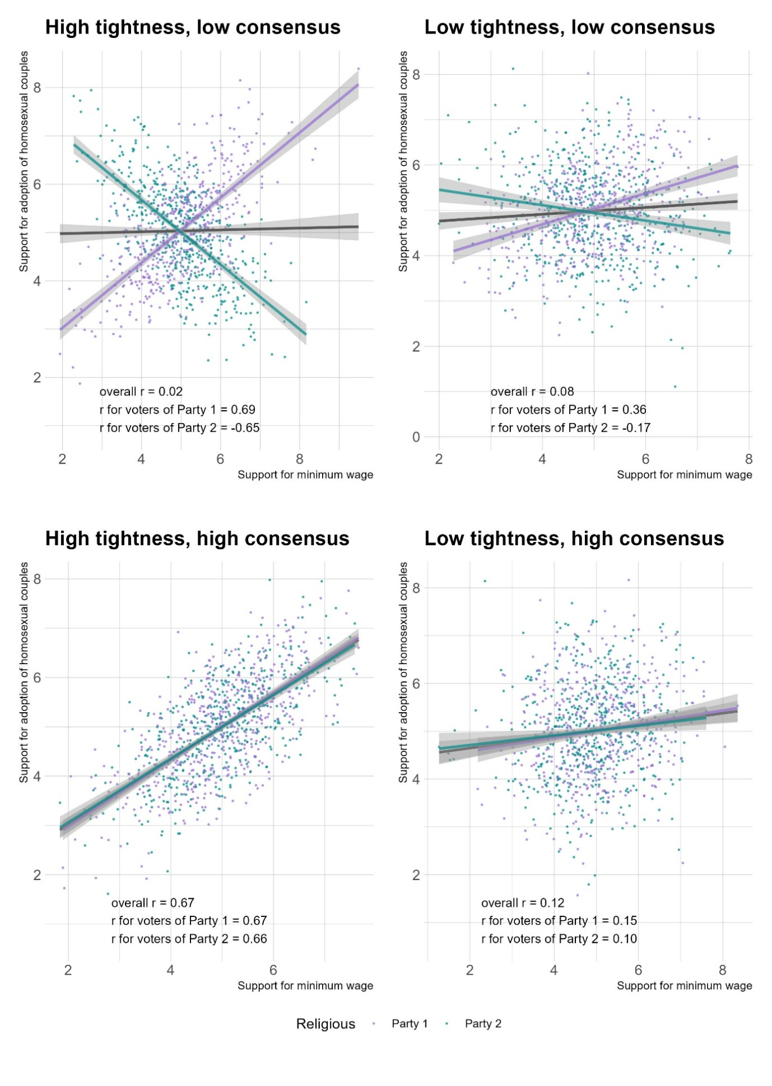

*Caption:* A typology of belief constraint, based on simulated data. Belief tightness occurs when political attitudes are highly associated. Belief consensus occurs when social groups structure their political attitudes in a similar way.

### 2.3 Research Hypotheses

No study has directly analyzed the Italian political belief system. Italy’s multiparty system make it an ideal case for testing the extension of the social theory of constraint. This country is characterized by intense political competition between numerous political parties, and this could result in belief systems structures with low consensus.

This study analyzes Italian political attitudes following the September 2022 general election, when the right-wing coalition—composed of Fratelli d’Italia (*Brothers of Italy* [FDI]), Lega (*League* [L]), and Forza Italia (*Go Italy* [FI])—secured a relative majority with 43.8% of the parliamentary vote. The primary left-wing coalition, including Partito Democratico (*Democratic Party* [PD]), Alleanza Verdi e Sinistra Italiana (*Green and Left Alliance* [AVS]), and +Europa (*+Europe* [+E]), won 26.1%. The Movimento 5 Stelle (*Five Star Movement* [M5S]) ran independently, winning 15.4%, and a centrist alliance garnered 7.8% (Giovannini et al., 2023).

Building on prior research, this study tests three hypotheses regarding belief constraint. The first concerns belief tightness, which refers to the extent to which political attitudes are interconnected and mutually predictive. Political interest has consistently emerged as a key predictor of belief constraint, as politically engaged individuals are more likely to internalize elite discourse and develop structured belief systems (Converse, 2006; Zaller, 1992). Studies using network models confirm that politically knowledgeable individuals exhibit stronger attitudinal associations and denser belief systems (Boutyline & Vaisey, 2017; Dalege et al., 2017, 2017; Fishman & Davis, 2022; Keskintürk, 2022b). However, most of this evidence comes from bipartisan political contexts, leaving open questions about whether these findings generalize to multiparty systems.

*H1: Tightness hypothesis*. The belief system of people with high political interest is tighter than that of people with low political interest.

While political acquaintance is a well-established predictor of attitudinal tightness, Converse (2006) acknowledged that education might play a similar role. Since education and political knowledge are highly correlated in Western societies (Grönlund & Milner, 2006), distinguishing their effects is crucial. Prior studies using non-network methodologies found that highly educated individuals exhibit greater attitudinal stability and consistency than the general public (Judd & Krosnick, 1982; Judd & Milburn, 1980; Peffley & Hurwitz, 1985). This suggests that belief tightness may stem not only from political exposure but also from cognitive skills associated with education, such as abstract reasoning and pattern recognition.

However, network-based evidence remains inconclusive. Boutyline and Vaisey (2017) found that educational attainment does not significantly predict belief tightness in the U.S., and Keskintürk (2022b) showed that a country’s average level of education is unrelated to belief constraint. In contrast, Van Noord et al. (2024) found that education plays a key role in structuring European belief systems, particularly in reinforcing ideological consistency. These mixed findings challenge the social theory of constraint, as they suggest belief organization might not depend solely on elite cues but also on individual cognitive capacities. If education fosters constraint independently of political engagement, belief tightness would arise from an individual’s ability to recognize and structure attitudinal relationships, rather than from exposure to ideological discourse.

*H2: Rival tightness hypothesis*. The belief system of individuals with high educational attainment is tighter than that of individuals with low educational attainment.

While researchers frequently stratify samples by sociodemographic variables to analyze variation in belief systems structures (e.g.: Boutyline & Vaisey, 2017; Franetovic & Bertero, 2023; Schlicht-Schmälzle et al., 2018), partisan alignment has been largely ignored as a moderating factor. Yet, stratification is conceptually equivalent to a moderation approach, where the selected variable is assumed to shape attitudinal relationships (see Method section). Given this, the absence of vote choice in prior research—likely due to the field’s North American focus—is striking.

In bipartisan systems like the U.S., where issue ownership (Petrocik, 1996) is clearly divided between Republicans and Democrats, belief structures are likely to be relatively uniform within each ideological camp. However, in multiparty contexts, partisan cues may conflict, leading to heterogeneous belief systems across electorates (Adams et al., 2021; Arndt, 2016; Macdonald et al., 1991). European research confirms that citizens do not uniformly structure their attitudes along a left-right divide (Barbet, 2020; Van Noord et al., 2024), and partisan competition further shapes these differences (Daenekindt et al., 2017; Van Den Hoogen et al., 2022). Italy provides a particularly salient case, as it features multiple ideologically distinct parties and one of its largest forces, the M5S, explicitly rejects the left-right framework (Benasaglio Berlucchi, 2022), potentially promoting low consensus on how political attitudes should be structured.

To test this, I estimate belief systems for supporters of the three largest political factions in the 2022 Italian general election: the right-wing coalition (FDI, L, FI), the left-wing coalition (PD, AVS, +E), and the Five Star Movement (M5S). If vote choice structures belief systems, we should observe systematic differences in attitudinal associations across electorates.

*H3: Consensus hypothesis*. The associations between political attitudes are moderated by self-reported vote choice.

## 3. Method

### 3.1 Data and variables

Analyses rely on the fifth wave of the ResPOnsE dataset, an Italian Rolling Cross-Sectional survey (Vezzoni et al., 2020). The sample was drawn using quota sampling based on residence, gender, and age group. Data collection occurred between October 20 and December 15, 2022, through a CAWI questionnaire. While earlier waves focused on the pandemic, this wave—fielded one month after the September 25, 2022 general election—included original and extensive measures of symbolic and operational components of Italian political beliefs. The survey features a core module, completed by all respondents, and additional randomly assigned thematic sections, one of which measured the political attitudes at the core of this study. The present study analyzes 1,149 respondents after list-wise deletion from an initial 1,850-person sample.

Table 1 (below) lists the attitudinal variables used in this study, while descriptive statistics appear in Table S1 (Supplement). Table S2 provides descriptives on the stratificational measures (political interest, education, self-reported vote-choice). Variables span multiple scales and have been recoded for directional consistency, ensuring higher values indicate greater support. Following past research (Brandt et al., 2019; Ellis & Stimson, 2012; Fishman & Davis, 2022; Free & Cantril, 1967)[2], attitudes are categorized as symbolic (political identity and party attachment) or operational (policy preferences). Symbolic variables include left-right self-placement and Propensity to Vote [PTV] scores for Italy’s five major parties (FDI, L, FI; PD; M5S). PTVs measure the electoral utility voters gain by voting for a party and offer a continuous measure that is complementary to vote-choice, while possessing high-variance (Van Der Eijk et al., 2006). Following past research on belief systems, the majority of selected variables are operational (Boutyline & Vaisey, 2017; Brandt et al., 2019; Keskintürk, 2022b). Four capture ethical issues: same-sex adoption, abortion, euthanasia, and same-sex marriage, all of which have been politically salient in Italy (Caldwell, 1981; Di Nicola, 2016; Vergallo, 2019). Four additional variables measure economic attitudes: income redistribution, state interventionism, unemployment policy (business vs. individual subsidies), and globalization views. These attitudes are fundamental components of political belief systems, as they are important in determining individuals’ positioning on the left-right spectrum (Bobbio, 1996). Given their prominence in the 2022 electoral campaign, additional items measure attitudes toward the flat tax, minimum wage, and citizenship income, which were central to the political communication of the right-wing coalition, PD, and M5S respectively (Bertero & Scaduto, 2023). Finally, the dataset includes two items tapping into salient socio-political issues at the time of the elections. These tap into support for supplying arms to Ukraine and attitudes toward migration.

### 3.2 Analytical strategy

The analytical strategy is divided into network estimation (detailed in Section 3.3) and hypothesis testing (Section 3.4). Figure 2 (below) summarizes these steps.

*Figure 2: Analytical strategy*

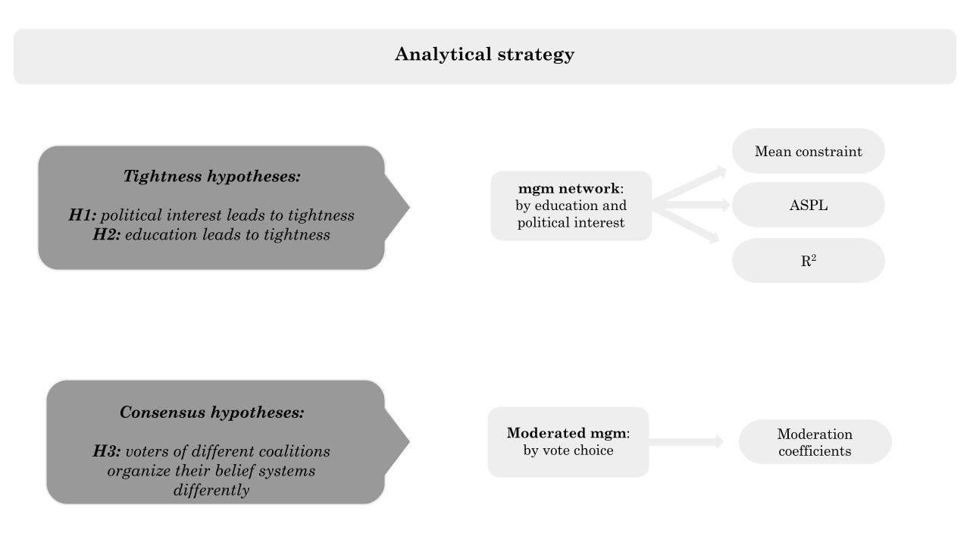

*Caption:* Analytical strategy of the Article. I address the tightness hypotheses by fitting network models on sample partitions with low versus high political interest and education. I perform bootstrap on each sample partition to test if the mean constraint, ASPL, and R2 of these networks differ significantly. I test H3 with a moderated network model, observing if self-reported vote choice moderates the network structure.

*Table 1: Label and survey questions*

|  |  |  |
| --- | --- | --- |
| **Label** | **Question** | **Scale** |
| L_R | Many people when talking about politics use the terms “left” and “right.” Thinking about your political views, where do you stand? | 0 (Left)  10 (right) |
| PTV_PD | [Among the various parties we have in Italy, each would like to have your vote in the future. Regardless of how you plan to vote in the next election,] how likely are you to vote for the Partito Democratico in the future? | 0 (Not likely)  10 (Very likely) |
| PTV_FI | [...] how likely are you to vote for Forza Italia in the future? | 0 (Not likely)  10 (Very likely) |
| PTV_L | [...] how likely are you to vote for Lega in the future? | 0 (Not likely)  10 (Very likely) |
| PTV_M5S | [...] how likely are you to vote for Movimento 5 Stelle in the future? | 0 (Not likely)  10 (Very likely) |
| PTV_FDI | [...] how likely are you to vote for Fratelli d’Italia in the future? | 0 (Not likely)  10 (Very likely) |
| adopt | [On political issues people have different opinions. What is your level of agreement with the following statements? Do you strongly agree, somewhat agree, slightly agree, or strongly disagree?] Gay and lesbian couples should have the same right to adopt a child as heterosexual couples | 1 (Disagree)  4 (Agree) |
| abort* | [...] Abortion must be made more difficult | 1 (Disagree)  4 (Agree) |
| eutha | [...] Euthanasia should be legal | 1 (Disagree)  4 (Agree) |
| marria | [...] Legalization of same-sex marriage is a good thing | 1 (Disagree)  4 (Agree) |
| redis | [Now we would like to know your opinion on some political issues. For each of the following statements, indicate your position on a scale ranging from 1=completely disagree, to 6=completely agree. If your opinion is roughly in the middle between the two, you may choose any other point on the scale.] It is necessary to reduce income differences between those with high incomes and those with low incomes. | 1 (Disagree)  6 (Agree) |
| flat_t | [...] It is necessary to introduce a flat tax (fixed tax rate, regardless of income). | 1 (Disagree)  6 (Agree) |
| m_wage | [...] A minimum hourly wage must be introduced by law. | 1 (Disagree)  6 (Agree) |
| cit_in | [...] It is necessary to maintain a guaranteed citizenship income for those below the poverty line. | 1 (Disagree)  6 (Agree) |
| globa* | [...] It is necessary to limit economic globalization. | 1 (Disagree)  6 (Agree) |
| immig | [...] It is necessary to give citizenship more easily to the children of legal immigrants born and raised in Italy. | 1 (Disagree)  6 (Agree) |
| big_go | Some say taxes should be reduced even at the cost of reducing public services. Others say services should be expanded even at the cost of raising taxes. Where would you place your opinion on a scale of 1 to 7? | 1 (Lower taxes)  7 (Extend ublic services) |
| pub_pri* | Resources to counter the negative effects of unemployment are limited. In such a situation, do you think it is more effective to give subsidies to people in economic hardship or to help businesses that hire? Please indicate where you would place your opinion on a scale of 1 to 7. | 1 (people)  7 (businesses) |
| ukrai* | Thinking about the war in Ukraine, do you favor or oppose supplying arms to Ukraine | 1 (Favor)  4 (Oppose) |

*Caption:* Survey variables and labels. The polarity of items marked with an asterisk was inverted. High scores indicate support for an issue or attachment to a party. Squared brackets replace prompts common to multiple questions.

### 3.3 Network models

This study estimates belief systems using two typed of Pairwise Markov Random Field models, which represent survey variables as nodes in a network where edges denote statistical associations (Lauritzen, 1996). Unlike simple correlational networks, these models identify unique and signed associations between variables while controlling for all others. H1 and H2 are assessed by splitting the sample at median levels of political interest and education, and by fitting four mixed graphical models. H3 is tested with a Moderated Network Model instead.

**Mixed Graphical Model [mgm].** This model uses survey data to estimate weighted and signed networks of political attitudes, where edges represent regularized partial associations (Haslbeck & Waldorp, 2020). This approach is more suitable than raw correlation networks, as it accounts for the unique variance shared between attitudes while filtering out spurious associations (Epskamp & Fried, 2018). The MGM is estimated using nodewise regularized regressions, where each attitude is regressed on all others using the graphical least absolute shrinkage and selection operator (graphical LASSO) (Tibshirani, 1996). This method ensures sparse and interpretable networks by penalizing weaker associations. The optimal level of regularization is determined via the Extended Bayesian Information Criterion (EBIC), a widely used model selection criterion that balances fit and complexity (Chen & Chen, 2008). Following recent applications in political psychology (Brandt et al., 2019), all attitudinal variables are treated as quasi-continuous, reducing the MGM to a Gaussian Graphical Model [GGM] (Epskamp et al., 2018). This allows for an interpretable network representation, where edges indicate signed, regularized partial correlations (Burger et al., 2023).

**Moderated Network Model [MNM].** This model is an extension of the mgm that allows for moderation effects in the belief network (Haslbeck et al., 2021). Instead of stratifying the sample, the MNM models self-reported vote choice as a moderator, identifying edges whose strength varies systematically across electorates. This approach mitigates the Berkson bias (Westreich, 2012), which could arise if vote choice were used as a stratification variable, artificially reducing the variance of political attitudes within subgroups (De Ron et al., 2021). The MNM follows the same combination of graphical LASSO and EBIC model selection, but incorporates an additional layer where moderation effects are estimated through nodewise regressions with interaction terms (Haslbeck, 2022). Significant moderation coefficients indicate party affiliation systematically alters the relationships between attitudes, revealing whether different electorates structure their political beliefs in distinct ways.

### 3.4 Hypothesis testing and measures

Prior studies have predominantly operationalized belief tightness using mean constraint, which captures the average absolute edge weight in a belief network (Boutyline & Vaisey, 2017; Keskintürk, 2022b; Gonthier & Guerra, 2023). This measure assumes that tighter belief systems are those in which attitudes exhibit stronger manifest associations. Hence, mean constraint measures the *consistency* of belief systems. However, mean constraint does not account for the structural position of attitudes within the network and may overestimate constraint in localized clusters while failing to capture the overall connectivity of the system. To address this limitation, some scholars have turned to Average Shortest Path Lengths [ASPL] (Dalege et al., 2017, 2019). In this Article I employ the weighted measure of ASPL which measures the average shortest path between all attitudes, considering edge weights (Opsahl et al., 2010). This metric assesses how dense and *interconnected* networks are, with lower values indicating tighter belief structures.

This study advances the belief system literature by introducing a new operationalization of belief tightness. Indeed, I introduce node-wise R² as an additional and theoretically grounded measure of tightness. Converse’s (2006) foundational theory suggests that tightly constrained belief systems should exhibit greater internal coherence, meaning that attitudes within the system should be highly predictive of one another. If belief systems are indeed structured, then an individual’s position on one issue should strongly determine their stance on other political attitudes. Node-wise R² quantifies the *predictiveness* of political attitudes. Therefore, this measure offers a novel and theory-driven measure of belief tightness.

To formally evaluate belief tightness, this study tests H1 (political interest) and H2 (education) by estimating bootstrapped distributions (Efron, 1987) for all three measures: mean constraint, ASPL, and node-wise R². I bootstrap 10,000 samples starting from the four sample partitions obtained splitting the original one at median levels of education and political interest. Then, I calculate these three measures on each of the 40,000 networks. This procedure generates one bootstrapped frequency distribution for each measure of tightness, and for each level of stratificational variables. If normality assumptions hold, the comparisons between these distributions are assessed using ANOVA; otherwise, I rely on the Mann-Whitney U test, a nonparametric alternative (McKnight & Najab, 2010).

Testing H3 (consensus hypothesis) requires assessing whether vote choice moderates attitudinal relationships. Since direct stratification by vote choice would reduce within-group variance, potentially biasing network estimation, I employ a MNM in which self-reported vote choice is modeled as a moderator of network edges. This approach allows for a direct test of H3, identifying edges significantly moderated by party choice. If vote choice influences belief structure, some attitudinal relationships should vary systematically across electorates, indicating low consensus in the Italian electorate.

## 4. Results

Figure 3 presents the results of the mgm network estimation, which represent four different Italian political belief systems. Nodes represent political attitudes (see Table 1), with yellow pies indicating R² values. Edges denote regularized partial correlations, with blue indicating positive and red negative associations; thickness reflects strength. The spatial arrangement of the network is standardized for comparability and follows a force-directed algorithm (Fruchterman & Reingold, 1991).

In the low-interest group (top left), the strongest association is between the support for homosexual marriage and adoption rights (β = 0.51), while the weakest is between citizenship income and PTV_FDI (β = 0.02). The high-interest group (top right) shows a denser network, with the same strongest association (β = 0.51) but a weaker link between big government and euthanasia (β = 0.01). Absent edges suggest two variables (e.g.: *big_go* and *globa*) are conditionally independent, meaning that they are uncorrelated if controlling for the remaining variables.

The low-education group (bottom left) again exhibits the strongest link between homosexual marriage and adoption (β = 0.52), while the weakest is between big government and adoption rights (β = 0.01). The high-education group (bottom right) follows a similar pattern, with its weakest connection between big government and euthanasia (β = 0.02). Across all networks, Ukraine policy and economic attitudes remain peripheral.

Mean constraint, a common measure of belief tightness, is lowest among politically disengaged individuals (0.08) and highest among politically engaged individuals (0.11), with education-based partitions falling in between (Low: 0.09, High: 0.10). Node-wise R² values indicate that far-right party preferences (PTV_FDI, PTV_L) are the most embedded, whereas PTV_M5S is the least integrated across all networks. Additionally, belief systems of politically disengaged individuals contain nearly half as many connections (39 vs. 74) as those of engaged individuals, while education-based partitions exhibit similar edge counts (58 vs. 66). Although only descriptively, these findings provide preliminary support for H1, indicating that political engagement, more than education, enhances belief system consistency and connectedness.

*Figure 3: Italian belief systems by Political Interest and Education*

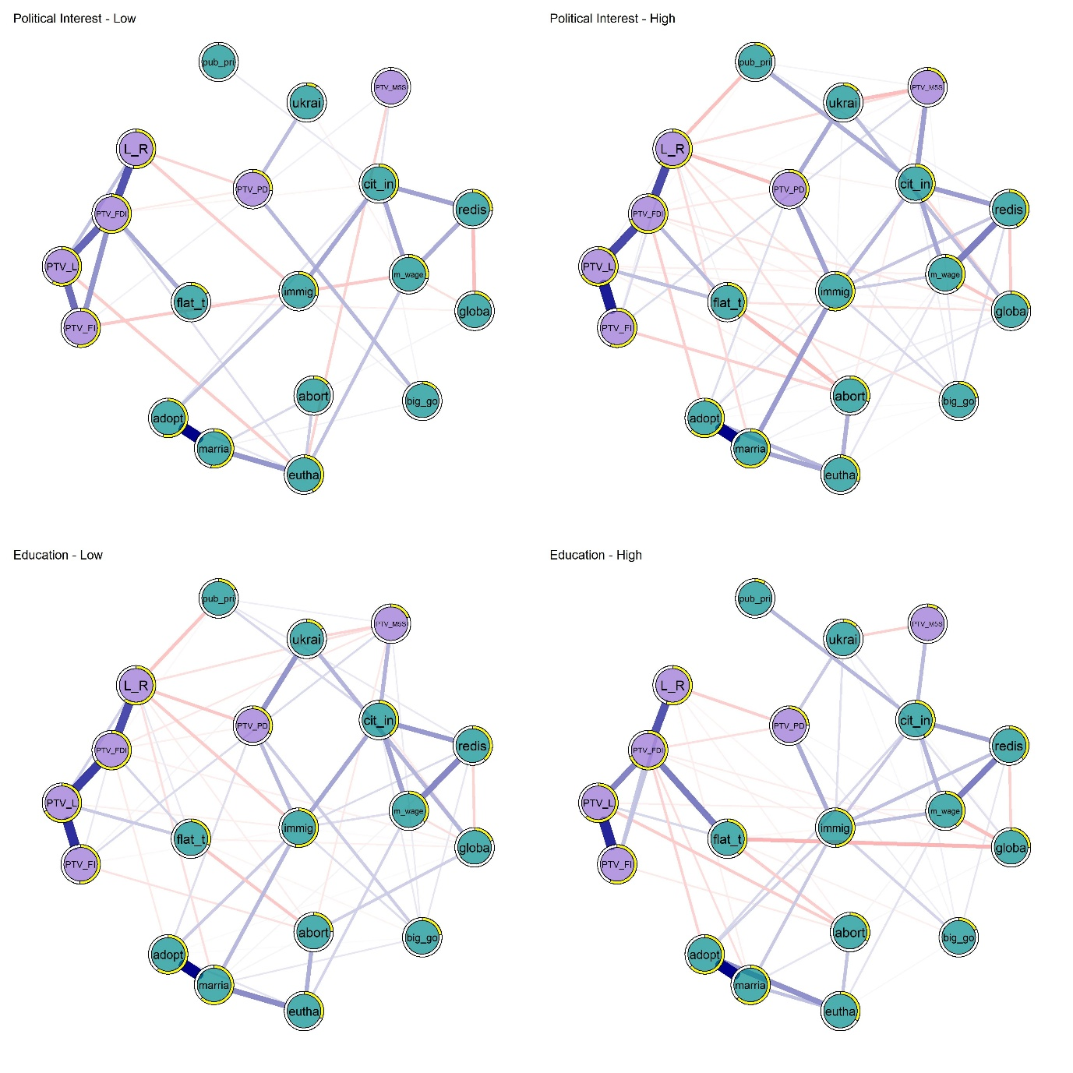

*Caption:* Political belief systems of Italians with low versus high political interest (top panels) and low versus high education (bottom panels). The plot shows mgm networks, where nodes are colored according to variable type (symbolic or operational). The yellow borders of the nodes indicate R2 values. Edges indicate regularized partial correlations, with blue [red] colors for positive [negative] associations. Node labels follow Table 1: *L_R* = Left right self-placement; *PTV_PD* = Propensity to vote for PD; *PTV_FI* = Propensity to vote for FI; *PTV_L* = Propensity to vote for L; *PTV_M5S* = Propensity to vote for M5S; *PTV_FDI* = Propensity to vote for FDI; *adopt* = Stepchild adoption; *abort* = Abortion; *eutha* = Euthanasia; *marria* = Homosexual marriage; *redis* = Redistribution; *flat_t =* Flat tax; *m_wage* = Minimum wage; *cit_in* = Citizenship income; *globa =* Globalization; *immig* = Immigration; *big_go* = Big government;  *pub_pri =* Public vs private; *ukrai* = Weapons to Ukraine

To gain a deeper understanding on R² results, Figure 4 visualizes node-wise differences between high and low political interest and education groups. Precise values are reported in Table S5 (Supplement). This descriptive visualization aligns with H1 and contrasts with H2. Political interest systematically increases R² values, with an average node-wise difference of 0.108. The largest effects emerge for the support of immigration (Δ = 0.26) and flat tax (Δ = 0.23), indicating that politically engaged individuals hold more structured attitudes on key cultural and economic issues. In contrast, education does not systematically increase R² values. In fact, in 9 out of 19 cases, R² values are higher in the low-education group, contradicting expectations. While some items show a notable increase (e.g.: flat tax, Δ = 0.10), the overall pattern is inconsistent, suggesting that education alone does not reliably enhance the integration of political attitudes within belief systems.

To statistically evaluate H1 and H2, I bootstrap 10,000 samples starting from each of the original partitions. I then re-estimate networks on the 40,000 samples to compare the belief system structures of individuals with high versus low political interest and high versus low education. I analyze differences in the bootstrapped distributions of mean constraint, ASPL, and node-wise R². I assess normality with the Shapiro-Wilk test, and homogeneity of variance with Levene’s test. The results, summarized in Table S3 (Supplement), indicate significant deviations from normality across all measures (p < .001), except for ASPL in high-education groups (p = .108). Additionally, Levene’s test suggests violations of homogeneity for most comparisons (p < .001), apart from R² in education-based partitions (p = .384).

Given violations of normality and homogeneity assumptions, I employed Mann-Whitney U tests instead of ANOVA. Since higher belief system tightness is expected in politically engaged and highly educated individuals, I tested for higher mean constraint and R² in these groups, while for ASPL, I expected lower values, indicating greater network density. Table 2 presents the results of these one-tailed tests.

*Figure 4: Beliefs’ constraint by levels of political interest and education*

*Caption:* Comparison of node-wise R2 across the belief systems of people with different levels of education (left) and political interest (right panel). Violet dots represent the values nodes score in the low groups; green indicate the node-wise R2 values in the belief systems of the high education and interest groups. Dots are linked by lines, which visualizes the gap in the portion of explained variance of these variables.

In line with H1, individuals with higher political interest exhibit significantly more structured, interconnected, and predictable belief systems. Mean constraint is notably higher in the high-interest group (W = 94,315, p < .001, Δ = 0.998), indicating that politically engaged individuals hold attitudes that are more tightly integrated. The higher R² in this group (W = 153,666,612, p < .001, Δ = 0.149) further supports this pattern, as their political attitudes are more mutually reinforcing and predictive of one another. Additionally, ASPL is significantly lower in the high-interest group (W = 19,608,272, p < .001, Δ = 0.608), meaning that their belief systems are more densely connected, with shorter paths between attitudes. For H2 (education), results provide only partial support. While mean constraint is significantly higher among the high-education group (W = 18,745,672, p < .001, Δ = 0.625), the effect size is smaller than for political interest, suggesting that education contributes to belief tightness but less than political engagement. However, neither ASPL nor R² showed significant differences between education groups (p = .124 for R²; p = 1.000 for ASPL), indicating that education alone does not significantly alter the density or predictability of belief systems.

*Table 2: Tests of H1 and H2*

| **Comparison** | **W** | **p** | **Δ** | **Lower CI** | **Upper CI** | **Rank** | **CLES** |
| --- | --- | --- | --- | --- | --- | --- | --- |
| Mean Constraint - Political Interest | 94,315 | 0.000 | 0.998 | 0.998 | 0.998 | 0.998 | 0.999 |
| Mean Constraint - Education | 18,745,672 | 0.000 | 0.625 | 0.613 | 0.637 | 0.625 | 0.813 |
| ASPL - Political Interest | 19,608,272 | 0.000 | 0.608 | 0.596 | 0.620 | 0.608 | 0.804 |
| ASPL - Education | 65,438,508 | 1.000 | -0.309 | -0.324 | -0.294 | -0.309 | 0.346 |
| R² - Political Interest | 153,666,612 | 0.000 | 0.149 | 0.137 | 0.160 | 0.149 | 0.574 |
| R² - Education | 179,265,932 | 0.124 | 0.007 | -0.005 | 0.019 | 0.007 | 0.503 |

Caption: Results of the one tail Mann-Whitney U tests comparing network properties between low and high groups for political interest and education. The table reports W-statistics, p-values, and effect sizes, including Cliff’s Delta (Δ), 95% confidence intervals (CI), rank-biserial correlations (Rank), and the Common Language Effect Size (CLES).

To ensure the robustness of the findings for H1, I conducted additional analyses using an alternative dichotomization of political interest. While the primary sample partitions were based on a median split (1–3 vs. 4), I re-estimated the bootstrapped distributions of mean constraint, ASPL, and R² using a more restrictive threshold, defining the low-interest group as 1–2 and the high-interest group as 3–4. The results, reported in Table S4 (Supplement), confirm the stability of the effects. Mean constraint remains significantly higher in the high-interest group (W = 94,315, p < .001, Δ = 0.998). The lower ASPL in the high-interest group (W = 19,608,272, p < .001, Δ = 0.608) further supports the notion that their belief systems are denser and more interconnected. Finally, R² values remain significantly greater for high-interest individuals (W = 153,666,612, p < .001, Δ = 0.149), indicating that political attitudes in this group are more predictive of one another.

Together, these results confirm that political interest plays a dominant and robust role in structuring belief systems, as its effects are consistent across all measures of belief system organization (mean constraint, ASPL, and R²). In contrast, the impact of education is only robust for mean constraint but does not extend to ASPL or R².

Finally, I assess whether Italian voters from different coalitions exhibit structurally distinct belief systems. The consensus hypothesis predicts that relationships between political attitudes are moderated by self-reported vote choice. If moderation effects are substantial, belief systems across electorates should differ to the extent that aggregating them biases estimates of tightness.

Figure 5 presents the results of the MNM, where vote choice (Left, M5S, or Right coalition) is specified as the moderating variable. Each panel depicts the belief system of each voting group and is obtained by conditioning the model on one value of the moderator. The standardized node layout facilitates comparison across networks. Significant moderation effects occur when a given edge is estimated with a different magnitude in the three panels.

In line with H3, the three belief systems exhibit notable differences. Of 171 possible associations, 14 are significantly moderated when comparing left-wing and M5S voters, 11 differ between left-wing and right-wing voters, and 23 are moderated when comparing right-wing and M5S voters. The most pronounced differences emerge in the association between the propensity to vote for M5S and PD. Right-wing voters perceive these choices as positively related (β = 0.474), suggesting they view M5S as part of the broader left-wing bloc. However, M5S and PD voters reject this categorization, seeing no connection between their parties (β = 0.000). A similar pattern appears in the relationship between PD and FDI: left-wing voters see no link between these parties (β = 0.000), while right-wing voters perceive them as negatively associated (β = -0.120), and M5S voters perceive a weak but positive association (β = -0.111). The divergence in these associations suggests that left- and right-wing voters largely share a traditional ideological cleavage, while M5S supporters place their party outside of this conventional alignment.

The differences between M5S and left-wing voters extend beyond symbolic attitudes to issue bundling patterns. M5S voters strongly associate their party support with backing the citizenship income (β = 0.150), whereas left-wing voters show a weaker connection (β = 0.052). This difference highlights how the citizenship income, while generally aligned with redistributive policies championed by the left, is uniquely central to M5S supporters. Furthermore, M5S voters perceive a relationship between the preference for subsidies to businesses versus individuals and PD support (β = -0.174), whereas left-wing voters show no such association (β = 0.000). This suggests that M5S voters see PD as more aligned with pro-business subsidy policies, contradicting conventional leftist economic positions. Additionally, M5S supporters display stronger connections between policies such as minimum wage and citizenship income (β = 0.071), whereas this link is weaker among left-wing voters (β = 0.000). These patterns indicate that M5S voters construct a distinct economic framework, blending redistributive policies with a more independent understanding of economic intervention.

The largest discrepancies appear between right-wing and M5S voters, with strong differences in symbolic attitudes, operational attitudes, and their interaction. As in the previous comparison, right-wing voters see PD and M5S as positively related choices (β = 0.474), while M5S voters see them as entirely independent (β = 0.000). This suggests that right-wing voters categorize M5S as part of an outsider bloc -composed by the Movement and the leftist alliance- whereas M5S supporters resist this classification, reinforcing their self-image as a third pole in Italian politics. Unlike right-wing voters, M5S supporters uniquely associate support for the flat tax with backing military aid to Ukraine (β = 0.084), a pattern absent in both left- and right-wing belief systems. This suggests M5S supporters construct their issue support in a way that does not conform to traditional ideological alignments. Further evidence of this distinct issue bundling is seen in their stronger association between immigration policy and citizenship income (β = 0.075), whereas right-wing voters show no such link. Additionally, M5S voters are more likely to perceive an association between support for abortion and euthanasia (β = 0.035), a connection that remains weaker among both left-wing and right-wing voters. These differences illustrate how M5S supporters diverge from conventional ideological frameworks, integrating issues in ways that challenge the mainstream left-right divide.

These findings confirm that vote choice shapes belief system organization, with the M5S electorate standing out as structurally distinct from both the left- and right-wing blocs, both in partisan preferences and policy positions. While left- and right-wing belief systems largely conform to a traditional ideological framework, M5S supporters display a distinct issue-bundling pattern, indicating that they do not organize political attitudes in the same way as other electorates.

As a final robustness check, I fit two additional MNMs, where I specify political interest and education (split at the median) as moderators. If political interest and education increase belief tightness, we should observe numerous significant moderation effects in their respective models. Figure S1 (Supplement) presents these results. In line with the previous results, education produces only two meaningful moderation effects (coefficients > 0.03), while political interest moderates 23 associations. For instance, low-education voters show no connection between support for the L and restricting abortion (β = 0.000), while higher-education voters associate support for the L with favoring abortion restrictions (β = -0.040). Similarly, higher-education voters link support for a flat tax with positive views on globalization (β = -0.093), whereas low-education voters do not (β = -0.053). By contrast, political interest moderates nearly a quarter of all belief system relationships (23 edges). The strongest effects involve the propensity to vote for M5S and support for sending arms to Ukraine, the support for same-sex marriage and pro-immigration attitudes, the association between left-right self-placement and preferring business subsidies over individual aid. Among these moderations, nearly half (44.44%) involve symbolic vs. operational attitudes, another 44.44% affect relationships between operational attitudes, and only 4.35% involve symbolic-symbolic associations. This pattern shows that political interest fosters greater ideological consistency by reinforcing connections between symbolic and policy attitudes.

*Figure 5: moderated network model, by self-reported vote choice*

Caption: Moderated Network Model with self-reported vote choice specified as the moderator. Blue edges represent positive regularized partial correlations, and red negative ones. A significant moderation effect occurs when an edge possesses a different width across the three panels. Node labels: *L_R* = Left right self-placement; *PTV_PD* = Propensity to vote for PD; *PTV_FI* = Propensity to vote for FI; *PTV_L* = Propensity to vote for L; *PTV_M5S* = Propensity to vote for M5S; *PTV_FDI* = Propensity to vote for FDI; *adopt* = Stepchild adoption; *abort* = Abortion; *eutha* = Euthanasia; *marria* = Homosexual marriage; *redis* = Redistribution; *flat_t =* Flat tax; *m_wage* = Minimum wage; *cit_in* = Citizenship income; *globa =* Globalization; *immig* = Immigration; *big_go* = Big government;  *pub_pri =* Public vs private; *ukrai* = Weapons to Ukraine. *Vote_cat* represents the moderator.

## 5. Discussion and Conclusions

This study built on the theory of social constraint, which conceptualized belief systems as cognitive structures shaped by elite discourse (Converse, 2006). Prior research showed that politically engaged individuals develop more constrained belief systems by internalizing party cues (Zaller, 1992; Boutyline & Vaisey, 2017; Fishman & Davis, 2022). However, this literature relied on mono-dimensional measures of constraint, assuming belief systems differ only in the strength of associations (tightness), while neglecting their structural variation across social groups (consensus). To address this gap, this study introduced a bidimensional framework, positing that belief constraint varies both in internal consistency and in the extent to which electorates share a common structure.

Italy offered a compelling case to examine belief tightness and consensus due to its multiparty system and the presence of M5S, an anti-establishment party (Chiaramonte et al., 2018) rejecting traditional left-right alignments (Benasaglio Berlucchi, 2022). Unlike bipolar systems, where voters receive consistent elite signals, multiparty competition introduces conflicting cues (Adams, 2020; Macdonald, 1991; Arndt, 2016), which might foster low belief consensus. Moreover, the M5S attracts young voters who resist ideological categorization (Improta et al., 2022). Therefore, it is important to observe whether these voters conceptualize political issues in radically different ways.

This study measured belief tightness with three complementary approaches. Prior research has either relied on mean constraint (Boutyline & Vaisey, 2017; Keskintürk, 2022b; Gonthier & Guerra, 2023) or ASPL (Dalege et al., 2017, 2019). Mean constraint captures consistency by averaging edge strengths but overlooks the broader network structure. ASPL counter this by assessing connectivity with a network approach which measures the average distance between components of the belief system. However, neither explicitly quantifies how well political attitudes predict each other, a core tenet of Converse’s (2006) theory. To fill this gap, this study introduced node-wise R² as a novel measure, directly assessing the extent to which attitudes are mutually predictive.

Findings strongly support H1, confirming political interest as a key predictor of belief tightness across all three measures. Politically engaged individuals exhibit significantly more consistent and interconnected belief systems, with effect sizes of extraordinary magnitude (mean constraint: Δ = 0.998, CLES = 0.999; ASPL: Δ = 0.608, CLES = 0.804), indicating that in nearly every bootstrapped sample, high-interest individuals displayed greater belief tightness. These results align with prior network-based research (Boutyline & Vaisey, 2017; Fishman & Davis, 2022; Dalege et al., 2019). Moreover, political attitudes in the high-interest group were substantially more predictive of each other. Node-wise R² values increased from an average of 0.26 in the low-interest group to 0.37 in the high-interest group—a 42% rise in belief predictability. This suggests that for highly engaged individuals, political attitudes are largely structured by their interconnections and/or by symbolic party attachments. In contrast, the variances of the attitudes of disengaged individuals are determined to a greater extent by variables exogenous to the belief system (see Haslbeck, 2021). This reinforces the argument that belief systems become more self-reinforcing with higher political interest, as the positions individuals adopt on certain issues are increasingly constrained by their broader ideological framework.

In contrast, education exhibits weaker effects. While mean constraint is higher among highly educated individuals (Δ = 0.625, CLES = 0.813), its impact on ASPL (-0.309, CLES = 0.346) and R² (Δ = 0.007, p = .124) is non-significant. In some cases, the low-education group exhibits even higher node-wise R² values. Prior research has shown that highly educated individuals hold more stable and coherent attitudes (Judd & Krosnick, 1982; Judd & Milburn, 1980; Peffley & Hurwitz, 1985), yet these results suggest that the tightness of political beliefs primarily stems from engagement with political discourse rather than general cognitive abilities (Converse, 2006; Zaller, 1992). The inconsistent effects of education further stress the need for multiple operationalizations of belief tightness.

The consensus hypothesis (H3) anticipated that vote choice would moderate belief system structures. The results confirm that belief systems are not uniform across electorates, with left- and right-wing voters exhibiting relatively high consensus, while M5S supporters display a structurally distinct belief network. The strongest moderation effects involve symbolic issues, particularly the propensity to vote for M5S and PD. Right-wing voters display strong and positive associations between the propensity to vote for these parties (β = 0.474), suggesting they see no differences between the electoral utilities they satisfy. However, this association vanishes among M5S and PD voters, who show no connection between the propensity to vote for their parties. A similar pattern appears in the relationship between the PTV for PD and FDI: left-wing voters detach their vote intentions for these parties, while right-wing voters perceive them as negatively associated (β = -0.120).

Beyond symbolic attitudes, M5S supporters structure political issues differently from both left- and right-wing voters. They exhibit a stronger association between support for the citizenship income and vote propensity for their party (β = 0.150) compared to left-wing voters (β = 0.052), reinforcing M5S’s distinct policy identity. Additionally, they uniquely link support for the flat tax with military aid to Ukraine (β = 0.084), a pattern absent among other electorates. These findings indicate that M5S voters not only differ in their perceptions of the electoral space but also bundle economic and cultural issues in ways that diverge from other voters.

These findings align with research showing that belief systems are heterogeneous (Baldassarri & Goldberg, 2014; Bertero et al., 2024; Van Noord et al., 2024; Barbet, 2020; Daenekindt et al., 2017; Van Den Hoogen et al., 2022). The substantial variation in belief tightness by political engagement and the low consensus across electorates suggest that studies relying on a single model for entire populations risk overlooking structural differences. Additionally, the role of party systems in shaping belief structures remains largely underexplored. Comparative research could clarify how tightness and consensus vary across electorates and political contexts. For instance, parties like Bloco de Esquerda in Portugal and La France Insoumise in France, which strongly advocate both economic redistribution and cultural progressivism, may promote high tightness and high consensus. In contrast, parties such as the German Greens, despite supporting both issues, might avoid framing them as interconnected, leading to low tightness but high consensus. Meanwhile, right-wing parties like Fidesz in Hungary and Freedom and Solidarity in Slovakia, which selectively endorse economic conservatism while rejecting social liberalism, could foster low consensus in their political contexts. If political interest drives belief tightness, these examples suggest that features of the political competition such as the Effective Number of Electoral Parties, or their strategies in issue bundling, may influence belief consensus.

Therefore, this study has three key limitations. First, the proposed extension of the theory of social constraint requires further validation with comparative data. Second, future research might incorporate multiple indicators of political interest and knowledge. Finally, there remains a gap between the causal theory of belief systems and their predominantly cross-sectional empirical examination. While Converse theorized belief systems as individual-level constructs, most studies analyze them at the population level (Brandt & Morgan, 2022). Bridging this gap may require adopting longitudinal network models (Epskamp et al., 2018) to track changes in belief constraint over time or experimental designs to isolate causal mechanisms (Brandt & Vallabha, 2023; Fishman & Davis, 2022; Turner-Zwinkels & Brandt, 2022).

## 6. Bibliography

Adams, J., Weschle, S., & Wlezien, C. (2021). Elite Interactions and Voters’ Perceptions of Parties’ Policy Positions. *American Journal of Political Science*, *65*(1), 101–114. https://doi.org/10.1111/ajps.12510

Arndt, C. (2016). Issue evolution and partisan polarization in a European multiparty system: Elite and mass repositioning in Denmark 1968–2011. *European Union Politics*, *17*(4), 660–682. https://doi.org/10.1177/1465116516658359

Baldassarri, D., & Gelman, A. (2008). Partisans Without Constraint: Political Polarization and Trends in American Public Opinion. *SSRN Electronic Journal*. https://doi.org/10.2139/ssrn.1010098

Baldassarri, D., & Goldberg, A. (2014). Neither Ideologues nor Agnostics: Alternative Voters’ Belief System in an Age of Partisan Politics. *American Journal of Sociology*, *120*(1), 45–95. https://doi.org/10.1086/676042

Barbet, B. (2020). Nobody seems to be fully representing me: Differential inter-attitudinal cohesion systems and their effects on satisfaction with the political system. *Electoral Studies*, *64*, 102116. https://doi.org/10.1016/j.electstud.2019.102116

Benasaglio Berlucchi, A. (2022). Populism without host ideologies: A new home for voters with exclusionary attitudes in Italy’s Five Star Movement? *Party Politics*, *28*(5), 811–825.

Bentall, R., Zavlis, O., Hyland, P., McBride, O., Bennett, K. M., & Hartman, T. K. (2023). *The structure of mass political belief systems: A network approach to understanding the Left-Right spectrum*. https://doi.org/10.31234/osf.io/w5pmx

Bertero, A., Franetovic, G., & Mijs, J. J. B. (2024). Inequality Belief Systems: What They Look Like, How to Study Them, and Why They Matter. *Social Indicators Research*. https://doi.org/10.1007/s11205-024-03352-5

Bertero, A., & Scaduto, G. (2023). A midsummer’s night dream: Political communication during the Italian 2022 electoral campaign. *Quaderni Dell Osservatorio Elettorale QOE - IJES*. https://doi.org/10.36253/qoe-14224

Bobbio, N. (1996). *Left and right: The significance of a political distinction*. University of Chicago Press.

Boutyline, A. (2017). Improving the Measurement of Shared Cultural Schemas with Correlational Class Analysis: Theory and Method. *Sociological Science*, *4*, 353–393. https://doi.org/10.15195/v4.a15

Boutyline, A., & Vaisey, S. (2017). Belief Network Analysis: A Relational Approach to Understanding the Structure of Attitudes. *American Journal of Sociology*, *122*(5), 1371–1447. https://doi.org/10.1086/691274

Brandt, M. J. (2022). Measuring the belief system of a person. *Journal of Personality and Social Psychology*, *123*(4), 830–853. https://doi.org/10.1037/pspp0000416

Brandt, M. J., & Morgan, G. S. (2022). Between-person methods provide limited insight about within-person belief systems. *Journal of Personality and Social Psychology*, *123*(3), 621–635. https://doi.org/10.1037/pspp0000404

Brandt, M. J., Sibley, C. G., & Osborne, D. (2019). What Is Central to Political Belief System Networks? *Personality and Social Psychology Bulletin*.

Brandt, M. J., & Vallabha, S. (2023). Inter‐attitude centrality does not appear to reduce persuasion for political attitudes. *European Journal of Social Psychology*, *53*(7), 1342–1358. https://doi.org/10.1002/ejsp.2980

Burger, J., Isvoranu, A.-M., Lunansky, G., Haslbeck, J. M. B., Epskamp, S., Hoekstra, R. H. A., Fried, E. I., Borsboom, D., & Blanken, T. F. (2023). Reporting standards for psychological network analyses in cross-sectional data. *Psychological Methods*, *28*(4), 806–824. https://doi.org/10.1037/met0000471

Caldwell, L. (1981). Abortion in Italy. *Feminist Review*, *7*(1), 49–63. https://doi.org/10.1057/fr.1981.4

Chen, J., & Chen, Z. (2008). Extended Bayesian information criteria for model selection with large model spaces. *Biometrika*, *95*(3), 759–771. https://doi.org/10.1093/biomet/asn034

Chiaramonte, A., Emanuele, V., Maggini, N., & Paparo, A. (2018). Populist Success in a Hung Parliament: The 2018 General Election in Italy. *South European Society and Politics*, *23*(4), 479–501. https://doi.org/10.1080/13608746.2018.1506513

Cohen, G. L. (2003). Party over policy: The dominating impact of group influence on political beliefs. *Journal of Personality and Social Psychology*, *85*(5), 808.

Converse, P. E. (2006). The nature of belief systems in mass publics (1964). *Critical Review*, *18*(1–3), 1–74. https://doi.org/10.1080/08913810608443650

Daenekindt, S., De Koster, W., & Van Der Waal, J. (2017). How people organise cultural attitudes: Cultural belief systems and the populist radical right. *West European Politics*, *40*(4), 791–811. https://doi.org/10.1080/01402382.2016.1271970

Dalege, J., Borsboom, D., Van Harreveld, F., & Van Der Maas, H. L. J. (2019). A Network Perspective on Attitude Strength: Testing the Connectivity Hypothesis. *Social Psychological and Personality Science*, *10*(6), 746–756. https://doi.org/10.1177/1948550618781062

Dalege, J., Borsboom, D., Van Harreveld, F., Waldorp, L. J., & Van Der Maas, H. L. J. (2017). Network Structure Explains the Impact of Attitudes on Voting Decisions. *Scientific Reports*, *7*(1), 4909. https://doi.org/10.1038/s41598-017-05048-y

De Ron, J., Fried, E. I., & Epskamp, S. (2021). Psychological networks in clinical populations: Investigating the consequences of Berkson’s bias. *Psychological Medicine*, *51*(1), 168–176. https://doi.org/10.1017/S0033291719003209

Di Nicola, P. (2016). Babies are not Born under a Cabbage Leaf. *Italian Sociological Review*, *Vol 6*, 293 Pages. https://doi.org/10.13136/ISR.V6I2.135

DiMaggio, P., & Goldberg, A. (2018). Searching for *Homo Economicus*: Variation in Americans’ Construals of and Attitudes toward Markets. *European Journal of Sociology*, *59*(2), 151–189. https://doi.org/10.1017/S0003975617000558

Efron, B. (1987). Better bootstrap confidence intervals. *Journal of the American Statistical Association*, *82*(397), 171–185.

Ellis, C., & Stimson, J. A. (2012). *Ideology in America* (1st ed.). Cambridge University Press. https://doi.org/10.1017/CBO9781139094009

Epskamp, S., & Fried, E. I. (2018). A tutorial on regularized partial correlation networks. *Psychological Methods*, *23*(4), 617–634. https://doi.org/10.1037/met0000167

Epskamp, S., Waldorp, L. J., Mõttus, R., & Borsboom, D. (2018). The Gaussian Graphical Model in Cross-Sectional and Time-Series Data. *Multivariate Behavioral Research*, *53*(4), 453–480. https://doi.org/10.1080/00273171.2018.1454823

Fishman, N., & Davis, N. T. (2022). Change We Can Believe In: Structural and Content Dynamics within Belief Networks. *American Journal of Political Science*, *66*(3), 648–663. https://doi.org/10.1111/ajps.12626

Franetovic, G., & Bertero, A. (2023). How do people understand inequality in Chile? A study through attitude network analysis. *AWARI*, *4*.

Free, L. A., & Cantril, H. (1967). The political beliefs of Americans: A study of public opinion.

Fruchterman, T. M. J., & Reingold, E. M. (1991). Graph drawing by force‐directed placement. *Software: Practice and Experience*, *21*(11), 1129–1164. https://doi.org/10.1002/spe.4380211102

Giovannini, A., Valbruzzi, M., & Vampa, D. (2023). Special Issue Introduction – The 2022 Italian general election: A political shock or the new normal? *Quaderni Dell Osservatorio Elettorale QOE - IJES*. https://doi.org/10.36253/qoe-14809

Goldberg, A. (2011). Mapping Shared Understandings Using Relational Class Analysis: The Case of the Cultural Omnivore Reexamined. *American Journal of Sociology*, *116*(5), 1397–1436. https://doi.org/10.1086/657976

Gonthier, F., & Guerra, T. (2023). How party polarization shapes the structuring of policy preferences in Europe. *Party Politics*, *29*(2), 384–393. https://doi.org/10.1177/13540688211064606

Grönlund, K., & Milner, H. (2006). The Determinants of Political Knowledge in Comparative Perspective. *Scandinavian Political Studies*, *29*(4), 386–406. https://doi.org/10.1111/j.1467-9477.2006.00157.x

Haslbeck, J. M. B. (2022). Estimating group differences in network models using moderation analysis. *Behavior Research Methods*, *54*(1), 522–540. https://doi.org/10.3758/s13428-021-01637-y

Haslbeck, J. M. B., Borsboom, D., & Waldorp, L. J. (2021). Moderated Network Models. *Multivariate Behavioral Research*, *56*(2), 256–287. https://doi.org/10.1080/00273171.2019.1677207

Haslbeck, J. M. B., & Waldorp, L. J. (2020). mgm: Estimating Time-Varying Mixed Graphical Models in High-Dimensional Data. *Journal of Statistical Software*, *93*(8). https://doi.org/10.18637/jss.v093.i08

Improta, M., Mannoni, E., Marcellino, C., & Trastulli, F. (2022). Voters, issues, and party loyalty: The 2022 Italian election under the magnifying glass. *Quaderni Dell’Osservatorio Elettorale QOE - IJES*. https://doi.org/10.36253/qoe-13956

Judd, C. M., & Krosnick, J. A. (1982). Attitude centrality, organization, and measurement. *Journal of Personality and Social Psychology*, *42*(3), 436–447. https://doi.org/10.1037/0022-3514.42.3.436

Judd, C. M., & Milburn, M. A. (1980). The Structure of Attitude Systems in the General Public: Comparisons of a Structural Equation Model. *American Sociological Review*, *45*(4), 627. https://doi.org/10.2307/2095012

Keskintürk, T. (2022a). Religious belief alignment: The structure of cultural beliefs from adolescence to emerging adulthood. *Poetics*, *90*, 101591. https://doi.org/10.1016/j.poetic.2021.101591

Keskintürk, T. (2022b). The organization of political belief networks: A cross-country analysis. *Social Science Research*, *107*, 102742. https://doi.org/10.1016/j.ssresearch.2022.102742

Keskintürk, T. (2022c). The organization of political belief networks: A cross-country analysis. *Social Science Research*, *107*, 102742. https://doi.org/10.1016/j.ssresearch.2022.102742

Lauritzen, S. L. (1996). *Graphical models* (Vol. 17). Clarendon Press.

Macdonald, S. E., Listhaug, O., & Rabinowitz, G. (1991). Issues and Party Support in Multiparty Systems. *American Political Science Review*, *85*(4), 1107–1131. https://doi.org/10.2307/1963938

Malka, A., & Lelkes, Y. (2010). More than Ideology: Conservative–Liberal Identity and Receptivity to Political Cues. *Social Justice Research*, *23*(2–3), 156–188. https://doi.org/10.1007/s11211-010-0114-3

Martin, J. L. (2000). The relation of aggregate statistics on beliefs to culture and cognition. *Poetics*, *28*(1), 5–20. https://doi.org/10.1016/S0304-422X(00)00010-3

Martin, J. L. (2002). Power, Authority, and the Constraint of Belief Systems. *American Journal of Sociology*, *107*(4), 861–904. https://doi.org/10.1086/343192

McKnight, P. E., & Najab, J. (2010). Mann‐Whitney U Test. In I. B. Weiner & W. E. Craighead (Eds.), *The Corsini Encyclopedia of Psychology* (1st ed., pp. 1–1). Wiley. https://doi.org/10.1002/9780470479216.corpsy0524

Opsahl, T., Agneessens, F., & Skvoretz, J. (2010). Node centrality in weighted networks: Generalizing degree and shortest paths. *Social Networks*, *32*(3), 245–251. https://doi.org/10.1016/j.socnet.2010.03.006

Peffley, M. A., & Hurwitz, J. (1985). A Hierarchical Model of Attitude Constraint. *American Journal of Political Science*, *29*(4), 871. https://doi.org/10.2307/2111185

Petrocik, J. R. (1996). Issue ownership in presidential elections, with a 1980 case study. *American Journal of Political Science*, 825–850.

Schlicht-Schmälzle, R., Chykina, V., & Schmälzle, R. (2018). An attitude network analysis of post-national citizenship identities. *PLOS ONE*, *13*(12), e0208241. https://doi.org/10.1371/journal.pone.0208241

Tibshirani, R. (1996). Regression Shrinkage and Selection Via the Lasso. *Journal of the Royal Statistical Society Series B: Statistical Methodology*, *58*(1), 267–288. https://doi.org/10.1111/j.2517-6161.1996.tb02080.x

Turner-Zwinkels, F. M., & Brandt, M. J. (2022). Belief system networks can be used to predict where to expect dynamic constraint. *Journal of Experimental Social Psychology*, *100*, 104279. https://doi.org/10.1016/j.jesp.2021.104279

Van Den Hoogen, E., Daenekindt, S., De Koster, W., & Van Der Waal, J. (2022). Support for European Union membership comes in various guises: Evidence from a Correlational Class Analysis of novel Dutch survey data. *European Union Politics*, *23*(3), 489–508. https://doi.org/10.1177/14651165221101505

Van Der Eijk, C., Van Der Brug, W., Kroh, M., & Franklin, M. (2006). Rethinking the dependent variable in voting behavior: On the measurement and analysis of electoral utilities. *Electoral Studies*, *25*(3), 424–447. https://doi.org/10.1016/j.electstud.2005.06.012

Van Noord, J., Turner-Zwinkels, F. M., Kesberg, R., Brandt, M. J., Easterbrook, M. J., Kuppens, T., & Spruyt, B. (2024). The nature and structure of European belief systems: Exploring the varieties of belief systems across 23 European countries. *European Sociological Review*, jcae011. https://doi.org/10.1093/esr/jcae011

Vergallo, G. M. (2019). The Marco Cappato and Fabiano Antoniani (dj Fabo) case paves the way for new assisted suicide legislation in Italy: An overview of statutes from several European countries. *European Journal of Health Law*, *26*(3), 221–239.

Vezzoni, C., Ladini, R., Molteni, F., Dotti Sani, G. M., Biolcati, F., Chiesi, A., Maraffi, M., Guglielmi, S., Pedrazzani, A., & Segatti, P. (2020). Investigating the social, economic and political consequences of Covid-19: A rolling cross-section approach. *Survey Research Methods*, 187-194 Pages. https://doi.org/10.18148/SRM/2020.V14I2.7745

Westreich, D. (2012). Berkson’s bias, selection bias, and missing data. *Epidemiology (Cambridge, Mass.)*, *23*(1), 159–164.

Zaller, J. (1992). *The nature and origins of mass opinion*. Cambridge university press.

1. The term consensus has been previously used to describe the likelihood that any two individuals in a given group will hold the same normative position on a set of attitudes (Martin, 2000, 2002). However, this definition conflates consensus with constraint, as individuals with highly correlated attitudes are necessarily more likely to agree on specific positions. In contrast, this study conceptualizes constraint as a bi-dimensional construct composed of tightness and consensus. By distinguishing between within-group inter-attitude strength and between-group homogeneity, this framework might be especially suitable to account for political contexts where party cues are fragmented and polarized.
2. The distinction between operational and symbolic beliefs involves a margin of subjectivity. To mitigate this limitation, one contribution classified attitudes into symbolic, operational, and “cross-level” categories (Keskintürk, 2022b). This paper adopts the binary scheme, as it is more consistent with the theory behind this distinction, and as these labels have here a descriptive purpose only.