Supplemental Material for the paper: Conspiracy Belief Systems: A Cross-National Psychological Network Analysis of Conspiracism

Figure S1: Means of CB and CM scales 2
Figure S2: Distribution of CB and CM scales 3
Figure S3: Dimensionality of CB (COMP-CB) and CM (GCB-5) scales 4
Table S1: Alphas 5
Table S2: KMO and Bartlett tests results 5
Table S3: CFA, fit statistics 5
Figure S4 (Part 1): Network of CM and CB items, EGA-based colors 6
Figure S4 (Part 2): Networks of CM and CB items, EGA-based colors 7
Figure S5 (Part 1): H1 Networks 8
Figure S5 (Part 2): H1 Networks 9
Figure S6 (Part 1): H2 Networks 10
Figure S6 (Part 2): H2 Networks 11

Figure S1: Means of CB and CM scales

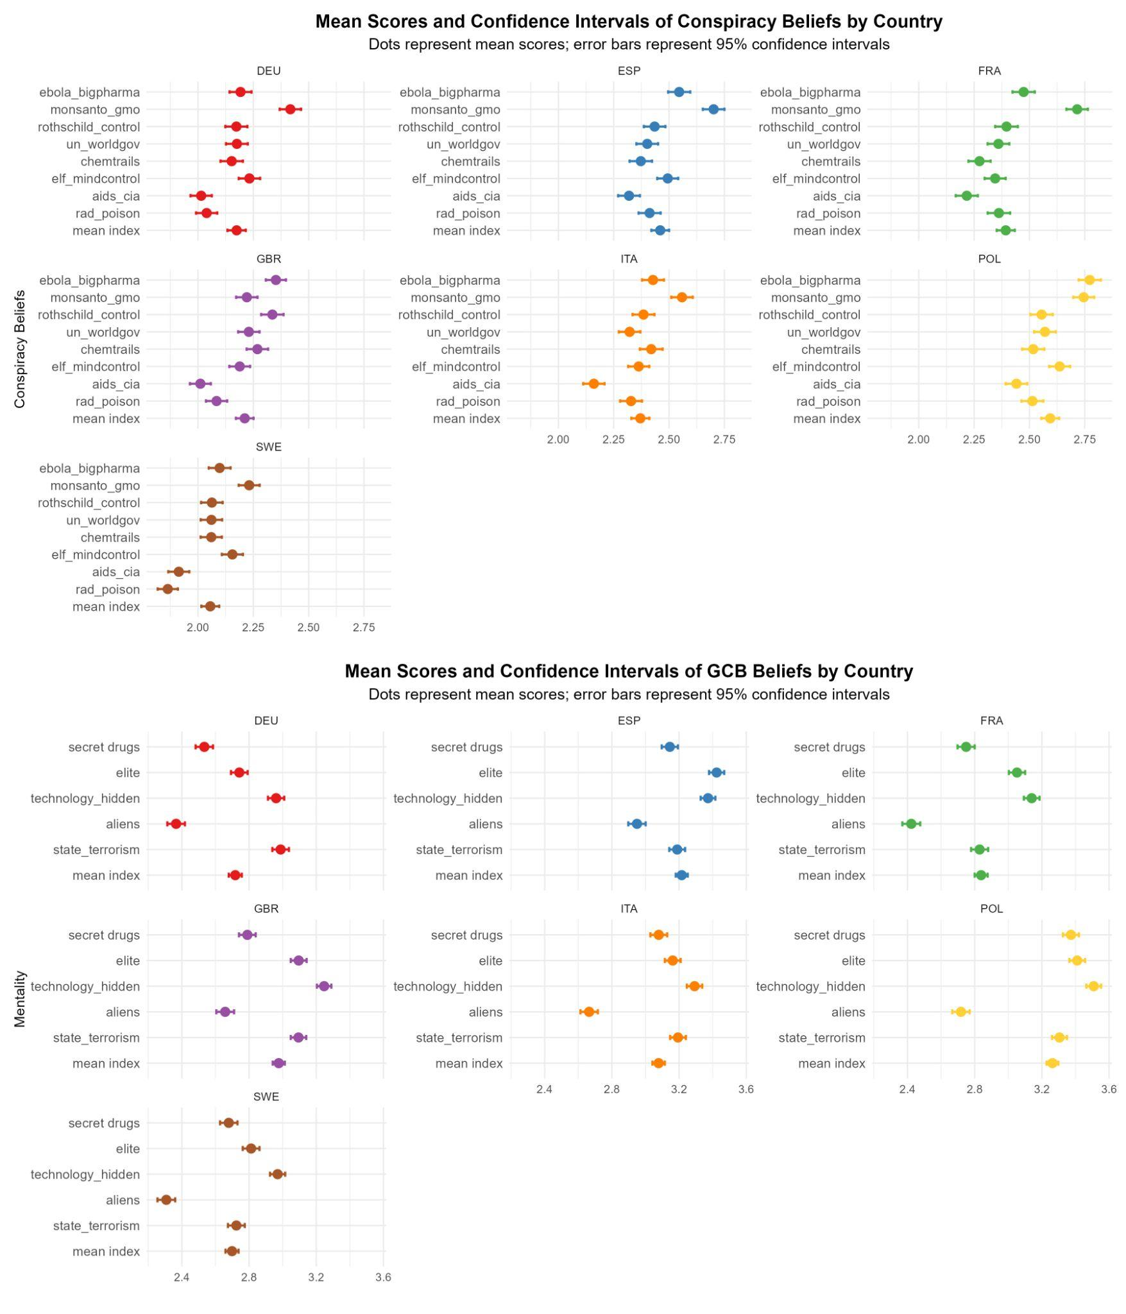

Figure S2: Distribution of CB and CM scales

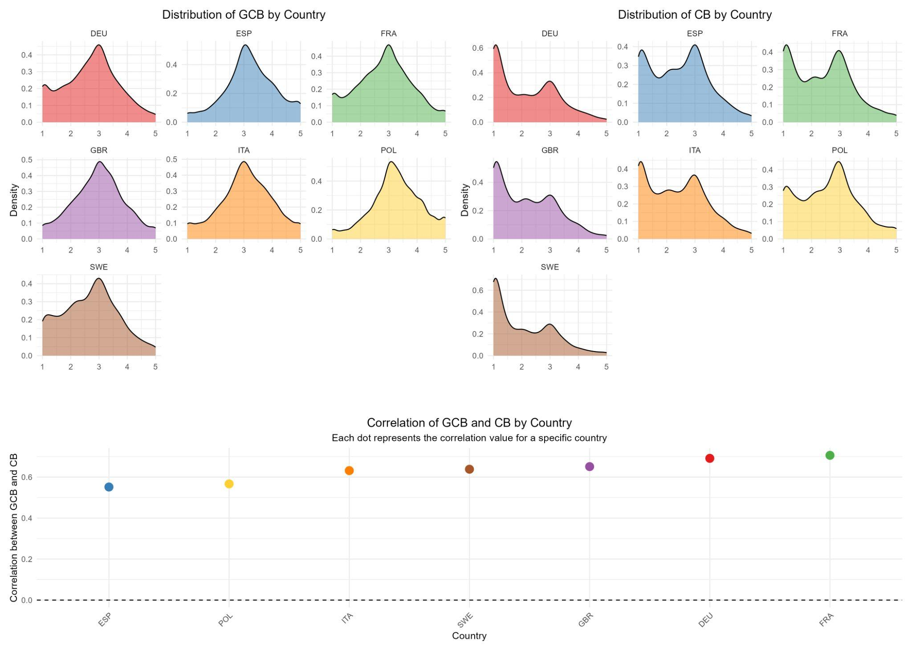

Figure S3: Dimensionality of CB (COMP-CB) and CM (GCB-5) scales
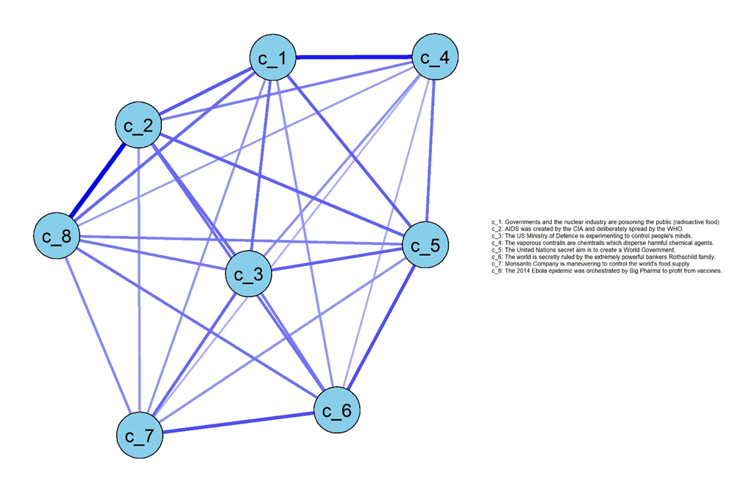


Table S1: Alphas

Scale | DEU | ESP | FRA | GBR | ITA | POL | SWE | USA
GCB-5 | 0.83 | 0.80 | 0.82 | 0.80 | 0.82 | 0.80 | 0.83 | 0.82
COMP-CB | 0.94 | 0.93 | 0.93 | 0.94 | 0.93 | 0.93 | 0.94 | 0.94

Table S2: KMO and Bartlett tests results

Country | KMO |  | Bartlett χ2 | Bartlett p value
DEU | 0.96 | Passed | 21659.75 | 0.00 | Passed
ESP | 0.95 | Passed | 17404.88 | 0.00 | Passed
FRA | 0.96 | Passed | 19775.36 | 0.00 | Passed
GBR | 0.96 | Passed | 19422.33 | 0.00 | Passed
ITA | 0.95 | Passed | 19574.15 | 0.00 | Passed
POL | 0.95 | Passed | 18451.59 | 0.00 | Passed
SWE | 0.95 | Passed | 21409.72 | 0.00 | Passed
USA | 0.96 | Passed | 20797.46 | 0.00 | Passed

Table S3: CFA, fit statistics
Country | χ2 | P value | CFI | TLI | RMSEA | SRMR | BIC
DEU | 465.40 | 0 | 0.98 | 0.98 | 0.05 | 0.03 | 86765.58
ESP | 341.97 | 0 | 0.98 | 0.98 | 0.04 | 0.03 | 89918.79
FRA | 448.48 | 0 | 0.98 | 0.98 | 0.05 | 0.03 | 88763.20
GBR | 343.42 | 0 | 0.99 | 0.98 | 0.04 | 0.03 | 86368.98
ITA | 464.67 | 0 | 0.98 | 0.98 | 0.05 | 0.03 | 87510.92
POL | 361.07 | 0 | 0.98 | 0.98 | 0.04 | 0.03 | 88560.71
SWE | 513.74 | 0 | 0.98 | 0.97 | 0.05 | 0.03 | 85628.15
USA | 245.23 | 0 | 0.99 | 0.99 | 0.03 | 0.02 | 90003.25

Figure S4 (Part 1): Network of CM and CB items, EGA-based colors
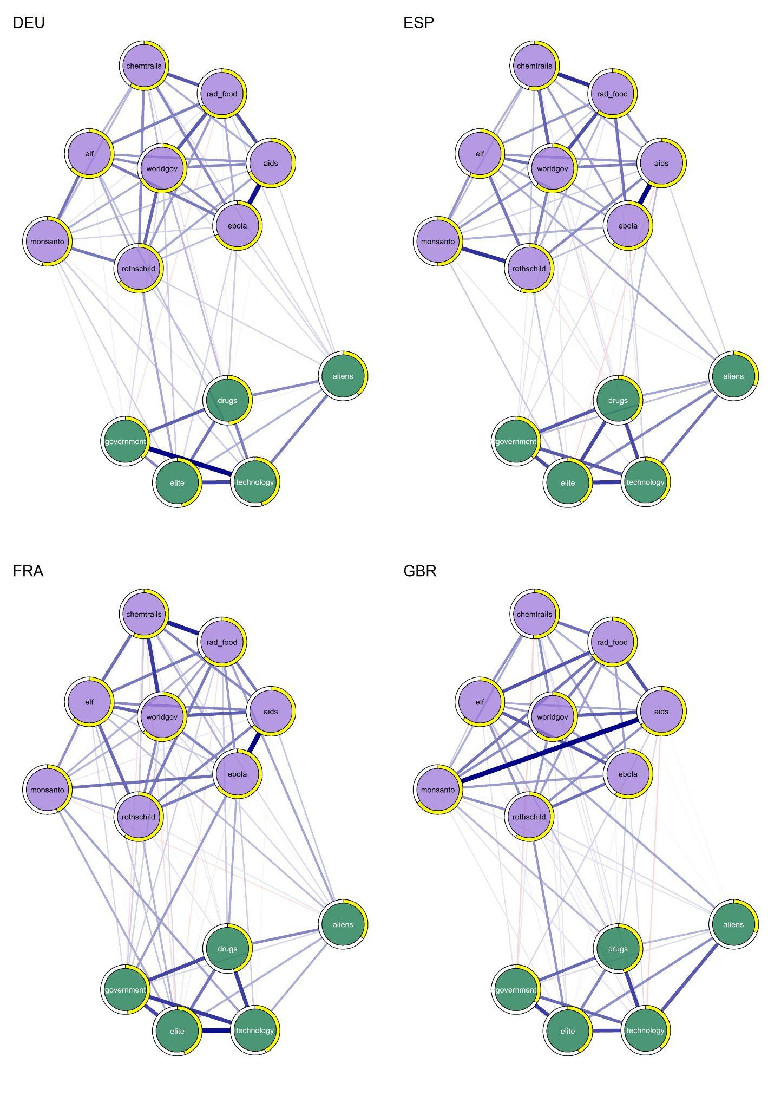

Figure S4 (Part 2): Networks of CM and CB items, EGA-based colors
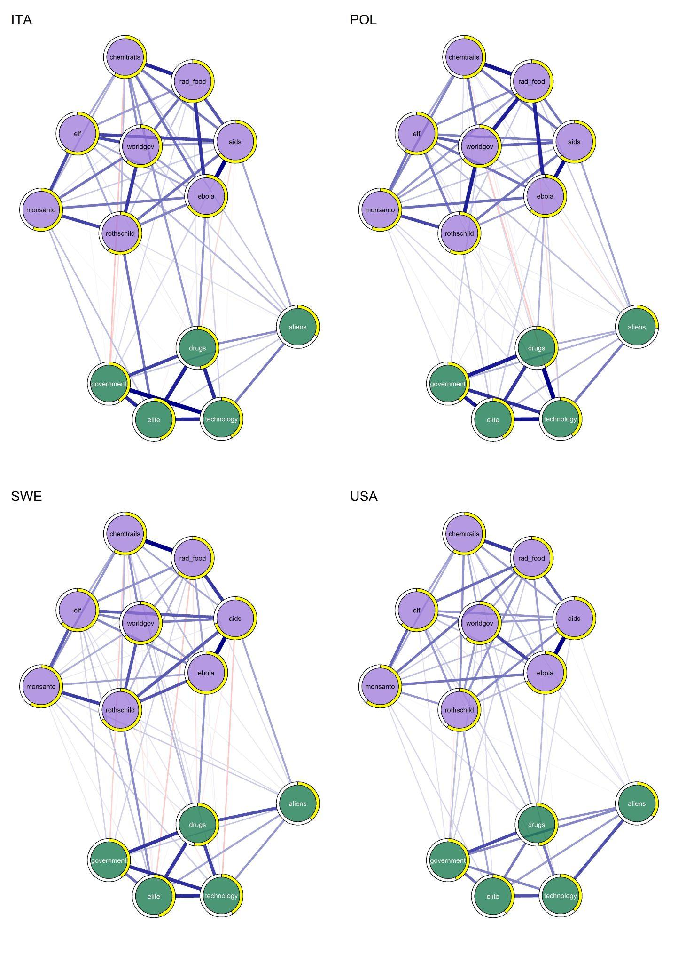

Figure S5 (Part 1): H1 Networks
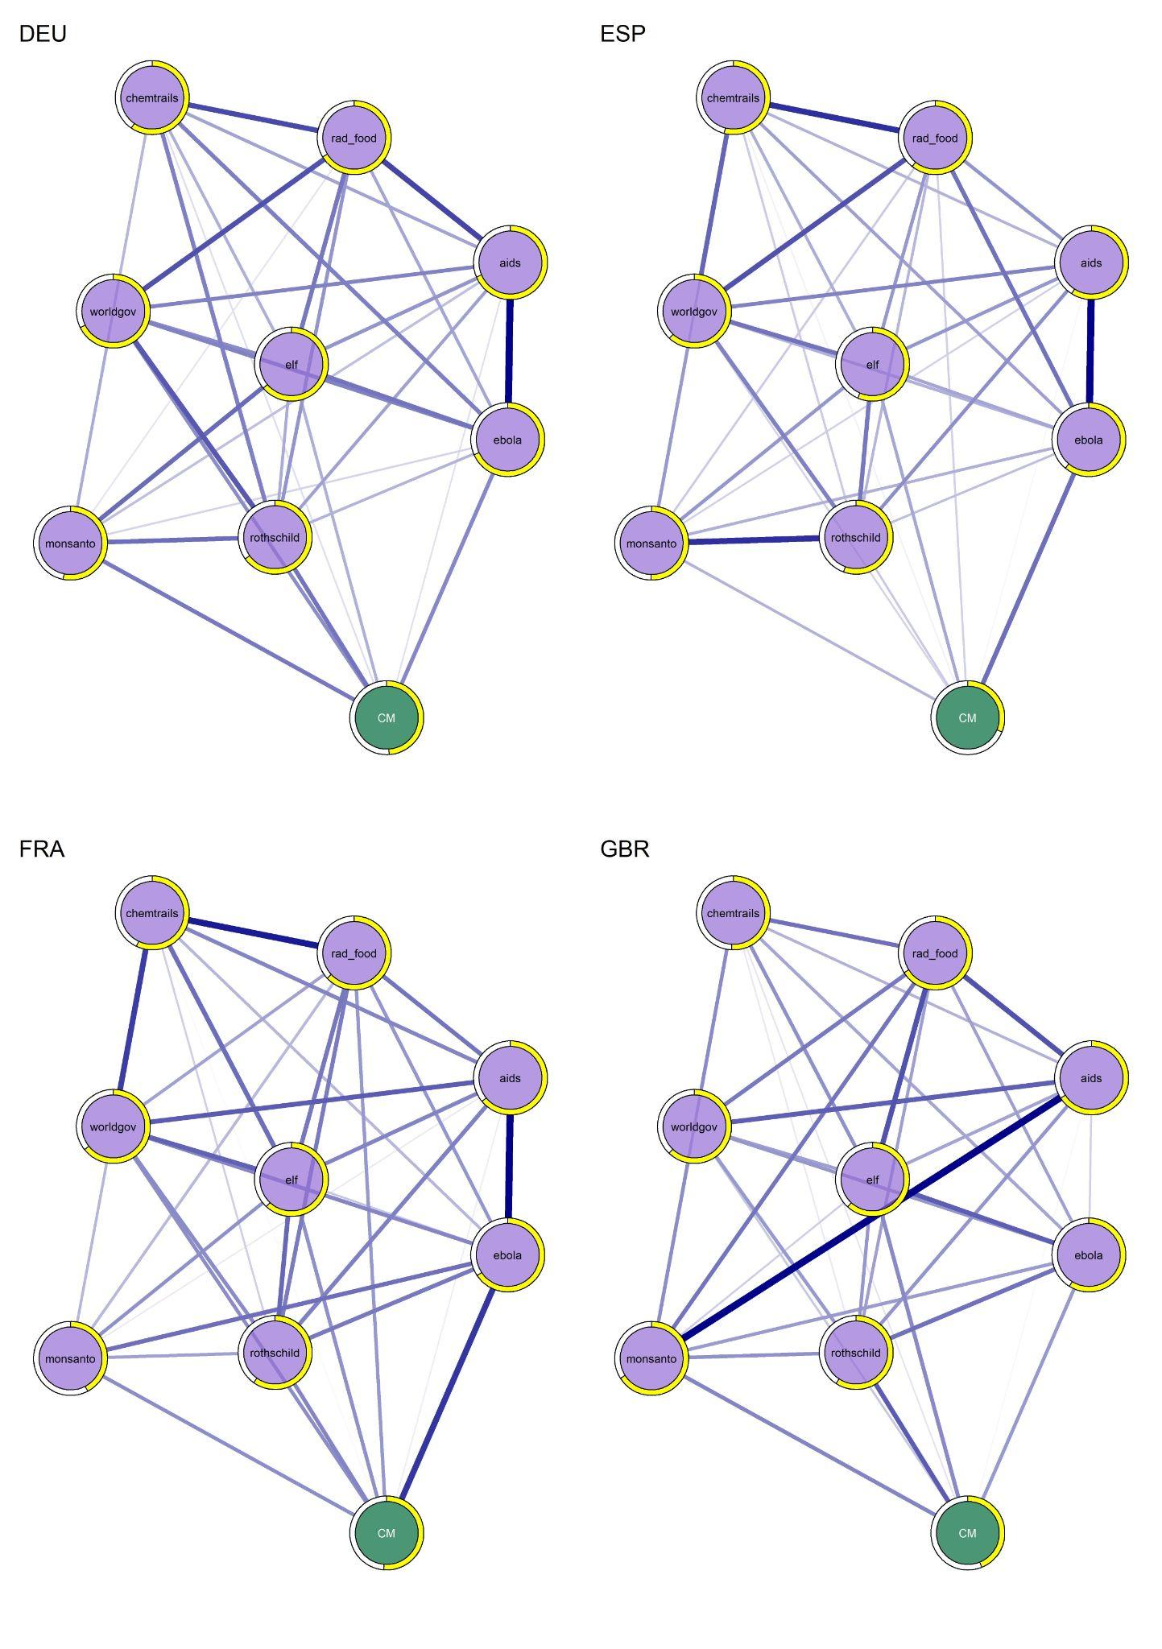

Figure S5 (Part 2): H1 Networks
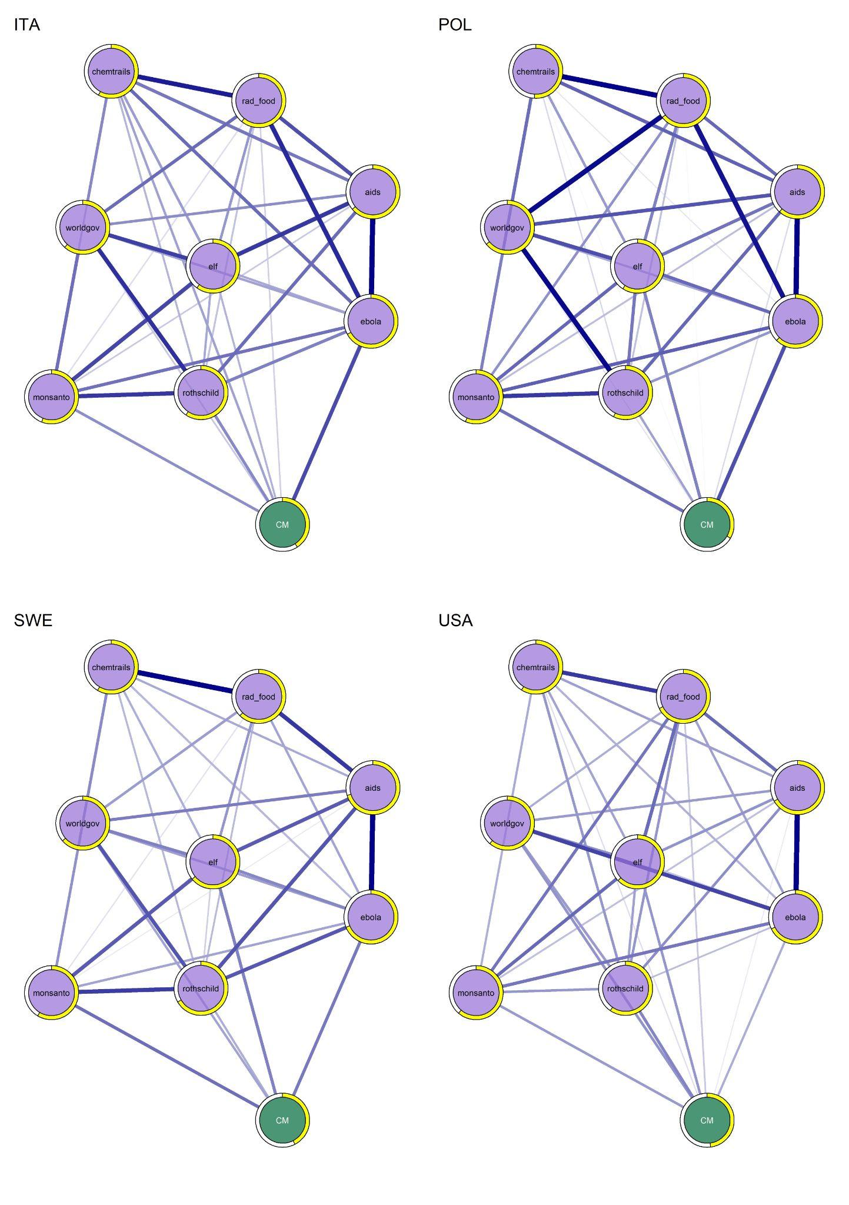

Figure S6 (Part 1): H2 Networks
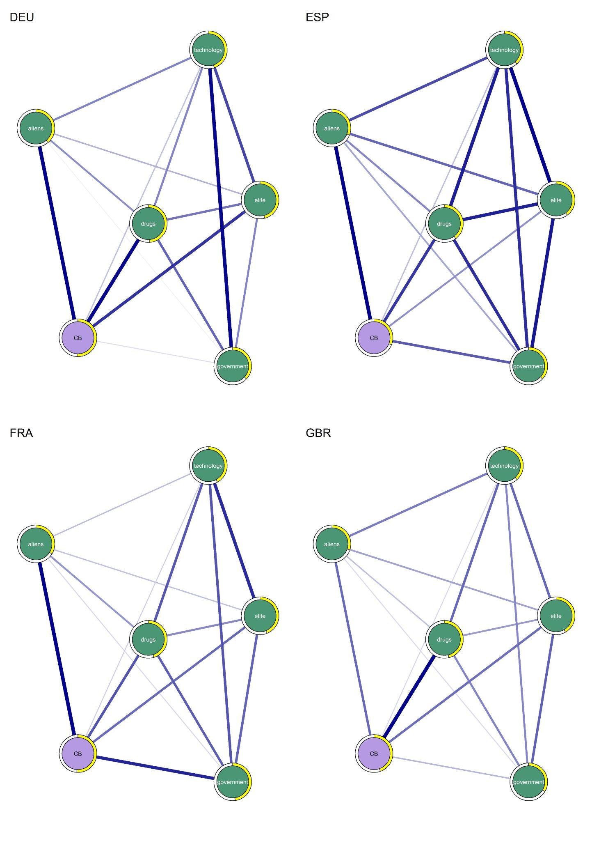

Figure S6 (Part 2): H2 Networks
