Conspiracy theories are central to the complex system of predictors of Italian vaccine hesitancy

Abstract
Although COVID-19 vaccines have long been widely available, their uptake has remained constrained by vaccine hesitancy. Research on this phenomenon has identified more than 50 determinants, but it has largely relied on reductionist approaches that examine the pairwise association between hesitancy and individual predictors. As a result, we know much more about which variables correlate with hesitancy than about how these factors are organized within a broader belief system. This article addresses that gap by adopting a network approach that reconstructs vaccine hesitancy as embedded in a wider configuration of attitudes, dispositions, and sociodemographic characteristics. Using Italian survey data, I estimate the network of these determinants in a country where hesitancy has been comparatively widespread. This approach highlights that vaccine hesitancy emerges from a highly connected system rather than from isolated factors alone. Within this system, conspiracy endorsement stands out as a central structuring element, being directly linked to most of the variables included in the analysis. The network approach also isolates a more limited set of factors that remain directly associated with hesitancy net of all other variables in the system, thereby moving beyond long inventories of correlates and pointing to a narrower set of targets for public intervention.

Keywords: Broad Attitude Network, Vaccine Hesitancy, Conspiracism, Italy

1 Introduction
In December 2019, Chinese authorities communicated that a new virus called COVID-19 was detected in Wuhan, in the province of Hubei. The disease rapidly expanded, leading the World Health Organization [WHO] to officially declare the outbreak of a pandemic on March 11, 2020. WHO recommended the adoption of preventive behaviours to cope with the pandemic, such as wearing face masks and maintaining social distancing. Despite the relevance of individual compliance to preventive behaviours and the implementation of adequate national-level policies, both strategies are insufficient to deal with such a highly infectious disease. Therefore, vaccines are crucial to react against the virus and were rapidly developed worldwide (Schoch-Spana et al., 2021). Nevertheless, a growing number of individuals are sceptical of them. Vaccine hesitancy is a “delay in acceptance or refusal of vaccination despite the availability of vaccination services” (MacDonald, 2015, p. 4163). Already in 2019, WHO considered vaccine hesitancy as one of the top ten threats to global health. COVID-19-related vaccine hesitancy is massively diffused worldwide, and it is more pronounced in high-income countries (Aw et al., 2021; Sallam, 2021). Hesitancy was largely investigated, and precious systematic reviews are already available (ibid.).
However, previous research has mostly adopted a reductionist strategy, examining vaccine hesitancy through its pairwise associations with a large set of predictors. This approach has generated an extensive catalogue of more than 50 determinants (Aw et al., 2021), but it offers limited leverage for understanding how these factors cohere as a broader belief system in the Converseian sense (Converse, 2006 [1964]). For political science, this is a crucial limitation: socio-political attitudes do not exist in isolation, but are embedded in wider constellations of political distrust, values, and interpretive schemas (Bertero et al., 2024). By focusing on isolated relationships, existing work overlooks the associations among predictors themselves and therefore misses an important part of the phenomenon. To address this limitation, this article adopts a complex systems perspective in which vaccine hesitancy is conceptualized as a multifaceted social and political outcome emerging from the interdependencies among its determinants. Methodologically, the article relies on a graphical model imported from network psychometrics, in which survey items are represented as nodes connected by weighted and undirected edges estimated from the data. Rather than treating predictors as independent covariates, this approach makes it possible to reconstruct the architecture of their mutual associations and to identify which beliefs are most central in the wider attitudinal system. This framework builds on the Causal Attitude Network [CAN] model, originally developed to study the structure of single attitudes (Dalege et al., 2016). More recently, CAN has been extended to the analysis of compliance with COVID-19 preventive behaviours (Chambon, Dalege, et al., 2022; Chambon et al., 2021, 2023; Kuiper et al., 2022) and vaccine intentions (Chambon, Kammeraad, et al., 2022). These “Broad Attitude Networks” expand the CAN framework to encompass non-attitudinal variables, whose inclusion is essential for understanding vaccine hesitancy. By leveraging this approach, I move beyond dyadic relationships between hesitancy and its predictors and instead reconstruct the broader web of beliefs, dispositions, and orientations within which hesitancy emerges in Italy.

This study constitutes one of the first applications of a complex systems approach to vaccine hesitancy and, to the best of my knowledge, the first attempt to mobilize it for a political science account of the phenomenon. I focus on Italy because vaccine hesitancy has been comparatively widespread in this case (Sallam, 2021) and because Italian scholarship has already identified a rich set of explanations using more conventional approaches. This makes Italy a useful setting not only for testing a new method, but also for showing what that method adds conceptually. In this article, I show that vaccine hesitancy is embedded in a broader system of attitudes in which some constructs matter less for their direct association with hesitancy than for their role in organizing the wider attitudinal field. The analysis identifies conspiracy beliefs as a central structuring element of this system. Section 2 reviews the literature and motivates a complex systems perspective. Section 3 presents the data and methods. The Results section reconstructs the Broad Attitude Network and compares its findings with those of alternative approaches. The Discussion and Conclusion address the implications, strengths, and limitations of the study.

2 Background

2.1 Theoretical predictors of vaccine hesitancy
Given its socio-political relevance, many studies sought to isolate the determinants of vaccine hesitancy. Macro-level studies highlight that vaccine hesitancy is more pronounced in wealthy countries (Aw et al., 2021; Sallam, 2021). Micro-level studies have established a wealth of predictors of this behavior. A valuable scoping review identified more than 50 predictors and classified them into Contextual, Individual, and Vaccine-related categories (Aw et al., 2021). While political scientists typically conceptualize variables such as political ideology or populist inclinations as operating at the individual level, I retain Aw et al.’s original labels for consistency with the public health literature. However, I explicitly treat these categories as heuristic tools to organize the vast number of predictors. Table 1 presents a relevant selection of these items. Section 1 of Supplement S1 covers these predictors in more detail.
Table 1: Theoretical predictors of vaccine hesitancy worldwide
Contextual | Individual | Vaccine-related
Political inclination: far right | Worry about COVID-19 | Belief that vaccines are unsafe
Political inclination: populist | Low risk perception | Opposing to mandatory vaccination
Distrust of institution | Endorsing conspiracy theories | Concerns about rapid development
Distrust of government | Trust in alternative medicine | Fear of needles
Religiosity | Internal health locus of control
Digital media diet | Low compliance with COVID-19 preventive behaviours
Sex, female | Distrust of health system
Lower age | Distrust of science
Lower education | Lesser sense of collective responsibility
Lower income
Living in a rural region
Source: selected from Aw et al., 2021.

This topic is also largely investigated in Italy (Aw et al., 2021) where hesitancy rates are among the highest in Europe (Sallam, 2021). Since vaccine hesitancy is a behaviour that can only emerge with the availability of vaccines, it is important to distinguish between studies fielded before and after the Italian vaccine day (December 27, 2020), as only the latter can study hesitant behaviours, following the definition proposed by the SAGE working group (MacDonald, 2015). The former can only investigate vaccine intentions, which are general attitudes toward an upcoming vaccine.
One of the earliest research on the topic analyzes a convenience sample of 735 Italian students, showing that 13% of them have sceptical vaccine intentions (Barello et al., 2020). Another work finds that vaccine intention is negatively correlated with worry about infection and trust in institutions, and negatively correlated with endorsement of conspiracy theories (Prati, 2020). A study conducted in September 2020 captures a striking level of negative vaccine intentions, with nearly 45 percent of the sample describing the rejection of a potential COVID-19 vaccine as likely or certain (Vecchia et al., 2020). Another research group investigates the willingness to undertake COVID-19 vaccines of oncological and rheumatological patients, finding no statistically significant differences between the two groups (Campochiaro et al., 2021). Other surveys study attitudes towards vaccination longitudinally. By sampling college students in a repeated cross-sectional design, Caserotti and colleagues illustrate that negative intentions toward vaccines increased immediately after the end of the Italian lockdown and that low-risk perception and negative attitudes toward vaccines predict greater scepticism (Caserotti et al., 2021). An additional repeated cross-sectional relies on two waves fielded during and immediately after the Italian lockdown (Palamenghi et al., 2020). This study confirms that individuals who trust science and have a high perception of the risk of COVID-19 consequences are unlikely to oppose vaccination. Finally, two studies examine vaccine intention with Path analysis and Structural Equation Modeling. One of these articles deals with the relationships between health engagement, risk perception, and attitudes toward vaccines (Graffigna et al., 2020). Health engagement predicts negative vaccine intentions; this association is only partially mediated by the general attitudes toward vaccines. In contrast, risk perception and perceived COVID-19 severity only weakly predict scepticism. The Structural Equation Model of the second paper confirms that conspiracy theory adherence, low trust in science, and negative attitudes toward vaccines lead to increased scepticism toward a potential COVID-19 vaccine (Pivetti et al., 2021).
Other Italian studies have analysed vaccine intentions in the presence of an already-developed COVID-19 vaccine. Low-risk perception, being woman, low levels of education, and income are confirmed as predictors of hesitancy in a representative sample of the Emilia Romagna Italian region (Reno et al., 2021). Interestingly, the effect of age is confined to one particular cohort, with those aged 35 to 54 less willing to undertake vaccination. Another medical study investigates the levels of vaccine hesitancy among patients with rheumatic and musculoskeletal diseases (Priori et al., 2021). The authors isolate female sex, low education, and lower age as predictors. Finally, Ladini and Vezzoni (2022) reconfirm the importance of endorsing conspiracy theories and find that belief in divine immanence is associated with higher levels of hesitancy. Moreover, they reveal that both relationships are mediated by institutional religiosity—that is, the level with which an individual is integrated into religious institutions. More recently, scholarship has explored broader socio-political and contextual factors is associated with higher levels of hesitancy. Kreps and Kriner (2023) demonstrate that compliance with vaccination mandates is strongly associated with an individual’s commitment to the rule of law and the social contract, as well as the cues provided by partisan elites. Furthermore, populist political orientations have been shown to independently predict COVID-19 vaccine refusal (Roccato & Russo, 2023). Finally, recent longitudinal analyses reveal that the relationship between conspiracy thinking and vaccine reluctance is not static, as it appears to increase during periods of high pandemic prevalence.
This section briefly reviewed the literature on the determinants of Italian vaccine hesitancy. While research has identified a heterogeneous set of over 50 predictors, most studies have relied on a reductionist approach, isolating pairwise relationships between single predictors and hesitant behaviours. The next section argues that adopting a complex systems approach can overcome this narrow outlook.

2.2 Complex system approach
While studying vaccine hesitancy, researchers have mainly followed a reductionist approach, studying many predictors in isolation. As a consequence, little is known about the between-predictors relationships, and about whether the identified dyadic interactions are robust to a wider set of control variables. Investigation of this research question requires a complex systems approach (Barabasi, 2007). Beyond serving as a powerful methodological tool to manage complex data, this approach reflects a specific, well-grounded model of opinion formation. It builds upon Converse’s (2006) seminal conceptualization of belief systems, positing that attitudes are not held in isolation, as they interact as elements of an interconnected system. Within this framework, variables dynamically influence and constrain each other without a strict, unidirectional causal ordering (Converse, 2006; for a recent application to Italian political belief systems, see: Bertero, 2025). Applying this framework, vaccine hesitancy is shaped by an intricate set of dependencies among multiple and heterogeneous variables. The key idea of a complex system approach is that studying twofold associations between variables is not sufficient for the full understanding of the whole system, whose overall state is determined by the interactions occurring between its components (Ladyman et al., 2013).
This paper adopts an extension of the Causal Attitude Network [CAN] model, which aims at measuring a single attitude as a network of connected evaluative reactions (Dalege et al., 2016). CAN conceptualizes an attitude as a higher-level construct that emerges from interactions among lower-order entities, which can be measured through standard attitudinal survey questions. CAN renders survey items as nodes of a network and estimates their conditional associations. These associations are represented as weighted, undirected network edges indicative of the influence between evaluative reactions forming the attitude network. However, CAN is not suited to address the complexity of the network of determinants of vaccine hesitancy, which is not only attitudinal in kind. Therefore, this paper adopts a “Broad Attitude Network” model, in which nodes can be single attitudes, sociodemographic variables, or self-reported behaviors (Chambon, Dalege, et al., 2022). This framework allows me to examine a wider set of variables, and to reconstruct the multivariate relationships existing between the theoretical predictors of hesitancy I discussed in Section 2.1.
Network estimation of multivariate data is implemented through graphical models. Broad Attitude Networks are based on a special type of graphical model called Pairwise Random Marokv Fields [PMRF] (Lauritzen, 1996). The edges of a PMRF are indicative of the unique variance shared by pairs of network nodes. Accordingly, two nodes are connected if -after controlling for each other variable in the model- they are still conditionally dependent. Conversely, nodes of a PMRF are untied only if conditionally independent after conditioning on every other variable.
Figure 1 reports a simplified Broad Attitude Network related to COVID-19 vaccine hesitancy. Nodes represent survey questions. An edge is interpretable as the linear influence between two variables, controlling for all other variables in the model. Blue edges represent positive linear influences, red negative ones. Edge width is proportional to the strength of the associations. In this example, the nodes low-risk perception, distrust in institutions, vaccines are unsafe, positively interact with hesitancy. The strongest association is between hesitancy and low-risk perception. Moreover, low-risk perception is negatively correlated with both vaccines are unsafe and distrust in institutions, even after controlling for the other variables in the model. These relationships imply that the state of vaccine hesitancy will likely align with the state of the other nodes. Therefore, an individual expressing low levels of risk perception, distrust of institutions, and negative attitudes toward vaccines is likely to be hesitant toward vaccine undertaking. Finally, the example shows that individuals who have negative attitudes toward vaccines should perceive the threat of COVID-19 infection as less severe, meaning that their status is possibly misaligned at the population level.
Figure 1: Example of a Broad Attitude Network
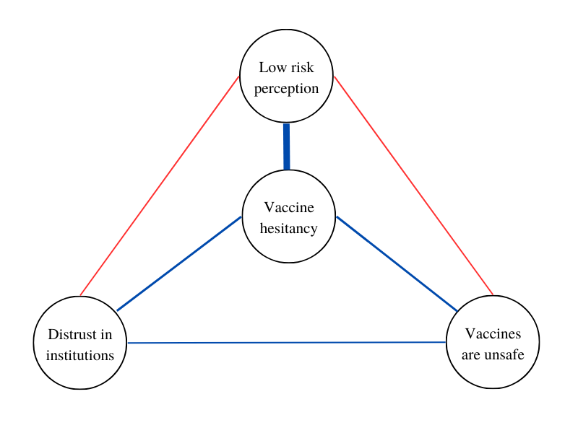
Note: Example of Broad Attitude Network. Vaccine hesitancy is part of a web of predictors, which are represented as nodes. Connections represent positive (blue) or negative (red) linear influences; their magnitude is coded through edges’ width.

3 Data and methods

3.1 Analytical strategy
Based on data availability, I begin selecting a subset of the theoretical predictors of vaccine hesitancy discussed in Section 2.1. Next, I reduce measurement error combining variables coming from three survey batteries in mean indexes. I compute mean indexes for institutional trust, attitudes toward the Italian government, and self-reported compliance to preventive behaviors. Details are provided in Section S2 (Supplement). Second, I retrieve the multivariate associations between these determinants and hesitancy itself, relying on the Broad Attitude Network approach. Since the edges are model parameters estimated through regularized regressions with an extensive set of control variables (see Section 3.4), this step entails information reduction that might guide policy making by suggesting the most important variables in the system—which I label “empirical predictors of vaccine hesitancy in Italy. Finally, I apply standard network analysis techniques to the network, to describe its structural characteristics.

3.2 Data and sample
The estimation of a moderate-size (20-30 variables) broad attitude network requires at least 500 respondents (Borkulo et al., 2015). I contribute to the Italian literature on vaccine hesitancy by working on a survey fielded after the start of the Italian vaccination campaign: wave three of ResPOnsE data, an Italian dataset endowed with a Rolling Cross Sectional [RCS] design (Vezzoni et al., 2020). The sample is obtained with quotas for the area of residence, gender, and age group, and it is gathered by an online panel from a commercial research institute (SWG SpA). Quotas cover an important selection of sociodemographic determinants of vaccine hesitancy. Wave three was fielded between March 17 and June 16, 2021, through a multipurpose CAWI questionnaire mostly focusing on the pandemic. Due to the skip structure of the questionnaire, only a subsample of 3767 respondents can answer all the variables featured in this research. Listwise deletion reduces the sample to 1.540 units.

3.3 Survey
Table 2 shows the survey questions and response options for each variable, which cover all categories of theoretical predictors presented in Section 2.1. Thirteen contextual determinants are examined, through variables tapping distrust of institutions, science, and government; three variables measure respondents’ populist political inclinations (high propensity to vote for the 5 Star Movement, Brothers of Italy, and the League); finally, the analysis includes self-reported frequency of prayer attendance, the prevalence of a digital media diet, and sociodemographic variables (sex, age, education, rural area of residence, economic insecurity). I include seven individual determinants, with variables measuring compliance to preventive behaviours against COVID-19, internal health locus of control, worry for infection, risk perception, and approval of alternative medicine. The research also includes a measure of beliefs about the origins of COVID-19, used here as an indicator of receptiveness to conspiratorial narratives. Respondents were asked whether they thought COVID-19 originated from animal-to-human transmission, from the US-China struggle for world supremacy, or from a flawed scientific experiment. In the context in which the survey was fielded, the latter two responses captured rejection of the dominant public-health account and greater openness to alternative, conspiratorial interpretations of the pandemic. Finally, two items regard general attitudes toward vaccines: the belief that vaccines are unsafe and the preference for a mandatory vaccination policy. The polarity of each variable is aligned to have high values of predictors associated with high values of hesitancy.

Vaccine hesitancy is obtained by combining two variables. One asks the respondent to indicate whether s/he already had a dose of vaccine; another surveys vaccine intention (“What is your intention regarding the administration of the COVID-19 vaccine?”). Response modes are “I will surely vaccinate”, “It is quite likely that I will vaccinate”, “It is unlikely that I will vaccinate”, and “Certainly I will not vaccinate”. Hesitancy is constructed as a dummy variable where individuals already vaccinated, or those saying they will “surely” and “likely” get a dose were coded with “0”. Hesitancy scores “1” if an individual says that s/he is not vaccinated and that s/he is not likely, or certainly not oriented, to undertake it.

3.4 Network methodology and network measures
Relying on the existing literature adopting the Broad Attitude Network approach to study the vaccine intention (Chambon, Kammeraad, et al., 2022) and compliance with preventive behaviours related to COVID-19 (Chambon et al., 2023), this paper applies a Mixed Graphical Model [mgm] (Haslbeck & Waldorp, 2020). This model is often applied in network psychometrics and can deal with the heterogeneity of variable types characterizing this research. The between-person network of determinants is obtained through a loop of node-wise regularized regressions. The mgm iteratively regresses each node on each other, including all remaining variables as controls. This produces two estimates per edge (i.e.: one when node X₁ predicts node X₂ and one when X₂ predicts X₁, controlling for the other variables). Coefficients are then averaged and become the edge weights of the network model. Each of these regressions requires dealing with a vast set of covariates, among which collinearity is likely to arise. To avoid it, mgm employs LASSO regularization in combination with cross-validation. Regularization is commonly used in network estimation since it reduces the size of the statistical model, minimizes the risk of including spurious relationships in the analysis, and enhances the interpretability of the system (Borsboom et al., 2021; Epskamp, 2016; Epskamp & Fried, 2018). Unlike linear regression, the goal of regularized regression is not to find the coefficients that minimize the sum of squared differences between the predicted values and the actual values of the target variable. In LASSO regularization, an additional penalty term is introduced. The tuning parameter lambda (λ) controls the amount of regularization applied. When λ is set to zero, LASSO regularization has no effect, and the model is mathematically equivalent to a linear regression. As λ increases, the penalty term becomes stronger, and it shrinks the coefficient estimates toward zero. Therefore LASSO regularization induces sparsity in the coefficient estimates and thus, in the resulting network matrix. As λ increases, the LASSO penalty starts to force some coefficients to become exactly zero, effectively performing variable selection. This means that LASSO can inductively identify and exclude covariates from the regressions composing the model. The appropriate value of the tuning parameter is obtained through k-fold cross-validation with k = 10 (both default settings in the mgm package). Cross-validation is a robust methodology used to evaluate the performance of machine learning models, and its application has been encouraged also outside of this realm (King et al., 2021). It involves dividing a dataset into multiple subsets and using one fold as a validation set while training the model on the remaining folds. Hence, the sample is divided into 10 subsets, the model is trained on 9 of these, and evaluated on the remaining “fold”. This process is repeated 10 times, with a different subset used as the validation set each time. The performance of the model is then averaged across the iterations and informs the choice of the appropriate tuning parameter (Haslbeck & Waldorp, 2020). Finally, I explore the predictability of each node, that is the portion of its variance that is explained by the connections it has with other variables. I do this graphically by coloring the border of each node with a pie plotting its predictability (Haslbeck & Waldorp, 2018). For variables modeled as continuous, I show R². For categorical variables -involved in logistic regressions- I examine two other measures: the accuracy of the intercept model and the additional accuracy. The first assesses the predictability of a node based on its simple frequency distribution. The second specifies how much variance the other variables in the model can explain in addition to the accuracy of the intercept.

Analyses are conducted in R and are fully reproducible. Code is provided through GitHub: [LINK to a GITHUB REPOSITORY; ANONYMIZED]. Network estimation is carried out with the mgm package (Haslbeck & Waldorp, 2020). The resulting weighted adjacency matrix is made available at S6) (Supplement). Network visualization and node centrality estimation rely on qgraph (Epskamp et al., 2012). Methodological studies in this field suggest adopting either Degree or Strength as a measure of centrality (Bringmann et al., 2019a). Degree centrality counts the number of ties in which a node is involved. Strength is the operationalization of degree centrality for weighted networks and is equal to the absolute sum of all edge weights of a node’s ties. Descriptives of Strength and Degree scores are reported in the article, while I provide their exact values in S4. Network communities are detected with one thousand iterations of the Walktrap community detection algorithm, performed on the absolute weighted adjacency matrix (Pons & Latapy, 2005). Section S5 provides more details on these operations. Connectivity is measured by the weighted Average Shortest Path Length, and calculated with tnet (Opsahl, 2009). The procedure starts by calculating all the geodesic distances between network nodes; then, distances are normalized by the average weight of network ties; finally, it calculates the mean of these normalized distances. Stability and robustness analyses are performed with bootnet (Epskamp et al., 2018), and are reported in S9. Additional robustness checks are reported in Supplement S10: re-estimating the networks on two random halves of the sample yields non-significant differences in the estimated edge weights.

Table 2: Survey variables
Name | Question | Scale
Vaccine hesitancy | Obtained combining: “Have you already received the COVID-19 vaccine?”; “What is your intention regarding the administration of the COVID-19 vaccine? | 0 (not hesitant) to 1 (hesitancy)
Vaccine bad for health | Vaccines wear down the immune system and expose it to various diseases | 1 (disagree) to 5 (agree)
Against mandatory vaccination | Vaccination against COVID-19 must be compulsory for everyone. | 1 (disagree) to 5 (agree)
Low worry about infection | In the last 7 days, have you been concerned about the possible consequences of the Coronavirus for your health? | 0 (less than three times) to 1 (three times or more in a week)
Low risk perception | Do you personally feel that you are more or less exposed to contagion than the majority of the population in your area? | 1 (more) to 5 (less exposed)
Endorsing conspiracy theories | What do you think is the most likely origin of the virus? | 0 (transition from animals to humans) to 1 (US-China war for world supremacy; Wrong scientific experiments)
Trust in alternative medicine | More space should be given to natural healing methods | 0 (disagree) to 10 (agree)
Internal health locus of control | How much do you think Italians with their own behaviors are responsible for the pandemic’s course? | 0 (not responsible) to 10 (responsible)
Economy prioritized over health | Faced with the Coronavirus crisis, governments may react in different ways. A government may prioritize reducing Coronavirus infections, even at the cost of causing a serious economic crisis for the country. Or a government may prioritize defending the national economy, even at the cost of increasing the number of infections. Where would you place your opinion? | 0 (health) to 10 (economy as a priority)
Propensity to vote for L | Among the various parties we have in Italy, each would like to have your vote in the future. Regardless of how you plan to vote in the next election, how likely are you to vote for the League in the future? | 0 (not likely) to 10 (likely)
Propensity to vote for 5SM | Among the various parties we have in Italy, each would like to have your vote in the future. Regardless of how you plan to vote in the next election, how likely are you to vote for the the Five Star Movement in the future? | 0 (not likely) to 10 (likely)
Propensity to vote for BOI | Among the various parties we have in Italy, each would like to have your vote in the future. Regardless of how you plan to vote in the next election, how likely are you to vote for Brothers of Italy in the future? | 0 (not likely) to 10 (likely)
Distrust of science | When it comes to vaccines, the recommendations of the scientific community can be trusted | 0 (agree) to 5 (disagree)
Religion, pray | In the last week, how often did you pray? | 0 (never) to 1 (more than -or once a- day; more than -or once a- week)
Digital media diet | Mainly, where do you get the most information about the Coronavirus crisis from? | 0 (non-digital media) to 1 (digital media)
Sex, female | Could you report your sex? | 0 (man) to 1 (female)
Age, young | Could you report your age? | 88 (min) to 18 (max)
Education level, low | Could you report your educational level? | 0 (more than high school) to 1 (less than high school)
Living in a rural region | Could you indicate how many people reside in your township? | 0 (more than 30K) to 1 (less than 30K)
Economic insecurity | Your household’s income allows you yo live… | 0 (comfortably; easily) to 1 (with some difficulties; we don't make ends meet)
Low compliance with preventive behaviors | Obtained combining: To what extent do the following sentences correspond to your behavior over the past seven days? “I stayed at least three feet away from other people”; “I wore a mask and/or gloves”; “I washed and sanitized my hands often” | 0 (high) to 10 (low compliance)
Disapproval of Government | Obtained combining: “What is your assessment of the measures imposed by the government to stop the spread of COVID-19?”; “How do you assess the actions of the Draghi government during the COVID-19 emergency?” | 0 (positive) to 10 (negative evaluation)
Distrust of institutions | Obtained combining: What degree of trust do you give to the following institutions? “The Italian parliament”; “The European Union” | 0 (low) to 10 (high trust)

4 Results
This section describes the results obtained through the Broad Attitude Network approach. Table 3 shows that 20% of respondents are hesitant toward COVID-19 vaccines. The sample is balanced in terms of gender (50% of women), and skews toward high age (M = 47). Levels of self-reported compliance with preventive behaviours against COVID-19 are remarkably high (M = 8.7; SD = 1.8). Relatively low rates of hesitancy are not mirrored in the general attitudes toward vaccines, which remain more negative on average (vac_bad: M = 2.1; SD = 1.2).
Table 3: Descriptives of selected variables
Variable (label) | Mean | St.Dev. | Min | Max | N
Vaccine hesitancy (hesitancy) | 0.2 | 0.4 | 0 | 1 | 1540
Vaccine bad for health (vac_bad) | 2.1 | 1.2 | 1 | 5 | 1540
Against mandatory vaccination (vac_free) | 2.4 | 1.3 | 1 | 5 | 1540
Low worry about infection (low_worry) | 0.7 | 0.5 | 0 | 1 | 1540
Low risk perception (low_risk) | 3.2 | 0.8 | 1 | 5 | 1540
Endorsing conspiracy theories (conspiracy) | 0.5 | 0.5 | 0 | 1 | 1540
Trust in alternative medicine (nat) | 4.1 | 3.2 | 0 | 10 | 1540
Internal health locus of control (int_locus) | 6.5 | 2.6 | 0 | 10 | 1540
Economy prioritized over health (pro_econ) | 4.9 | 2.6 | 0 | 10 | 1540
Propensity to vote for L (PTV_L) | 2.6 | 3.3 | 0 | 10 | 1540
Propensity to vote for 5SM (PTV_5SM) | 2.7 | 3.3 | 0 | 10 | 1540
Propensity to vote for BOI (PTV_BOI) | 2.5 | 3.5 | 0 | 10 | 1540
Distrust of science (distrust_sci) | 2.3 | 1.2 | 1 | 5 | 1540
Religion, pray (pray) | 0.6 | 0.5 | 0 | 1 | 1540
Digital media diet (media) | 0.5 | 0.5 | 0 | 1 | 1540
Sex, female (female) | 0.5 | 0.5 | 0 | 1 | 1540
Age, young (young) | 47.3 | 14.9 | 18 | 88 | 1540
Education level, low (low_educ) | 0.6 | 0.5 | 0 | 1 | 1540
Living in a rural region (rural) | 0.4 | 0.5 | 0 | 1 | 1540
Economic insecurity (eco_insec) | 2.5 | 0.6 | 1 | 4 | 1540
Low compliance with preventive behaviors (low_comp) | 1.3 | 1.8 | 0 | 10 | 1540
Disapproval of Government (distrust_gov) | 4.4 | 2.3 | 0 | 10 | 1540
Distrust of institutions (distrust_inst) | 5.5 | 2.5 | 0 | 10 | 1540

4.1 The complex system
Network estimation results are presented in Figure 2. Edges indicate relationships between two items, after conditioning on every other node in the model. Blue edges represent positive linear influences, red negative ones. Edge width is proportional to the strength of the associations. The web of predictors of hesitancy forms a fully connected network. Hesitancy is plotted as a box to enhance interpretability. Note that the status of this variable is not special for the model, since network estimation is obtained by regressing each variable iteratively on each other. Figure 2 reveals that most of the variables are not directly connected to hesitancy. Therefore, not all empirical predictors are confirmed to interact directly with it. However, the Weighted Average Shortest Path Lenght scores 1.56. A unit of distance refers to one step with the average weight in the network. Therefore, this value suggests that on average nodes are 1.56 steps with average tie weight away from each other. This also implies that, on average, every predictor can impact hesitancy rapidly. Indeed, most of the nodes that are not directly connected to hesitancy (e.g., distrust_gov) can usually reach it through the intermediation of an additional node only (e.g., from distrust_gov to either conspiracy or distrust_sci and from these to hesitancy).

The border of each node shows its predictability, which is a measure that captures how much of its variance is explained by its connections to other variables in the complex system. I compute R² for continuous variables, and I visualize it with blue-colored borders. For categorical variables I show the accuracy of the intercept model (orange) and the additional accuracy provided by the other neighboring nodes (red); the sum of the two represents the overall predictability of categorical nodes. I observe drastic variations in predictability. The nodes hesitancy and conspiracy have high accuracy of the intercept model. However, other variables are important for their predictability, as testified by the red portion of their borders. The variance of these variables is remarkably captured by the complex system, as testified by the small white portion of their borders. In contrast, other categorical variables such as low_worry and rural have greater unexplained variance, mainly because the other nodes do not interact significantly with them. Variation persists among continuous variables. Nodes dealing with attitudes towards vaccines (vac_free and vac_bad) are deeply embedded in the network and thus have high R². In contrast, the predictability of other nodes, such as low_risk and eco_insec, is lower, mainly because of their weak interactions with other predictors.

Figure 2: Broad Attitude Network of vaccine hesitancy in Italy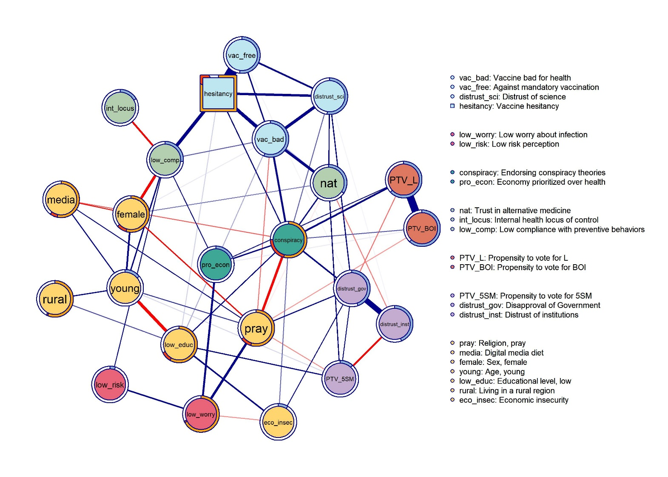
Note: Circular nodes represent 22 theoretical predictors of vaccine hesitancy, which is plotted as a box. Edges represent statistical relationships between nodes that are present even after controlling for each other item. Blue [red] edges represent positive [negative] linear influences. Edge width is proportional to the strength of each tie, and edge weights below .06 are omitted from the network plot to improve readability. Node colors indicate network community membership. Node borders indicate the predictability of the variance of each node.

4.2 Communities
Network communities are subsets of nodes that are more likely to interact together than with others. Therefore, communities provide insights into the clustering of the predictor of hesitancy. In Figure 2, communities are highlighted in different colors. Seven communities are detected. Vaccine hesitancy clusters together with negative attitudes toward vaccines, preference for non-mandatory vaccination, and distrust of science (light blue). This community comprehends all variables directly related to the COVID-19 vaccine (vac_bad, vac_free, and hesitancy). Self-reported compliance, internal health locus of control, and support for alternative medicine form a second cluster (light green). The node conspiracy clusters with pro_econ, forming the dark green cluster. The political cluster (orange) gathers rightist political preferences (PTV_L and PTV_BOI). Risk perception and worry about COVID-19 infection belong to the red community. Interestingly, PTV_5SM cluster together with distrust of institutions and disapproval of government (purple) and the yellow cluster is composed of all sociodemographic variables (sex, age, rural area, economic insecurity, and education) plus the nodes pray and media.

4.3 Centrality
Centrality measures the relative importance of network nodes. Figure 3 lists Strength centrality scores. Hesitancy emerges as the most central node in the network. The table shows that conspiracy is second according to the Strength metric. However, point estimates do not consent to compare directly the centrality of these two nodes. A bootstrapped difference test reveals that their difference is statistically significant (bootstrapped CI: [0.14;1.05]). Additional information is obtained by investigating the determinants of the high centrality of these nodes. The node hesitancy is involved in strong relationships with a restricted number of other nodes. Conspiracy follows the opposite pattern because its high values of Strength are determined by a vast number of ties, rather than by their high intensity. Indeed, it records an impressive value of Degree centrality, being connected to 15 out of 22 nodes. Degree centrality scores are provided at S4. Sociodemographic variables have moderate (pray, young, and eco_insec) to low (female, low_educ, media, and rural) Strength. The centrality of low_comp is moderately high. Finally, Table 3 negatively highlights low_risk and low_worry, which are both peripheral in the network.

Figure 3: Strength centrality
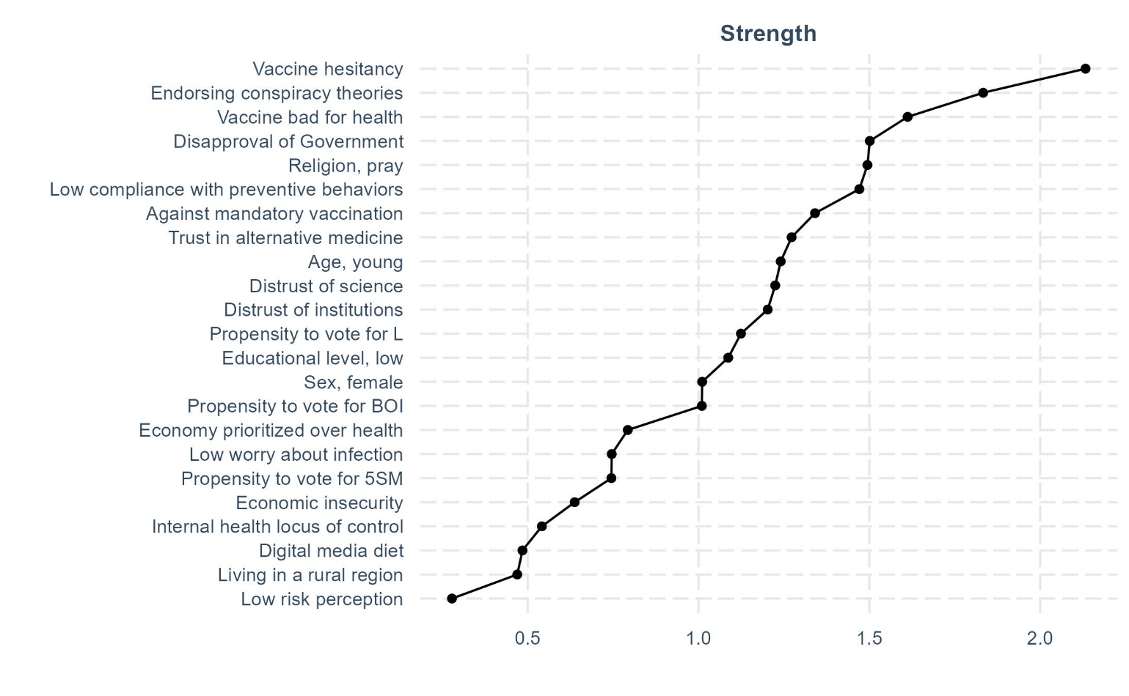

4.4 Relevant network edges
The strongest edges in the network are those between hesitancy and vac_free (edge weight = 0,95), PTV_L and PTV_BOI (0,71), distrust_inst, and distrust_gov (0,50). Moreover, Figure 2 highlights other connections of moderate intensity (edge weights between 0,34 and 0,20). Negative attitudes toward vaccines are positively correlated with vaccine hesitancy (0,34), endorsing conspiracy theories (0,20), distrust of science (0,30), and support for alternative medicine (0,28). Male gender is associated with reduced compliance to preventive behaviours (0,27), and this is in turn related to increased hesitancy (0,34). The relationships with which conspiracy is involved are also worthy of attention. Importantly, this node is directly tied to hesitancy, and it is also involved in meaningful relationships with the other nodes clustering with it (vac_bad, and distrust_sci). Additionally, conspiracy is positively related to a higher propensity to vote for rightist populist parties (PTV_BOI, PTV_L), and to all trust indicators (distrust_inst, distrus_gov, and distrust_sci). Therefore, this node is not only interacting with many variables, as discussed in the precedent section. It is also involved in meaningful relationships with the nodes having the strongest associations with vaccine hesitancy. Another interesting result is the negative tie between the propensity to vote for the populist Five Star Movement and distrust of institutions (-0,20).

4.5 Empirical predictors of vaccine hesitancy
Table 4 presents the empirical predictors of vaccine hesitancy in Italy, displaying the variables that maintain a non-zero edge (i.e.: a direct conditional association) with hesitancy following the application of LASSO regularization. By filtering out spurious correlations, this approach isolates the core components of the system. Hesitancy interacts most intensely with proximal, vaccine-related attitudes, specifically opposition to mandatory vaccination (edge weight = 0.95) and the belief that vaccines are harmful (0.34). However, hesitancy is also directly tied to behavioral non-compliance with preventive measures (0.34) and a broader distrust of science (0.23). Furthermore, the endorsement of conspiracy theories (0.12) and trust in alternative medicine (0.07) emerge as direct predictors, embedding hesitancy within a wider framework of epistemic skepticism. Finally, a low educational level (0.07) is the only sociodemographic variable that retains a direct connection to hesitancy.

Table 4: Empirical predictors of vaccine hesitancy in Italy
Predictor | Edge weight
Against mandatory vaccination | 0.95
Vaccine bad for health | 0.34
Low compliance with preventive behaviors | 0.34
Endorsing conspiracy theories | 0.12
Distrust of science | 0.23
Trust in alternative medicine | 0.07
Low educational level | 0.07

4.6 Comparing complex system and regression approaches
A clear advantage of the network approach is that it generates metrics that are not intelligible from other multivariate techniques, such as network connectivity and node centrality. Other techniques for multivariate analysis have important limitations when applied to a system of this size. Standard regression analysis cannot easily manage a statistical model of this breadth without risking the detection of negligible effects or failing to discern core variables from marginal ones. Alternatively, while factor analysis aggregates predictors into mean indices, its input is the correlation matrix between observed variables, focusing on their raw variance. Conversely, the network analysis of multivariate data deals with the unique variance shared by pairs of variables (i.e.: the association they have net of the effect of all other variables).

To demonstrate that network metrics (Strength and Degree) cannot simply be inferred from regression analysis, I compare the Strength centrality score of each node with the coefficients obtained in standard regression models. I fit 17 logistic regressions where each theoretical predictor is regressed onto vaccine hesitancy, controlling for sex, age, education, rurality, and economic insecurity. I then calculate the odds ratios to examine their association with Strength scores.

Figure 4: Scatterplot between Strength and regression coefficient
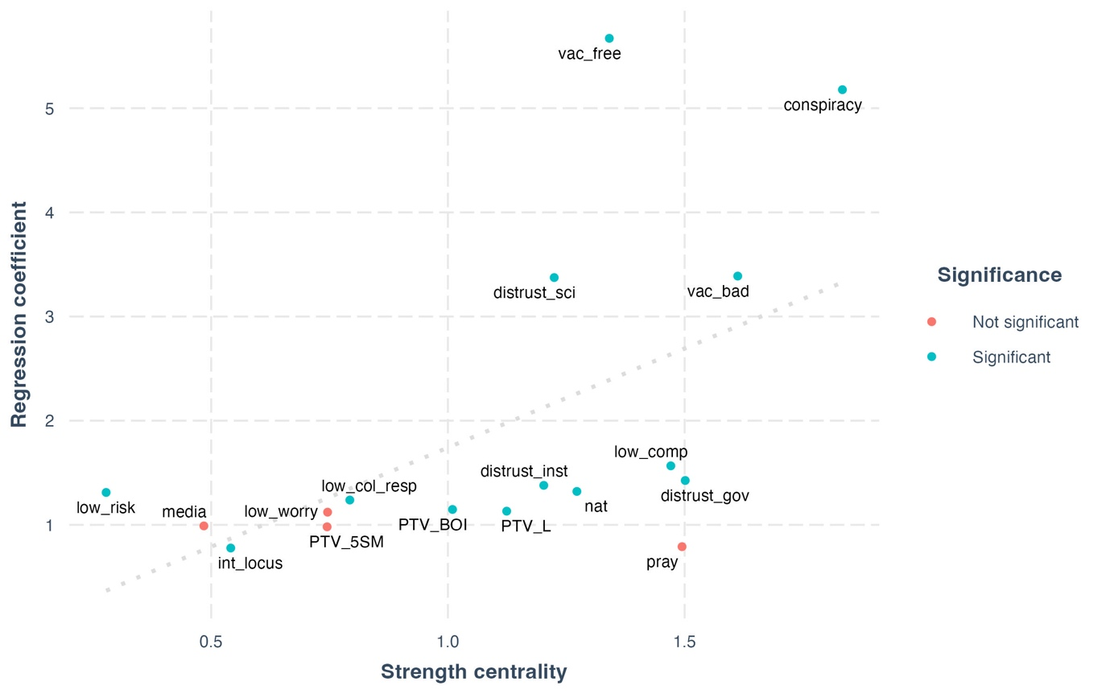
Note: Strength centrality and regression coefficients (odds ratio). Coefficients are obtained with node-wise logit (DV=hesitancy; C=sex, age, educ, rural region, economic insecurity).
Figure 4 presents a scatterplot of these two metrics. Removing the outliers (vac_free, conspiracy, distrust_sci, and vac_bad), I find that Strength and standard regression coefficients are generally not associated. This confirms that centrality metrics capture distinct structural information: strong regression predictors are not automatically central nodes in the system. However, and crucially, conspiracy has high Strength, the highest Degree, and even a strong odds ratio. Hence, both methodologies converge in suggesting its substantial role in predicting hesitancy.

Table 5 compares the empirical predictors across these four metrics: Strength, Degree, standard regression coefficients, and network edge weights. To allow for direct comparison, I report these as Z-scores, so that scores above 0 are interpretable as higher than the mean value observed among this restricted subset of empirical predictors.

Table 5: Comparison of Strength scores, regression coefficients, and edge weights
Variable | Coefficient | Edge weight | Strength | Degree | Significance
vac_free | 1.42 | 2.10 | -0.26 | -1.82 | Significant
conspiracy | 1.14 | -0.60 | 1.69 | 1.10 | Significant
vac_bad | 0.12 | 0.13 | 0.81 | -0.23 | Significant
distrust_sci | 0.11 | -0.23 | -0.72 | -0.23 | Significant
low_educ | -0.81 | -0.77 | -1.25 | -0.23 | Significant
low_comp | -0.92 | 0.12 | 0.26 | 0.30 | Significant
nat | -1.06 | -0.75 | -0.53 | 1.10 | Significant

All empirical predictors are associated with statistically significant regression coefficients, but analyzing these variables across the other metrics reveals heterogeneities. The variable measuring opposition to mandatory vaccination (vac_free) demonstrates the highest relative regression coefficient (Z = 1.42) and the strongest direct conditional edge with hesitancy (Z = 2.10). Despite this massive dyadic association, it underperforms across centrality metrics, holding the lowest relative Degree (Z = -1.82) in the group, implying it plays a marginal role in the broader complex system by interacting with few variables and with feeble overall intensity. Conversely, endorsing conspiracy theories is highly predictive of vaccine hesitancy in standard regression models (Z = 1.14) and remains highly central to the overall system, demonstrating the highest Strength (Z = 1.69) and Degree (Z = 1.10). Notably, its direct conditional edge weight to hesitancy yields a negative Z-score (-0.60), meaning that its direct, unmediated tie to hesitancy is weaker than the average of the other empirical predictors. Therefore, its true importance lies in its unmatched structural centrality and ability to bridge the system at large. The node representing the belief that vaccines are bad for health (vac_bad) features above-average scores for its standard coefficient (Z = 0.12), robust edge weight (Z = 0.13), and Strength (Z = 0.81). However, its variance is mostly explained by its proximal interaction with hesitancy and other variables strictly within its specific attitude cluster. Distrust of science (distrust_sci) presents a similar predictive profile, functioning as an above-average traditional predictor (Z = 0.11) but displaying lower relative centrality within the overall network, as reflected by its negative Z-scores for edge weight and Strength. Looking at compliance with preventive behaviors (low_comp), this variable has one of the weakest relative regression coefficients (Z = -0.92) but maintains positive Z-scores for network edge weight (0.12) and Degree (0.30), demonstrating how a traditional regression model can occasionally underestimate the unique conditional relevance of a behavioral predictor. Support for alternative medicine (nat) exhibits the weakest relative standard coefficient (Z = -1.06) alongside a below-average edge weight, yet it maintains a remarkably high Degree centrality (Z = 1.10). Finally, low education (low_educ) scores negatively across all evaluated metrics.

5 Discussion and Conclusions
This section situates the findings within the broader literature on vaccine hesitancy and shows what is gained by analysing the phenomenon through a complex systems perspective. The level of hesitancy observed here is comparable to that reported in other Italian studies fielded after the start of the vaccination campaign (Ladini & Vezzoni, 2022; Reno et al., 2021). I showed the main advantage of the Broad Attitude Network approach is holistic perspective. Rather than treating each determinant as an isolated correlate of hesitancy, these methods make it possible to examine how theoretically relevant variables are organized into a wider system. In this study, the predictors of hesitancy form a fully connected network with relatively high connectivity compared to other cross-sectional Broad Attitude Networks on COVID-19-related attitudes (Chambon, Dalege, et al., 2022). This suggests that vaccine hesitancy should not be understood as the product of a few disconnected causes, but as an outcome embedded in a dense structure of mutually related beliefs, dispositions, and orientations. Nodes also cluster in substantively meaningful ways: sociodemographic variables form the largest community, while hesitancy is located closer to more proximal vaccine-related attitudes. In addition, network predictability indicates that the variance of some nodes, especially hesitancy and conspiracy endorsement, is well accounted for by the rest of the system.
The first substantive contribution of the article is therefore not merely to enumerate predictors, but to distinguish between the broader universe of theoretically relevant variables and the smaller set of constructs that retain a direct association with hesitancy once the wider system is considered. My analyses isolate seven variables that remain directly connected to hesitancy. These results confirm the importance of proximal vaccine-specific attitudes, especially opposition to mandatory vaccination and the belief that vaccines are harmful to health. At the same time, they show that hesitancy is not reducible to a narrow medical or behavioural calculus. It is directly connected to non-compliance with preventive measures, distrust of science, reliance on alternative medicine, conspiracy endorsement, and low educational attainment. The contribution of the analysis lies precisely in showing how these factors hang together conditionally rather than simply adding one more inventory of determinants to an already crowded literature.
The second and more original contribution concerns the structural role of conspiracy endorsement within this wider attitudinal field. While hesitancy itself displays high Strength centrality, conspiracy endorsement emerges as the most connected node in the network, directly linked to approximately 70% of the other variables. This pattern suggests that conspiracy beliefs should not be interpreted merely as one predictor among many. Instead, they appear to function as a key structuring element within the broader belief system surrounding vaccine hesitancy. More specifically, conspiracy endorsement connects variables that might otherwise be studied separately, including populist orientations, distrust in institutions and science, alternative medicine, non-compliance with preventive behaviours, and negative vaccine attitudes. In this sense, the article’s central claim is not simply that conspiracy beliefs predict hesitancy, but that they help organize the broader configuration of attitudes within which hesitancy is embedded.
This point has broader implications for how vaccine hesitancy is theorized in political science. Much of the literature has approached hesitancy as a public health outcome shaped by many independent psychological, informational, and sociodemographic factors. The network reconstructed here instead suggests that hesitancy is part of a broader configuration of political distrust and belief. From this perspective, conspiracy endorsement matters not only because it has a direct tie to hesitancy, but because it bridges distinct areas of the attitudinal space and contributes to holding the system together. The relevance of conspiracy beliefs thus lies in their systemic position: they connect distrust, anti-establishment orientations, alternative epistemologies, and vaccine-related scepticism into a coherent structure.
These findings also carry implications for public policy. Standard interventions against vaccine hesitancy often rely on an information-deficit model, assuming that resistance can be reduced primarily by providing accurate information about vaccine safety and efficacy. The network perspective suggests a more cautious view. If vaccine hesitancy is embedded in a wider system of distrust and conspiratorial views, interventions targeted only at the most proximate attitudes may have limited effects. Corrective information may fail not simply because individuals lack knowledge, but because the sources producing that information are themselves perceived as untrustworthy. This does not mean that factual communication is irrelevant, but it does suggest that effective interventions should also address the broader relational and interpretive context in which hesitancy takes shape. Strategies aimed at countering generalized misinformation, relying on trusted intermediaries, and rebuilding institutional and epistemic trust may therefore be more promising than narrowly technocratic messaging alone.
At the same time, these conclusions should be interpreted in light of several limitations. First, cross-sectional applications of network approaches do not permit causal inference (Neal et al., 2022). In particular, centrality metrics should not be read as direct evidence of causal primacy (Bringmann et al., 2019b; Dablander & Hinne, 2019). Future work based on longitudinal data would be better suited to assessing temporal ordering and directional influence. Second, the analysis could not include the full theoretical universe of vaccine hesitancy predictors, and future research would benefit from theory-driven data collection specifically designed for network estimation. Third, listwise deletion substantially reduced the original sample, which complicates straightforward generalization to the Italian population. Fourth, my operationalization of conspiracy endorsement could only rely on a single item about the origins of COVID-19. Although this measure captures openness to conspiracy-related pandemic narratives, it is narrower than the validated multi-item scales commonly used in the literature to assess broader constructs such as conspiracy mentality (Imhoff & Bruder, 2014) or conspiracy beliefs (see Mancosu et al., 2025, and Mancosu et al., 2026).

Bibliography
Aw, J., Seng, J. J. B., Seah, S. S. Y., & Low, L. L. (2021). COVID-19 Vaccine Hesitancy—A Scoping Review of Literature in High-Income Countries. Vaccines, 9(8), 900. https://doi.org/10.3390/vaccines9080900
Barabasi, A.-L. (2007). The Architecture of Complexity. IEEE Control Systems, 27(4), 33–42. https://doi.org/10.1109/mcs.2007.384127
Barello, S., Nania, T., Dellafiore, F., Graffigna, G., & Caruso, R. (2020). ‘Vaccine hesitancy’ among university students in Italy during the COVID-19 pandemic. European Journal of Epidemiology, 35(8), 781–783. https://doi.org/10.1007/s10654-020-00670-z
Bertero, A. (2025). Beyond constraint: Tightness and consensus of political belief systems. Italian Political Science Review/Rivista Italiana Di Scienza Politica, 1–18. https://doi.org/10.1017/ipo.2025.10080
Bertero, A., Franetovic, G., & Mijs, J. J. B. (2024). Inequality Belief Systems: What They Look Like, How to Study Them, and Why They Matter. Social Indicators Research. https://doi.org/10.1007/s11205-024-03352-5
Borkulo, C. D. van, Borsboom, D., Epskamp, S., Blanken, T. F., Boschloo, L., Schoevers, R. A., & Waldorp, L. J. (2015). A new method for constructing networks from binary data. Scientific Reports, 4(1), 5918. https://doi.org/10.1038/srep05918
Borsboom, D., Deserno, M. K., Rhemtulla, M., Epskamp, S., Fried, E. I., McNally, R. J., Robinaugh, D. J., Perugini, M., Dalege, J., Costantini, G., Isvoranu, A.-M., Wysocki, A. C., Borkulo, C. D. van, Bork, R. van, & Waldorp, L. J. (2021). Network analysis of multivariate data in psychological science. Nature Reviews Methods Primers, 1(1), 58. https://doi.org/10.1038/s43586-021-00055-w
Bringmann, L. F., Elmer, T., Epskamp, S., Krause, R. W., Schoch, D., Wichers, M., Wigman, J. T. W., & Snippe, E. (2019a). What do centrality measures measure in psychological networks? Journal of Abnormal Psychology, 128(8), 892–903. https://doi.org/10.1037/abn0000446
Bringmann, L. F., Elmer, T., Epskamp, S., Krause, R. W., Schoch, D., Wichers, M., Wigman, J. T. W., & Snippe, E. (2019b). What do centrality measures measure in psychological networks? Journal of Abnormal Psychology, 128(8), 892–903. https://doi.org/10.1037/abn0000446
Campochiaro, C., Trignani, G., Tomelleri, A., Cascinu, S., Dagna, L., & Group, C.-19 V. S. (2021). Potential acceptance of COVID-19 vaccine in rheumatological patients: A monocentric comparative survey. Annals of the Rheumatic Diseases, 80(6), 816–817. https://doi.org/10.1136/annrheumdis-2020-219811
Caserotti, M., Girardi, P., Rubaltelli, E., Tasso, A., Lotto, L., & Gavaruzzi, T. (2021). Associations of COVID-19 risk perception with vaccine hesitancy over time for Italian residents. Social Science & Medicine, 272, 113688. https://doi.org/10.1016/j.socscimed.2021.113688
Castellini, G., Savarese, M., Leone, S., Previtali, E., Armuzzi, A., & Graffigna, G. (2020). Italian IBD Patients Coping With Covid-19 Emergency: The Mitigating Role of Psychological Readiness to Engage in Self-care. Inflammatory Bowel Diseases, 26(10), izaa185-. https://doi.org/10.1093/ibd/izaa185
Chambon, M., Dalege, J., Borsboom, D., Waldorp, L. J., Maas, H. L. J., & Harreveld, F. (2023). How compliance with behavioural measures during the initial phase of a pandemic develops over time: A longitudinal COVID‐19 study. British Journal of Social Psychology, 62(1), 302–321. https://doi.org/10.1111/bjso.12572
Chambon, M., Dalege, J., Elberse, J. E., & van Harreveld, F. (2022). A Psychological Network Approach to Attitudes and Preventive Behaviors During Pandemics: A COVID-19 Study in the United Kingdom and the Netherlands. Social Psychological and Personality Science, 13(1), 233–245. https://doi.org/10.1177/19485506211002420
Chambon, M., Dalege, J., Waldorp, L., van der Maas, H., Borsboom, D., & van Harreveld, F. (2021). Tailored interventions into broad attitude networks towards the COVID-19 pandemic [Preprint]. PsyArXiv. https://doi.org/10.31234/osf.io/fmu9w
Chambon, M., Kammeraad, W. G., van Harreveld, F., Dalege, J., Elberse, J. E., & van der Maas, H. L. J. (2022). Understanding change in COVID-19 vaccination intention with network analysis of longitudinal data from Dutch adults. Npj Vaccines, 7(1), 114. https://doi.org/10.1038/s41541-022-00533-6
Converse, P. E. (2006). The nature of belief systems in mass publics (1964). Critical Review, 18(1–3), 1–74. https://doi.org/10.1080/08913810608443650
Dablander, F., & Hinne, M. (2019). Node centrality measures are a poor substitute for causal inference. Scientific Reports, 9(1), 6846. https://doi.org/10.1038/s41598-019-43033-9
Dalege, J., Borsboom, D., van Harreveld, F., van den Berg, H., Conner, M., & van der Maas, H. L. J. (2016). Toward a formalized account of attitudes: The Causal Attitude Network (CAN) model. Psychological Review, 123(1), 2–22. https://doi.org/10.1037/a0039802
Epskamp, S. (2016). Brief Report on Estimating Regularized Gaussian Networks from Continuous and Ordinal Data. arXiv. https://doi.org/10.48550/arxiv.1606.05771
Epskamp, S., Borsboom, D., & Fried, E. I. (2018). Estimating psychological networks and their accuracy: A tutorial paper. Behavior Research Methods, 50(1), 195–212. https://doi.org/10.3758/s13428-017-0862-1
Epskamp, S., Cramer, A. O. J., Waldorp, L. J., Schmittmann, V. D., & Borsboom, D. (2012). qgraph: Network Visualizations of Relationships in Psychometric Data. Journal of Statistical Software, 48(4), 1–18.
Epskamp, S., & Fried, E. I. (2018). A Tutorial on Regularized Partial Correlation Networks. Psychological Methods, 23(4), 617–634. https://doi.org/10.1037/met0000167
Graffigna, G., Palamenghi, L., Boccia, S., & Barello, S. (2020). Relationship between Citizens’ Health Engagement and Intention to Take the COVID-19 Vaccine in Italy: A Mediation Analysis. Vaccines, 8(4), 576. https://doi.org/10.3390/vaccines8040576
Haslbeck, J. M. B., & Waldorp, L. J. (2018). How well do network models predict observations? On the importance of predictability in network models. Behavior Research Methods, 50(2), 853–861. https://doi.org/10.3758/s13428-017-0910-x
Haslbeck, J. M. B., & Waldorp, L. J. (2020). mgm: Estimating Time-Varying Mixed Graphical Models in High-Dimensional Data. Journal of Statistical Software, 93(8). https://doi.org/10.18637/jss.v093.i08
Imhoff, R., & Bruder, M. (2014). Speaking (Un–)Truth to Power: Conspiracy Mentality as A Generalised Political Attitude. European Journal of Personality, 28(1), 25–43. https://doi.org/10.1002/per.1930
King, R. D., Orhobor, O. I., & Taylor, C. C. (2021). Cross-validation is safe to use. Nature Machine Intelligence, 3(4), 276–276. https://doi.org/10.1038/s42256-021-00332-z
Kreps, S. E., & Kriner, D. L. (2023). Resistance to COVID-19 vaccination and the social contract: Evidence from Italy. Npj Vaccines, 8(1), 60. https://doi.org/10.1038/s41541-023-00660-8
Kuiper, M. E., Chambon, M., Bruijn, A. L. de, Folmer, C. R., Olthuis, E. H., Brownlee, M., Kooistra, E. B., Fine, A., Harreveld, F. van, Lunansky, G., & Rooij, B. van. (2022). A Network Approach to Compliance: A Complexity Science Understanding of How Rules Shape Behavior. Journal of Business Ethics, 1–26. https://doi.org/10.1007/s10551-022-05128-8
Ladini, R., & Vezzoni, C. (2022). When Believing in Divine Immanence Explains Vaccine Hesitancy: A Matter of Conspiracy Beliefs? Politics and Governance, 10(4). https://doi.org/10.17645/pag.v10i4.5766
Ladyman, J., Lambert, J., & Wiesner, K. (2013). What is a complex system? European Journal for Philosophy of Science, 3(1), 33–67. https://doi.org/10.1007/s13194-012-0056-8
Lauritzen, S. L. (1996). Graphical models (Vol. 17). Clarendon Press.
MacDonald, N. E. (2015). Vaccine hesitancy: Definition, scope and determinants. Vaccine, 33(34), 4161–4164. https://doi.org/10.1016/j.vaccine.2015.04.036
Mancosu, M., Bertero, A., & Vegetti, F. (2025). Measuring Belief in Conspiracy Theories Across Borders: A Cross- National Psychometric Approach. In Review. https://doi.org/10.21203/rs.3.rs-7138689/v1
Mancosu, M., Vassallo, S., Pedrazzani, A., Belluati, M., Ventura, S., Bertero, A., & Sumbul, U. (2026). Supply, Demand, and Communication of Conspiracy Theories in Comparative Perspective.
Neal, Z. P., Forbes, M. K., Neal, J. W., Brusco, M., Krueger, R., Markon, K. E., Steinley, D., Wasserman, S., & Wright, A. G. C. (2022). Annotated bibliography of critiques of psychometric network analysis. https://doi.org/10.31234/osf.io/ke6qn
Opsahl, T. (2009). Structure and Evolution of Weighted Networks. University of London (Queen Mary College), London, UK. http://toreopsahl.com/publications/thesis/
Palamenghi, L., Barello, S., Boccia, S., & Graffigna, G. (2020). Mistrust in biomedical research and vaccine hesitancy: The forefront challenge in the battle against COVID-19 in Italy. European Journal of Epidemiology, 35(8), 785–788. https://doi.org/10.1007/s10654-020-00675-8
Pivetti, M., Melotti, G., Bonomo, M., & Hakoköngäs, E. (2021). Conspiracy Beliefs and Acceptance of COVID-Vaccine: An Exploratory Study in Italy. Social Sciences, 10(3), 108. https://doi.org/10.3390/socsci10030108
Pons, P., & Latapy, M. (2005). Computer and Information Sciences—ISCIS 2005, 20th International Symposium, Istanbul, Turkey, October 26-28, 2005. Proceedings. Lecture Notes in Computer Science, 284–293. https://doi.org/10.1007/11569596_31
Prati, G. (2020). Intention to receive a vaccine against SARS-CoV-2 in Italy and its association with trust, worry and beliefs about the origin of the virus. Health Education Research, 35(6), 505–511. https://doi.org/10.1093/her/cyaa043
Priori, R., Pellegrino, G., Colafrancesco, S., Alessandri, C., Ceccarelli, F., Franco, M. D., Riccieri, V., Scrivo, R., Scavalli, A. S., Spinelli, F. R., & Conti, F. (2021). SARS-CoV-2 vaccine hesitancy among patients with rheumatic and musculoskeletal diseases: A message for rheumatologists. Annals of the Rheumatic Diseases, 80(7), 953–954. https://doi.org/10.1136/annrheumdis-2021-220059
Reno, C., Maietti, E., Fantini, M. P., Savoia, E., Manzoli, L., Montalti, M., & Gori, D. (2021). Enhancing COVID-19 Vaccines Acceptance: Results from a Survey on Vaccine Hesitancy in Northern Italy. Vaccines, 9(4), 378. https://doi.org/10.3390/vaccines9040378
Roccato, M., & Russo, S. (2023). A new look on politicized reticence to vaccination: Populism and COVID-19 vaccine refusal. Psychological Medicine, 53(8), 3769–3770. https://doi.org/10.1017/S0033291721004736
Sallam, M. (2021). COVID-19 Vaccine Hesitancy Worldwide: A Concise Systematic Review of Vaccine Acceptance Rates. Vaccines, 9(2), 160. https://doi.org/10.3390/vaccines9020160
Schoch-Spana, M., Brunson, E. K., Long, R., Ruth, A., Ravi, S. J., Trotochaud, M., Borio, L., Brewer, J., Buccina, J., Connell, N., Hall, L. L., Kass, N., Kirkland, A., Koonin, L., Larson, H., Lu, B. F., Omer, S. B., Orenstein, W. A., Poland, G. A., … White, A. (2021). The public’s role in COVID-19 vaccination: Human-centered recommendations to enhance pandemic vaccine awareness, access, and acceptance in the United States. Vaccine, 39(40), 6004–6012. https://doi.org/10.1016/j.vaccine.2020.10.059
Vecchia, C. L., Negri, E., Alicandro, G., & Scarpino, V. (2020). Attitudes towards influenza vaccine and a potential COVID-19 vaccine in Italy and differences across occupational groups, September 2020. La Medicina Del Lavoro, 111(6), 445–448. https://doi.org/10.23749/mdl.v111i6.10813
Vezzoni, C., Ladini, R., Molteni, F., Dotti Sani, G. M., Biolcati, F., Chiesi, A., Maraffi, M., Guglielmi, S., Pedrazzani, A., & Segatti, P. (2020). Investigating the social, economic and political consequences of Covid-19: A rolling cross-section approach. Survey Research Methods, 187-194 Pages. https://doi.org/10.18148/SRM/2020.V14I2.7745

This remark is further elaborated in Section 2.1, where I highlight that past research measured hesitancy as an attitude, rather than a self-reported behavior.
Health engagement is the individual proactivity in the management of health-related issues (Castellini et al., 2020).
Divine immanence is a set of religious beliefs encompassing the conviction that miracles exist, that God directly intervenes in our lives, and that prayer can heal illnesses.
In the remainder of the article, nodes are denoted in italics
Individuals are split randomly into 90 groups, which are invited to fill in the questionnaire on different days. In this way, time becomes a random variable, and data can be analyzed cross-sectionally (by aggregating the 90 sub-samples) or longitudinally (e.g., by computing moving averages). The potential of RCS is not exploited by this paper, which investigates vaccine hesitancy cross-sectionally.
These parties are labeled as populist in the Chapel Hill Expert Survey.
This eases the interpretation of the network model, without changing its statistical properties. For example, the polarity of the variable “educational level” is inverted, and the item is renamed as “Educational level, low”.
Note that the polarity of the age variable is reversed in the analysis. Table 2 shows the original value of this variable to facilitate its interpretation.
I avoid fitting regression models where control variables predict hesitancy, because the size of these model will be smaller of one covariate with respect to the other 17. This would bias the direct comparison of the coefficients.

