Conspiracy theories are central to the complex system of predictors of Italian vaccine hesitancy

Abstract
Vaccines against COVID-19 are available worldwide, but their uptake is hampered by vaccine hesitancy. The determinants of this skepticism received copious empirical attention. Researchers have identified more than 50 predictors of this behavior. However, these determinants have been identified through a reductionist approach, studying the pairwise interactions hesitancy has with other variables. Moreover, the abundance of these factors can hinder the design of effective interventions. To overcome these limitations, we adopt a complex systems approach to study vaccine hesitancy in Italy, where hesitation rates are among the highest in the world. We adopt a mixed graphical model that renders survey variables as nodes of a network whose weighted, undirected edges are estimated from real data and are indicative of their linear influences. Results reveal that endorsing conspiracy theories plays a fundamental role in this system, as this variable is tied to almost 70% of the other predictors. Finally, we isolate a restricted list of empirical predictors that can help policymakers willing to implement intervention strategies.

Keywords: Broad Attitude Network, Complex System, Vaccine Hesitancy, Italy

Please use colors for every figure in the manuscript and in the supplemental materials.

1 Introduction
In December 2019, Chinese authorities communicated that a new virus called COVID-19 was detected in Wuhan, in the province of Hubei. The disease rapidly expanded, leading the World Health Organization [WHO] to officially declare the outbreak of a pandemic on March 11, 2020. WHO recommended the adoption of preventive behaviors to cope with the pandemic, such as wearing face masks and maintaining social distancing. Despite the relevance of individual compliance to preventive behaviors and the implementation of adequate national-level policies, both strategies are insufficient to deal with such a highly infectious disease. Therefore, vaccines are crucial to react against the virus and were rapidly developed worldwide (Schoch-Spana et al., 2021). Nevertheless, a growing number of individuals are skeptical of them. Vaccine hesitancy is a “delay in acceptance or refusal of vaccination despite the availability of vaccination services” (MacDonald, 2015, p. 4163). Already in 2019, WHO considered vaccine hesitancy as one of the top ten threats to global health. COVID-19-related vaccine hesitancy is massively diffused worldwide, and it is more pronounced in high-income countries (Aw et al., 2021; Sallam, 2021). Hesitancy was largely investigated, and precious systematic reviews are already available (ibid.).
However, past research has adopted a reductionist approach, studying hesitancy as determined by its pairwise interactions with a large set of predictors. As a consequence, scholars have identified more than 50 determinants of this behaviors (Aw et al., 2021), and policymakers may find it difficult to design effective interventions. Moreover, a reductionist approach overlooks the associations occurring between these predictors, neglecting an important part of the picture. To overcome these limitations, this article adopts a complex system approach in which vaccine hesitancy is framed as a multifaceted social and political problem emerging from the intricate lower-level relationships between its predictors. Methodologically, this paper relies on a graphical model imported from network psychometrics in which survey items are rendered as network nodes. These vertices are tied by weighted and undirected edges that are estimated from real data, and that correspond to negative or positive linear influences between the selected survey variables. This approach is based on the Causal Attitude Network [CAN] model, which was mostly applied to the measurement of single attitudes (Dalege et al., 2016). Recently, CAN was extended to study compliance with preventive behaviors against COVID-19 (Chambon et al., 2021; Chambon, Dalege, et al., 2022; Chambon et al., 2023; Kuiper et al., 2022) and vaccine intentions (Chambon, Kammeraad, et al., 2022). These “Broad Attitude Networks” expand CAN’s framework to encompass non-attitudinal variables, since their inclusion is fundamental for the understanding of vaccine hesitancy. By leveraging this new methodological approach, we zoom out from the dyadic interactions between hesitancy and its predictors. This allows us to reconstruct the web of determinants of vaccine hesitancy, and to isolate a restricted list of the most important variables contributing to its emergence in Italy.

This study constitutes the first application of a complex system approach to the study of vaccine hesitancy. We choose Italy as a case study since this country has hesitancy rates among the highest in the world (Sallam, 2021). Moreover, Italian vaccine hesitancy was also extensively investigated by scholars adopting narrower approaches. Engaging with their findings will allow us to gauge the strength of the new method. Section 2 presents an overview of the theoretical predictors of vaccine hesitancy and explains the advantages of a complex system approach. In Section 3 we present data, methods, and the analytical strategy of this paper. In the Results Section, we describe the Broad Attitude Network, and we identify a list of empirical predictors of vaccine hesitancy. These variables are those on which public policies are suggested to focus. In the Discussion, we compare our findings with those obtained with alternative methodologies, and we show that our approach generates new knowledge on this phenomenon. The Conclusions specify the strengths and limitations of this work.

2 Background

2.1 Theoretical predictors of vaccine hesitancy
Between 2020 and 2023, a plethora of studies sought to isolate the determinants of vaccine hesitancy. Macro-level studies highlight that vaccine hesitancy is more pronounced in wealthy countries (Aw et al., 2021; Sallam, 2021). Micro-level studies have established a wealth of predictors of this behavior. A valuable scoping review identified more than 50 predictors and classified them into Contextual, Individual, and Vaccine-related categories (Aw et al., 2021). Table 1 presents a relevant selection of these items. Section 1 of Supplement S1 covers these predictors in more detail, and the interested reader is advised to consult Aw et al. (2021) for an exhaustive list.
Table 1: Theoretical predictors of vaccine hesitancy worldwide
Contextual | Individual | Vaccine-related
Political inclination: far right | Worry about COVID-19 | Belief that vaccines are unsafe
Political inclination: populist | Low risk perception | Opposing to mandatory vaccination
Distrust of institution | Endorsing conspiracy theories | Concerns about rapid development
Distrust of government | Trust in alternative medicine | Fear of needles
Religiosity | Internal health locus of control
Digital media diet | Low compliance with COVID-19 preventive behaviours
Sex, female | Distrust of health system
Lower age | Distrust of science
Lower education | Lesser sense of collective responsibility
Lower income
Living in a rural region
Source: selected from Aw et al., 2021.

This topic is also largely investigated in Italy (Aw et al., 2021) where hesitancy rates are among the highest in Europe (Sallam, 2021). Indeed, between 2020 and March 2023, more than twelve papers have explored the Italian determinants of vaccine hesitancy. All these studies are based on survey methodology. Since vaccine hesitancy is a behavior that can only emerge with the availability of vaccines, it is important to distinguish between studies fielded before and after the Italian vaccine day (December 27, 2020), as only the latter can study hesitant behaviors, following the definition proposed by the SAGE working group (MacDonald, 2015). The former can only investigate vaccine intentions, which are general attitudes toward an upcoming vaccine.
One of the earliest research on the topic analyzes a convenience sample of 735 Italian students, showing that 13% of them have skeptical vaccine intentions (Barello et al., 2020). Another work finds that vaccine intention is negatively correlated with worry about infection and trust in institutions, and negatively correlated with endorsement of conspiracy theories (Prati, 2020). A study conducted in September 2020 captures a striking level of negative vaccine intentions, with nearly 45 percent of the sample describing the rejection of a potential COVID-19 vaccine as likely or certain (Vecchia et al., 2020). Another research group investigates the willingness to undertake COVID-19 vaccines of oncological and rheumatological patients, finding no statistically significant differences between the two groups (Campochiaro et al., 2021). Other surveys study attitudes towards vaccination longitudinally. By sampling college students in a repeated cross-sectional design, Caserotti and colleagues illustrate that negative intentions toward vaccines increased immediately after the end of the Italian lockout and that low-risk perception and negative attitudes toward vaccines predict greater skepticism (Caserotti et al., 2021). An additional repeated cross-sectional relies on two waves fielded during and immediately after the Italian lockdown (Palamenghi et al., 2020). This study confirms that individuals who trust science and have a high perception of the risk of COVID-19 consequences are unlikely to oppose vaccination. Finally, two studies examine vaccine intention with Path analysis and Structural Equation Modeling. One of these articles deals with the relationships between health engagement, risk perception, and attitudes toward vaccines (Graffigna et al., 2020). Health engagement predicts negative vaccine intentions; this association is only partially mediated by the general attitudes toward vaccines. In contrast, risk perception and perceived COVID-19 severity only weakly predict skepticism. The Structural Equation Model of the second paper confirms that conspiracy theory adherence, low trust in science, and negative attitudes toward vaccines lead to increased skepticism toward a potential COVID-19 vaccine (Pivetti et al., 2021).
To our knowledge, only three Italian studies analyze vaccine intentions in the presence of an already-developed COVID-19 vaccine. Low-risk perception, being woman, low levels of education, and income are confirmed as predictors of hesitancy in a representative sample of the Emilia Romagna Italian region (Reno et al., 2021). Interestingly, the effect of age is confined to one particular cohort, with those aged 35 to 54 less willing to undertake vaccination. Another medical study investigates the levels of vaccine hesitancy among patients with rheumatic and musculoskeletal diseases (Priori et al., 2021). The authors isolate female sex, low education, and lower age as predictors. Finally, Ladini and Vezzoni (2022) reconfirm the importance of endorsing conspiracy theories and find that belief in divine immanence is associated with higher levels of hesitancy. Moreover, they reveal that both relationships are mediated by institutional religiosity - that is, the level with which an individual is integrated into religious institutions.
This Section briefly reviewed the literature on the determinants of vaccine hesitancy, focusing on the Italian context, where a substantial portion of the literature has studied attitudinal rather than self-reported behavioral data. Researchers found more than 50 predictors and highlighted their heterogeneity. However, most research groups adopted a reductionist approach, trying to explain hesitancy rates through the examination of pairwise relationships between single predictors and this behavior. The next section argues that adopting a complex systems approach can help overcome this narrow outlook.

2.2 Complex system approach
Vaccine hesitancy is a complex social phenomenon that emerges from the interplay of social, political, and psychological variables. Scholars have identified more than 50 predictors of this behavior. However, researchers have mainly followed a reductionist approach, studying these variables in isolation. As a consequence, little is known about the between-predictors relationships, and about whether the identified dyadic interactions are robust to a wider set of control variables. Investigation of this research question requires a complex systems approach (Barabasi, 2007). Applying this framework, vaccine hesitancy is shaped by an intricate set of dependencies among multiple and heterogeneous variables. The key idea of a complex system approach is that studying twofold associations between variables is not sufficient for the full understanding of the whole system, whose overall state is determined by the interactions occurring between its components (Ladyman et al., 2013).
This paper adopts an extension of the Causal Attitude Network [CAN] model, which aims at measuring a single attitude as a network of connected evaluative reactions (Dalege et al., 2016). CAN conceptualizes an attitude as a higher-level construct that emerges from interactions among lower-order entities, which can be measured through standard attitudinal survey questions. CAN renders survey items as nodes of a network and estimates their conditional associations. These associations are represented as weighted, undirected network edges indicative of the influence between evaluative reactions forming the attitude network. However, CAN is not suited to address the complexity of the network of determinants of vaccine hesitancy, which is not only attitudinal in kind. Therefore, this paper adopts a “Broad Attitude Network” model, in which nodes can be single attitudes, sociodemographic variables, or self-reported behaviors (Chambon, Dalege, et al., 2022). This framework allows us to examine a wider set of variables, and to reconstruct the multivariate relationships existing between the theoretical predictors of hesitancy we discussed in Section 2.1.
Network estimation of multivariate data is implemented through graphical models. Broad Attitude Networks are based on a special type of graphical model called Pairwise Random Marokv Fields [PMRF] (Lauritzen, 1996). The edges of a PMRF are indicative of the unique variance shared by pairs of network nodes. Accordingly, two nodes are connected if -after controlling for each other variable in the model- they are still conditionally dependent. Conversely, nodes of a PMRF are untied only if conditionally independent after conditioning on every other variable. Attitude networks can be estimated from dichotomous (Borkulo et al., 2015), continuous (Epskamp, Waldorp, et al., 2018), and mixed data types (Haslbeck & Waldorp, 2020). As detailed in Section 3.4, this paper adopts the latter type of network estimation to accommodate a mixed data format.
Figure 1 reports a simplified Broad Attitude Network related to COVID-19 vaccine hesitancy. Nodes represent survey questions. An edge is interpretable as the linear influence between two variables, controlling for all other variables in the model. Blue edges represent positive linear influences, red negative ones. Edge width is proportional to the strength of the associations. In this simplified example, the nodes low-risk perception, distrust in institutions, vaccines are unsafe, positively interact with hesitancy. The strongest association is between hesitancy and low-risk perception. Moreover, low-risk perception is negatively correlated with both vaccines are unsafe and distrust in institutions, even after controlling for the other variables in the model. These relationships imply that the state of vaccine hesitancy will likely align with the state of the other nodes. Therefore, an individual expressing low levels of risk perception, distrust of institutions, and negative attitudes toward vaccines is likely to be hesitant toward vaccine undertaking. Furthermore, in this trivial example, individuals who have negative attitudes toward vaccines should perceive the threat of COVID-19 infection as less severe. These two variables are negatively related, meaning that their status is possibly misaligned at the population level.
Figure 1: Example of a Broad Attitude Network
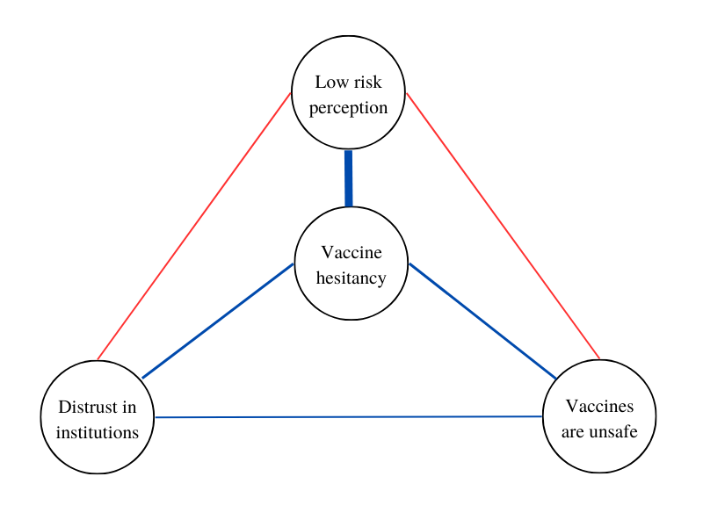
Note: Example of Broad Attitude Network. Vaccine hesitancy is part of a web of predictors, which are represented as nodes. Connections represent positive (blue) or negative (red) linear influences; their importance is reflected in the edges’ width.

3 Data and methods
This section describes the methodological features of the current study. Both the Methods and Results sections follow reporting standards for psychological network analyses in Cross-Sectional Data (Burger et al., 2022).

3.1 Analytical strategy
This section outlines the rationale of the present work. First, we select a subset of the theoretical predictors of vaccine hesitancy discussed in Section 2.1. Next, we combine variables coming from three survey batteries in mean indexes. This is done to avoid strong associations between answers provoked by the same stimulus, which would constitute an instrument effect. We compute mean indexes for variables regarding institutional trust, judgments on the Italian government, and variables tapping compliance to preventive behaviors. Details are provided in Section 2 of Supplement S1. Second, we retrieve the multivariate associations between these determinants and hesitancy itself. We do this by estimating a Broad Attitude Network, a complex system built upon the interactions of the selected variables. Since the edges are model parameters estimated through regularized regressions with an extensive set of control variables (see Section 3.4), this represents the first level of information reduction. Third, we apply standard network analysis techniques to the network, to describe its structural characteristics. After this, we reduce the Broad Attitude Network to its backbone. The backbone of a network is a sparse and unweighted subgraph that preserves the structural features of the original one but includes only the most relevant edges (Neal, 2022). This represents the second layer of information reduction. Finally, variables that are (1), directly tied to hesitancy in the network model and, (2) retained in the backbone will be labeled as empirical predictors of vaccine hesitancy in Italy.

3.2 Data and sample
The estimation of a moderate-size (20-30 variables) broad attitude network requires at least 500 participants (Borkulo et al., 2015). Regardless of our innovative methodological approach, we contribute to the Italian literature on vaccine hesitancy by working on a survey fielded after the start of the Italian vaccination campaign: wave three of ResPOnsE data, an Italian dataset endowed with a Rolling Cross Sectional [RCS] design (Vezzoni et al., 2020; Biolcati et al., 2021). The sample is obtained with quotas for the area of residence, gender, and age group, and it is gathered by an online panel from a commercial research institute (SWG SpA). Note that quotas cover an important selection of sociodemographic determinants of vaccine hesitancy. Wave three was fielded between March 17 and June 16, 2021, through a multipurpose CAWI questionnaire mostly focusing on the pandemic. Due to the skip structure of the questionnaire, only a subsample of 3767 respondents can answer all the variables featured in this research. This is documented in Section 1 of Supplement S2. Listwise deletion reduces the sample to 1.540 units.

3.3 Survey
Table 2 shows the survey questions and response options for each variable. Data cover all categories of theoretical predictors presented in Section 2.1. Thirteen contextual determinants are examined, through variables tapping distrust of institutions, science, and government; three variables measure respondents’ populist political inclinations (high propensity to vote for the 5 Star Movement, Brothers of Italy, and the League); finally, the analysis includes self-reported frequency of prayer attendance, the prevalence of a digital media diet, and sociodemographic variables (sex, age, education, rural area of residence, economic insecurity). Seven individual determinants are included, with variables measuring compliance to preventive behaviors against COVID-19, the level of collective responsibility, internal health locus of control, worry for infection, risk perception, and approval of alternative medicine. The research also includes endorsement of conspiracy theories. Respondents were asked about the origins of the virus, having to indicate whether they thought COVID-19 originated from a transition from animals to humans, from the US-China war for world supremacy, or a flawed scientific experiment. Respondents who chose the second and third options are considered to hold conspiracy theories about the origin of the virus. Finally, two items regard general attitudes toward vaccines: the belief that vaccines are unsafe and the preference for a mandatory vaccination policy. The polarity of each variable is aligned to have high values of predictors associated with high values of hesitancy.

Vaccine hesitancy is obtained by combining two variables. One asks the respondent to indicate whether s/he already had a dose of vaccine; another surveys vaccine intention (“What is your intention regarding the administration of the COVID-19 vaccine?”). Response modes are "I will surely vaccinate", "It is quite likely that I will vaccinate", "It is unlikely that I will vaccinate", and "Certainly I will not vaccinate". Hesitancy is constructed as a dummy variable where individuals already vaccinated, or those saying they will “surely” and “likely” get a dose were coded with “0”. Hesitancy scores “1” if an individual says that s/he is not vaccinated and that s/he is not likely, or certainly not oriented, to undertake it.

3.4 Network methodology and network measures
Relying on the existing literature adopting the Broad Attitude Network approach to study the vaccine intention (Chambon, Kammeraad, et al., 2022) and compliance with preventive behaviors related to COVID-19 (Chambon et al., 2023), this paper applies a Mixed Graphical Model [mgm] (Haslbeck & Waldorp, 2020). This model is often applied in network psychometrics and can deal with the heterogeneity of variable types characterizing this research. The between-person network of determinants is obtained through a loop of node-wise regularized regressions. The mgm iteratively regresses each node on each other, including all remaining variables as controls. This produces two estimates per edge (e.g.: one when node X₁ predicts node X₂ and one when X₂ predicts X₁, controlling for the other variables). Coefficients are then averaged and become the edge weights of the network model. Each of these regressions requires dealing with a vast set of covariates, among which colinearity is likely to arise. To avoid it, mgm employs LASSO regularization in combination with cross-validation. Regularization is commonly used in network estimation since it reduces the size of the statistical model, minimizes the risk of including spurious relationships in the analysis, and enhances the interpretability of the network plot (Borsboom et al., 2021; Epskamp, 2016; Epskamp & Fried, 2018). Unlike linear regression, the goal of regularized regression is not to find the coefficients that minimize the sum of squared differences between the predicted values and the actual values of the target variable. In LASSO regularization, an additional penalty term is introduced. The tuning parameter lambda (λ) controls the amount of regularization applied. When λ is set to zero, LASSO regularization has no effect, and the model is mathematically equivalent to a linear regression. As λ increases, the penalty term becomes more significant, and it shrinks the coefficient estimates toward zero. Therefore LASSO regularization induces sparsity in the coefficient estimates and thus, in the resulting network matrix. As λ increases, the LASSO penalty starts to force some coefficients to become exactly zero, effectively performing variable selection. This means that LASSO can identify and exclude irrelevant covariates from the regressions composing the model. The appropriate value of the tuning parameter is obtained through k-fold cross-validation with k = 10 (both default settings in the mgm package). Cross-validation is a robust methodology used to evaluate the performance of machine learning models, and its application has been encouraged also outside of this realm (King et al., 2021). It involves dividing a dataset into multiple subsets and using one fold as a validation set while training the model on the remaining folds. Hence, the sample is divided into 10 subsets, the model is trained on 9 of these, and evaluated on the remaining “fold”. This process is repeated 10 times, with a different subset used as the validation set each time. The performance of the model is then averaged across the iterations and informs the choice of the appropriate tuning parameter (Haslbeck & Waldorp, 2020). Finally, we explore the predictability of each node, that is the portion of its variance that is explained by the connections it has with other variables. We do this graphically by coloring the border of each node with a pie plotting its predictability (Haslbeck & Waldorp, 2018). For variables modeled as continuous, we show R². For categorical variables -involved in logistic regressions- we examine two other measures: the accuracy of the intercept model and the additional accuracy. The first assesses the predictability of a node based on its simple frequency distribution. The second specifies how much variance the other variables in the model can explain in addition to the accuracy of the intercept. The interested reader is suggested to consult the work of Haslbeck & Waldorp for a detailed discussion (2018).

Analyses are conducted in R and are fully reproducible with the script provided in Supplement S2. Network estimation is carried out with the mgm package (Haslbeck & Waldorp, 2020). The resulting weighted adjacency matrix is made available in Section 6 of Supplement S1. Network visualization and node centrality estimation rely on qgraph (Epskamp et al., 2012). The peculiar nature of psychological networks forces researchers to adopt either Degree or Strength as a measure of centrality (Bringmann et al., 2019). Degree centrality counts the number of ties in which a node is involved. Strength is the operationalization of degree centrality for weighted networks, and is equal to the absolute sum of all edge weights of a node’s ties (Opsahl et al., 2010). Strength and Degree are extensively commented in the article, and we provide their exact values in Section 4 of Supplement S2. Network communities are detected with one thousand iterations of the Walktrap community algorithm, performed on the absolute weighted adjacency matrix (Pons & Latapy, 2005). Section 5 of Supplement S2 shows the results of the iterations and their final average. Connectivity is measured by the weighted Average Shortest Path Length (Opsahl et al., 2010), and calculated with tnet (Opsahl, 2009). The procedure starts by calculating all the geodesic distances between network nodes; then, distances are normalized by the average weight of network ties; finally, we calculate the mean of normalized distances. The backbone of the network is extracted with the backbone package, which is applied to the absolute weighted adjacency matrix (Neal, 2022). Stability and robustness analyses are performed with bootnet (Epskamp, Borsboom, et al., 2018), and are made available in Section 9 of Supplement S1. Additional robustness checks are available in Section 10 of Supplement S2, where we show that randomizing the sample in two partitions and re-estimating the networks leads to small changes in edge weights and centrality metrics.

Table 2: Variables included in the analysis and their survey questions
Name | Question | Scale
Vaccine hesitancy | Obtained combining: “Have you already received the COVID-19 vaccine?”; “What is your intention regarding the administration of the COVID-19 vaccine? | 0 (not hesitant) to 1 (hesitancy)
Vaccine bad for health | Vaccines wear down the immune system and expose it to various diseases | 1 (disagree) to 5 (agree)
Against mandatory vaccination | Vaccination against COVID-19 must be compulsory for everyone. | 1 (disagree) to 5 (agree)
Low worry about infection | In the last 7 days, have you been concerned about the possible consequences of the Coronavirus for your health? | 0 (less than three times) to 1 (three times or more in a week)
Low risk perception | Do you personally feel that you are more or less exposed to contagion than the majority of the population in your area? | 1 (more) to 5 (less exposed)
Endorsing conspiracy theories | What do you think is the most likely origin of the virus? | 0 (transition from animals to humans) to 1 (US-China war for world supremacy; Wrong scientific experiments)
Trust in alternative medicine | More space should be given to natural healing methods | 0 (disagree) to 10 (agree)
Internal health locus of control | How much do you think Italians with their own behaviors are responsible for the pandemic’s course? | 0 (not responsible) to 10 (responsible)
Low sense of collective responsibility | Faced with the Coronavirus crisis, governments may react in different ways. A government may prioritize reducing Coronavirus infections, even at the cost of causing a serious economic crisis for the country. Or a government may prioritize defending the national economy, even at the cost of increasing the number of infections. Where would you place your opinion? | 0 (health) to 10 (economy as a priority)
Propensity to vote for L | Among the various parties we have in Italy, each would like to have your vote in the future. Regardless of how you plan to vote in the next election, how likely are you to vote for the League in the future? | 0 (not likely) to 10 (likely)
Propensity to vote for 5SM | Among the various parties we have in Italy, each would like to have your vote in the future. Regardless of how you plan to vote in the next election, how likely are you to vote for the the Five Star Movement in the future? | 0 (not likely) to 10 (likely)
Propensity to vote for BOI | Among the various parties we have in Italy, each would like to have your vote in the future. Regardless of how you plan to vote in the next election, how likely are you to vote for Brothers of Italy in the future? | 0 (not likely) to 10 (likely)
Distrust of science | When it comes to vaccines, the recommendations of the scientific community can be trusted | 0 (agree) to 5 (disagree)
Religion, pray | In the last week, how often did you pray? | 0 (never) to 1 (more than -or once a- day; more than -or once a- week)
Digital media diet | Mainly, where do you get the most information about the Coronavirus crisis from? | 0 (non-digital media) to 1 (digital media)
Sex, female | Could you report your sex? | 0 (man) to 1 (female)
Age, young | Could you report your age? | 88 (min) to 18 (max)
Education level, low | Could you report your educational level? | 0 (more than high school) to 1 (less than high school)
Living in a rural region | Could you indicate how many people reside in your township? | 0 (more than 30K) to 1 (less than 30K)
Economic insecurity | Your household’s income allows you yo live… | 0 (comfortably; easily) to 1 (with some difficulties; we don't make ends meet)
Low compliance with preventive behaviors | Obtained combining: To what extent do the following sentences correspond to your behavior over the past seven days? “I stayed at least three feet away from other people”; “I wore a mask and/or gloves”; “I washed and sanitized my hands often” | 0 (high) to 10 (low compliance)
Disapproval of Government | Obtained combining: “What is your assessment of the measures imposed by the government to stop the spread of COVID-19?”; “How do you assess the actions of the Draghi government during the COVID-19 emergency?” | 0 (positive) to 10 (negative evaluation)
Distrust of institutions | Obtained combining: What degree of trust do you give to the following institutions? “The Italian parliament”; “The European Union” | 0 (low) to 10 (high trust)

4 Results
This section describes the results obtained through the Broad Attitude Network approach. Descriptive statistics reported in Table 3 show that 20% of respondents are hesitant toward COVID-19 vaccines. The sample is balanced in terms of gender (50% of women), and the mean age is 47 years old. Levels of self-reported compliance with preventive behaviors against COVID-19 are remarkably high (M = 8.7; SD = 1.8). Relatively low rates of hesitancy are not mirrored in the general attitudes toward vaccines, which remain more negative on average (vac_bad: M = 2.1; SD = 1.2).
Table 3: Descriptives of selected variables
Variable (label) | Mean | St.Dev. | Min | Max | N
Vaccine hesitancy (hesitancy) | 0.2 | 0.4 | 0 | 1 | 1540
Vaccine bad for health (vac_bad) | 2.1 | 1.2 | 1 | 5 | 1540
Against mandatory vaccination (vac_free) | 2.4 | 1.3 | 1 | 5 | 1540
Low worry about infection (low_worry) | 0.7 | 0.5 | 0 | 1 | 1540
Low risk perception (low_risk) | 3.2 | 0.8 | 1 | 5 | 1540
Endorsing conspiracy theories (conspiracy) | 0.5 | 0.5 | 0 | 1 | 1540
Trust in alternative medicine (nat) | 4.1 | 3.2 | 0 | 10 | 1540
Internal health locus of control (int_locus) | 6.5 | 2.6 | 0 | 10 | 1540
Low sense of collective responsibility (low_col_resp) | 4.9 | 2.6 | 0 | 10 | 1540
Propensity to vote for L (PTV_L) | 2.6 | 3.3 | 0 | 10 | 1540
Propensity to vote for 5SM (PTV_5SM) | 2.7 | 3.3 | 0 | 10 | 1540
Propensity to vote for BOI (PTV_BOI) | 2.5 | 3.5 | 0 | 10 | 1540
Distrust of science (distrust_sci) | 2.3 | 1.2 | 1 | 5 | 1540
Religion, pray (pray) | 0.6 | 0.5 | 0 | 1 | 1540
Digital media diet (media) | 0.5 | 0.5 | 0 | 1 | 1540
Sex, female (female) | 0.5 | 0.5 | 0 | 1 | 1540
Age, young (young) | 47.3 | 14.9 | 18 | 88 | 1540
Education level, low (low_educ) | 0.6 | 0.5 | 0 | 1 | 1540
Living in a rural region (rural) | 0.4 | 0.5 | 0 | 1 | 1540
Economic insecurity (eco_insec) | 2.5 | 0.6 | 1 | 4 | 1540
Low compliance with preventive behaviors (low_comp) | 1.3 | 1.8 | 0 | 10 | 1540
Disapproval of Government (distrust_gov) | 4.4 | 2.3 | 0 | 10 | 1540
Distrust of institutions (distrust_inst) | 5.5 | 2.5 | 0 | 10 | 1540

4.1 Network estimation
Network estimation results are presented in Figure 2. Edges indicate relationships between two items, after conditioning on every other node in the model. Blue edges represent positive linear influences, red negative ones. Edge width is proportional to the strength of the associations. The web of predictors of hesitancy forms a fully connected network. Hesitancy is plotted as a box to enhance interpretability. Note that the status of this variable is not special for the model, since network estimation is obtained by regressing each variable iteratively on each other. Figure 2 reveals that most of the variables are not directly connected to hesitancy. This represents the first layer of information reduction, as not all empirical predictors are confirmed to interact directly with it. However, the Weighted Average Shortest Path Lenght scores 1.56. A unit of distance refers to one step with the average weight in the network. Therefore, this value suggests that on average nodes are 1.56 steps with average tie weight away from each other. This also implies that, on average, every predictor can impact hesitancy rapidly. Indeed, most of the nodes that are not directly connected to hesitancy (e.g., distrust_gov) can usually reach it through the intermediation of an additional node only (e.g., from distrust_gov to either conspiracy or distrust_sci and from these to hesitancy).

The border of each node shows its predictability, which is a measure that captures how much of its variance is explained by its connections to other variables in the complex system. We compute R² for continuous variables, and we visualize it with blue-colored borders. For categorical variables we show the accuracy of the intercept model (orange) and the additional accuracy provided by the other neighboring nodes (red); the sum of the two represents the overall predictability of categorical nodes. We observe drastic variations in predictability. The nodes hesitancy and conspiracy have high accuracy of the intercept model. However, other variables are important for their predictability, as testified by the red portion of their borders. The variance of these variables is remarkably captured by the complex system, as testified by the small white portion of their borders. In contrast, other categorical variables such as low_worry and rural have greater unexplained variance, mainly because the other nodes do not interact significantly with them. Variation persists among continuous variables. Nodes dealing with attitudes towards vaccines (vac_free and vac_bad) are deeply embedded in the network and thus have high R². In contrast, the predictability of other nodes, such as low_risk and eco_insec, is lower, mainly because of their weak interactions with other predictors.

Figure 2: Broad Attitude Network of vaccine hesitancy in Italy
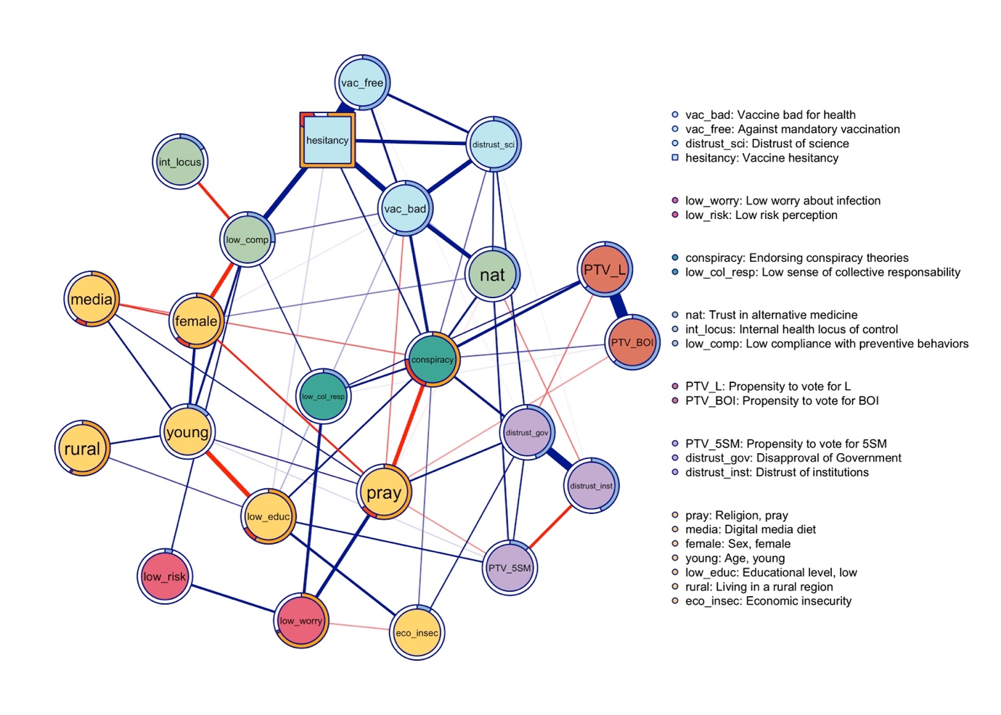
Note: Circular nodes represent 22 theoretical predictors of vaccine hesitancy, which is plotted as a box. Edges represent statistical relationships between nodes that are present even after controlling for each other item. Blue [red] edges represent positive [negative] linear influences. Edge width is proportional to the strength of each tie, and edge weights below .06 are omitted from the network plot to improve readability. Node colors indicate network community membership. Node borders indicate the predictability of the variance of each node.

4.2 Communities
Network communities are subsets of nodes that are more likely to interact together than with others. Therefore, communities provide insights into the clustering of the predictor of hesitancy. In Figure 2, communities are highlighted in different colors. Seven communities are detected. Vaccine hesitancy clusters together with negative attitudes toward vaccines, preference for non-mandatory vaccination, and distrust of science (light blue). This community comprehends all variables directly related to the COVID-19 vaccine (vac_bad, vac_free, and hesitancy). Self-reported compliance, internal locus of control, and support for alternative medicine form a second cluster (light green). The node conspiracy clusters with low collective responsibility, forming the dark green cluster. The political cluster (orange) gathers rightist political preferences (PTV_L and PTV_BOI). Risk perception and worry about COVID-19 infection belong to the red community. Interestingly, PTV_5SM cluster together with distrust of institutions and disapproval of government (purple) and the yellow cluster is composed of all sociodemographic variables (sex, age, rural area, economic insecurity, and education) plus the nodes pray and media.

4.3 Centrality
Centrality measures the relative importance of network nodes. Table 3 below lists Strength centrality scores. Hesitancy emerges as the most central node in the network. The table shows that conspiracy is second according to the Strength metric. However, point estimates do not consent to compare directly the centrality of these two nodes. A bootstrapped difference test reveals that the difference is statistically significant (bootstrapped CI 0.14 - 1.05). Additional information is obtained by investigating the determinants of the high centrality of these nodes. The node hesitancy is involved in strong relationships with a restricted number of other nodes (see Table 4). Conspiracy follows the opposite pattern because its high values of Strength are determined by a vast number of ties, rather than by their high intensity. Indeed, conspiracy records an impressive value of Degree centrality, being connected to 15 out of 22 nodes. Degree centrality scores are provided in Section 4 of Supplement S1. Sociodemographic variables have moderate (pray, young, and eco_insec) to low (female, low_educ, media, and rural) Strength. The centrality of low_comp is moderately high. Finally, Table 3 negatively highlights low_risk and low_worry, which are both peripheral in the network.

Table 3: Strength centrality table
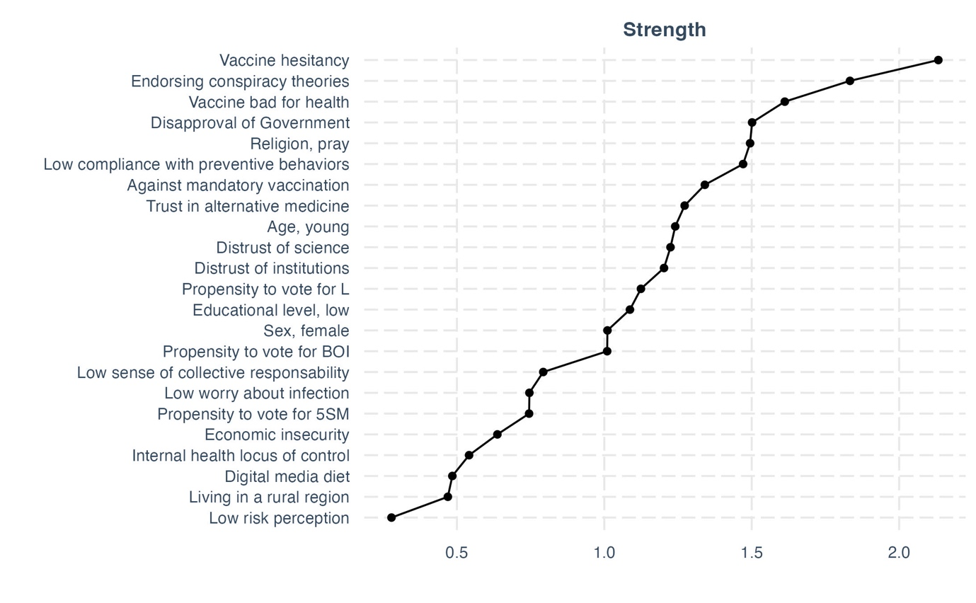

4.4 Relevant network edges
The strongest edges in the network are those between hesitancy and vac_free (edge weight = 0,95), PTV_L and PTV_BOI (0,71), distrust_inst, and distrust_gov (0,50). Moreover, Figure 2 highlights other connections of moderate intensity (edge weights between 0,34 and 0,20). Negative attitudes toward vaccines are positively correlated with vaccine hesitancy (0,34), endorsing conspiracy theories (0,20), distrust of science (0,30), and support for alternative medicine (0,28). Male gender is associated with reduced compliance to preventive behaviors (0,27), and this is in turn related to increased hesitancy (0,34). The relationships with which conspiracy is involved are also worthy of attention. Importantly, this node is directly tied to hesitancy, and it is also involved in meaningful relationships with the other nodes clustering with it (vac_bad, and distrust_sci). Additionally, conspiracy is positively related to a higher propensity to vote for rightist populist parties (PTV_BOI, PTV_L), and to all trust indicators (distrust_inst, distrus_gov, and distrust_sci). Therefore, this node is not only interacting with many variables, as discussed in the precedent section. It is also involved in meaningful relationships with the nodes having the strongest associations with vaccine hesitancy. Another interesting result is the negative tie between the propensity to vote for the populist Five Star Movement and distrust of institutions (-0,20).

4.5 Backbone
Figure 3 plots the backbone of the Broad Attitude Network. An edge is retained in the backbone if its weight is statistically significant (alpha = 0.05) using the disparity filter (Serrano et al., 2009). The disparity filter compares each edge weight to its expected weight in a null model where the total weight of each node is uniformly distributed across its edges. This reduces the number of edges by 82% and thus reduces the number of connected nodes by 26.1%. In this undirected and unweighted network, eight nodes are plotted as isolates. These nodes are the ones less involved in the Broad Attitude Network: they are systematically characterized by low Strength centrality (see Table 3) and by a high distance from hesitancy. The only important exception is distrust_sci, which has both a medium value of centrality and a direct connection with hesitancy, despite being discarded from the backbone.

Figure 3: Backbone of the Broad Attitude Network
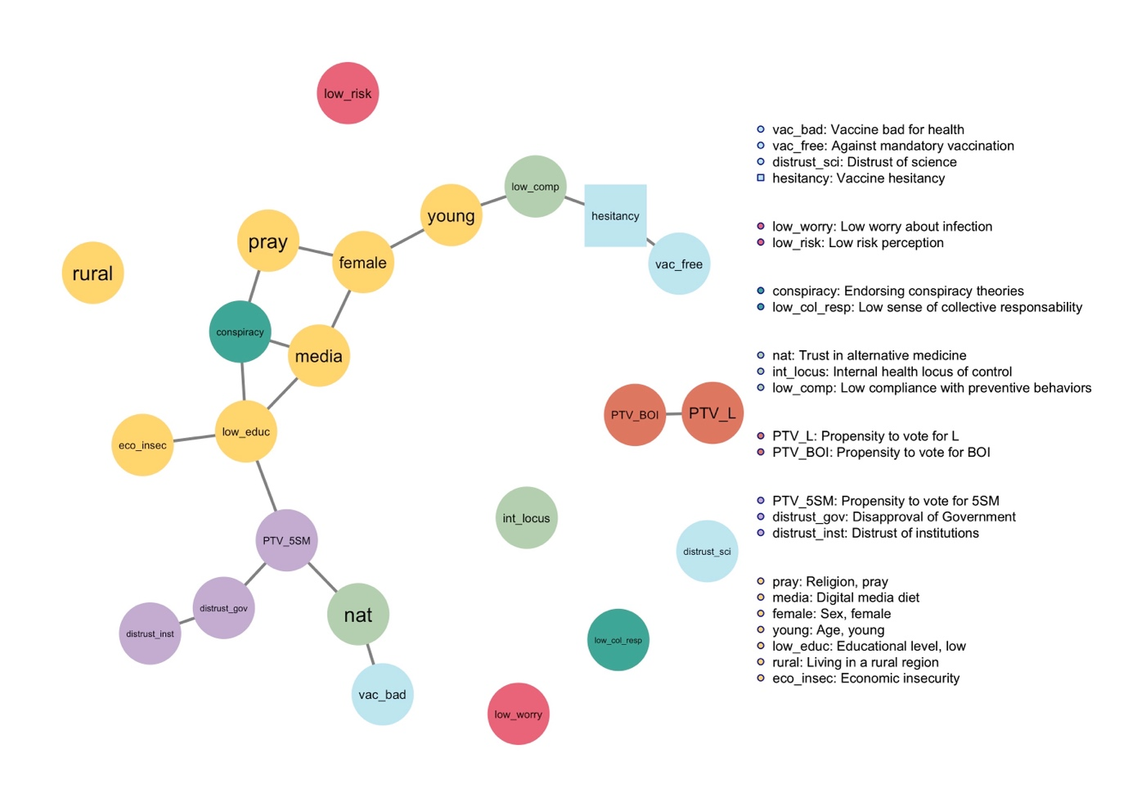
Note: Backbone of the Broad Attitude Network. Nodes (survey variables) are connected by unweighted and undirected edges that represent statistical associations that overcome the application of the disparity filter. Weaker edges are suppressed, so that peripheral nodes become isolated.

4.6 Empirical predictors of vaccine hesitancy
Table 4 shows the empirical predictors of vaccine hesitancy in Italy and the weight of the edges they share with hesitancy. These nodes are those that (1) are directly linked to hesitancy, and (2) are also present in the backbone. The table shows that vaccine hesitancy is mostly interacting with vaccine-related variables like vac_free and vac_bad. Low self-reported compliance, the endorsement of conspiracy theories, and trust in alternative medicine are all associated with higher levels of hesitancy. Finally, education is the only sociodemographic variable overcoming the two steps of information reduction.

Table 4: Empirical predictors of vaccine hesitancy in Italy
Predictor | Edge weight
Against mandatory vaccination | 0.95
Vaccine bad for health | 0.34
Low compliance with preventive behaviors | 0.34
Endorsing conspiracy theories | 0.12
Trust in alternative medicine | 0.07
Low educational level | 0.07

5 Discussion
This Section has two aims. First, we situate our findings into the broader literature on vaccine hesitancy. Second, we discuss how the complex system approach improved our understanding of this phenomenon.
We found hesitancy rates comparable to those reported in other Italian studies fielded after the start of the vaccination campaign (Ladini & Vezzoni, 2022; Reno et al., 2021). We adopted a Broad Attitude Network approach to avoid a reductionist approach. We found that the theoretical predictors of hesitancy form a fully connected network which is characterized by relatively high connectivity, if compared to the other cross-sectional example of Broad Attitude Networks regarding COVID-19 (Chambon, Dalege, et al., 2022). This means that all variables contributed to establishing the emergence of vaccine hesitancy, as even if not all theoretical predictors directly interact with hesitancy, most of them can influence it with the mediation of a single node only. Nodes clustered depending on their semantic meaning. Sociodemographic variables formed the biggest community in the network, and hesitancy mostly interacts with vaccine-related variables. Centrality gives insights into the effect that change in one variable may have on the whole system (Chambon et al., 2021). We found that hesitancy and conspiracy have the highest Strength and that the latter also has a high Degree centrality. Therefore, hesitancy is best involved in the network, whereas conspiracy is likely to interact with a greater number of variables, although with lesser intensity. This means that changes in the values of hesitancy are likely to produce wider changes in other predictors; complementary, changes in the values of the empirical predictors of hesitancy would have a strong impact on hesitancy. However, changes in conspiracy would involve a wider re-adaptation of the complex system; complementary, a wider set of nodes could lead to a change in the variable conspiracy since this node is tied to 68% of network nodes (15 out of 22). Also, the centrality table negatively highlighted low_worry and low_risk. This is important since both variables are currently considered important in the literature on vaccine hesitancy, whereas they are discarded from the list of empirical predictors. These variables might emerge as strong predictors of hesitancy when adopting a reductionist framework but result marginal when zooming out to the multivariate relationships occurring between elements of the system. Finally, the analysis of the predictability of each node revealed that the variance of certain variables (e.g., hesitancy, conspiracy) is extremely well captured by the system. This means that the states of these variables are likely to be determined by other nodes of the model. Conversely, nodes characterized by low predictability (e.g., low_risk) are elements of the system that are likely to be influenced by variables omitted from these analyses.
The main substantive contribution of this work is the identification of a set of empirical predictors of vaccine hesitancy in Italy. The list was obtained with an innovative combination of network estimation and backbone reduction. In the remainder of the discussion, we show that this result could not have been obtained with other established methodologies. Moreover, other techniques for multivariate have important limitations. Regression analysis can not deal with a statistical model of this size. This led scholars to isolate a vast number of predictors, without being able to discern core variables from marginal ones. Regression models are suited to evaluate the entity and the significance of the effect of one predictor on vaccine hesitancy. However, the risk is the detection of negligible effects. An alternative method is factor analysis. Researchers willing to examine the role of several predictors could aggregate them in mean indices, and fit regression models with the resulting variables. However, the input of factor analysis is the correlation matrix between observed variables. Therefore, this method focuses on the raw variance shared across all variables (Golino et al., 2020, p. 295). Conversely, network analysis of multivariate deals with the unique variance shared by pair of variables, that is the association they have, net of the effect of other variables in the model (Borsboom et al., 2021). Finally, Structural Equation Models have a wider toolkit, being more established. This technique could be leveraged to test theory-driven hypotheses, and different models can be compared in terms of goodness of fit. However, when the phenomenon of interest is new and understudied, it is difficult to find clear research hypotheses, and it is even more difficult to rely on strong theoretical evidence. Researchers could exploit systematic reviews to build competing models including different sets of predictors of vaccine hesitancy. However, unlike in a data-driven network approach, these operations would struggle to model the associations occurring between the determinants, which are unlikely to be covered by any review.

A clear advantage of the network approach is that it generates metrics that are not intelligible from other multivariate techniques, such as network connectivity and node centrality. The latter is currently at the center of an academic debate. During the early phases of network psychometrics, researchers adopted many measures of centrality, such as betweenness and closeness. However, these metrics were developed and thought for social networks, where nodes have agency; this is not a trivial issue, as importing these measures requires a correct understanding of their assumptions. Betweenness and closeness are based on the geodesic distances since they were designed to describe information flows. Conversely, what is flowing in a Broad Attitude Network is the influence between variables, the description of which is best performed with Strength (Bringmann et al., 2019). Moreover, an additional misunderstanding lies in interpreting central nodes as variables with high causal power for the phenomenon in question (Neal et al., 2022). Despite this could seem intuitive, researchers showed that centrality metric and causal power only weakly correlate (Dablander & Hinne, 2019). Indeed, Strength centrality should only be used to infer the dynamic of the system (Carter et al., 2020; Chambon et al., 2021; Turner-Zwinkels & Brandt, 2022), and its interpretation should not be overextended.

To demonstrate that Strength and Degree can not be obtained through regression analysis, we compare the Strength centrality score of each node with the coefficients one would obtain in several regression models of limited size. We fit 17 logistic regressions where each theoretical predictor is regressed onto vaccine hesitancy, always controlling for sex, age, education, rurality, and economic insecurity. Next, we calculate the odds ratio of the coefficients, and we examine the association they share with Strength scores. Models and odds ratio coefficients are reported in Sections 7 and 8 of Supplement S1. Figure 4 presents a scatterplot of these two metrics. Importantly, removing the outliers (vac_free, conspiracy, distrust_sci, and vac_bad) we find that Strength and coefficients are not associated. This means that centrality metrics can not be inferred from regressions, as strong predictors are not always important nodes of a Broad Attitude Network. In Section 8 of Supplement S2, we replicate these analyses for Degree centrality, showing it does not correlate with regression coefficients.

Figure 4: Scatterplot between Strength and regression coefficient
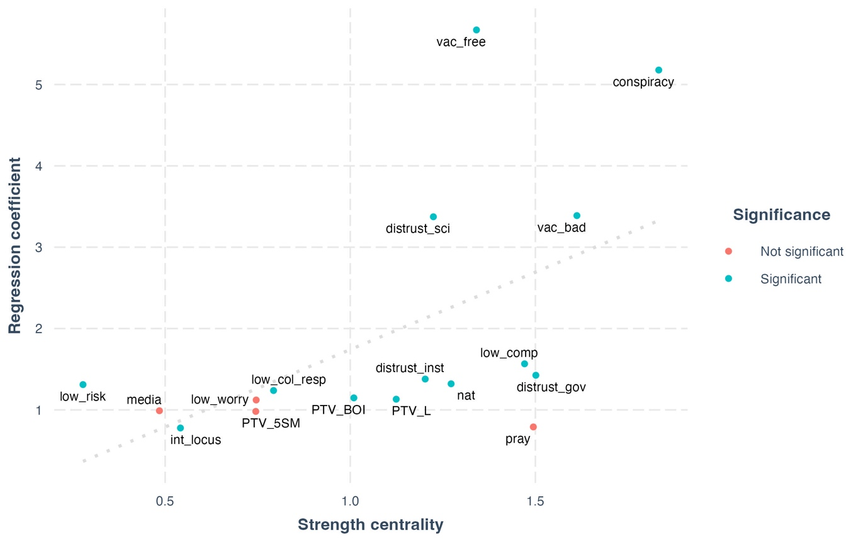
Note: Strength centrality and regression coefficients (odds ratio). Coefficients are obtained with node-wise logit (DV=hesitancy; C=sex, age, educ, rural region, economic insecurity).

Finally, we discuss how the complex system approach can improve our understanding of vaccine hesitancy by focusing on empirical predictors. Table 5 compares these variables across four different metrics. We study the Strength and Degree of each node, the coefficients of the regression models described before, and the weight of the edge each node has with hesitancy. To allow for a direct comparison we report the Z-scores for each metric so that scores above 0 are interpretable as higher than the mean value observed among the empirical predictors. Regression analysis could only inform us about the first column of this table. The difference between the second and third columns is that edge weights are calculated considering a greater number of controls, and with LASSO regularization. Consistently, all empirical predictors are associated with statistically significant regression coefficients (last column). The variable vac_free has the highest regression coefficient and the strongest edge with hesitancy. This means that this variable has the strongest dyadic association with the variable of interest. However, this node underperforms across all centrality metrics. This means that these two variables strongly interact, but this also implies that vac_free has a marginal role in the complex system, interacting with a few variables (Degree) and with feeble intensity (Strength). This is consistent with what we have shown in Section 4.3, where we investigated the determinants of the Strength centrality of different nodes. Endorsing conspiracy theory is highly predictive of vaccine hesitancy in a reduced regression model. However, this relationship is not robust to additional control, as highlighted by the negative Z-score for its edge weight. Additionally, this variable is central to the system. The node vac_bad has a high coefficient, edge weight, and Strength, but its variance is mostly explained by its interaction with hesitancy and other variables from the blue cluster. Therefore, this node can deeply impact hesitancy, while being relatively isolated from the other predictors. Education scores low across all metrics and is likely to be the empirical predictor less influencing hesitancy. Compliance with preventive behaviors has a weak relationship with hesitancy, but their edge weight is quite important. This shows that a misspecified regression model can also underestimate the relevance of a predictor. Finally, nat has a weak relationship with hesitancy and low Strength centrality. However, a change in this variable could affect many other predictors since it has a very high score of Degree centrality.

Table 5: Comparison of Strength scores, regression coefficients, and edge weights
Variable | Coefficient | Edge weight | Strength | Degree | Significance
vac_free | 1.32 | 1.89 | -0.36 | -1.71 | Significant
conspiracy | 1.06 | -0.58 | 1.51 | 0.98 | Significant
vac_bad | 0.13 | 0.07 | 0.67 | -0.24 | Significant
educ | -0.72 | -0.73 | -1.32 | -0.24 | Significant
low_comp | -0.83 | 0.07 | 0.13 | 0.24 | Significant
nat | -0.96 | -0.73 | -0.62 | 0.98 | Significant

6 Conclusions
This paper has important limitations. First, cross-sectional data can not provide insights into causality (Neal et al., 2022). This might be mitigated by the adoption of longitudinal data. Second, due to the paucity of data, it was impossible to investigate the entire list of theoretical predictors of vaccine hesitancy. Yet, the data we selected are the best resource we found in Italy. Future research investigating issues related to COVID-19 should begin with the construction of a theory-driven questionnaire, rather than selecting relevant variables from an existing dataset. Third, listwise deletion importantly reduced the original sample, complicating straightforward inference on the Italian population. Finally, edges and centrality metrics are sensitive to variable selection, meaning that the inclusion of additional variables could change their scores.
The contributions of this paper are twofold. Regarding vaccine hesitancy, this work represents its largest empirical investigation in Italy. The application of a complex systems approach enabled a novel understanding of the relationship between predictors of hesitation, thus providing a multidimensional, systemic, and nuanced understanding of this puzzle. Moreover, this study investigated hesitancy as a concrete behavior, rather than as a preliminary attitude toward as-yet undeveloped vaccines. Secondly, this article also contributes to the Broad Attitude Network literature. This multi-step approach starts by estimating a network from the conditional associations existing between a selected list of variables. Later, the resulting system is analyzed through social network analysis techniques. Broad Attitude Networks thus inherit the “boundary specification problem” from the field of network analysis (Pažitka & Wójcik, 2021). In traditional social networks, this problem is related to the delimitation of the research setting or the selection of relevant actors. For the Broad Attitude Network, this problem translates to a careful selection of variables. The present work outlined a new path to address this obstacle by (1) starting with a theoretical list of vaccine hesitancy predictors and (2) applying a second layer of information reduction to the estimated network (the backbone procedure). The first step is commonly implemented in network psychometrics, where researchers studying a syndrome only focus on symptoms of the Diagnostic and Statistical Manual of Mental Disorders (Borsboom et al., 2021). However, to our knowledge, the application of backbone reduction is unprecedented in this field.

Bibliography
Aw, J., Seng, J. J. B., Seah, S. S. Y., & Low, L. L. (2021). COVID-19 Vaccine Hesitancy—A Scoping Review of Literature in High-Income Countries. Vaccines, 9(8), 900. https://doi.org/10.3390/vaccines9080900
Barabasi, A.-L. (2007). The Architecture of Complexity. IEEE Control Systems, 27(4), 33–42. https://doi.org/10.1109/mcs.2007.384127
Barello, S., Nania, T., Dellafiore, F., Graffigna, G., & Caruso, R. (2020). ‘Vaccine hesitancy’ among university students in Italy during the COVID-19 pandemic. European Journal of Epidemiology, 35(8), 781–783. https://doi.org/10.1007/s10654-020-00670-z
Borkulo, C. D. van, Borsboom, D., Epskamp, S., Blanken, T. F., Boschloo, L., Schoevers, R. A., & Waldorp, L. J. (2015). A new method for constructing networks from binary data. Scientific Reports, 4(1), 5918. https://doi.org/10.1038/srep05918
Borsboom, D., Deserno, M. K., Rhemtulla, M., Epskamp, S., Fried, E. I., McNally, R. J., Robinaugh, D. J., Perugini, M., Dalege, J., Costantini, G., Isvoranu, A.-M., Wysocki, A. C., Borkulo, C. D. van, Bork, R. van, & Waldorp, L. J. (2021). Network analysis of multivariate data in psychological science. Nature Reviews Methods Primers, 1(1), 58. https://doi.org/10.1038/s43586-021-00055-w
Bringmann, L. F., Elmer, T., Epskamp, S., Krause, R. W., Schoch, D., Wichers, M., Wigman, J. T. W., & Snippe, E. (2019). What do centrality measures measure in psychological networks? Journal of Abnormal Psychology, 128(8), 892–903. https://doi.org/10.1037/abn0000446
Burger, J., Isvoranu, A.-M., Lunansky, G., Haslbeck, J. M. B., Epskamp, S., Hoekstra, R. H. A., Fried, E. I., Borsboom, D., & Blanken, T. F. (2022). Reporting Standards for Psychological Network Analyses in Cross-Sectional Data. Psychological Methods. https://doi.org/10.1037/met0000471
Campochiaro, C., Trignani, G., Tomelleri, A., Cascinu, S., Dagna, L., & Group, C.-19 V. S. (2021). Potential acceptance of COVID-19 vaccine in rheumatological patients: A monocentric comparative survey. Annals of the Rheumatic Diseases, 80(6), 816–817. https://doi.org/10.1136/annrheumdis-2020-219811
Carter, N. T., Lowery, M. R., Smith, R. W., Conley, K. M., Harris, A. M., Listyg, B., Maupin, C. K., King, R. T., & Carter, D. R. (2020). Understanding Job Satisfaction in the Causal Attitude Network (CAN) Model. Journal of Applied Psychology, 105(9), 959–993. https://doi.org/10.1037/apl0000469
Caserotti, M., Girardi, P., Rubaltelli, E., Tasso, A., Lotto, L., & Gavaruzzi, T. (2021). Associations of COVID-19 risk perception with vaccine hesitancy over time for Italian residents. Social Science & Medicine, 272, 113688. https://doi.org/10.1016/j.socscimed.2021.113688
Castellini, G., Savarese, M., Leone, S., Previtali, E., Armuzzi, A., & Graffigna, G. (2020). Italian IBD Patients Coping With Covid-19 Emergency: The Mitigating Role of Psychological Readiness to Engage in Self-care. Inflammatory Bowel Diseases, 26(10), izaa185-. https://doi.org/10.1093/ibd/izaa185
Chambon, M., Dalege, J., Borsboom, D., Waldorp, L. J., Maas, H. L. J., & Harreveld, F. (2023). How compliance with behavioural measures during the initial phase of a pandemic develops over time: A longitudinal COVID‐19 study. British Journal of Social Psychology, 62(1), 302–321. https://doi.org/10.1111/bjso.12572
Chambon, M., Dalege, J., Elberse, J. E., & van Harreveld, F. (2022). A Psychological Network Approach to Attitudes and Preventive Behaviors During Pandemics: A COVID-19 Study in the United Kingdom and the Netherlands. Social Psychological and Personality Science, 13(1), 233–245. https://doi.org/10.1177/19485506211002420
Chambon, M., Dalege, J., Waldorp, L., van der Maas, H., Borsboom, D., & van Harreveld, F. (2021). Tailored interventions into broad attitude networks towards the COVID-19 pandemic [Preprint]. PsyArXiv. https://doi.org/10.31234/osf.io/fmu9w
Chambon, M., Kammeraad, W. G., van Harreveld, F., Dalege, J., Elberse, J. E., & van der Maas, H. L. J. (2022). Understanding change in COVID-19 vaccination intention with network analysis of longitudinal data from Dutch adults. Npj Vaccines, 7(1), 114. https://doi.org/10.1038/s41541-022-00533-6
Dablander, F., & Hinne, M. (2019). Node centrality measures are a poor substitute for causal inference. Scientific Reports, 9(1), 6846. https://doi.org/10.1038/s41598-019-43033-9
Dalege, J., Borsboom, D., van Harreveld, F., van den Berg, H., Conner, M., & van der Maas, H. L. J. (2016). Toward a formalized account of attitudes: The Causal Attitude Network (CAN) model. Psychological Review, 123(1), 2–22. https://doi.org/10.1037/a0039802
Epskamp, S. (2016). Brief Report on Estimating Regularized Gaussian Networks from Continuous and Ordinal Data. ArXiv. https://doi.org/10.48550/arxiv.1606.05771
Epskamp, S., Borsboom, D., & Fried, E. I. (2018). Estimating psychological networks and their accuracy: A tutorial paper. Behavior Research Methods, 50(1), 195–212. https://doi.org/10.3758/s13428-017-0862-1
Epskamp, S., Cramer, A. O. J., Waldorp, L. J., Schmittmann, V. D., & Borsboom, D. (2012). qgraph: Network Visualizations of Relationships in Psychometric Data. Journal of Statistical Software, 48(4), 1–18.
Epskamp, S., & Fried, E. I. (2018). A Tutorial on Regularized Partial Correlation Networks. Psychological Methods, 23(4), 617–634. https://doi.org/10.1037/met0000167
Epskamp, S., Waldorp, L. J., Mõttus, R., & Borsboom, D. (2018). The Gaussian Graphical Model in Cross-Sectional and Time-Series Data. Multivariate Behavioral Research, 53(4), 453–480. https://doi.org/10.1080/00273171.2018.1454823
Golino, H., Shi, D., Christensen, A. P., Garrido, L. E., Nieto, M. D., Sadana, R., Thiyagarajan, J. A., & Martinez-Molina, A. (2020). Investigating the performance of exploratory graph analysis and traditional techniques to identify the number of latent factors: A simulation and tutorial. Psychological Methods, 25(3), 292–320. https://doi.org/10.1037/met0000255
Graffigna, G., Palamenghi, L., Boccia, S., & Barello, S. (2020). Relationship between Citizens’ Health Engagement and Intention to Take the COVID-19 Vaccine in Italy: A Mediation Analysis. Vaccines, 8(4), 576. https://doi.org/10.3390/vaccines8040576
Haslbeck, J. M. B., & Waldorp, L. J. (2018). How well do network models predict observations? On the importance of predictability in network models. Behavior Research Methods, 50(2), 853–861. https://doi.org/10.3758/s13428-017-0910-x
Haslbeck, J. M. B., & Waldorp, L. J. (2020). mgm: Estimating Time-Varying Mixed Graphical Models in High-Dimensional Data. Journal of Statistical Software, 93(8). https://doi.org/10.18637/jss.v093.i08
King, R. D., Orhobor, O. I., & Taylor, C. C. (2021). Cross-validation is safe to use. Nature Machine Intelligence, 3(4), 276–276. https://doi.org/10.1038/s42256-021-00332-z
Kuiper, M. E., Chambon, M., Bruijn, A. L. de, Folmer, C. R., Olthuis, E. H., Brownlee, M., Kooistra, E. B., Fine, A., Harreveld, F. van, Lunansky, G., & Rooij, B. van. (2022). A Network Approach to Compliance: A Complexity Science Understanding of How Rules Shape Behavior. Journal of Business Ethics, 1–26. https://doi.org/10.1007/s10551-022-05128-8
Ladini, R., & Vezzoni, C. (2022). When Believing in Divine Immanence Explains Vaccine Hesitancy: A Matter of Conspiracy Beliefs? Politics and Governance, 10(4). https://doi.org/10.17645/pag.v10i4.5766
Ladyman, J., Lambert, J., & Wiesner, K. (2013). What is a complex system? European Journal for Philosophy of Science, 3(1), 33–67. https://doi.org/10.1007/s13194-012-0056-8
Lauritzen, S. L. (1996). Graphical models (Vol. 17). Clarendon Press.
MacDonald, N. E. (2015). Vaccine hesitancy: Definition, scope and determinants. Vaccine, 33(34), 4161–4164. https://doi.org/10.1016/j.vaccine.2015.04.036
Neal, Z. P. (2022). backbone: An R package to extract network backbones. PLoS ONE, 17(5), e0269137. https://doi.org/10.1371/journal.pone.0269137
Neal, Z. P., Forbes, M. K., Neal, J. W., Brusco, M., Krueger, R., Markon, K. E., Steinley, D., Wasserman, S., & Wright, A. G. C. (2022). Critiques of network analysis of multivariate data in psychological science. https://doi.org/10.31234/osf.io/jqs3n
Opsahl, T. (2009). Structure and Evolution of Weighted Networks. University of London (Queen Mary College), London, UK. http://toreopsahl.com/publications/thesis/
Opsahl, T., Agneessens, F., & Skvoretz, J. (2010). Node centrality in weighted networks: Generalizing degree and shortest paths. Social Networks, 32(3), 245–251. https://doi.org/10.1016/j.socnet.2010.03.006
Palamenghi, L., Barello, S., Boccia, S., & Graffigna, G. (2020). Mistrust in biomedical research and vaccine hesitancy: The forefront challenge in the battle against COVID-19 in Italy. European Journal of Epidemiology, 35(8), 785–788. https://doi.org/10.1007/s10654-020-00675-8
Pažitka, V., & Wójcik, D. (2021). The network boundary specification problem in the global and world city research: Investigation of the reliability of empirical results from sampled networks. Journal of Geographical Systems, 23(1), 97–114. https://doi.org/10.1007/s10109-020-00340-4
Pivetti, M., Melotti, G., Bonomo, M., & Hakoköngäs, E. (2021). Conspiracy Beliefs and Acceptance of COVID-Vaccine: An Exploratory Study in Italy. Social Sciences, 10(3), 108. https://doi.org/10.3390/socsci10030108
Pons, P., & Latapy, M. (2005). Computer and Information Sciences—ISCIS 2005, 20th International Symposium, Istanbul, Turkey, October 26-28, 2005. Proceedings. Lecture Notes in Computer Science, 284–293. https://doi.org/10.1007/11569596_31
Prati, G. (2020). Intention to receive a vaccine against SARS-CoV-2 in Italy and its association with trust, worry and beliefs about the origin of the virus. Health Education Research, 35(6), 505–511. https://doi.org/10.1093/her/cyaa043
Priori, R., Pellegrino, G., Colafrancesco, S., Alessandri, C., Ceccarelli, F., Franco, M. D., Riccieri, V., Scrivo, R., Scavalli, A. S., Spinelli, F. R., & Conti, F. (2021). SARS-CoV-2 vaccine hesitancy among patients with rheumatic and musculoskeletal diseases: A message for rheumatologists. Annals of the Rheumatic Diseases, 80(7), 953–954. https://doi.org/10.1136/annrheumdis-2021-220059
Reno, C., Maietti, E., Fantini, M. P., Savoia, E., Manzoli, L., Montalti, M., & Gori, D. (2021). Enhancing COVID-19 Vaccines Acceptance: Results from a Survey on Vaccine Hesitancy in Northern Italy. Vaccines, 9(4), 378. https://doi.org/10.3390/vaccines9040378
Sallam, M. (2021). COVID-19 Vaccine Hesitancy Worldwide: A Concise Systematic Review of Vaccine Acceptance Rates. Vaccines, 9(2), 160. https://doi.org/10.3390/vaccines9020160
Schoch-Spana, M., Brunson, E. K., Long, R., Ruth, A., Ravi, S. J., Trotochaud, M., Borio, L., Brewer, J., Buccina, J., Connell, N., Hall, L. L., Kass, N., Kirkland, A., Koonin, L., Larson, H., Lu, B. F., Omer, S. B., Orenstein, W. A., Poland, G. A., … White, A. (2021). The public’s role in COVID-19 vaccination: Human-centered recommendations to enhance pandemic vaccine awareness, access, and acceptance in the United States. Vaccine, 39(40), 6004–6012. https://doi.org/10.1016/j.vaccine.2020.10.059
Serrano, M. Á., Boguñá, M., & Vespignani, A. (2009). Extracting the multiscale backbone of complex weighted networks. Proceedings of the National Academy of Sciences, 106(16), 6483–6488. https://doi.org/10.1073/pnas.0808904106
Turner-Zwinkels, F. M., & Brandt, M. J. (2022). Belief system networks can be used to predict where to expect dynamic constraint. Journal of Experimental Social Psychology, 100, 104279. https://doi.org/10.1016/j.jesp.2021.104279
Vecchia, C. L., Negri, E., Alicandro, G., & Scarpino, V. (2020). Attitudes towards influenza vaccine and a potential COVID-19 vaccine in Italy and differences across occupational groups, September 2020. La Medicina Del Lavoro, 111(6), 445–448. https://doi.org/10.23749/mdl.v111i6.10813

This remark is further elaborated in Section 2.1, where we highlight that past research measured hesitancy as an attitude, rather than a self-reported behavior.
Health engagement is the individual proactivity in the management of health-related issues, and is associated with greater hesitancy (Castellini et al., 2020).
Divine immanence is a set of religious beliefs encompassing the conviction that miracles exist, that God directly intervenes in our lives, and that prayer can heal illnesses
In the remainder of the article, nodes are denoted in italics
Individuals are split randomly into 90 groups, which are invited to fill in the questionnaire on different days. In this way, time becomes a random variable, and data can be analyzed cross-sectionally (by aggregating the 90 sub-samples) or longitudinally (e.g., by computing moving averages). The potential of RCS is not exploited by this paper, which investigates vaccine hesitancy cross-sectionally.
These parties are labeld as populist in the Chapel Hill Expert Survey.
This eases the interpretation of the network model, without changing its statistical properties. For example, the polarity of the variable “educational level” is inverted, and the item is renamed as “Educational level, low”.
Note that the polarity of the age variable is reversed in the analysis. Table 2 shows the original value of this variable to facilitate its interpretation.
The test reveals significance if CI does not include zero (Epskamp, Borsboom, et al., 2018).
We avoid fitting regression models where control variables predict hesitancy, because the size of these model will be smaller of one covariate with respect to the other 17. This would bias the direct comparison of the coefficients.

