TUTORIAL:

<https://www.youtube.com/watch?v=Vr4cdpsoVEo>

<https://alselectro.wordpress.com/2014/10/21/bluetooth-hc05-how-to-pair-two-modules/>

<http://blog.zakkemble.co.uk/getting-bluetooth-modules-talking-to-each-other/>

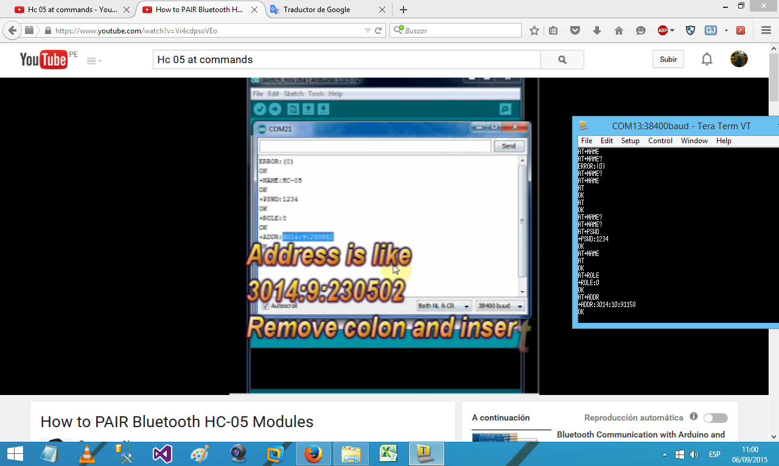

OK

AT+NAME=

ERROR:(4)

AT+NAME

AT+NAME?

ERROR:(0)

AT+NAME?

AT+NAME

AT

OK

AT

OK

AT+NAME?

AT+NAME?

AT+PSWD

+PSWD:1234

OK

AT+NAME

AT

OK

AT+ROLE

+ROLE:0

OK

AT+ADDR

+ADDR:3014:10:91158

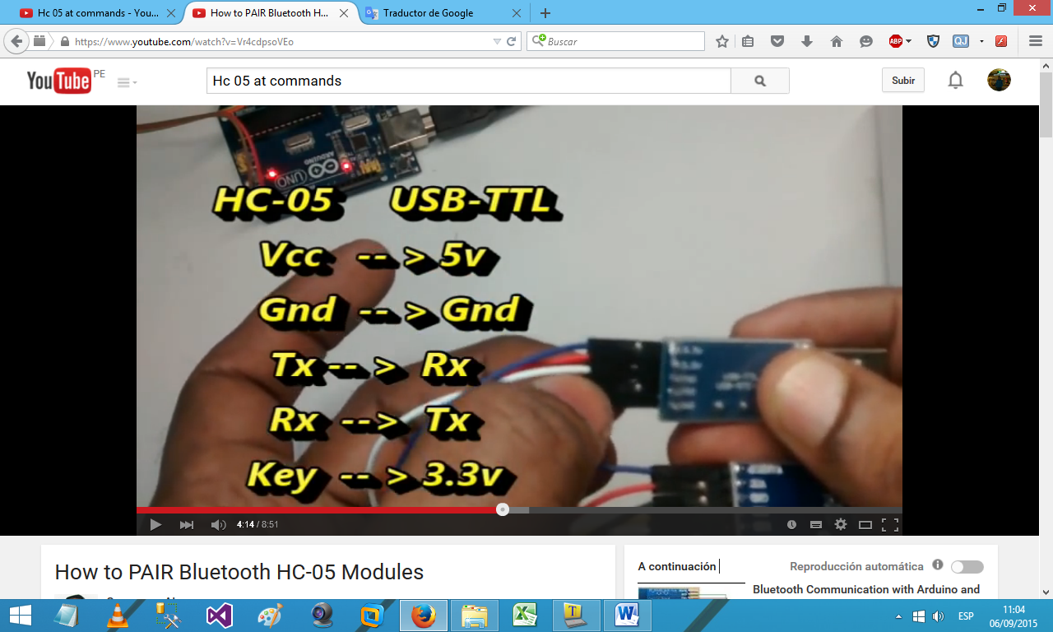

*ROLE :

0 ESCLAVO

1 MAESTRO

AT+STATE

+STATE:INQUIRING

OK

AT+ADDR

+ADDR:98d3:31:404629

OK

AT

AT+ADRR

AT+NAME

AT+ROLE

AT+PSWD

*Notas:

-La velocidad por defecto es 38400 BAUDIOS

-Por defecto el HC05 es esclavo.

NL and CR arduino

Prints data to the serial port as human-readable ASCII text followed by a carriage return character (ASCII 13, or '\r') and a newline character (ASCII 10, or '\n'). This command takes the same forms as [Serial.print](https://www.arduino.cc/en/Serial/Print)().