7.10. Barrett’s algorithm of reduction modulo m

Algorithms of reduction modulo m are algorithms, which computes the remainder from division of a natural number 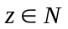 by a natural number m, where 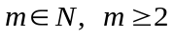 i.e. they compute the value 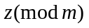. We describe in the sequel two fast algorithms of reduction modulo m : Barrett’s algorithm and Montgomery’s algorithm . In this section we deal only with Barrett’s algorithm.

Barrett’s algorithm is a fast algorithm of computation 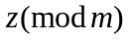. In short we say: Barrett’s reduction. In practice, Barrett’s algorithm is used for large numbers z and m with hundreds of decimal digits. For relatively small numbers for example 64 b or 128 b numbers written in common binary notation the fastest method of computation is use of assembler instructions (DIV and IDIV in a case of the family of microprocessors Intel xx86).

Assume 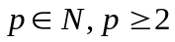 and 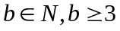 (p is not necessary a prime). Denote 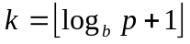. It is the smallest number of positions (digits) which has to be devoted to write down the number p in common notation with a radix b .

Barrett’s reduction algorithm see. fig. 8.41 computes the value 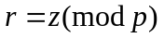 for 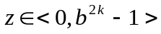. We have of course 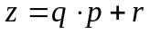, where 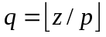 and 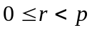, then 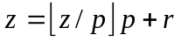. In the first step we compute a constant 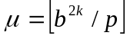.

___________________________________________________________________________
Algorithm: Barrett’s Algorithm
___________________________________________________________________________

Input data: , , , , and a precomputed constant .

Output data: 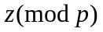
__________________________________________________________________________

1. 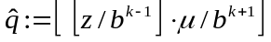

2. 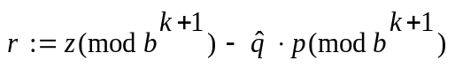

3. if 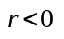 then 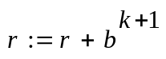

4. while 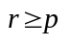 do 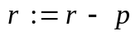

return(r)

___________________________________________________________________________

Fig. 7.41 Barrett’s algorithm of reduction modulo m

Theorem (on correctness of the Barrett’s algorithm)

If , 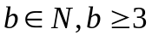, 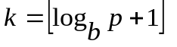, 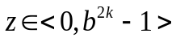, 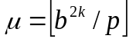

then the Barrett’s algorithm is correct i.e. returns 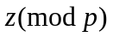,

Proof. 1. We prove, that a number computed in the step 1 of the algorithm is a good approximation of the number 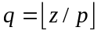. More strictly, we show that, 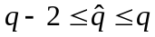. Indeed we have:

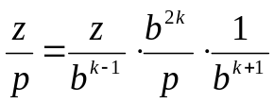

then we obtain
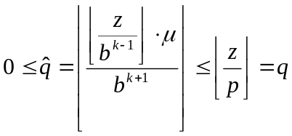

Hence the following inequality is fulfilled: 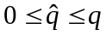. It can be proved also, that 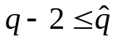. Indeed, denote

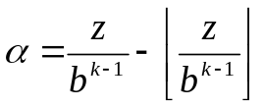, 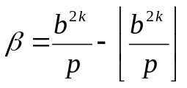

From the floor function properties we have: 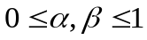 then:

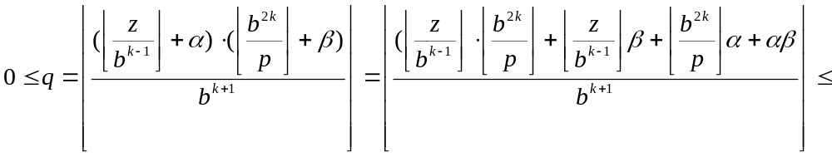
(1)
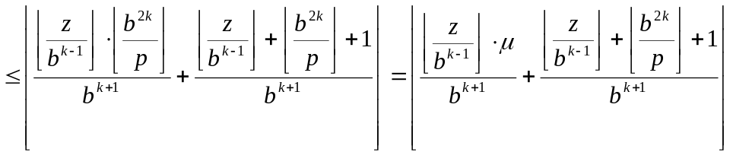

From assumptions and b is chosen in such a way (in assumptions) that 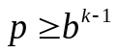 then we have:

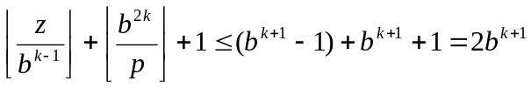

Hence using the assessment (1) of the number q we obtain:

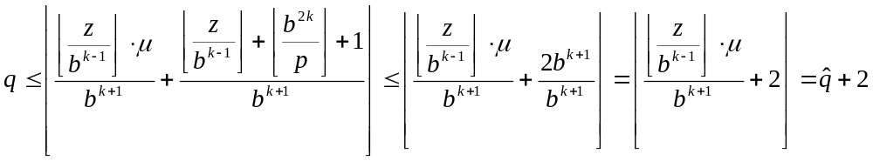

Then finally we have . It is worth to note that to compute , we need only one multiplication z by a constant . Divisions by 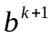 are left shifts.

2. The value of the variable r computed in the second step of the algorithm is the following:

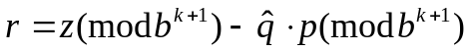,

and fulfills the inequality 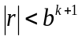 and fulfills also the following congruence (simple verification)

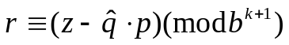

3. After execution of the step number 3 (conditional addition of 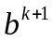) we have in the sequel

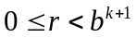 and 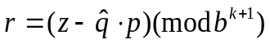 (equality)

4. Of course 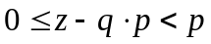, then we have from proven in the p.1 inequality 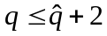, that:

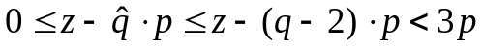

5. The number k is chosen in such a way, that 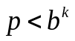. Multiplying both sides of the inequality by b, we obtain 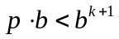. We have assumed, that 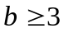 then 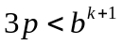.

6. From proven in the p.4 and p.5 inequalities we obtain

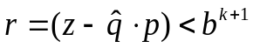

Then after the step number 3 we have:

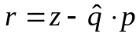

7. Our aim is computation of 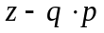 . After execution of the step number 3 of the algorithm we have:

If after the third step of the algorithm we have 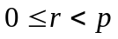 then r is a correct result.

If not then we subtract in the 4-th step a number p from r i.e. 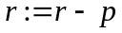 and if then r a correct result. From the following inequality which was above proven

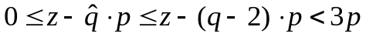

it follows that to obtain we need at most 2 subtractions of the number p. ■

