ECRYP - Exam Problems (September, 2016), 12.09.2016

Solve ten arbitrary problems from the following list.

Problem # 1
Assume 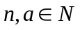 and 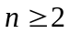. Prove that if 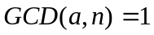 then

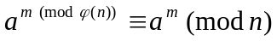

Problem # 2
Define the Diffie-Hellman protocol of key exchanging. Why is it a secure protocol ?

Problem # 3

Compute three last decimal digits of the following numbers

a) 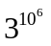 b) 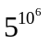 .

Problem # 4
Compute values of the Euler phi function
a) (5358) , b) (3458), c) (2¹⁰⁰⁰), d) 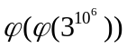, 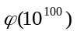

Problem # 5
Solve the following set of congruencies :

x ≡ 6 (mod 7)
x ≡ 4 (mod 5)
x ≡ 10 (mod 11)
x ≡ 12 (mod 13)

Problem # 6
Solve the following set of congruencies :

x ≡ 1 (mod 7)
x ≡ 2 (mod 5)
x ≡ 3(mod 11)
x ≡ 4 (mod 13)

Problem # 7
Describe the ELGamal cryptosystem (i.e. ElGamal cipher) and choose ELGamal cryptosystem parameters (multiplicative group generator public key, private key) for the field 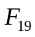.

Problem # 8
Compute log₅8 in the ring Z₁₃ and in the ring Z_{19 .}

Problem # 9
Add the following polynomials (bytes) in the quotient ring

:

a) ‘57’ and ’02’
b) ‘03’ and ’03’
c) ‘FF’ and ’0F’

Hint: see AES

Problem # 10
Multiply the following polynomials (bytes) in the quotient ring
:

a) ‘57’ and ’02’
b) ‘03’ and ’03’
c) ‘FF’ and ’0F’

Hint: see AES

Problem # 11
Compute inverses of 6, 7, 8
a) in the multiplicative group Z*₁₇
b) in the multiplicative group Z*_{13.}

Problem # 12
How many times we have to repeat experiments in the cave of Zero Knowledge to obtain probability of fraud less then 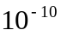.

Problem # 13
Describe the Fiat-Shamir entity authentication protocol. How many times we have to repeat the Fiat-Shamir protocol to obtain the probability of error less than 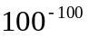.

Problem # 14
Assume we test primality of natural numbers with the probabilistic Miller-Rabin test. Compute probability of the fact that an odd composite number n is accepted as a prime.

Can the Miller-Rabin test qualify a prime as a composite number.

How many experiments (random choices of the basis a ) we have to do to be sure with probability 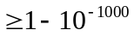 that the tested number n is a prime.

Problem # 15
Describe the ElGamal signature algorithm and prove that verification formula is true when the parameters are correct.

