Edgar Sanchez Aldrete
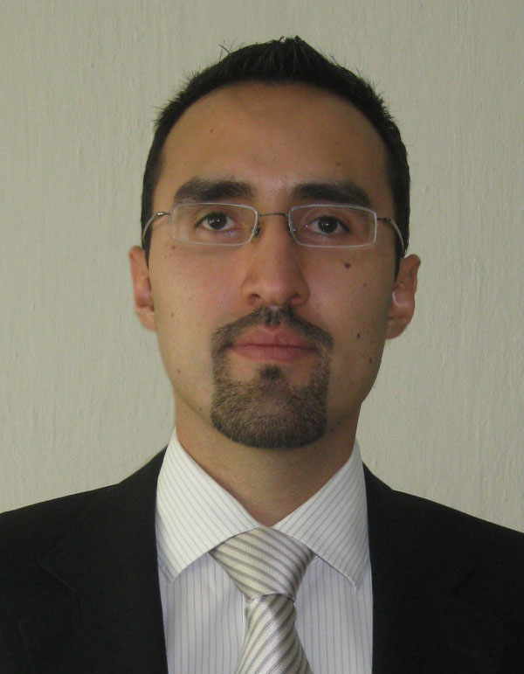
Summary:

- Efficient management of projects and global business vision.
- Great experience directing people at international level.
- Extensive knowledge of BI/Data Warehouse. Using TDWI design and analysis techniques therefore deploying successful projects with large companies that demand performance and information volume. Delivering integral solutions using: ETL, Data Mining, Data Quality, OLAP, Web, and Dash Boards Tools.
- Over 8 years working with several BI tools from ETL to OLAP.

CONTACT INFORMATION:

Address: Av. Gral. Mariano Escobedo 331-2, Col. Polanco.
Del. Miguel Hidalgo, Mexico, D.F. C.P. 11570.
Mobile: +52 (55) 1820 0745.
E-mail: sanchezaldrete@yahoo.com

WORK EXPERIENCE

UST Global – Mexico City month/year –month/year

Role: Sr. BI Solutions Architect and Tech Lead 02/2013 – Current

Responsibilities:
- BI solutions/projects design and implementations at international level for different company’s clients.
- Re-architecture of different customers’ projects.
- Analysis of customer’s needs and translating them into Data Warehouse designs and implementations.
- Closely collaborate with tools and systems administrators in order to optimize and tune all the components of the processes, e.g. queries, store procedures, shell scritps, perl scripts, DataStage jobs, etc.
- Design and development of ETL processes with different technologies such as SAP BW/BI, DataStage, Data Services, Informatica, etc.
- Generate different OLAP reports by using SAP Business Objects.
- Define and implement entire data processes across different technologies to take advantage of the distinct technologies features/benefits.
- Lead a technical team on site to meet our clients’ expectations and needs.

Intel – Guadalajara, City month/year –month/year

Role: BI-ETL Architect and Developer 05/2011 – 02/2013

Responsibilities:
- Participate in several re-architecture projects for different solutions, mainly BI.
- Use Teradata as DWH-DBMS to allocate the Data Warehouse, develop ETL processes and optimize Teradata Code and tables to save some nodes.
- Analysis of customer’s needs and translating them into Data Warehouse designs and implementations.
- Closely collaborate with DBA team to optimize and tune queries, store procedures, etc.
- Development of ETL processes in AB Initio and SAP BW/BI.
- Generate different OLAP reports by using SAP Business Objects.
- Schedule and plan loads/jobs through Autosys.
- Creation of scripts to launch loads since different environments like UNIX.
- Lead offshore sustaining teams to meet SLAs.

freescale semiconductor – Guadalajara, City month/year –month/year

Role: Business Intelligence Developer & Sustainer 11/2007 – 04/2011

Responsibilities:
- Management of Data Acquisition processes, related to the advanced intelligent manufacturing. In a continuous search for a better yield performance.
- Data Warehouse application developer and sustainer, using Unix Shell Scripts, Perl, Teradata.
- Development of ETL (DataStage) processes to feed the Data Warehouse.
- Continuous improvement of the ETL processes and data quality.
- Query optimization/tuning.
- Design and implementation of Data Warehouse solutions.
- Leading and mentoring our support team in India.

UNYCORP – Mexico, City month/year –month/year

Role: Business Intelligence Consultant 02/2006 – 10/2007

Responsibilities:
- Trained our customers in Data Warehouse, and how to use the tools that we delivered in Mexico. Offering the necessary knowledge to take the right way to build excellence projects that answer all requirements of a specific company, in consequence to reach the maximum performance to business.
- Developed or directed teams to develop Business Intelligence quality projects, covering the most important information requirements to support the process of decision making. Identifying the key primary indicators and presenting the information as the company require.
- Technical support of: ETL (DataStage, Informatica and Data Integrator), Business Objects Enterprise (Complete Suite), Crystal Reports and Crystal Xcelsius.

El Palacio de Hierro – Mexico, City month/year –month/year

Role: Business Intelligence Senior Analyst 02/2005 – 01/2006

Responsibilities:
- Developed, managed and improved Data Warehouse projects, basically supporting to financial area with it Data Mart, these project obtained the project of the year award (inside of the company), delivering critical information related to the stores, the companies of the group.
- Generated improvement proposal of some existing systems, and new systems to cover an opportunity area.
- Managed and applied reengineering to the systems of advertisement, logistic, optical center, and perfume warehouses.

Integral solutions .net – Mexico, City month/year –month/year

Role: Owner 01/2004 – 02/2005

- Responsibilities:
- Analyzed, designed, tested and implemented systems.
- Developed administrative applications, sites and other kind of systems.
- Sold computers, devices, printers, etc.
- Managed web sites with hosting.
- Maintaining.
- Coordinated system installations with Swatch Stores in Mexico.
- Directed a developer team.

ADVTECH – Mexico, City month/year –month/year

Role: System Manager 07/1999 – 01/2004

- Responsibilities:
- Managed and evaluated hardware and software projects.
- Developed applications using clipper, visual Fox Pro, Visual Basic.
- Managed the company net and computing resources.
- Trained users in our developments.
- Migrated systems.
- Supervised and measured the teams’ productivity.
- Assured projects quality.

EDUCATION

Career: Computing Science UPIICSA -IPN 2002

Professional Training and Certifications:

Certification/Training Institution Year
Business Objects WebIntelligence UNYCORP 2006
Business Objects Universe Design UNYCORP 2006
Business Objects Data Integrator UNYCORP 2006
Balance Scorecards and Dash boards UNYCORP 2006
DataStage 7.5.2 UNYCORP 2006
DataStage Advanced UNYCORP 2006
Data Warehouse Methodology UNYCORP 2006
IBM WebSphere IIS DataStage (EE v8) IBM Chicago, USA 2007
Perl Stonehenge Portland, USA 2008
PM and Agile Freescale PM Office 2009
Lean Fundamentals Freescale Lean Office 2010
Teradata Advance (v12&13) Coffing Data Warehousing 2010

Classif. Skill Years Self Rating Last Used
of Experience on a scale of 1-5 Month /Year

PGL ASP 8 5 06/2008
PGL ASPX 1 4 02/2007
PGL PHP 2 5 12/2006
PGL HTML 8 5 06/2008
PGL Java Script 8 5 07/2008
PGL Visual Basic 4 5 01/2006
PGL Visual Delphi 3 5 02/2005
PGL Visual Fox Pro 9 5 05/2009
PGL C 2 3 09/2007
PGL Korn Shell 8 4 Current
PGL Perl 5 4 Current
DB Oracle 6 4 Current
DB Red Brick 2 5 02/2007
DB SQL 9 5 11/2010
DB Teradata 5 5 Current
DB DB2 1 4 10/2007
DB Informix 2 5 09/2007
DB Access 7 5 07/2008
OS Windows all 11 5 08/2008
OS UNIX 8 4 Current
OS AIX 2 3 09/2007
OS Linux 8 4 Current
OS MacOS 1 2 01/2005
DataStage 8 5 Current
Informatica 1 3 09/2007
Data Integrator 6 5 11/2010
Business Objects 8 5 Current
Crystal Reports 4 5 12/2008
Crystal Xcelsius 3 4 09/2007

MAIN ACHIEVEMENTS/AWARDS

- Costumer’s ISO Certification: The ERP I developed with ADVTECH helped Customer Company achieved an ISO certification.
- Reliable Data Source: The Financial Data Mart I created was acknowledged as one of the most reliable data sources of Palacio de Hierro.
- Right First Time: The Data Warehouse project I developed for Schering Plough received the ‘right first time’ award for giving visibility to all the processes in that company and help them find opportunity areas. Since the first time we released it.
- Financial Data Mart for meeting Basel Agreements: I participated in the development of financial Data Mart for Scotiabank Mexico to be able to accomplish Basel Agreements.
- tdwi best practices award 2009: The Data Warehouse (called Diamond) where I’ve been actively contributing has been acknowledged as the project that has been implemented with the best practices of Data Warehouse according to the data warehousing institute.
- Super SRA at Intel: Recognition given to me due to a standardized analysis procedure I develop to identify all Down Stream Applications Impacted by any change to any project and even better, this allows us to exactly point out where to change the DSA’s to be in sync and avoid data losses. This procedure has been adopted by the IT areas of the company at International level. •
- Saved 5 Teradata Nodes (over 15 mi USD): as a result of an optimization project that covered several ETL processes of the EDW.
- Found out and solved a depreciation issue (World wide): that saved millions due to the depreciation was ending before the real date.
- Re-architecture of several Subject Areas (Processes): that reduced the sustaining/maintenance tasks up to 90% and simplified the processes.

