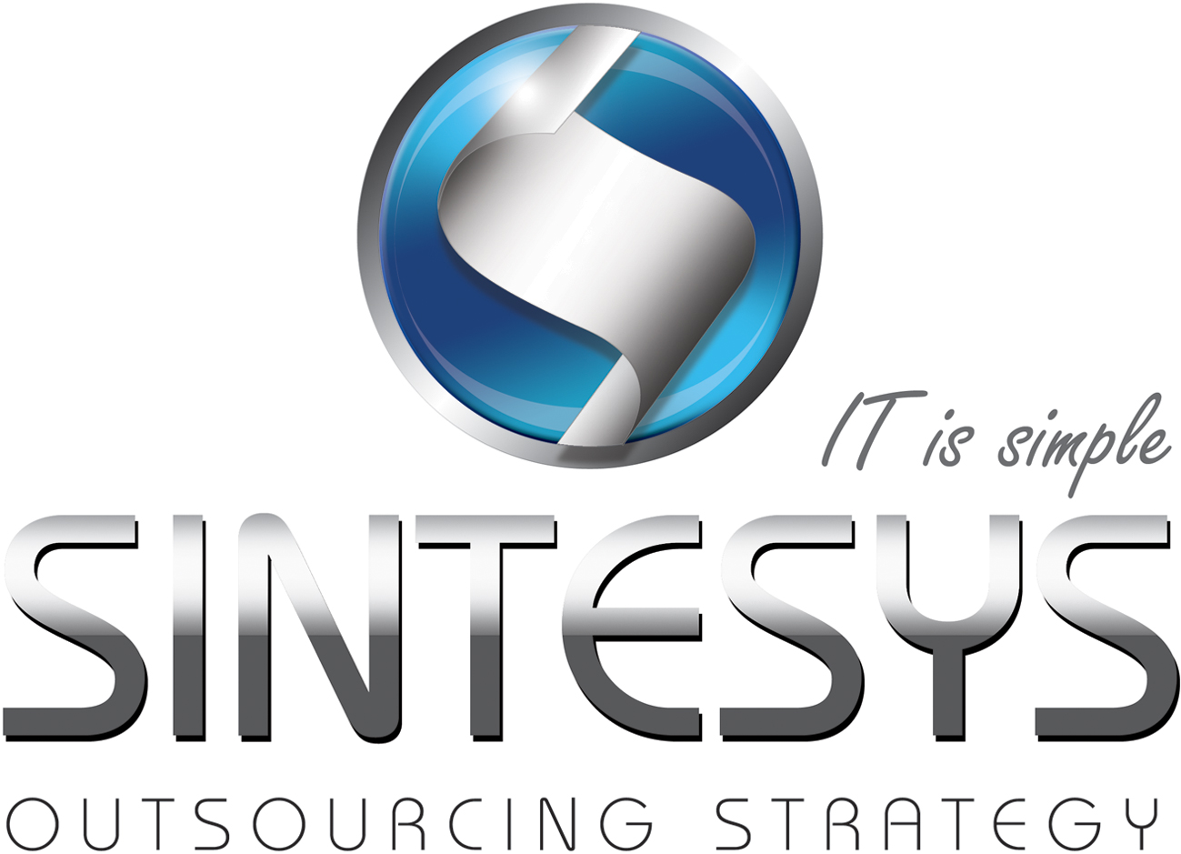Israel Gaytán

Big Data Architect

Big Data Architect.

Results driven IT Professional with 8+ years of experience focusing on Architecting Enterprise solutions basically on .NET Platform ( C#, SQLSERVER,WindowsForms,ASP.NET) and 2+ years focused on big data technologies like Hadoop, Hive, Pig, HBase ,MongoDB, R and Python for processing large datasets and running distributed computations writing Map Reduce Programs. Experience analyzing large datasets and making ad-hoc queries with Hive and architecting and setting up Amazon Elastic Map Reduce environments for data processing.

Experience on loading data from relational database systems in to Hadoop (HDFS) using Sqoop and using Python for: loading, cleaning, transforming, merging and reshaping data. Experience in “R” for getting statistical information on datasets and writing R parallel programs for Hadoop.

Speaker at Big Data events such as Software Guru magazine (the most prestigious IT Media in LatinAmerica). Instructor in KMMX in MongoDB , Pytho and R. Experience teaching different technologies from Hadoop for indivuduals to python and R.

Experience adopting SCRUM and evangelizing teams in the framework and related technologies that involves the project. Documentation on the process and guidelines for colaborative development from source code to CVS(GIT)

# Certifications

Certified Scrum Master (Member 000155404)

# Professional Experience

|  |  |  |  |
| --- | --- | --- | --- |
| Big data architect | | | |
| Company: | Sucrosoft | Location:México City | |
| Client: | Sucrosoft | Dates: | May 2013 to Date |
| Technologies: | Windows Forms,C#,MongoDB,Python | | |
| Activities | -Architect the application with Use Cases , Sequence, Colaboration and Class Diagrams  -Implemented several design patterns for improve data access  -Responsible for gathering requirements, elaborate technical documentation, and business rules.  -Installed and configured MongoDB in a sharded environment  -Developed Map Reduce Programs in MongoDB  -Deduplication and cleansing of data with Python (Pandas) -Designed and Implemented a data migration strategy for NoSQL from SqlServer  -Scrum Master | | |

|  |  |  |  |
| --- | --- | --- | --- |
| Big Data Architect | | | |
| Company: | Flock | Location: México City | |
| Client: | Coke- Telmex | Dates: | December 2012 to April 2013 |
| Technologies: | Hadoop, HBase, Python, R | | |
| Activities | -Implemented the Big Data Strategy for the Consumer Intelligent System (Generate Marketing efficiencies)  -Implemented a local Cluster (Cloudera Distribution) for development and testing purposes -Experience importing and exporting structured data into HDFS and Hive in to Hadoop from SqlServer(Sqoop)  -Experience making queries with Hive and PIG -Deployed the application into Amazon Elastic Map Reduce  -Streamlined cluster scaling and configuration  -Designed and implemented de deduplication and cleansing of the data with Python  - Statistical Analysis with Python  -Experience writing R parallel programs with Hadoop for sophisticated intensive computations  - Experience mining social data from twitter and Facebook - Experience working with GIGYA ,JANRAINand GNIP APIS.  - Scrum Master | | |

|  |  |  |  |
| --- | --- | --- | --- |
| Solutions architect | | | |
| Company: | Talent Process | Location : México City | |
| Client: | Various | Dates: | August 2012 December2013 |
| Technologies: | Python, Hadoop,MongoDB | | |
| Activities | -Architect for improve the platform in serveral aspects, performance, maintainability, escalability.  - Installed Apache Hadoop  - Installed MongoDB in a sharded environment  - Strategy for anaylize resumes with python  - Experience importing and exporting structured data into HDFS and Hivein to Hadoop from MySQL(Sqoop)  -Developed Map Reduce Jobs for summarization and data organization for candidates and related jobs  -Developed a recommendation engine  -Developed different kind of clusters for determine similarity between candidates,classifying, filtering etc ..based on the jobs searches and job candidates data | | |

|  |  |  |  |
| --- | --- | --- | --- |
| Solutions architect | | | |
| Company: | CESIGSA | Location Poza Rica de Hidalgo , Veracruz | |
| Client: | PEMEX | Dates: | June 2009, August 2011 |
| Technologies: | .NET,C#,SQL SERVER,NHIBERNATE, WebORB, Flex,Flash Media Server | | |
| Activities | -Solutions Architect  -Responsible for develop, testing and deploying strategies for a collaborative platform (Enterprise Well Management Studio) for drilling operations in Poza Rica,Veracruz.  -Implemented an MVC design pattern (RobotLegs) on the front End,  -Implemented SOA for the Backend and .NET  - Responsible for develop and maintain a Data Visualization tool (Dashboard) for see statistics for drillings and well interventions.  Scrum Master. | | |

|  |  |  |  |
| --- | --- | --- | --- |
| Solutions architect | | | |
| Company: | Israels Sports Center | Location: México city | |
| Client: | PEMEX | Dates: | January 2009 May 2009 |
| Technologies: | .NET, SQL SERVER,WebORB,Flex | | |
| Activities | -Responsible for architect and develop modules for a in house ERP .  -Responsible for architect a SOA for make RPC calls  -Implemented a MVC pattern on the front end for easy escalability and maintainability  -Experience developing stored procedures  -Experience developing C# business rules | | |

|  |  |  |  |
| --- | --- | --- | --- |
| Senior developer | | | |
| Company: | Leo Burnett | Location: México City | |
| Client: | Philip Morris | Dates: | 2007, 2008 |
| Technologies: | .NET,Flash | | |
| Activities | -Responsible for develop Rich Internet Applications  -Experience gathering requirements from the clients  -Intereactive Adobe AIR Developer | | |
|  |  | | |

|  |  |  |  |
| --- | --- | --- | --- |
| senior developer | | | |
| Company: | SIAT | Location: México City | |
| Client: | Philip Morris | Dates: | 2005, 2006 |
| Technologies: | .NET | | |
| Activities | -.Net webservices developer for synchronize data between clients in parking stations .  -Responsible for develop a secure web service using Triple Des (Encryptor Decriptor Service) | | |

# EDUCATION

|  |
| --- |
| Universidad Nacional Autonóma de México |
|  |

# HIGHLIGHT OF QUALIFICATIONS

|  |
| --- |
| Big Data Architect |
| Hadoop Developer |
| Statistical Analysis with Python And R |
| Certified Scrum Master |
| Proficient English level |
|  |

# OTHER TECHNOLOGIES

|  |  |  |
| --- | --- | --- |
| **Technology** | **Years of Experience** | **Level**  **(Basic / Proficient / Advanced)** |
| **Programming Languages** | | |
| C# | 6 | Advanced |
| Python | 3 | Proficient |
| R | 1 | Basic |
| ActionScript | 8 | Advanced |
| JavaScript | 8 | Advanced |
| Flex | 6 | Advanced |
| **Databases** | | |
| MongoDB | 2 | Advanced |
| SQL Server | 6 | Advanced |
| MySQL | 6 | Advanced |
| Hadoop | 1 | Proficient |
| HBase | 1 | Proficient |
| Hive (language) | 1 | Proficient |
| Sqoop | 1 | Proficient |
| Pig (language) | 1 | Basic |
| **Operating Systems** |  |  |
| Windows 2003 Server | 8 | Proficient |
| Linux (Ubuntu) | 3 | Proficient |
| Mac OSX | 4 | Proficient |
|  |  |  |
|  |  |  |
| **Application Servers** |  |  |
| **Others (Add categories if necessary)** |  |  |
| Flex Framework | 6 | Advanced |
| Adobe AIR | 6 | Advanced |
| Pig | 0 | Basic |
|  |  |  |
|  |  |  |