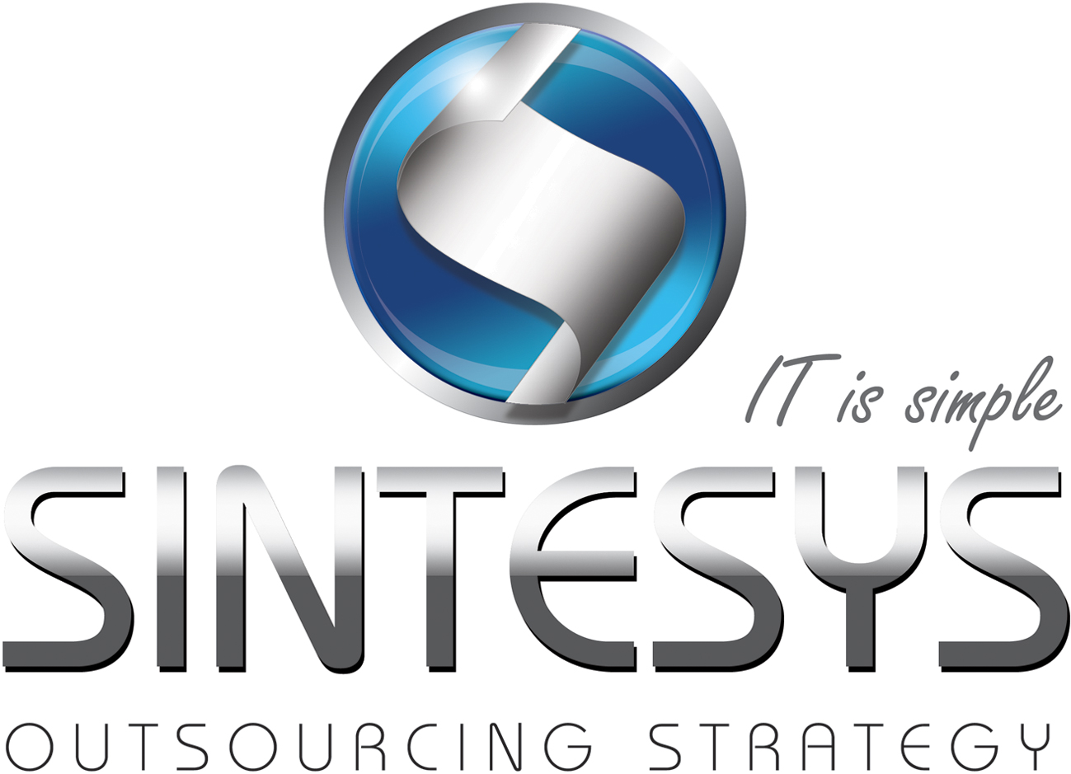Alain Aguilar

SERVICENOW ADMINISTRATOR & JAVA DEVELOPER

# Certifications

Oracle Certified Professional, Java SE 6 Programmer

# Professional Experience

|  |  |  |  |
| --- | --- | --- | --- |
| Systems Lead | | | |
| Company: | FEGQ |  | |
| Client: |  | Date: | January 2013 to date |
| Role: | Systems Lead | Services: | Systems Lead |
| Technologies: | Java, SQL Server, HTML/CSS, Cisco Networks. | | |
| Activities: | Responsible for the entire information technology infrastructure, manage network services, manage database services, systems programming with java, Solarsoft ERP implementation, management and administration of Kepler ERP. | | |

|  |  |  |  |
| --- | --- | --- | --- |
| ServiceNow Administrator | | | |
| Company: | iGate |  |  |
| Client: | GE Corporate | Date: | May 2012 Dec 2012 |
| Role: | Service Now Developer | Services: | Support & Development |
| Technologies: | JavaScript, HTML/CSS, Ajax. | | |
| Activities: | Development with java, javascript, ajax for UI components in Service Now application following SDLC standards. Responsible for the analysis and design of user’s requirements of a few catalog items and tester for all enhancements deployed in sub-production environments. | | |

|  |  |  |  |
| --- | --- | --- | --- |
| System Analyst | | | |
| Company: | Santander Produban |  | |
| Client: | Santander | Date: | Oct 2010 May 2012 |
| Role: | Analyst System | Services: | Support & Development |
| Technologies: | Sybase, Tivoli, Control M, Ullink, Fidessa, Citrix, Java, Oracle, Shell, Unix. | | |
| Activities: | Monitoring banking processes, solutions and reporting of faults found in the system. Programming shells in unix. Report faults using unix logs.Monitoring physical memory and logic servers by tivoli tool, programing in java with unix, maintenance sybase database, IP addressing, configuring firewall rules, configuring servers connection between the city of Queretaro and NY. | | |

|  |  |  |  |
| --- | --- | --- | --- |
| Engineer, System Assistant | | | |
| Client: | Swift Denim | Date: | Sep 2006 July 2010 |
| Role: | Microsoft Developer | Services: | Support & Development |
| Technologies: | Windows x, Java, Visual Basic, Sql Server, Cisco Networks | | |
| Activities: | Analysis and development of systems with java and visual studio, Technical Support to 50 users, monitoring production systems, Network Administrator, administrator and programmer of Lotus Notes email solved the current problems.  IBM AS400 System Programming, Windows 2003 server administration, network configuration and administration with the city of Atlanta and Mexico City through a dedicated link. SQL administration and monitoring with SQL server profile, SQL Server programming creation of queries, views, store procedure, triggers, index and constraints, installing and configuring the SQL Server, designing and creation a database in SQL server for the production systems, creation some transaction dates for production reports, creation SQLCLR for using in visual studio 2005, permission to the users, creating data source connection for java web systems, creating a data mining structure, configuring report services, creating publishing and viewing reports, creation a data source view for reports.  Installation ERP system of Intelisis Company, handling and installation of the operating system unix, participated in the training of intelisis system erp, mail server migration to IBM Domino to Microsoft Exchange Server, disk cloning, database migration, administration and configuration of active directory.  Development of a java web for inventory control of spare parts warehouse, developed in jsp and servlets with struts for the logic of the system, database development in SQL server 2000. Report generator in java web for catching styles used in the production over a period of time, the front was developed with jsp and hibernate for the logic, the database system used was mysql. System to keep track of equipment loaned to employees developed with java jsp web with the front and struts for the logic, database sql server 2000 using netbeans for java and ajax to behold. | | |

# EDUCATION

|  |
| --- |
| **Information Technology Master (MSI), Pachuca Polytechnic University**  **Computer Science Degree, Pachuca Tecnológico University** |

# HIGHLIGHT OF QUALIFICATIONS

|  |
| --- |
| Java, JEE and JavaScript |
| Good analysis and design skills |
| Visual Basic development specialist |
| JDBC development. |
| Struts, Ajax development specialist |
| Advanced English level |