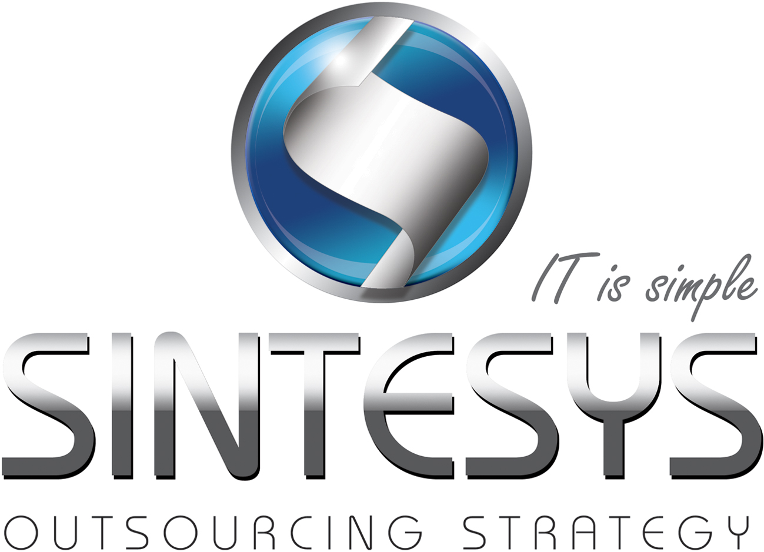Alberto Fernandez

SERVICENOW DEVELOPER

ServiceNow Developer with 1+ years of experience in coding, designing and implementation of Service Request, Change and Incident.

# Professional Experience

|  |  |  |  |
| --- | --- | --- | --- |
| Consultant services (Software engineer) | | | |
| Company: | iGate |  | |
| Client: | GE Corporate | Date: | January 2012 to date |
| Role: | ServiceNow Developer | Services: | Development, designing & coordination |
| Technologies: | JavaScript, DHMTL, HTML/CSS, JQuery, Java, XML, DOM, Jelly, Service-now APIs | | |
| Activities: | NearShore developer lead, configuration, designing and development on ServiceNow platform extending out of the box components by changing the DOM in HTML to enhance features in the UI.  As a part of the RTS team we work mostly for the Client Services stream (Service Request). We use the SDLC methodology to manage the enhancements and new features in the system.  I’m in charge of coordinate the NearShore work and manage the most of the critical incidents P0 and P1 in the catalog items workflows.  Responsible for the updates to the customer in the NearShore team. | | |

|  |  |  |  |
| --- | --- | --- | --- |
| Freelance developer and software analyst | | | |
| Company: | NA |  | |
| Client: | Grupo Educare & Huevocartoon | Date: | August 2010 January 2012 |
| Role: | Software engineer & analyst | Services: | Development of solutions on demand |
| Technologies: | Java, SQL, HSQL, UML, SDLC, Hibernate, XML, Eclipse, Netbeans | | |
| Activities: | Analysis of needs and requirements.  Propose solutions for improve the business activities.  Administration and project development.  Systems Programming.  Maintenance of systems. | | |

|  |  |  |  |
| --- | --- | --- | --- |
| IT and Pedagogical advisor | | | |
| Client: | Desarrollo de Tecnología de Información | Date: | August 2009 to January 2012 |
| Role: | IT and Pedagogical advisor | Services: | Consultant |
| Technologies: | Educational technologies, eLearning’s, robotic development languages, Google technologies | | |
| Activities: | • Pedagogical advice in software technologies for education.  • Advice for school systems and technology infrastructure.  • Coordination of customer support.  • Monitoring and reporting of results.  • Maintenance and support equipment (Formatting, repair, assembly etc).  • Coordination of Helpdesk.  • Impart courses for update and certification (Microsoft Office).  • Teach educational robotics for high school students.  • Coordination of customer payments. | | |

# EDUCATION

|  |
| --- |
| Queretaro Institute of Technology (Mexico) |

# HIGHLIGHT OF QUALIFICATIONS

|  |
| --- |
| Strong knowledge in Java, JEE, C++, JavaScript, HTML, Mysql, HSQL, XML, CSS |
| Strong knowledge in Service now scripting (client & server side), administration and implementation of DOM and HTML to improve the out of the box design.  Strong knowledge in Workflows and business logic. |
| Strong skills in analysis of code, needs, requirements, innovation and simplification of process. |
| Ability to learn new technologies quick |
| Strong knowledge in JDBC & Hibernate |
| Good English level |