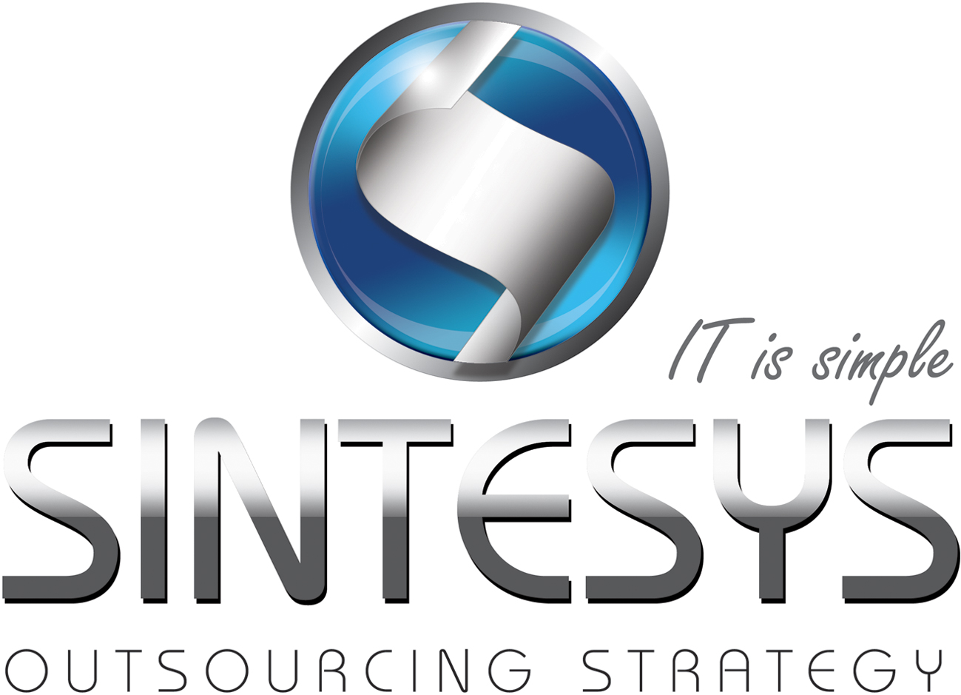Eduardo Morales S

SERVICENOW SENIOR SOFTWARE ENGINEER

Coordinate ServiceNow Operations and Develop software components for implementation on Incident and Problem ITIL Modules for a company with Global business operations.

# Certifications

Oracle Certified Associated Java SE 6

Oracle Certified Professional, Java SE 6 Programmer (In progress)

Oracle Certified Professional, Java EE 5 Web Component Developer (In progress)

Oracle Database 11g Administrator Certified Associate (In progress)

# Professional Experience

|  |  |  |  |
| --- | --- | --- | --- |
| Consultant services (Specialist) | | | |
| Company: | iGate Global Solutions |  | |
| Client: | GE Corporate | Date: | July 2012 to date |
| Role: | ServiceNow Specialist | Services: | Developer, Specialist, Advisory. |
| Technologies: | JavaScript, DHMTL, HTML/CSS, JQuery, Java, XML, Agile – SCRUM. | | |
| Activities: | Incident and Problem Module Management configured to meet business requirements worldwide within global GE Corporate to support ITIL Internal Processes. Support and Development for US, Canada, Europe and Asia. Coordination with team members from USA and India.  Workflows, script includes, client scripts and business rules designed with best practices implemented to enhance performance on UI interfaces.    I develop several components to add new functionality within the current instance which is in operation, mainly related to concurrent modification of incident records, additional requirements to fit business unit needs and recently collaborating in those related to increase the performance response of the main entry point for Incident Module. Besides this assisting on the operations and changes related to the Problem Module business needs.  I am on charge of the deployment of the software components for two streams(Incident and Problem) besides support Cross Streams Operations | | |

|  |  |  |  |
| --- | --- | --- | --- |
| Java Senior Software Developer | | | |
| Company: | New World Monkeys |  | | |
| Client: | Hershey’s Mexico | Date: | April – June 2012 | |
| Role: | Analyst Programmer | Services: | Developer, Specialist, Advisory. | |
| Technologies: | Spring MVC, Hibernate, JSP, JavaScript, JasperReports, Restful Web Services, JSON , DHMTL, HTML/CSS, JQuery, Java, XML, UML, SCRUM. | | | |
| Activities: | Developing of front and back services for the site [www.hersheysteconecta.com.mx](http://www.hersheysteconecta.com.mx)  My work consisted on organize the project, construct the necessary classes to manage www and sms request, handle the business logic and create the service layer, data access object layer to access the database to persist the state of each request to meet the business needs. Which have to follow the constraints to complain with the terms and conditions of the marketing campaign.  Besides this several administrator utilities were developed. Those used for the call center users which enable the participation of final users through phone and the executive report and administrator interface which help to manage the prices and state of the campaign during his duration. | | | |

|  |  |  |  |
| --- | --- | --- | --- |
| Java Software Developer | | | |
| Company: | Vision Software Factory |  | | |
| Client: | SENASICA | Date: | November 2011–February 2012. | |
| Role: | Java Developer | Services: | Developer, Advisory. | |
| Technologies: | JSF, ADF, Weblogic Server and Portal, Ajax, RichFaces, Spring, Hibernate, JSP, JavaScript, JasperReports, DHMTL, HTML/CSS, JQuery, Java, XML. Web Services, SOAPUI, UML, SCRUM. | | | |
| Activities: | Collaborating on the construction of a web portal developed with different  Technologies mainly related to Oracle ADF Framework and Oracle Weblogic Servers.  Construction of several projects which were assembled into a web portal. The combination of technologies was a main point in this project.  My work consisted on construction of ViewControllers, web pages, Mbeans, scripts creation of single projects with ADF Framework and correction of bugs in several components which conforms the portal.  Some reports were developed using jasperReport technologies. | | | |

|  |  |  |  |
| --- | --- | --- | --- |
| Junior Software Developer | | | |
| Company: | CICATA – Querétaro |  | | |
| Client: | IPN | Date: | January 2010 – June 2011. | |
| Role: | Junior Software Developer | Services: | Developer, Advisory. | |
| Technologies: | Java, XML, UML, SCRUM, C++, MartLab. | | | |
| Activities: | Collaboration on Developing a Module of Movement Detection using stochastic methods of 2nd order. Developing of a first prototype of a surveillance software system which was able to detect changes in a given environment. Two algorithms were developed with MatLab, Background Subtraction and Detection by a Gaussian function.  Research project in parallelism and concurrency. Knowledge generation in the field of concurrency and Java related technologies.  Analysis of a existent system to proceed with its implementation on a tight coupled system (multicore system). Several prototypes were developed using the native thread mechanisms in Java. Then using the utilities in java.util.concurrent package - Java Concurrency Utilities. | | | |

# EDUCATION

|  |
| --- |
| Computational Engineering Degree. Universidad Autónoma de Querétaro. (2009) |
| Computing and Network Specialist Associated Degree. UAQ.(2005) |

# HIGHLIGHT OF QUALIFICATIONS

|  |
| --- |
| Java, JEE, JavaScript specialist. |
| ServiceNow specialist. |
| Instructor of Java Technologies. |
| RESTful and SOAP Web Services specialist. |
| Struts, Spring, Jasper Reports development specialist. |
| JDBC, Hibernate and Data Modeler specialist. |
| Oracle Database, ADF Framework and Weblogic specialist. |
| Advanced English level |