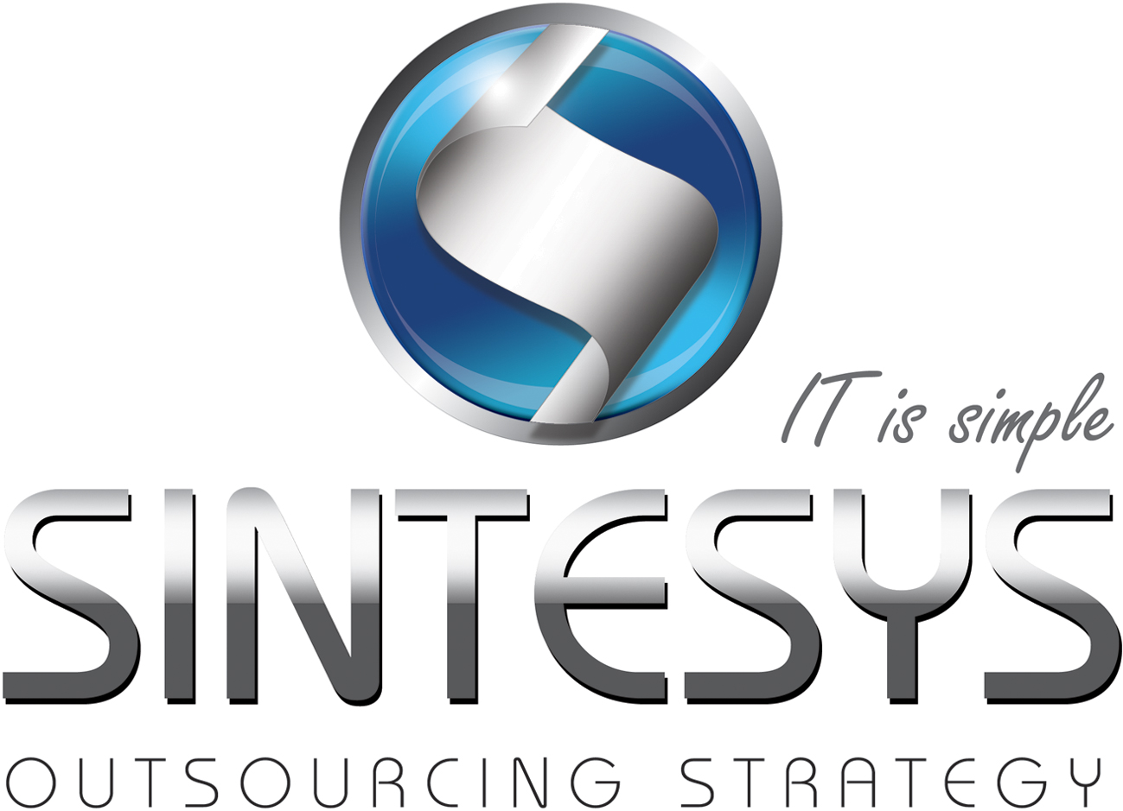Luis Saucedo

SERVICENOW ADMINISTRATOR & JAVA DEVELOPER

Web developer with 3+ years of experience in successful implementations, including ServiceNow administration.

# Certifications

# Professional Experience

|  |  |  |  |
| --- | --- | --- | --- |
| Consultant services (Adminstrator) | | | |
| Company: | iGate |  | |
| Client: | GE Corporate | Date: | November 2011 to date |
| Role: | ServiceNow Adminstrator | Services: | Specialist, Advisory, Technical Lead |
| Technologies: | JavaScript, DHMTL, HTML/CSS, JQuery, Java, XML, SOAPUI | | |
| Activities: | Analysis, gathering of requirements, design, proposition of solutions, development, testing and deployment between different environments (Development, QA, Pre Production and Production) of new features and maintenance to Web Applications based on Service Now into the “Client Services – End User Services” Stream.  Working with Client Script, Script Include, Macros, XML, Jelly, Business rules, Workflow and UI policy implementing best practices to enhance and get the better performance on each component used. | | |

|  |  |  |  |
| --- | --- | --- | --- |
| Consultant services (Consultant) | | | |
| Company: | TCS |  | |
| Client: | Santander Bank of Spain | Date: | January 2011 to November 2011 |
| Role: | Java Web Developer | Services: | Consultant |
| Technologies: | Java SE, SQl, BanksFear, Java Script, XML, HTML, Struts, JDBC, JSP, Java Server Faces | | |
| Activities: | Analysis and design of requirements  Definition of actions and beans for struts  Setup and configuration of JSF for ajax calls  Design and implementation of data structures in database | | |

|  |  |  |  |
| --- | --- | --- | --- |
| Consultant services (Consultant) | | | |
| Company: | Durango Software S. A. de C.V |  | |
| Client: | Durango’s State Government | Date: | February 2010 to January 2011 |
| Role: | Java Web Developer | Services: | Consultant |
| Technologies: | Java SE, SQl, Java Server Faces, Rich Faces, XML, HTML, Java Persistence API, JSP, Enterprise Java Bean | | |
| Activities: | Responsible to build JSP, HTML and JavaBeans  Designed SQL queries  Analysis and Design of requirements | | |

# EDUCATION

|  |
| --- |
| Durango Institute of Technology (Mexico) |

# HIGHLIGHT OF QUALIFICATIONS

|  |
| --- |
| Analysis, design and development skills |
| Java development |
| Conversational English level |