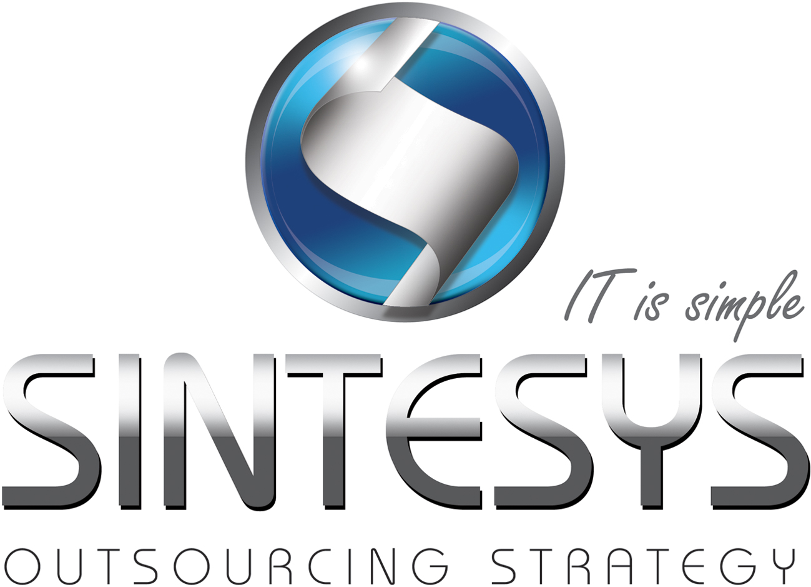Oscar Lopez

SERVICENOW ARCHITECT

Lead ServiceNow projects with 3+ years of experience in successful implementations of Incident, Change and Problem, including Integration with SOAP Web Services and Service Request.

# Certifications

Oracle Certified Professional, Java SE 6 Programmer

W3Schools HTML/CSS

W3Schools JavaScript

W3Schools XML

# Professional Experience

|  |  |  |  |
| --- | --- | --- | --- |
| Consultant services (Architect) | | | |
| Company: | iGate |  | |
| Client: | GE Corporate | Date: | January 2010 to date |
| Role: | ServiceNow Architect | Services: | Specialist, Advisory, Technical Lead |
| Technologies: | JavaScript, DHMTL, HTML/CSS, JQuery, Java, XML, SOAPUI | | |
| Activities: | * Nearshore coordinator * Architect for B2B process, designing, configuring and developing Scripted Web Services and Transform Map Web Services. * Built UI interfaces for Incident Management * Created business rules, client scripts and script includes to manage dynamic data * Design and build email notifications and templates * Design and built jobs to auto close tickets and child tickets * Design code standards for scripts * Applied ITIL best practices for incident ticket prioritization | | |

GE Energy Contracts

|  |  |  |  |
| --- | --- | --- | --- |
| Customer Contracts | | | |
| Client: | GE Energy | Date: | April 2009 January 2010 |
| Role: | Team Leader | Services: | Enhancements, Support & Development |
| Technologies: | Oracle 10g, Java, JEE, Struts, Spring, RESTEasy Web Services, JDBC, UML, JavaScript, HTML/CSS, JSP, JSTL, JaxBe, JBoss | | |
| Activities: | Responsible for the development of new modules for GE Energy Customer Contracts system web based. Designed prototypes, UML documentation and use cases in order to develop different CRUD applications to meet requirements. Deployed RESTful web services with RESTEasy framework.  Responsible for the deployment in production with successful implementation.  Lead a team of 5 people, 2 in Mexico and 3 at India. | | |

|  |  |  |  |
| --- | --- | --- | --- |
| Consultant services (Team Lead) | | | |
| Company: | Softtek |  | |
| Client: | Hewlett Packard – Palo Alto, CA | Date: | November 2006 December 2008 |
| Role: | ServiceNow Architect | Services: | Enhancements, Support & Development |
| Technologies: | Oracle 10g, Java, JEE, Struts, Spring, JDBC, UML, JavaScript, HTML/CSS, JSP, JSTL, Tomcat | | |
| Activities: | Maintenance and development of web application AdminTool built in Java with Oracle to manage contracts, products and bundles of Hewlett Packard customer across the globe for vendors and third-party systems in Americas. Extensive management and technical skills were required to lead resources at Offshore and resources Nearshore to keep coordination and plan activities on every phase of SDLC with customers, sponsors and stakeholders in HP headquarters at Palo Alto, CA. | | |

|  |  |  |  |
| --- | --- | --- | --- |
| Consultant services | | | |
| Client: | Irwin Reasearch & Development Inc | Date: | June 2005 a November 2006 |
| Role: | Microsoft Developer | Services: | Consultant |
| Technologies: | Visual C++ 2005, Informix | | |
| Activities: | Support, maintenance and development for various client/server projects with Irwin Research & Development Inc. customer at Yakima Washington. Responsible for the Accounting (General Ledger) system and the manufacturing system (for managing serial/parallel workstations jobs/tasks) of customer's shop in Yakima Washington, both developed in Visual C++ from Visual Studio 2002 to Visual Studio 2005. | | |

# EDUCATION

|  |
| --- |
| Queretaro Institute of Technology (Mexico) |

# HIGHLIGHT OF QUALIFICATIONS

|  |
| --- |
| Java, JEE and JavaScript expert |
| Good analisis and design skills |
| Instructor of Java and ServiceNow |
| RESTful and SOAP Web Services development specialist |
| Visual C++ development specialist |
| JDBC, Hibernate development specialist |
| Struts, Spring, iReport, Jasper Reports development specialist |
| Advanced English level |